

**Dharmsinh Desai University, Nadiad**

Faculty of Technology, Department of Computer Engineering

B. Tech. CE Semester – VI

Subject: (CE – 621) System Design Practice

Project Title:

**Quiz Game**

**(Android App)**

By:

Chintal Jain CE045 (17CEUOS087)

Nimisha Jain CE046 (17CEUOS120)

**Guided By:**

|  |
| --- |
| **Prof. Sheetal S. Shah** |
|  |



**Dharmsinh Desai University, Nadiad**

Faculty of Technology, Department of Computer Engineering

**CERTIFICATE**

This is to certify that System Design Practice entitled “**Quiz Game(Android App)**” is the bonafied report of work carried out by

1**)Chintal Jain (17CEUOS087)**

**2)Nimisha Jain (17CEUOS120)**

Of Department of Computer Engineering ,Semester VI , academic year 2019-2020, under our supervision and guidance.

|  |  |  |
| --- | --- | --- |
|  |  |  |
| **Guide** |  | **HOD** |
| **Prof. Sheetal S. Shah**  Associate Professor of Department of Computer Engineering, Dharmsinh Desai University, Nadiad |  | **Dr. C. K. Bhensdadia**  Head of Department of Computer Engineering, Dharmsinh Desai University, Nadiad |
|  |  |  |

Table of Contents

**1 Abstract ……………………………………………………………………..……………………………..…4**

**2 Introduction …………………………………………………………………………………………........5**

2.1 Project Details: Brief Introduction ……………………….................5

2.2 Technology and Tools Used …………………………………................5

**3 Software Requirement Specifications ………………………..……………………………….. 6**

3.1 Scope ………………………………………..………………………………………..6

3.2 Users …………………………………………………………………………………..6

3.3 System Functional Requirements ……………….……………………….6

3.4 Other Non‐Functional Requirements ……………….…………………9

**4 Design ………………………….……………………….…………………………………………………….10**

4.1 Usecase Diagram………..…………………………………………………......10

4.2 Class Diagram ………………………….………….………………….………….11

4.3 Sequence Diagram ………………………..…….……………..……………..12

4.4 Activity Diagram………………….………………………………….…..……..13

4.5 State Diagram ……….……………………………………………………………15

4.6 E-R Diagram ……………..………………………………………………..……...16

4.6 Data Dictionary……..…….……………………………………………..……...17

**5 Implementation Details …………………………………….…………………………………………20**

5.1 Activities Created …………………..……..…………………………………...20

5.2 Functional prototypes ………………..……………………..…….………...23

**6 Testing …………………………………………………………………………………………………………24**

6.1 Testing Method….………………………………….……………………………24

6.4 Test Cases ………………………………………………………………….……….24

**7 Screen‐shots of the System ………………………………………………………………….........27**

**8 Caonclusion …………………………………………………………………………………….……………..33**

**9 Limitations of System …………………………………………………………………………………..34**

**10 Future Extensions to the System …………………………………………………………….….34**

**11 Bibliography ……………………………………………………….……………………………………..35**

**Abstract**

As we all know how knowledge is useful to person in any field and in each field person got position based on his/her knowledge. So, it is require to have an idea to test the knowledge of person & one platform which can help to increase knowledge as well as to test the knowledge. Our application is built on the same idea. It enable a person to test his/her knowledge. It basically creates quiz for different subjects & topics having much important questions. The person who wants to test knowledge of others can create such quizzes & other person can evaluate same to test skill & knowledge. Our application runs on android mobile which is now available to most of the people & internet is also required which is also available easier in India right now. So, anyone from anywhere can use our app to test skillset & can prepare for his/her better future. It also enables user to create real time quiz & evaluate result which is also a need in this technology enhancement world. Our app seems like a game but also useful game which can be used for just shake of fun, crucial exams etc. So with our app user feels like he/she is playing game that include more interest in user to use our app. It also provide user friendly design so user can feel comfort while playing Game.

**Introduction**

**2.1. Brief Introduction**



Firewiz is an android game application. Through our app different user can create different time of quiz and can play the quiz created by user & admins. This app is for testing one’s skill set & knowledge and is also for fun like playing a game. At the time of workshops on different topics in different field how organizer comes to know that participated audience gathered information correctly or not. At this situation our app comes in to picture. It satisfied the above requirement of organizers easily because it is developed on smart phones which is available to most of us and from anywhere they can use it.

**2.2. Tools/Technologies Used**

Technologies : Java Core,

XML,

Firebase Real Time Database,

Tools : Android Studio, Git hub Desktop

Platforms : <http://console.firebase.google.com> for firebase console

Android 4.0.3 IceCreamSanwich (All android version supports this) with minimum API version 16

Git hub for maintaining Version Control System.

**Software Requirement Specifications**

**3.1 Product Scope**

This system is designed to enable users & quiz setters to play & create quiz from anywhere any time. It enables the person to evaluate quiz results & based on that make ranking for participants. It also enable workshop/seminar organizers for the same and to have feedback on its content delivery.

**3.2 Types of Users:-**

1. End user (Player & Quiz setter)

2. Admin

**3.3. System Functional Requirements**

*1) End user (Player & Quiz setter):-*

R.1.1 : Create quiz

Description :- Any user even admin can create quiz for gamers.

Inputs :- Quiz duration in seconds, name & its description.

Output :- Ask to add question and unique quiz id.

R.1.2 : Show Available Quiz

Description :- User can see available quiz & can participate in it to play.

Input :- User selection.

Output : Available quiz with it details.

R.1.3 : Add Question to Quiz

Description :- User can add question at the time of creation of quiz.

Inputs :- Question Details with it scores.

Output :- Message.

R.1.4 : Play Quiz

Description :- Enable user to evaluate quiz.

Inputs :- Quiz id.

Output :- Quiz and its questions.

R.1.5 : Manage Account

- R.1.5.1 : Modify User Details

Description :- User can modify his/her details such like

e-mail, contact number, username, password etc.

Inputs :- User Selection with modification parameter.

Output :- User Details.

- R.1.5.2 : View past quizzes played

Description :- User can see all past quizzes played by him/her.

Inputs :- User Selection.

Output :- Past Played Quizzes with results.

- R.1.5.3 : Manage Favourite Quiz

Description :- User can view add delete his favourite

Quiz.

Inputs :- User Selection.

Output :- Favourite Quiz list.

- R.1.5.4 : Delete Account

Description :- User can delete his/her account.

Inputs :- User Selection.

Output :- Entries will be deleted.

R.1.6 : Register User

Description :- User have to register to use our app.

Inputs :- User details like name, username,

password, contact etc.

Output :- Entry in database.

R.1.7 : Search Quiz

Description :- User can filter quiz by any quiz parameter to play it.

Inputs :- Search query with filter option.

Output :- Quiz list according to filter selected.

R.1.8 : Host Quiz Live

Description :- User can make quiz live for some duration to evaluate result for group of people like in workshops/seminars.

Inputs :- User Selection.

Output :- Quiz Live Id.

R.1.9 : Display Quiz Score

Description :- Player can see his/her obtained score for a particular quiz played.

Inputs :- User Selection with quiz.

Output :- Obtained score with all question & corresponding answer.

*2) Admin:-*

R.2.1 : Manage Users

- R.2.1.1 : Add new users.

Description :- Admin can add new users.

Input :- User details.

- R.2.1.2 : Delete User

Description :- Admin can delete a user if it is malicious user.

Input :- User selection.

- R.2.1.3 : Display User

Description :- Admin can see the all user details.

Input :- User selection.

Output :- Users List.

R.2.2 : Manage Quiz

- R.2.2.1 : Add quiz

Description :- Admin can also add quizzes which is public to everyone and live for .

Input :- Quiz details.

- R.2.2.2 : Delete quiz

Description :- Admin can delete if it is not suitable.

Input :- User selection.

- R.2.2.3 : Display quizzes

Description :- Admin can see all live & available quiz.

Input :- User selection.

Output :- Quizzes List with its questions and plays.

R.2.3 : Display Statistics

Description :- Admin can see the overall statistics.

Input :- User selection.

Output :- Statistics.

**3.4. Other Non-functional Requirements**

**1 Performance**

Performance The system must be interactive and the delays involved must be less. So in every action‐response of the system, there are no immediate delays. In case of opening App components, of popping error messages and saving the settings or sessions there is delay much below 3 seconds.

**2 Safety**

User details should be securely stored to the server. The main security concern is for user account hence proper login mechanism should be used to avoid hacking.

**3 Reliability**

As the system provide the right tools for discussion, problem solving it must be made sure that the system is reliable in its operations and for securing the sensitive details.

**4 Database**

System requires to access users data fastly to maintain the performance.

**Design**

**4.1 Use Case Diagrams**

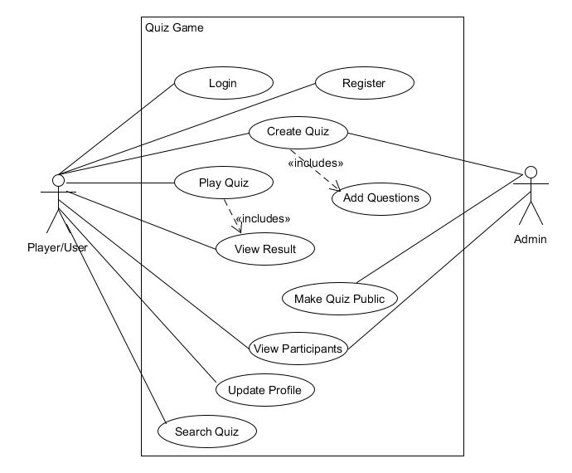

**4.2 Class Diagrams**

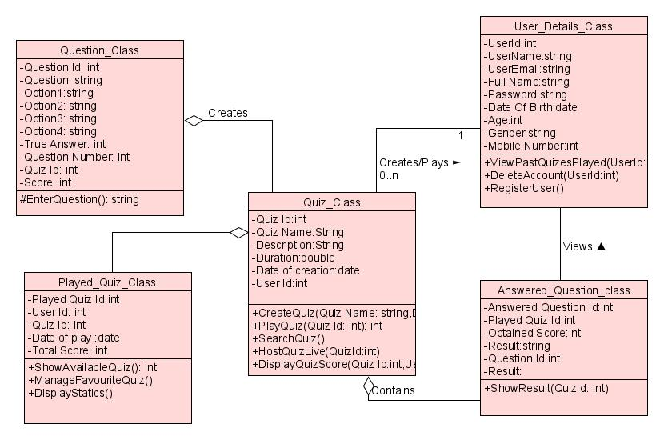

**4.3 Sequence Diagrams**

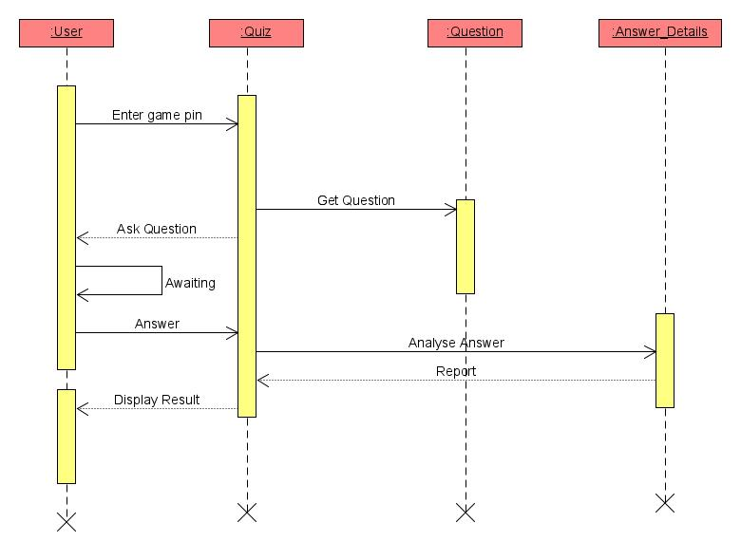

Sequence Diagram For Play Quiz

**4.4 Activity Diagrams**

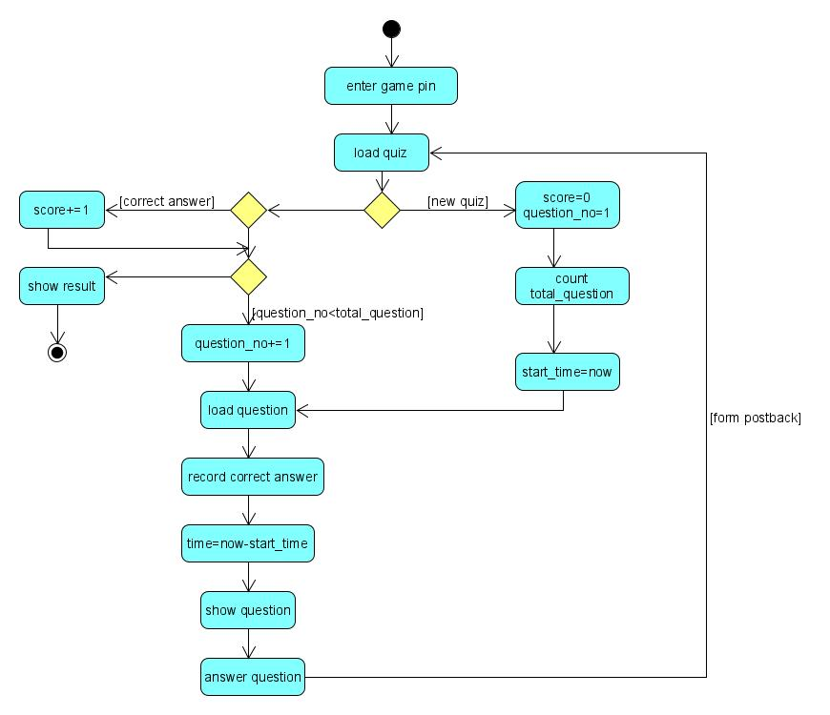

Activity Diagram For Play Quiz

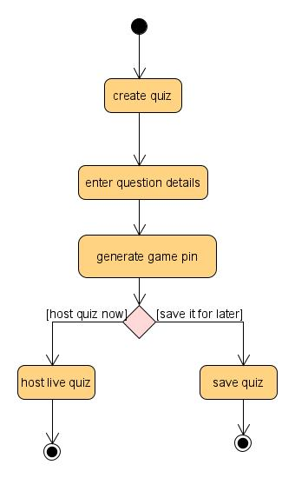

Activity Diagram For Create Quiz

**4.5 State Diagrams**

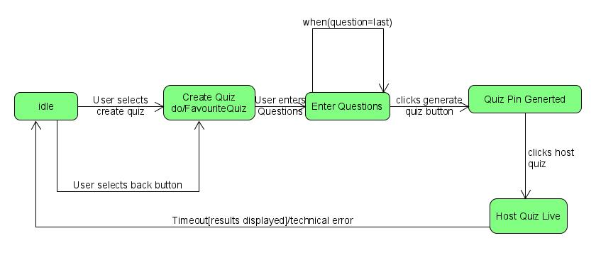

State Diagram For Create Quiz

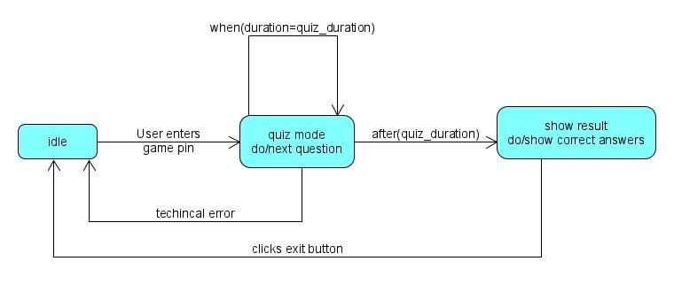

State Diagram For Play Quiz

**4.6 E-R Diagrams**

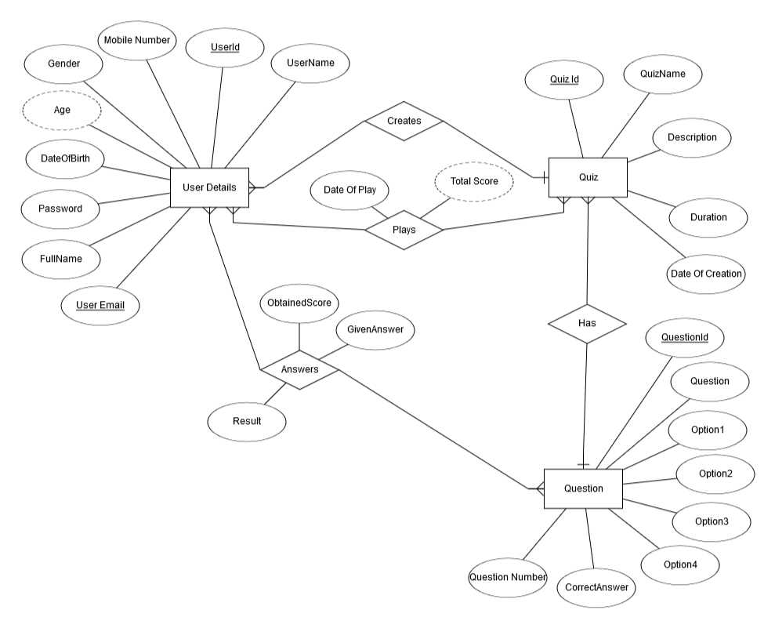

**4.7 Data Dictionary**

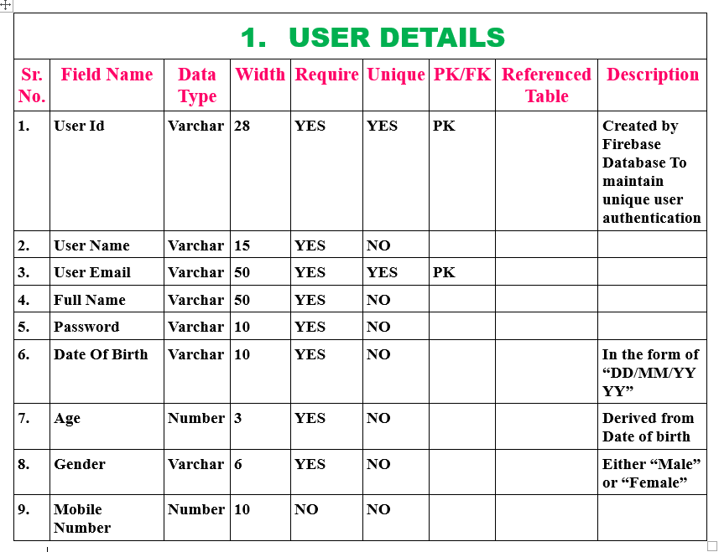

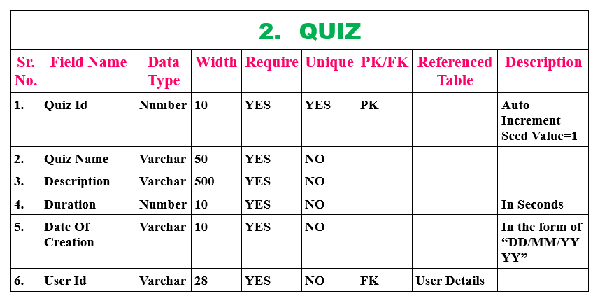

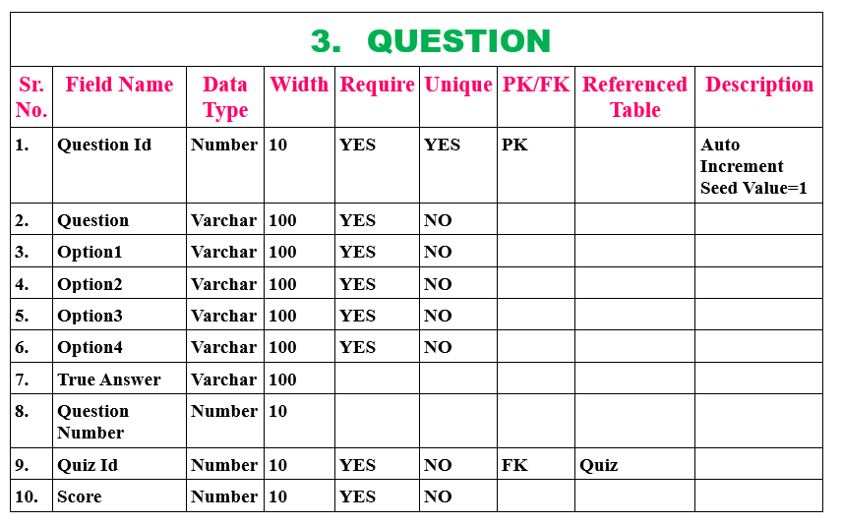

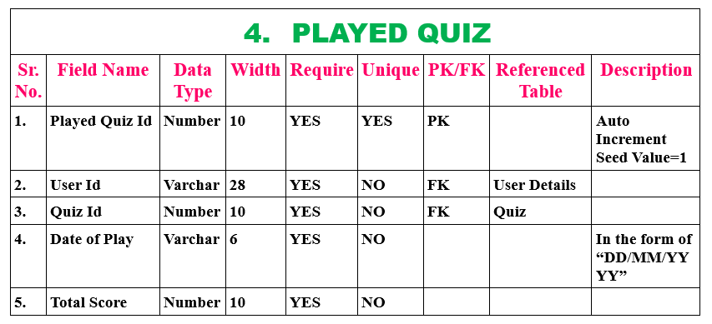

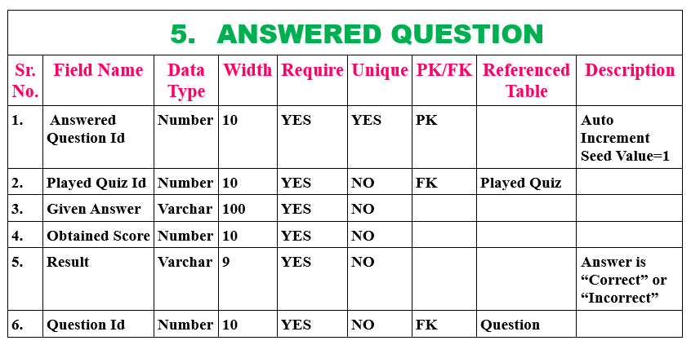

**Implementation Details**

* 1. **Activities Description**
* **Main Activity:**

This is simple a splash activity and stays on screen for 3 seconds. It simply starts animation for our app & loads data to app depending on internaet connection. After 3 second it will transfer to home activity.

* **Sign Up Activity:**

This activity is used to store user’s data to the database and enables the user to login to the system. All the fields in this module contains required validations and it uses user model to store data.

Input : User’s Informations

Output : User Registered and redirect to login page

Processing : Validating user’s data and then storing them to database

* **Login Activity:**

This module takes users credentions and then verifies it with registered users , if user is not registered the invalid credentials is shown else if they match with database then login user. Also if user is not registered it has redirection to signup activity which enable user to register to app.

Input: User Credentials

Output: Logging user.

Processing: Verifing user credentials with the database.

* **Home Activity:**

This activity is our home page which will load after 3 seconds of launching the app i.e. after completion of main activity.

From here user can registered & login (if already registered), can create quiz and make it available, can play quiz & by providing unique quiz id.

Input : User Selection

Output :Corresponding response

* **User Profile Activity:**

This activity has login and signup buttons if user is not logged in and if user is logged in then he/she can see his/her profile & can make changes from this activity.

Input : User Selection

Output : Corresponding response

Processing : Validating Fields and then updating the database.

* **Create Quiz Activity:**

This activity takes quiz details from user & pass it to Add Question Activity to make entry in database. To create Quiz user must have to login so if user is not logged in it will prompt a message for login & prevent him/her to create quiz.

Input : User Selection

Output : Corresponding response

* **Add Question Activity:**

This activity adds questions details given by user to quiz. It uses quiz & question model to perform operations. It will also check that quiz has minimum one question & after having one question it enables user to add quiz to database & make it available to players. It also validates all fields. After successful entry it will redirect user to home page.

Input : User Selection

Output : Corresponding response

Processing : Validating Fields and then make entry in the database.

* **Play Quiz Activity:**

This activity fetch the quiz questions from database. This is our main functionality where in given time period user has to answer questions. It also required that user is logged in. If user it not logged in it will prompt error message and don’t allow user to play any quiz.

After user completes quiz or time limits over it will land user to result activity which shows statistics of quiz played.

During the game if user give corret answer that answer turns too green color and if in correct answer then correct anser turns to green color & selected answer to red color.

Input : User Selection

Output : Corresponding response

* **Result Activity:**

This activity shows the result of played quiz after finishing of game. This will take input from intent given by Play Quiz Activity &

* 1. **Function Prototypes**
* **Login :**



* **Sign Up :**



* **Play Quiz changing question :**



* **Starting reverse timer :**



* **Validate User Data :**



* **Firebase Database References :**



* **Add quiz to database :**



* **Add question to database :**



* **Add user details to database :**



**Testing**

* 1. **Testing Method:**

We have performed Black - box testing for the testing purpose.

* 1. **Test Cases:**

For Registration:

Email must be of corrct email. So if

Input=”abc” Output is invalid.

Similarly there is validations for every fields.

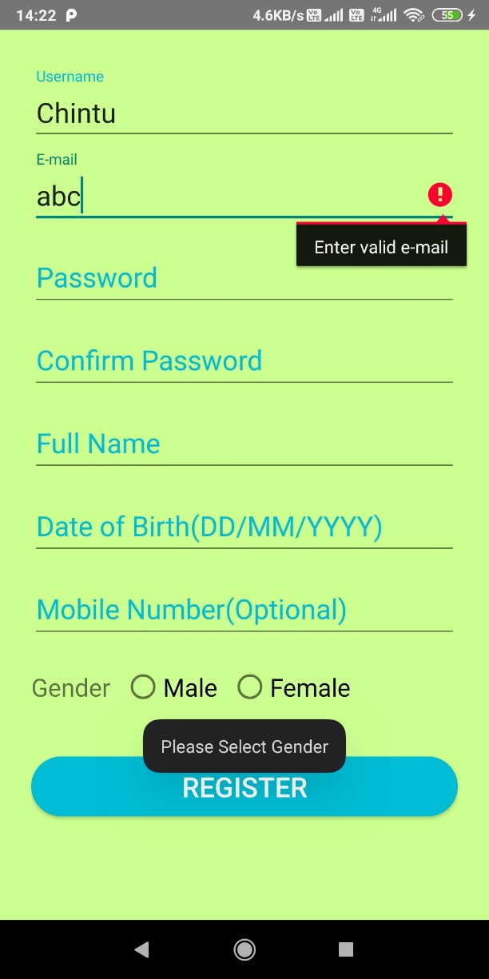 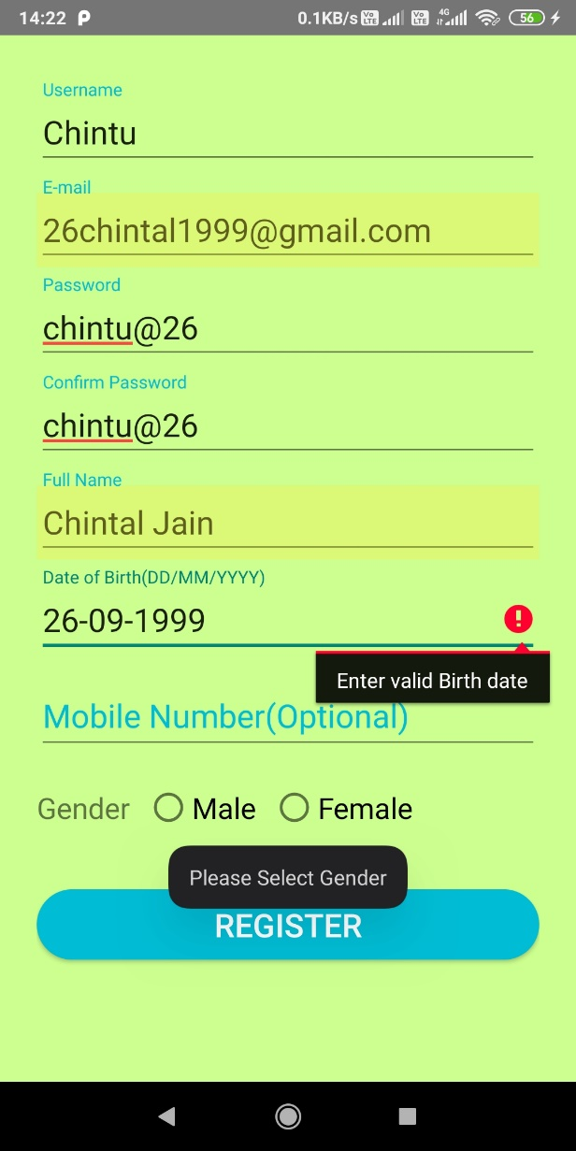

Login:

If credentials are invalid then error message is shown.

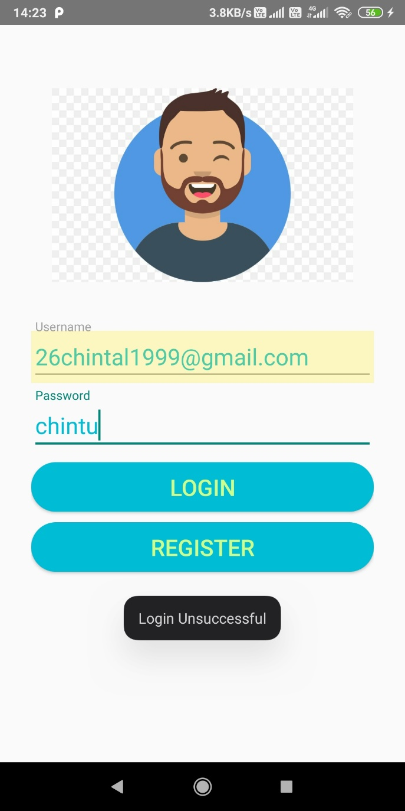

Quiz Creation :-

If duration is not digit it will ask to enter dnumber > 0.

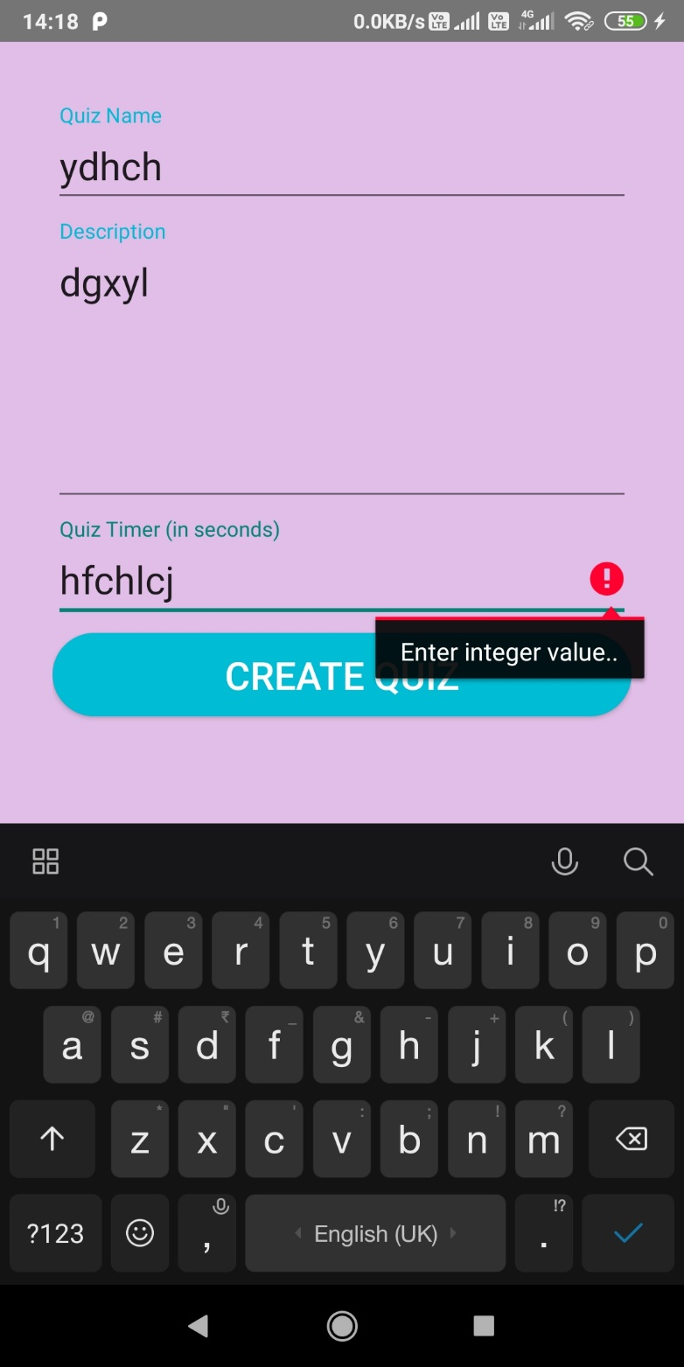

**Screenshots**

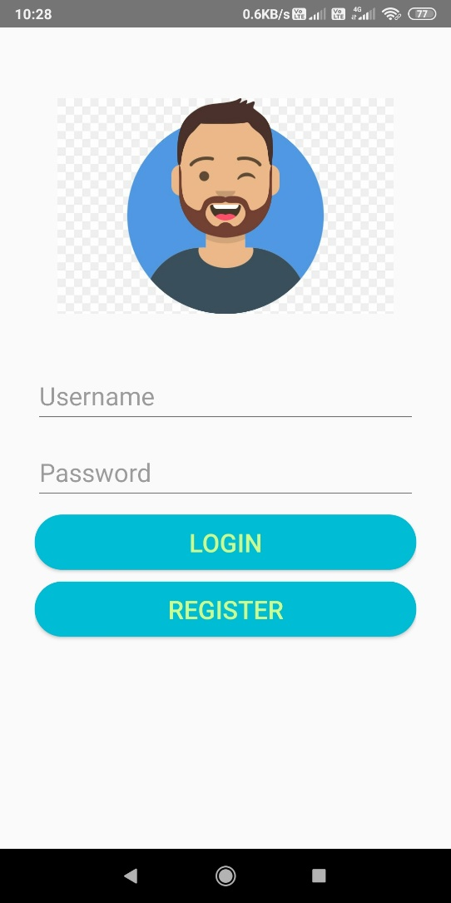 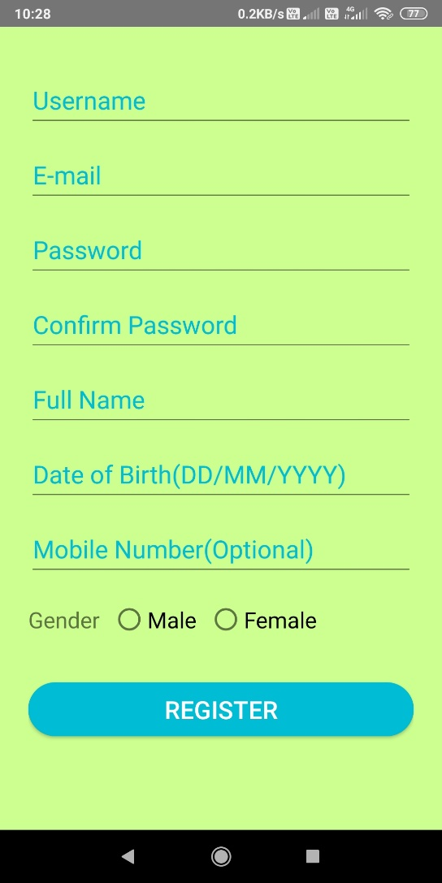

Figure7.1 : Login Figure7.2 : Signup

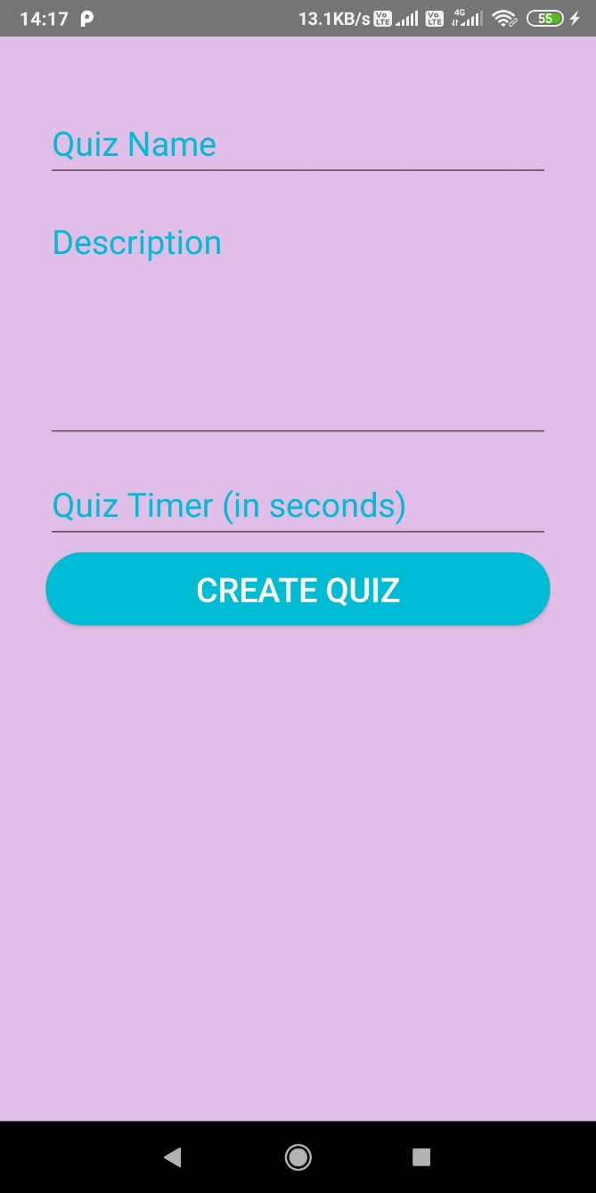

Figure7.3 : Quiz Creation

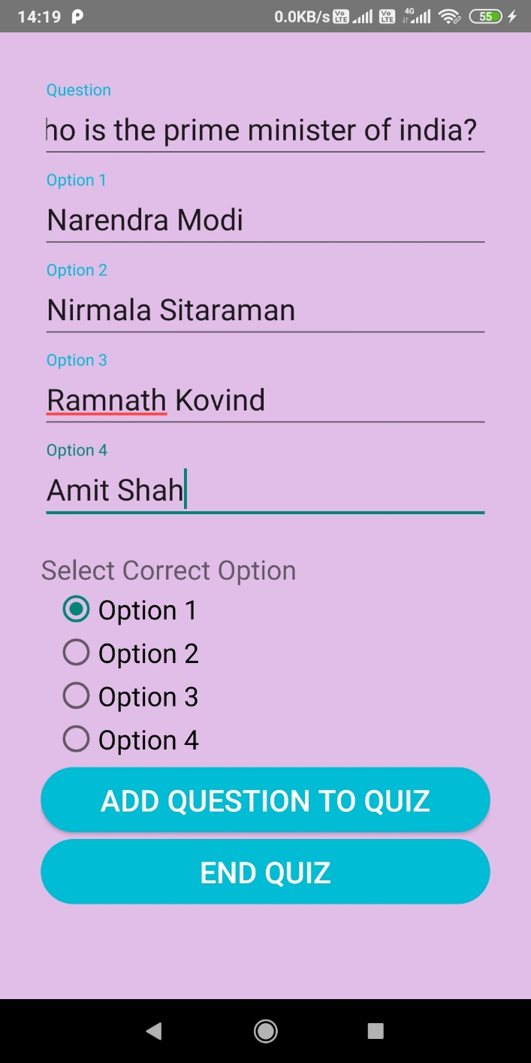

Figure7.4 : Add Question To Quiz

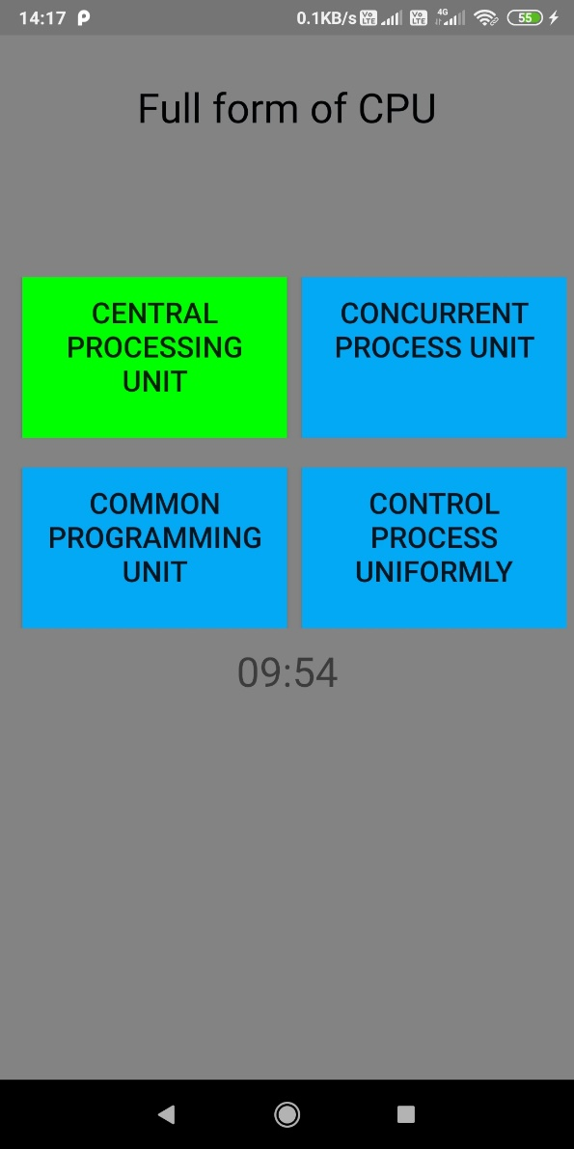 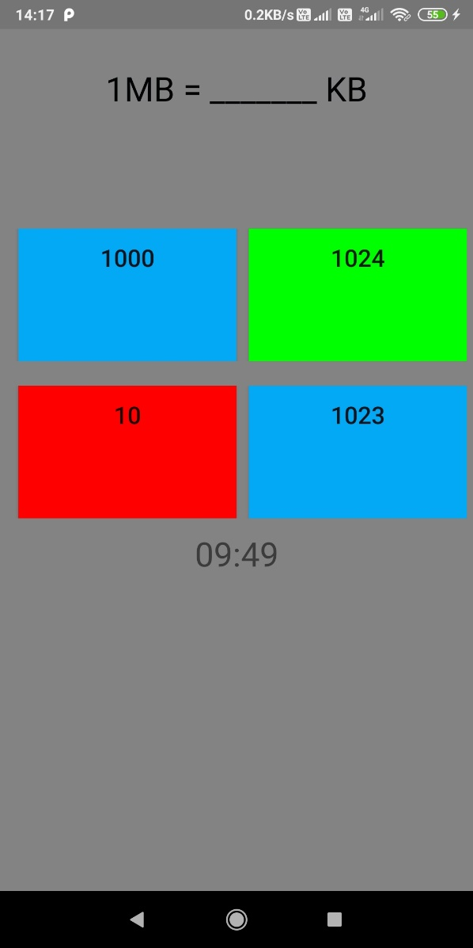

Figure7.5 : User giving correct answer Figure7.6 : User giving in-correct answer

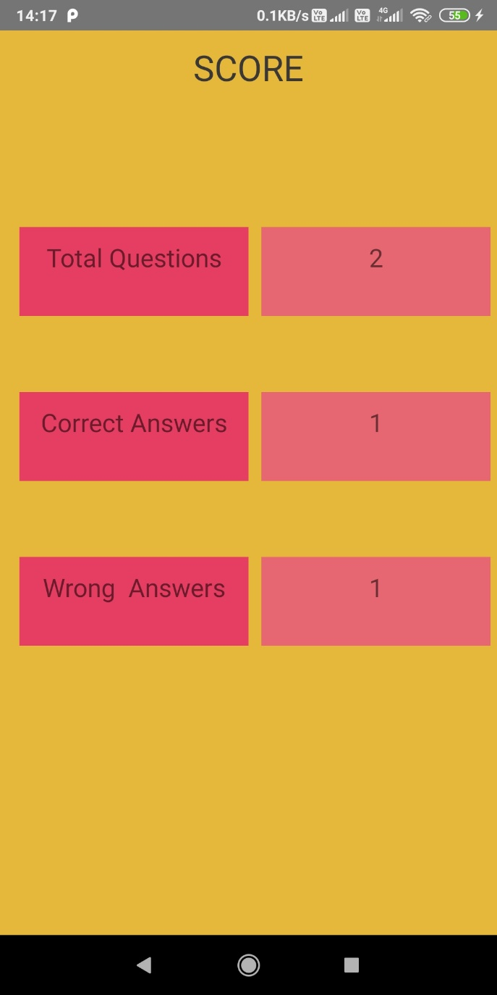

Figure7.7 : Result Activity

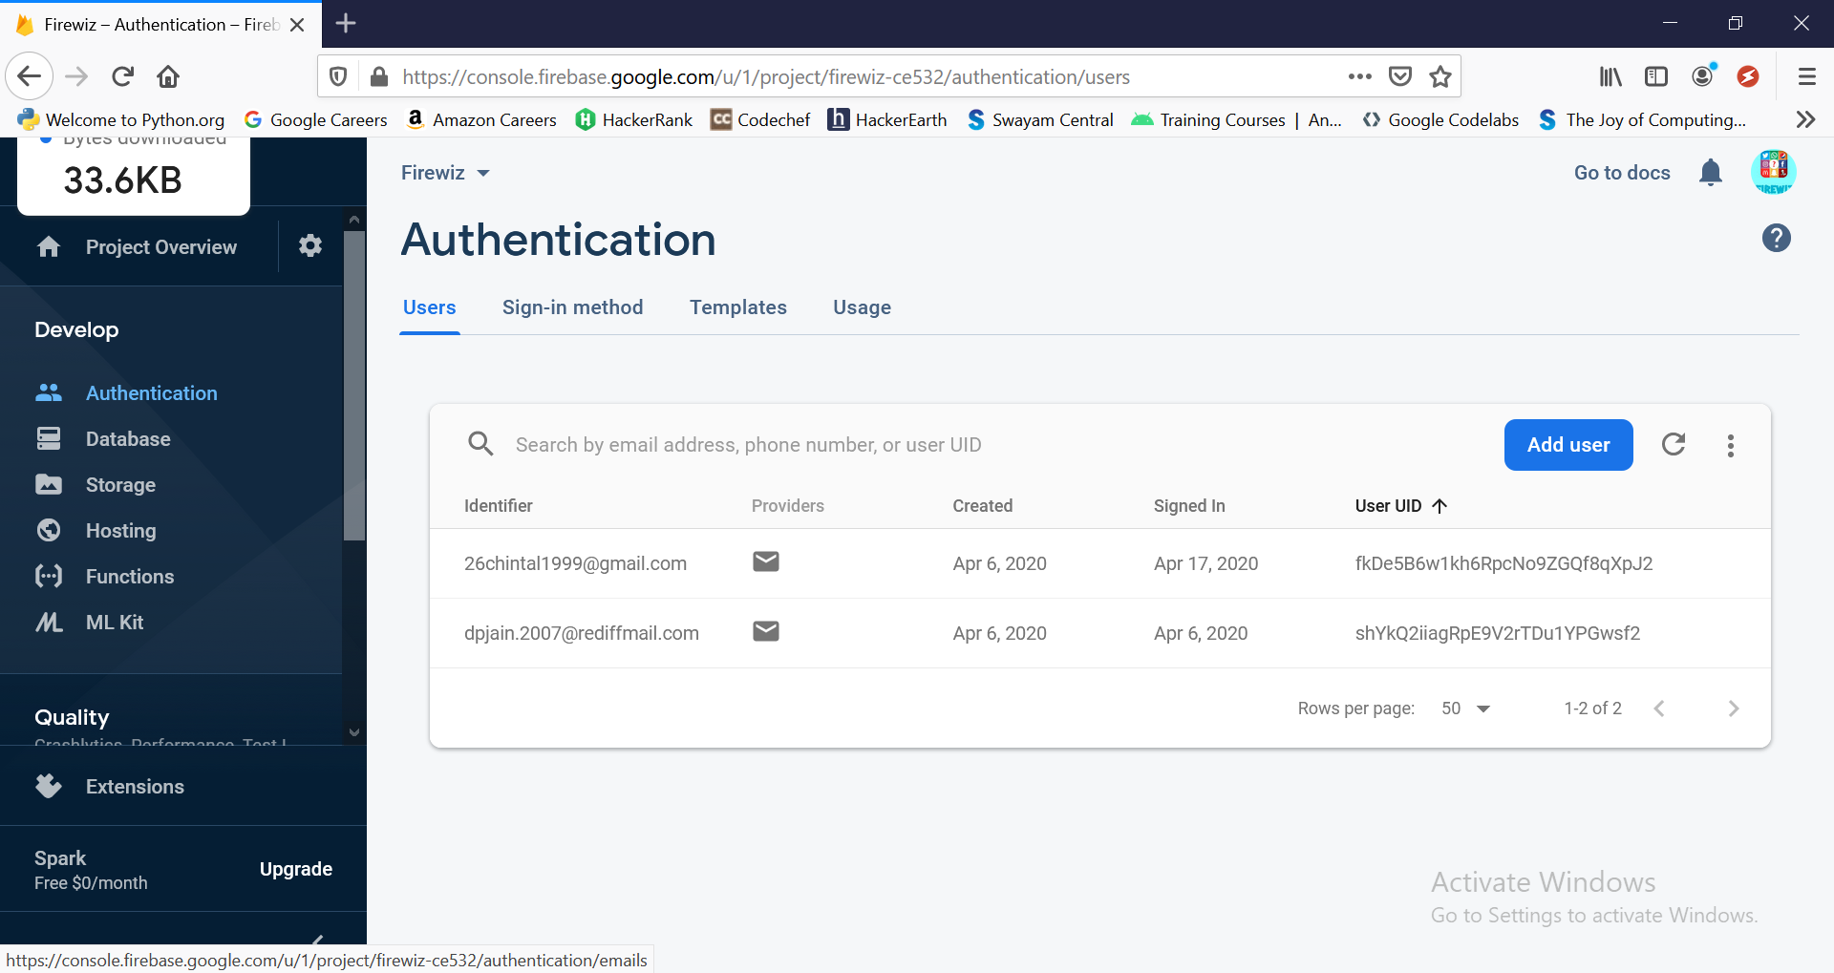

Figure 7.8 Firebase Authentication

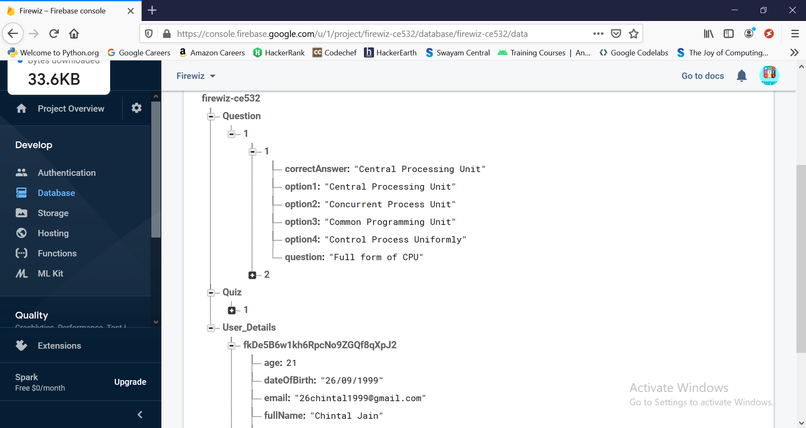

Figure 7.9 : Firebase Database

**Conclusion**

The functionality implemented in the system was done after understanding all the system modules according to the requirements.

Functionalities that are successfully implemented in the system are:

* User Registration containing all the necessary validations on fields.
* Login
* User Authentication Using Firebase
* Logout
* Quiz Creation
* Adding Question to quiz
* Play quiz
* View Result
* Home Page

After the implementation and coding of system, comprehensive testing was performed on the system to determine the loopholes and possible flaws in the system.

We have learned new technology android and build a nice app. Also we successfully learnt firebase for database.

**Limitations and Future Enhancements**

* **Limitations**
* Currently user cannot host the quiz live.
* There is a timer for whole quiz.
* Each question of quiz is assigned equal score of 1 point.
* **Functionalities not Implemented**
* Hosting Quiz Live.
* Make Quiz Available Publically.
* Group Quiz like available in Kahoot App.
* History check.
* **Future Extension**
* Make design more powerful and user friendly.
* Mailing functionality.
* Assign timer for each question.
* Evaluate result on timing and calculate score accordingly.

**Bibliography**

* **Websites:**

1. <https://codelabs.developers.google.com/android-training/> - To learn Android
2. <https://developer.android.com/courses> - DSc android course
3. <https://firebase.google.com/> - To understand firebase
4. <https://stackoverflow.com>/questions/ – For Solving errors & questions.

* **Useful Links:**

1. <https://console.firebase.google.com/u/0/> - Firebase console.

2. https://fonts.google.com –For getting fonts families.

3. <https://material.io/components/> - To have different design

4. <https://www.youtube.com/firebase> - For learning firebase

5. <https://kahoot.com/>

6. Kahoot app -

https://play.google.com/store/apps/details?id=no.mobitroll.kahoot.android&hl=en_IN