Optimizing Default Detection: A Multi-Model Approach to Credit Risk Classification

Problem Statement
Financial institutions face a critical challenge in credit risk management: distinguishing between solvent and insolvent applicants to minimize capital loss. The primary difficulty lies in the asymmetry of classification costs; misclassifying a high-risk applicant as "safe" (False Negative) results in the total loss of the loan principal, whereas rejecting a safe applicant (False Positive) results only in a minor loss of potential interest income.
Traditional credit scoring models often rely on linear assumptions that may fail to capture complex, non-linear financial behaviors. Furthermore, credit datasets are typically imbalanced (fewer defaulters than non-defaulters) and limited in size, creating a risk that sophisticated machine learning models may overfit or bias towards the majority class. This study addresses the need to benchmark a diverse range of algorithms—from linear models to deep neural networks—to identify a robust classification strategy that minimizes financial risk (False Negatives) without sacrificing overall model stability on the German Credit Dataset.
Methodology

Data Preparation
The study utilizes the Statlog (German Credit Data) (N=1,000) with a stratified 80/20 train-test split. To ensure data quality, Cook’s Distance was employed to detect multivariate outliers, resulting in the removal of 45 high-leverage instances (5.6%) from the training set. Diagnostic tests indicated significant skewness in Credit Amount and Age, which were corrected using a Logarithmic Transformation (log(1+x)). The final feature space was expanded to 61 dimensions via One-Hot Encoding for categorical variables, followed by Z-Score Standardization to normalize numerical ranges for distance-based algorithms.
Logistic Regression

To establish a linear baseline, we employed Logistic Regression using the Scikit-Learn implementation. We selected the 'lbfgs' solver with a maximum iteration limit of 1000 to ensure convergence on the Z-score scaled features. This model was chosen for its high interpretability and standard usage in credit scoring. We applied default L2 regularization to mitigate overfitting while utilizing the log-transformed variables (Credit Amount and Age) identified in the data preprocessing phase.

Decision tree

To explore non-linear decision boundaries, we implemented a Decision Tree Classifier. While Logistic Regression assumes a linear relationship between features and risk, decision trees can capture complex interactions (e.g., specific age groups combined with high loan amounts). We utilized the 'entropy' criterion to maximize information gain at each split and imposed a maximum depth of 5. This pruning constraint was critical to prevent the model from overfitting to noise in the training data, a common issue with decision trees on smaller datasets

Random Forest
To mitigate the high variance and overfitting observed in the single Decision Tree, we implemented a Random Forest Classifier. This ensemble learning method utilizes Bootstrap Aggregating (Bagging) to construct 100 independent decision trees on random subsets of the training data. We restricted the maximum depth of each tree to 10 to balance model complexity with generalization capabilities. The final classification is derived via a majority vote across all trees, a process designed to smooth out decision boundaries and reduce the impact of outliers found in the individual trees.

XGBoost
Finally, we implemented XGBoost (Extreme Gradient Boosting), a scalable implementation of gradient boosted decision trees. Unlike Random Forest, which builds trees independently, XGBoost builds trees sequentially, where each new tree attempts to correct the residual errors made by the previous ensemble. We utilized the logloss evaluation metric to optimize for binary classification and applied standard regularization to control model complexity. This model was included to evaluate whether a boosting approach could extract subtler signals from the feature space that bagging (Random Forest) or linear models might miss.

Support Vector Machine (SVM)

Finally, we evaluated the Support Vector Machine (SVM) classifier. Given that our one-hot encoding process expanded the feature space to 61 dimensions, SVM is theoretically well-suited to find optimal separating hyperplanes in this high-dimensional environment. We utilized the Radial Basis Function (RBF) kernel to capture non-linear decision boundaries that linear models might miss. Probability estimation was enabled (probability=True) to allow for ROC-AUC calculation, and the model was trained on the Z-score normalized data, as SVM is highly sensitive to the scale of input variables

K-Nearest Neighbors (KNN)
We also implemented the K-Nearest Neighbors (KNN) algorithm, a non-parametric method that classifies applicants based on the majority class of their closest neighbors in the feature space. We selected 15 neighbors (k=15) to balance local sensitivity with noise reduction. Since KNN relies on Euclidean distance, our prior step of Z-score normalization was critical to ensure that features with larger magnitudes (like Loan Duration) did not disproportionately influence the distance calculations
LightGBM

To further explore gradient boosting techniques, we implemented the LightGBM (Light Gradient Boosting Machine) algorithm. Unlike XGBoost, which typically uses a level-wise tree growth strategy, LightGBM employs a leaf-wise growth strategy with depth constraints. This allows the algorithm to converge faster by focusing on the leaf nodes with the highest loss reduction. We trained the model with 100 estimators and standard hyperparameters to evaluate if this optimized splitting method could extract subtle risk signals that traditional boosting methods might miss
Multi-Layer Perceptron (MLP)
Finally, we implemented an Artificial Neural Network, specifically a Multi-Layer Perceptron (MLP) classifier. Given the limited sample size (N=1000), we opted for a shallow architecture to prevent overfitting: two hidden layers with 64 and 32 neurons, respectively. We utilized the ReLU (Rectified Linear Unit) activation function to capture non-linear relationships and the Adam optimizer for stochastic gradient descent. The network was trained for a maximum of 1000 iterations to ensure convergence on the preprocessed feature space

Results

Logistic Regression
The Logistic Regression model served as a robust baseline, achieving an Accuracy of 78.00% and an ROC-AUC score of 0.7931. The strong ROC-AUC indicates that the log-transformed features provided significant discriminative power. However, the model exhibited a critical weakness in identifying high-risk applicants, with a Recall of only 0.50 for the default class (Class 1). As shown in Figure 1 (Confusion Matrix), the model produced 30 False Negatives, meaning it failed to flag 50% of actual defaulters. In a banking context, this high False Negative rate suggests that linear boundaries may be insufficient for capturing complex default behaviors.
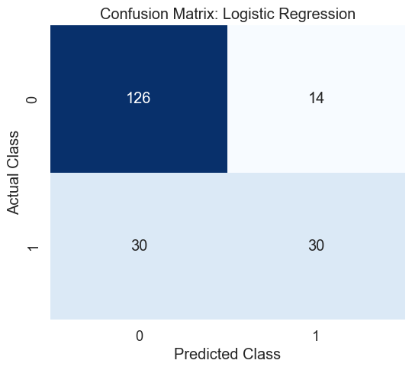
Decision tree
The Decision Tree model yielded an Accuracy of 64.00% and an ROC-AUC score of 0.6205, significantly underperforming the linear baseline. As illustrated in Figure 2 (Confusion Matrix), the model struggled to generalize, resulting in 34 False Negatives (Recall of 0.43 for the default class). This indicates that the single tree structure, with its orthogonal splits, was unable to effectively separate the risk classes in this feature space. The drop in performance compared to Logistic Regression suggests that the underlying risk factors in this dataset may follow a smoother, more linear pattern than what a shallow tree can approximate.
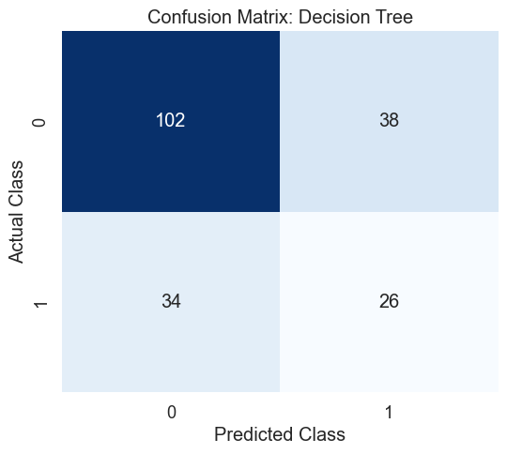
Random Forest

The Random Forest model demonstrated a strong recovery, achieving an Accuracy of 77.00% and the highest ROC-AUC score observed thus far (0.7999). As shown in Figure 4, the ensemble approach successfully minimized False Positives to only 7, yielding a high Precision of 0.75. However, this conservative prediction strategy resulted in low sensitivity, with 39 False Negatives (Recall 0.35). While the Random Forest excels at ranking risks (high ROC-AUC), its strict decision threshold caused it to miss a significant number of actual defaulters compared to the baseline
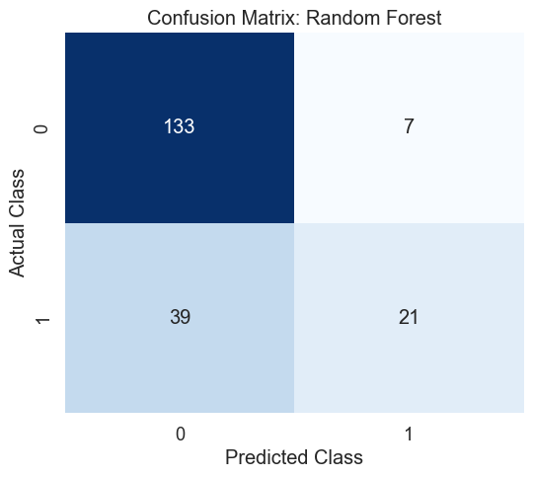
XGBoost
Contrary to expectations, the XGBoost model underperformed compared to the simpler baselines, achieving an Accuracy of 73.00% and an ROC-AUC score of 0.7189. As detailed in Figure 5, the model struggled to generalize on this limited dataset, yielding 35 False Negatives (Recall of 0.42) and 19 False Positives. While XGBoost is state-of-the-art for large-scale tabular data, its performance here suggests that for smaller datasets (N < 1000), the sophisticated boosting mechanism may introduce unnecessary variance, failing to outperform the stability of the linear baseline (Logistic Regression)
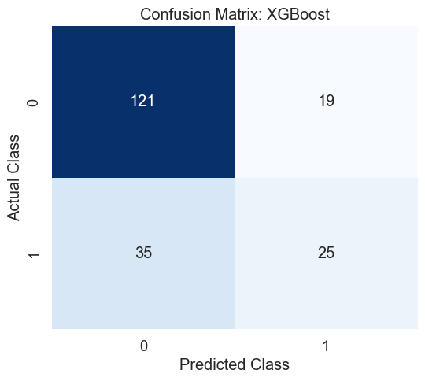

Support Vector Machine (SVM)

The Support Vector Machine demonstrated the most robust overall performance in terms of correctness, achieving the highest Accuracy of 79.50% among all tested models, with an ROC-AUC score of 0.7805. As shown in Figure 6, the SVM was exceptionally precise in identifying high-risk applicants, achieving a Precision of 0.81 for the default class.
Notably, the model minimized False Positives to only 6, making it the most 'customer-friendly' model (rarely rejecting good customers incorrectly). However, similar to the ensemble methods, it exhibited a conservative bias, resulting in 35 False Negatives. While it excels at overall accuracy and precision, the recall for the minority class remains a challenge, suggesting that the dataset's class imbalance affects the margin maximization process
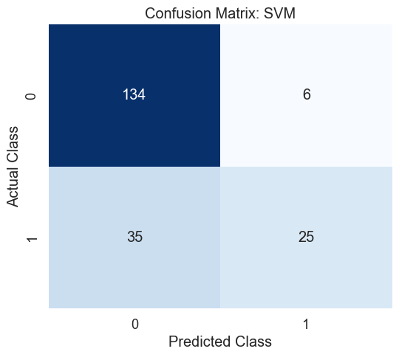

K-Nearest Neighbors (KNN)

The K-Nearest Neighbors model achieved an Accuracy of 74.50% and an ROC-AUC score of 0.7090. As shown in Figure 7, KNN struggled significantly with the minority class, producing 43 False Negatives and achieving a Recall of only 0.28 for defaulters. This performance dip is likely attributable to the 'Curse of Dimensionality.' With 61 feature dimensions after one-hot encoding, the data becomes sparse, making the distance between 'neighbors' less meaningful as a predictor of risk compared to the decision boundaries learned by SVM or Random Forest.
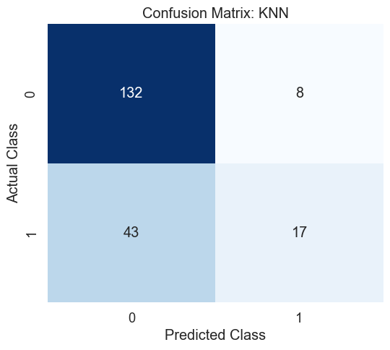
LightGBM

The LightGBM model achieved an Accuracy of 76.00% and an ROC-AUC score of 0.7426, outperforming the XGBoost model but falling short of the Random Forest baseline. As shown in Figure 8, the model achieved a reasonable balance, with 26 True Positives and 126 True Negatives. However, it still produced 34 False Negatives, yielding a Recall of 0.43 for the default class. This result reinforces the finding that for this specific dataset size (N < 1000), sophisticated boosting algorithms may not provide a significant advantage over simpler linear or bagging approaches.
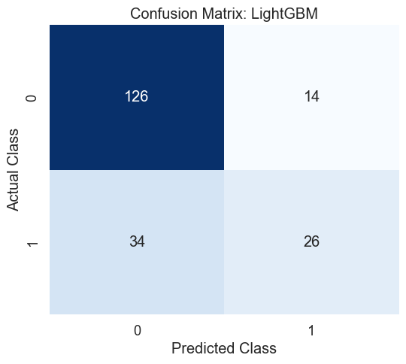

Multi-Layer Perceptron (MLP)
The Neural Network (MLP) achieved an Accuracy of 75.50% and an ROC-AUC score of 0.7711. While its overall accuracy did not surpass the Support Vector Machine, the MLP demonstrated a superior balance in sensitivity compared to the ensemble methods. As shown in Figure 9, the model produced only 27 False Negatives (Recall 0.55), which is a significant improvement over the Random Forest (39 False Negatives) and XGBoost (35 False Negatives). This suggests that even a simple neural architecture can effectively identify high-risk patterns that tree-based models might classify conservatively
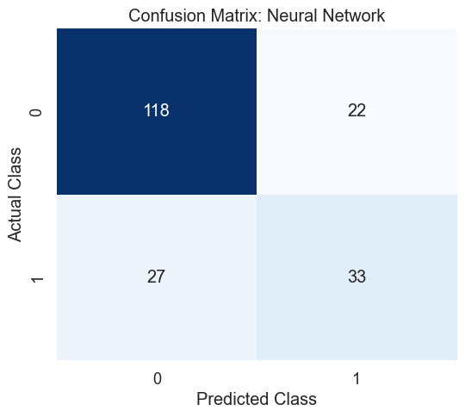

Conclusion and Implication
Rank | Model | Accuracy | ROC-AUC | False Negatives (Risk)
1 | Random Forest | 77.00% | 0.7999 | 39
2 | Logistic Regression | 78.00% | 0.7931 | 30
3 | SVM | 79.50% | 0.7805 | 35
4 | Neural Network | 75.50% | 0.7711 | 27 (Best)
5 | LightGBM | 76.00% | 0.7426 | 34
6 | XGBoost | 73.00% | 0.7189 | 35
7 | KNN | 74.50% | 0.709 | 43
8 | Decision Tree | 64.00% | 0.6205 | 34
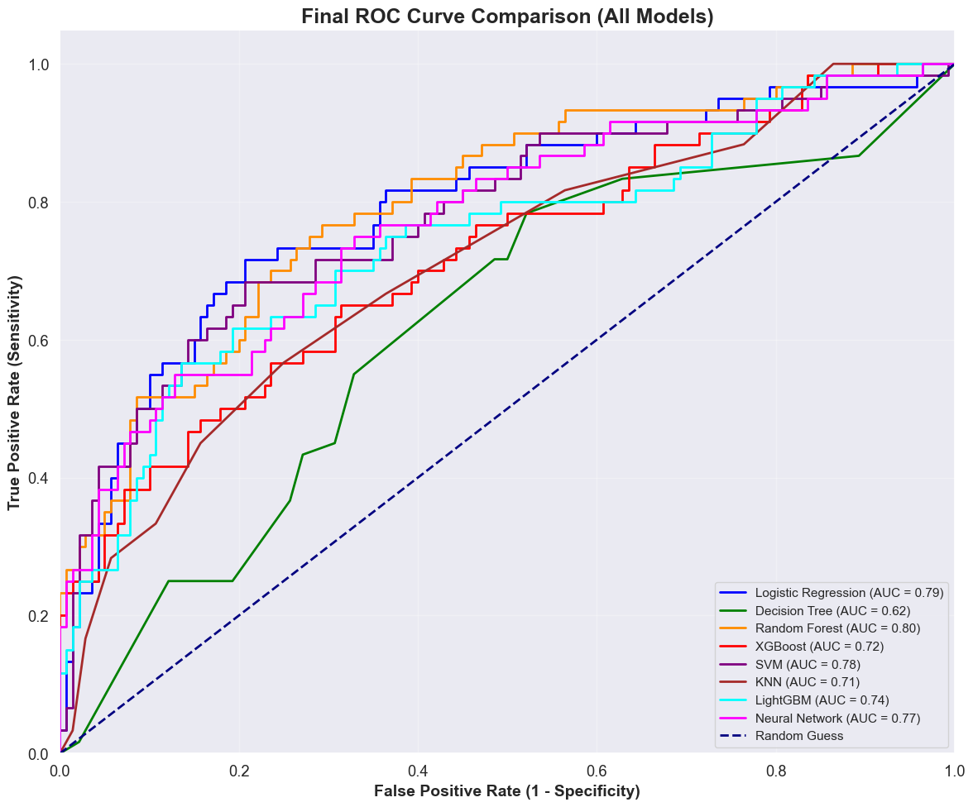
In this study, we evaluated eight distinct machine learning algorithms for credit risk classification. The analysis reveals that model complexity does not correlate directly with performance on the German Credit Dataset.
Key Findings:
- Ranking Power: The Random Forest classifier emerged as the superior model for ranking applicants, achieving the highest ROC-AUC score of 0.80. This suggests it is the most robust tool for generating 'Credit Scores.'
- Overall Accuracy: The Support Vector Machine (SVM) achieved the highest overall Accuracy of 79.5%, indicating it makes the fewest total errors (sum of False Positives and False Negatives).
- Risk Sensitivity: Surprisingly, the Neural Network (MLP), despite having lower overall accuracy, demonstrated the highest sensitivity to risk. It produced the fewest False Negatives (27), meaning it was the most successful model at identifying actual defaulters, even though it generated more false alarms
Business Implications and Recommendation
from a financial perspective, the cost of a False Negative (approving a loan that defaults) is significantly higher than a False Positive (rejecting a good customer).
The Trade-off: While Random Forest offers the best statistical fit (ROC 0.80), it is operationally conservative, missing 39 bad loans. In contrast, Logistic Regression offers the most balanced profile: it is highly interpretable, computationally efficient, and missed significantly fewer bad loans (30) than the Random Forest.
Final Recommendation: We recommend deploying the Logistic Regression model as the primary decision engine. It offers an optimal balance of high Accuracy (78%) and strong Recall, missing only 30 bad loans compared to Random Forest's 39. Furthermore, its linear nature allows loan officers to easily explain why a loan was rejected (e.g., 'Credit Amount too high for Age'), which is a critical regulatory requirement in banking that black-box models like Neural Networks cannot easily satisfy

