**Term Paper Report**

*Chintan Jayeshkumar Kharadi(101169771)*

**Abstract**

Data Mining is used to search for the patterns in huge database. Association, Classification and Clustering are three goals in Data Mining. Association is defined as correlation between two items in database. From Association, I can produce new set which is useful to get knowledge of how many times the data is used in each basket and based on that I can iterate the support and confidence and get the results by using Apriori algorithm. This report will discuss the market basket analysis using Apriori algorithm.

**Introduction**

Due to the advent of state-of-the-art database systems, recording our digital footprint has become easier. The items that are bought in a supermarket, the clothes we buy and return, financial transactions or any other digital transactions I make online are also recorded. This kind of advancement in information technology also has its shortcomings. In case of firms which support a large digital traffic are often faced with the problem of storing the said large traffic. Although the latest technology in database is sophisticated enough to keep the data stacks operational, it is not a necessity to store these data I need to analyze the data to provide the firm with better value. For companies to thrive in the competition and recent user-centered market conditions, they need the help of marketing strategies that are efficient, affordable and productive. For this the firms need to make decisions that follow a strategy and are supported by data that is accurate and reliable. By the help of new technical innovations, data mining is becoming the tool of choice for this process. Extracting important information from a large database is known as data mining. It transforms large data stacks in distilled information.

In this project, I am going to determine the association rules by using market basket analysis on the study case that is Online Retails Data set which includes all transactions for UK-registered Company for the dates from 01/12/2009 to 09.12.2011. The firm specializes in all season gift ware and big parts of their clientele are wholesalers. To recognize the product groups that sell together in a designated time interval is the aim of this study. After passing different stages, the data was converted to a format that “WEKA”, well-known data mining software, is able to recognize. By using WEKA in conjunction with FP-Growth algorithm and Apriori algorithm**,** I can acquire association rules. After acquiring the association rules, I can evaluate the performance of the both algorithms.

**Related Work**

In [1] they carried out analysis on a yearly data called "Do it yourself" retailer to indicate the associated product pairs by using the market basket analysis. Then the effects of various promotional activities on these product pairs were analyzed and the necessary suggestions were made in the direction of the outcome. [2] predict that, the enterprises with retail chain stores, there is one road block that all purchasing patterns could not be retrieved because of the prediction that products are always on store shelves at all times. In order to overcome this situation, they added warehouse and time information to the rules they developed differently in similar studies. Hence, they aimed to use the association rules in the developing marketing strategy, inventory, product supply and various distribution strategies for the entire retail store chain. In[3] it was believed that in multi store environments healthy results of traditional association rules of data mining could not be produced An algorithm identical to the Apriori algorithm was researched to examine the association rules in these stores. The rules generated by this developed algorithm provided information about location of the shop and its time period. It was seen that the proposed method was much better than the previous Apriori algorithm in terms of simulation work done in shops with different sizes and continuous changing product mixes. [4] had worked with the Taiwan National Health Insurance Agency to obtain the rules of association among various diseases on the twelve-month health insurance data. In the study, they carried out experiments using the ant colony system, association rules and clustering. In [5] they conducted an analysis for association rule on the education emergency services and done research on different hospital in the Aegean Region. As per the rules of association found by the Apriori algorithm, it has been seen that there were associations regarding gender, , emergency service arrival time, stay time, and few disease diagnoses. This study will help to guide reconstruct of emergency departments by determining the causes of emergency service applications of the patients in that region and the patient end of study, the data set containing the data in profiles. They also used clustering analysis and association rules to identify such related product categories in a retailer's store. Store products were grouped into fast -food, ready-food and non-food and their respective inter-subcategory relations were analyzed using customer receipt data. Thus, it helps to identify the associated categories. [6] Timor and Simsek determined factors affecting customers' buying behavior with decision trees in one of Turkey's largest chain of markets operating in the retail sector. They determined these factors by analyzing association rules for customer shopping records for the time of four months in 2004. [7] They proposed a new system for alarm correlation analysis to analyze the relationships between failures based on association mining in a telecommunication company. [8] In his work on three different internet shopping markets in Taiwan, He used learn valuable customers and developed the RFMDR model by using supervised Apriori algorithm. In [9] he used association rules to identify factors that cause bladder, prostate, cervical, breast, lung, and skin cancers. At last among the three different algorithms used for this purpose, they found that Apriori was the best contributor.

**Background**

*Data Set:*

For market basket analysis, I carried out experiments on Online Retail II Data Set which contains retails transactions data of two years. These transactions are for UK based company and it contains data for dates 01/12/2009-09/12/2011. Most of the customers for this company are wholesalers. The company has all-occasion gift-ware products to sell. The attribute for the used data set is as given below:

* *StockCode*: This defines the Stock Code (e.g. Product (item) code). It has value of 5-digit and assigned in one to one manner to specific product and it is nominal.
* *InvoiceNo*: This defines invoice number which sometimes starts with ‘c’ [c: Cancellation]. It has value of 6-digit and assigned in one to one manner to specific transaction and it is nominal.
* *InvoiceDate*: This defines invoice time and date which means when any transaction happens the day and time of that is noted and value is given to InvoiceDate and it is numeric.
* *CustomerID*: This attribute defines Id of the customer by customer number which has value of 5-digit and assigned in one to one manner to particular customer specific product and it is nominal.
* *Quantity*: This attribute defines the quantities of each item or product for a specific transaction and it is always numeric.
* *UnitPrice*: This attribute defines the unit price which is in sterling (Â£) and it is also numeric.
* *Country*: This attribute defines the country name of a customer residence and it is nominal.
* *Description*: This attribute defines the item name and it is also nominal.

*R Language:*

For Machine learning I can use R language (created by Ross Ihaka and Robert Gentleman) has extensive graphical and statistical methods for data analysis. Previously it was just a text editor and then numerous efforts were made to advance the user interface of R.

This advancement in R was due to the contributions by R users. Inclusion of powerful packages in R has made it more and more powerful with time. Packages like, tidyr, SparkR, readr, data.table, dplyr, ggplot2 have made computation much faster. Here, I have used R language to convert the csv file to ARFF file.

*Weka*

It is data mining software which uses collection of ML(machine learning) algorithms to apply directly onto the data or called from programming languages like Java. WEKA is a collection of tools for: Association, Clustering, Regression, Data pre-processing, Classification and Visualization. Weka supports the following data types for attributes: Numeric, <nominal-specification>, String, date.

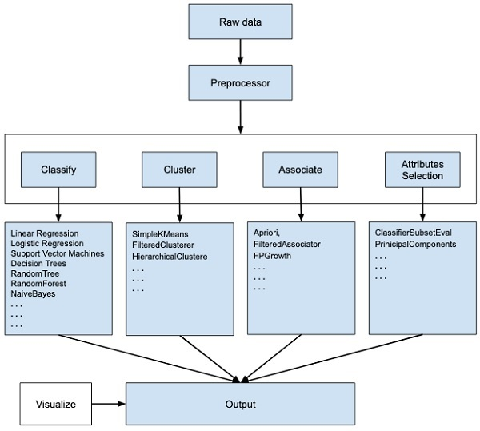

Figure 1Components of WEKA

The described figure gives overall components offered by WEKA. Depending on the kind of ML model that I are trying to develop, I would select one of the options such as Classify, Cluster, or Associate are offered by WEKA. Under each component, WEKA provides the implementation of various algorithms. I would select an algorithm of our choice, set the desired parameters and run it on the dataset that I are trying to analyze. Thus, WEKA would give you the statistical output of the model processing. At the end it provides us a visualization tool to inspect the data.

Weka uses the Attribute Relation File Format (ARFF) for data analysis, by default. It has two parts: The data section lists the data instances and the header section defines the relation (data set) name, type and attribute name.

An ARFF file requires the declaration of the relation, attribute and data. Relation is the first line in any ARFF file, written in the header section. Then I have to write data set name/the relation. The relation name should be a string and if it contains spaces, then it should be enclosed between quotes. Attribute - These are declared with their names and the type or range in the header section. Data – Defined in the Data section followed by the list of all data segments.

*Market Basket Analysis*

Market Basket Analysis is main technique used by many retailers to describe associations between items. It works by looking for combinations of items that occur together frequently in transactions. To describe in different manner, it allows retailers to identify relationships between the items that people buy.

Association Rules are widely used to analyze retail basket or transaction data, and are intended to identify strong rules discovered in transaction data using measures of interestingness, based on the concept of strong rules.

*Apriori algorithm for finding frequency item set:*

The Apriori algorithm analyses a data set to determine which combinations of items occur together frequently. It is at the core of various algorithms for data mining problems. The best known problem is finding the association rules that hold in a basket-item relation. Basic idea behind this algorithm is

* The sets of items that have minimum support can be considered.
* An item set can only be a large item set if all its subsets are large item sets.
* Association rules can be generated from frequent item sets.



Figure 2 Flow of Association Rule Generation

*Association Rule:*

Association rule is related to the statement of “what’ with what”. This matter can be in a form of

The association rules used to discover hidden relationships in a large data set are descriptive models of data mining. With this method, a series of operations are applied to the records in the database in bulk, and the rules describing the relations between the records are extracted. By the technique of association rules, it is presented as a summary by evaluating how much the development of a series of events affects the occurrence of a certain event. Rules that are equal to and higher than the success rate set at the beginning of the application are determined by the analyst[33].With this technique, all possible interesting patterns in the database can be accessed. Thanks to access to all points, the possibility of application even in the growing heaps of data that becomes larger as a result of exponential growth of the records in the database, and the fast calculation logic, it is becoming increasingly widespread in the mining of commercial databases.

The association rules, which are often referred to in the literature as market basket analysis, are used to identify related products that are purchased together in a single trade or purchased within a certain period of time after a product is purchased. Thus, information can be obtained about customers' cross-purchasing behaviors The significance of an associative rule can be figured in the presence of two parameters, namely support and confidence. Support (supporting value) is the percentage of combinations of product items in the database. While, confidence (certainty value) is a value to determine the strength of inter-item relationships in association rules. The number of support is used to denote the number of products containing product groups A and B, is represented as A B

𝑆 = Σ(𝑇𝑎+𝑇𝑐) / Σ(𝑇)

Support (A) = The number of transaction that contain A / Total Transaction

where:

S = Support

Σ(𝑇𝑎+𝑇𝑐) = the number of transaction that contains antecedentand consequent*.*

Σ(𝑇) = the number of transaction.

C = Σ(𝑇𝑎+𝑇𝑐) / Σ(𝑇𝑎)

Confidence = 𝑃(𝐴 | 𝐵)

= number of transaction that contain A and B/ Total transaction that contains A.

where:

C = Confidence

Σ(𝑇𝑎+𝑇𝑐) = the number of transaction that contains antecedent and consequent.

Σ(𝑇𝑎) = the number of transaction that contains antecedent.

**Experiments and Results**

*Step 1 : Data Preparation*

*Converting excel to csv then to arff*

To carry out the experiment with given data set, it is necessary that data should be in arff format as WEKA accept this format only. At first the given dataset was in excel format when I downloaded. So I first converted to csv format by using excel. After storing all data in single excel named "Finaldata.csv"(shown in fig below) I tried to get that data in arff file format. To get this, I implemented R here. As discussed in background, R is also a programming language and software environment for statistical analysis, graphics representation and reporting. As seen in figure below, in line(3) I have tried to read all the data from the csv file "Finaldata.csv" and in the next line(4) I write those all data in arff file format named "filek.arff".

Now this "filek.arff" is ready to be loaded in WEKA for further analysis of dataset.

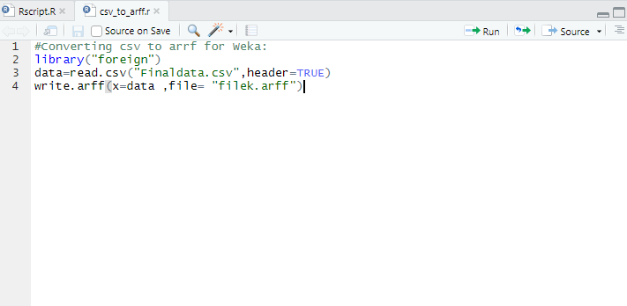

Figure 3 Converting CSV File to ARFF using R

*Step 2: Setting up data in Weka*

Often our raw data for machine learning is not in an ideal form for modeling. I need to prepare or reshape it to meet the expectations of different machine learning algorithms. By using the previously created arff file, I have loaded all given data in the WEKA. Now to carry out further experiments of applying association on this large data set, I need each attribute data type of the data should be in the format supported by WEKA. As explained in the background that WEKA support only following attributes: numeric, nominal, String, date. To achieve this I have used discrete function i.e. already given in WEKA. Discrete attributes are those that describe a category, called nominal attributes. Hence by applying discrete function I have transformed all data types to nominal. This nominal data type is supported by WEKA and our data is now ready to carry out further analysis.

*Step 3: Setting up Visualization tools in Weka*

*Installing plugin*

To get the performed analysis in one visualization diagram, I need several plugins to be installed in our WEKA. The plugin required to generate three dimensional view of the results obtain is as given below:

*1. Scatterplot 3D*

It is a visualization component for displaying a 3D scatter plot of the data using Java 3D.

*2. AssosiationRulesVisualizer*

It provides 3D visualization for the result obtained. I can get such thing in ARrules viwer.

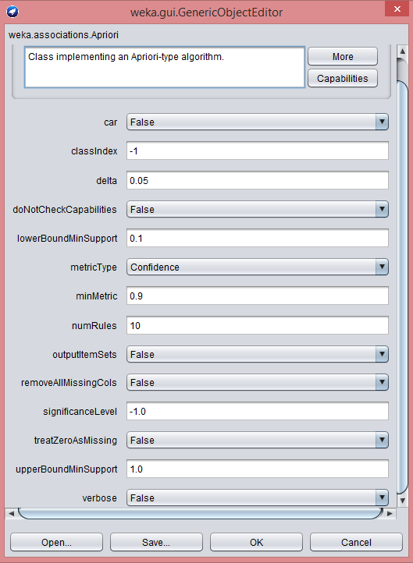

Figure 5 Apriori algorithm parameters

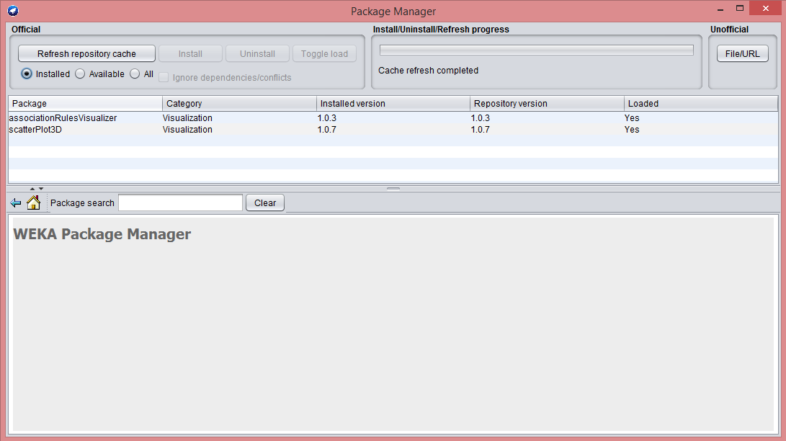

Figure 4 AssocationRulesVisualizer and Scatterplot3D

*Step 4: Setting parameters for Apriori algorithm*

In our experiments I have used Apriori algorithm. Weka offers functionality to vary several parameters before running algorithm. The parameters such as lowerboundmin support, numRules, upperBoundMinSupport plays major role in evaluating output. in our experiments I have varied the value of numRules to 5, 10, 15, 20. Similary I have set the minimum support and confindence to 0.9 and set outputItemSets to true. Here by enabling outputItemSets I get the large frequent item set and its occurrences in the result.

*Step 5 : Executing experiment with various set of rules :*

*A) When set of rules is 5*

In the first scenario, I have carried out experiment by setting numRules to 5. Total 5 best rules obtained with each having minimum confidence to 0.9 as shown in below figure. There are total three large item set obtained each of that L(1) contains quantity, price, country while L(2) contains (quantity, price), (quantity, country), (price, country) and L(3) contains (quantity, price, country). These all obtained item set are called as frequent item set. The table shows result of all the rule obtained by performing apriori algorithm.

Table 1 Results of All The Rules

|  |  |  |  |
| --- | --- | --- | --- |
| **Rule No** | **Antecedent** | **Consequent** | **Confidence** |
| 1 | Quantity[0-16199], Country (96122) | Price [-7312.18-1944.256] (961174) | 1 |
| 2 | Quantity[0-16199] (1044418) | Price [-7312.18-1944.256] (1044356) | 1 |
| 3 | Country (981330) | Price (-7312.18-1944.256) 981212 | 1 |
| 4 | Price [-7312.18-1944.256], Country (981212) | Quantity[0-16199], Country (961174) | 0.98 |
| 5 | Country (981330) | Quantity[0-16199], Country (961222) | 0.98 |

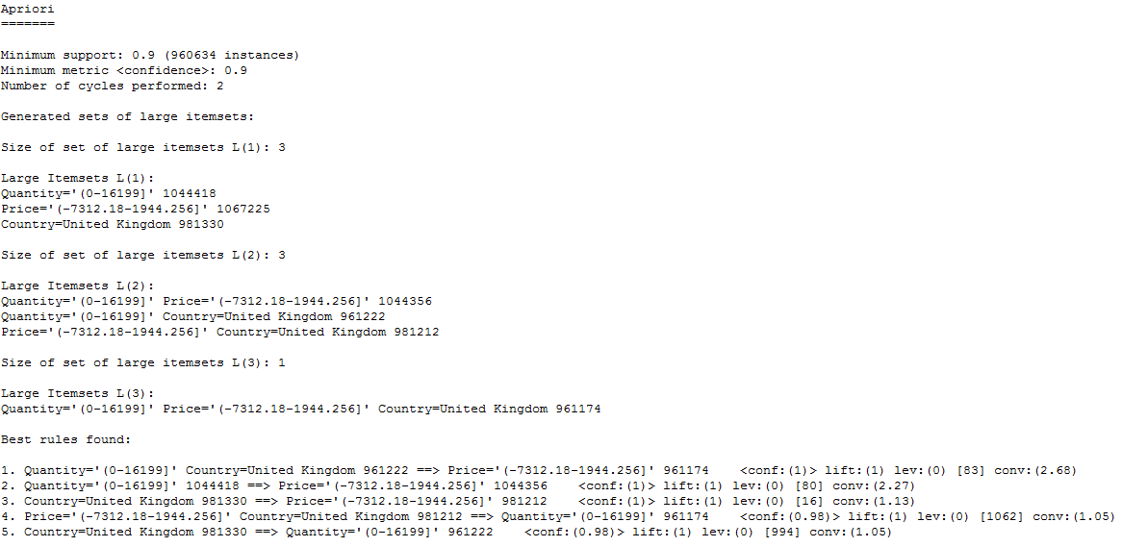

Figure 6 Apriori Algorithm Results

The 3D representation shown in the graph below gives us the pictorial view of the obtained result set. There are total 5 rules out which I pick second rule is the best one. In second rule I can see the confidence and support value is the highest.

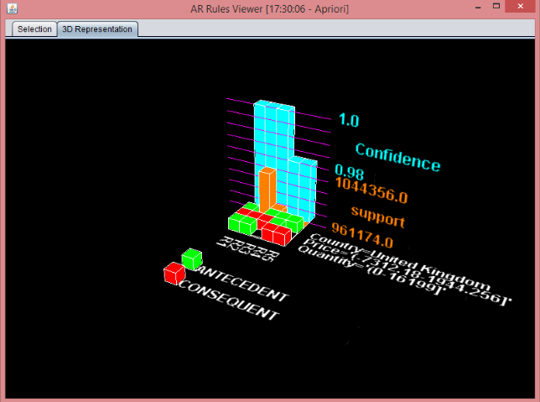

Figure 7 AR Rules Viewer

*B) When set of rules is 10*

In the second scenario, I have carried out experiment by setting numRules to 10. Total 10 best rules obtained with each having minimum confidence to 0.9 as shown in below figure. Same as scenario A, there are total three large item set obtained each of that L(1) contains quantity, price, country while L(2) contains (quantity, price), (quantity, country), (price, country) and L(3) contains (quantity, price, country). Table below show the corresponding result obtained:

Table 2 Results For Rule 10

|  |  |  |  |
| --- | --- | --- | --- |
| **Rule No** | **Antecedent** | **Consequent** | **Confidence** |
| 1 | Quantity[0-16199], Country (961222) | Price [-7312.18-1944.256] (961174) | 1 |
| 2 | Quantity[0-16199] (1044418) | Price [-7312.18-1944.256] (1044356) | 1 |
| 3 | Country (981330) | Price [-7312.18-1944.256] (981212) | 1 |
| 4 | Price [-7312.18-1944.256], Country (981212) | Quantity[0-16199], Country (961174) | 0.98 |
| 5 | Country (981330) | Quantity[0-16199], Country (961222) | 0.98 |
| 6 | Country (981330) | Quantity[0-16199], Price [-7312.18-1944.256] (961174) | 0.98 |
| 7 | Price [-7312.18-1944.256] (1067225) | Quantity[0-16199] (1044356) | 0.98 |
| 8 | Quantity[0-16199] Price [-7312.18-1944.256] (1044356) | Country (961174) | 0.92 |
| 9 | Quantity[0-16199] (1044418) | Country (96122) | 0.92 |
| 10 | Quantity[0-16199] (1044418) | Price [-7312.18-1944.256] Country (961174) | 0.92 |

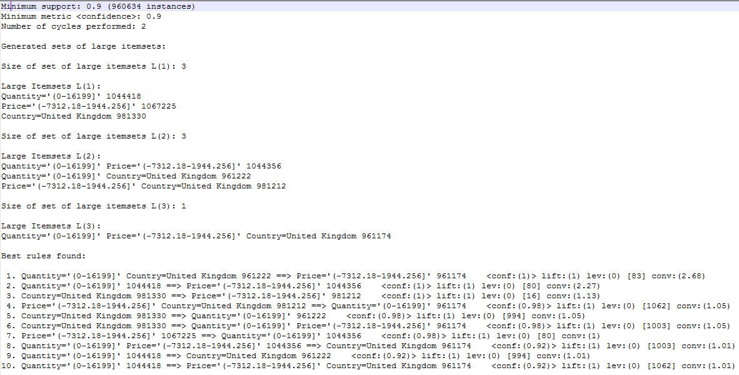

Figure 8 Result of Apriori Algorithm on Rule=10

As shown in the 3D graph below, rule 2 remains the best rule for 10 number of set. This is because I have set minimum value of confidence to 0.9. Thus I will get all the rule whose confidence range will be in range from [0.9 -1]. You can also notice that first 5 rules generated are same as previous one in 5 number of sets, reason behind it is I have just increased the number of rules I want i.e. from 5 to 10. Hence the rule set has increased accordingly.

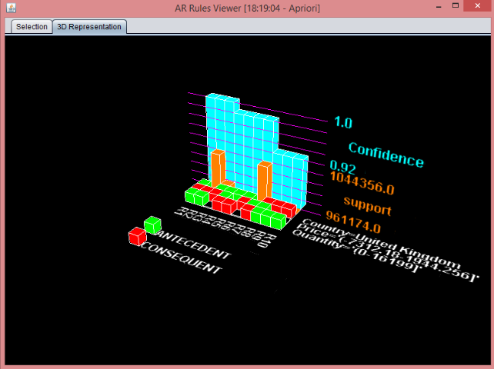

Figure 9 AR Rules Viewer for set of rules 10

*C) When set of rules is 15*

In the third scenario, I have carried out experiment by setting numRules to 15. Total 12 best rules obtained with each having minimum confidence to 0.9 as shown in below figure.

Table 3 Results for set of rules =15

|  |  |  |  |
| --- | --- | --- | --- |
| **Rule No** | **Antecedent** | **Consequent** | **Confidence** |
| 1 | Quantity[0-16199], Country (961222) | Price [-7312.18-1944.256] (961174) | 1 |
| 2 | Quantity[0-16199] (1044418) | Price [-7312.18-1944.256] (1044356) | 1 |
| 3 | Country (981330) | Price [-7312.18-1944.256] (981212) | 1 |
| 4 | Price [-7312.18-1944.256], Country (981212) | Quantity[0-16199], Country (961174) | 0.98 |
| 5 | Country (981330) | Quantity[0-16199], Country (961222) | 0.98 |
| 6 | Country (981330) | Quantity[0-16199], Price [-7312.18-1944.256] (961174) | 0.98 |
| 7 | Price [-7312.18-1944.256] (1067225) | Quantity[0-16199] (1044356) | 0.98 |
| 8 | Quantity[0-16199] Price [-7312.18-1944.256] (1044356) | Country (961174) | 0.92 |
| 9 | Quantity[0-16199] (1044418) | Country (961222) | 0.92 |
| 10 | Quantity[0-16199] (1044418) | Price [-7312.18-1944.256] Country (961174) | 0.92 |
| 11 | Price [-7312.18-1944.256] (1067225) | Country (981212) | 0.92 |
| 12 | Price [-7312.18-1944.256] (1067225) | Quantity[0-16199] Country (961174) | 0.9 |

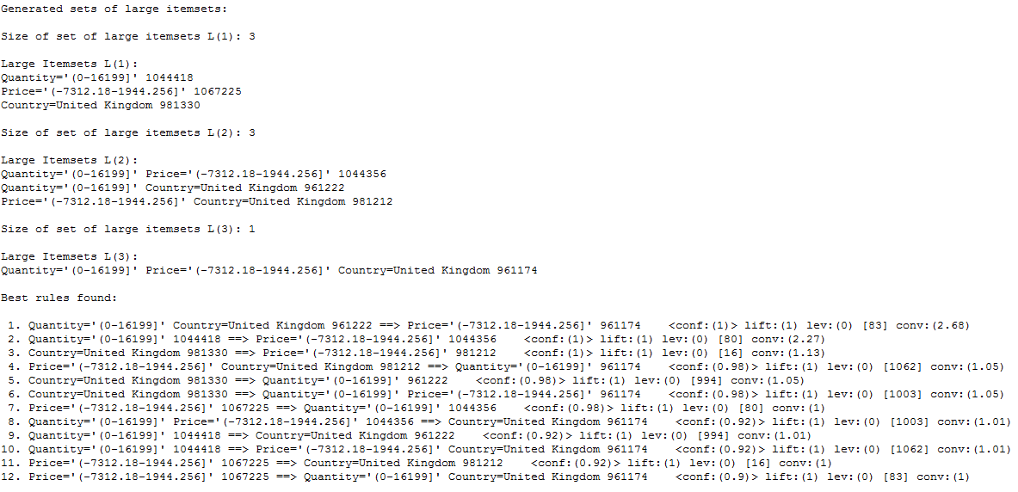

Figure 10 Priori Algorithm Result for set of rules=15

As I can see in the table generated for number of set 15 that there are total 12 best rules have been given. As discussed, in comparison with previous experiment I have increased the no of rules from 10 to 15. Even though I am getting 12 result set due to minimum confidence set is to 0.9. As observed in given table the 12th rule has confidence value to 0.9. This indicates that the rule after this may contain the confidence less than 0.9.

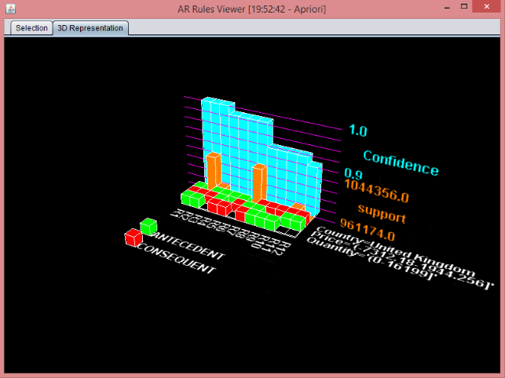

Figure 11 AR Rules Viewer for set of rules=15

*D) When set of rules is 20*

In the third scenario, I have carried out experiment by setting numRules to 20. Total 12 best rules obtained with each having minimum confidence to 0.9 as shown in below figure.

Table 4 Results for set of rules=20

|  |  |  |  |
| --- | --- | --- | --- |
| **Rule No** | **Antecedent** | **Consequent** | **Confidence** |
| 1 | Quantity[0-16199], Country (961222) | Price [-7312.18-1944.256] (961174) | 1 |
| 2 | Quantity[0-16199] (1044418) | Price [-7312.18-1944.256] (1044356) | 1 |
| 3 | Country (981330) | Price [-7312.18-1944.256] (981212) | 1 |
| 4 | Price [-7312.18-1944.256], Country (981212) | Quantity[0-16199], Country (961174) | 0.98 |
| 5 | Country (981330) | Quantity[0-16199], Country (961222) | 0.98 |
| 6 | Country (981330) | Quantity[0-16199], Price [-7312.18-1944.256] (961174) | 0.98 |
| 7 | Price [-7312.18-1944.256] (1067225) | Quantity[0-16199] (1044356) | 0.98 |
| 8 | Quantity[0-16199] Price [-7312.18-1944.256] (1044356) | Country (961174) | 0.92 |
| 9 | Quantity[0-16199] (1044418) | Country (961222) | 0.92 |
| 10 | Quantity[0-16199] (1044418) | Price [-7312.18-1944.256] Country (961174) | 0.92 |
| 11 | Price [-7312.18-1944.256] (1067225) | Country (981212) | 0.92 |
| 12 | Price [-7312.18-1944.256] (1067225) | Quantity[0-16199] Country (961174) | 0.9 |

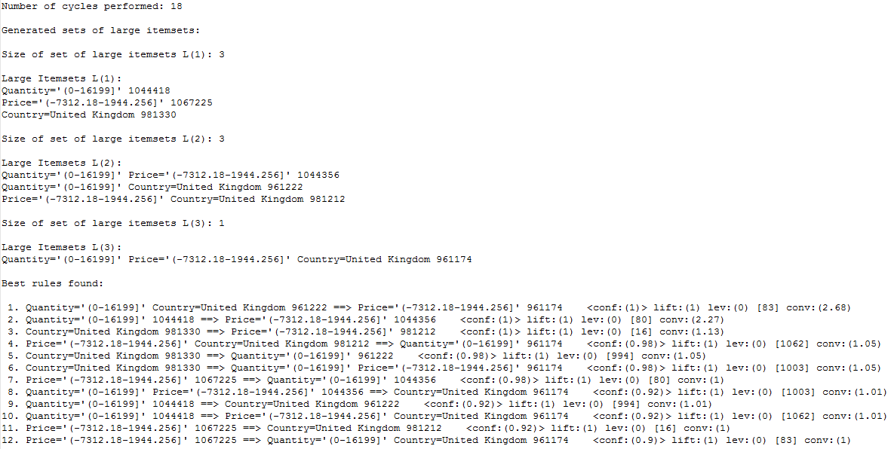

Figure 12 APriori Algorithm for set of rules=20

I can observe that the result obtained in number of rules to 20 is exactly similar to result obtained with number of rules to 15. As explained, this is because the minimum limit set to the confidence is 0.9, so here 12th rule obtained satisfy this condition. Hence, if I increase number of rules value to even 50 it won't make any difference. Thus, if I want more set of rules in same scenario then I should reduce the minimum value of confidence such that I get more number of rules.

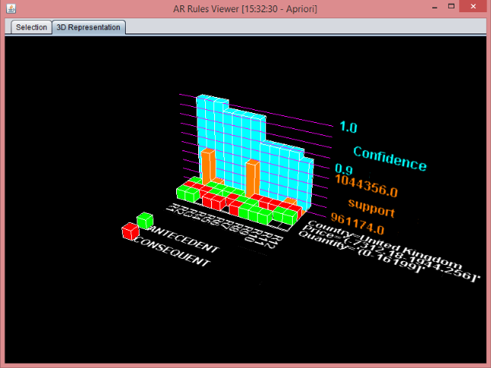

Figure 13 AR Rules Viewer for set of rules=20

**Conclusions**

In overall experiment and analysis I have considered one large data set of retail system and implemented various techniques of market basket analysis using apriori algorithm. In our experiment I have considered four different set of rules and tried to evaluate on best rule out of them. This rule has been analyzed by two such parameters of market basket analysis whose support and confidence are the highest. Apart from all other rules best rules states the best combination pair that has frequently identified in the large data set. As seen in the experiment I have concluded that in all four scenarios Rule 2 stands to be the best in all parameters.

In future work, I aim to carry out same analysis method using clustering in Weka. Clustering will help to categories the identical component into different clusters. This will be almost similar to what I have done in apriori algorithm which gives us one of the best outcomes. Another algorithm that is most likely to be implemented is FP growth algorithm.

**References**

1. D. Van Den Poel, J. De Schamphelaere, and G. Wets, “Direct and indirect effects of retail promotions on sales and profits in the do-it-yourself market,” *Expert Syst. Appl.*, vol. 27, no. 1, pp. 53– 62, 2004.

2. Y. L. Chen, K. Tang, R. J. Shen, and Y. H. Hu,“Market basket analysis in a multiple store environment,” *Decis. Support Syst.*, vol. 40, no. 2, pp. 339–354, 2005.

3. C. H. Yun, K. T. Chuang, and M. S. Chen, “Adherence clustering: An efficient method for mining market-basket clusters,” *Inf. Syst.*, vol. 31, no. 3, pp. 170–186, 2006.

4. R. J. Kuo, S. Y. Lin, and C. W. Shih, “Mining association rules through integration of clustering analysis and ant colony system for health insurance database in Taiwan,” *Expert Syst. Appl.*, vol. 33, no. 3, pp. 794–808, 2007.

5. E. Ergün, “Ürün Kategorileri Arasındaki Satıs _liskisinin Birliktelik Kuralları ve Kümeleme Analizi ile Belirlenmesi ve Perakende Sektöründe Bir Uygulama,” Afyon Kocatepe University, 2008.

6. M. Timor and U. T. Simsek, “Veri Madenciliginde Sepet Analizi ile Tüketici Davranısı Modellemesi,” *Istanbul Manag. J.*, vol. 59, pp. 3–10, 2008.

7. T. Li and X. Li, “Novel alarm correlation analysis system based on association rules mining in telecommunication networks,” *Inf. Sci. (Ny).*, vol. 180, no. 16, pp. 2960–2978, 2010.

8. W. Y. Chiang, “To mine association rules of customer values via a data mining procedure with improved model: An empirical case study,” *Expert* *Syst. Appl.*, vol. 38, no. 3, pp. 1716–1722, 2011.

9. J. Nahar, K. S. Tickle, A. B. M. S. Ali, and Y. P. P. Chen, “Significant cancer prevention factor extraction: An association rule discovery approach,” *J. Med. Syst.*, vol. 35, no. 3, pp. 353–367, 2011.

10.https://www.researchgate.net/publication/322161863_Market_Basket_Analysis_to_Identify_Customer_Behaviours_by_Way_of_Transaction_Data

11.https://www.researchgate.net/publication/332413484_A_STUDY_ON_MARKET_BASKET_ANALYSIS_AND_ASSOCIATION_MINING

12. https://www.irjet.net/archives/V5/i4/IRJET-V5I4632.pdf

13. https://ieeexplore.ieee.org/document/7231468

14. https://www.ripublication.com/irph/ijict_spl/ijictv4n4spl_11.pdf

15.https://www.researchgate.net/publication/325085811_Determination_of_Association_Rules_with_Market_Basket_Analysis_Application_in_the_Retail_Sector

16 . E. Güngör, N. Yalçın, and N. Yurtay, “Apriori Algoritması ile Teknik Seçmeli Ders Seçim Analizi,” in *International Congress on Education,* *Distance Education and Educational Technology*, 2013.

17. M. Kaur and S. Kang, “Market Basket Analysis: Identify the Changing Trends of Market Data Using Association Rule Mining,” *Procedia Comput. Sci.*, vol. 85, no. Cms, pp. 78–85, 2016.

P. Yazgan and A. O. Kusakci, “A Literature Survey on Association Rule Mining Algorithms,” *Southeas* *st Eur. J. Soft Comput.*, vol. 5, no. 1, pp. 5–14, 2016.