**CHAPTER 1: INTRODUCTION**

* 1. **Problem statement & Description**
* There are major three reason why we choose this project,
* first is about students They are not aware about what and which professors study and work on which new technology and project. This is happened because of communication gap between student and mentor.
* Second reason is about mentor, because of busy scheduling of college mentor sometimes cannot able to give time for his/her working batch.
* last one reason is parents, they also want to know what is happening in collage and what is progress of their child.
* In this application, there are three main entities students, parents and mentors. Functionalities of application are chat with all above entity as per group or head to head chat, student progress report, daily post related to what is happening in college campus on which technology and which topic, parents talk, etc.

**CHAPTER 2: SYSTEM REQUIREMENTS**

**2.1 Tools and technology used**

**Hardware requirement**:

* RAM> 2GB
* Android/IOS >16 API

**Software requirement:**

* expo cli
* node JS (v- 12.16.1)
* android/IOS emulator > 16API
* VS Code (v- 3.4.1)
* any browser

**CHAPTER 3: SYSTEM DESIGN**

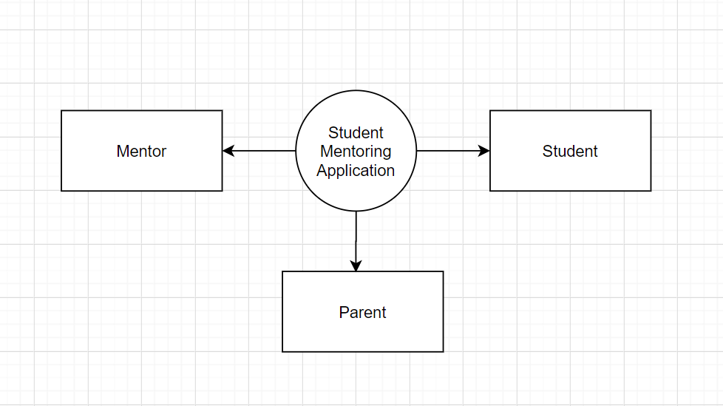

* **In above figure, we can see three main aspects of application Mentor. Student and Parents.**

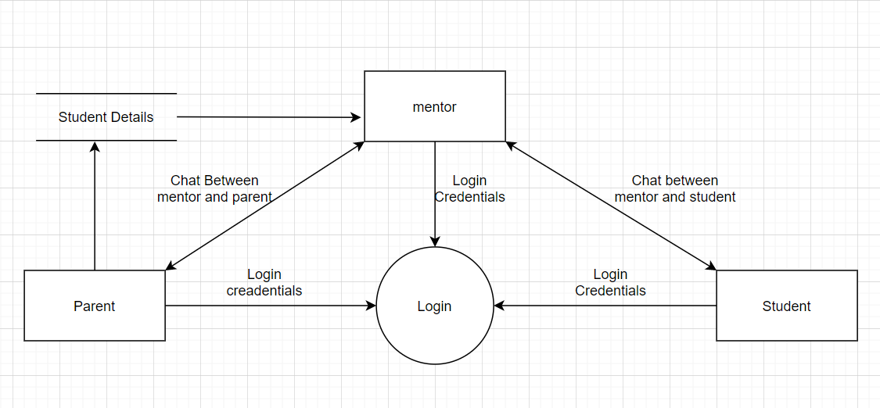

* **In above figure, all entities are first of all have to login in application for getting particular result from server.**
* **Suppose, for Student there are UI fields like list of mentor with working project and completed projects and innovative idea – Blogs on different technology and also chat field are there so they can chat with mentor on topic related to particular technology with mentor.**
* **And also parent are there which have UI fields like student progress, marks, attendance,etc. and also parents can talk privately to mentor of their child and also a group chat of parents.**
* **Mentor entity have UI field of List of student and List of Parents as per batch wise. And also chat has field in UI/UX.**

**CHAPTER 4: FUTURE ENHANCEMENT**

At the future, with data of student we can make a dashboard which show all progresses of student accordingly different parameters.

**CHAPTER 5: REFRENCES**

<https://github.com/Chintanpatel-student/Student-mentoring-app>

<https://reactnative.dev/docs/getting-started>