Socket Programming Project
Video Streaming using IP Multicast
Description
Implement a multicast video streaming application. The server continuously broadcasts MJPEG video frames to a multicast group, and multiple clients join the group to watch the stream. No RTSP, RTP, TCP/UDP selection, or separate control/data channels are required.

Architecture
Server -> Multicast Group (239.1.1.1:5004) -> Multiple Clients
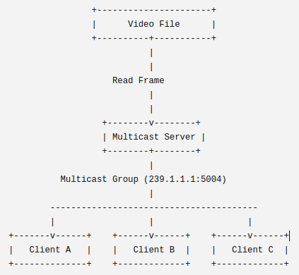

Functional Requirements
Server:
- Read a MJPEG video file frame by frame.
- Packetize each frame.
- Send every frame to a multicast IP address.
- Broadcast frames at approximately 20 FPS (50 ms/frame).
- Continue streaming until the video ends.
- Restart the video automatically after reaching the last frame
Client:
- Join the multicast group.
- Receive multicast packets.
- Decode received packets.
- Display the video in real time.
- Leave the multicast group when exiting.

Running
Server:
python Server.py <file MJPEG>
Client:
python Client.py

Grading Rubric (10 pts)
Requirement | Points | Description
Server implementation | 2.5 | Multicast server
Client implementation | 2.5 | Receive/display video
Packet format | 2.0 | Custom packet
Multiple clients & loss detection | 2.0 | Concurrency/statistics
Report | 1.0 | Architecture/testing

