1.frame_hold.html

<!DOCTYPE html>

<html>

    <frameset rows="30%,70%">

        <frame name="top" src="logo.html"/>"

        <frameset cols="25%,50%,25%">

            <frame name="left" src="linkhold.html"/>

            <frame name="centered" src="center.html"/>

            <frame name="right" src="activities.html"/>

        </frameset>

    </frameset>

</html>

Logo.html

<!DOCTYPE html>

<html>

    <head>

        <img src="C:\Users\VENKATESHWARULU\Downloads\logo.PNG">

        <marquee behavior="scroll" direction="right"> Welcome to Amrita Vishwa Vidyapeetham</marquee>

    </head>

</html>

Linkhold.html

<!DOCTYPE html>

<html>

    <body>

    <p><h3>Forms:</h3></p>

    <ul>

        <li><a href ="Home.html" target="centered">Home</a></li>

        <li><a href ="Registration.html" target="centered">Registration</a></li>

        <li><a href ="Feedback.html" target="centered">Feedback</a></li>

        <li><a href ="Administrations.html" target="centered">Administration details</a></li>

        <li><a href ="contact.html" target="centered">Contact Information</a></li>

    </ul>

</body>

</html>

Registration.html

<!DOCTYPE html>

<html>

<style>

    input[type=text],

    select,

    textarea {

        width: 100%;

        padding: 12px;

        border: 1px solid #ccc;

        border-radius: 4px;

        box-sizing: border-box;

        margin-top: 6px;

        margin-bottom: 16px;

        resize: vertical

    }

    input[type=submit] {

        background-color: #4CAF50;

        color: white;

        padding: 12px 20px;

        border: none;

        border-radius: 4px;

        cursor: pointer;

    }

    input[type=submit]:hover {

        background-color: #45a049;

    }

    .container {

        border-radius: 5px;

        background-color: #f2f2f2;

        padding: 20px;

    }

</style>

<head>

    <div class="container">

        <form method="POST">

            <fieldset>

                <legend>Registration Form</legend>

                <label for="lname">Last Name*</label><br>

                <input type="text" id="lname" value="hello"><br>

                <lable for="fname">First Name* </lable><br>

                <input type="text" id="fname" value="world"><br>

                <lable for="email">Email*</lable><br>

                <input type="email" id="email" value="hello@gmail.com"><br>

                <label for="ph">Phone Number*</label><br>

                <input type="text" id="ph"><br>

                <label for="res">Address</label><br>

                <textarea name="resume" id="res" rows="10" cols="30"></textarea><br>

                <input type="submit" value="Submit">

            </fieldset>

        </form>

    </div>

</head>

</html>

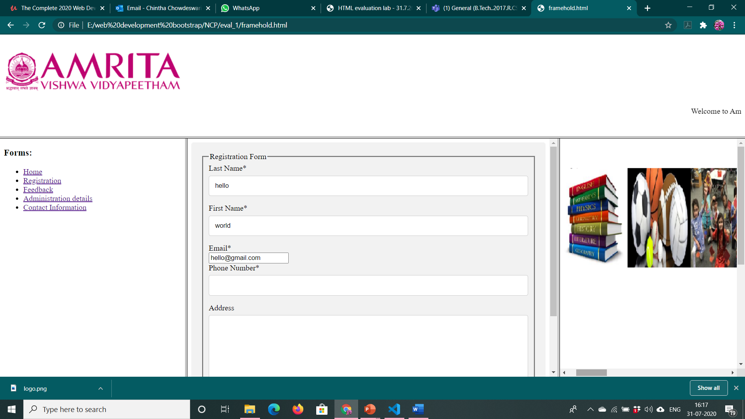

Feedback.html

<!DOCTYPE html>

<html>

    <style>

        input[type=text], select, textarea {

  width: 100%;

  padding: 12px;

  border: 1px solid #ccc;

  border-radius: 4px;

  box-sizing: border-box;

  margin-top: 6px;

  margin-bottom: 16px;

  resize: vertical

}

input[type=submit] {

  background-color: #4CAF50;

  color: white;

  padding: 12px 20px;

  border: none;

  border-radius: 4px;

  cursor: pointer;

}

input[type=submit]:hover {

  background-color: #45a049;

}

.container {

  border-radius: 5px;

  background-color: #f2f2f2;

  padding: 20px;

}

    </style>

    <body>

        <div class="container">

            <form action="action_page.php">

              <label for="fname">First Name</label><br>

              <input type="text" id="fname" name="firstname" placeholder="Your name.."><br>.

              <label for="lname">Last Name</label><br>

              <input type="text" id="lname" name="lastname" placeholder="Your last name.."><br>

              <label for="subject">comments</label><br>

              <textarea id="subject" name="subject" placeholder="Write something.." style="height:200px"></textarea><br>

              <input type="submit" value="Submit">

            </form>

          </div>

    </body>

</html>

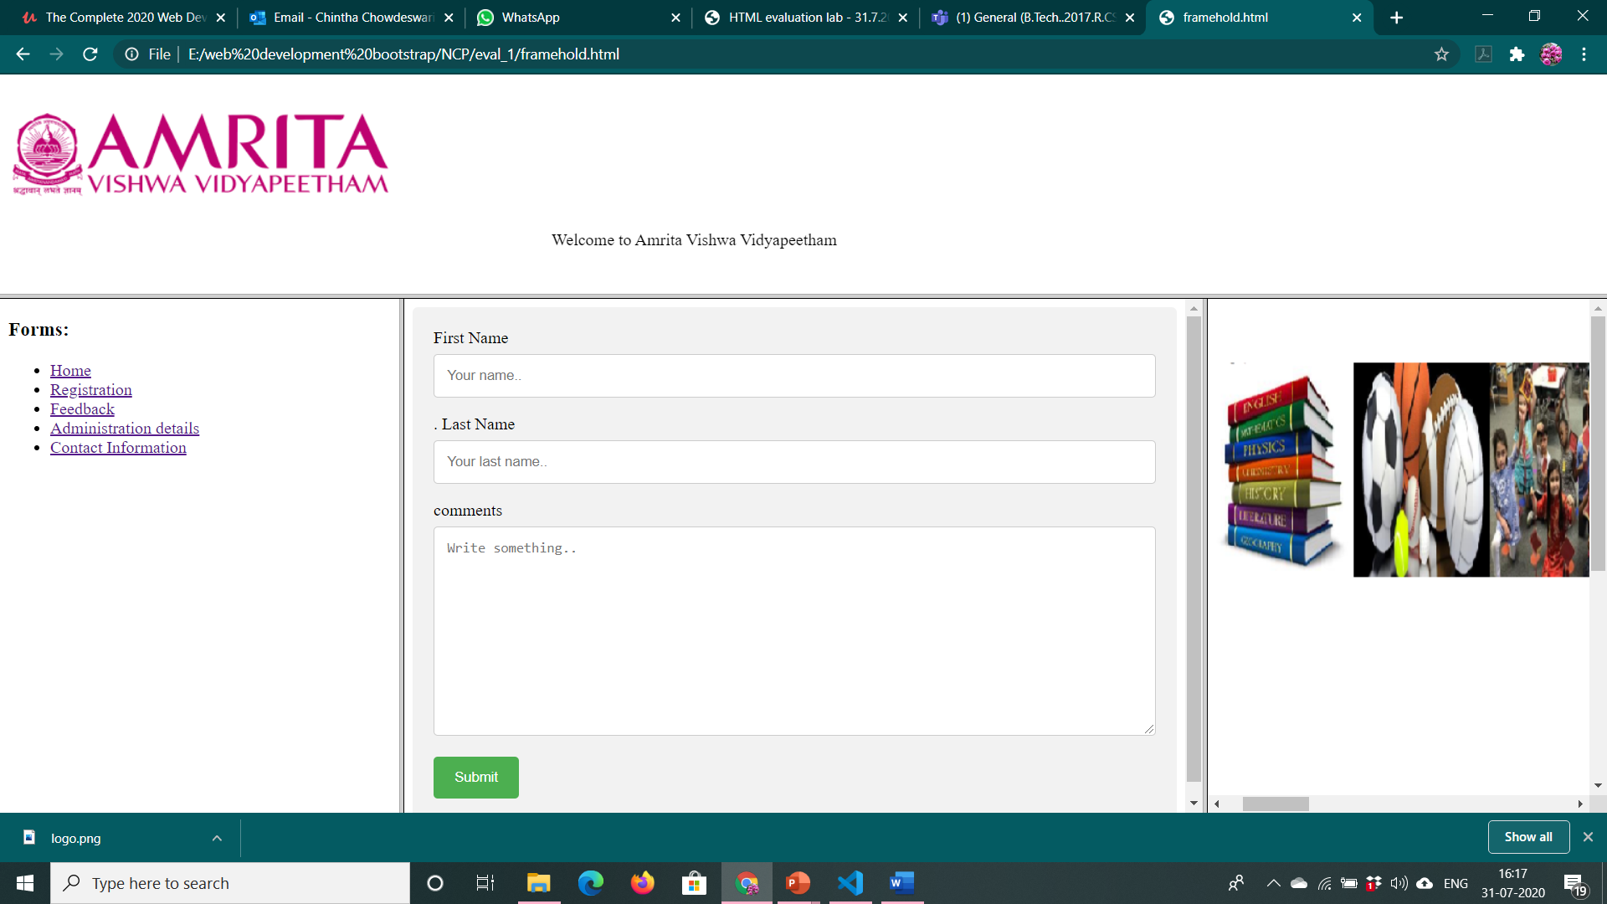

Administration.html

<html>

<head>

<style>

table {

  font-family: arial, sans-serif;

  border-collapse: collapse;

  width: 100%;

}

td{

  border: 1px solid #dddddd;

  text-align: left;

  padding: 8px;

}

tr:nth-child(even) {

  background-color: #dddddd;

}

</style>

</head>

<body>

<h2>HTML Table</h2>

<table>

  <tr>

    <td>Chancellor</td>

    <td>Sri Mata Amritanandamayi Devi</td>

  </tr>

  <tr>

    <td>President </td>

    <td>ampoojya Swami

        Amritaswarupananda</td>

  </tr>

  <tr>

    <td>Vice Chancellor</td>

    <td>Dr P.Venkat Rangan</td>

  </tr>

  <tr>

    <td>Medical Director & Principal</td>

    <td>Dr. C. Nagarajan</td>

    </tr>

</table>

</body>

</html>

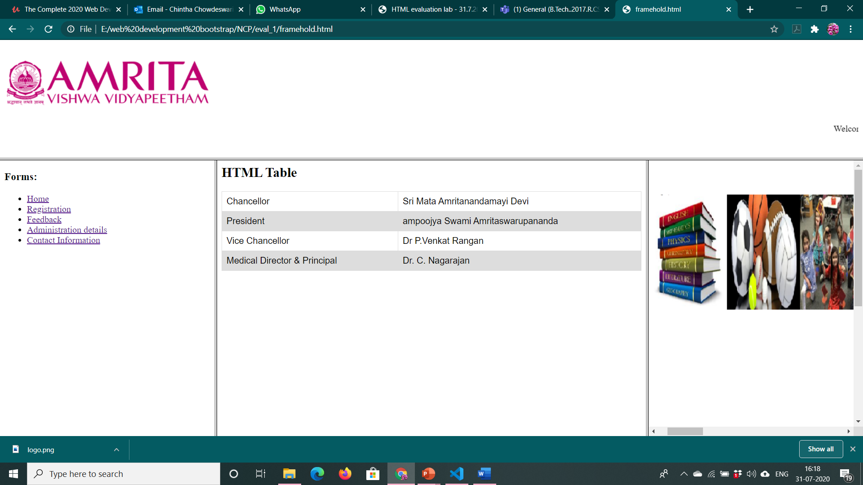

Contact.html

<!DOCTYPE html>

<html>

<head>

<style>

table {

  font-family: arial, sans-serif;

  border-collapse: collapse;

  width: 100%;

}

td{

  border: 1px solid #dddddd;

  text-align: left;

  padding: 8px;

}

tr:nth-child(even) {

  background-color: #dddddd;

}

</style>

</head>

<body>

<h2>Contact details:</h2>

<table>

  <tr>

    <td>Amritapuri </td>

    <td>+91 (476)  280 1280</td>

  </tr>

  <tr>

    <td>Bengaluru</td>

    <td>91 (80) 2518 3700</td>

  </tr>

  <tr>

    <td>Coimbatore</td>

    <td>+91 (422) 2685 000</td>

  </tr>

</table>

</body>

</html>

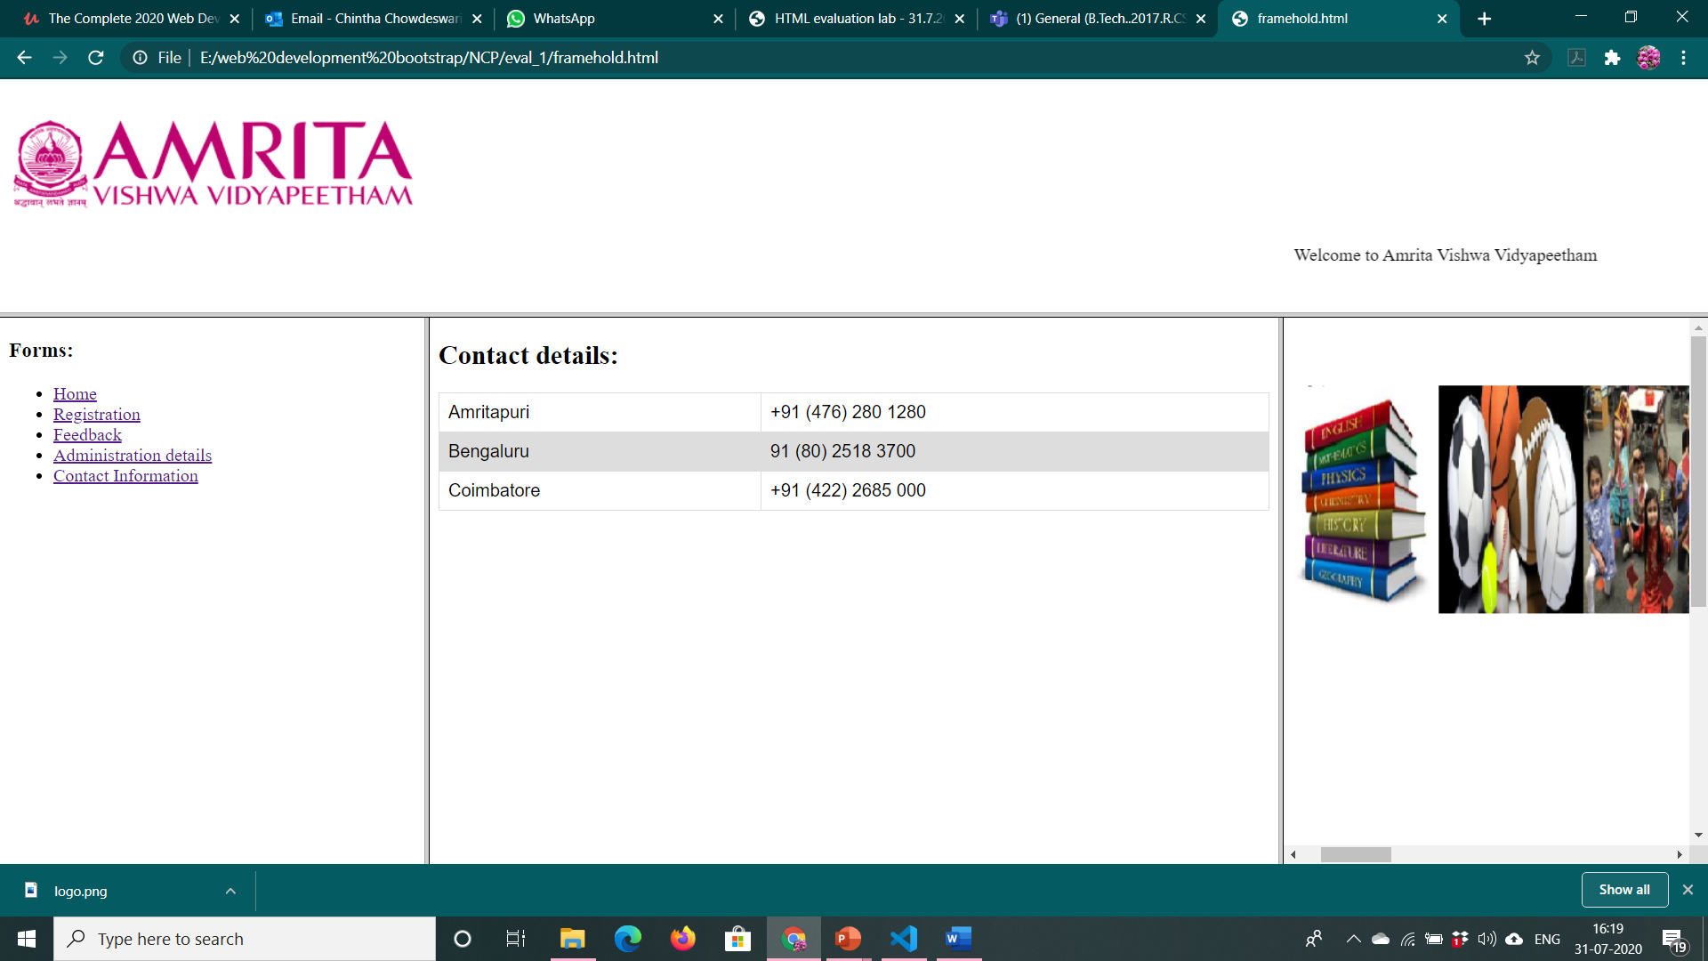

Frame3.html

<!DOCTYPE html>

<html>

    <head>

    <img src="C:\Users\VENKATESHWARULU\Downloads\culture.PNG" alt="rectangleplace" usemap="#rectmap">

<map name="rectmap">

  <area shape="rect" coords="81,54,231,256" alt="1" href="spr.html" target="_blank">

  <area shape="rect" coords="233,53,361,256" alt="2" href="aca.html"target="_blank" >

  <area shape="rect" coords="364,54,514,257" alt="3" href="cult.html" target="_blank">

</map>

</head>

</html>

Spr.html

<!DOCTYPE html>

<html>

    <p><h5>A state of the art gymnatium with Treadmills, Elleptical cross trainer, Upright bike and with Multi-stationed machiens, seperate for boath boys and girls. Indoor facilities for Table tennis, Chess, Badminton and Carom. Out door Facilities for Volleyball, Throwball, Basketball and Cricket nets. Five acres of land has been identified near campus premises for building a multi-dimensional sports complex.</h5></p>

</html>

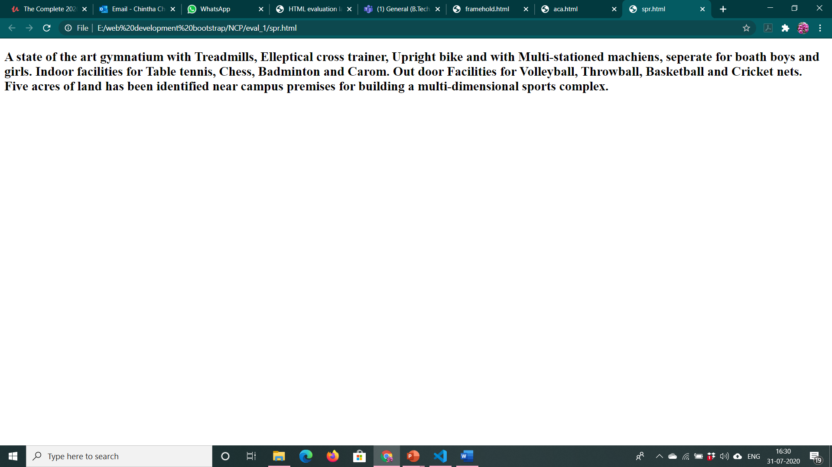

Aca.html

<!DOCTYPE html>

<html>

    <p><h5>Amrita Vishwa Vidyapeetham personifies multi-disciplinary academic excellence through the exceptional quality of its education system that is modern and comprehensive, with special emphasis on core human values.

        Undergraduate, postgraduate and doctoral programmes are offered in Engineering, Business, Medicine, Dentistry, Pharmacy, Nursing, Journalism, Biotechnology, Information Technology, Arts and Sciences, Health Sciences, Teacher Education, Microbiology, Hospital Management, Visual Media Studies, Mass Communication, Social Work, Nanosciences and Ayurveda.</h5></p>

</html>

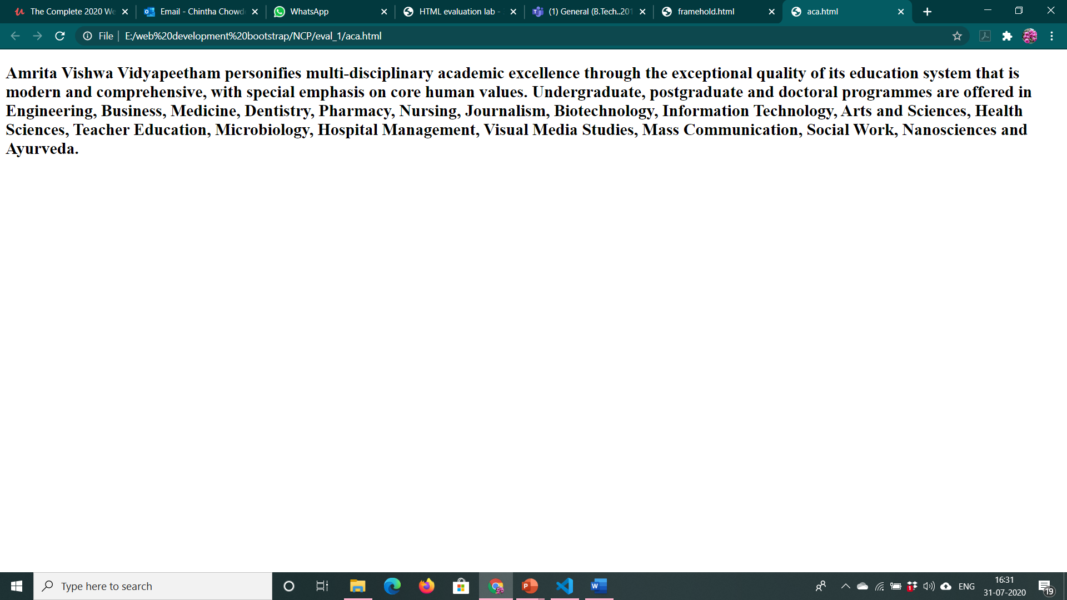

Cult.html

<!DOCTYPE html>

<html>

    <p><h5>The Department of Cultural Education at Amrita Vishwa Vidyapeetham has been translating our beloved Chancellor Amma’s vision of imparting good samskaras or cultural values to the students. The department offers the cultural education foundation course of two credits to all undergraduate and postgraduate students of the institution, apart from various electives. The course includes yoga classes, meditation and personality development through a positive appreciation of Indian Culture and Heritage.

    </h5></p>

</html>

