1.nestedtable_lab2

<!DOCTYPE html>

<head>

    <table border="1">

        <tr>

            <td>Nested table2

                <table>

                    <tr>

                        <td>column1</td>

                        <td>column2</td>

                    </tr>

                    <tr>

                        <td>Our First Table</td>

                        <td>With in</td>

                    </tr>

                </table>

            </td>

            <td>

                Nested table2

                <table >

                    <td>

                        <ul style="list-style-type:disc">

                        <li>List Object1</li>

                        <li>List Object2</li>

                        <li>List Object3</li>

                        </ul>

                    </td>

                </table>

            </td>

        </tr>

        <tr>

            <td>Nested table3

                <table>

                    <tr>

                        <td>

                            Nested Table

                        </td>

                        <td>Demo Continued</td>

                    </tr>

                </table>

            </td>

            <td>Nested table4

                <h1 style="background-color:rgb(128,128,128);">HTML</h1>

            </td>

        </tr>

    </table>

</head>

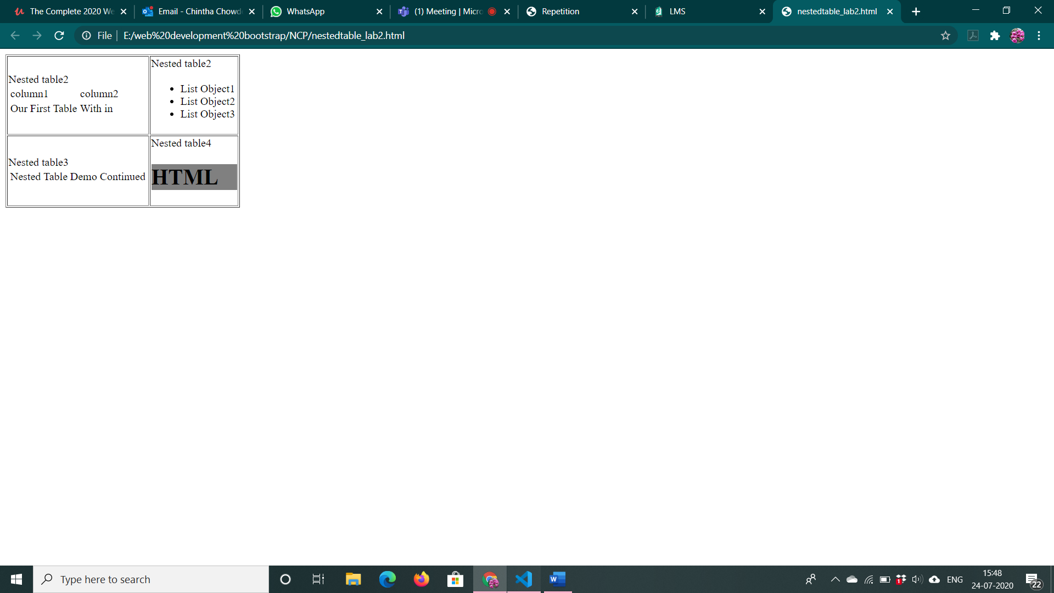

2.timetable.html

<!DOCTYPE html>

<html>

<style type="text/css">

    .tg  {border-collapse:collapse;border-spacing:0;}

    .tg td{border-color:black;border-style:solid;border-width:1px;font-family:Arial, sans-serif;font-size:14px;

      overflow:hidden;padding:10px 5px;word-break:normal;}

    .tg th{border-color:black;border-style:solid;border-width:1px;font-family:Arial, sans-serif;font-size:14px;

      font-weight:normal;overflow:hidden;padding:10px 5px;word-break:normal;}

    .tg .tg-36ox{border-color:inherit;color:#fe0000;text-align:left;vertical-align:top}

    .tg .tg-sg5v{border-color:inherit;font-size:100%;text-align:left;vertical-align:top}

    .tg .tg-fpwh{background-color:#32cb00;border-color:inherit;text-align:center;vertical-align:top}

    .tg .tg-ik58{background-color:#ffcb2f;border-color:inherit;text-align:left;vertical-align:top}

    .tg .tg-0pky{border-color:inherit;text-align:left;vertical-align:top}

    .tg .tg-i1q2{background-color:#34cdf9;border-color:inherit;text-align:left;vertical-align:top}

    </style>

    <table class="tg">

    <thead>

      <tr>

        <th class="tg-fpwh" colspan="12">Online Timetable Slots</th>

      </tr>

    </thead>

    <tbody>

      <tr>

        <td class="tg-ik58">Dept</td>

        <td class="tg-ik58">CSE</td>

        <td class="tg-ik58">Semester</td>

        <td class="tg-ik58">VII</td>

        <td class="tg-ik58">Class</td>

        <td class="tg-ik58">Btech.CSE</td>

        <td class="tg-ik58">Section</td>

        <td class="tg-ik58">D</td>

        <td class="tg-ik58">ClassAdvisor</td>

        <td class="tg-ik58">Mrs. Prathilothamai<br>Mr. A K Sumesh</td>

        <td class="tg-ik58">Emailid</td>

      </tr>

      <tr>

        <td class="tg-0pky" rowspan="2">Time/Day</td>

        <td class="tg-0pky">Slot1</td>

        <td class="tg-0pky">Slot2</td>

        <td class="tg-0pky">Slot3</td>

        <td class="tg-0pky">Slot4</td>

        <td class="tg-i1q2" rowspan="8">Lunch<br>Break</td>

        <td class="tg-0pky">Slot 5</td>

        <td class="tg-0pky">Slot 6</td>

        <td class="tg-0pky">Slot 7</td>

        <td class="tg-0pky">Slot 8</td>

        <td class="tg-36ox">Slot 9</td>

      </tr>

      <tr>

        <td class="tg-0pky">9-10</td>

        <td class="tg-0pky">10-11</td>

        <td class="tg-0pky">11-12</td>

        <td class="tg-0pky">12-1</td>

        <td class="tg-0pky">14-15</td>

        <td class="tg-0pky">15-16</td>

        <td class="tg-0pky">16-17</td>

        <td class="tg-0pky">17-18</td>

        <td class="tg-36ox">18-19</td>

      </tr>

      <tr>

        <td class="tg-0pky">Monday</td>

        <td class="tg-0pky">15CSE402<br>Structure and Interpretations<br>Computer Programs<br>Dr. Ragesh Krishnan K</td>

        <td class="tg-0pky"></td>

        <td class="tg-0pky"></td>

        <td class="tg-0pky"></td>

        <td class="tg-sg5v" colspan="2">Elective 5 Lab<br>Faculty 1<br>Faculty 2<br>Faculty 3<br>Elective 5A Lab<br>Faculty 4 <br>Faculty 5<br>Faculty 6</td>

        <td class="tg-0pky"></td>

        <td class="tg-0pky"></td>

        <td class="tg-36ox">Discussion</td>

      </tr>

      <tr>

        <td class="tg-0pky">Tuesday</td>

        <td class="tg-0pky">15CSE401<br>MLDM<br>Mr Manu Madhavan</td>

        <td class="tg-0pky">Elective 5 Lab<br>Faculty 1<br>Faculty 2<br>Faculty 3<br>Elective 5A Lab<br>Faculty 4 <br>Faculty 5<br>Faculty 6</td>

        <td class="tg-0pky"></td>

        <td class="tg-0pky">Elective 5 Lab<br>Faculty 1<br>Faculty 2<br>Faculty 3<br>Elective 5A Lab<br>Faculty 4 <br>Faculty 5<br>Faculty 6</td>

        <td class="tg-0pky"></td>

        <td class="tg-0pky"></td>

        <td class="tg-0pky"></td>

        <td class="tg-0pky"></td>

        <td class="tg-36ox">Discussion</td>

      </tr>

      <tr>

        <td class="tg-0pky">Wednesday</td>

        <td class="tg-0pky">Elective 5 Lab<br>Faculty 1<br>Faculty 2<br>Faculty 3<br>Elective 5A Lab<br>Faculty 4 <br>Faculty 5<br>Faculty 6</td>

        <td class="tg-0pky">15CSE401<br>MLDM<br>Mr Manu Madhavan</td>

        <td class="tg-0pky"></td>

        <td class="tg-0pky">15CSE402<br>Structure and Interpretations<br>Computer Programs<br>Dr. Ragesh Krishnan K</td>

        <td class="tg-0pky" colspan="2">Elective 5 Lab<br>Faculty 1<br>Faculty 2<br>Faculty 3<br>Elective 5A Lab<br>Faculty 4 <br>Faculty 5<br>Faculty 6</td>

      <td class="tg-0pky"></td>

      <td class="tg-0pky"></td>

      <td class="tg-36ox">Discussion</td>

    </tr>

    <tr>

      <td class="tg-0pky">Thursday</td>

      <td class="tg-0pky">Elective 5 Lab<br>Faculty 1<br>Faculty 2<br>Faculty 3<br>Elective 5A Lab<br>Faculty 4 <br>Faculty 5<br>Faculty 6</td>

      <td class="tg-0pky"></td>

      <td class="tg-0pky">Soft Skills</td>

      <td class="tg-0pky">15CSE376<br>NCP<br>Dr. Arun Kumar</td>

      <td class="tg-0pky"></td>

      <td class="tg-0pky"></td>

      <td class="tg-0pky"></td>

      <td class="tg-0pky"></td>

      <td class="tg-36ox">Discussion</td>

    </tr>

    <tr>

      <td class="tg-0pky">Friday</td>

      <td class="tg-0pky">15CSE376<br>NCP<br>Dr. Arun Kumar</td>

      <td class="tg-0pky">Elective 5 Lab<br>Faculty 1<br>Faculty 2<br>Faculty 3<br>Elective 5A Lab<br>Faculty 4 <br>Faculty 5<br>Faculty 6</td>

      <td class="tg-0pky"></td>

      <td class="tg-0pky">15CSE402<br>Structure and Interpretations<br>Computer Programs<br>Dr. Ragesh Krishnan K</td>

      <td class="tg-0pky" colspan="2">Elective 5 Lab<br>Faculty 1<br>Faculty 2<br>Faculty 3<br>Elective 5A Lab<br>Faculty 4 <br>Faculty 5<br>Faculty 6</td>

      <td class="tg-0pky"></td>

      <td class="tg-0pky"></td>

      <td class="tg-36ox">Discussion</td>

    </tr>

    <tr>

      <td class="tg-0pky">Saturday</td>

      <td class="tg-0pky">15CSE402<br>Structure and Interpretations<br>Computer Programs<br>Dr. Ragesh Krishnan K</td>

      <td class="tg-0pky"></td>

      <td class="tg-0pky">Elective 5 Lab<br>Faculty 1<br>Faculty 2<br>Faculty 3<br>Elective 5A Lab<br>Faculty 4 <br>Faculty 5<br>Faculty 6</td>

      <td class="tg-0pky">15CSE401<br>MLDM<br>Mr Manu Madhavan</td>

      <td class="tg-0pky"></td>

      <td class="tg-0pky"></td>

      <td class="tg-0pky"></td>

      <td class="tg-0pky"></td>

      <td class="tg-36ox">Discussion</td>

    </tr>

  </tbody>

  </table>

  </html>

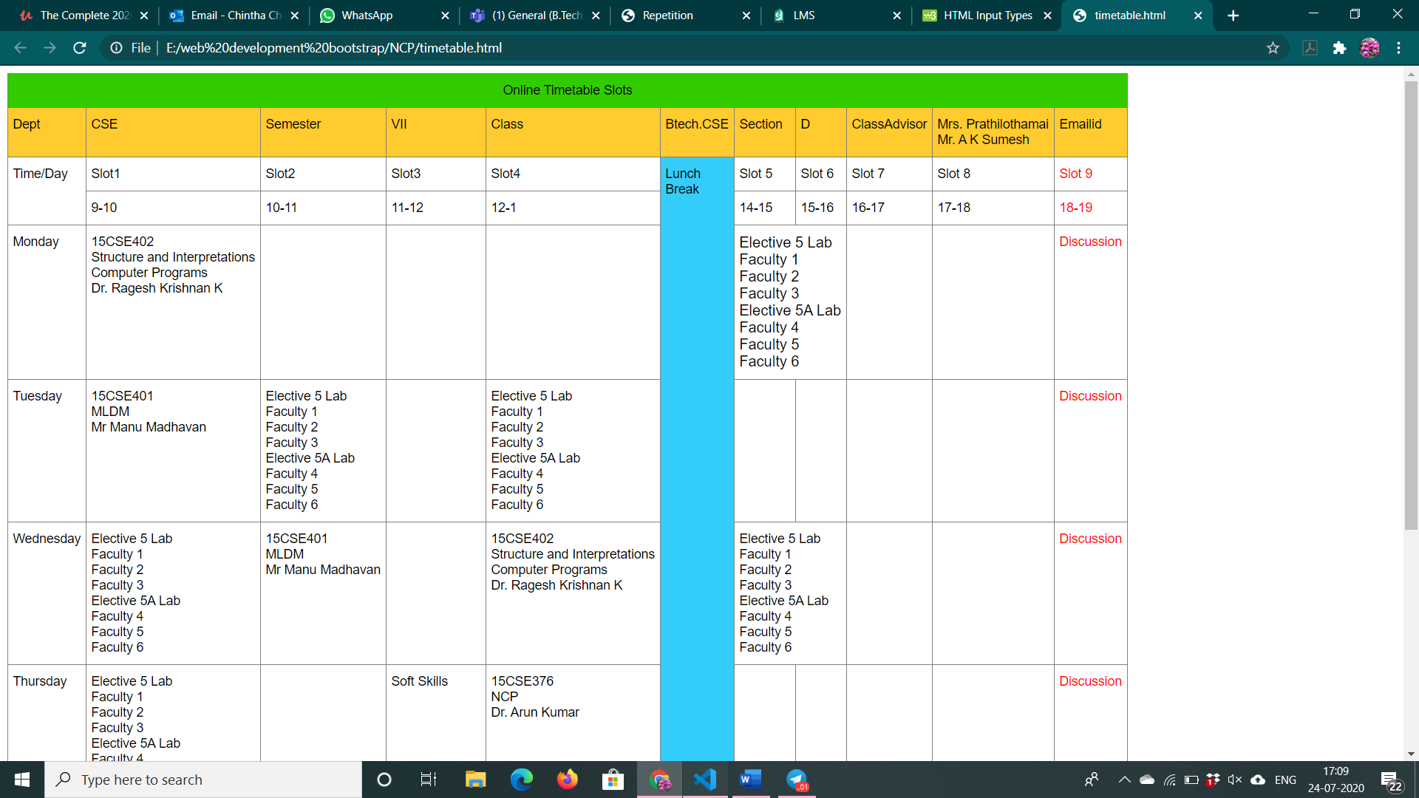

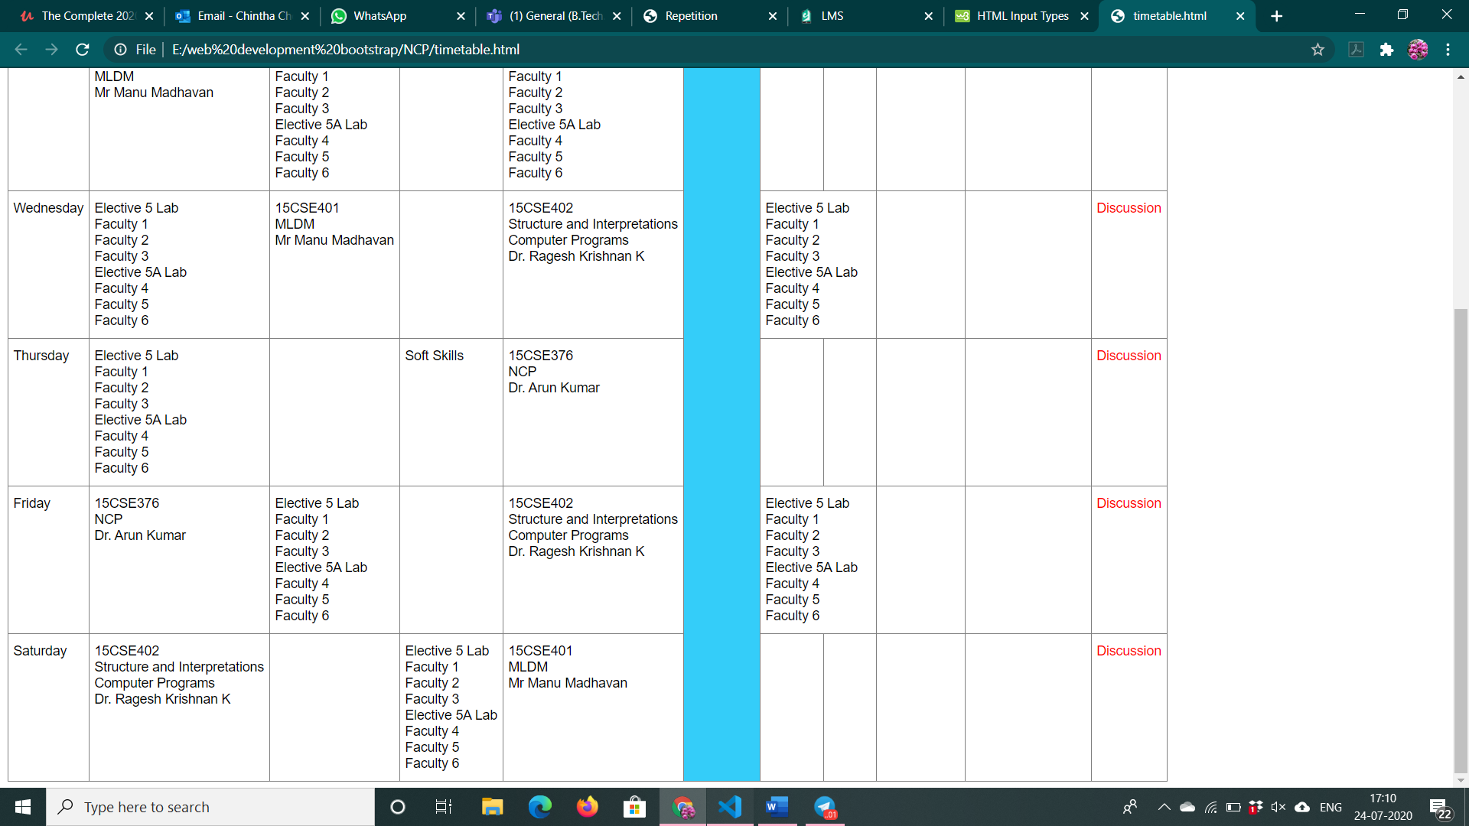

4.frames.html

<!DOCTYPE html>

<html>

<frameset rows="10%,20%,50%,20%,*">

    <frame name="row1" src="row1.html" />

    <frame name="row2" src="row2.html" />

    <frame name="row3" src="row3.html" />

    <frame name="row4" src="row4.html" />

</frameset>

</html>

Row1.html

<!DOCTYPE html>

<html>

    <form method="POST">

      <table>

          <tr>

             <td><input type="radio" id="id" name="id" value="id"></td>

             <td><label for="id">ID</label></td>

             <td><input type="radio" id="passport" name="passport" value="passport"></td>

             <td><label for="passport">Passport</label></td>

             <td><lable for="number">&nbsp;&nbsp;&nbsp;&nbsp;&nbsp;&nbsp;&nbsp;&nbsp;&nbsp;&nbsp;&nbsp;&nbsp;&nbsp;&nbsp;&nbsp;&nbsp;&nbsp;Number</lable></td>

             <td><input type="text" id="number"></td>

             <td><lable for="date">&nbsp;&nbsp;&nbsp;&nbsp;&nbsp;&nbsp;&nbsp;&nbsp;&nbsp;&nbsp;&nbsp;&nbsp;&nbsp;&nbsp;&nbsp;&nbsp;&nbsp;Date</lable></td>

             <td><input type="date" id="date"></td>

             <td><lable for="type">&nbsp;&nbsp;&nbsp;&nbsp;&nbsp;&nbsp;&nbsp;&nbsp;&nbsp;&nbsp;&nbsp;&nbsp;&nbsp;&nbsp;&nbsp;&nbsp;&nbsp;Passport country</lable></td>

             <td><select id="type" name="country">

                 <option value="india">India</option>

                 <option value="Japan">Japan</option>

                 <option value="australia">Australia</option>

             </select></td>

          </tr>

      </table>

    </form>

</html>

Row2.html

<!DOCTYPE html>

<html>

    <form method="POST">

        <table>

            <tr>

                <td><label for="title">Title</label></td>

                <td><input type="text" id="title" value="hello"></td>

                <td><label for="fname">&nbsp;&nbsp;&nbsp;&nbsp;&nbsp;&nbsp;&nbsp;&nbsp;&nbsp;&nbsp;&nbsp;&nbsp;&nbsp;&nbsp;&nbsp;&nbsp;&nbsp;First Name</label></td>

                <td><input type="text" id="fname" value="hello"></td>

                <td><label for="lname">&nbsp;&nbsp;&nbsp;&nbsp;&nbsp;&nbsp;&nbsp;&nbsp;&nbsp;&nbsp;&nbsp;&nbsp;&nbsp;&nbsp;&nbsp;&nbsp;&nbsp;Last Name</label></td>

                <td><input type="text" id="lname" value="hello"></td>

            </tr>

            <tr>

                <td><label for="carid">Demo Card-ID</label></td>

                <td><input type="text" id="carid" value="hello"></td>

                <td><label for="num">&nbsp;&nbsp;&nbsp;&nbsp;&nbsp;&nbsp;&nbsp;&nbsp;&nbsp;&nbsp;&nbsp;&nbsp;&nbsp;&nbsp;&nbsp;&nbsp;&nbsp;Card number</label></td>

                <td><input type="text" id="num" value="hello"></td>

                <td><label for="bdate">&nbsp;&nbsp;&nbsp;&nbsp;&nbsp;&nbsp;&nbsp;&nbsp;&nbsp;&nbsp;&nbsp;&nbsp;&nbsp;&nbsp;&nbsp;&nbsp;&nbsp;Birth Date</label></td>

                <td><input type="date" id="bdate" ></td>

            </tr>

        </table>

    </form>

</html>

Row3.html

<!DOCTYPE html>

<html>

    <form method="POST">

        <table>

            <tr>

                <td><lable for="ltype">License country</lable></td>

             <td><select id="ltype" name="country">

                 <option value="india">India</option>

                 <option value="Japan">Japan</option>

                 <option value="australia">Australia</option>

             </select></td>

             <td><label for="idate">&nbsp;&nbsp;&nbsp;&nbsp;&nbsp;&nbsp;&nbsp;&nbsp;&nbsp;&nbsp;&nbsp;&nbsp;&nbsp;&nbsp;&nbsp;&nbsp;&nbsp;Issue Date</label></td>

                <td><input type="date" id="idate" ></td>

                <td><label for="data">&nbsp;&nbsp;&nbsp;&nbsp;&nbsp;&nbsp;&nbsp;&nbsp;&nbsp;&nbsp;&nbsp;&nbsp;&nbsp;&nbsp;&nbsp;&nbsp;&nbsp;DATA</label></td>

                <td><input type="text" id="data"></td>

            </tr>

            <tr>

                <td><label for="driver">Driver License</label></td>

                <td><input type="text" id="driver"></td>

                <td><label for="edate">&nbsp;&nbsp;&nbsp;&nbsp;&nbsp;&nbsp;&nbsp;&nbsp;&nbsp;&nbsp;&nbsp;&nbsp;&nbsp;&nbsp;&nbsp;&nbsp;&nbsp;Expiry Date</label></td>

                <td><input type="date" id="edate" ></td>

                <td><label for="phone">&nbsp;&nbsp;&nbsp;&nbsp;&nbsp;&nbsp;&nbsp;&nbsp;&nbsp;&nbsp;&nbsp;&nbsp;&nbsp;&nbsp;&nbsp;&nbsp;&nbsp;Phone 1</label></td>

                <td><input type="text" id="phone"></td>

            </tr>

            <tr>

                <td><label for="add">Address</label></td>

                <td><textarea name="add" id="add" rows="4" cols="30"></textarea></td>

                <td><label for="phone2">&nbsp;&nbsp;&nbsp;&nbsp;&nbsp;&nbsp;&nbsp;&nbsp;&nbsp;&nbsp;&nbsp;&nbsp;&nbsp;&nbsp;&nbsp;&nbsp;&nbsp;&nbsp;

                    Phone 2</label></td>

                <td><input type="text" id="phone2"></td>

            </tr>

            <tr>

                <td><label for="fax">Fax 1</label></td>

                <td><input type="text" id="fax"></td>

            </tr>

            <tr>

                <td><label for="state">CityState</label></td>

                <td><input type="text" id="state"></td></td>

                <td><label for="zip">&nbsp;&nbsp;&nbsp;&nbsp;&nbsp;&nbsp;&nbsp;&nbsp;&nbsp;&nbsp;&nbsp;&nbsp;&nbsp;&nbsp;&nbsp;&nbsp;&nbsp;Zip</label></td>

                <td><input type="text" id="zip"></td>

                <td><lable for="ctry">&nbsp;&nbsp;&nbsp;&nbsp;&nbsp;&nbsp;&nbsp;&nbsp;&nbsp;&nbsp;&nbsp;&nbsp;&nbsp;&nbsp;&nbsp;&nbsp;&nbsp;Country</lable></td>

             <td><select id="ctry" name="country">

                 <option value="india">India</option>

                 <option value="Japan">Japan</option>

                 <option value="australia">Australia</option>

             </select></td>

             <td><label for="sms">&nbsp;&nbsp;&nbsp;&nbsp;&nbsp;&nbsp;&nbsp;&nbsp;&nbsp;&nbsp;&nbsp;&nbsp;&nbsp;&nbsp;&nbsp;&nbsp;&nbsp;SMS</label></td>

                <td><input type="text" id="sms"></td>

            </tr>

        </table>

    </form>

</html>

Row4.html

<!DOCTYPE html>

<html>

    <table>

        <tr>

            <td><lable for="emp">Employer</lable></td>

        <td><select id="emp" name="employer">

            <option value="0">0</option>

            <option value="1">1</option>

            <option value="2">2</option>

        </select></td>

        <td><lable for="cust">&nbsp;&nbsp;&nbsp;&nbsp;&nbsp;&nbsp;&nbsp;&nbsp;&nbsp;&nbsp;&nbsp;&nbsp;&nbsp;&nbsp;&nbsp;&nbsp;&nbsp;Customer sorce type</lable></td>

        <td><select id="cust" name="custom">

            <option value="0">0</option>

            <option value="1">1</option>

            <option value="2">2</option>

        </select></td>

        <td><label for="email">&nbsp;&nbsp;&nbsp;&nbsp;&nbsp;&nbsp;&nbsp;&nbsp;&nbsp;&nbsp;&nbsp;&nbsp;&nbsp;&nbsp;&nbsp;&nbsp;&nbsp;Email</label></td>

        <td><input type="email" id="email"></td>

        </tr>

        <tr>

            <td><label for="local">Local Address</label></td>

            <td><input type="text" id="local"></td>

            <td><label for="ph">&nbsp;&nbsp;&nbsp;&nbsp;&nbsp;&nbsp;&nbsp;&nbsp;&nbsp;&nbsp;&nbsp;&nbsp;&nbsp;&nbsp;&nbsp;&nbsp;&nbsp;Local Phone</label></td>

        <td><input type="text" id="ph"></td>

        </tr>

    </table>

</html>

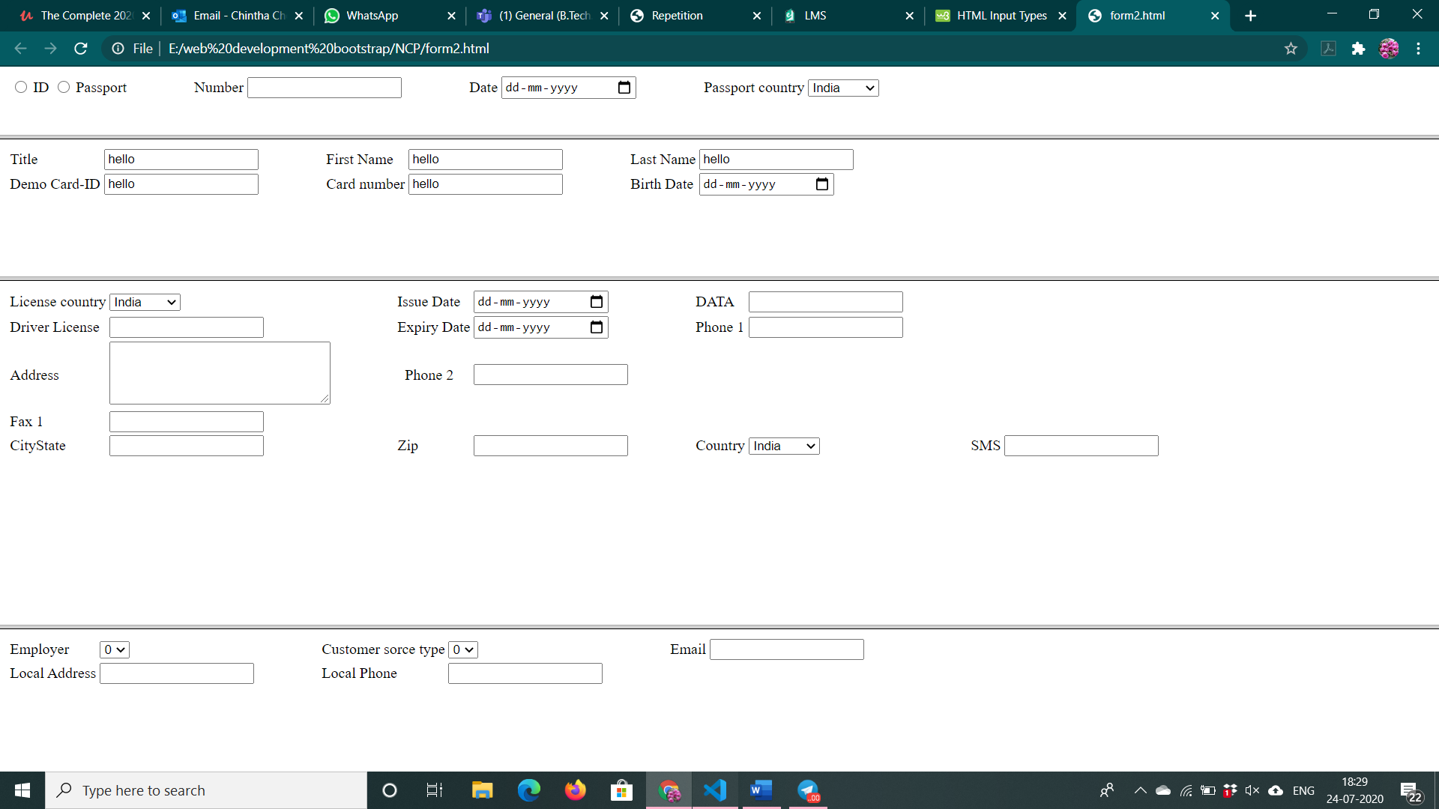

3.image.html

<!DOCTYPE html>

<html>

    <head>

    <img src="C:\Users\venkateswarulu\Desktop\computer.JPEG" alt="rectangleplace" usemap="#commap">

<map name="commap">

  <area shape="rect" coords="120,70,170,140" alt="printer" href="printer.html">

  <area shape="rect" coords="210,30,350,130" alt="monitor" href="monitor.html">

  <area shape="rect" coords="190,160,260,210" alt="speakers" href="speakers.html">

   <area shape="rect" coords="420,140,440,210" alt="mouse" href="mouse.html">

    <area shape="rect" coords="370,60,430,170" alt="cpu" href="cpu.html">

   <area shape="rect" coords="270,170,480,190" alt="keyobard" href="keyoard.html">

</map>

</head>

</html>

