1. <!DOCTYPE html>

<html lang="en">

<head>

    <meta charset="UTF-8">

    <meta name="viewport" content="width=device-width, initial-scale=1.0">

    <title>Document</title>

</head>

<body>

    <input type="number" id="rows">

    <input type="number" id="cols">

    <input type="submit" id="gen" value="Generate" onclick="gen()">

    <table id="mul" border="2px" style="border-style: solid;">

    </table>

</body>

<script>

    function gen()

    {

        console.log("Hello");

        var r=parseInt(document.getElementById("rows").value)

        var c=parseInt(document.getElementById("cols").value)

        output=""

        for(var i=1;i<=r;i++)

        {

            output+="<tr>"

            for(var j=1;j<=c;j++)

            {

                output+="<td>"+j*i+"</td>"

            }

            output+="</tr>"

        }

        document.getElementById("mul").innerHTML=output

    }

</script>

</html>

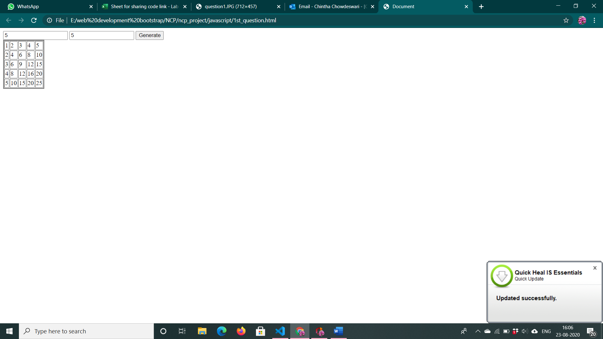

2. <!DOCTYPE html>

<html lang="en">

<head>

    <meta charset="UTF-8">

    <meta name="viewport" content="width=device-width, initial-scale=1.0">

    <title>Document</title>

</head>

<body>

    <h1>Date Validator</h1>

    <input id="dateed" placeholder="Enter Date in dd-mm-yyyy format" size="30" type="text" onkeyup="validate()" onclick="validate()" onchange="validate()">

    <!-- <input id="date" type="button" onclick="validate()" value="Validate"> -->

    <p style="color: red;" id="answer"></p>

</body>

<script>

    function validate()

    {

        var date=document.getElementById("dateed").value

        var rgexp = /^(0[1-9]|1\d|2\d|3[01])\-(0[1-9]|1[0-2])\-(19|20)\d{2}$/;

        var isValidDate = rgexp.test(date);

        if(date=="")

        {

            document.getElementById("answer").innerText = ""

            document.getElementById("answer").style.color = "green";

        }

        else if(isValidDate)

        {

            document.getElementById("answer").innerText="Valid"

            document.getElementById("answer").style.color="green";

        }

        else{

             document.getElementById("answer").innerText = "Invalid, please enter valid date"

            document.getElementById("answer").style.color = "red";

        }

    }

</script>

</html>

<!DOCTYPE html>

<html lang="en">

<head>

    <meta charset="UTF-8">

    <meta name="viewport" content="width=device-width, initial-scale=1.0">

    <title>Document</title>

</head>

<body>

    <h1>Date Validator</h1>

    <input id="dateed" placeholder="Enter Date in dd-mm-yyyy format" size="30" type="text" onkeyup="validate()" onclick="validate()" onchange="validate()">

    <!-- <input id="date" type="button" onclick="validate()" value="Validate"> -->

    <p style="color: red;" id="answer"></p>

</body>

<script>

    function validate()

    {

        var date=document.getElementById("dateed").value

        var rgexp = /^(0[1-9]|1\d|2\d|3[01])\-(0[1-9]|1[0-2])\-(19|20)\d{2}$/;

        var isValidDate = rgexp.test(date);

        if(date=="")

        {

            document.getElementById("answer").innerText = ""

            document.getElementById("answer").style.color = "green";

        }

        else if(isValidDate)

        {

            document.getElementById("answer").innerText="Valid"

            document.getElementById("answer").style.color="green";

        }

        else{

             document.getElementById("answer").innerText = "Invalid, please enter valid date"

            document.getElementById("answer").style.color = "red";

        }

    }

</script>

</html>

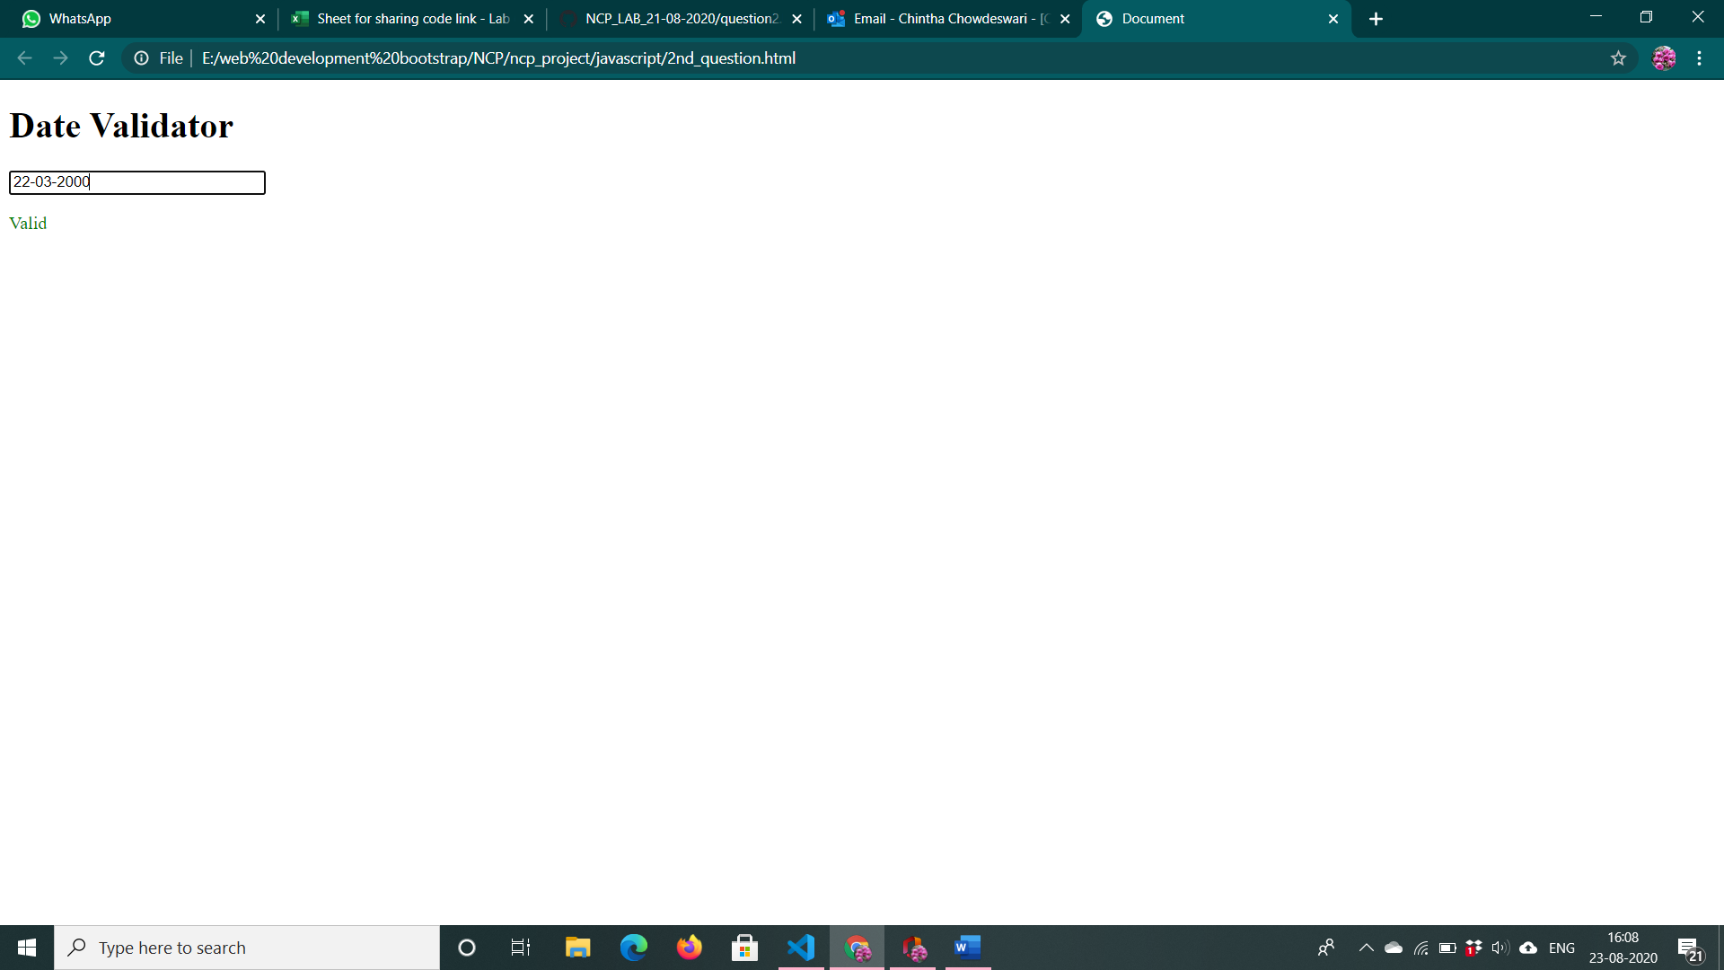

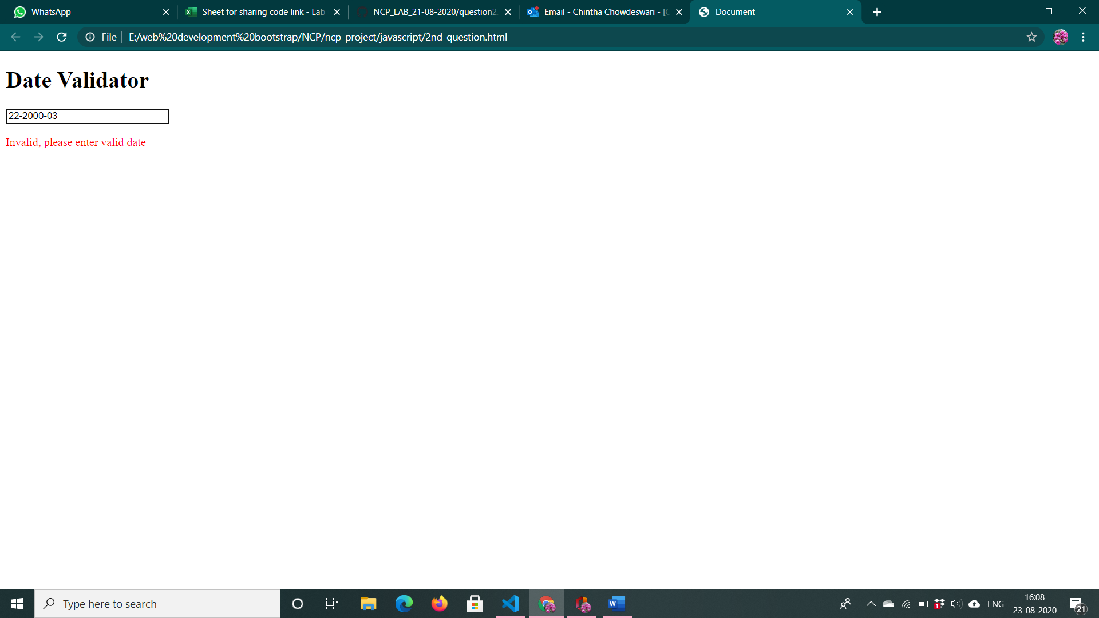

3. <!DOCTYPE html>

<html lang="en">

<head>

    <meta charset="UTF-8">

    <meta name="viewport" content="width=device-width, initial-scale=1.0">

    <title>Document</title>

</head>

<body>

    <input type="text" name="chapter" id="chapter">

    <input type="number" name="page" id="page">

    <input type="button" name="submit" id="submit" value="Print" onclick="generatePageNumber()">

    <table style="table-layout: fixed;" id="list" >

    </table>

    <script>

        document.addEventListener("keyup", function (event) {

            if (event.keyCode === 13) {

                event.preventDefault();

                generatePageNumber()

            }

        });

        var arr=[]

        function generatePageNumber()

        {

            var c_name=document.getElementById("chapter").value

            var pg= document.getElementById("page").value

            if(c_name==""||pg=="")

            {

                alert("Enter data")

            }

            else{

                arr.push({ chap: c_name, pg: pg })

                arr = arr.sort(function (a, b) {

                    return parseInt(a.pg) - parseInt(b.pg);

                })

                var output = ""

                for (var i = 0; i < arr.length; i++) {

                    output += "<tr><td>"+(i+1)+"</td><td>"

                    var slen = arr[i].chap.length

                    // console.log(slen+" "+arr[i].pg.length)

                    output += arr[i].chap

                    for (var j = 0; j < (75 - (slen + arr[i].pg.length)); j++) {

                        output += ". "

                    }

                    output += "</td><td>"+arr[i].pg + "</td></tr><br>"

                }

                document.getElementById("list").innerHTML = output

                document.getElementById("chapter").value=""

                document.getElementById("chapter").select()

                document.getElementById("page").value=""

            }

        }

    </script>

</body>

</html>

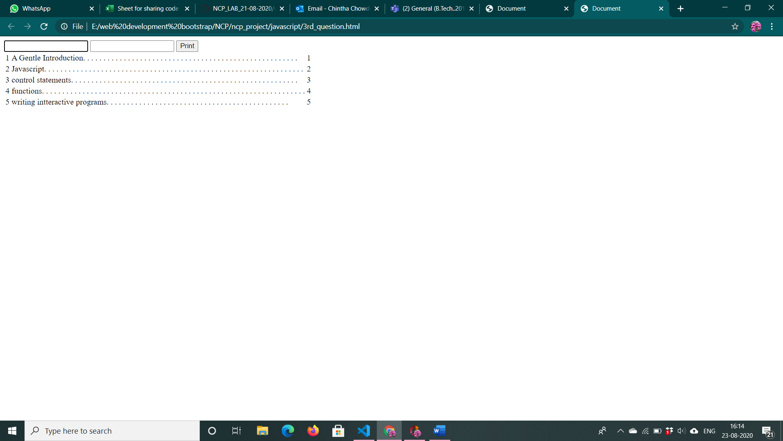

4. <!DOCTYPE html>

<html lang="en">

<head>

    <meta charset="UTF-8">

    <meta name="viewport" content="width=device-width, initial-scale=1.0">

    <title>Document</title>

    <link href="https://fonts.googleapis.com/css2?family=Press+Start+2P&display=swap" rel="stylesheet">

</head>

<style>

    input[type=submit]

    {

        background-color: black;

        color: #1900ff;

    }

    input[type=button]

    {

        background-color: black;

        color:  #1900ff;

    }

</style>

<body style="font-family: 'Press Start 2P', cursive; color:  #1900ff; background-color: black;" onload="startTime()">

    <h2>Clock</h2>

    <table>

        <thead>

            <tr>

                <td><div id="date"></div></td>

                <td><div id="day"></div></td>

            </tr>

        </thead>

        <tbody>

            <tr style="text-align: center;">

                <td colspan="2"><div id="time"></div></td>

            </tr>

        </tbody>

    </table>

    <br><br>

    <h2>Alarm</h2>

    <input type="time" id="alarmtime" style="color: #41FF00; background-color: black;" onkeyup="stopAlarm()">

    <input type="submit" id="setalarm" value="Set Alarm"  onclick="setAlarmFunc()">

    <audio src="http://www.dobomusic.com/superheroes/Harry%20Potter%20and%20the%20Sorcerer_s%20Stone%20Suite.mp3" id="alarmring"></audio>

    <p id="alarmindicator" style="visibility: hidden;">Alarm ringing...</p>

    <br><br>

    <h2>Stop Watch</h2>

        <input type="button" onclick="startWatch()" value="START" />

        <input type="button" onclick="stopWatch()" value="STOP" />

        <input type="button" onclick="resetWatch()" value="ZERO" />

    <p id="res"><span id="min">0</span> : <span id="sec">00</span> : <span id="msec">000</span></p>

    <script>

        var setAlarm=false

        function setAlarmFunc()

        {

            console.log("Alarm On");

            setAlarm=true

        }

        function stopAlarm()

        {

            setAlarm=false

        }

        let week=["Sunday","Monday","Tuesday","Wednesday","Thursday","Friday","Saturday"]

        function startTime() {

            var today = new Date();

            var h = today.getHours();

            var m = today.getMinutes();

            var s = today.getSeconds();

            m = checkTime(m);

            s = checkTime(s);

            document.getElementById("date").innerText=today.getDate()+"-"+today.getMonth()+"-"+today.getFullYear()

            document.getElementById("day").innerText=week[today.getDay()]

            document.getElementById('time').innerHTML =

                h + ":" + m + ":" + s;

            var t = setTimeout(startTime, 500);

            if(setAlarm)

            {

                var hcheck=document.getElementById("alarmtime").value

                var currtimevalue=checkTime(today.getHours())+":"+checkTime(today.getMinutes())

                if(hcheck==currtimevalue)

                {

                    document.getElementById("alarmring").play()

                    document.getElementById("alarmindicator").style.visibility="visible"

                }

                else{

                     document.getElementById("alarmring").pause()

                     document.getElementById("alarmindicator").style.visibility = "hidden"

                }

            }

        }

        function checkTime(i) {

            if (i < 10) { i = "0" + i };  // add zero in front of numbers < 10

            return i;

        }

        var timer = null;

        var min_txt = document.getElementById("min");

        var min = Number(min_txt.innerHTML);

        var sec_txt = document.getElementById("sec");

        var sec = Number(sec_txt.innerHTML);

        var msec_txt = document.getElementById("msec");

        var msec = Number(msec_txt.innerHTML);

        function stopTimeMilliseconds(timer) {

            if (timer) {

                clearInterval(timer);

                return timer;

            }

            else return timer;

        }

        function startTimeMilliseconds() {

            var currDate = new Date();

            return currDate.getTime();

        }

        function getElapsedTimeMilliseconds(startMilliseconds) {

            if (startMilliseconds > 0) {

                var currDate = new Date();

                elapsedMilliseconds = (currDate.getTime() - startMilliseconds);

                return elapsedMilliseconds;

            }

            else {

                return elapsedMilliseconds = 0;

            }

        }

        function startWatch() {

            timer = stopTimeMilliseconds(timer);

            var startMilliseconds = startTimeMilliseconds();

            timer = setInterval(function () {

                var elapsedMilliseconds = getElapsedTimeMilliseconds(startMilliseconds);

                if (msec < 10) {

                    msec_txt.innerHTML = "00" + msec;

                }

                else if (msec < 100) {

                    msec_txt.innerHTML = "0" + msec;

                }

                else {

                    msec_txt.innerHTML = msec;

                }

                if (sec < 10) {

                    sec_txt.innerHTML = "0" + sec;

                }

                else {

                    sec_txt.innerHTML = sec;

                }

                min_txt.innerHTML = min;

                msec = elapsedMilliseconds;

                if (min >= 59 && sec >= 59 && msec > 900) {

                    timer = stopTimeMilliseconds(timer);

                    return true;

                }

                if (sec > 59) {

                    sec = 0;

                    min++;

                }

                if (msec > 999) {

                    msec = 0;

                    sec++;

                    startWatch();

                }

            }, 10);

        }

        function stopWatch() {

            timer = stopTimeMilliseconds(timer);

            return true;

        }

        function resetWatch() {

            timer = stopTimeMilliseconds(timer);

            msec_txt.innerHTML = "000";

            msec = 0;

            sec_txt.innerHTML = "00";

            sec = 0;

            min_txt.innerHTML = "0";

            min = 0;

            return true;

        }

    </script>

</body>

</html>

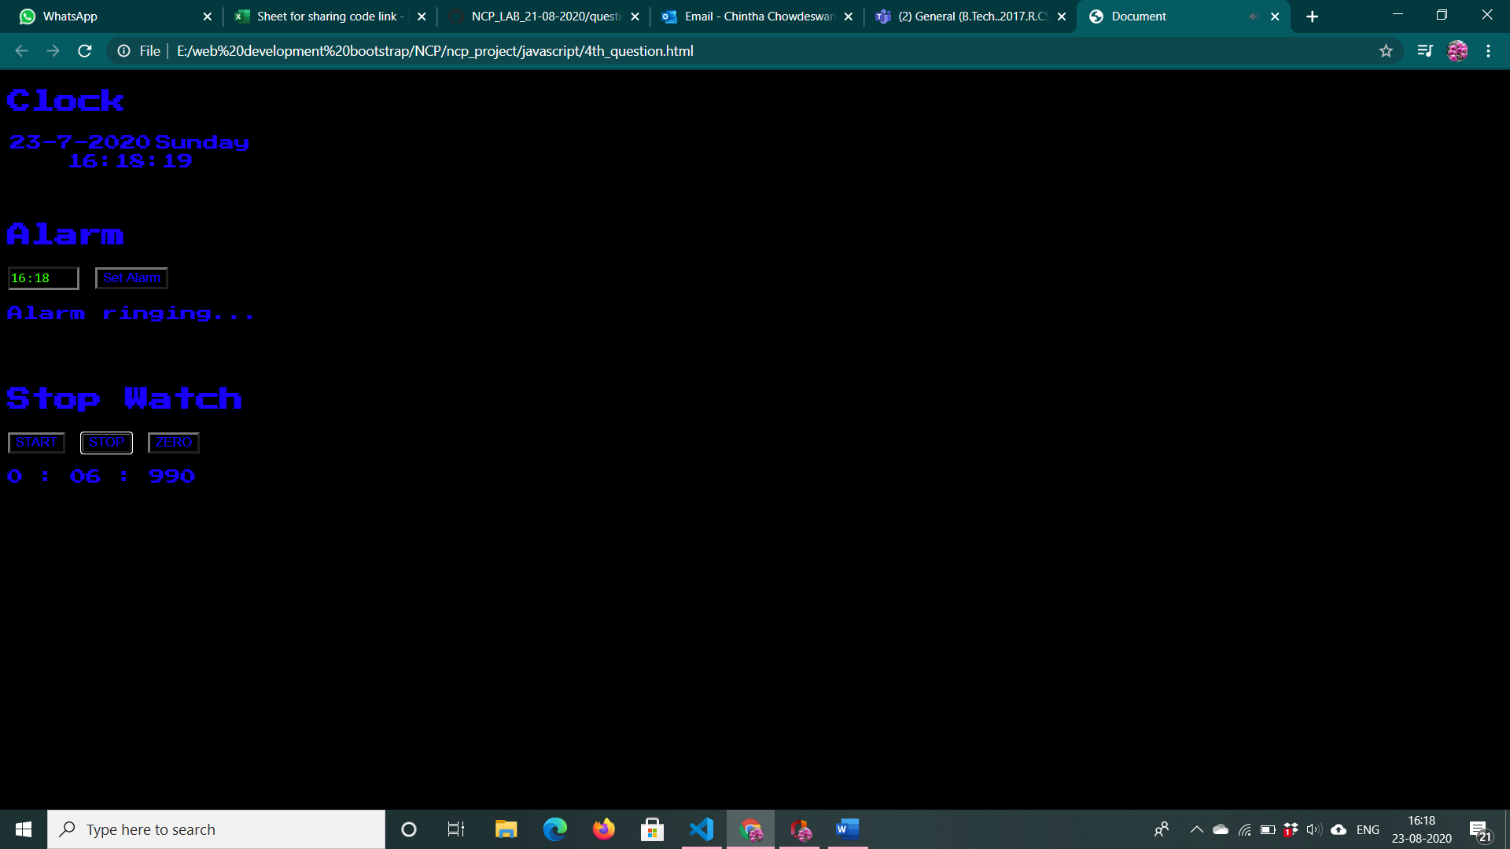

5. <!DOCTYPE html>

<html lang="en">

<head>

    <meta charset="UTF-8">

    <meta name="viewport" content="width=device-width, initial-scale=1.0">

    <title>Document</title>

</head>

<body>

    <img src="" id="image" style="height: 300px; width: auto;">

    <h3 id="desc"></h3>

    <button id="gen" onclick="thefunc()">Randomize</button>

    <table border="1px" style="border-style: dotted;">

        <tr>

            <td>Pikachu</td>

            <td id="1">0</td>

        </tr>

        <tr>

            <td>Bulbusar</td>

            <td id="2">0</td>

        </tr>

        <tr>

            <td>Charamander</td>

            <td id="3">0</td>

        </tr>

        <tr>

            <td>Mewtwo</td>

            <td id="4">0</td>

        </tr>

        <tr>

            <td>Squirtle</td>

            <td id="5">0</td>

        </tr>

    </table>

    <script>

        var n = {"1": 0,"2": 0,"3": 0,"4": 0,"5": 0,}

        var texts = ["Pikachu","Bulbusar","Charamander","Mewtwo","Squirtle"]

        var images = [

            "https://i.pinimg.com/originals/76/47/9d/76479dd91dc55c2768ddccfc30a4fbf5.png",

            "https://i.pinimg.com/originals/d6/61/96/d66196beb60d306a966ea39ed11c2b3d.png",

            "https://cdn.imgbin.com/18/8/6/imgbin-pok-mon-go-charmander-charizard-bulbasaur-cute-babies-iCsfpV0BZRYSyajmCK4A7XbJM.jpg",

            "https://cdn.bulbagarden.net/upload/thumb/7/78/150Mewtwo.png/1200px-150Mewtwo.png",

            "https://img.pokemondb.net/artwork/large/squirtle.jpg"

            ]

        function thefunc()

        {

            for(var i=0;i<10;i++)

            {

                setTimeout(function () {

                    var rand = Math.floor(Math.random() * 5)

                    if (document.getElementById(String(rand + 1)).innerText == "0") {

                        document.getElementById(String(rand + 1)).innerText = "1"

                        n[String(rand + 1)] = 1

                    } else {

                        document.getElementById(String(rand + 1)).innerText = String(parseInt(document.getElementById(String(rand + 1)).innerText) + 1)

                        n[String(rand + 1)] = parseInt(document.getElementById(String(rand + 1)).innerText) + 1

                    }

                    document.getElementById('desc').innerText = texts[rand]

                    document.getElementById("image").src = images[rand]

                }, 2000 * i);

            }

        }

    </script>

</body>

</html>

