1. <!DOCTYPE html>

<html>

    <body>

        <script>

            function text_to_array(n){

               var array = new Array();

               array = n.split(" ");

                document.write("array of words is : "+"["+ array+"]");

            }

            var n = prompt("enter some phrases");

            text_to_array(n);

        </script>

    </body>

</html>

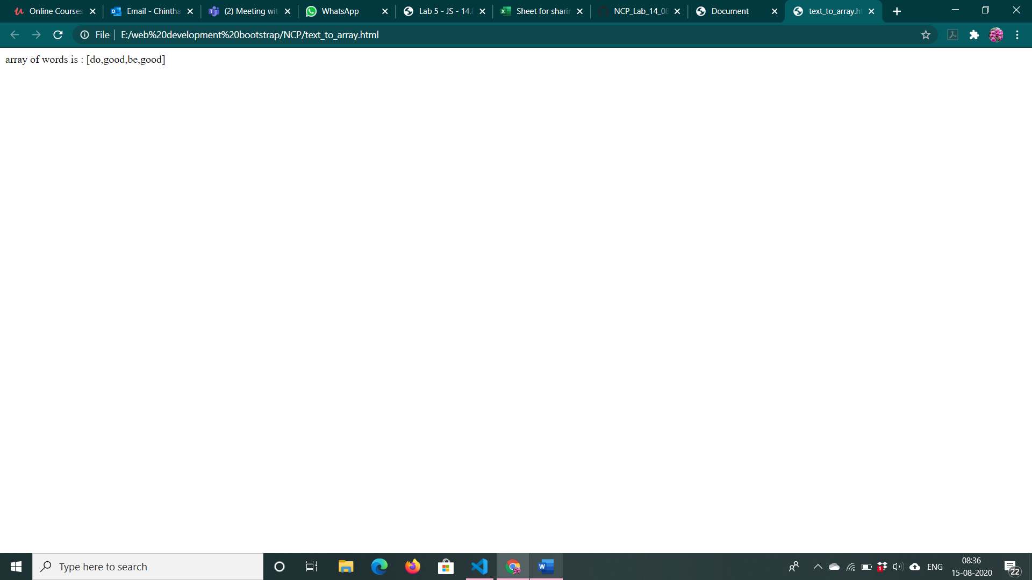

2. <!DOCTYPE html>

<html lang="en">

<head>

    <meta charset="UTF-8">

    <meta name="viewport" content="width=device-width, initial-scale=1.0">

    <title>Document</title>

</head>

<body>

    <input type="button" onclick="getinput()" value="Generate">

    <ul id="list">

    </ul>

</body>

<script>

    function getinput() {

        var n = parseInt(window.prompt("Enter number of elements"));

        var arr = []

        var output = ""

        for (var i = 0; i < n ; i++) {

            arr[i]=window.prompt("Enter String")

        }

        arr= reverse_sort(arr)

        for (var i = 0; i < arr.length; i++) {

            output += "<li>" + arr[i] + "</li>\n"

        }

        document.getElementById("list").innerHTML = output

    }

    function reverse_sort(arr)

    {

        arr.sort().reverse()

        return arr

    }

</script>

</html>

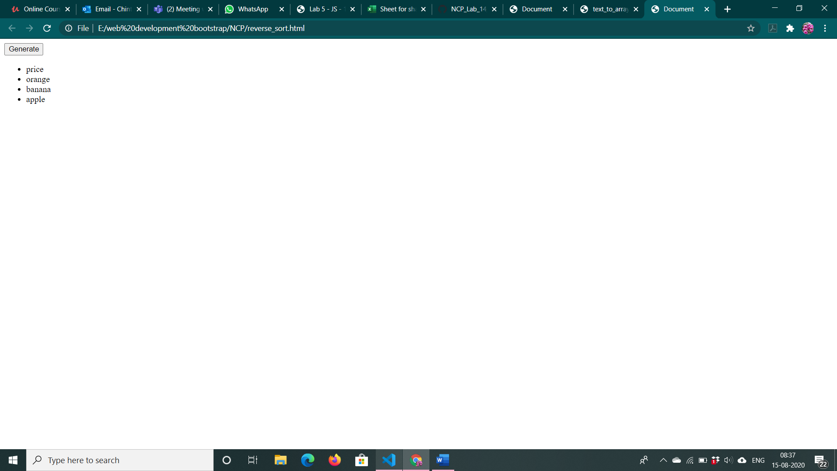

3. <!DOCTYPE html>

<html lang="en">

<head>

    <meta charset="UTF-8">

    <meta name="viewport" content="width=device-width, initial-scale=1.0">

    <title>Document</title>

</head>

<body>

    <input type="button" onclick="print()" value="Generate">

    <div id="list">

    </div>

</body>

<script>

    function print() {

        var arr=[]

        var i=0

        while(true){

            var number=window.prompt("Enter number, enter blank to cancel..")

            if(number==null||number===""||number==undefined)

            {

                break;

            }

            else{

                arr[i++] = parseInt(number)

            }

        }

        var output=""

        var logout=""

        var n=Math.max(...arr)

        console.log(n);

        for(var j=0;j<n;j++)

        {

            output += "<p>"

            for(var k=0;k<arr.length;k++)

            {

                if(arr[k]>0)

                {

                    logout+="*"

                    output+="*"

                    arr[k]-=1

                }

            }

            logout+="\n"

            output+="</p>\n"

        }

        console.log(logout);

        document.getElementById("list").innerHTML = output

    }

</script>

</html>

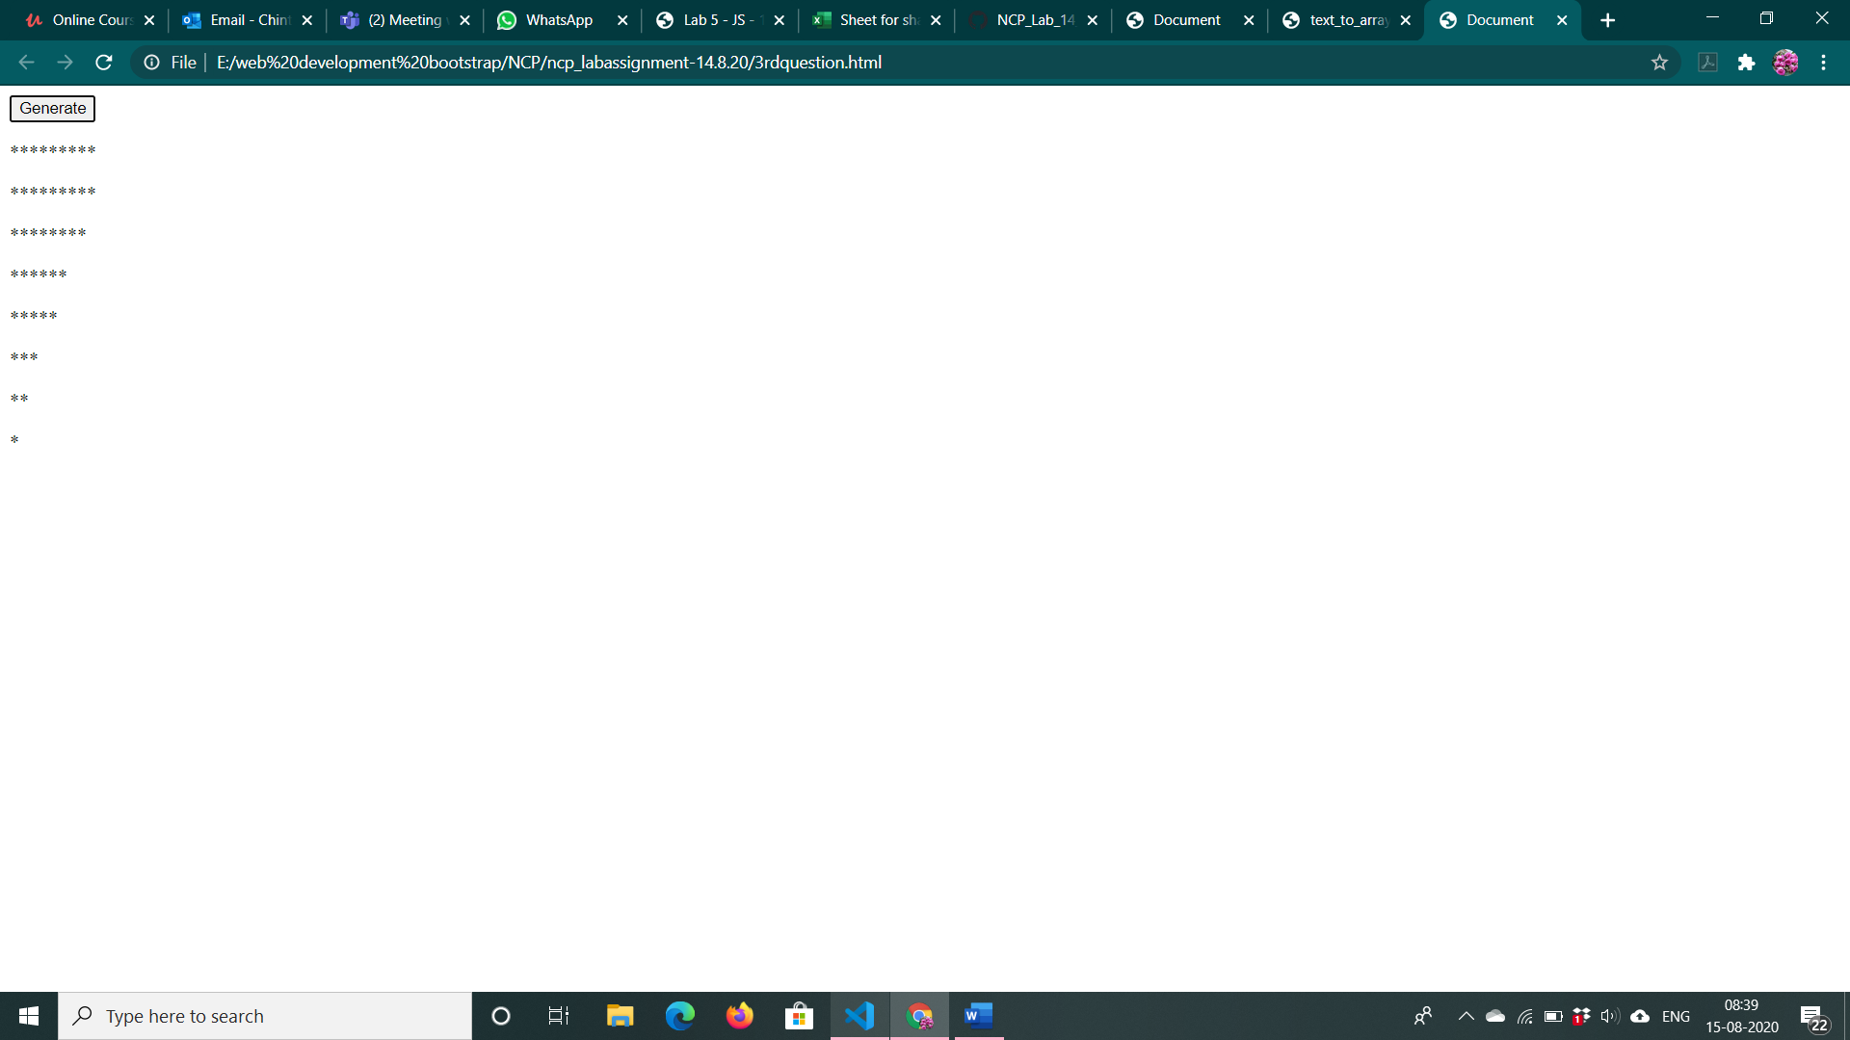

4. <!DOCTYPE html>

<html lang="en">

<head>

    <meta charset="UTF-8">

    <meta name="viewport" content="width=device-width, initial-scale=1.0">

    <title>Document</title>

</head>

<body>

    <input id="dateed" type="text">

    <input id="date" type="button" onclick="validate()" value="Validate">

    <p style="color: red;" id="answer"></p>

</body>

<script>

    function validate()

    {

        var date=document.getElementById("dateed").value

        var rgexp = /^(0[1-9]|1\d|2\d|3[01])\-(0[1-9]|1[0-2])\-(19|20)\d{2}$/;

        var isValidDate = rgexp.test(date);

        if(isValidDate)

        {

            document.getElementById("answer").innerText="Valid"

            document.getElementById("answer").style.color="green";

        }

        else{

             document.getElementById("answer").innerText = "Invalid"

            document.getElementById("answer").style.color = "red";

        }

    }

</script>

</html>

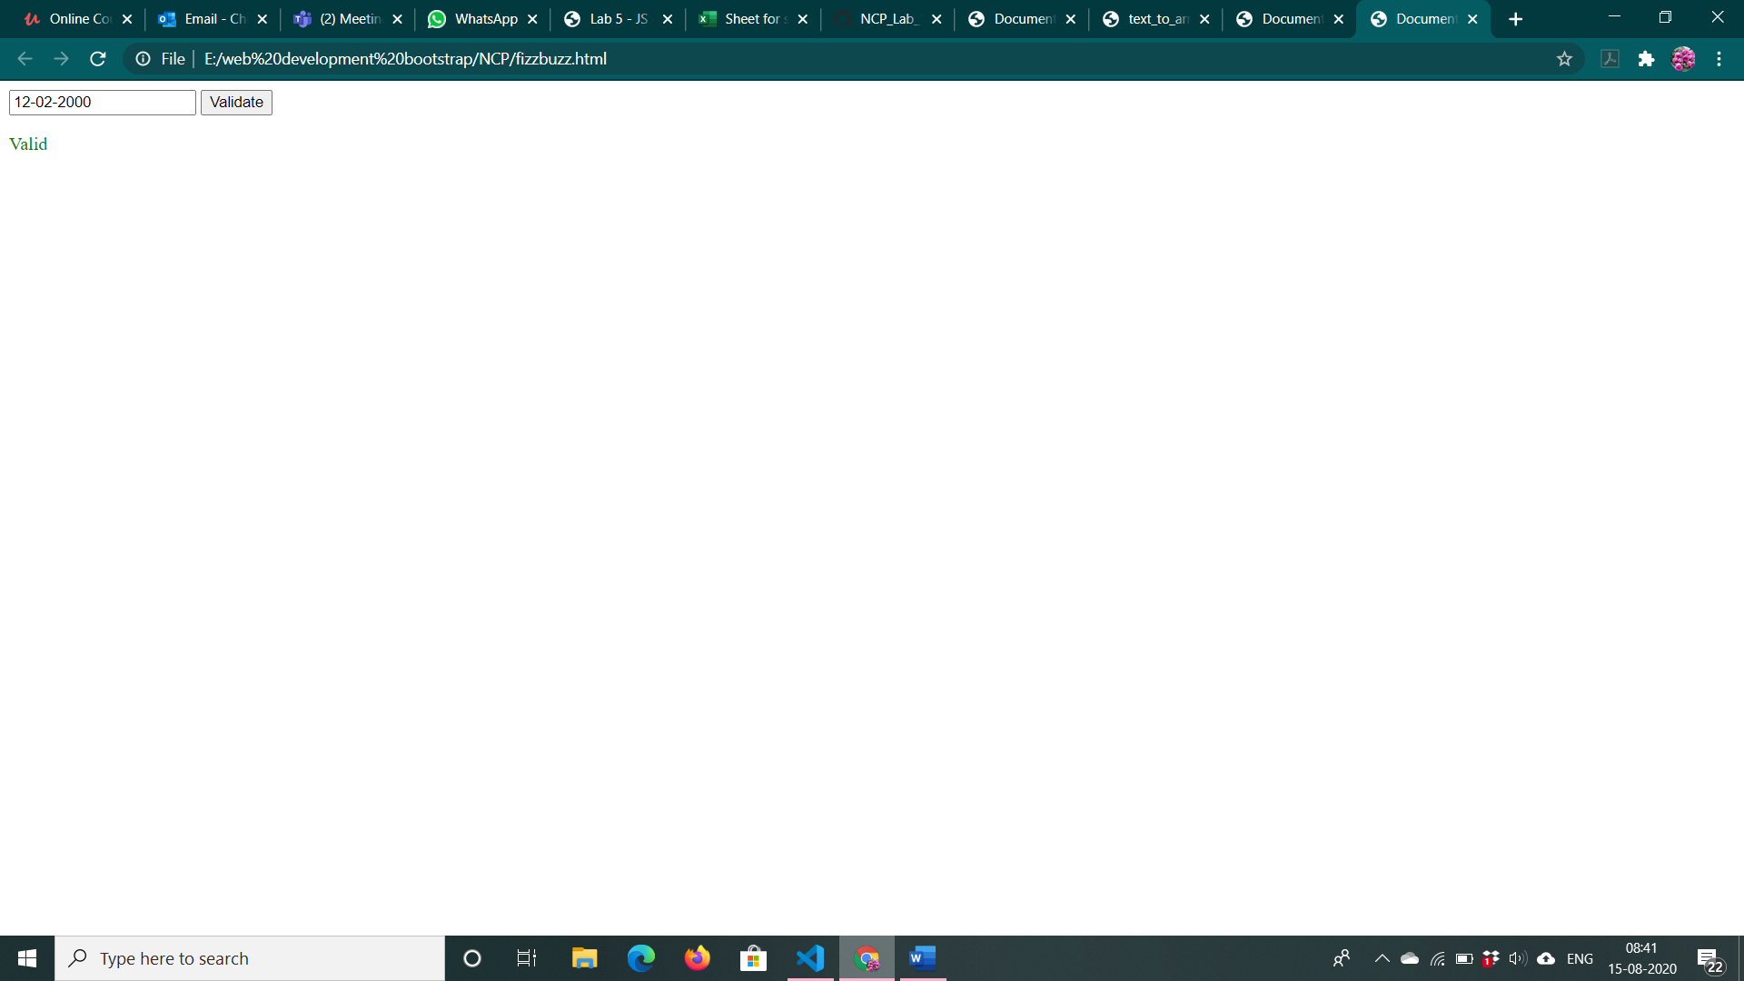

5. <!DOCTYPE html>

<html lang="en">

<head>

    <meta charset="UTF-8">

    <meta name="viewport" content="width=device-width, initial-scale=1.0">

    <title>Document</title>

</head>

<body>

    <input type="button" onclick="generate()" value="Generate">

    <ul id="list">

    </ul>

</body>

<script>

    function generate() {

        output=""

        for(var i=1;i<100;i++)

        {

            if(i%15==0)

            {

                output+="<li>"+i+":"+"FizzBuzz</li>\n"

            }

            else if(i%3==0)

            {

                output += "<li>" + i + ":" + "Fizz</li>\n"

            }

            else if(i%5==0){

                output += "<li>" + i + ":" + "Buzz</li>\n"

            }

        }

        document.getElementById("list").innerHTML=output

    }

</script>

</html>

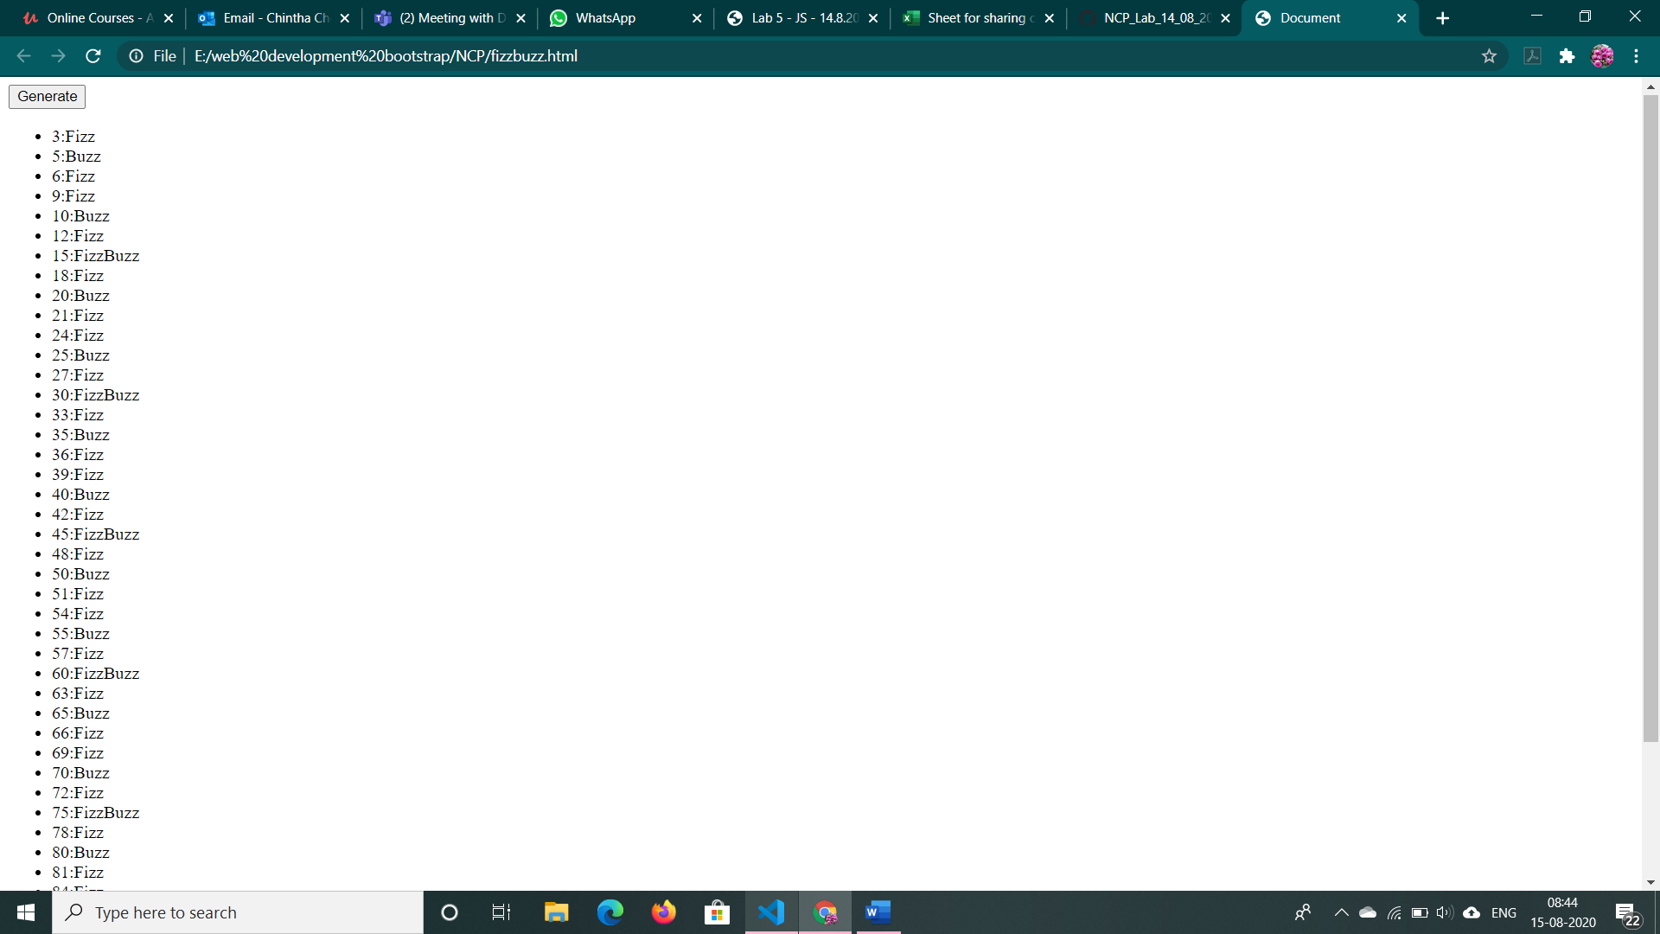

6. <!DOCTYPE html>

<html lang="en">

<head>

    <meta charset="UTF-8">

    <meta name="viewport" content="width=device-width, initial-scale=1.0">

    <title>Document</title>

</head>

<body>

    <input type="button" value="Display" onclick="displayGrades()">

</body>

<script>

    function displayGrades()

    {

        for(var a=60;a<100;a++)

        {

            console.log("For "+a+" the grade you receive is "+assignGrades(a));

        }

    }

    function assignGrades(mark)

    {

        if(mark<60)

        {

            return 'F'

        }

        else if(mark<70)

        {

            return 'E'

        }

        else if (mark < 80) {

            return 'D'

        }

        else if (mark < 85) {

            return 'C'

        }

        else if (mark < 90) {

            return 'B'

        }

        else if (mark < 100) {

            return 'A'

        }

    }

</script>

</html>

