CA4-Implementaion output screenshots

Mahesh(11907444)

I have created new project called ca4-implementaion in jenkins server. After that I had integrated ansible with Jenkins and also I had added my AWS credentials to it. I have configured to trigger the ansible playbook when build is run.

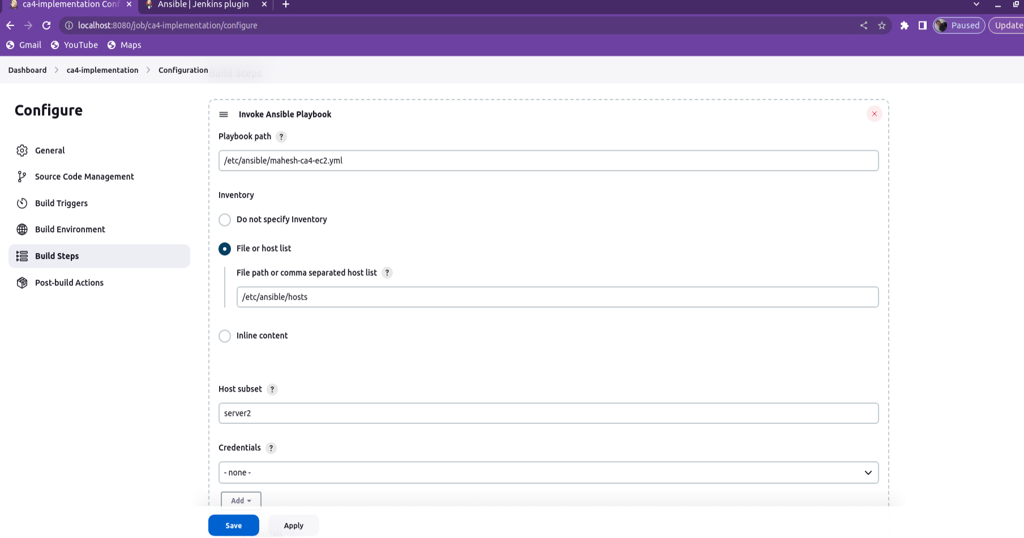

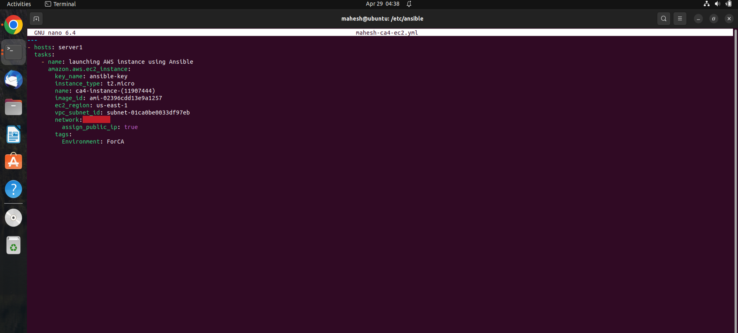

Above is the ansible yaml file to launch instance

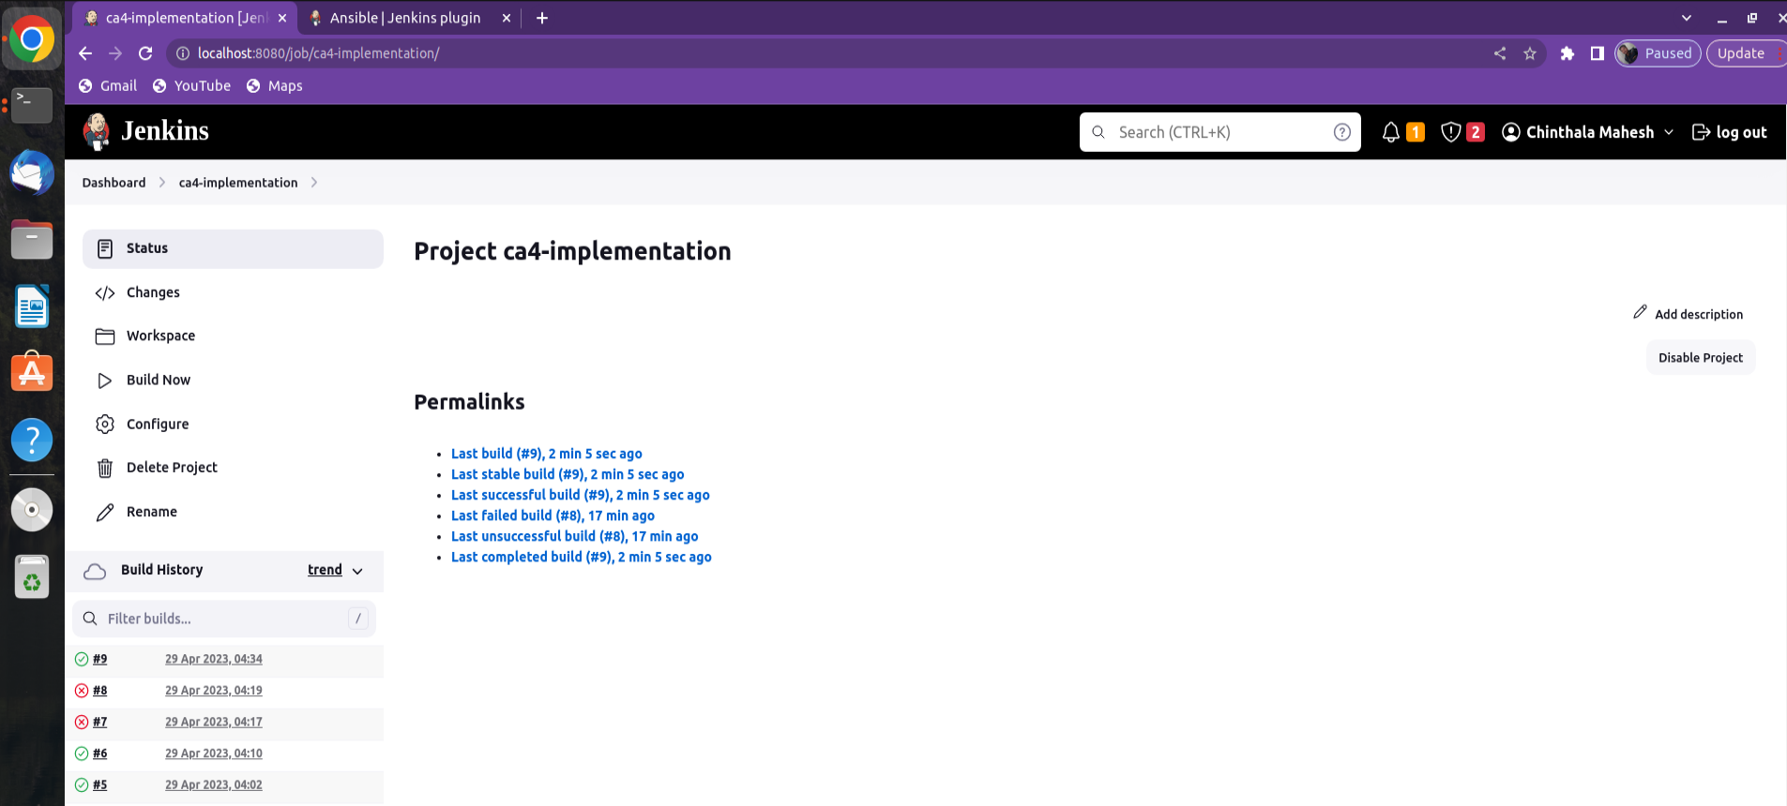

We can see at build no 9 build is successful

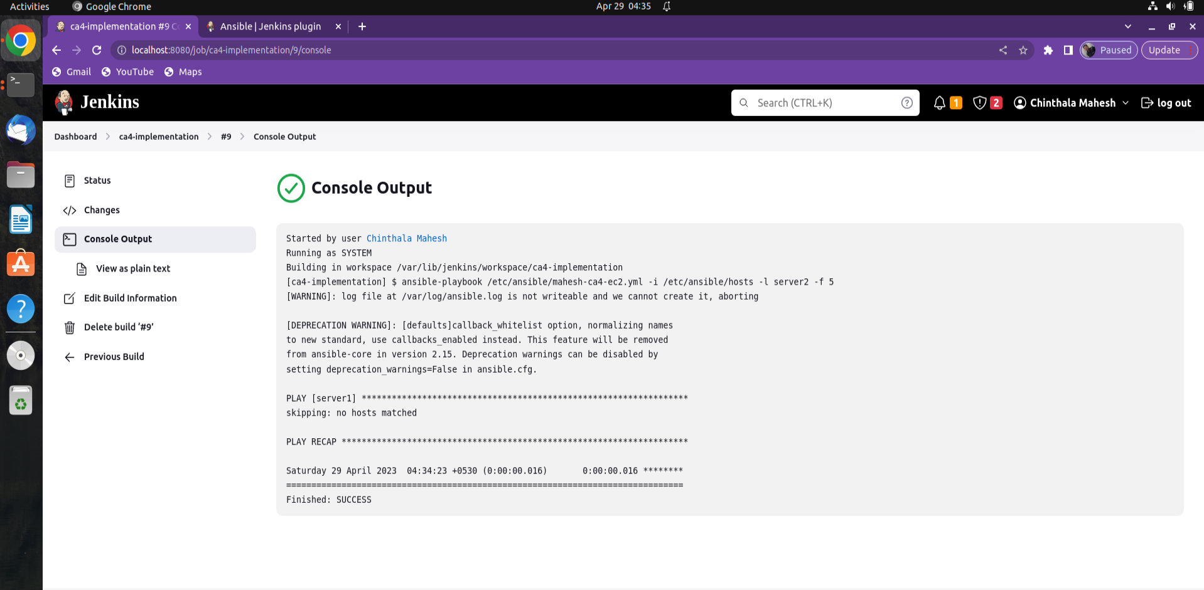

We can also see the console output it is showing Finished:SUCCESS which means our ansible playbook executed successfully and instance is provisioned in AWS

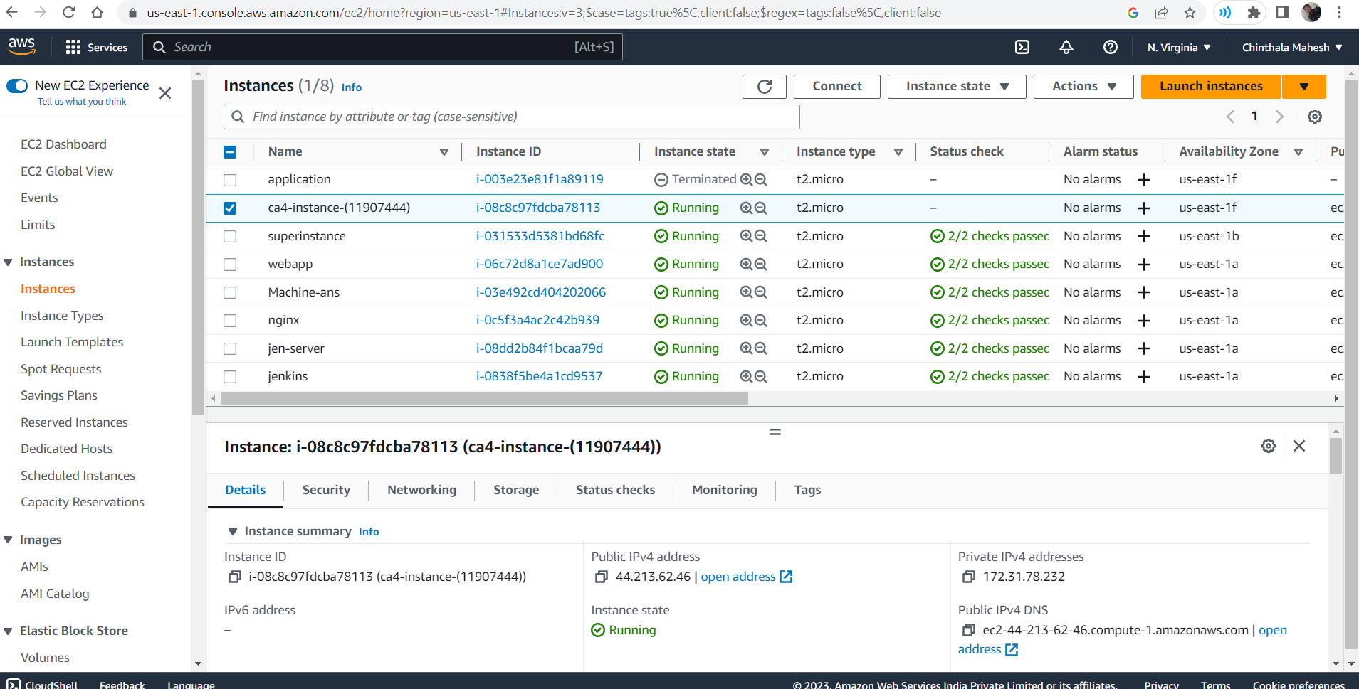

We can see from the above image instance with name ca4-instance-(11907444) is provisioned in the aws and we can also check the instance state it is running.