**Lab Assignment-1**

**Task1: Create a Simple HTML Page**

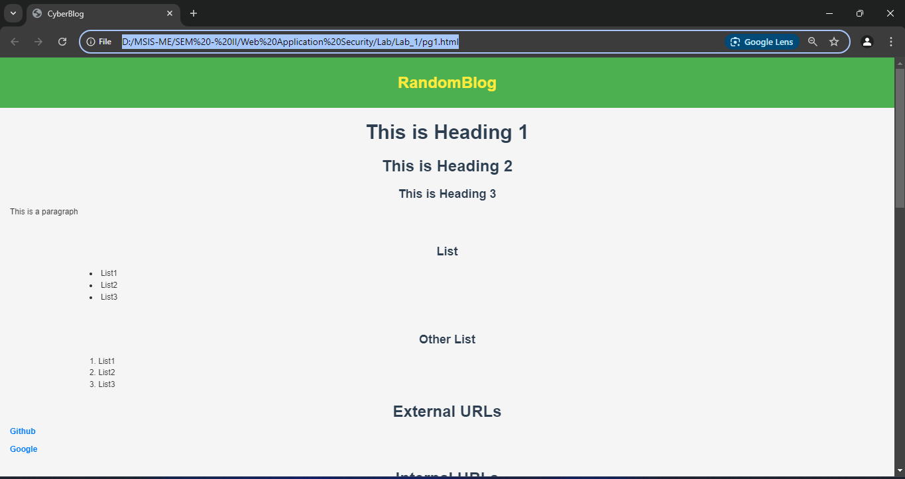

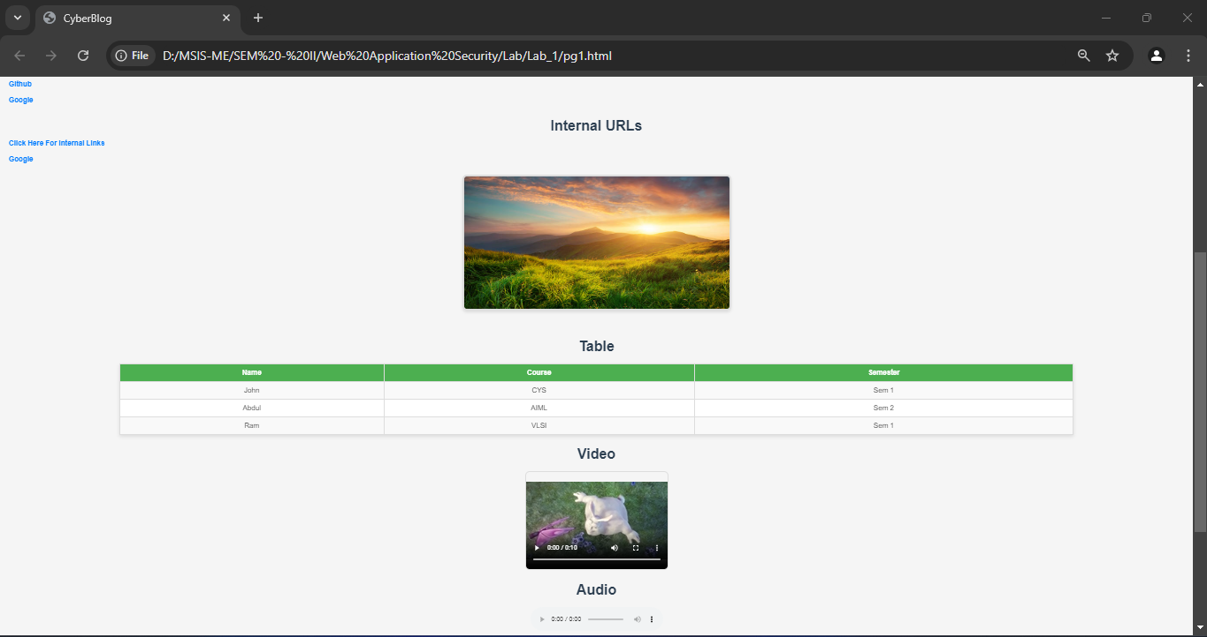

**Task 3: Inspect the Source Code of your page**

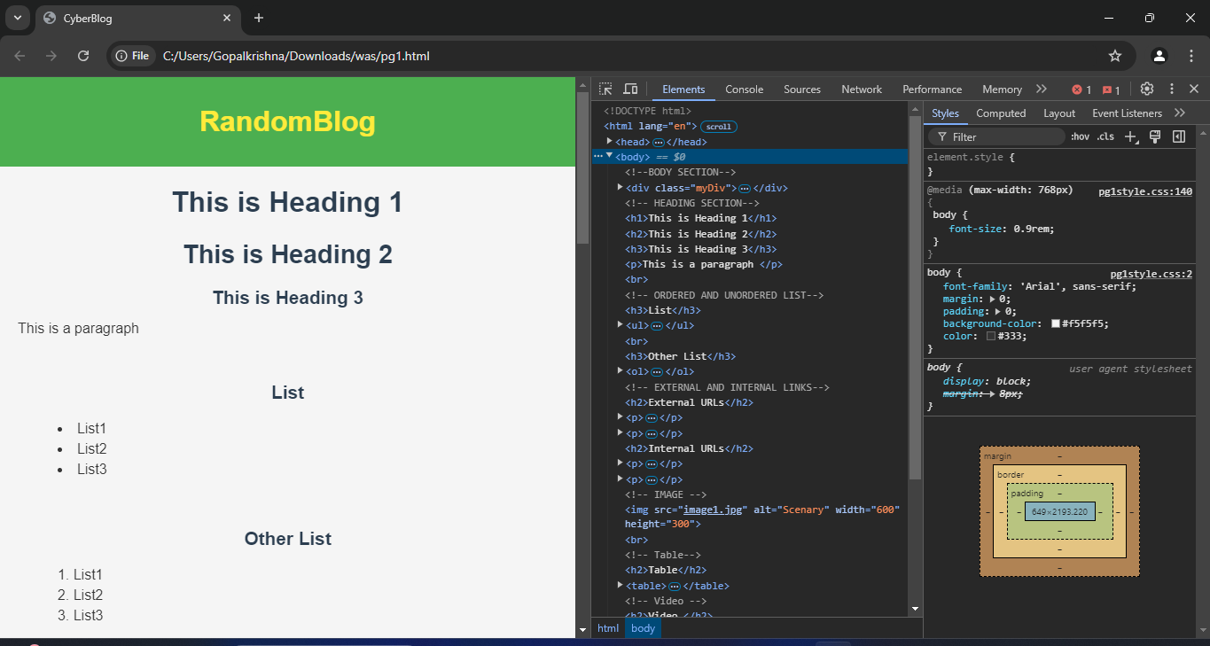

The HTML is well-structured, and the CSS is clean and responsive. Improvements like consolidating redundant links, enhancing alt text, and refining table and media styling for better consistency would further elevate the design.

**Task 2: Inspect the Source Code of a Website**

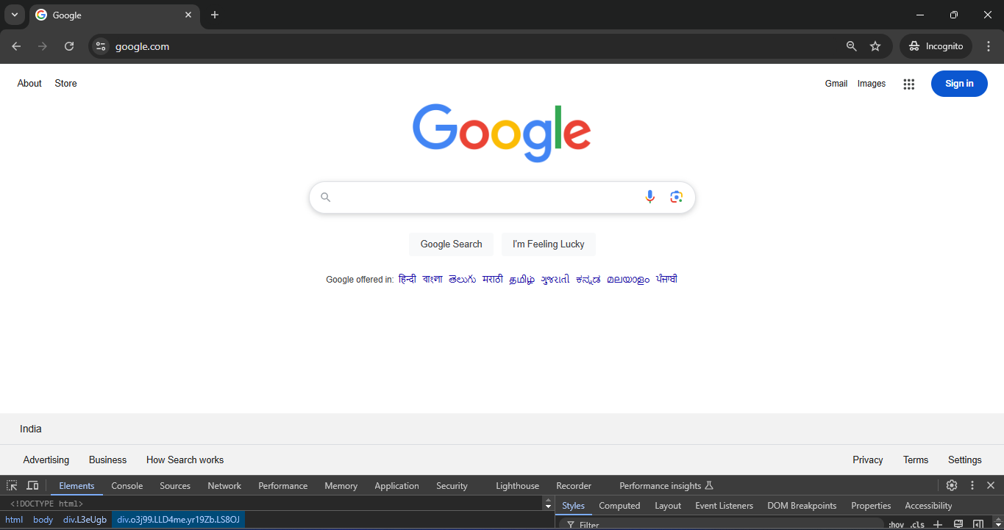

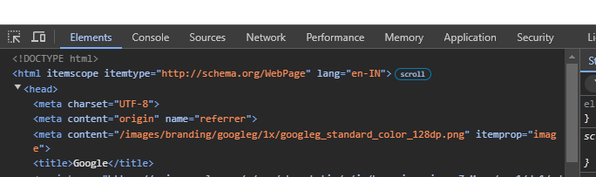

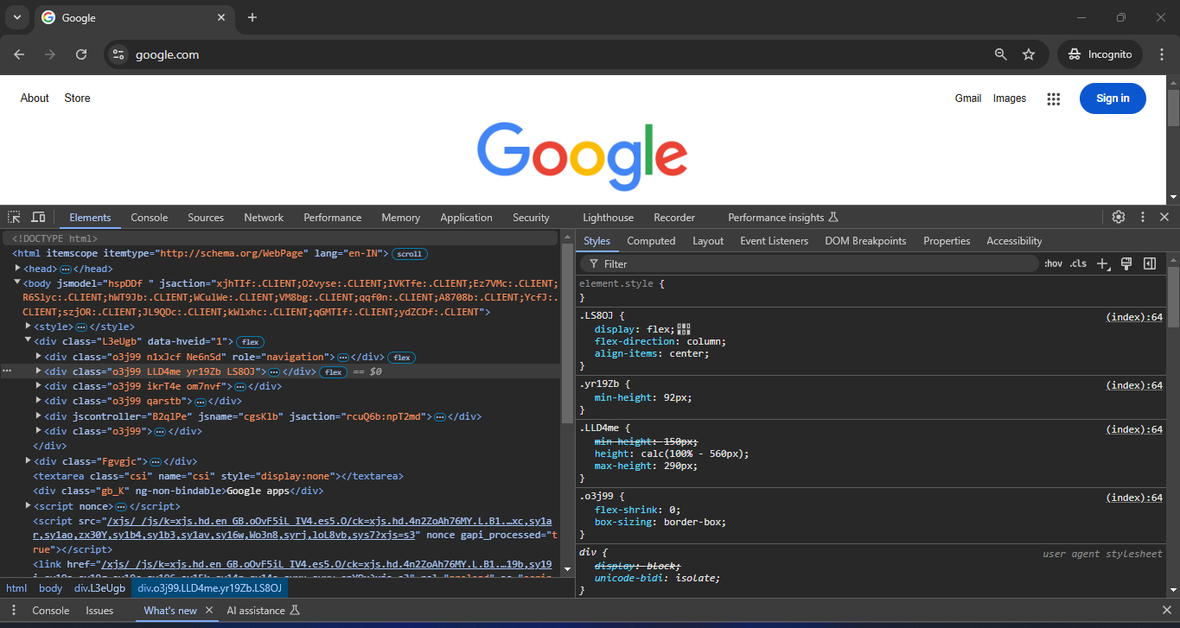

Google's homepage uses <meta> tags to set the character encoding, adjust the viewport, and ensure compatibility, but it doesn’t have explicit headings or other semantic elements. There’s no multimedia content like <video> or <iframe>, and security-related tags like CSP or SRI aren’t directly visible in the HTML. CORS and other security policies are likely handled through server-side headers. The design is minimal, focusing on functionality, while security measures are implemented behind the scenes beyond what’s visible in the HTML.

**Task 4: Apply Styles Using CSS**



