Gowtham Patel C
261100690007

- Getting Help

Task | Command Name | Syntax | Example | Screenshots
To get manual page for the known command | man | man [command] | man ls | 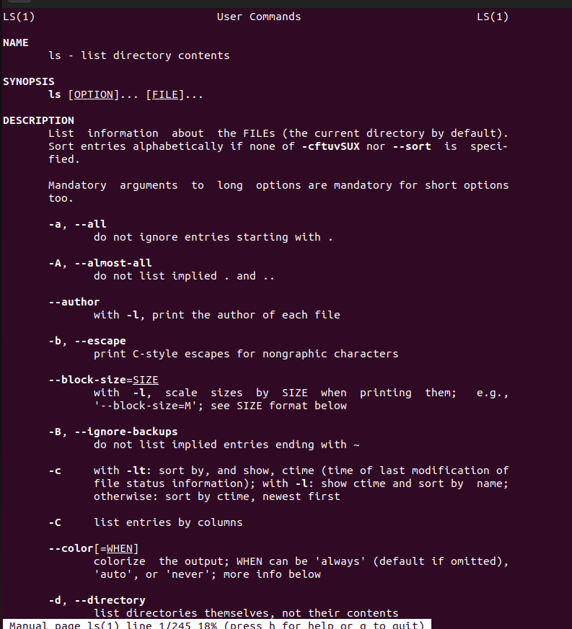
To get manual page for the unknown command | apropos or man -k | apropos [keyword] | apropos "copy files" | 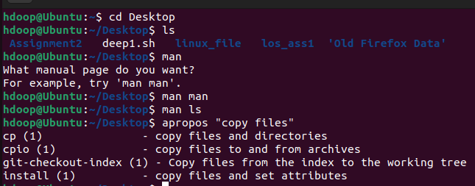
To know the source file binary | whereis | whereis [command] | whereis bash | 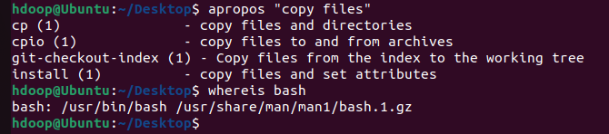
To know the path of the command | which | which [command] | which python3 | 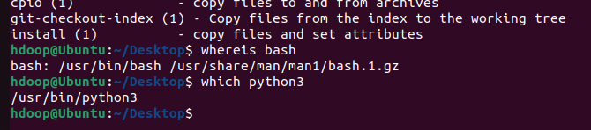
To know the command is external or internal | type | type [command] | type cd | 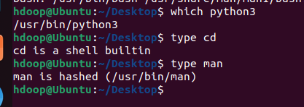
To get help for the internal command | help | help [command] | help pwd | 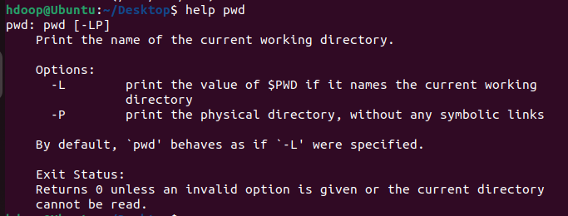
To list out bash commands | compgen | compgen [option] | compgen -b | 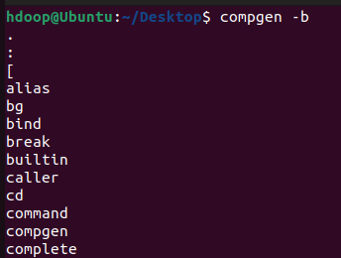
To know the usage of the command | --help | [command] –help | mkdir --help | 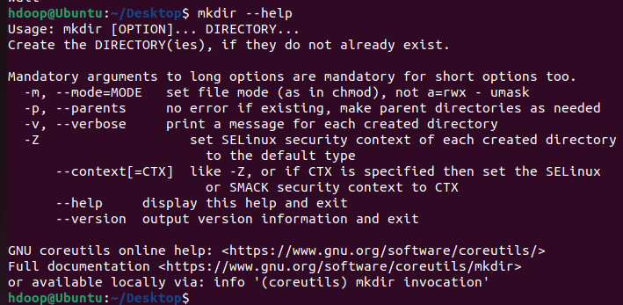

- Basic Commands
Task | Command Name | Syntax | Example | Screenshots
To know today’s date | date | date | date | 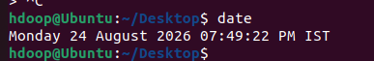
To print calendar | cal | cal [month] [year] | cal | 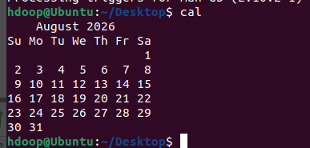
To print kernel version | uname | uname -r | uname -r | 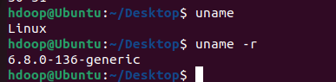
To print default shell | echo | echo $SHELL | echo $shell | 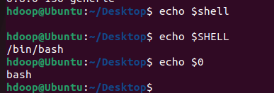
To print currently logged in user | whoami | whoami | whoami | 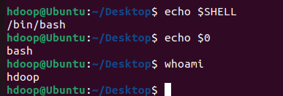
To create shortcut for command | alias | alias name=”command” | alias ll='ls -al' | 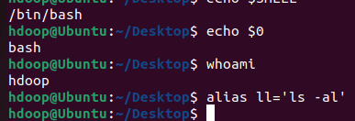
To delete shortcut | unalias | unalias name | unalias ll | 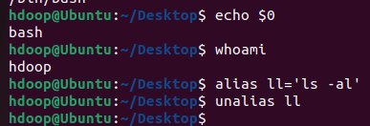
To change the timestamp of the file | touch | touch filename | touch -t 202608241200.00 1.txt | 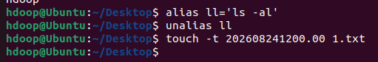
To clear the screen | clear | clear | clear | 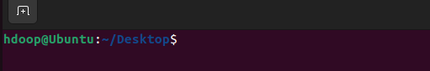
To create empty files | touch | touch file1.txt file2.txt | touch 2.txt 3.txt | 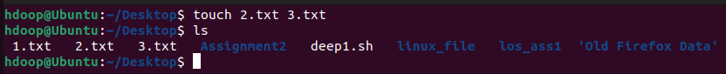
To know disk usage | du | du [options] | du -sh | 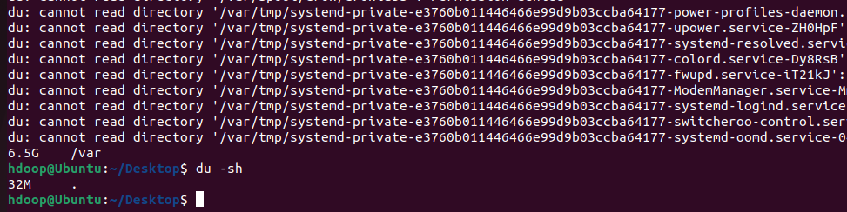
To know free space in the system | df | df [options] | df -h | 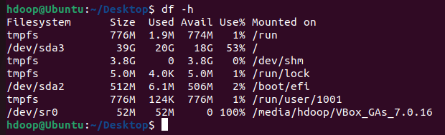
To know about the Linux release | cat / lsb_release | cat /etc/os-release | cat /etc/os-release | 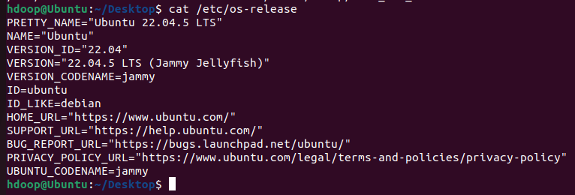
To show login history | last | last | last | 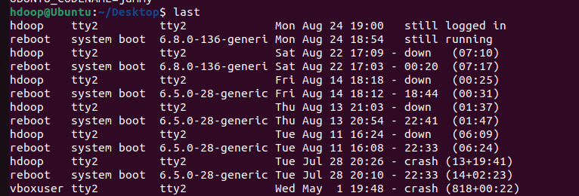
To check the current user privileges | sudo or id | sudo -l or id | sudo -l or id | 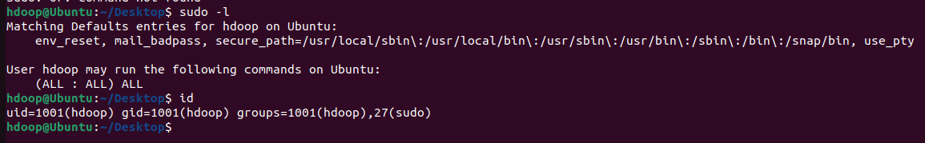
To find about the Linux release | cat / lsb_release | cat /etc/os-release | cat /etc/os-release
To check system uptime | uptime | uptime | uptime | 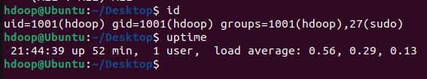
To shutdown | shutdown | shutdown [time] | shutdown now
To restart | reboot | reboot | reboot

- Navigation
Task | Command | Syntax | Screenshots
To navigate home directory | cd | cd ~ | 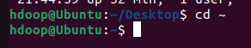
To navigate to the parent directory | cd | cd .. | 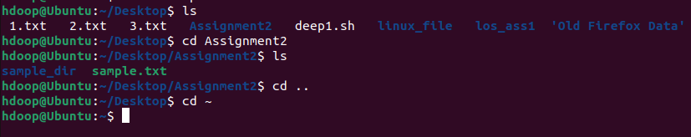
To navigate to the child directory | cd | cd foldername
Alternate command to cd | pushd / popd | pushd /path/to/dir | 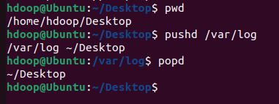
To go back to the previous directory | cd | cd - | 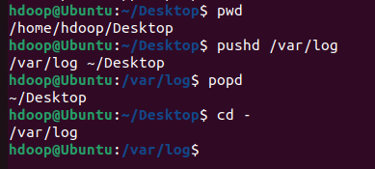
To go to the root directory | cd | cd / | 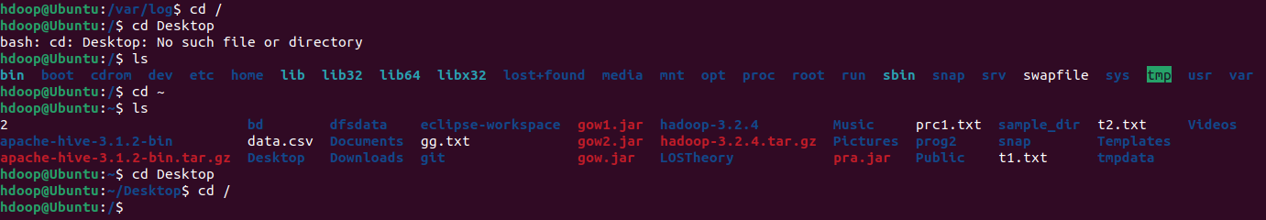

- File System
Task | Syntax | Command
How to identify the file system | df | 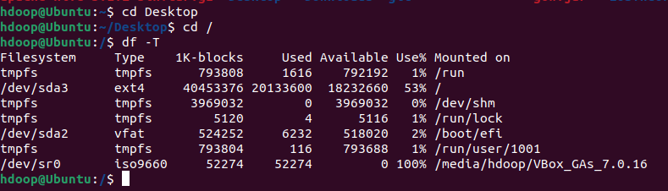  df -T

- Globbing
Create a dedicated practice directory containing sample files such as:
index.html, login.html, admin.htm, report.txt, access.log, error.log, user1.txt, user2.log, file123, backup1.html, backup2.txt
Use globbing patterns wherever possible, rather than specifying filenames individually.
- List all files ending in .html.
- List all files other than .html files using extended globbing.
- List filenames containing at least one numeric digit.
- List files whose names begin with user followed by a single digit.
- List files ending in either .txt or .log using a single extended glob pattern.
- List files that do not end in .txt or .log.
- List files beginning with either access or error using extended globbing.
- List .html files whose filenames contain a numeric digit.
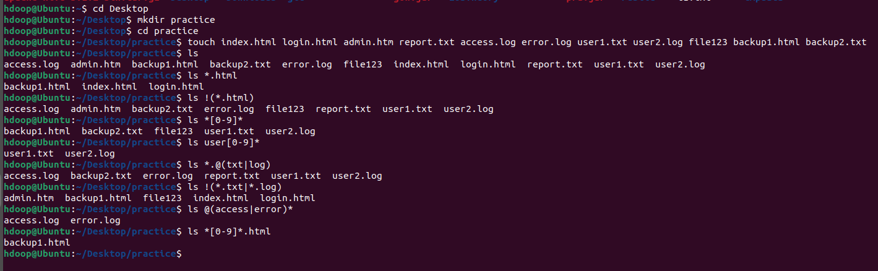
- Extended Globbing
- Assume a directory contains:
access.log, error.log, auth.log, auth.log.1, auth.log.2, system.log, notes.txt
Write an extended glob pattern that selects only access.log, error.log, and auth.log.
Select all files except notes.txt.
Select files named either auth.log.1 or auth.log.2 using pattern matching rather than writing both complete filenames separately.

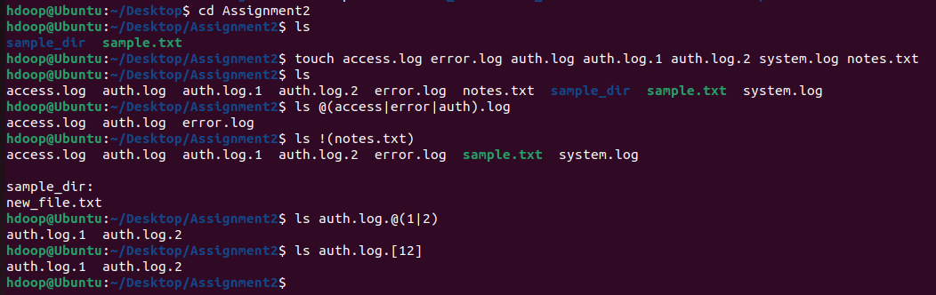
- Given the files:
malware1.log, malware2.log, malwareA.log, malware_report.txt, normal.log
construct a glob pattern that identifies .log files whose names start with malware and contain a numeric character.
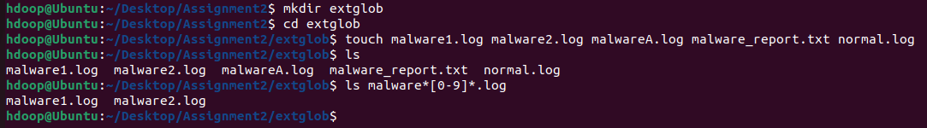
- Given:
failed_login.log, successful_login.log, login_backup.log, login.txt, firewall.log
use extended globbing to select .log files containing either failed_login or successful_login.
Construct a pattern that lists all .log files except firewall.log.

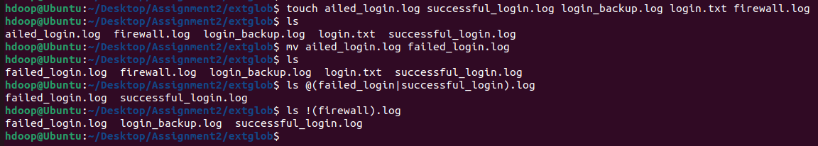
- Filters
- Display the first 10 entries of login.log.
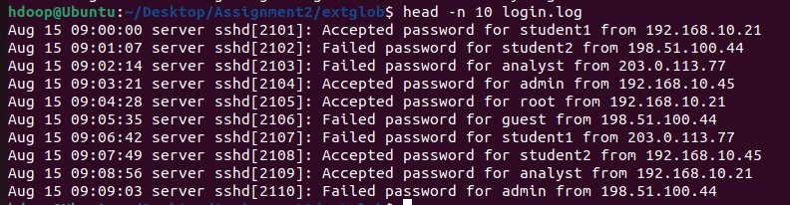
- Display the first 5 entries of access.log.
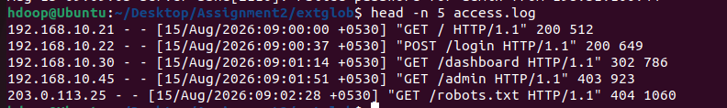
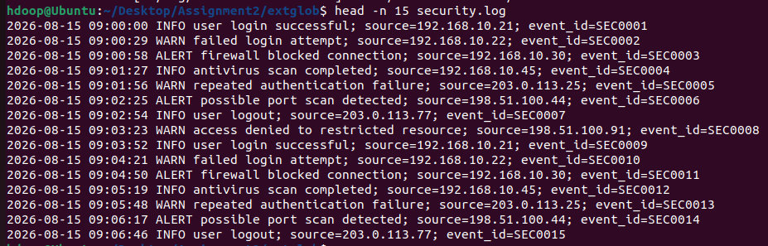
- Display the first 15 security events from security.log.

- Display the first 20 events recorded in incident.log.
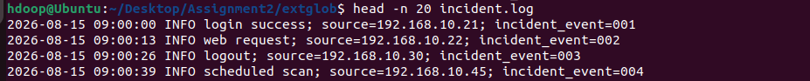
- Display only the first entry in login.log.
- Display the first 25 web requests recorded in access.log.
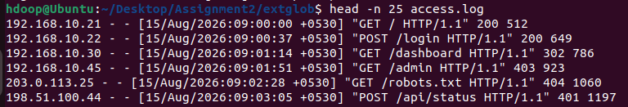
- Display the last 10 entries of login.log.
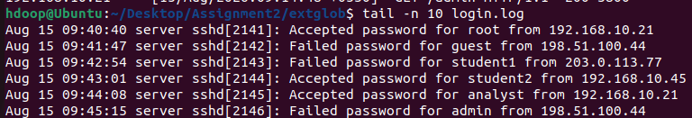
- Display the last 5 entries of access.log.
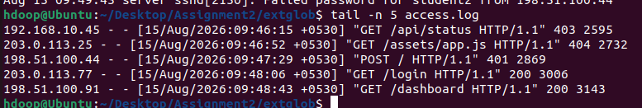
- Display the 20 most recent security events from security.log.
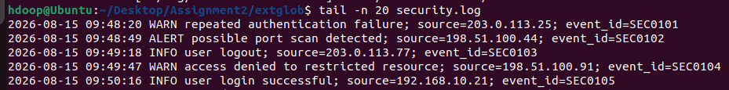
- Display the 25 most recent events from incident.log.
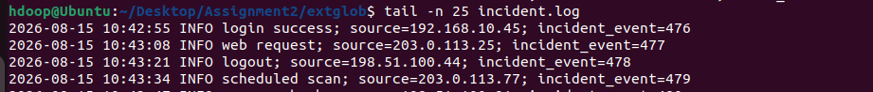
- Display only the last entry in security.log.
- Display the last 50 events recorded in incident.log.
- Display the contents of login.log starting from line 41 until the end of the file.
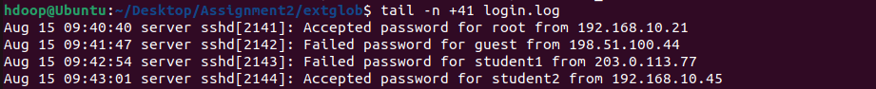
- Display the contents of security.log starting from line 101 until the end of the file.
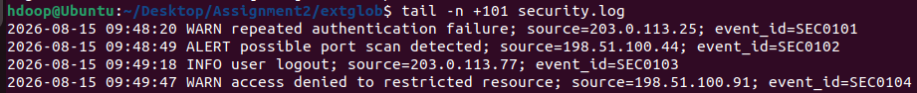
- Find the total number of lines in login.log.

- Find the total number of lines in access.log.
- Find the total number of security events in security.log.
- Determine the total number of events recorded in incident.log.
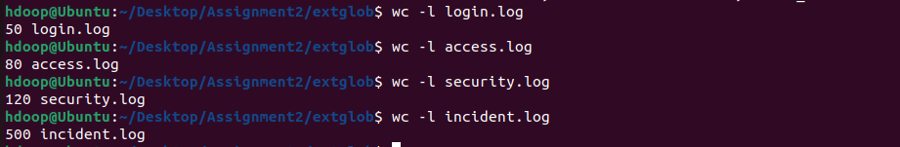
- Count the number of words in login.log.
- Count the number of bytes in security.log.
- Display the line, word, and byte counts of access.log.
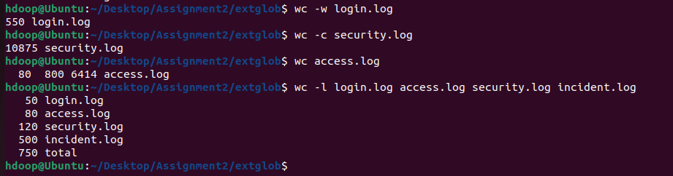
- Find the line counts of all four .log files using a single wc command.

- Display the first 20 entries of login.log and, from those entries, display only the last 5.
- Display the last 20 entries of login.log and, from those entries, display only the first 5.
- Display the first 30 entries of access.log and then display only the last 10 entries from that output.
- Display the last 30 entries of access.log and then display only the first 10 entries.
- Display the first 50 events from security.log and then display the last 10 events from those 50.

- Display the last 50 events from security.log and then display the first 10 events from those 50.
- Display entries from line 11 to line 20 of login.log.
- Display entries from line 21 to line 30 of login.log.
- Display entries from line 11 to line 20 of access.log.
- Display entries from line 31 to line 40 of access.log.
- Display security events from line 21 to line 30 of security.log.
- Display security events from line 51 to line 60 of security.log.
- Display incident events from line 101 to line 110 of incident.log.
- Display incident events from line 201 to line 220 of incident.log.
- Display incident events from line 491 to line 500.
- Take the first 20 entries of login.log and count how many lines are displayed.
- Take the last 15 entries of access.log and count how many lines are displayed.
- Take the first 50 entries of security.log and count the number of words in those entries.
- Take the last 25 entries of security.log and count the number of lines.

- Extract lines 21–30 from login.log and count the number of extracted lines.
- Extract lines 51–60 from access.log and count the number of extracted lines.
- Extract events 101–150 from incident.log and count how many events are displayed.
- Display the first 100 events from incident.log, take the last 20 events from that output, and count the number of lines.

