Gowtham Patel C
261100690007

Part 1: Examine an ARP Request
Step 1: Generate ARP requests by pinging 192.168.13.2 from 192.168.13.3.

a. Enter Simulation mode and enter the command ping 192.168.13.3. Two PDUs will be generated. The ping command cannot complete the ICMP packet without knowing the MAC address of the destination. So the computer sends an ARP broadcast frame to find the MAC address of the destination.

b. Click Capture/Forward once. The ARP PDU moves Switch0 while the ICMP PDU disappears, waiting for the ARP reply. Open the PDU and record the destination MAC address.
Ans: FFFF.FFFF. FFFF

c. Click Capture/Forward to move the PDU to the next device.
How many copies of the PDU did Switch0 make?
Ans: 3 copies (PC0, PC2, Router0 )

What is the IP address of the device that accepted the PDU?
Ans: 192.168.13.2

d. Open the PDU and examine Layer 2.
What happened to the source and destination MAC addresses?
Ans: The source MAC address remains the same, while the destination remains the broadcast MAC address FFFF.FFFF. FFFF
Source MAC: 0090.0C4A.0AA3
Destination MAC: FFFF.FFFF. FFFF

e. Click Capture/Forward until the PDU returns to 192.168.13.2.
How many copies of the PDU did the switch make during the ARP reply?
Ans: 1 copy
The ARP reply is a unicast frame, so Switch0 forwards it only to the destination, PC1.

Step 2: Examine the ARP table.

a. Note that the ICMP packet reappears. Open the PDU and examine the MAC addresses.
Do the MAC addresses of the source and destination align with their IP addresses?
Ans: Yes
- 192.168.13.3 → 0090.0C4A.0AA3
- 192.168.13.2 → 00D0.9749.245E

b. Switch back to Realtime and the ping completes.
c. Click 192.168.13.2 and enter the arp–a command. To what IP address does the MAC address entry correspond?
Ans: 192.168.13.3
In general, when does an end device issue an ARP request?
Ans: An end device issues an ARP request when it needs to determine the MAC address associated with an IP address on the local network and that mapping is not already in its ARP table.

Part 2: Examine a Switch MAC Address Table

Step 1: Generate additional traffic to populate the switch MAC address table.
a. From 192.168.13.2, enter the ping 192.168.13.4 command.
b. Click 10.0.0.2 and open the Command Prompt.
c. Enter the ping 10.0.0.3 command.
How many replies were sent and received?
Ans: 4

Step 2: Examine the MAC address table on the switches.
a. Click Switch1 and then the CLI tab. Enter the show mac-address-table command.
Do the entries correspond to those in the table above?
Ans: Yes
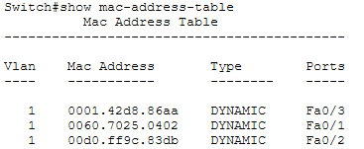

b. Click Switch0, then the CLI tab.
Enter the show mac-address-table command.
Do the entries correspond to those in the table above?
Ans: Yes
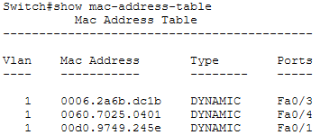

Why are two MAC addresses associated with one port?
Ans: Because that port is connected to a router interface, and the router can have multiple MAC addresses associated with its interfaces or learned addresses. A switch can therefore learn more than one MAC address through a single port.

Part 3: Examine the ARP Process in Remote Communications
Step 1: Generate traffic to produce ARP traffic.
a. Click 192.168.13.2 and open the Command Prompt.
b. Enter the ping 10.0.0.1 command.
c. Type arp –a.
What is the IP address of the new ARP table entry?
Ans: 192.168.13.1

d. Enter arp -d to clear the ARP table and switch to Simulation mode.
e. Repeat the ping to 10.0.0.1.
How many PDUs appear?
Ans: 2 PDUs (ARP Request, ICMP Echo Request)

f. Click Capture/Forward.
Click the PDU that is now at Switch1.
What is the target destination IP destination address of the ARP request?
Ans: 192.168.13.1

g. The destination IP address is not 10.0.0.1. Why?
Ans: Because 10.0.0.1 is on a different network. PC0 cannot directly reach the remote network using the destination device's MAC address.
Instead, PC0 sends the packet to its default gateway, which is:
192.168.13.1

Step 2: Examine the ARP table on Router0.

a. Switch to Realtime mode. Click Router0 and then the CLI tab.
b. Enter privileged EXEC mode and then the show mac-address-table command. (Type en ) How many MAC addresses are in the table? Why?
Ans: 0 MAC addresses.
A router does not use a switch-style MAC address table to forward packets. Router0 uses its routing table and ARP table instead.

c. Enter the show arp command.
Is there an entry for 192.168.13.2?
Ans: Yes.
192.168.13.2: MAC address of PC0: 00D0.9749.245E

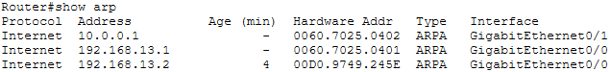

What happens to the first ping in a situation where the router responds to the ARP request? Ans: The first ping may take longer or fail initially because the router must first respond to the ARP request and learn the required MAC address. Once the MAC address is learned, subsequent ICMP packets can be forwarded normally.

