Gowtham Patel C
26110069007

Ethical Hacking LAB

Vulnerability assessment

nslookup manipal.edu

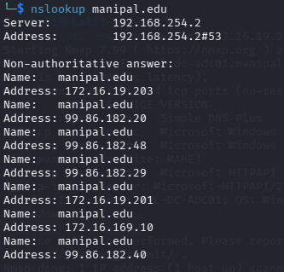

dig manipal.edu
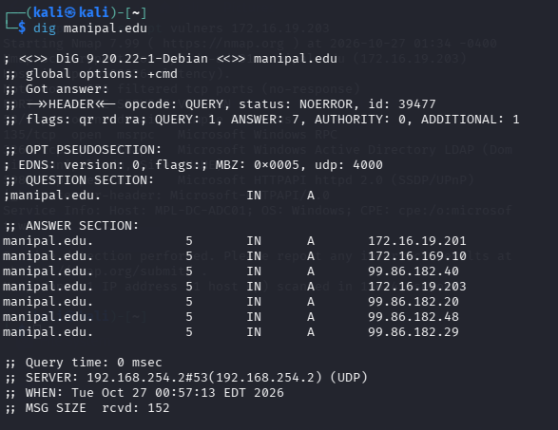
nmap -F 172.16.19.203

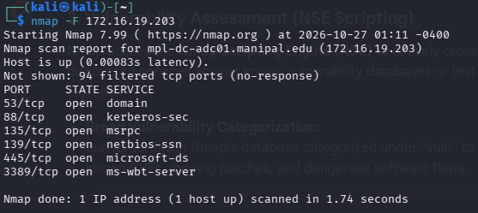

nmap -pn 172.16.19.203

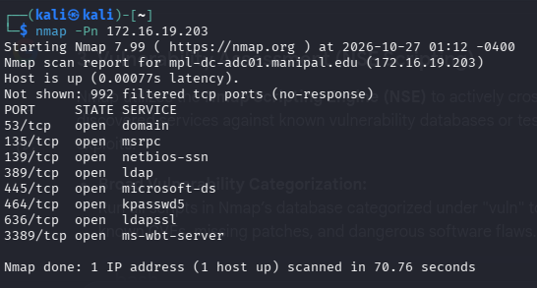

nmap -–open 172.16.19.203

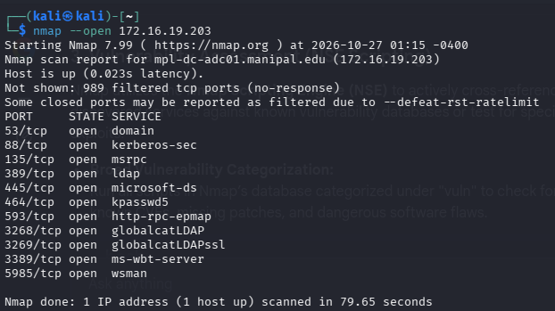

sudo nmap -O 172.16.19.203

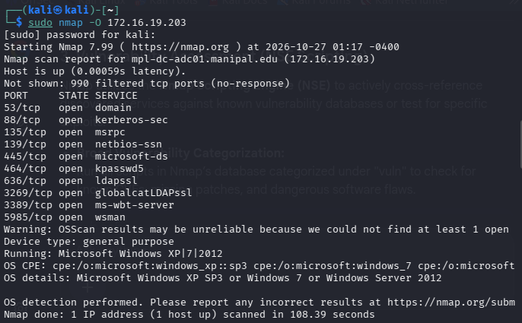

nmap -sV 172.16.19.203
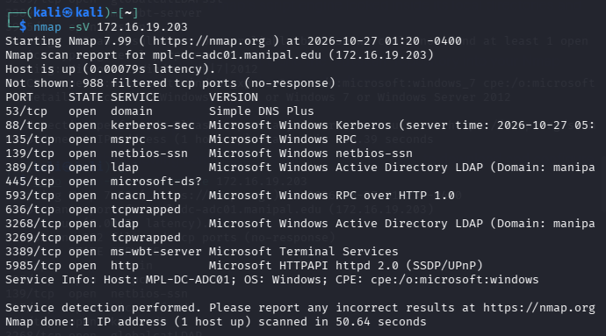

nmap -sn 172.16.19.203/16
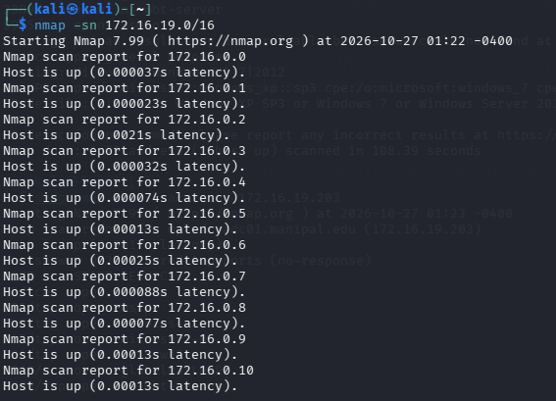

sudo nmap -O –traceroute 172.16.19.203
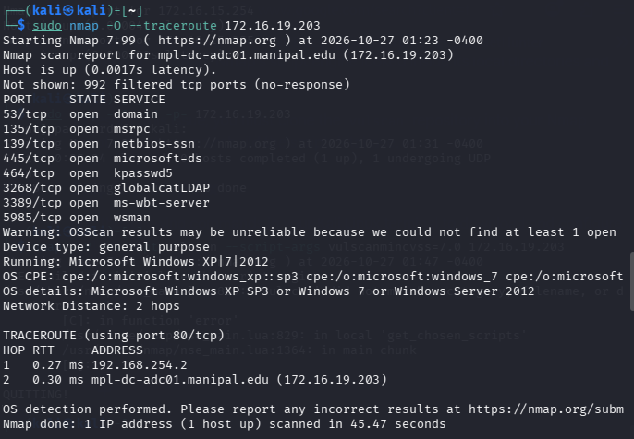

nmap -sV –version-intensity 5 172.16.19.203
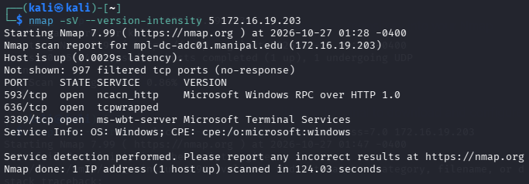

sudo nmap -sS -sU -p- 172.16.19.203
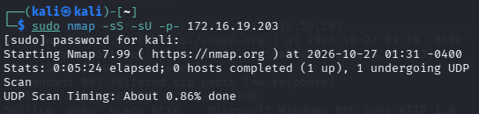

nmap -sV –script vulners 172.16.19.203
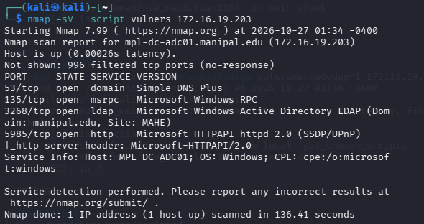

nmap --script malware 172.16.19.203
