Gowtham Patel C
261100690007

Cryptology LAB B1

1. Affine cipher cryptanalysis

Write a Python program to decipher the following ciphertext using a brute-force attack. Assume that the Affine cipher was used with the mapping A = 0, B = 1, …, Z = 25.
XPALASXYFGFUKPXUSOGEUTKCDGFXANMGNVS

The plaintext "ab" is encrypted as "GL".
- Generate all valid key pairs and their corresponding plaintexts.
- Use the given plaintext–ciphertext pair to identify the correct keys.
- Display the keys and the recovered plaintext.

import math

CT = "XPALASXYFGFUKPXUSOGEUTKCDGFXANMGNVS"

# Known plaintext-ciphertext pair
known_PT = "ab"
known_CT = "GL"

# Function to decrypt Affine cipher
def affine_decrypt(text, a, b):
a_inverse = pow(a, -1, 26)
PT = ""

for ch in text:
if ch.isalpha():
y = ord(ch.upper()) - ord('A')
x = (a_inverse * (y - b)) % 26
PT += chr(x + ord('A'))
else:
PT += ch

return PT

# Generate all valid key pairs
valid_keys = []

for a in range(26):
if math.gcd(a, 26) == 1:
for b in range(26):
valid_keys.append((a, b))

print("Total valid key pairs:", len(valid_keys))

for a, b in valid_keys:
PT = affine_decrypt(CT, a, b)
print(f"Key (a={a}, b={b}) -> {PT}")

# Verify using known plaintext-ciphertext pair
if affine_decrypt(known_CT, a, b).lower() == known_PT:
print("\nCorrect key found!")
print("a =", a)
print("b =", b)
print("Recovered plaintext:", PT)

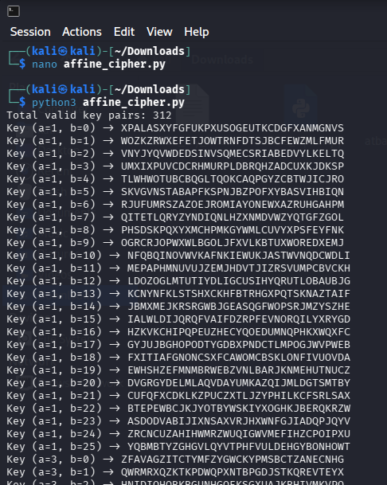

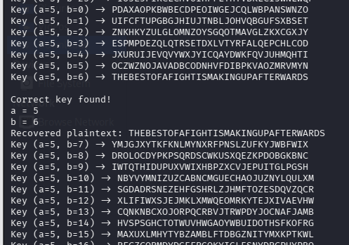

2. Algorithm identification, encryption, and decryption

Examine the following pseudocode:
BEGIN
INPUT message
SET result ← ""

FOR EACH character IN message
IF character is an uppercase letter THEN
position ← ASCII(character) − ASCII('A')
result ← result + CHARACTER(ASCII('Z') − position)

ELSE IF character is a lowercase letter THEN
position ← ASCII(character) − ASCII('a')
result ← result + CHARACTER(ASCII('z') − position)

ELSE
result ← result + character
END IF
END FOR

OUTPUT result
END

- Identify the cipher and state whether it uses substitution or transposition.
: Atbash Cipher , Monoalphabetic Substitution

- Implement the algorithm in Python.
- Encrypt the message "Cyber Security".
- Decrypt the resulting ciphertext and verify that the original message is recovered.

def atbash_cipher(message):
res = ""

for ch in message:

if ch.isupper():
pos = ord(ch) - ord('A')
res += chr(ord('Z') - pos)

elif ch.islower():
pos = ord(ch) - ord('a')
res += chr(ord('z') - pos)

else:
res += ch

return res

message = "Cyber Security"

# Encryption
CT = atbash_cipher(message)

print("Original Message:", message)
print("Encrypted Message:", CT)

# Decryption
decrypted_message = atbash_cipher(CT)

print("Decrypted Message:", decrypted_message)

# Verification
if decrypted_message == message:
print("Verification Successful!")
else:
print("Verification Failed!")

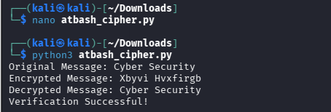

3. Crack the password protected document.
Please find attached password protected pdf.
Use wordlist - rockyou.txt which is available in Kali.
Wordlist can be installed using
` sudo apt update && sudo apt install wordlists `

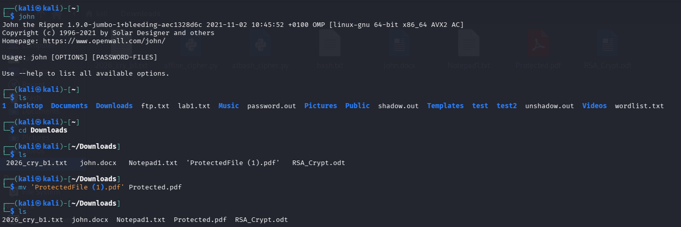

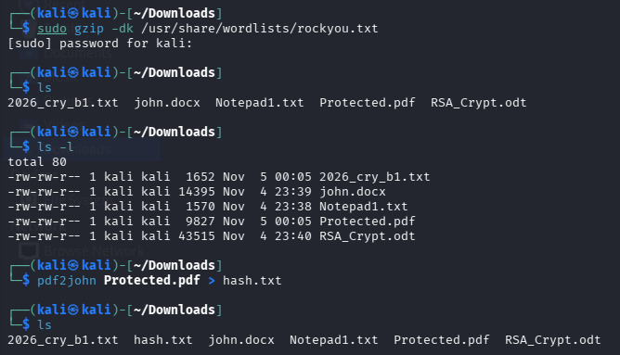

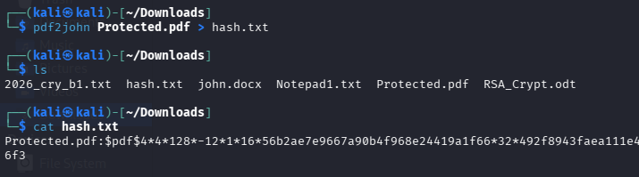
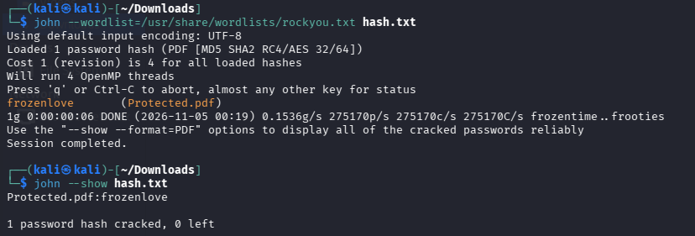

Password for the protected pdf file = “ frozenlove ”

