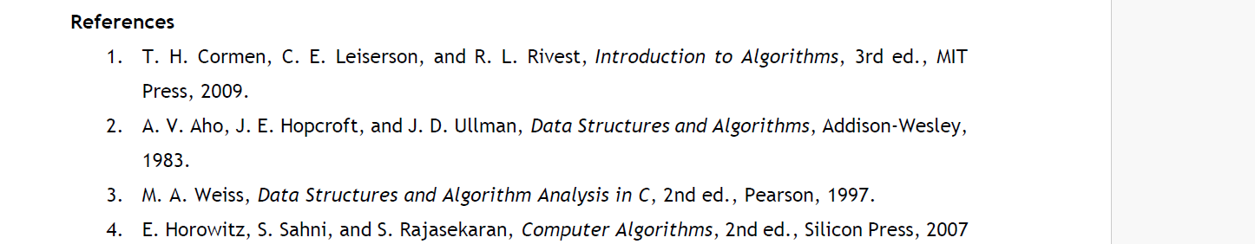
(4)
Algorithm:
Definition
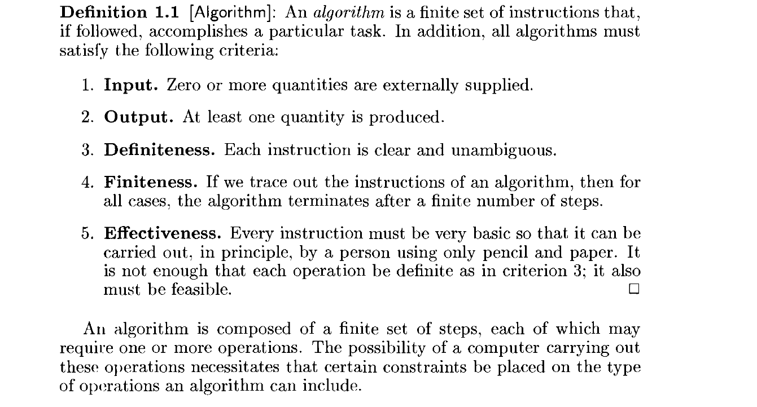
Areas of Study
- How to devise algorithms - study various design techniques that have proven to be useful in that they have often yielded good algorithms

- How to validate algorithm – process that is used to validate – Once an algorithm is devised, it is necessary to show that it computes the correct answer for all possible legal inputs.

- How to analyze algorithms - Analysis of algorithms or performance analysis refers to the task of determining how much computing time and storage an algorithm requires

4. How to test a program – Testing a program consists of two phases: debugging and profiling (or performance measurement)

ALGORITHM SPECIFICATION – Pseudocode Conventions

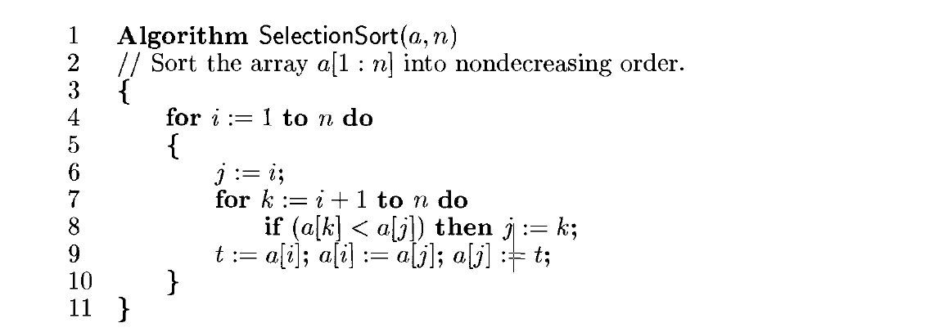

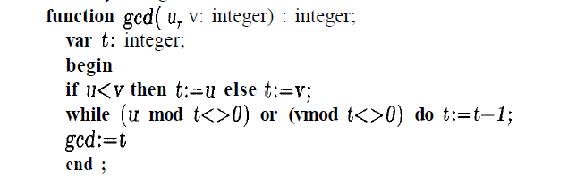

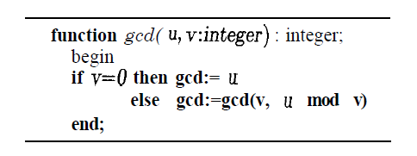

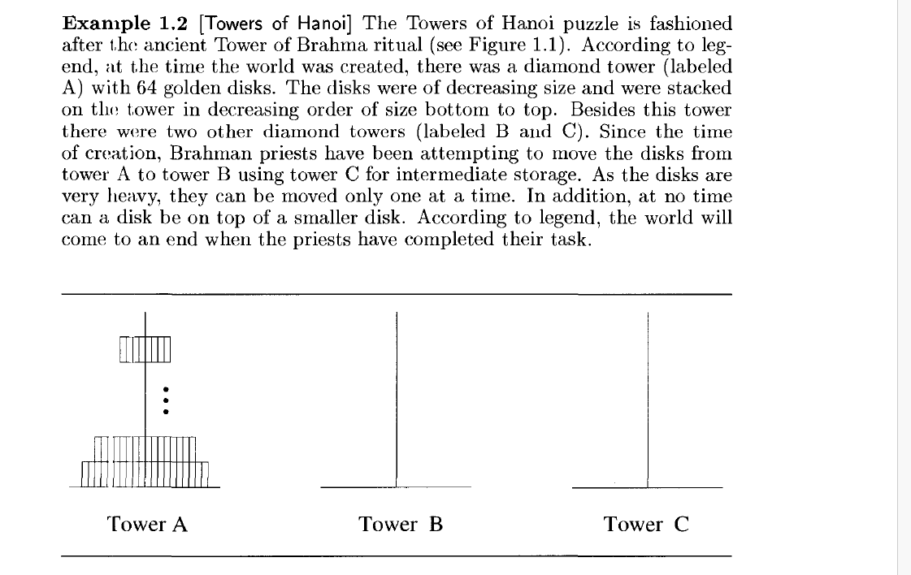

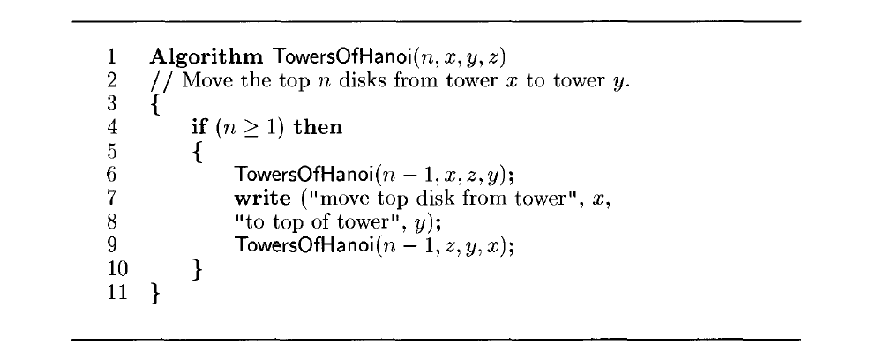

There are many criteria upon which we can judge an algorithm. For instance
1. We would like an algorithm that is easy to understand, code, and debug.
1.Does it do what we want it to do?
2.Does it work correctly according to the original specifications of the task?
3. Is there documentation that describes how to use it and how it works?
4. Are procedures created in such a way that they perform logical subfunctions
5.Is the code readable?
2. We would like an algorithm that makes efficient use of the computer's resources,
especially, one that runs as fast as possible.

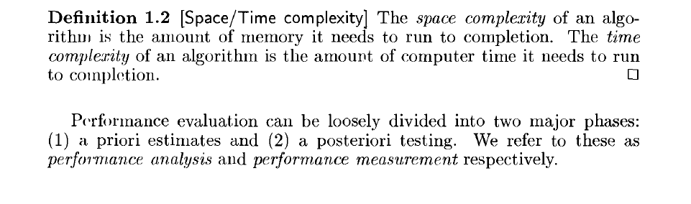
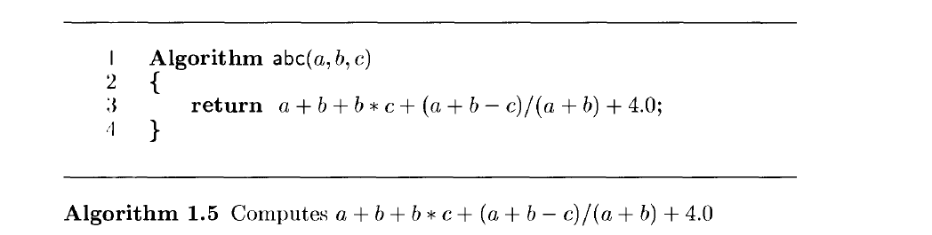
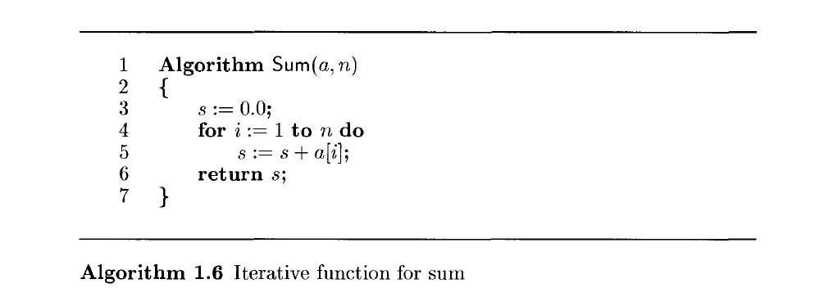

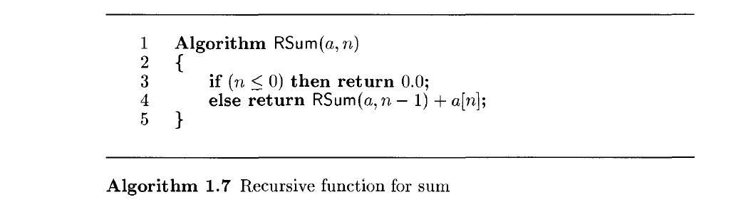
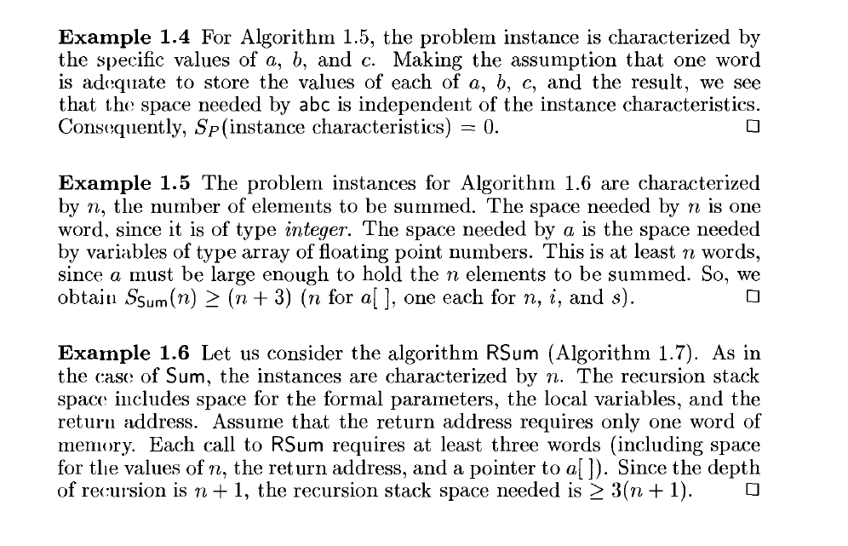
Time Complexity
The time T(P )taken by a program P is the sum of the compile time and the run (or execution) time. This run time is denoted by tp (instance characteristics)

Compute number of steps (Step count)

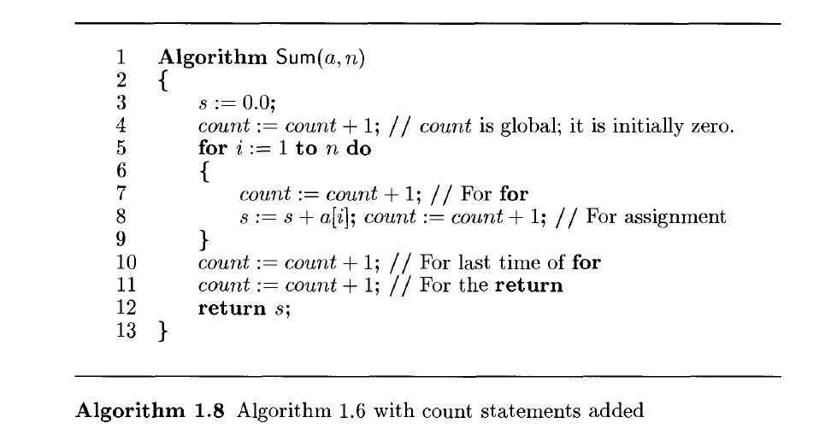
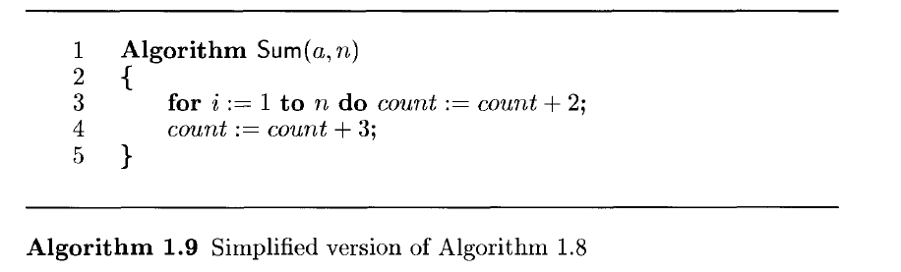
Each invocation of Sum (Algorithm 1.6) executes a total of 2n + 3 steps.
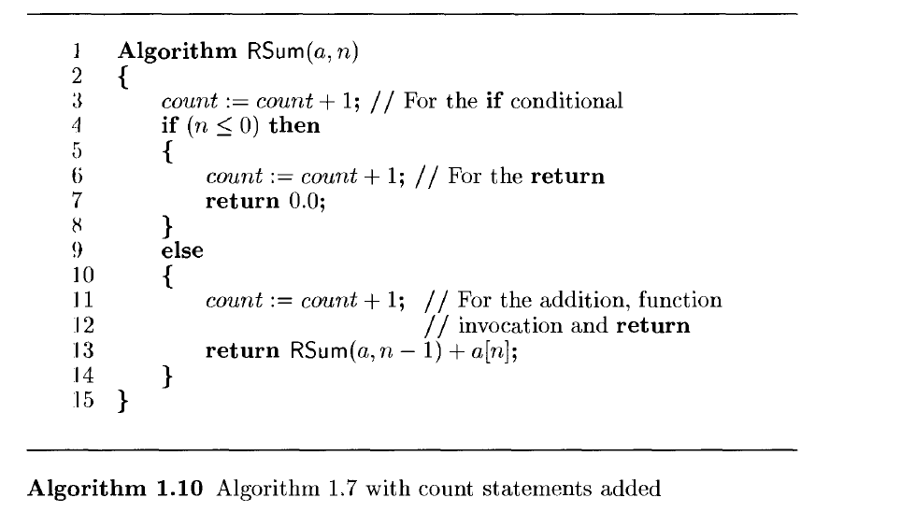
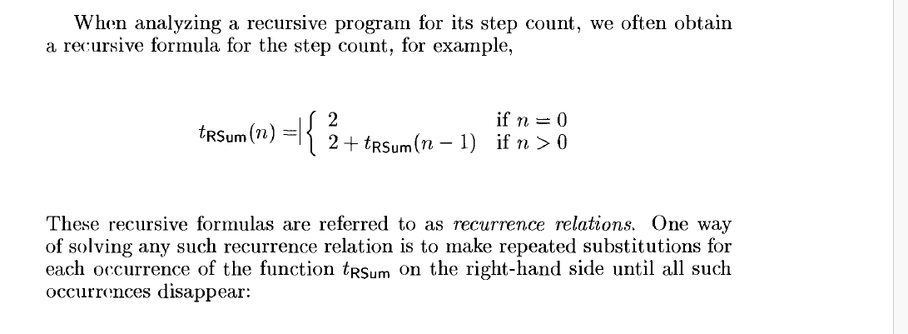
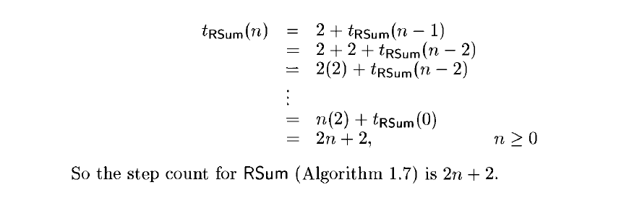

Matrix Addition
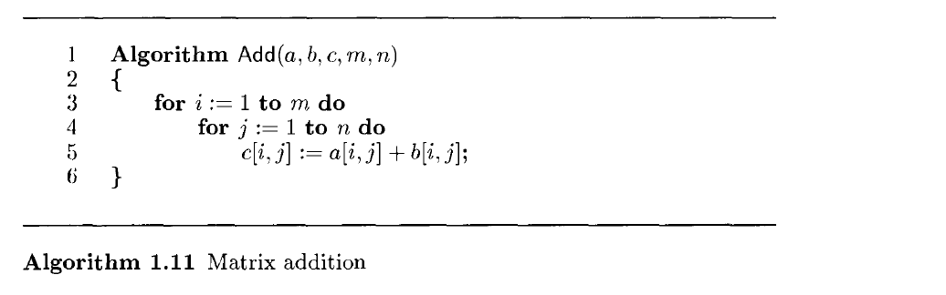
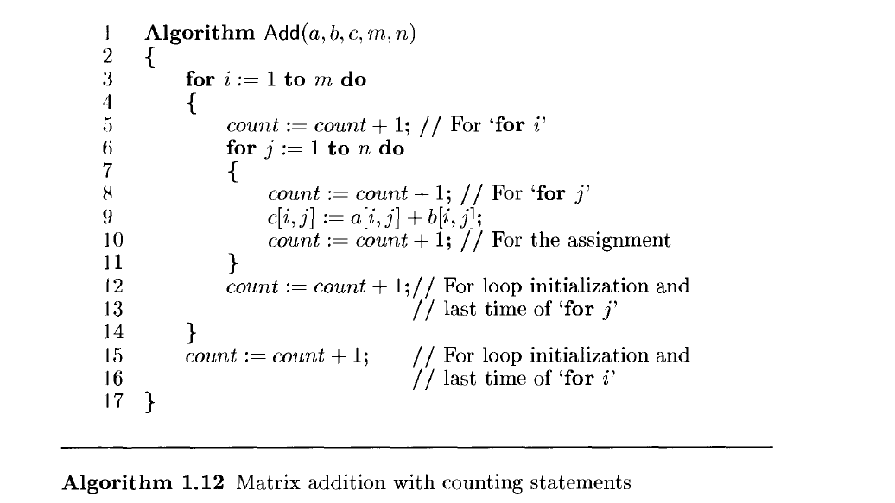
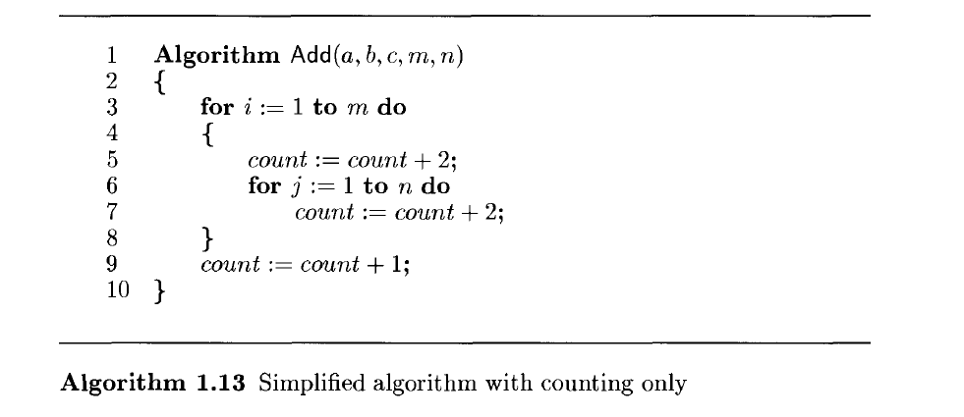
Step count = 2mn + 2m + 1

Input size - One of the instance characteristics that is frequently used in the literature is the input size. The input size of any instance of a problem is defined to be the number of words (or the number of elements) needed to describe that instance. Run times for many of the algorithms are expressed as functions of the corresponding input size.

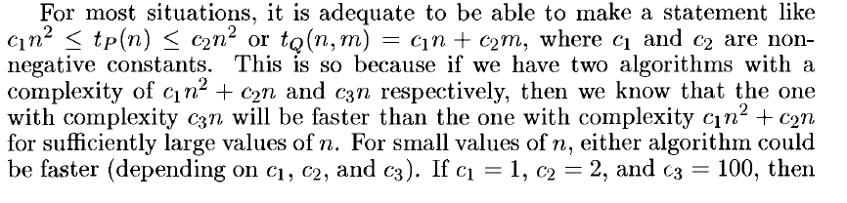
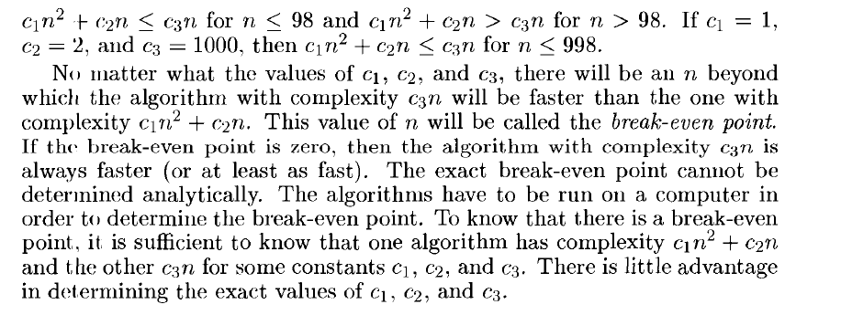

asymptotic describes how a function, curve, or algorithm behaves as its input or variable grows closer to infinity or a specific limit.
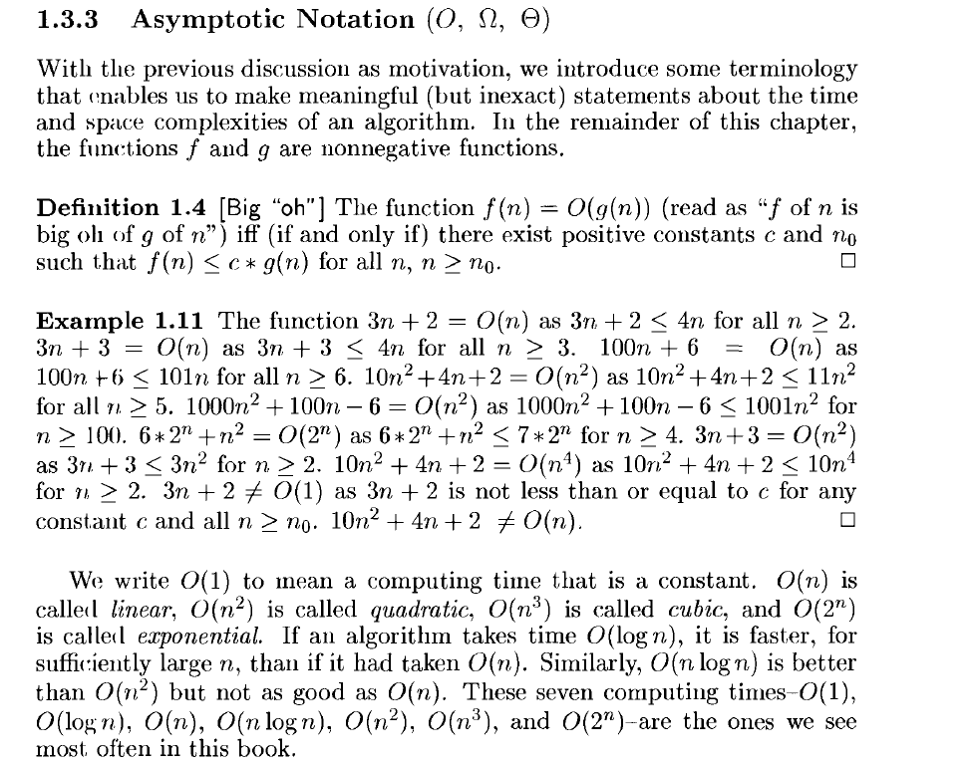
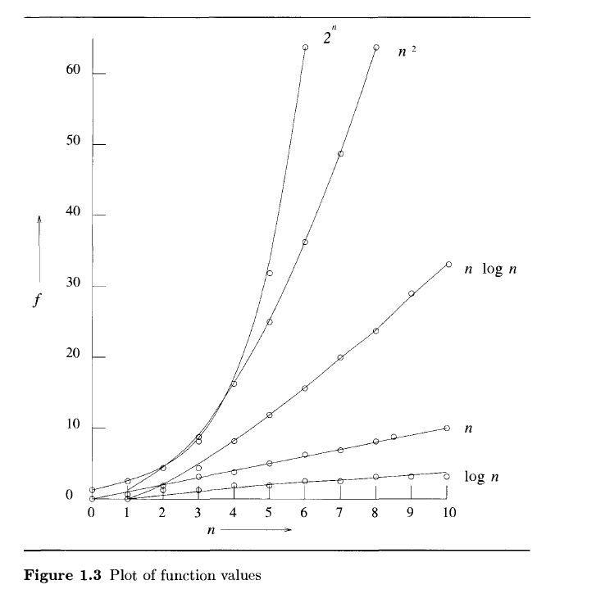

Big Oh indicates Upper bound
