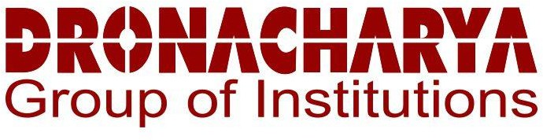

Subject – Mini Project

Submitted To - Submitted By – Dipanshu Bisht

Year - 3 rd Year/ 5th Sem

Roll no. – 2102300100065

# Acknowledgement

I would like to express my profound gratitude to Mr./Mrs. (name of the HOD), of (designation and department name) department, and Mr./Mrs. (Dean) of

university for their contributions to the completion of my project titled .

I would like to express my special thanks to our mentor Mr./Mrs. for his/her time and efforts he/she provided throughout the year. Your useful advice and suggestions were really helpful to me during the project’s completion. In this aspect, I am eternally grateful to you.

I would like to acknowledge that this project was completed entirely by me and not by someone else.

Signature Your name

**TABLE OF CONTENTS**

# Abstract

The " DGI Space" is a comprehensive online platform designed to streamline access to academic resources for students at Dronacharya Group Of Institution

, Greater Noida. The project addresses the evolving needs of contemporary education by providing a centralized repository for notes, YouTube links,

and previous year question papers. The platform aims to enhance the learning experience by fostering collaboration and efficient resource sharing among students.

Key Features:

1: User-Friendly Interface: The website boasts a user-friendly

interface built with HTML, CSS, and JavaScript, ensuring ease of navigation and accessibility for all students.

2: Resource Diversity: Students can access a wide range of

educational materials, including subject notes, curated YouTube links, and previous year question papers

, all organized by academic year and subject.

~~3: Interactivity and Engag~~ement: Interactive features such as dynamic content updates and user feedback mechanisms promote engagement and collaboration among students.

4:Scalability and Future Expansion: The project is designed with scalability in mind, allowing for future expansion of features and resources to accommodate the growing needs of the student community.

**Introduction**

In the dynamic landscape of modern education,

the demand for accessible and collaborative learning resources has become paramount. Recognizing this need, we proudly present the "DGI space" —

an innovative platform designed to revolutionize the way students at Dronacharya group of

Institution access and engag with academic materials.

#### Project Objectives:

The primary objectives of DGI Space are:

* + Providing Notes: Make quality education accessible to learners through an online platform.
  + Connection with others: Facilitate interactive and engaging learning experiences .

.

* + Increase knowledge: Implement adaptive learning techniques to cater to individual learning styles and pace.
  + User-Friendly Interface: Develop an intuitive and user-friendly interface to enhance the overall user experience.

**2. Features:**

DGI space boasts a variety of features that set it apart from traditional learning platforms:

* + Provide every single Content: Engaging video lectures, interactive simulations, and real-world examples enhance the learning experience.
  + Adaptive Assessments: Customized quizzes and assessments adapt to individual learning levels, ensuring effective knowledge retention.
  + Collaborative Tools: Discussion forums, group projects, and live

Q&A sessions foster collaboration among learners and instructors.

* + Progress Tracking: Detailed analytics and progress reports help

learners and educators monitor performance and identify areas for improvement.

* + Certification and Recognition: Upon completion of courses,

learners receive certifications recognized by industry standards, enhancing their employability.

#### Development Process:

* + The development of Edlearn.study followed an agile

methodology, ensuring flexibility and responsiveness to user feedback. The process involved the following stages:

* + Market Research: Understanding the needs and preferences of the target audience through extensive market research.
  + Platform Design: Collaborating with UX/UI designers to create an intuitive and visually appealing platform.
  + Content Creation: Developing high-quality multimedia content in collaboration with subject matter experts.
  + Testing and Iteration: Continuous testing and iteration based on user feedback to enhance platform functionality and user experience.
  + Launch and Marketing: A strategic launch plan, including digital marketing campaigns and partnerships with educational institutions.

#### Challenges and Solutions:

* + Several challenges were encountered during the development process, including technical issues, content quality control, and user onboarding. These challenges were addressed through a combination of technical solutions, rigorous quality control processes, and user training modules.

#### Future Prospects:

* + Edlearn is poised for growth and expansion. Future plans include:
  + Course Expansion: Continuously adding new courses to cater to evolving industry demands.
  + Global Reach: Expanding the platform's reach to a global audience through localization and partnerships with international educational institutions.
  + Technology Integration: Incorporating emerging technologies such as AI and AR/VR to enhance the learning experience.
  + Community Building: Fostering a vibrant online learning community through events, webinars, and networking opportunities.

## System Design

The most creative and challenging of the system life cycle is system design. The term design describes a final system and the process by which it is developed. The design phase focuses on the detailed implementation of the system recommended in the feasibility study.

Technology Used :

1: HTML

2: CSS

3: Java Script

Other’s css :

* Icon cdn link
* Animation

### NOTATIONS USED

The logic data flow diagram can be drawn using four simple notations i.e.

special symbols or icons and the notations that associates them with a specific system. The notations are specified below:

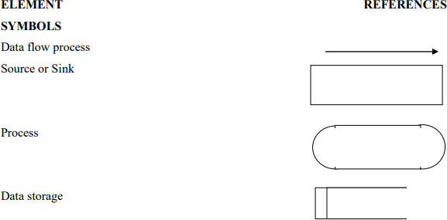

### DESCRIPTION

* Process : Describes how input data is converted to output data.
* Data Store : Describes the repositories of data in a system.
* Data Flow : Describes the data flowing between process, stores and external entities.
* Sources : An external entity causing the origin of data.
* Sink : An external entity, which consumes the data.

### DFD : LEVEL 0

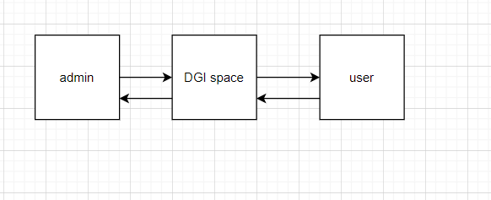

**USER PROCESSES**

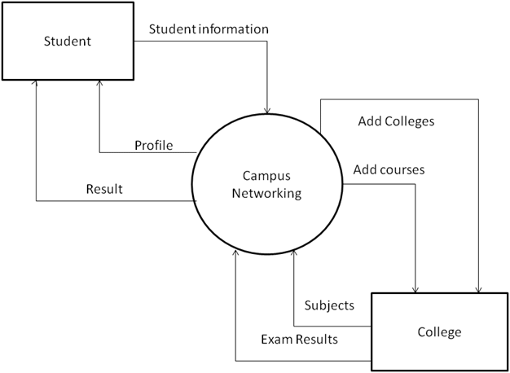

**HARDWARE AND SOFTWARE SPECIFICATION**

#### Hardware Specification

* Processor : Intel Pentium 4 with 1.5 Giga Hertz or higher
* Primary Memory : 1024MB RAM or higher
* Secondary : 20 GB Hard disk or higher
* Monitor : LCD or higher
* Keyboard : 104 keys
* Pointing Device : Mouse or Touchpad

#### Software Specification

* Operating System : Windows 10 or higher
* Frontend : HTML, CSS, JavaScript,font-awsome-icon.
* Git Hub pages

Desktop -View

Home pages



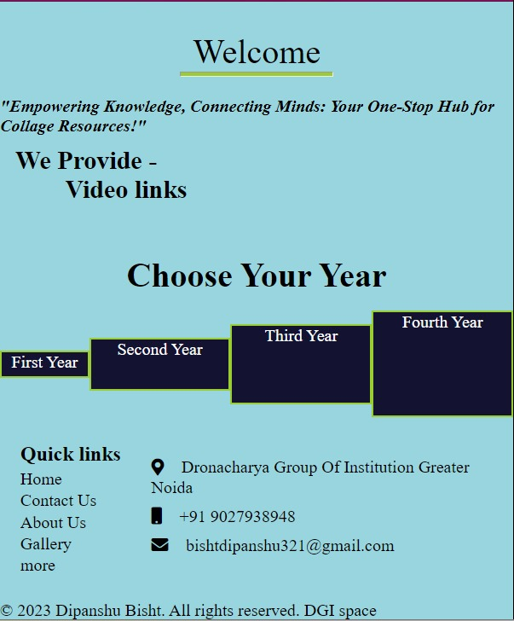

Footer

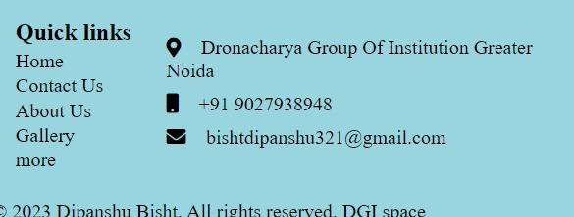

Internal structure of first year

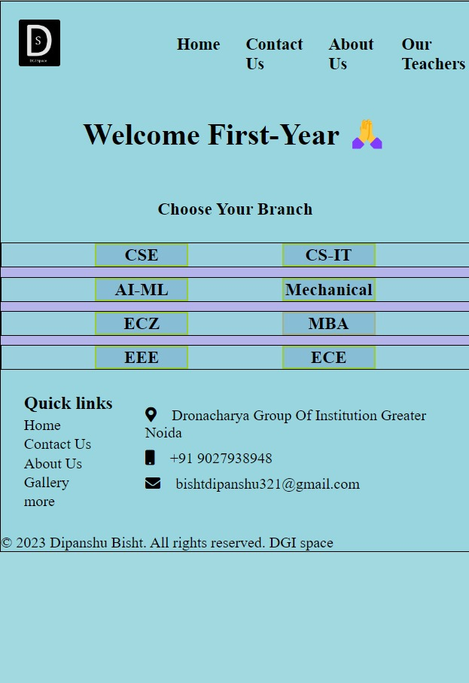

Our Teachers page

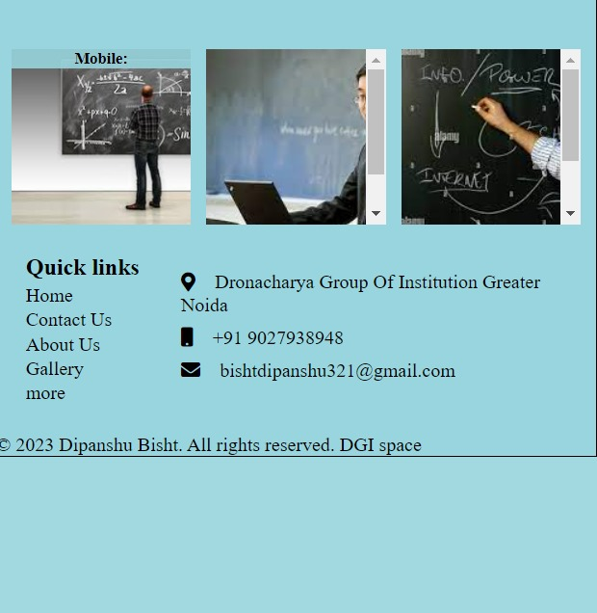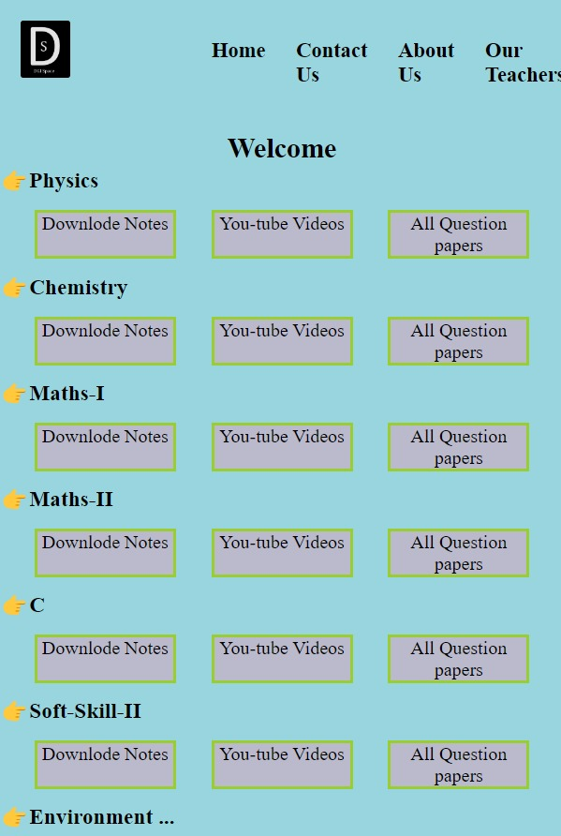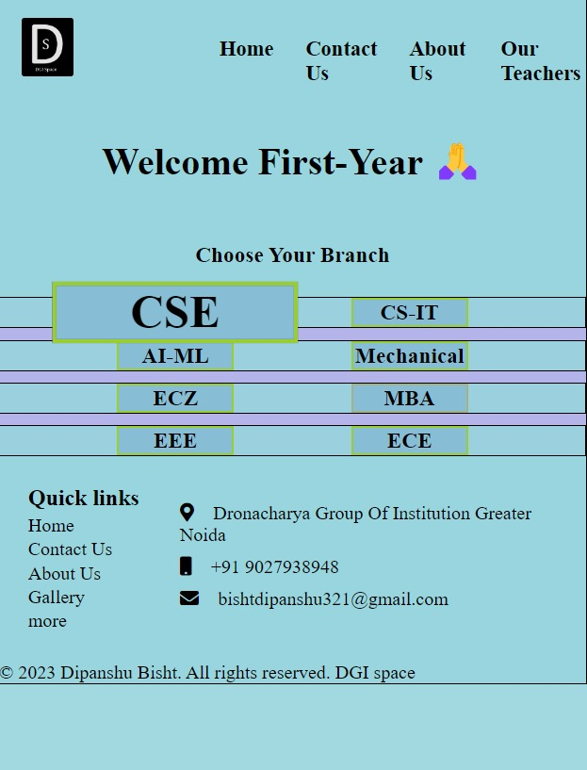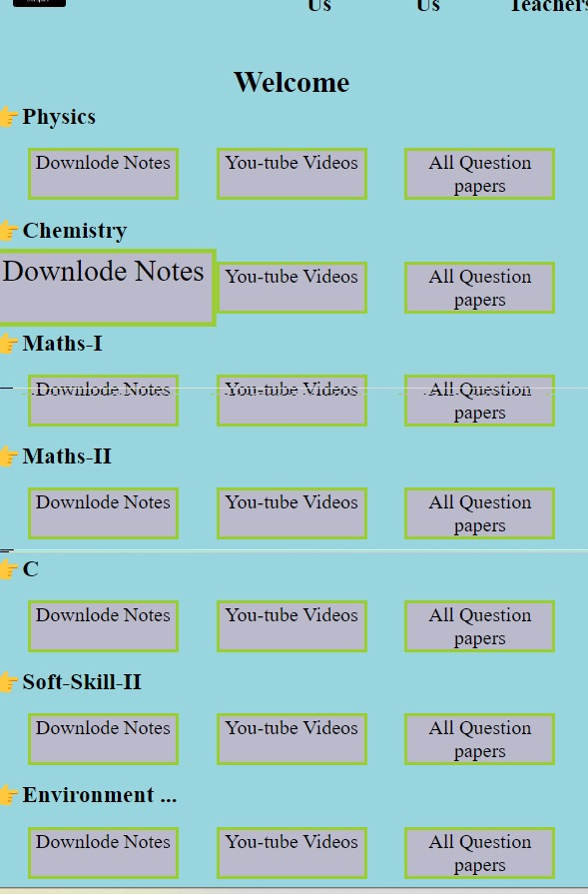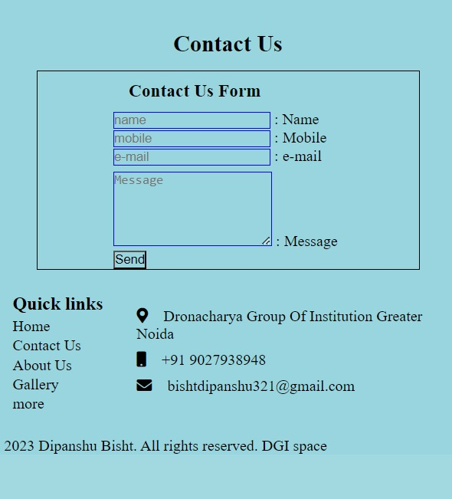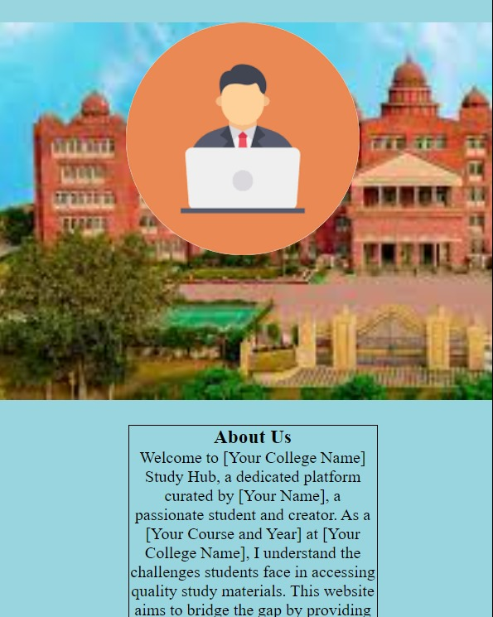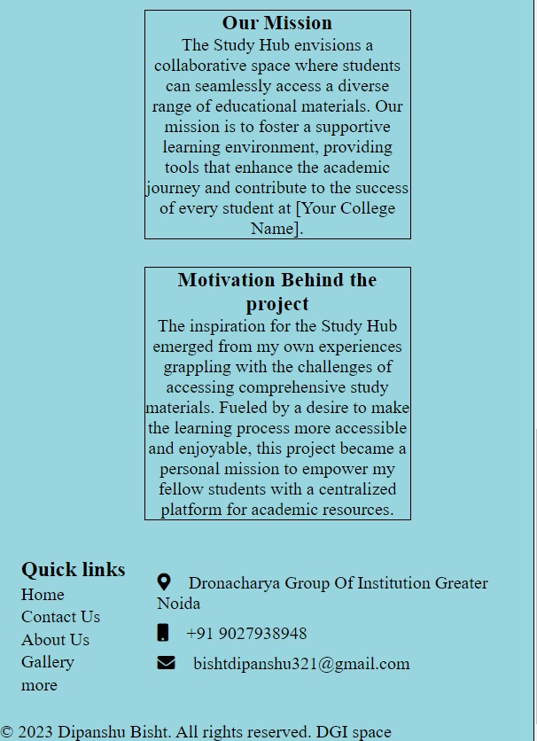

**Conclusion**

In today's Web development, a good page design is essential. A bad design will lead to the loss of visitors and that can lead to a loss of business. In general, a good page layout has to satisfy the basic elements of a good page design. This includes color contrast, text organization, font selection, style of a page, page size, graphics used, and consistency. In order to create a well-designed page for a specific audience. The developer needs to organized and analyze the users' statistics and the background of the users. Although it can be hard to come up with a design that is well suited to all of the users, there will be a design that is appropriate for most of the audience. The better the page design, the more hits a page will get. That implies an increase in accessibility and a possible increase in business.