Task 1

Similar Website Research

- https://www.catherinegratwicke.com/

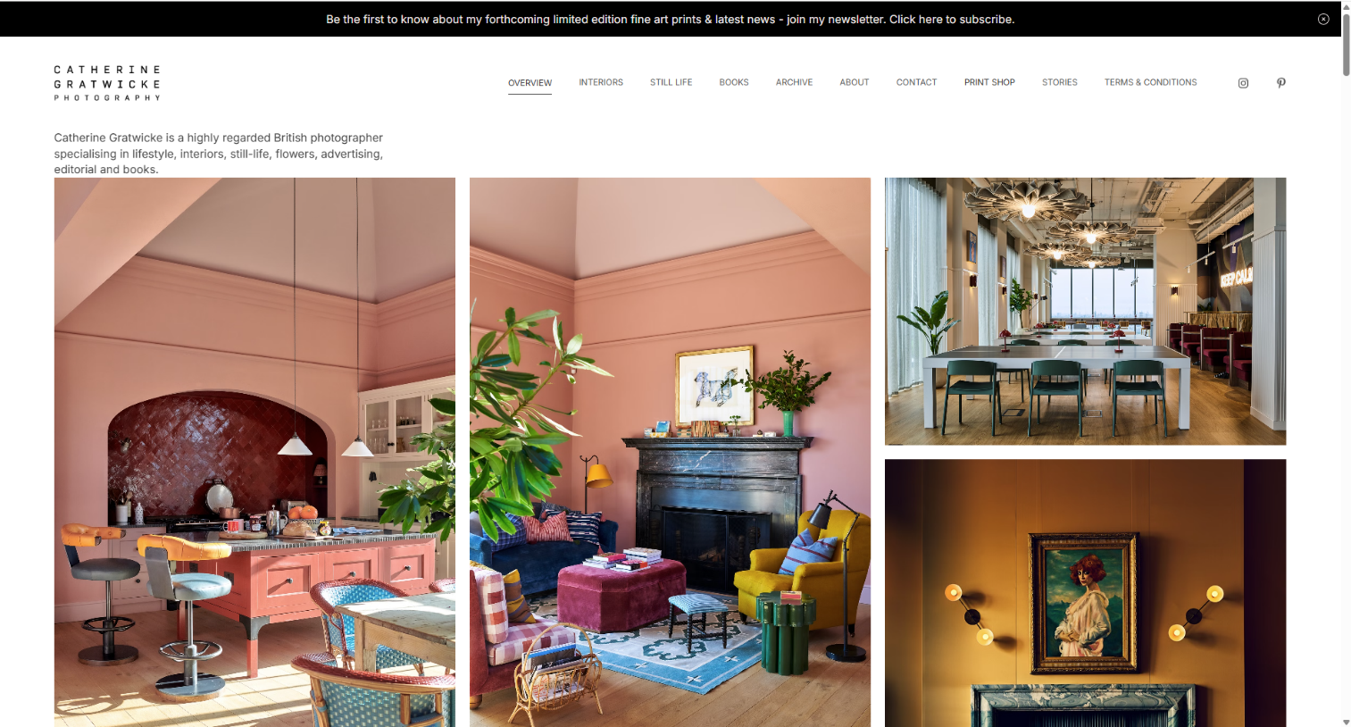

This website’s home page strikes as very engaging at first glance. It acts as the first impression and visual hook. It immediately communicates Catherine Gratwicke’s photographic style and quality. It also directs users to other key sections of content including the about page, print shop and stories. Navigation is clean and clear letting the user focus more on the art. The home page has a very efficient use of white space which gets along all necessary information to the user in a very visually engaging way. It contains her featured photography and highlights her recent or signature work. This helps to immediately display the site’s content to the user.

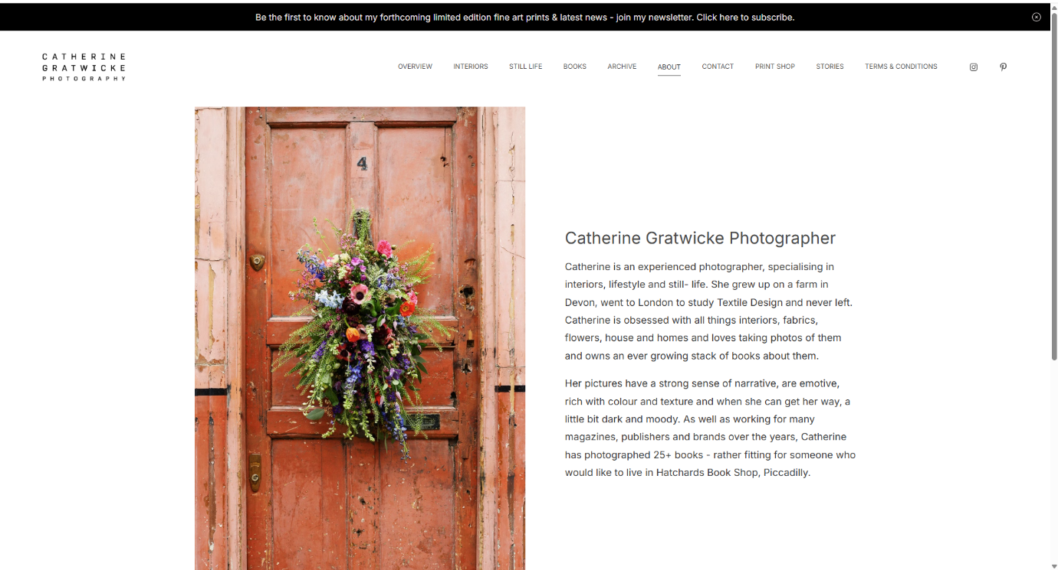

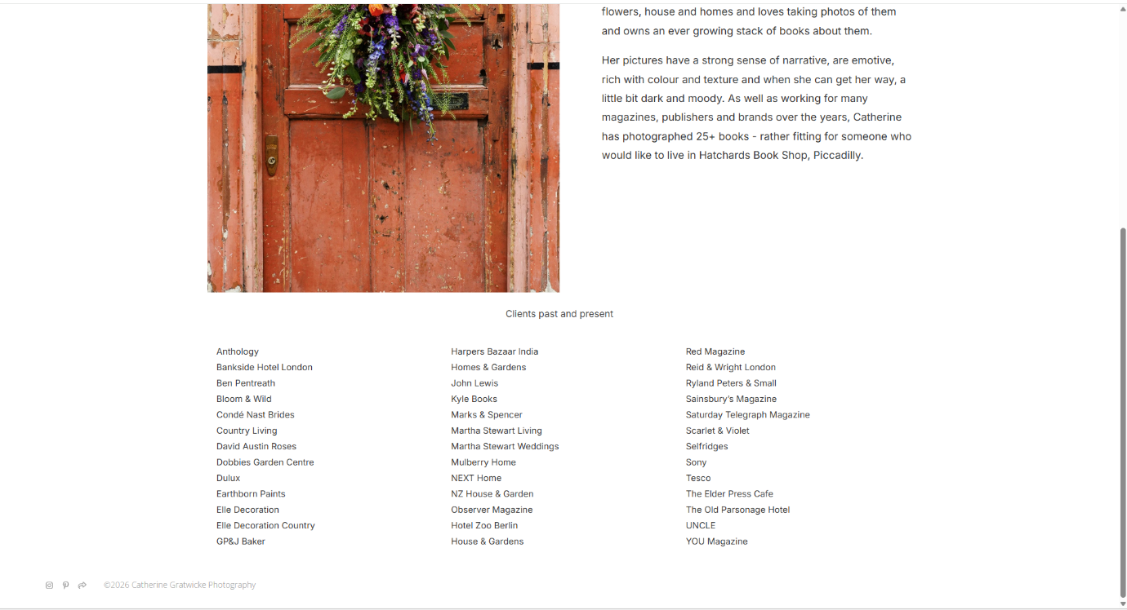

The about page of this website is structured very well. It has efficient use of white space, and it introduces Catherine Gratwicke as an individual. It also has a very helpful display of all her past and present clients. The picture of the flowers on the door helps to visualise her photographic focus and signify to the user that she is interested with all things flowers and interior. This helps to build trust and credibility with potential clients and collaborators. This page’s purpose is to display her biography, professional background, experience and her creative philosophy.

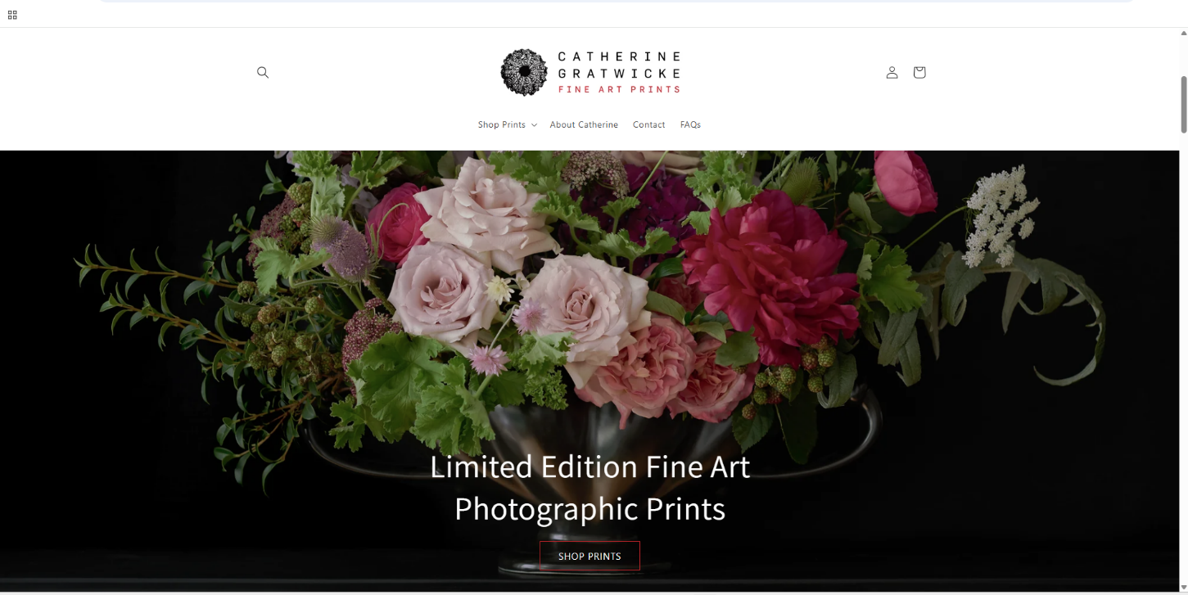

For this photographer’s website, the listing section is accessed through the print shop tab on the navigation bar of the website. It redirects you to another website dedicated solely to the presentation of the photographer’s prints as products for sale. It allows users to browse available prints. The home page of this print shop website draws the user in immediately through clean and clear navigation. This allows for more focus on an example of a print for sale with a link to the tab “Shop Prints” on it.

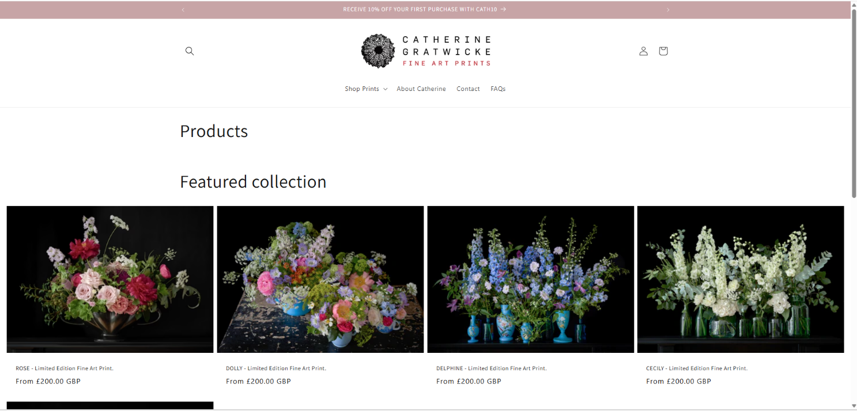

The “Shop Prints” page which acts as the listing section contains thumbnails of the prints in the featured collection for sale. It also contains the titles of individual prints and prices. These thumbnails act as links to individual print pages. This page is constructed extremely well as it involves clean and clear navigation. The headings to the actual products listed for sale have a larger font size than the text in the navigation bar. This helps to direct user focus towards the actual products. The website ensures efficient use of white space. This gets all the information across about available products while still ensuring for a non-overwhelming user experience.

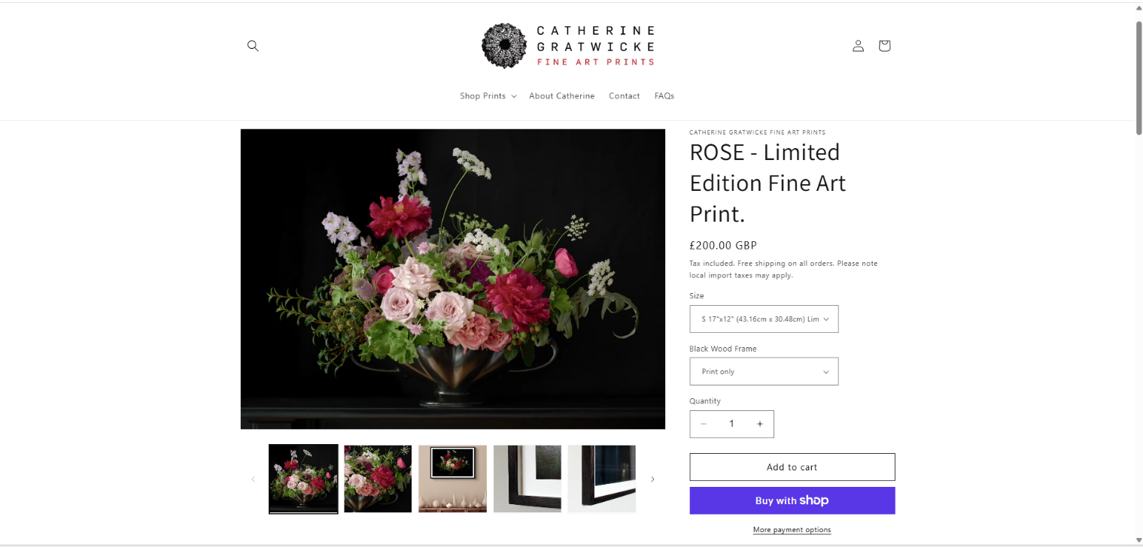

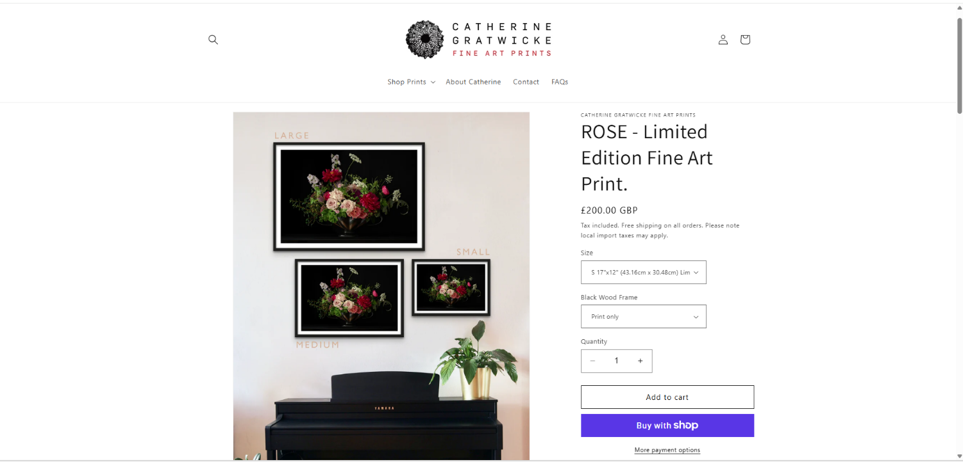

The product detail page helps users to decide to purchase a specific print. The large preview of the product alongside additional images help to display the print in a frame and how it would look in different home settings for all the different available sizes. This gives the user a good idea of what their chosen print would look like hung up in their home. The size options and the option to have a print only or have it framed increase customisability for the user. Additional content also includes the product details consisting of product titles and prices. The user can choose the quantity that they would like. They could then choose to add the product to the cart if they are sure of their decision to purchase it. The product detail page uses clean and clear text in small enough font sizes to create more focus on the product preview. There is also effective use of white space to get all information across about a product to the user with little overwhelm.

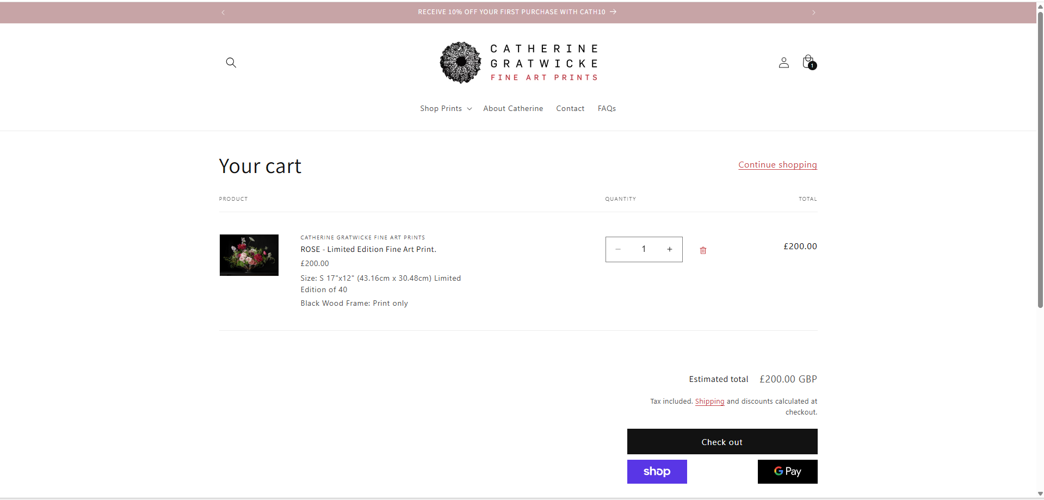

The basket page helps users to temporarily store selected products before checkout. It also allows users to review and modify their order. The heading “Your cart” is in a large font size to direct the user’s attention towards the products in their basket. In the quantity section of the cart, the user can modify their order by changing the quantity or entirely deleting the selected product. This page displays key details such as the name of the product, its specifications, quantity and price in large font sizes to attract user attention towards them. There is also an excellent use of white space to allow for a minimalist, non-congested webpage. To proceed to purchase the product, the user has three options through three clear buttons. “Checkout” lets the user purchase items in their basket through a longer method that includes a form. “Shop” and “Google pay” are express checkout options to let the user checkout quicker.

- https://www.drewthefotographer.com/

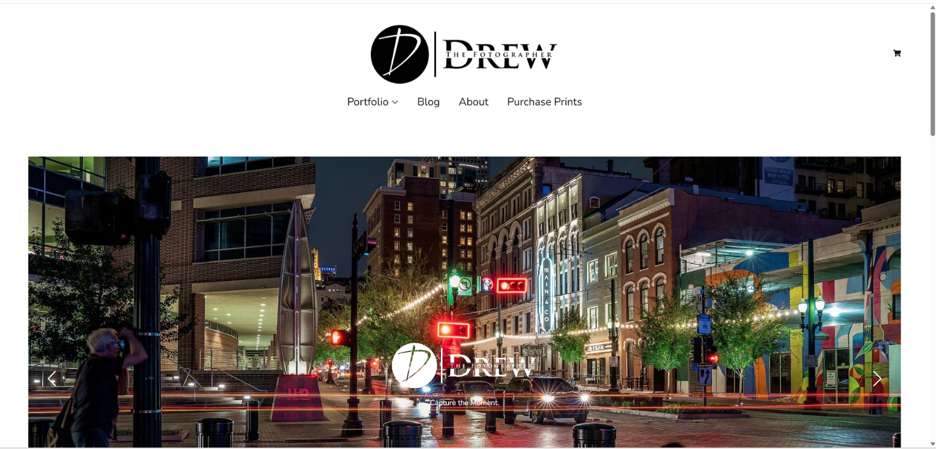

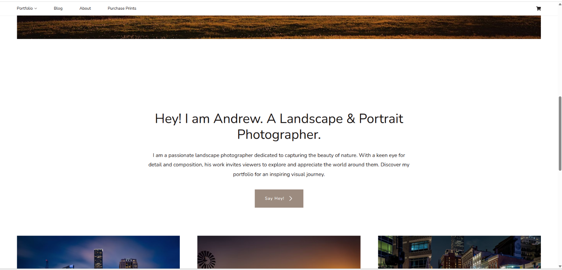

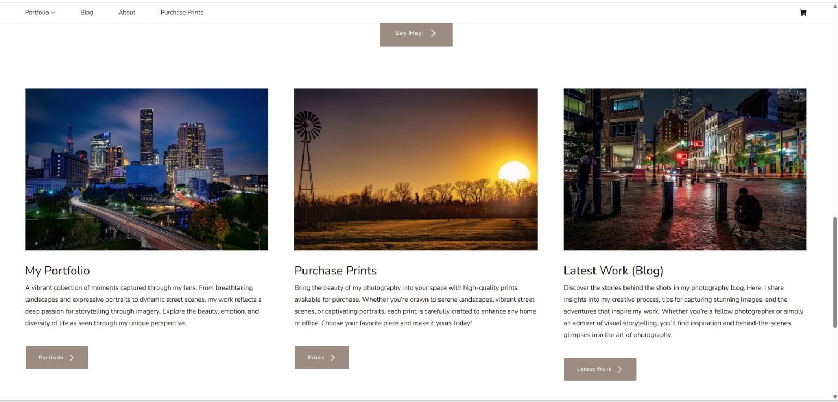

Task 2

Design inspiration

I will be designing a website for the landscape and still life photography genre.

- https://www.atulpratapchauhan.com/

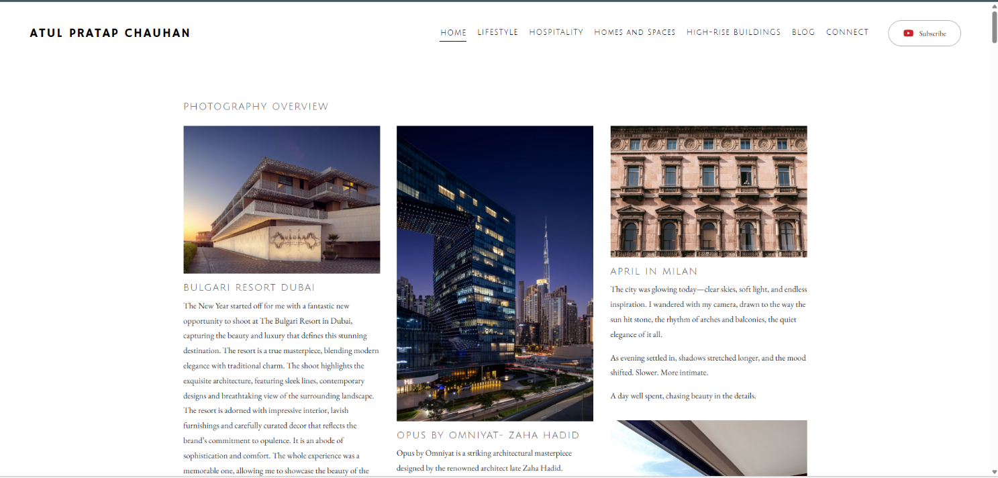

This website offered me some design inspiration in the form of the use of a white background and the organised layout of the photos. There’s also an effective use of white space with clean and clear navigation.
- https://www.drewthefotographer.com/

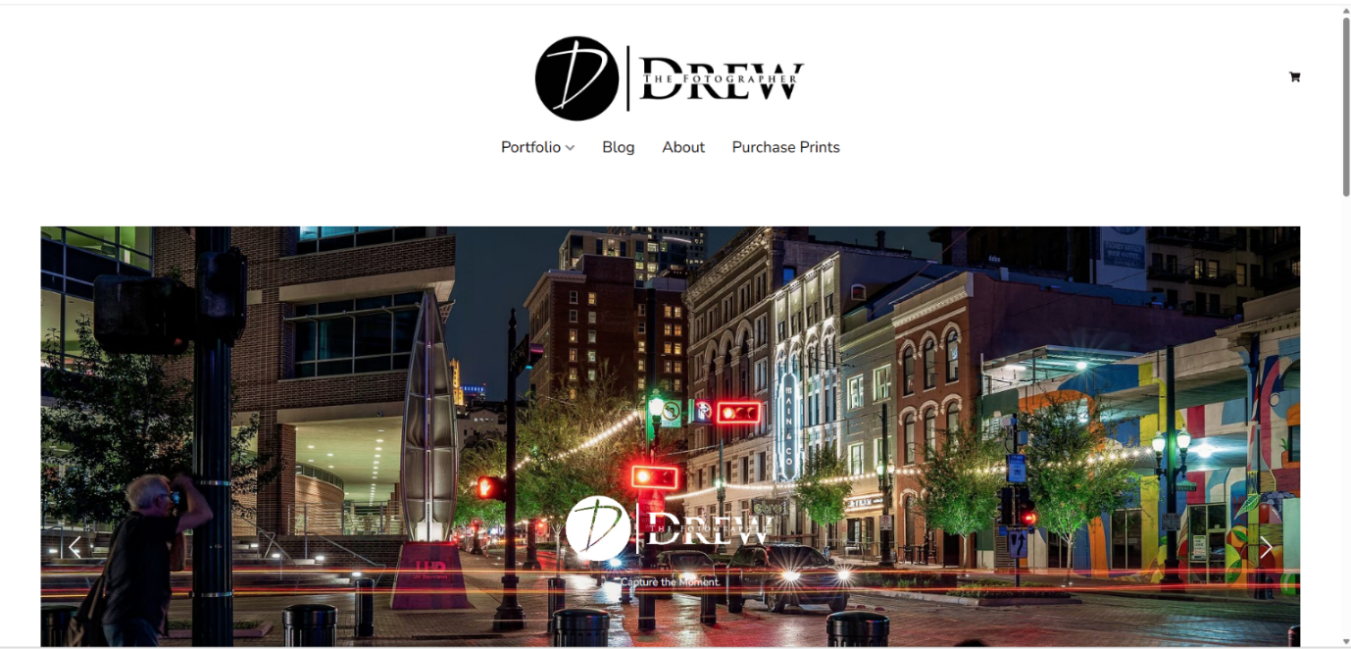

This website offered me some design inspiration due to its font style which is very clear and bold and stands out to the user. It’s extremely readable which helps for much more efficient navigation by the user.

Graphical mockup

Laptop screen – 1080px width(Homepage)

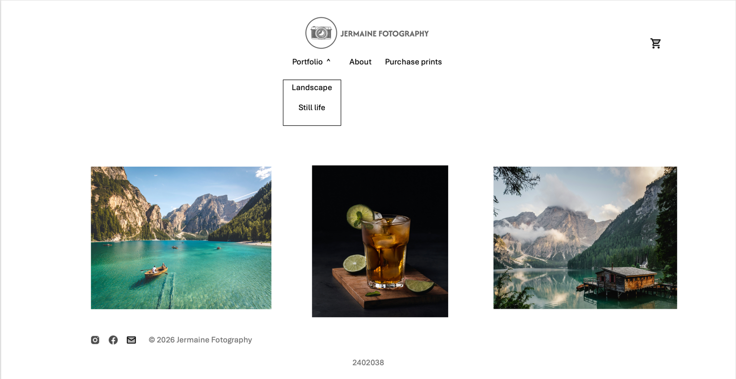

Smartphone screen – 480px width(Homepage)

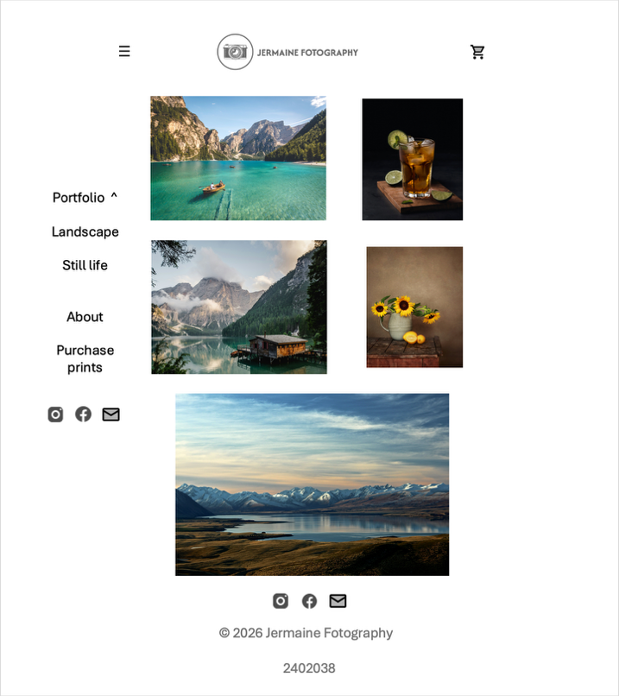

Justification of design

I designed the webpage as above to optimise for minimality, simplicity, usability and a welcoming user experience. This is clearly demonstrated by the use of clear and clean navigation. There are also small icons for the contact details and the cart. This helps to really put more focus on the content of the website which is the art. I also implemented an effective use of white space for a non-overwhelming user experience.

The dropdown menu helps to showcase the two different genres of photography that the photographer is involved in. I also added a menu bar to the smartphone design which will cover the whole screen when clicked on to display all the different webpages that the user can access. This will occur without horizontal scrolling.

Task 4

4.1 Evaluation with users

User(my flatmate)

- What do you like about the design?

I loved that it had really good usability. The navigation is clean and clear, immediately placing an emphasis on the stunning and neatly organised photos. I also loved that there is a really effective use of white space so there is not a lot of clutter. These features really made my user experience enjoyable.

- What’s missing that you would like to see?

I would like to see more image views of the product that I would potentially like to purchase in each individual product details page. I would also like to see a facility for me to leave reviews of the products or a section for other customers’ reviews.

- What else would you suggest?

I would suggest more professional and stylistic font for the navigation and headings across all webpages. I would also suggest adding featured prints for sale on the homepage.

4.2 Automatic evaluation of code against W3C

index.html
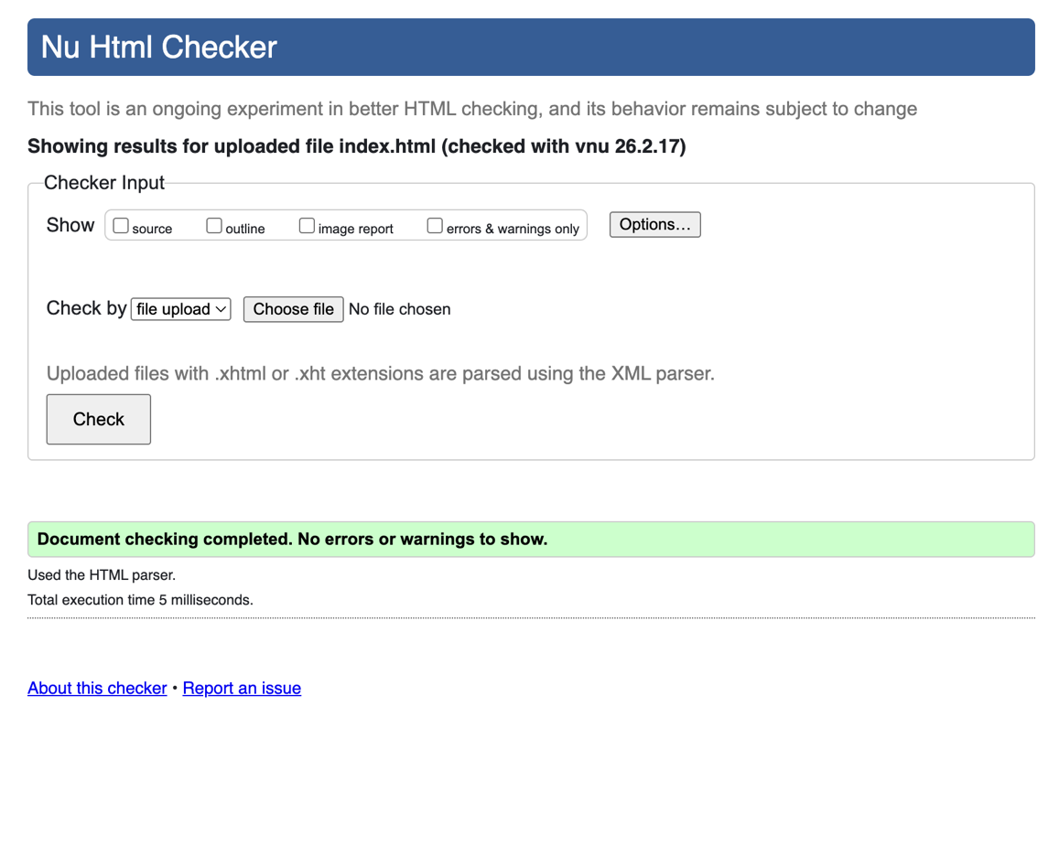

about.html

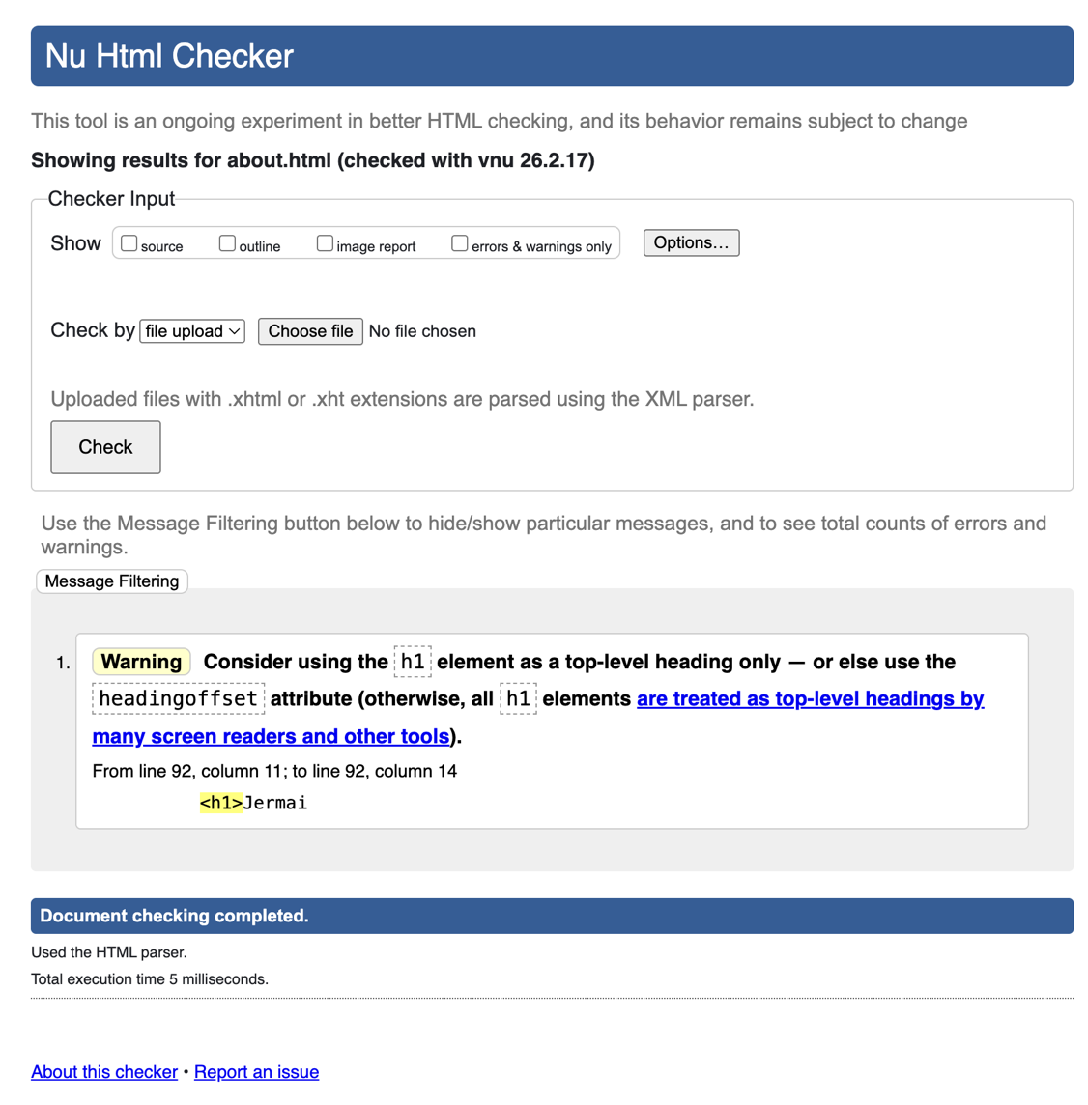

purchase-prints.html

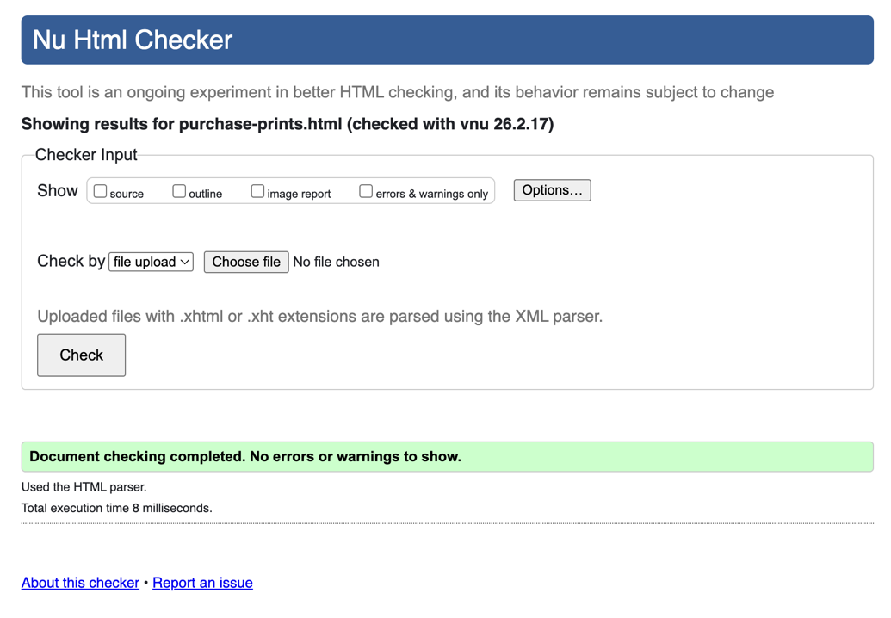
basket.html

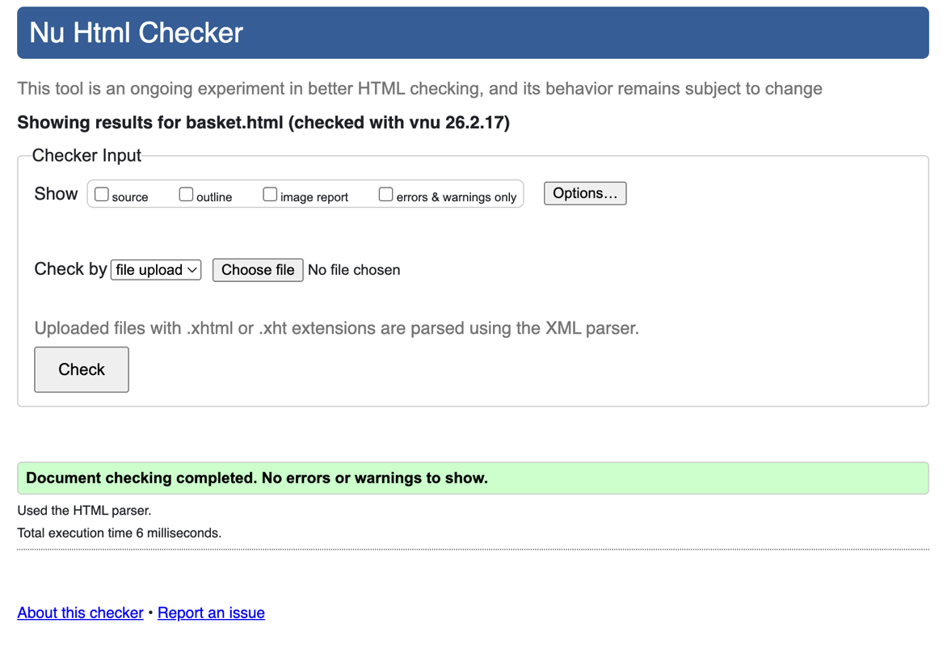

landscape.html

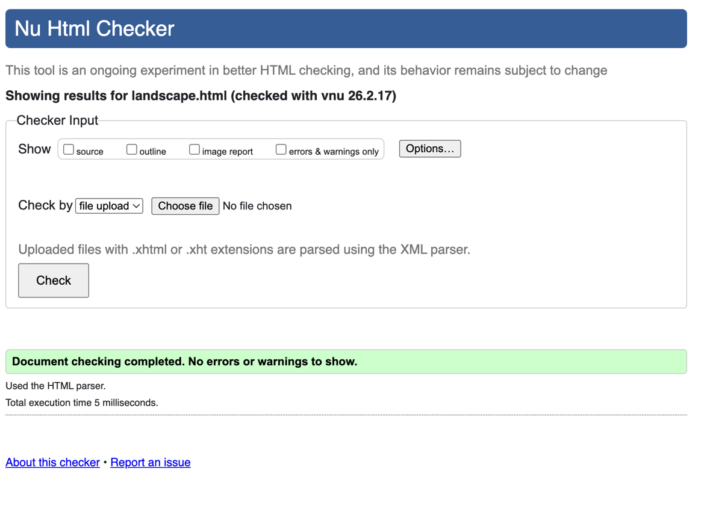

still-life.html 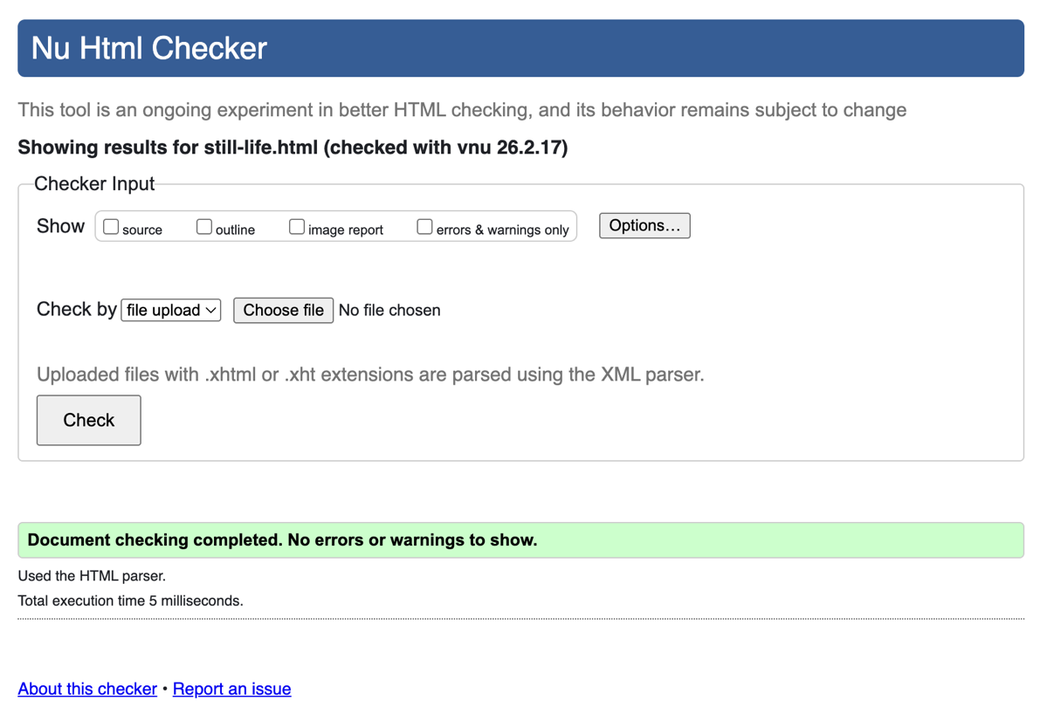

product-lemon-grove-still-life.html

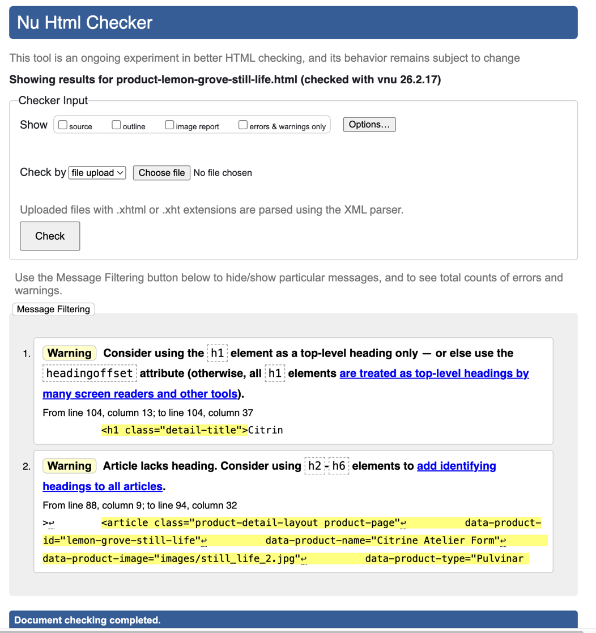

product-rolling-green-hills.html

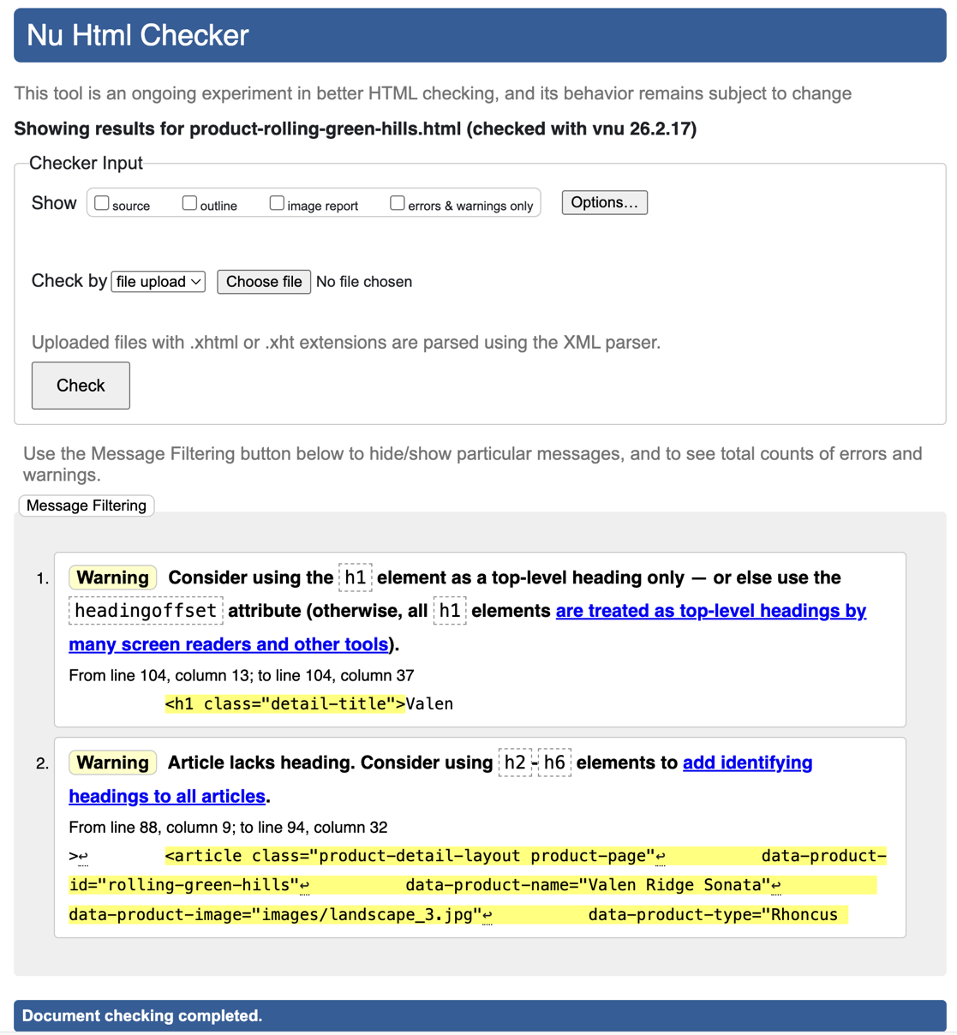

product-sunflowers-and-lemons.html

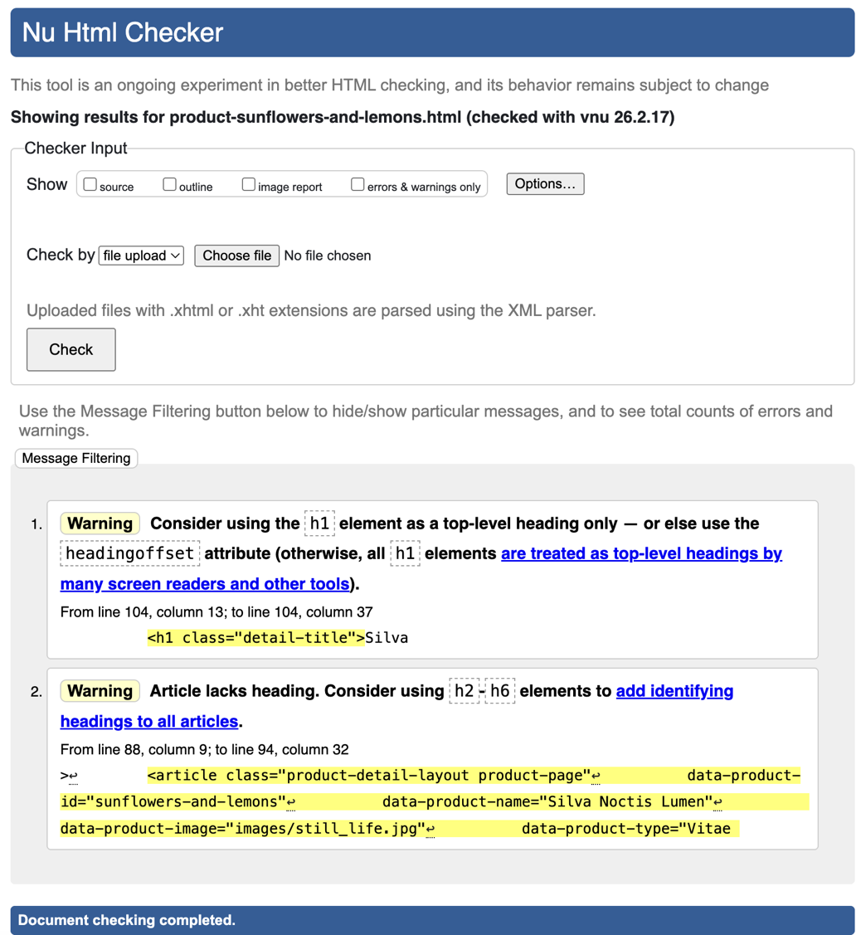

product-turquoise-alpine-lake.html

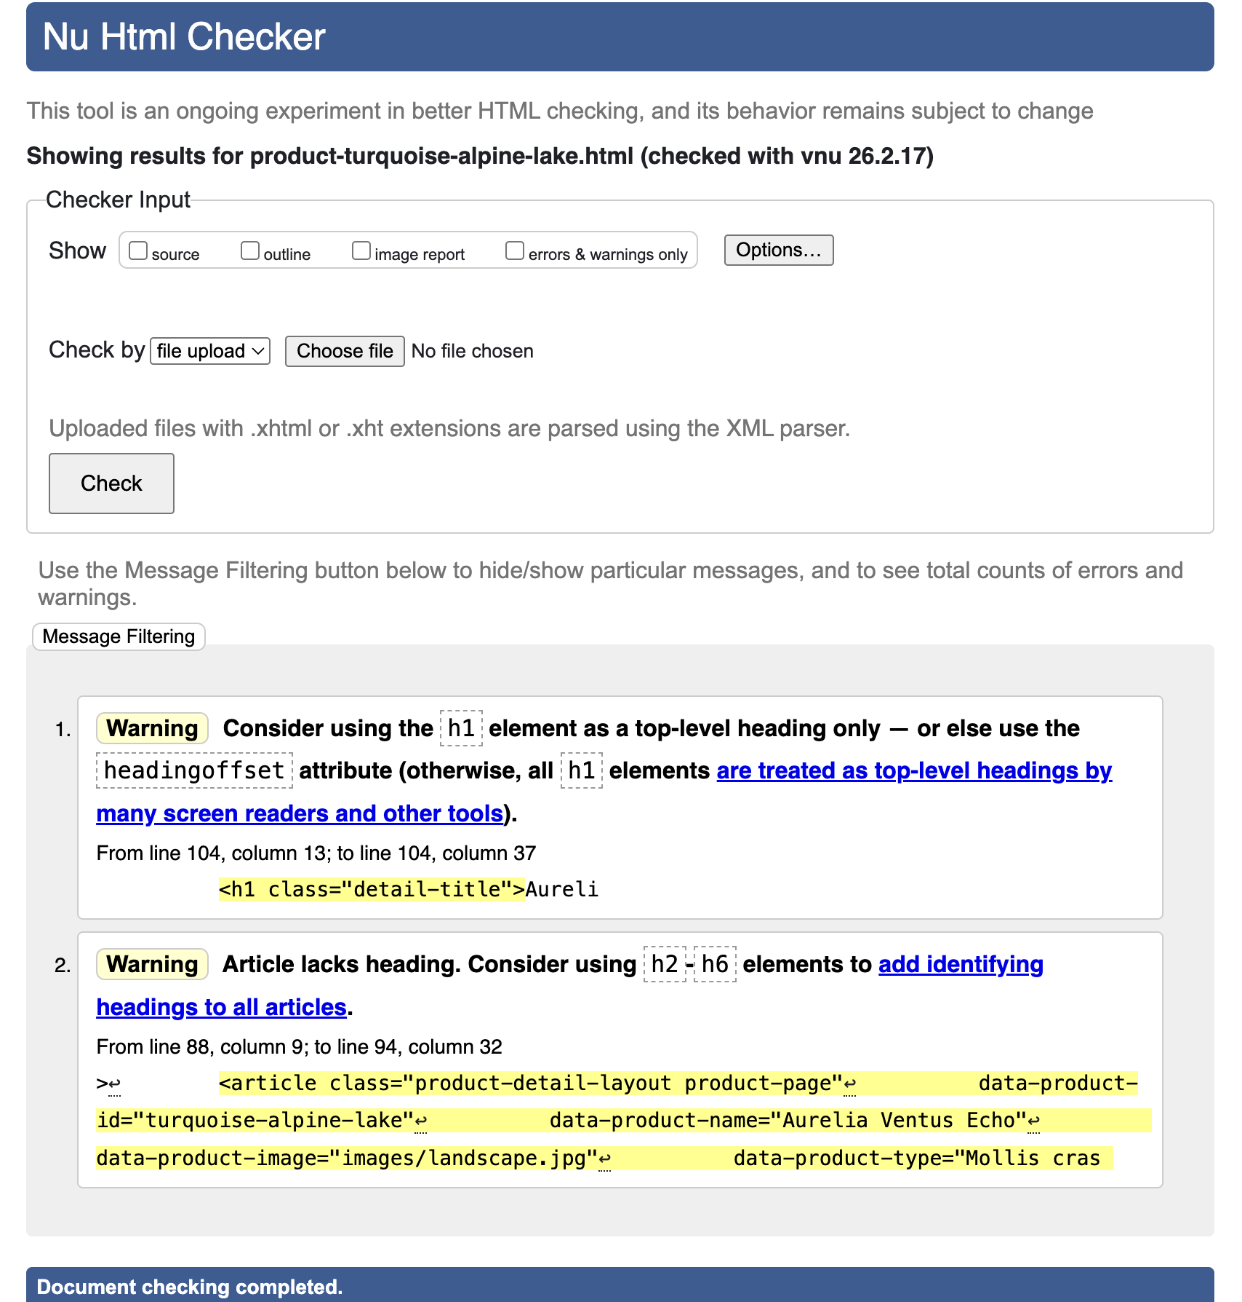

product-two-pears-in-sunlight.html

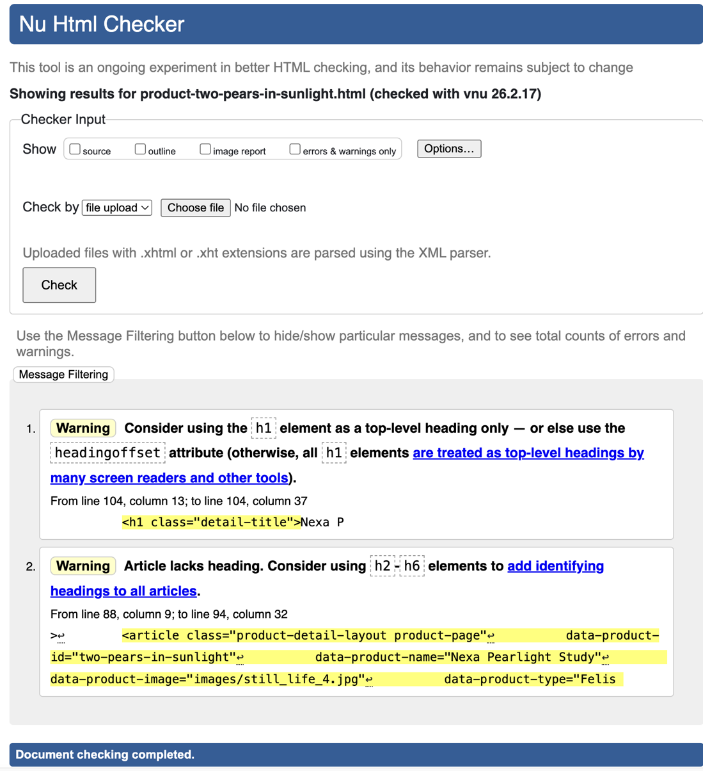

style.css

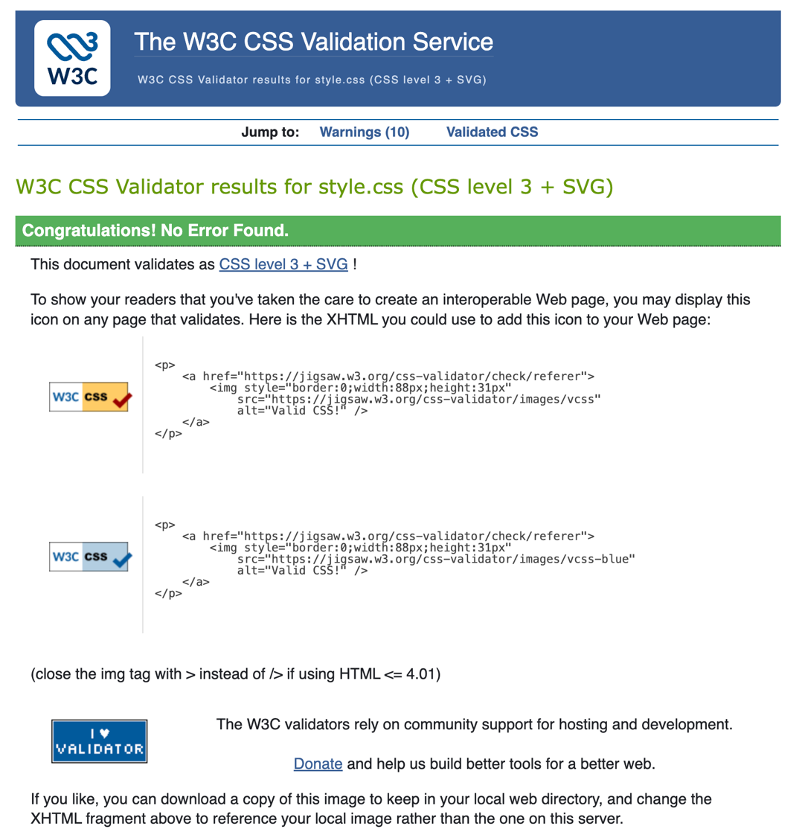

4.3 Self appraisal

I believe I designed a very visually engaging and appealing website. I made for a very user-friendly browsing experience. The navigation in my website is clean and clear which helps to direct the user’s attention towards the amazing photography which is laid out in a beautiful structure. The website has very good usability and uses white space effectively to reduce clutter and hence, overwhelm. Ensuring for an enjoyable and stress-free user experience.

I would like to improve my design by using more professional and stylistic font for the navigation and headings across all webpages. I would also like to add more image views of each product in each individual product details page. Another great addition and improvement would be to add a section on each product’s page dedicated to customers’ reviews. A huge limitation for me is time constraints. Some CSS techniques I need to learn would be animations and the best practices for design and development. My knowledge on web components could also be improved as this would definitely progress my web development skills.

