Step 1: create an account of github
Search github sign in open link and complete process

Step 2: install git
- Download and install Git from official website
- Keep default settings during installation
https://git-scm.com/install/windows
step 3:
Open Command Prompt and type:
git –version

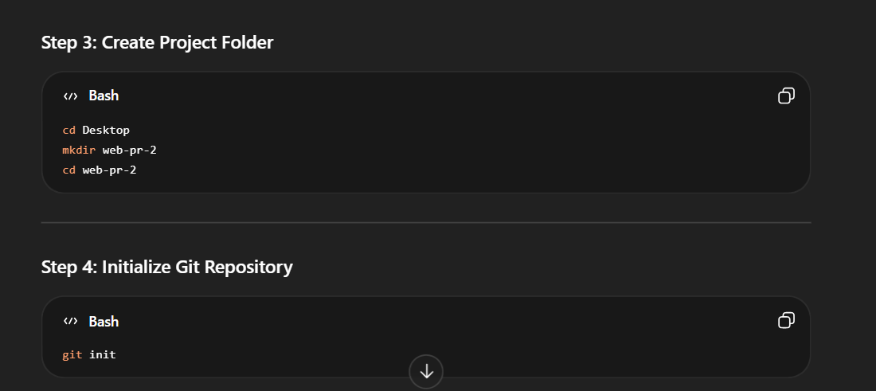

In your account page of github this will see you

echo "# web-pr-2" >> README.md
git init
git add README.md
git commit -m "first commit"
git branch -M main
git remote add origin https://github.com/Chinuuuuuuuuuuuuuuu/web-pr-2.git
git push -u origin main
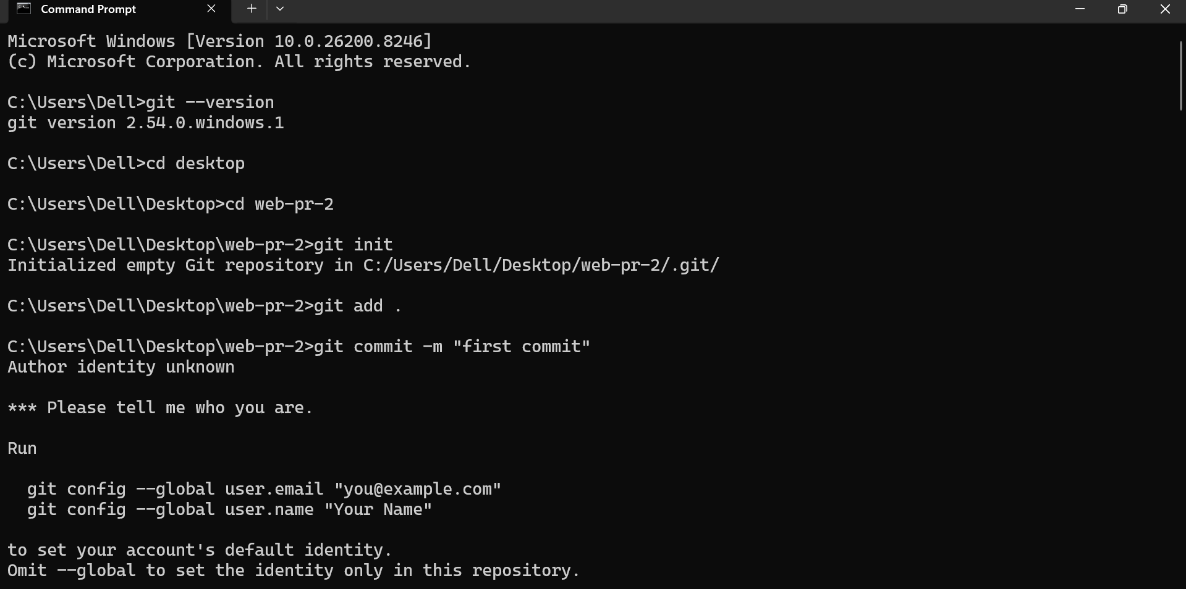
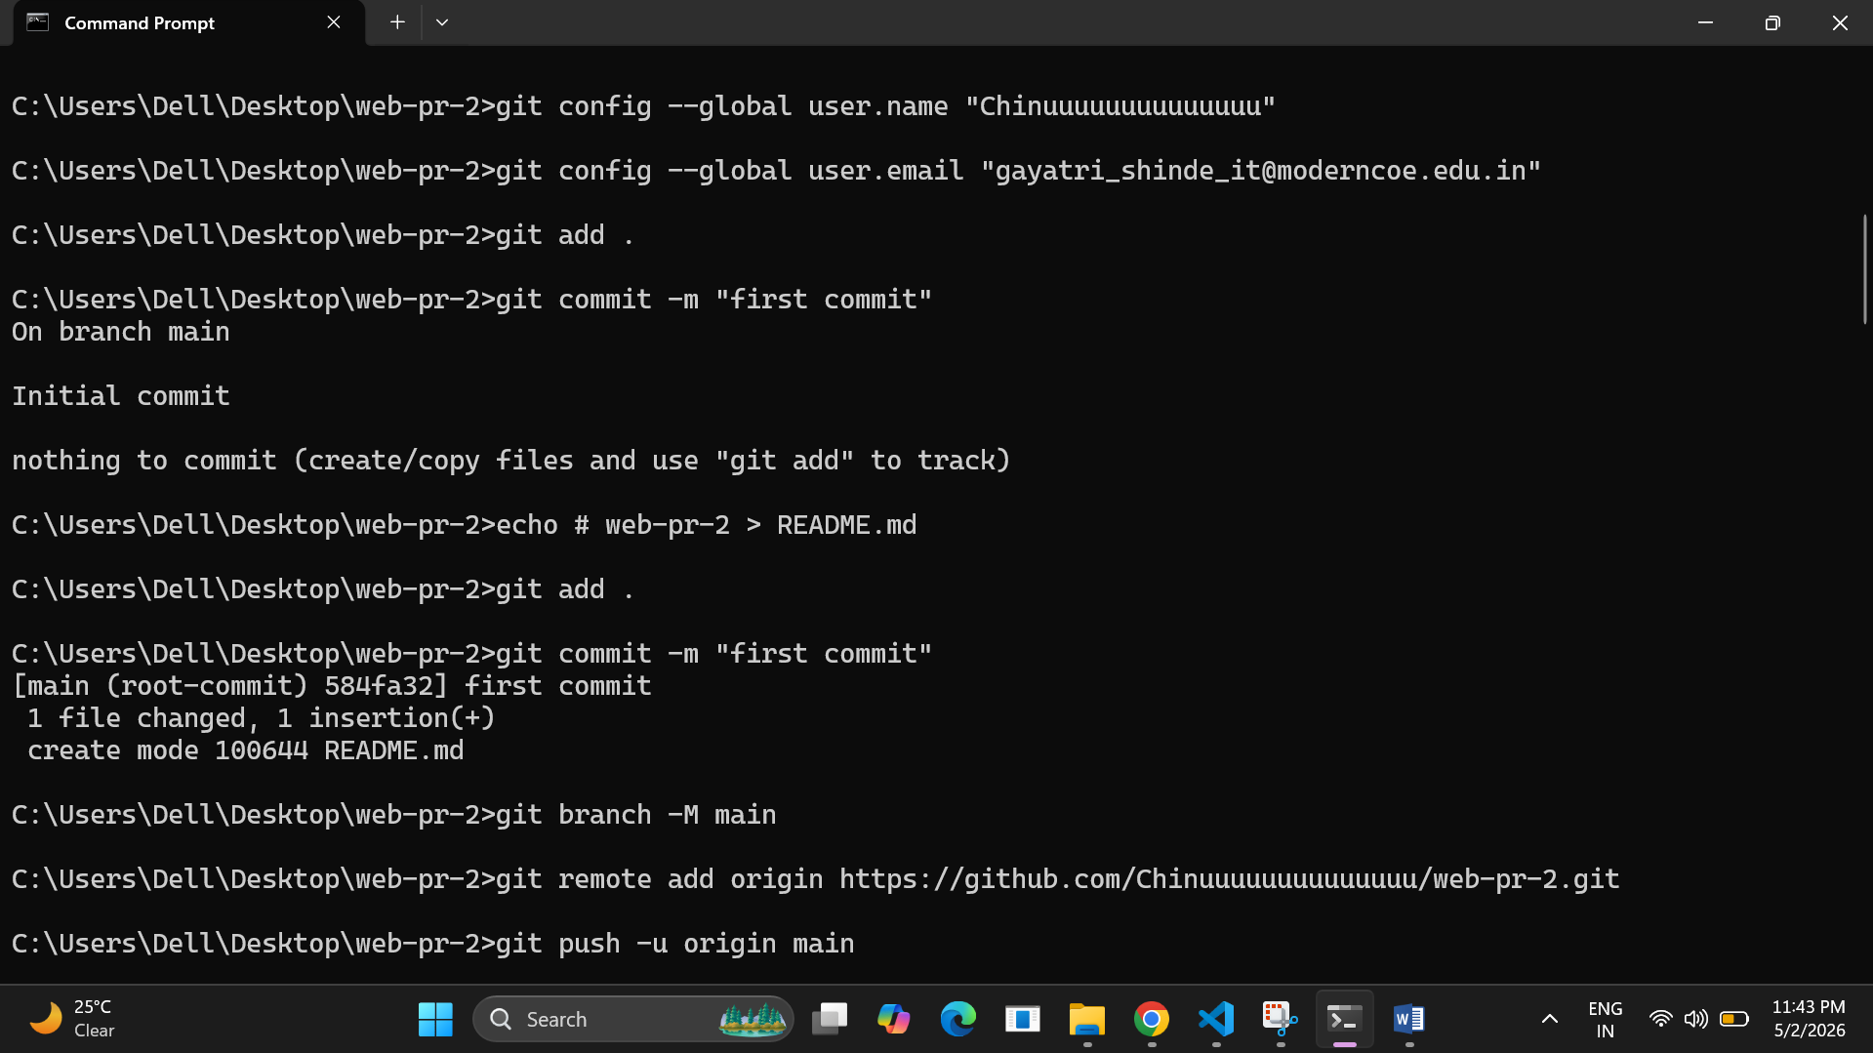
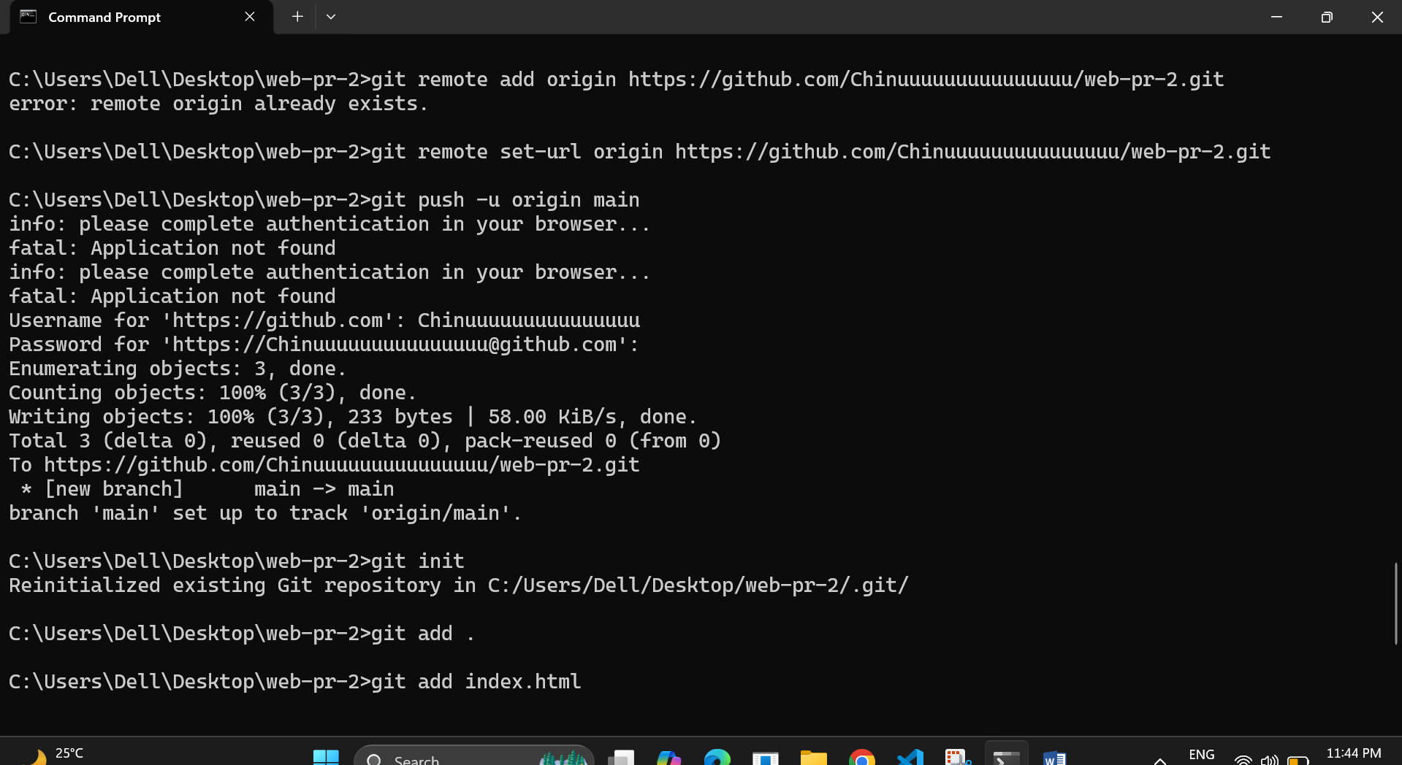
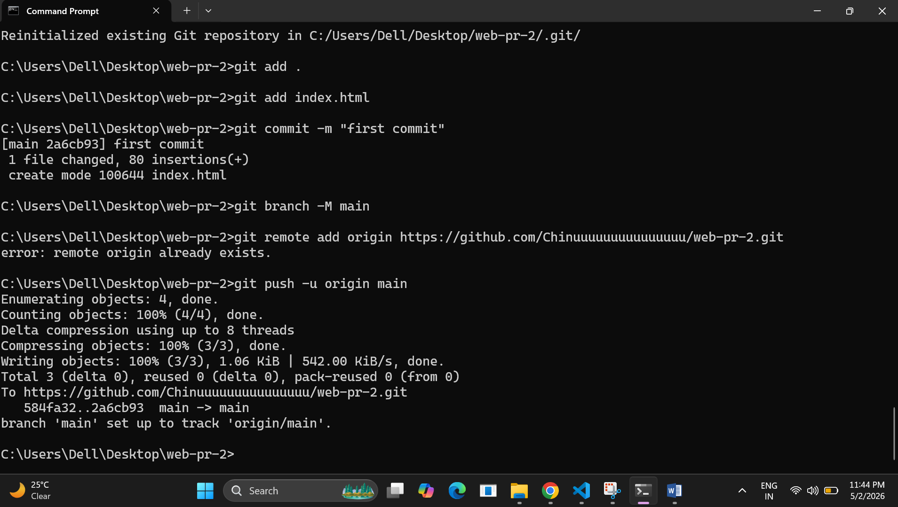
Do not enter password which u create while sign in
Instead of type personal access token
https://github.com/settings/tokens
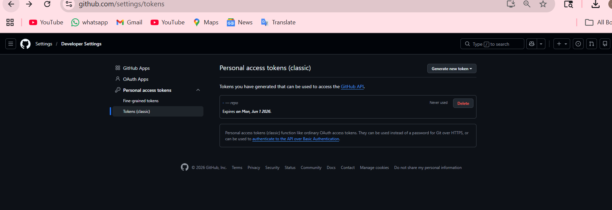
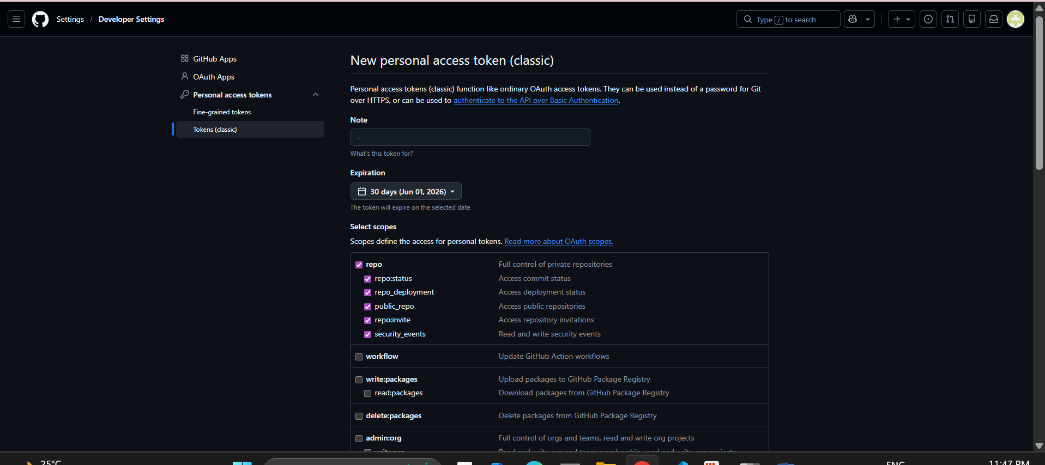
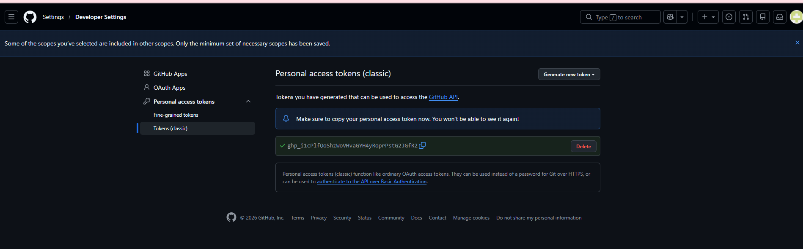
Final op
