**Email Investigation**

Step 1 Check Email Headers

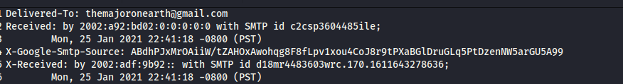

Step 2 Check For Authentication Protocol-> check that all three protocol are passed SRF,DKIM,DMARC



Step 3 File/Attachment Information

Decoding the base 64 pdf file to hex using cyberchef

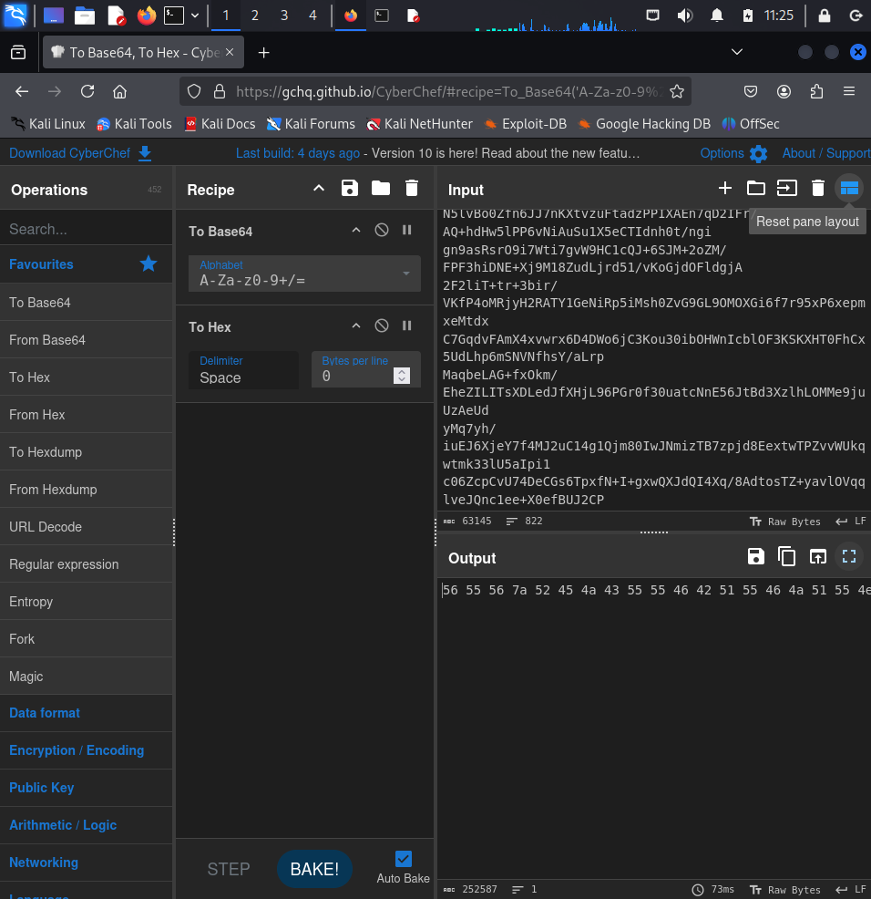

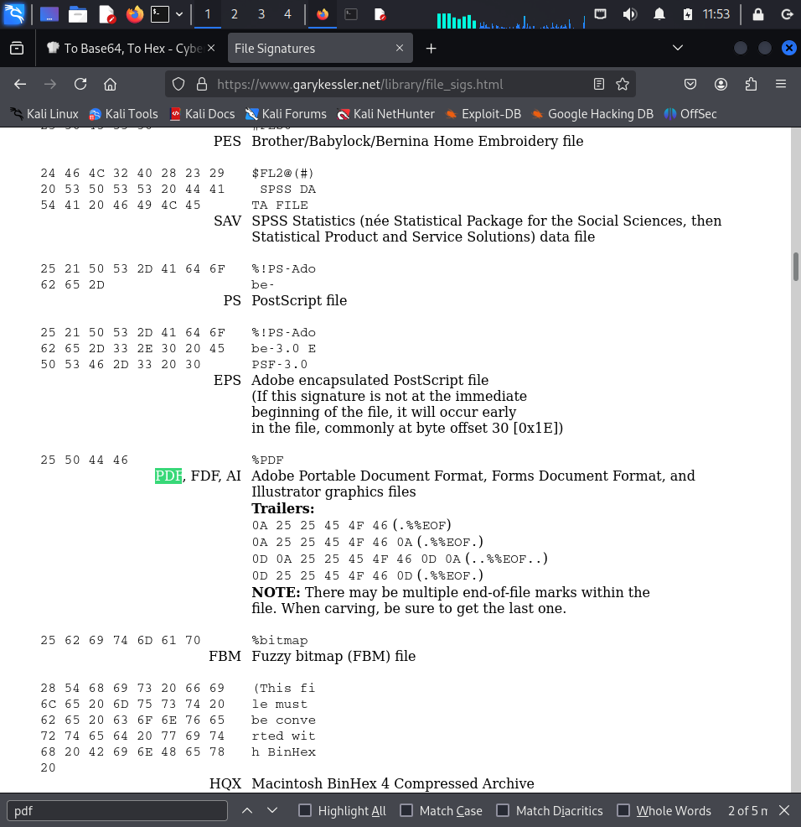

Both the Hex Value Doesn’t match

Now We Will Create a attach.zip file from the output of cyberchef and will extract it

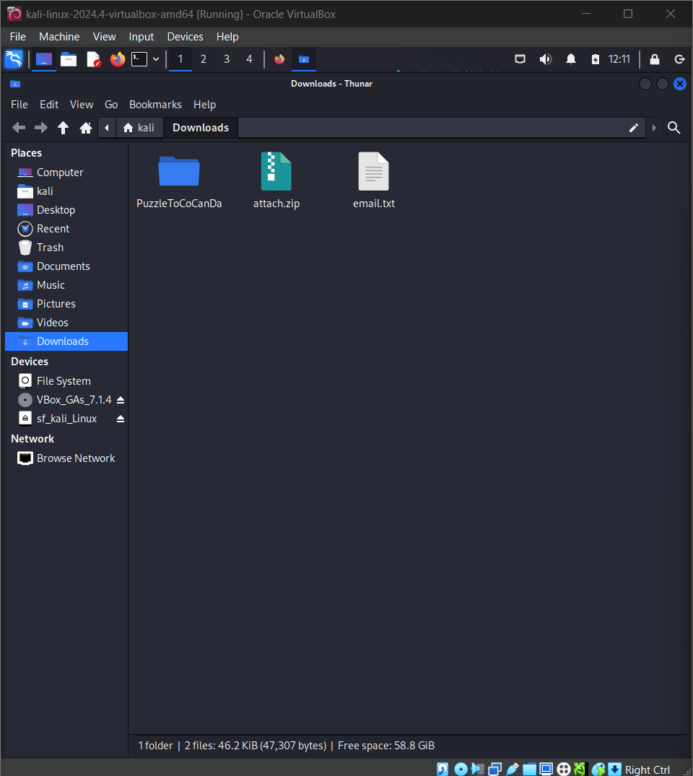

**Verification of Zip file**

**Installing Ghex-** sudo apt install ghex

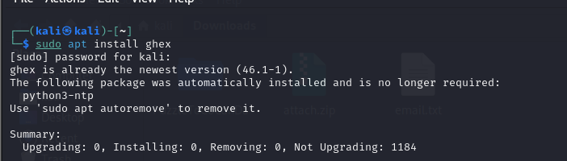

**To Scan all metadata at once**-exiftool -u PuzzleToCoCanDa/*

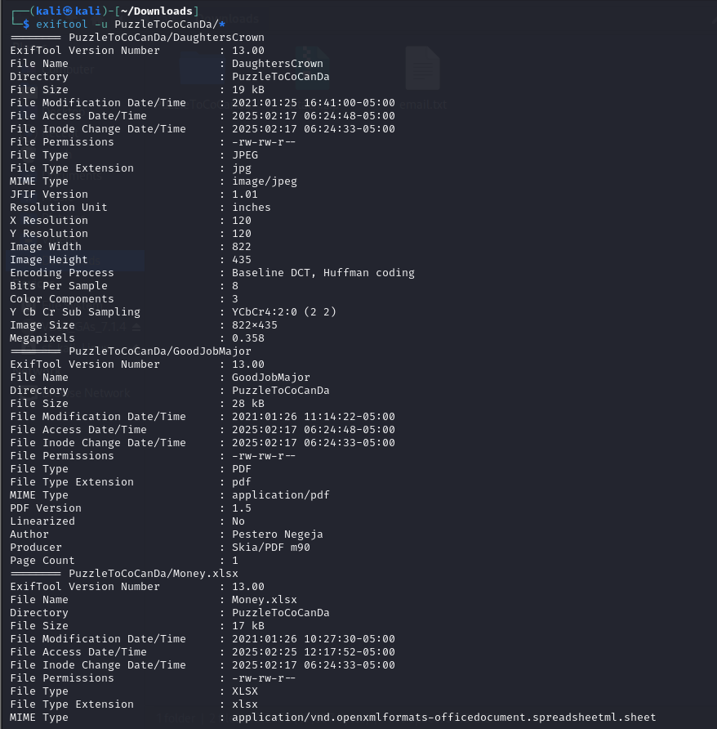

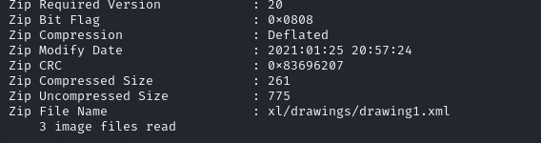

**To Check the Hex values of document-** ghex

1. **DaughtersCrown**

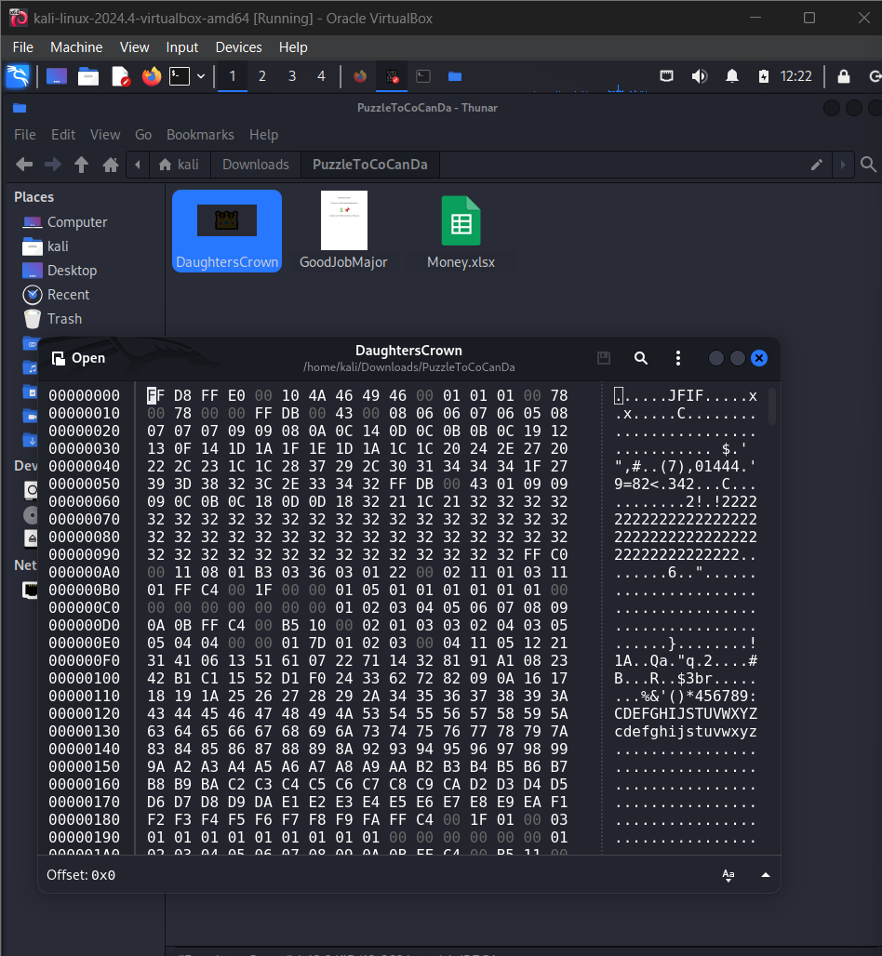

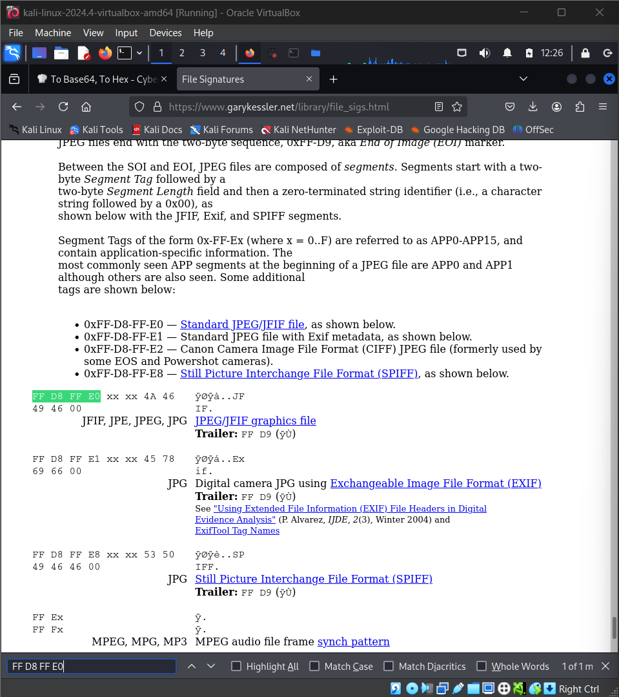

**Hex Value-Match**

1. **GoodJobMajor**

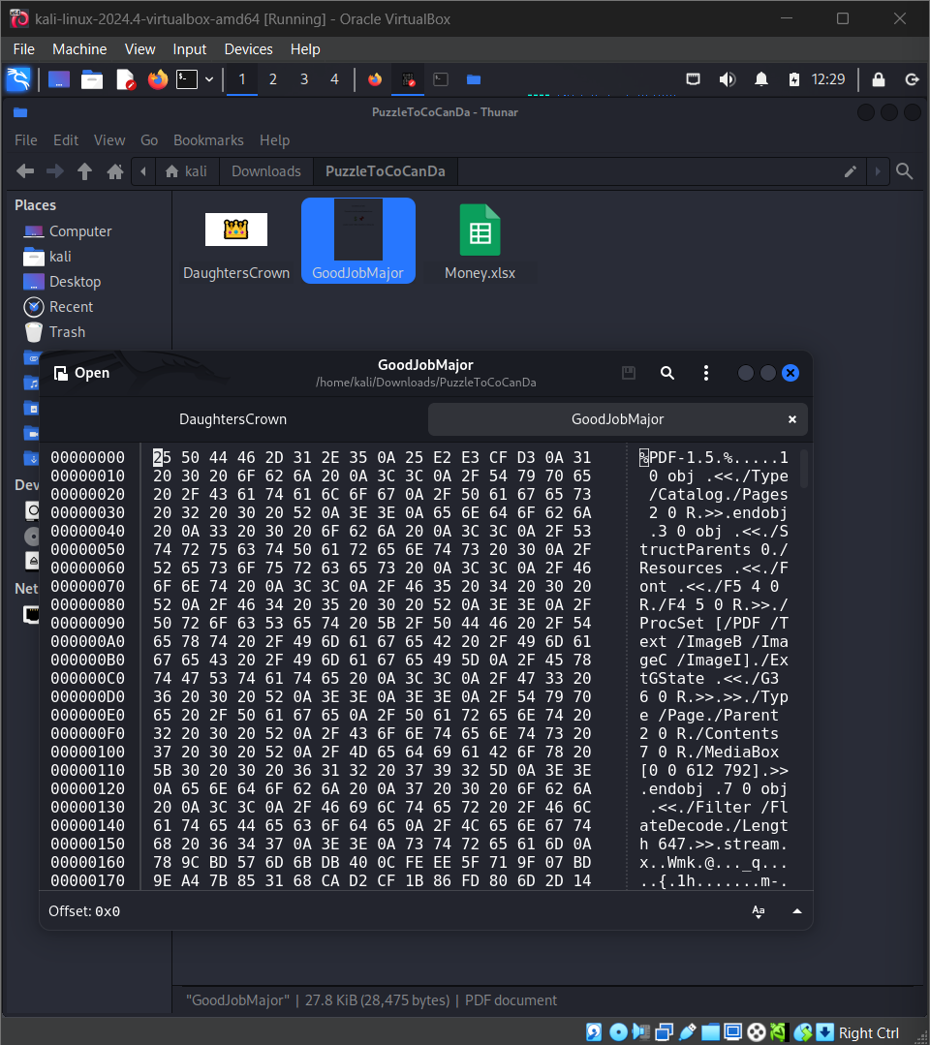

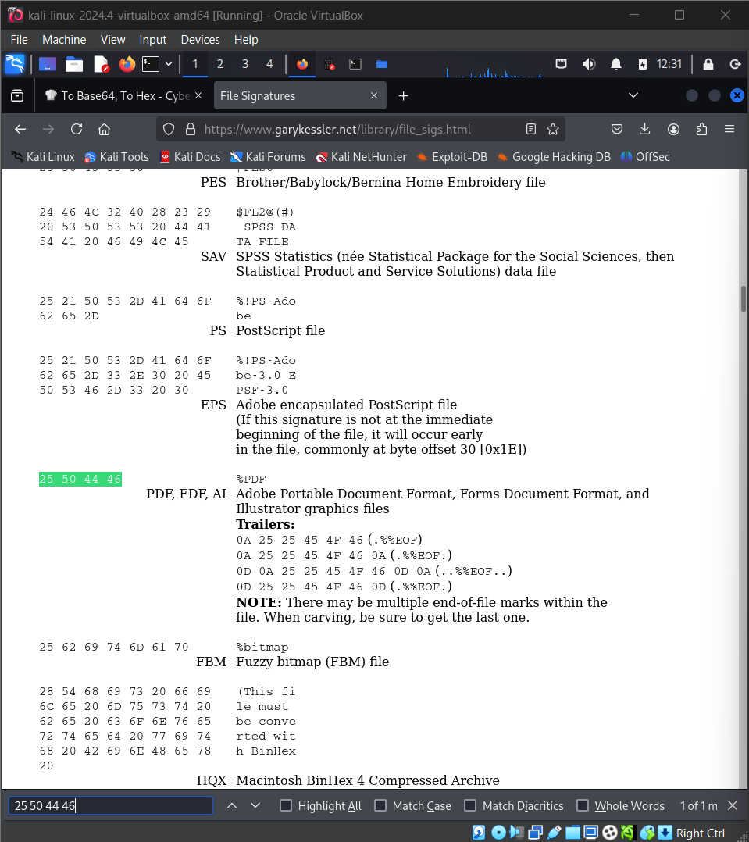

**Hex Value-Match**

1. **Money.xlsx**

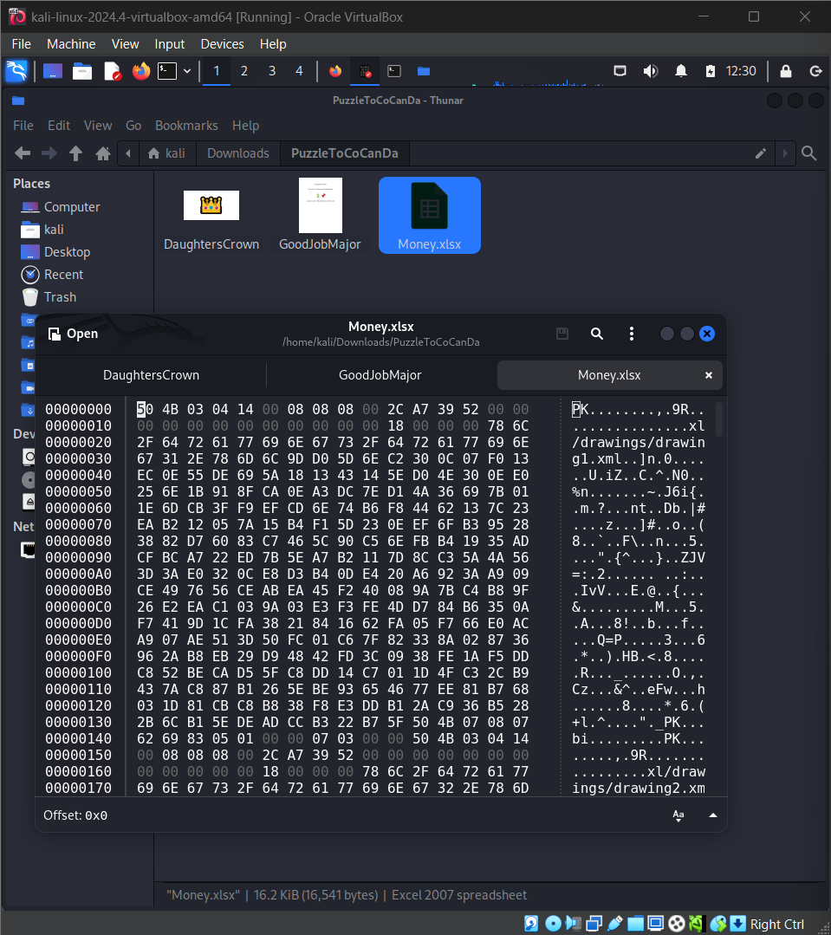

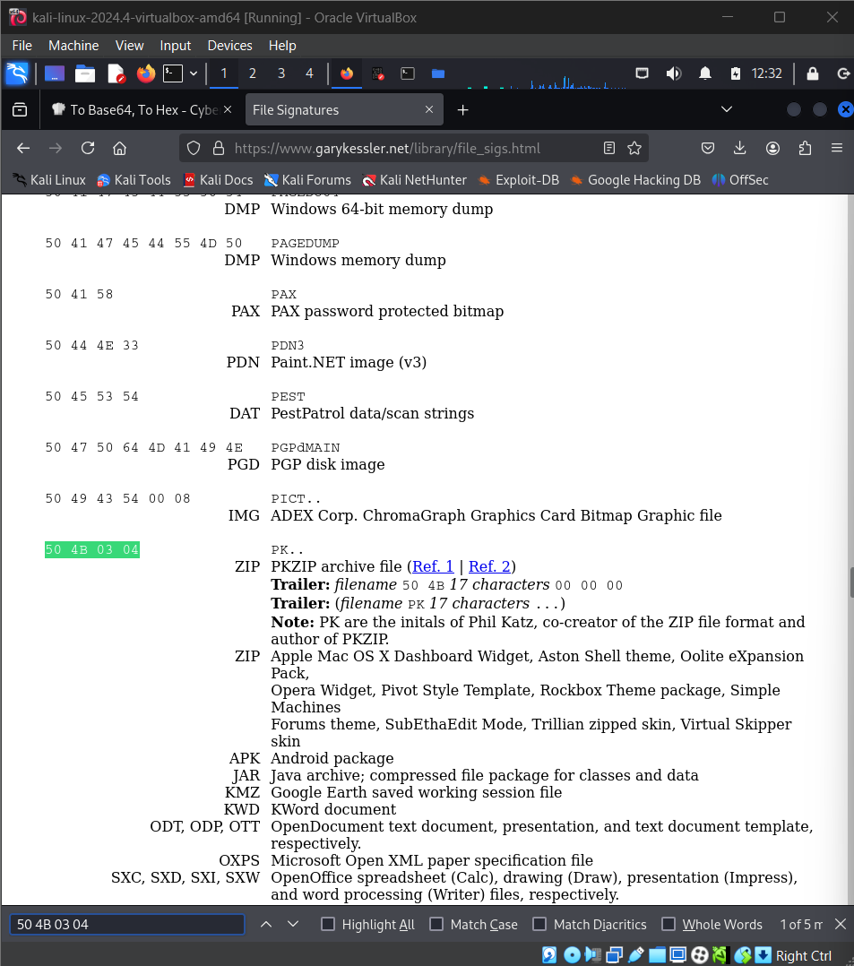

**Hex Value- MisMatch**

**Opening the Spreadsheet in google spreadsheet using fake gmail**

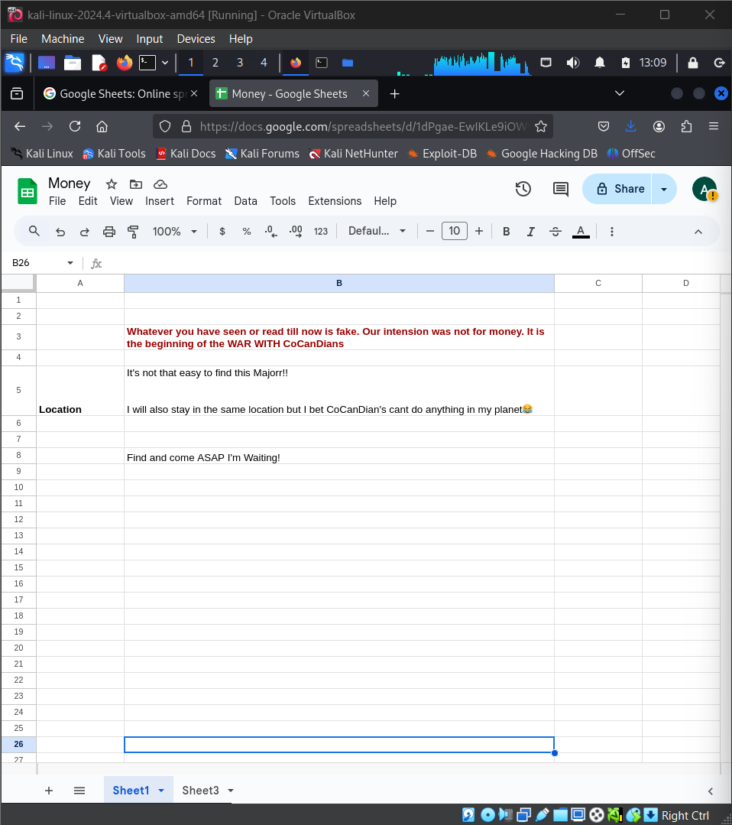

**Hidden Message found in Sheert 3**

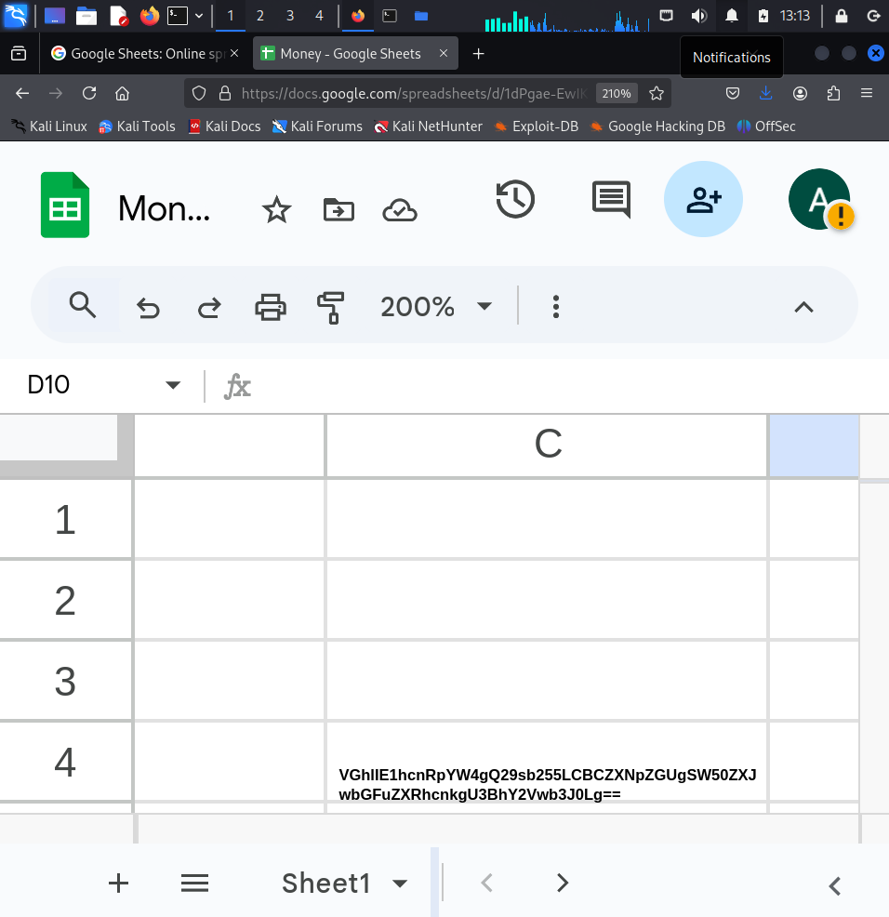

**Decoding it from base 64 Using Cyberchef- Found The Location**

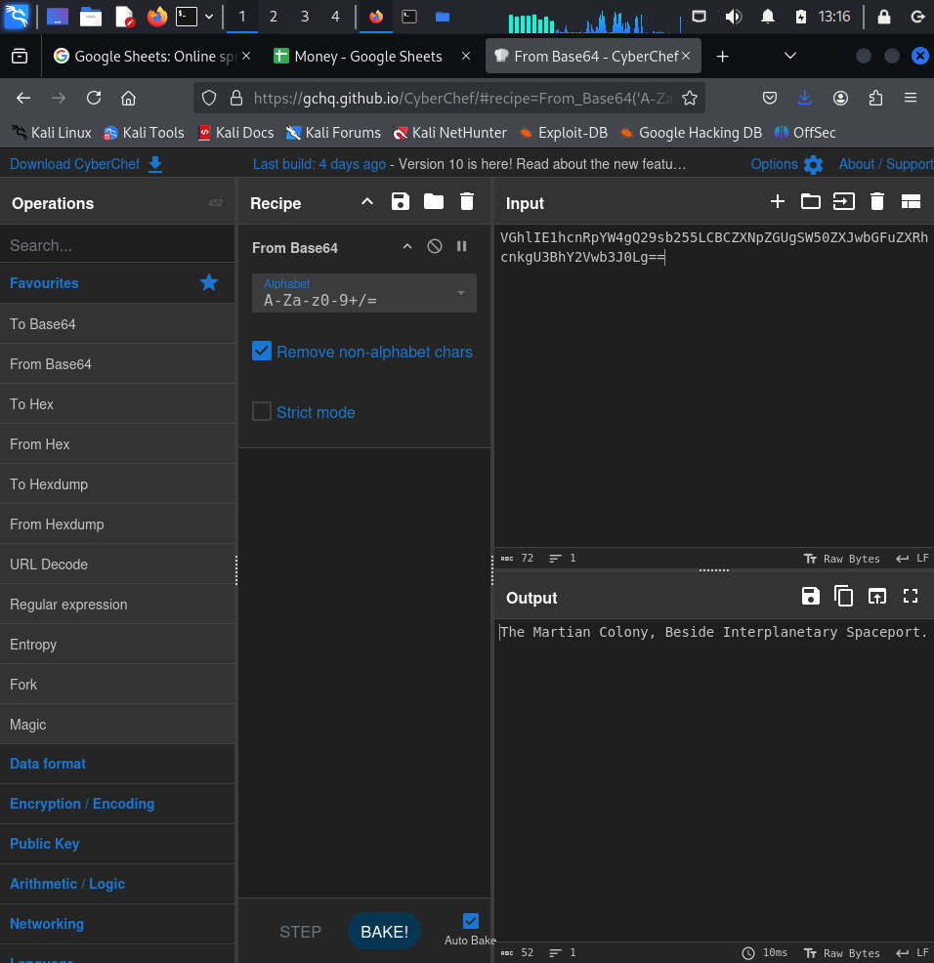

**Further Checking**

1. **traceout 93.99.104.210**

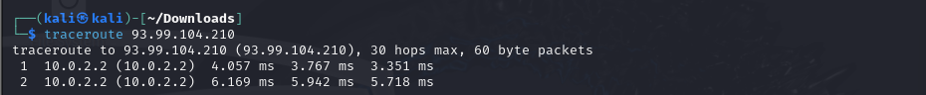

1. **nmap -sS 93.99.104.210**

