Nigeria Crude Oil Production Analysis
An Exploratory Data Analysis of OPEC Monthly Production Data (1973–2018)

Prepared by
Chinaemerem Eziaha Okolie

Institution:
Federal University of Technology Owerri (FUTO)

Department:
Computer Science

Course:
Data Analytics Portfolio Project

May 2026

Tools Used:
Microsoft Excel | DB Browser for SQLite | Power BI Desktop

Table of Contents
1. Introduction 1
1.1 Project Background 1
1.2 Objectives 1
1.3 Tools Used 1
1.4 Dataset Description 1
2. Data Cleaning & Preparation 2
2.1 Data Source 2
2.2 Column Renaming 2
2.3 Data Import 2
3. SQL Analysis 3
3.1 Q1: Nigeria's Monthly Production Trend 3
3.2 Q2: Nigeria's Average Production by Decade 6
3.3 Q3: Nigeria vs Total OPEC Contribution 7
3.4 Q4: Top 5 Highest Producing OPEC Countries 9
3.5 Q5: Nigeria's Best and Worst Production Years 12
3.6 Q6: Nigeria vs Saudi Arabia vs Iraq 13
3.7 Q7: OPEC Production Trend Over Decades 15
3.8 Q8: Nigeria's Production Boom & Bust Periods 17
4. Dashboard Overview 19
4.1 Page 1: Overview 19
4.2 Page 2: Nigeria Production Analysis 20
4.3 Page 3: OPEC Country Comparison 20
4.4 Page 4: Decade & Long-Term Trends 20
4.5 Page 5: Insights & Recommendations 20
5. Key Insights & Recommendations 21
5.1 Key Findings 21
5.2 Business Recommendations 22
5.2.1 Lessons from Saudi Arabia's Dominance 23
6. Conclusion 24
7. References 25

1. Introduction

1.1 Project Background
Nigeria is one of Africa's largest crude oil producers and a key member of the Organization of the Petroleum Exporting Countries (OPEC). This project analyzes Nigeria's crude oil production trends from 1973 to 2018 using monthly OPEC production data. The analysis explores Nigeria's production history, its contribution to total OPEC output, and how it compares to other major oil-producing nations.

1.2 Objectives
The objectives of this analysis are to:
1. Analyze Nigeria's monthly crude oil production trend from 1973 to 2018
2. Calculate Nigeria's percentage contribution to total OPEC production
3. Identify Nigeria's best and worst production years
4. Compare Nigeria's production against Saudi Arabia and Iraq
5. Identify production boom and bust periods
6. Present findings through an interactive Power BI dashboard

1.3 Tools Used
- Microsoft Excel: Data exploration and column renaming
- DB Browser for SQLite: SQL querying and data analysis
- Power BI Desktop: Interactive dashboard and visualizations

1.4 Dataset Description
- Source: Kaggle (OPEC Oil Data on a Monthly Basis)
- File: opec_monthly_production.csv
- Date Range: January 1973 - 2018
- Total Records: 547 rows
- Total Columns: 15
- Unit of Measurement: Thousand Barrels Per Day (Thousand B/D)
- Countries Covered: Algeria, Angola, Ecuador, Gabon, Iran, Iraq,
- Kuwait, Libya, Nigeria, Qatar, Saudi Arabia, UAE, Venezuela

2. Data Cleaning & Preparation

2.1 Data Source
The dataset was sourced from Kaggle and downloaded as a ZIP file containing one CSV file titled "OPEC oil data on a monthly basis.csv"

2.2 Column Renaming
To simplify SQL querying, column names were shortened in Excel
before import. The following renaming were applied:
  - "Crude Oil Production, Algeria" → Algeria
  - "Crude Oil Production, Angola" → Angola
  - "Crude Oil Production, Ecuador" → Ecuador
  - "Crude Oil Production, Gabon" → Gabon
  - "Crude Oil Production, Iran" → Iran
  - "Crude Oil Production, Iraq" → Iraq
  - "Crude Oil Production, Kuwait" → Kuwait
  - "Crude Oil Production, Libya" → Libya
  - "Crude Oil Production, Nigeria" → Nigeria
  - "Crude Oil Production, Qatar" → Qatar
  - "Crude Oil Production, Saudi Arabia" → Saudi_Arabia
  - "Crude Oil Production, United Arab Emirates" → UAE
  - "Crude Oil Production, Venezuela" → Venezuela
  - "Crude Oil Production, Total OPEC" → Total OPEC

2.3 Data Import
The cleaned CSV file was saved as opec_monthly_production.csv and imported into DB Browser for SQLite as a table named opec_monthly_production. The "First row contains field names" option was enabled during import to correctly assign column headers. No null values or duplicate rows were detected during initial exploration.

3. SQL Analysis

3.1 Q1: Nigeria's Monthly Production Trend
Objective:
To analyze how Nigeria's crude oil production has changed monthly from 1973 to 2018 and track Nigeria's percentage contribution to total OPEC production over time.
SQL Query:
-- Q1: Nigeria's Monthly Production Trend
SELECT
Month,
Nigeria,
`Total OPEC`,
ROUND ((Nigeria * 100.0 / `Total OPEC`), 2) AS Nigeria_OPEC_Share_Pct
FROM opec_monthly_production
ORDER BY Month ASC;

Explanation:
This query retrieves Nigeria's monthly crude oil production alongside total OPEC production from 1973 to 2018. The ROUND function calculates Nigeria's percentage contribution to total OPEC output each month, allowing us to track both Nigeria's absolute production volume and its relative influence within OPEC over time. Results are ordered chronologically from earliest to latest month.
Key Findings:
  - 547 months of data analyzed spanning 45 years (1973 — 2018)
  - Nigeria's production in April 1973 was 1,963 thousand B/D representing 6.68% of total OPEC output
  - Nigeria's production in May 2018 was 1,880 thousand B/D representing 5.37% of total OPEC output
  - Peak production was recorded in June/July 2005 at 2,695 thousand B/D - Nigeria's strongest output period
  - Lowest production was recorded in August 1981 at just 707 thousand B/D - reflecting the impact of the global oil glut and falling crude prices of the early 1980s
  - Nigeria's OPEC share declined from 6.68% in 1973 to 5.37% in 2018 suggesting other OPEC members grew production faster than Nigeria over this period
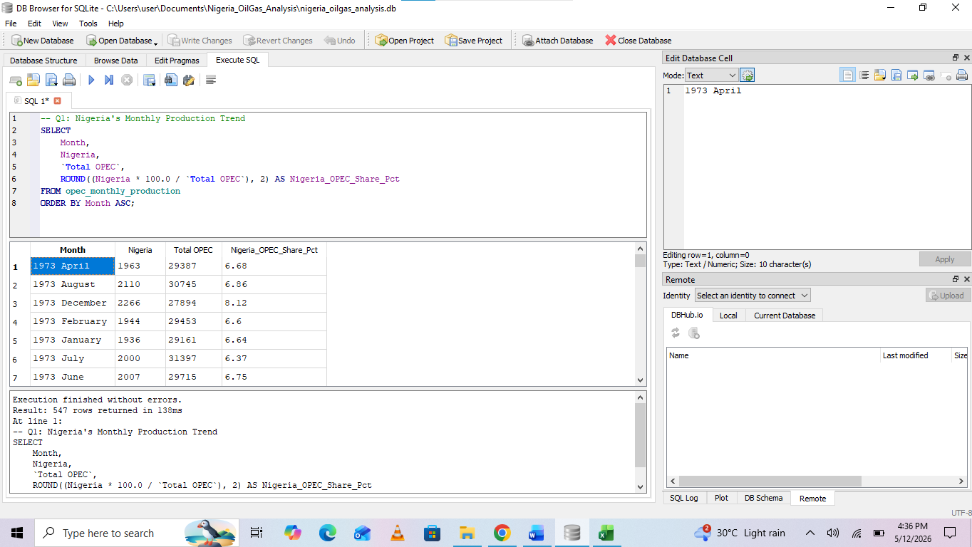
Figure 1. Nigeria's First Record (April 1973)
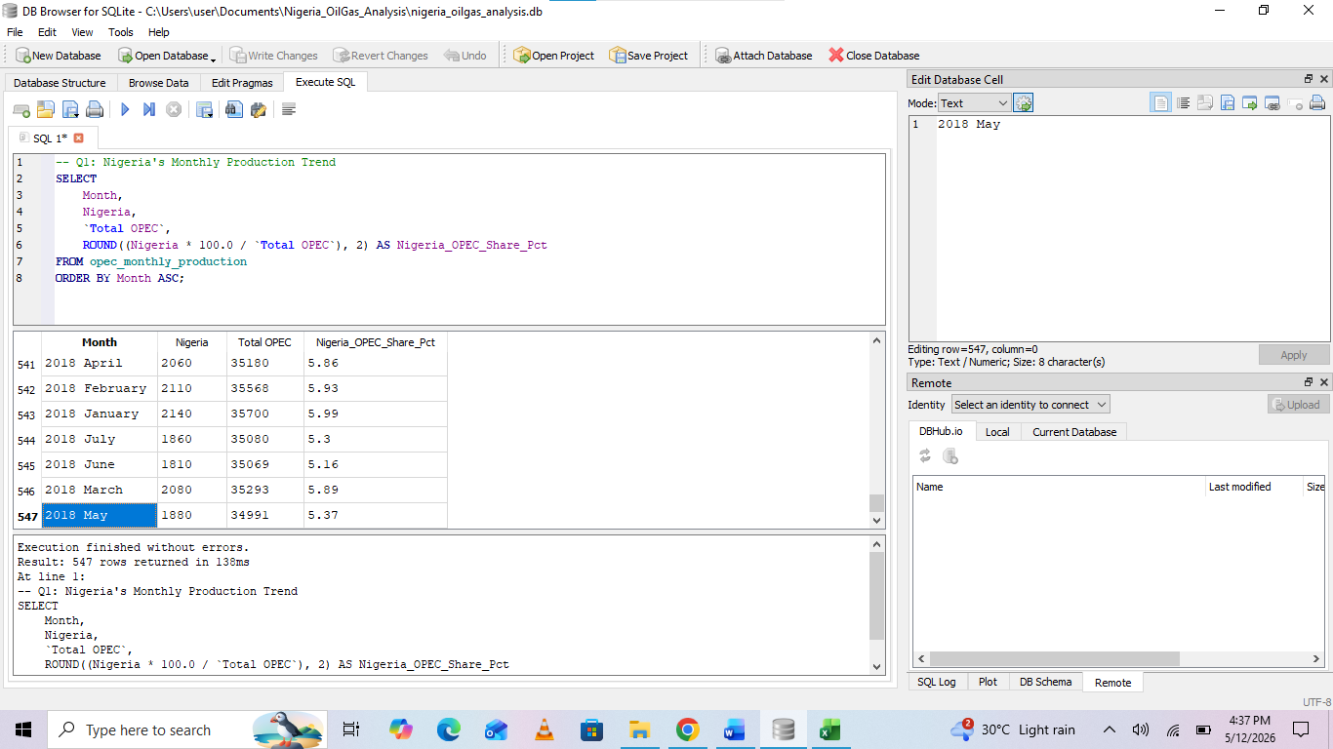
Figure 2. Nigeria's Last Record (May 2018)
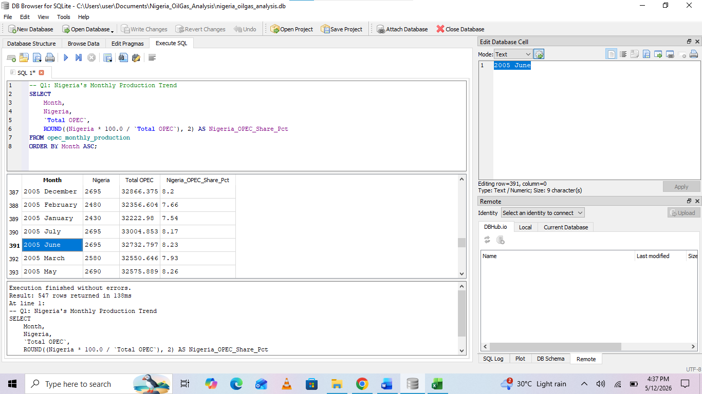
Figure 3. Nigeria's Peak Production (June/July 2005)

3.2 Q2: Nigeria's Average Production by Decade
Objective:
To analyze Nigeria's average crude oil production by decade and track how Nigeria's share of total OPEC production has evolved over each ten-year period from the 1970s to 2010s.
SQL Query:
-- Q2: Nigeria's Average Production by Decade
SELECT
CASE
WHEN Month LIKE '197%' THEN '1970s'
WHEN Month LIKE '198%' THEN '1980s'
WHEN Month LIKE '199%' THEN '1990s'
WHEN Month LIKE '200%' THEN '2000s'
WHEN Month LIKE '201%' THEN '2010s'
END AS Decade,
ROUND(AVG(Nigeria), 2) AS Avg_Nigeria_Production,
ROUND(AVG(`Total OPEC`), 2) AS Avg_OPEC_Production,
ROUND((AVG(Nigeria) * 100.0 / AVG(`Total OPEC`)), 2) AS Avg_Nigeria_Share_Pct
FROM opec_monthly_production
GROUP BY Decade
ORDER BY Decade ASC;

Explanation:
This query uses a CASE statement to group monthly records into decades based on the year portion of the Month column. The AVG function calculates the average production for Nigeria and total OPEC within each decade. The percentage share is calculated by dividing Nigeria's average production by the average total OPEC production and multiplying by 100. Results are grouped and ordered by decade chronologically.
Key Findings:
  - Five decades of data analyzed from the 1970s to 2010s
  - Nigeria's highest average production was in the 2000s at 2,293.32 thousand B/D
  - Nigeria's lowest average production was in the 1980s at 1,488.03 thousand B/D reflecting the global oil glut and price crash of that era
  - Nigeria's highest OPEC share was in the 1980s and 1990s at 7.79% each; notably because total OPEC production also fell sharply in the 1980s
  - Nigeria's OPEC share has been declining in the 2010s dropping to 6.53% as other members ramped up production
  - Total OPEC production grew significantly from 28,916 thousand B/D in the 1970s to 34,178 thousand B/D in the 2010s showing overall cartel expansion
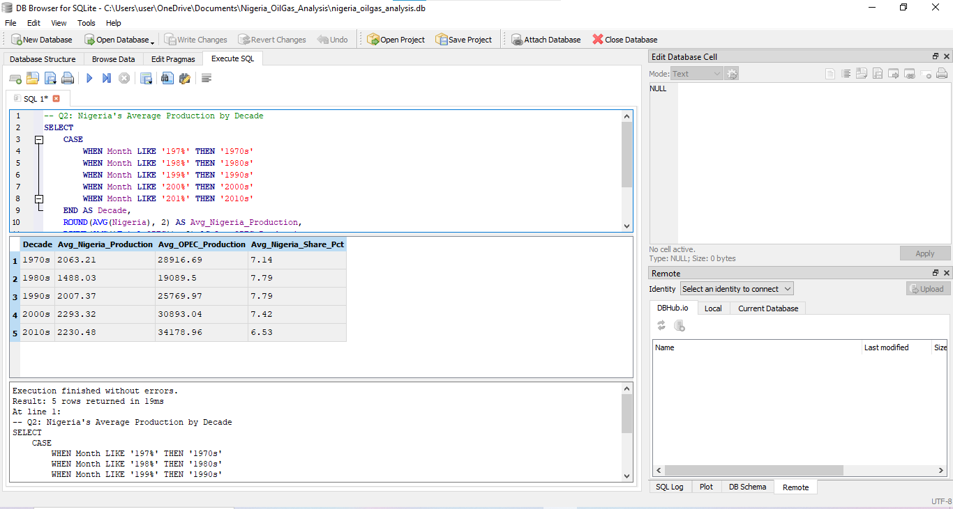
Figure 4. Nigeria's Average Production by Decade

3.3 Q3: Nigeria vs Total OPEC Contribution
Objective:
To calculate Nigeria's overall contribution to total OPEC production across the entire dataset, including average, peak, lowest and cumulative production figures.
SQL Query:
-- Q3: Nigeria vs Total OPEC Contribution
SELECT
ROUND(AVG(Nigeria), 2) AS Avg_Nigeria_Production,
ROUND(AVG(`Total OPEC`), 2) AS Avg_OPEC_Production,
ROUND((AVG(Nigeria) * 100.0 / AVG(`Total OPEC`)), 2) AS Avg_Nigeria_Share_Pct,
ROUND(MAX(Nigeria), 2) AS Peak_Nigeria_Production,
ROUND(MIN(Nigeria), 2) AS Lowest_Nigeria_Production,
ROUND(SUM(Nigeria), 2) AS Total_Nigeria_Production
FROM opec_monthly_production;

Explanation:
This query calculates overall summary statistics for Nigeria's crude oil production across all 547 months. AVG computes the monthly average for both Nigeria and total OPEC production. MAX and MIN identify Nigeria's highest and lowest single month production figures respectively. SUM calculates Nigeria's total cumulative production across the entire period. The percentage share shows Nigeria's average contribution to OPEC output over the full 45-year period.
Key Findings:
  - Nigeria averaged 2,006.76 thousand barrels per day over the entire 45-year period
  - Nigeria consistently contributed an average of 7.30% to total OPEC production
  - Nigeria's peak single month production was 2,695.00 thousand B/D
  - Nigeria's lowest single month production was 675.00 thousand B/D; a dramatic drop likely due to political instability or militant activity
  - Nigeria's total cumulative production across all 547 months was 1,097,695.50 thousand barrels; nearly 1.1 billion thousand barrels over 45 years
  - The gap between peak (2,695) and lowest (675) production shows significant volatility in Nigeria's output highlighting the impact of external shocks on production
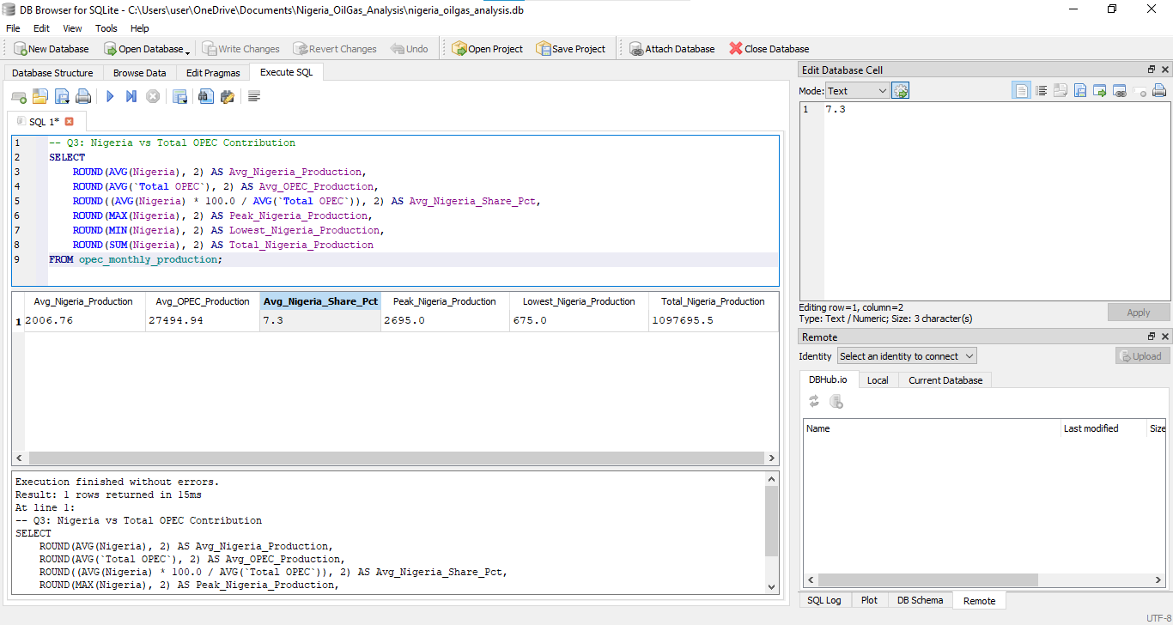Figure 5. Nigeria vs Total OPEC Contribution

3.4 Q4: Top 5 Highest Producing OPEC Countries
Objective:
To identify the top 5 highest producing OPEC member countries by average monthly crude oil production across the entire period from 1973 to 2018.
SQL Query:
-- Q4: Top 5 Highest Producing OPEC Countries
SELECT
'Algeria' AS Country, ROUND(AVG(Algeria), 2) AS Avg_Production FROM opec_monthly_production
UNION ALL
SELECT 'Angola', ROUND(AVG(Angola), 2) FROM opec_monthly_production
UNION ALL
SELECT 'Ecuador', ROUND(AVG(Ecuador), 2) FROM opec_monthly_production
UNION ALL
SELECT 'Gabon', ROUND(AVG(Gabon), 2) FROM opec_monthly_production
UNION ALL
SELECT 'Iran', ROUND(AVG(Iran), 2) FROM opec_monthly_production
UNION ALL
SELECT 'Iraq', ROUND(AVG(Iraq), 2) FROM opec_monthly_production
UNION ALL
SELECT 'Kuwait', ROUND(AVG(Kuwait), 2) FROM opec_monthly_production
UNION ALL
SELECT 'Libya', ROUND(AVG(Libya), 2) FROM opec_monthly_production
UNION ALL
SELECT 'Nigeria', ROUND(AVG(Nigeria), 2) FROM opec_monthly_production
UNION ALL
SELECT 'Qatar', ROUND(AVG(Qatar), 2) FROM opec_monthly_production
UNION ALL
SELECT 'Saudi Arabia', ROUND(AVG(`Saudi Arabia`), 2) FROM opec_monthly_production
UNION ALL
SELECT 'United Arab Emirates', ROUND(AVG(`United Arab Emirates`), 2) FROM opec_monthly_production
UNION ALL
SELECT 'Venezuela', ROUND(AVG(Venezuela), 2) FROM opec_monthly_production
ORDER BY Avg_Production DESC
LIMIT 5;
Explanation:
Since each country's production is stored in separate columns, a UNION ALL statement is used to unpivot the data; combining all 13 countries into a single column for comparison. AVG calculates the average monthly production for each country across all available months. Results are ordered by average production in descending order and limited to the top 5 using the LIMIT clause.
Key Findings:
  - Saudi Arabia is the dominant OPEC producer by a significant margin averaging 8,094.05 thousand B/D; nearly double the second highest producer Iran at 3,623.43 thousand B/D
  - Venezuela ranks third with an average of 2,406.83 thousand B/D
  - United Arab Emirates and Iraq round out the top 5 with averages of 2,185.71 and 2,115.26 thousand B/D respectively
  - Nigeria with an average of 2,006.76 thousand B/D narrowly missed the top 5 ranking sixth overall among OPEC members
  - Saudi Arabia's average production is approximately 4 times that of Nigeria highlighting the significant gap between the cartel's largest and mid-tier producers
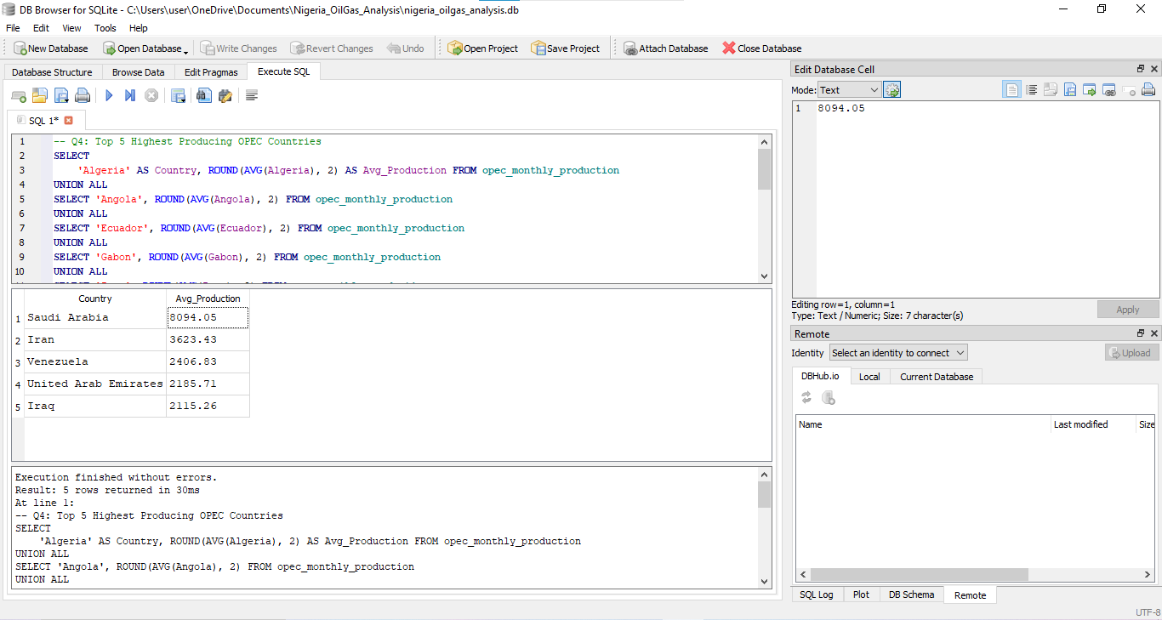
Figure 6. Top 5 Highest Producing OPEC

3.5 Q5: Nigeria's Best and Worst Production Years
Objective:
To identify Nigeria's best and worst crude oil production years by calculating average annual production, peak monthly production and lowest monthly production for each year from 1973 to 2018.
SQL Query:
-- Q5: Nigeria's Best and Worst Production Years
SELECT
SUBSTR(Month, 1, 4) AS Year,
ROUND(AVG(Nigeria), 2) AS Avg_Annual_Production,
ROUND(MAX(Nigeria), 2) AS Peak_Monthly_Production,
ROUND(MIN(Nigeria), 2) AS Lowest_Monthly_Production
FROM opec_monthly_production
GROUP BY Year
ORDER BY Avg_Annual_Production DESC;
Explanation:
This query uses the SUBSTR function to extract the first 4 characters of the Month column to isolate the year. AVG, MAX and MIN functions calculate the average, peak and lowest monthly production for each year respectively. Results are grouped by year and ordered by average annual production in descending order, placing the best performing years at the top and worst performing years at the bottom.
Key Findings:
  - 46 years of annual production data analyzed
  - Nigeria's best production year was 2005 with an average of 2,626.67 thousand B/D and a peak of 2,695.00 thousand B/D in a single month
  - 2011 and 2012 were also strong years averaging 2,474.08 and 2,457.08 thousand B/D respectively suggesting the early 2010s were a period of sustained high output
  - Nigeria's worst production year was 1983 with an average of just 1,237.08 thousand B/D and a record low of 675.00 thousand B/D in a single month
  - 1982 and 1983 were Nigeria's two worst consecutive years coinciding with the global oil price crash and OPEC production quota disputes of the early 1980s
  - The gap between the best year (2005: 2,626.67) and worst year (1983: 1,237.08) is 1,389.59 thousand B/D highlighting the extreme volatility in Nigeria's production history
  - 1987 rounds out the three worst years with an average of 1,339.58 thousand B/D reflecting continued production struggles throughout the mid to late 1980s
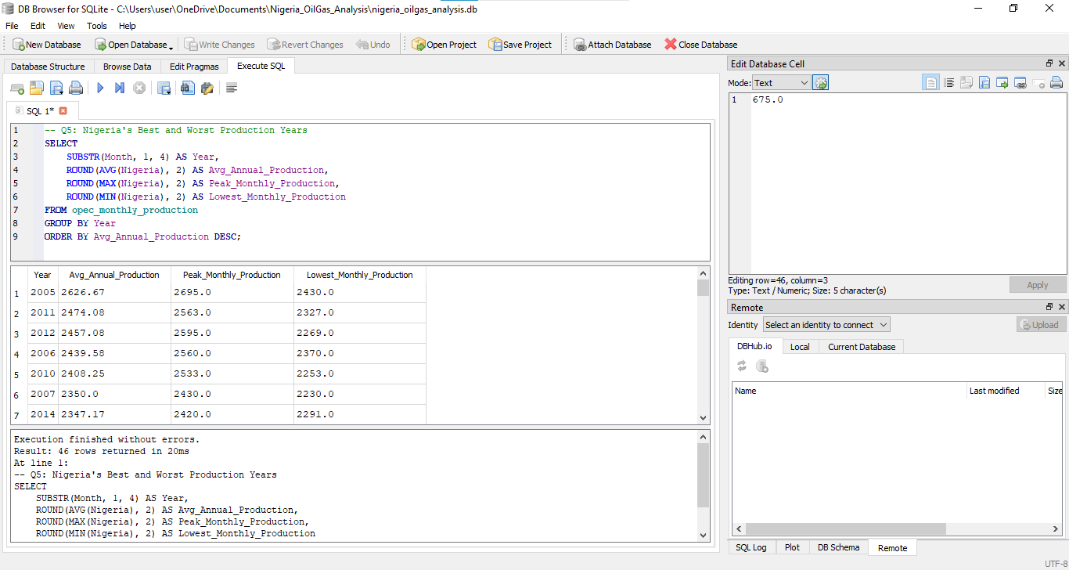
Figure 7. Nigeria's Best and Worst Production Years

3.6 Q6: Nigeria vs Saudi Arabia vs Iraq
Objective:
To compare Nigeria's average crude oil production against Saudi Arabia and Iraq on a decade-by-decade basis from the 1970s to 2010s, identifying production gaps and trends among these three major OPEC producers.
SQL Query:
-- Q6: Nigeria vs Saudi Arabia vs Iraq Comparison
SELECT
CASE
WHEN Month LIKE '197%' THEN '1970s'
WHEN Month LIKE '198%' THEN '1980s'
WHEN Month LIKE '199%' THEN '1990s'
WHEN Month LIKE '200%' THEN '2000s'
WHEN Month LIKE '201%' THEN '2010s'
END AS Decade,
ROUND(AVG(Nigeria), 2) AS Avg_Nigeria,
ROUND(AVG(`Saudi Arabia`), 2) AS Avg_Saudi_Arabia,
ROUND(AVG(Iraq), 2) AS Avg_Iraq
FROM opec_monthly_production
GROUP BY Decade
ORDER BY Decade ASC;

Explanation:
This query uses a CASE WHEN statement to group monthly records into decades using the LIKE operator with a wildcard (%) to match years starting with 197, 198, 199, 200 and 201. AVG calculates the average monthly production for Nigeria, Saudi Arabia and Iraq within each decade. Backticks are used around Saudi Arabia because its column name contains a space. Results are grouped by decade and ordered chronologically.
Key Findings:
  - Saudi Arabia consistently dominates production across all five decades averaging between 5,861.46 and 9,827.06 thousand B/D; far exceeding both Nigeria and Iraq
  - Saudi Arabia's production grew from 8,400.01 thousand B/D in the 1970s to 9,827.06 thousand B/D in the 2010s showing sustained and growing output
  - Iraq experienced a dramatic production collapse in the 1990s dropping to just 1,081.20 thousand B/D; directly attributable to the Gulf War (1990-1991) and subsequent UN economic sanctions
  - Iraq has shown the strongest recovery in the 2010s reaching 3,495.17 thousand B/D surpassing its 1970s levels as post invasion reconstruction boosted output
  - Nigeria maintained relatively stable production across all decades ranging between 1,488.03 and 2,293.32 thousand B/D without the extreme shocks seen in Iraq
  - The production gap between Saudi Arabia and Nigeria widened in the 2010s with Saudi Arabia producing approximately 4.4 times more than Nigeria
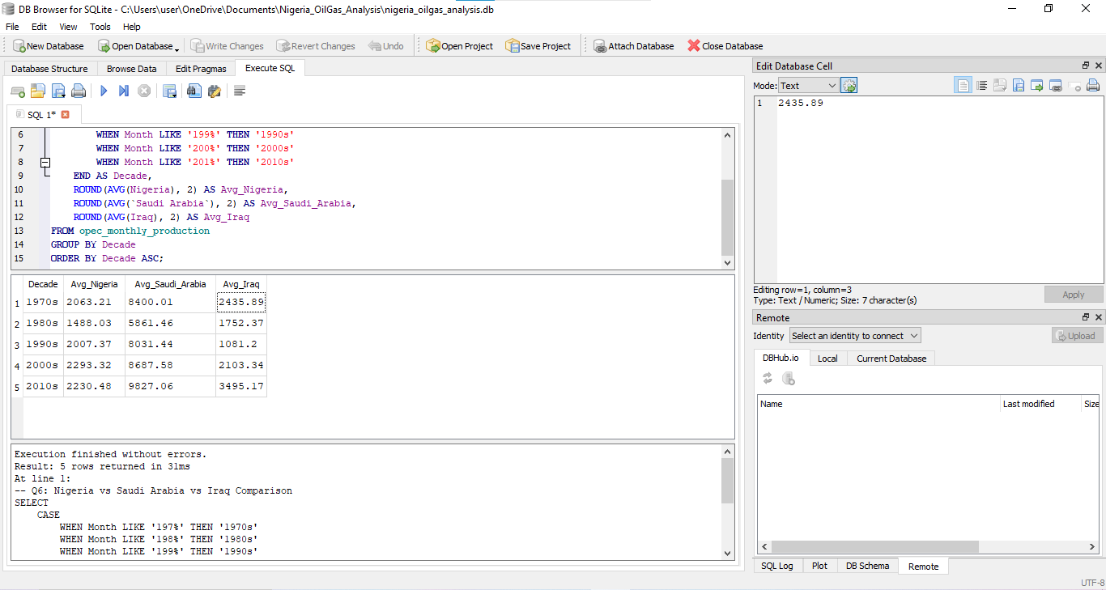Figure 8. Nigeria vs Saudi Arabia vs Iraq by Decade

3.7 Q7: OPEC Production Trend Over Decades
Objective:
To analyze total OPEC crude oil production trends across each decade from the 1970s to 2010s, identifying periods of growth, decline and stability in overall cartel output.
SQL Query:
-- Q7: OPEC Production Trend Over Decades
SELECT
CASE
WHEN Month LIKE '197%' THEN '1970s'
WHEN Month LIKE '198%' THEN '1980s'
WHEN Month LIKE '199%' THEN '1990s'
WHEN Month LIKE '200%' THEN '2000s'
WHEN Month LIKE '201%' THEN '2010s'
END AS Decade,
ROUND(AVG(`Total OPEC`), 2) AS Avg_OPEC_Production,
ROUND(MAX(`Total OPEC`), 2) AS Peak_OPEC_Production,
ROUND(MIN(`Total OPEC`), 2) AS Lowest_OPEC_Production
FROM opec_monthly_production
GROUP BY Decade
ORDER BY Decade ASC;

Explanation:
This query uses the same CASE WHEN decade grouping pattern as previous queries. AVG, MAX and MIN functions calculate the average, peak and lowest total OPEC production for each decade respectively. The Total OPEC column is wrapped in backticks because it contains a space in its column name. Results are grouped by decade and ordered chronologically to reveal long term production trends across the cartel.
Key Findings:
  - Total OPEC production has grown overall from an average of 28,916.69 thousand B/D in the 1970s to 34,178.96 thousand B/D in the 2010s representing an 18.2% increase over 45 years
  - The 1980s saw the most dramatic collapse in OPEC production with average output dropping to just 19,089.50 thousand B/D; a 34% decline from the 1970s driven by falling global oil demand, the oil price crash and internal OPEC quota disputes
  - The 1980s also recorded the lowest single month OPEC production of 13,711.00 thousand B/D reflecting the severity of the production cuts during that period
  - OPEC recovered strongly through the 1990s and 2000s reaching a new peak average of 30,893.04 thousand B/D in the 2000s driven by rising global energy demand
  - The 2010s is the most stable decade with the smallest gap between peak (36,475.85) and lowest (32,134.50) production suggesting better cartel coordination and quota management
  - The 2010s recorded the highest ever average OPEC production of 34,178.96 thousand B/D and the highest single month peak of 36,475.85 thousand B/D
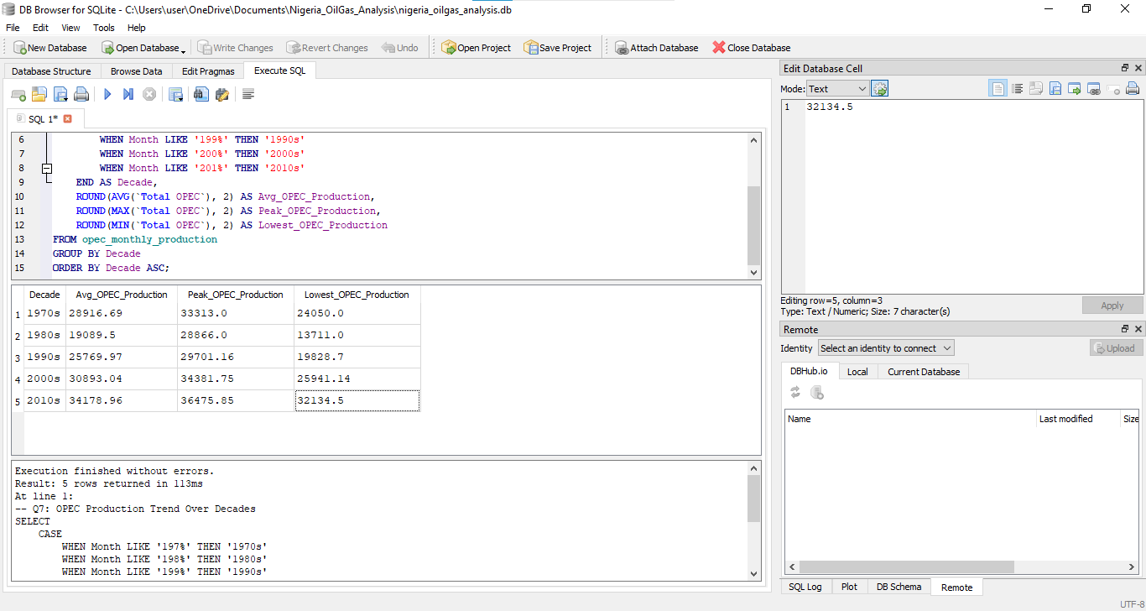Figure 9. OPEC Production Trend Over Decades

3.8 Q8: Nigeria's Production Boom & Bust Periods
Objective:
To classify each year of Nigeria's crude oil production history as a Boom, Bust or Stable period based on average annual production thresholds, identifying patterns and cycles in Nigeria's production history from 1973 to 2018.
SQL Query:
-- Q8: Nigeria's Production Boom & Bust Periods
SELECT
SUBSTR(Month, 1, 4) AS Year,
ROUND(AVG(Nigeria), 2) AS Avg_Annual_Production,
CASE
WHEN AVG(Nigeria) >= 2200 THEN 'Boom'
WHEN AVG(Nigeria) <= 1500 THEN 'Bust'
ELSE 'Stable'
END AS Period_Type
FROM opec_monthly_production
GROUP BY Year
ORDER BY Year ASC;
Explanation:
This query uses SUBSTR to extract the year from the Month column and AVG to calculate average annual production. A CASE WHEN statement then classifies each year into three categories based on production thresholds. Years averaging 2,200 thousand B/D or above are classified as Boom periods, years averaging 1,500 thousand B/D or below are classified as Bust periods, and all years in between are classified as Stable periods. Results are grouped by year and ordered chronologically to reveal Nigeria's production cycles over 45 years.
Key Findings:
  - 46 years of Nigeria's production history classified into three distinct periods
  - Nigeria experienced 14 Boom years, 8 Bust years and 24 Stable years between 1973 and 2018
  - The most severe period was 1981-1988; 8 consecutive Bust years driven by the global oil price crash, falling demand and OPEC production quota disputes
  - Nigeria's golden production era was 2003-2007 with 5 consecutive Boom years peaking at 2,626.67 thousand B/D in 2005
  - 2009 remarkably recovered to Boom status despite the global financial crisis of 2008-2009 showing resilience in Nigeria's production capacity
  - Production declined back to Stable in 2016 and 2017 largely due to Niger Delta militant attacks and pipeline vandalism disrupting output
  - Nigeria has never recorded two consecutive Boom periods separated by more than one Stable year suggesting structural challenges prevent sustained long term production growth
  - The early 2010s (2010-2014) represent Nigeria's longest consecutive Boom streak of 5 years reflecting improved security and investment in the Niger Delta region
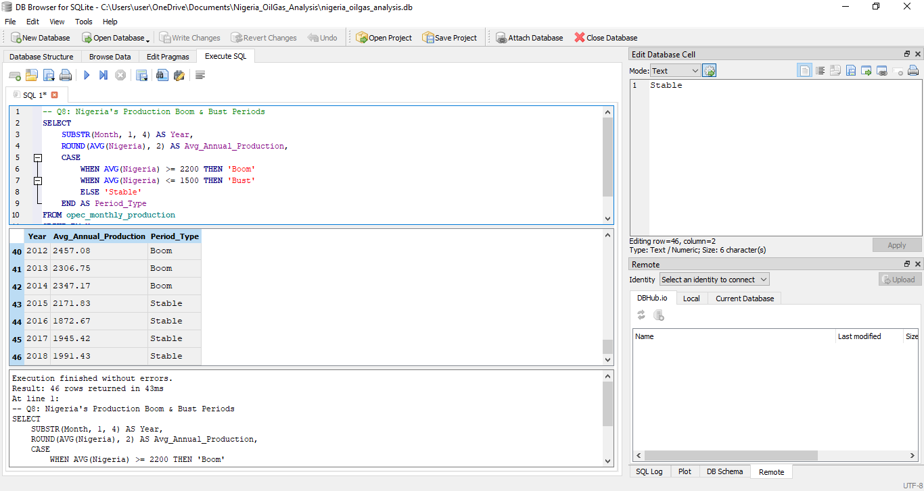Figure 10. Nigeria's Production Boom & Bust Periods

4. Dashboard Overview

4.1 Page 1: Overview
Purpose: High level summary of the entire dataset
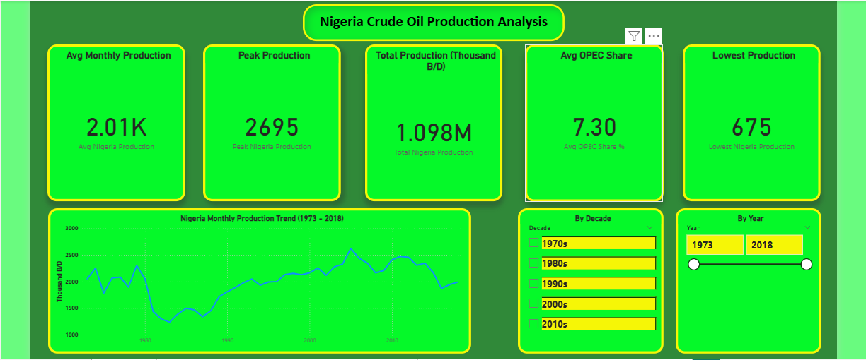
Figure 11. Dashboard Page 1 — Overview
Visuals:
  - KPI Card: Total Nigeria Production (sum)
  - KPI Card: Average Nigeria Monthly Production
  - KPI Card: Nigeria's Average OPEC Share (7.30%)
  - KPI Card: Peak Production Month (June/July 2005)
  - Line Chart: Nigeria's Monthly Production Trend 1973-2018

4.2 Page 2: Nigeria Production Analysis
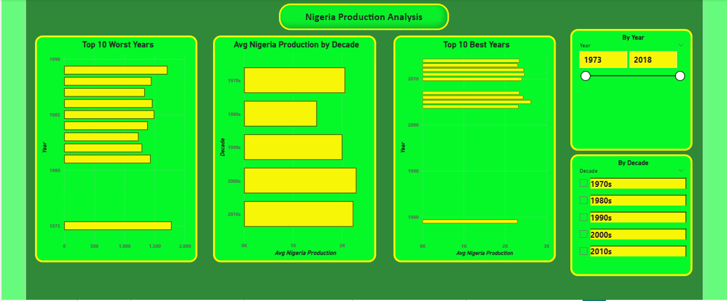
Purpose: Deep dive into Nigeria's production history
Figure 12. Dashboard Page 2 — Nigeria Production Analysis

Visuals:
  - Bar Chart: Average Production by Decade
  - Bar Chart: Top 10 Best Production Years
  - Bar Chart: Top 10 Worst Production Years
  - Line Chart: Boom vs Bust periods over time

4.3 Page 3: OPEC Country Comparison
Purpose: How Nigeria compares to other OPEC members
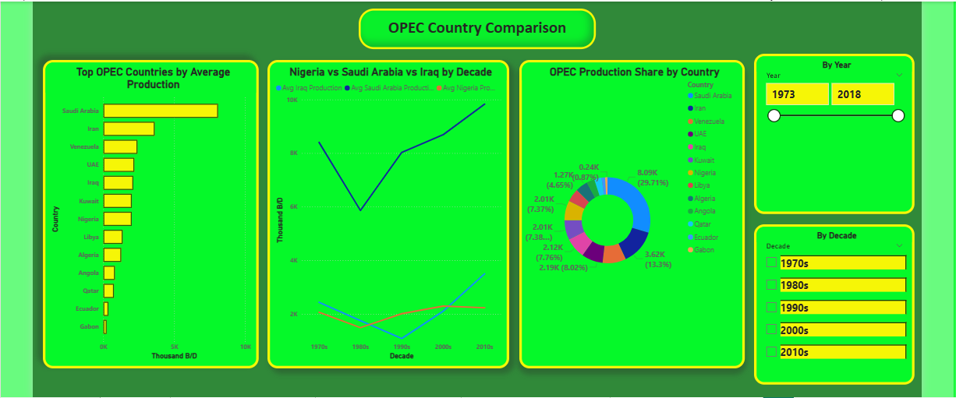
Figure 13. Dashboard Page 3 — OPEC Country Comparison
Visuals:
  - Bar Chart: Top 5 OPEC Countries by Average Production
  - Line Chart: Nigeria vs Saudi Arabia vs Iraq by Decade
  - Donut Chart: Each Country's Share of Total OPEC Production

4.4 Page 4: Decade & Long-Term Trends
Purpose: Macro level OPEC and Nigeria trends over decades
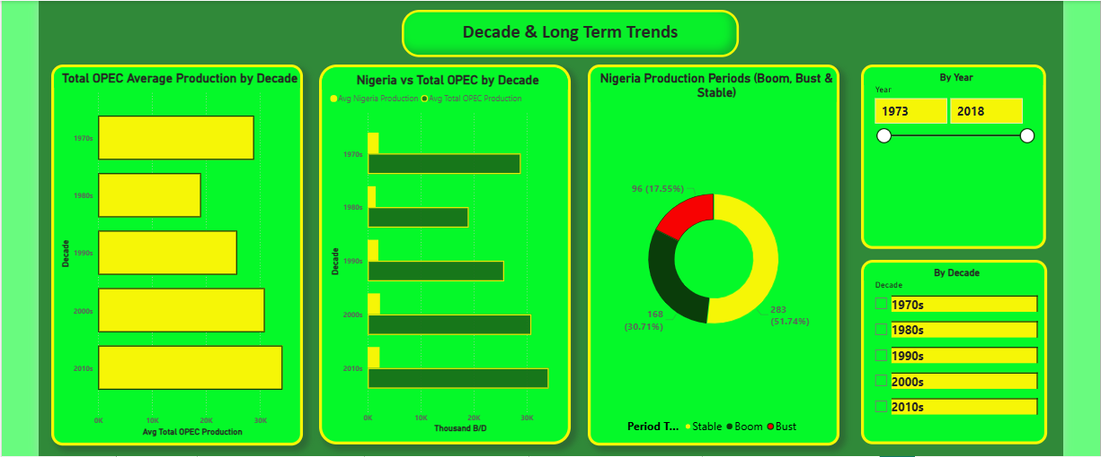
Figure 14. Dashboard Page 4 — Decade & Long-Term Trends
Visuals:
  - Bar Chart: Total OPEC Production by Decade
  - Clustered Bar Chart: Nigeria vs Total OPEC Average by Decade
  - Donut Chart: Nigeria Production Periods (Boom, Bust & Stable)

4.5 Page 5: Insights & Recommendations
Purpose: Summary of key findings and strategic recommendations
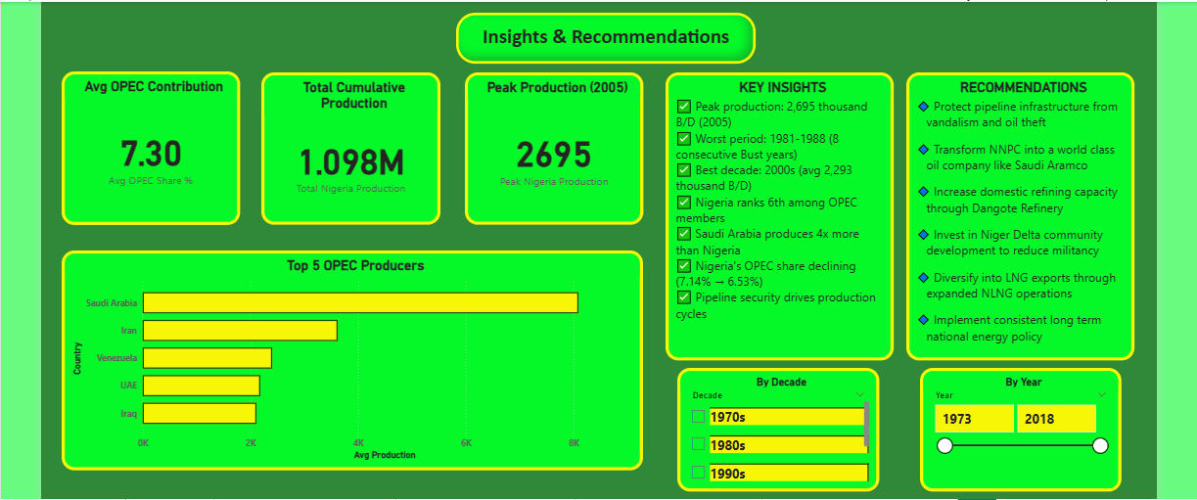
Figure 15. Dashboard Page 5 — Insights & Recommendations
Visuals:
  - Text boxes with key insights
  - KPI Cards highlighting most important numbers
  - Bar Chart: Boom vs Bust vs Stable years count

5. Key Insights & Recommendations

5.1 Key Findings
- Nigeria's Production Range:
Nigeria's crude oil production ranged from a record low of 675 thousand B/D (August 1981/1983) to a peak of 2,695 thousand B/D (June/July 2005) over 45 years reflecting significant volatility in output.
- Nigeria's OPEC Contribution:
Nigeria maintained an average OPEC share of 7.30% over the entire period, contributing a cumulative 1,097,695.50 thousand barrels across 547 months. However, this share has been declining from 7.14% in the 1970s to 6.53% in the 2010s.
- The Lost Decade - 1981 to 1988:
Nigeria experienced 8 consecutive Bust years between 1981 and 1988; its worst production period in history. This was driven by the global oil price crash, falling demand and OPEC quota disputes which collectively reduced Nigeria's average production to just 1,388 thousand B/D during this period.
- Nigeria's Golden Era - 2003 to 2007:
Nigeria's best sustained production period was 2003 to 2007 with 5 consecutive Boom years peaking at 2,626.67 thousand B/D in 2005. This period coincided with improved security in the Niger Delta and significant foreign investment in oil infrastructure.
- Saudi Arabia's Dominance:
Saudi Arabia is the undisputed OPEC production leader averaging 8,094.05 thousand B/D; approximately 4 times Nigeria's average output. Nigeria ranked sixth overall among OPEC members narrowly missing the top 5.
- Iraq's Volatility vs Nigeria's Stability:
While Nigeria maintained relatively stable production across decades, Iraq experienced dramatic swings; collapsing to 1,081.20 thousand B/D in the 1990s due to the Gulf War and UN sanctions before recovering strongly to 3,495.17 thousand B/D in the 2010s.
- OPEC's Overall Growth:
Total OPEC production grew by 18.2% from an average of 28,916.69 thousand B/D in the 1970s to 34,178.96 thousand B/D in the 2010s with the 2010s being the most stable and highest producing decade in OPEC history.

5.2 Business Recommendations
Based on the analysis of 45 years of OPEC production data, the following strategic recommendations are made for Nigeria's oil and gas sector:
- Transform NNPC Into a World Class Oil Company
Nigeria must transform NNPC Limited into a truly commercial, transparent and efficient entity modeled after Saudi Aramco. This includes reducing corruption, attracting top technical talent, embracing modern drilling technology and improving corporate governance to maximize production efficiency.
- Protect Pipeline Infrastructure
Nigeria loses significant revenue annually to pipeline vandalism and oil theft (bunkering) in the Niger Delta. Investing in modern pipeline monitoring technology, stronger community engagement programs and improved security frameworks would protect and potentially increase production levels significantly.
- Increase Domestic Refining Capacity
Nigeria currently exports most of its crude oil unrefined and imports petroleum products at great cost. Fully operationalizing the Dangote Refinery and investing in additional refining capacity would increase revenue retention and reduce economic vulnerability to global oil price fluctuations.
- Diversify Within the Energy Sector
Saudi Arabia is already investing heavily in Vision 2030 to reduce oil dependence. Nigeria should similarly invest in gas monetization through expanded NLNG operations, renewable energy development and petrochemicals to build a more resilient and diversified energy economy.
- Pursue Political Stability & Consistent Policy
Nigeria's production history shows that political instability directly hurts output. Consistent government policy on oil and gas investment, transparent licensing rounds and long-term national energy planning would attract more foreign direct investment and sustain production growth.
- Learn From Iraq's Recovery
Iraq grew from 1,081.20 thousand B/D in the 1990s to 3,495.17 thousand B/D in the 2010s through aggressive post conflict investment in oil infrastructure. Nigeria can adopt a similar focused investment approach in the Niger Delta to unlock its full production potential.

5.2.1 Lessons from Saudi Arabia's Dominance
Saudi Arabia's consistent production dominance over 45 years is attributable to five key factors that Nigeria can study and adopt:
- Geological Advantage & Reserve Management
Saudi Arabia's Ghawar oil field is the largest conventional oil field ever discovered containing an estimated 48 billion barrels. While Nigeria cannot replicate this geological advantage, it can better manage and explore its existing reserves through improved seismic surveying and exploration investment.
- Saudi Aramco - Operational Excellence
Saudi Aramco is widely regarded as the world's most efficient and profitable oil company with decades of investment in world class infrastructure, technology and human capital. Nigeria's NNPC Limited must pursue similar operational excellence standards.
- Political Stability Enabling Long Term Investment
Saudi Arabia's political stability has allowed consistent decades long investment in oil infrastructure. Nigeria must prioritize Niger Delta stability and consistent energy policy to attract and retain long term investment.
- Strategic OPEC Leadership
Saudi Arabia effectively leads OPEC production strategy using its vast reserves as geopolitical leverage. Nigeria should leverage its position as Africa's largest producer to play a stronger strategic role within OPEC negotiations.
- Infrastructure Investment at Scale
Saudi Arabia has invested massively in pipelines, refineries, export terminals and processing facilities over decades. Nigeria must match this level of infrastructure investment to eliminate production bottlenecks and maximize output.

Conclusion
This analysis examined 45 years of OPEC monthly crude oil production data from 1973 to 2018, with a specific focus on Nigeria's production performance, trends and position within the cartel. Using SQL for data analysis and Power BI for visualization, the project revealed significant insights into Nigeria's production cycles, its comparison with major producers and the structural challenges that have prevented Nigeria from reaching its full production potential.
Nigeria's production history is characterized by periods of boom driven by favorable global conditions and investment, and busts driven by political instability, global price crashes and infrastructure challenges. The analysis shows that while Nigeria has maintained a relatively consistent OPEC share of approximately 7.30%, this share is declining as other members grow faster. To reverse this trend Nigeria must invest in operational excellence, infrastructure protection and political stability; drawing lessons from Saudi Arabia's sustained production dominance.
This project demonstrates the power of data analytics in extracting meaningful insights from historical energy data to inform strategic decision making in Nigeria's oil and gas sector.

References
Kaggle. (2023). OPEC oil data on a monthly basis [Dataset]. Retrieved from https://www.kaggle.com
Organization of the Petroleum Exporting Countries. (2023). OPEC annual statistical bulletin. Retrieved from https://www.opec.org
Nigeria Extractive Industries Transparency Initiative. (2023). NEITI reports and data. Retrieved from https://www.neiti.gov.ng
U.S. Energy Information Administration. (2023). International energy data — Nigeria. Retrieved from https://www.eia.gov
Microsoft Corporation. (2023). Microsoft Excel [Computer software]. Microsoft.
DB Browser for SQLite. (2023). DB Browser for SQLite [Computer software]. Retrieved from https://sqlitebrowser.org
Microsoft Corporation. (2023). Power BI Desktop [Computer software]. Microsoft.

