Aim of the project:

Create a Banking backend application with Java Spring Boot and MySQL to have all the CRUD operations, Create, Update, Delete, Read All.

The Data Base consists of 2 tables: Client and Account. A client can have multiple accounts and an account can be owned/used/belong to only one client.

Flow of data from Data Base(DB) to user.

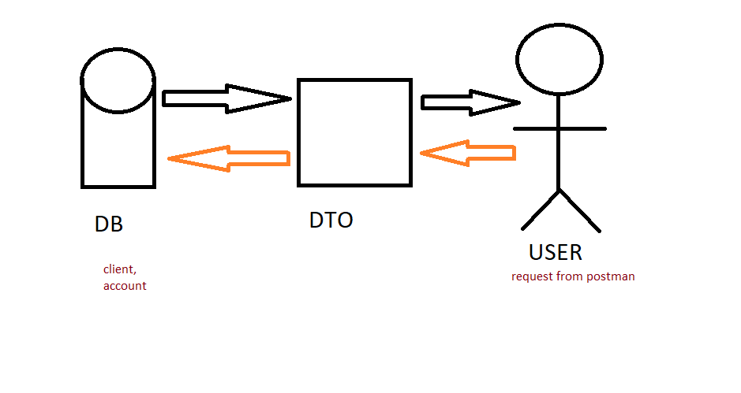

Figure 1Class Diagram

