DOCUMENTATION

ASSIGNMENT 2

STUDENT NAME: Chiorean Bianca Anamaria
GROUP: 3

CONTENTS

1. Assignment Objective 3
2. Problem Analysis, Modeling, Scenarios, Use Cases 3
3. Design 3
4. Implementation 3
5. Results 3
6. Conclusions 3
7. Bibliography 3

Assignment Objective
The main objective of the assignment is to design and implement a queue management application which assigns clients to a queue such that the time is minimized (chosen method: pick queue with the shortest waiting time).

The sub-objectives are:
- Find an appropriate design for the interface
- Identifying the actors
- Identifying the correct data structures
- Using threads for parallelism
- Synchronizing threads
- Minimizing the waiting time
- Test the application

Problem Analysis, Modeling, Scenarios, Use Cases
The functional requirements are:
- The simulation application should allow users to setup the simulation
- The simulation application should allow users to start the simulation
- The simulations application should display the real-time queues evaluation
- The simulations application should display the following statistics at the end:
  - Average waiting time
  - Average service time
  - The Peak hour
Use Case: start simulation
Primary Actor: user
Main Success Scenarios:
      - The user inserts the values for the: number of clients, number of queues, simulation interval, minimum and maximum arrival time, and minimum and maximum service time
      - The user clicks on the start simulation button
Alternative Sequence: Invalid values for the setup parameters
- The user inserts invalid values for the application’s setup parameters
- The application displays an error message and requests the user to insert valid values
- The scenario returns to step 1

Design
Class diagrams:
Figure 1 Controller
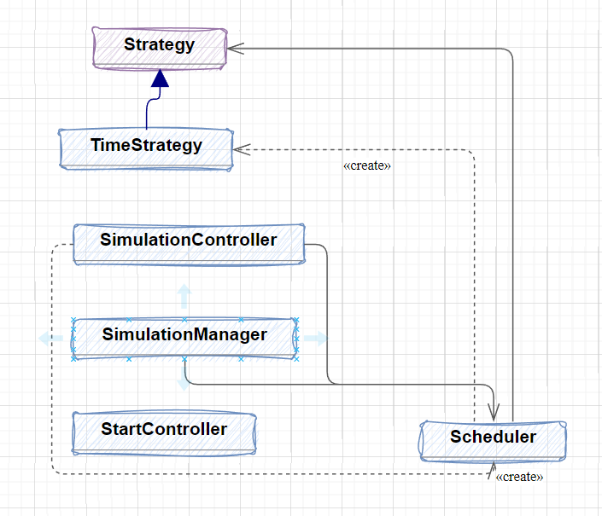
Figure 2Controller
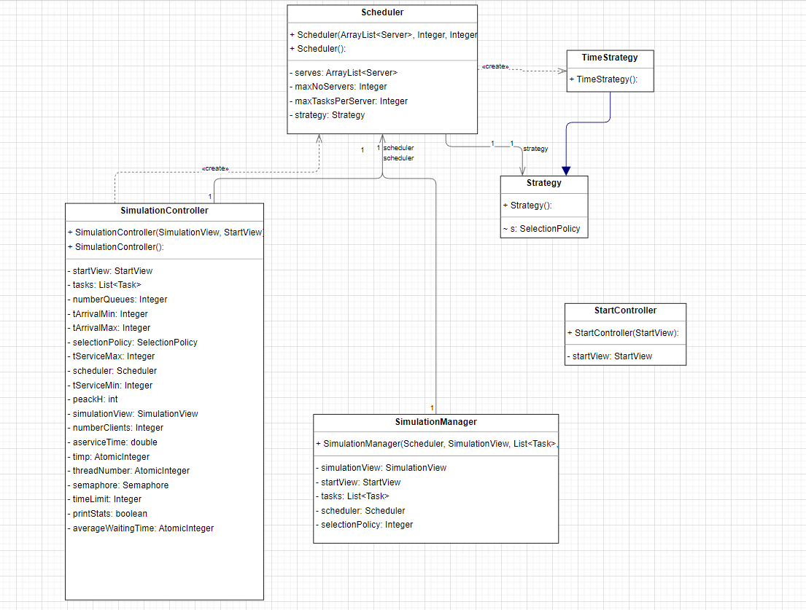
Figure 3:Models
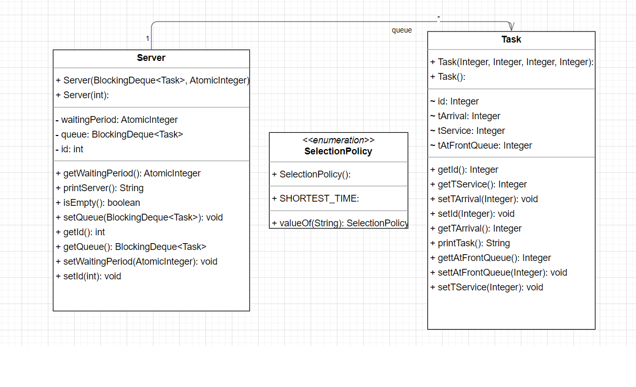
Figure 4:View
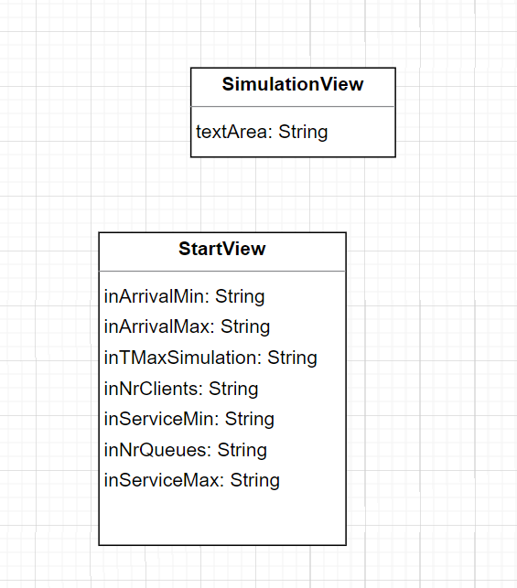
Figure 5:Package Diagram
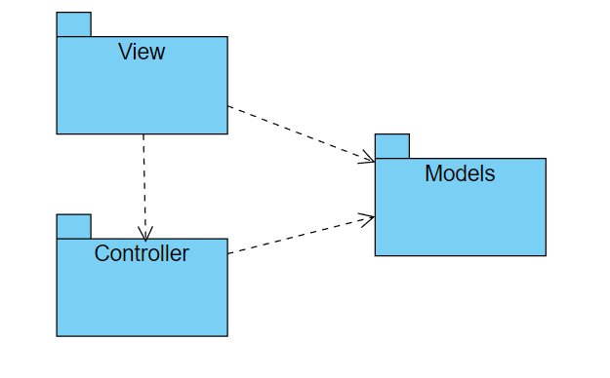

Implementation
The graphical user interface is composed by two parts:
- The Start window, where the user inputs the number of clients, number of queues, simulation interval, arrival and service time (min and max) (Figure 4.1)
- The Simulation window, where the output can be seen
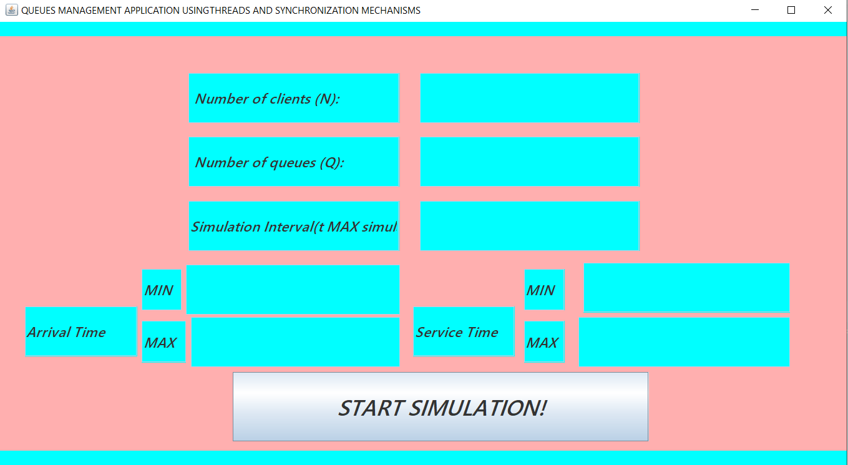
Figure 4.6: Start window
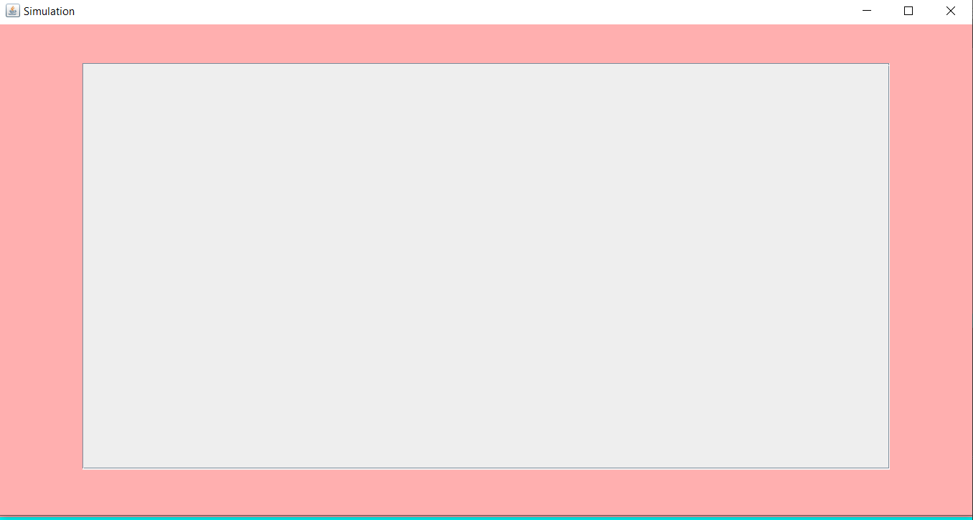
Figure 4.7: Simulation window
The simulation window is equipped with a scroll bar for ease of reading the output.
Time Strategy from controller package is the “sorting”/choosing algorithm. It iterates through all the Servers(inside them there is a queue) and for each of the server it calculate the minimum waiting time among them. Using that result, the given task as a parameter will be added in the corresponding queue. This class also implement the abstract class Strategy. Further development could bring new choosing algorithms.

Simulation Controller is the bread and butter of the application. There are done the initializations, the random generation of tasks/customers, where the Runnable is implements, where the threads are build, synchronized and the statistics are calculated.
Scheduler groups together important information about the application. It also contains am important printing method: printing a queue. Task as a similar method but for only one task. The printing queue method uses printTask as a buildingblock.

Models package models the “real world” objects such as SelectionPolicy (could be a contract), Server(cashier) and Task (client). The classes are used the build the above ones.

The synchronization mechanisms for the threads are the following:
- Semaphore, all the times t to happen “at the same time”
- Atomical Variables – these kind of variables are incremented/ decremented/added in one clock cycle. No other normal operation can interfere with them.

The interface is resizable.

Results

For the test, Main contains some hardcoded values in the texfields for ease of testing (avoiding to manualy inpot the same value over and over again). The result are as expected.
Each time a time unit passes, the waiting clients, the waiting time of each queue, queues with all the custuomes in them and the state (add/delete or just arrived/ leaving).
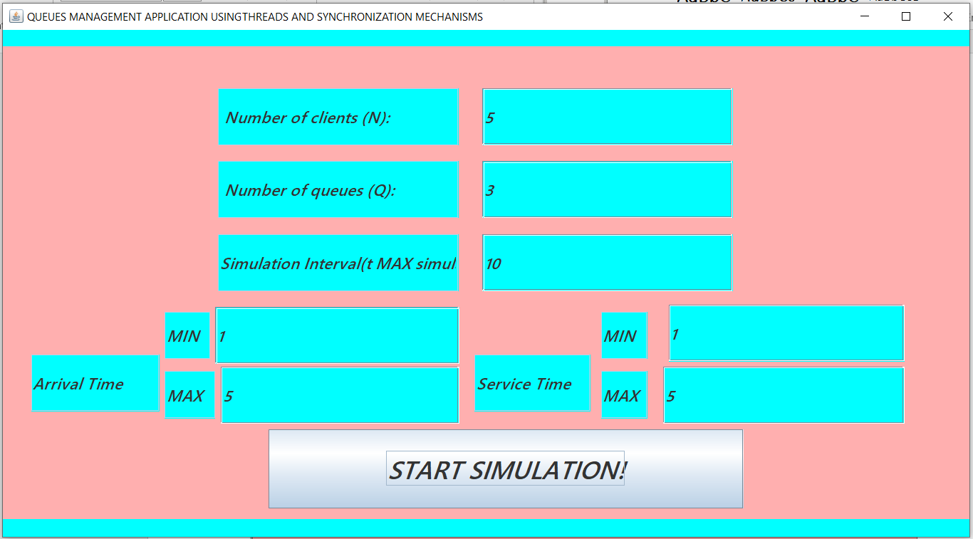
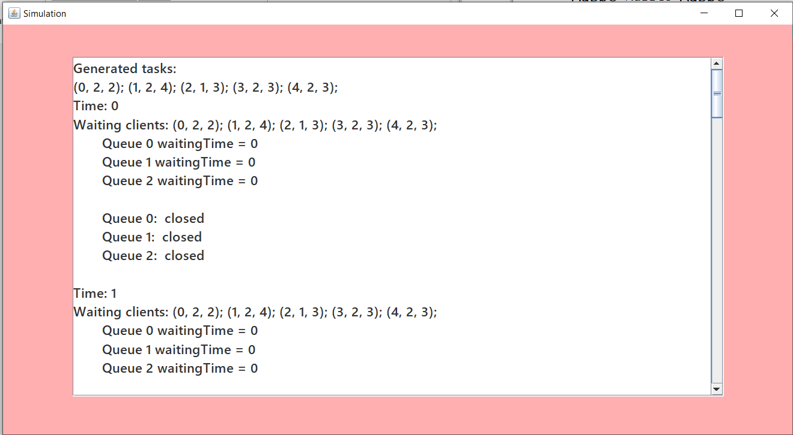

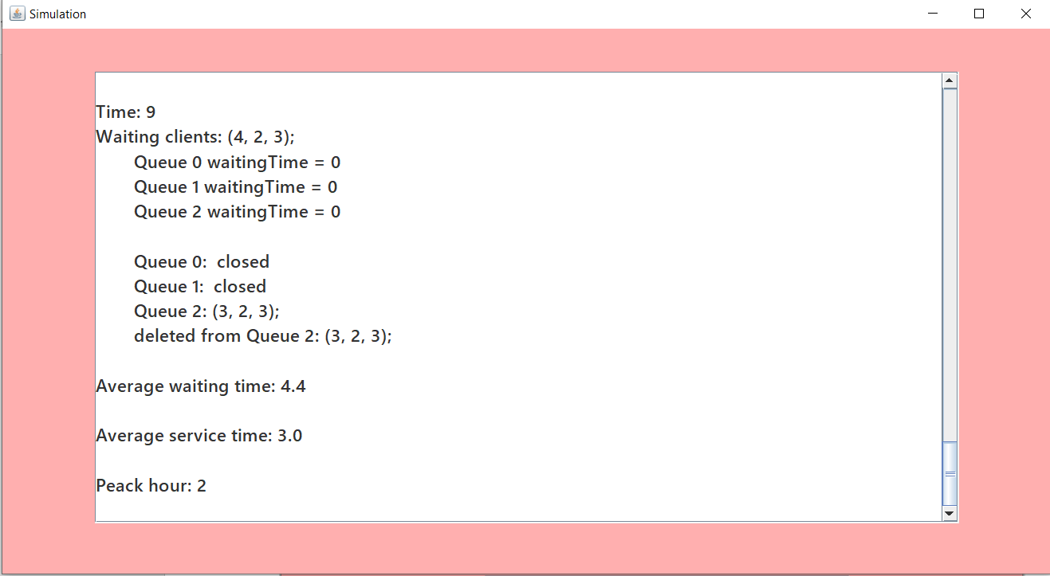

Conclusions
Developing this application I learned to prioritize my tasks, work in parallel (developing the interface and the operations), divide the work load, how to work with threads and how to synchronize them. I observed how important are the comments in the code for documentation, the importance of suggestive variable, methods, classes names.

Bibliography.
- Generate random numbers - https://www.baeldung.com/java-generating-random-numbers-in-range

