INTERNATIONAL CYBERSECURITY AND
DIGITAL FORENSICS ACADEMY (ICDFA)
GRC102 — Information Security Governance
Week 4 Practical Laboratory
Linux Security Monitoring and Auditing
Audit and Control-Assurance Report: From Technical Evidence to Governance Assurance
Student name | Chioma Ameh
Registration number | C11/26/CGRCE/17567
Course / module | GRC102 — Information Security Governance / Module 4: Monitoring and Auditing Security Controls
Role in the scenario | Security Control Assurance Analyst
Laboratory environment | ICDFA Ubuntu Practice Hub (assigned Linux VM, reached through the Academy e-campus portal)
Assigned host | student000302 (Ubuntu 24.04.4 LTS)
Laboratory dates | 29–30 September 2026
Submission deadline | 02 October 2026, 11:59 PM WAT
Evidence | Screenshots are embedded in each module (Figures 1–31); an index is in Appendix C

Declaration of Authenticity and AI Use
I, Chioma Ameh (registration number C11/26/CGRCE/17567), confirm that every command, screenshot and log output in this report comes from my own hands-on work in the ICDFA Ubuntu Practice Hub environment assigned to me. Nothing has been invented or altered: no command output, event, Lynis finding or timestamp. The screenshots show the browser address bar, so the ICDFA lab session they come from can be seen. The only editing I did was trimming unused blank space at the right and bottom edges of some screenshots; the terminal text itself is untouched.
Where my environment could not produce the evidence the brief asks for (auditd would not run, and the usual log files were missing), I have shown the real error output and treated the limitation as a finding. I have not replaced it with simulated output.
AI use. I used an AI assistant (Claude, by Anthropic) to help me organise this report, polish the language and draft explanations of the evidence I supplied. I did the lab work myself, checked the technical statements against my own screenshots, and I can explain every command, finding and recommendation in it.

Student | Chioma Ameh (C11/26/CGRCE/17567)
Signature / date | ______________________ / ____ October 2026

Contents
1 Executive Summary
2 Scope and Authorisation (Figures 1–2)
3 Methodology, Equivalent Sources and Limitations (Figures 3–4)
4 Findings — Evidence Bundle 1: auditd Configuration and Events (Figures 5–11)
5 Findings — Evidence Bundle 2: Linux Log Analysis (Figures 12–14)
6 Findings — Evidence Bundle 3: Lynis Security Assessment, with consolidated findings register (Figures 15–31)
7 Control-Monitoring Table and Governance Escalation (Evidence Bundle 4)
8 SIEM / Continuous Monitoring Mapping (Evidence Bundle 5, one page)
9 Remediation and Retest Plan
10 Conclusion
11 References
A Appendix A — Security Event / Finding Records
B Appendix B — Evidence Completeness Matrix
C Appendix C — Supporting Screenshot and Command-Output Evidence (Figure Index)

The brief asks for six evidence bundles. Bundle 1 is Section 4, Bundle 2 is Section 5, Bundle 3 is Section 6, Bundle 4 is Section 7, Bundle 5 is Section 8 and Bundle 6 is this report as a whole. The screenshots sit next to the text that discusses them, and Appendix C lists every figure for quick reference.

1. Executive Summary
This report sets out what I found in the GRC102 Week 4 practical lab. I worked on my assigned ICDFA Ubuntu Practice Hub machine (host student000302, Ubuntu 24.04.4 LTS) on 29 and 30 September 2026. Taking the role of a security control assurance analyst, I set up and queried the Linux audit system, reviewed the log sources available, ran a Lynis security assessment, and turned the results into a governance-focused control-monitoring record.
Overall control posture: I could not give assurance over the detective controls on this host. The audit daemon is installed but not running. My custom audit rules were written but could not be loaded. The usual log sources (the systemd journal, auth.log and syslog) are either missing or empty. In practice, that means privileged activity and authentication events on this machine cannot currently be tied to a user or a time. Lynis, an independent tool, backs this up: it finds no running log daemon and recommends enabling auditd. It also gives the host a hardening index of 62 from 232 tests, with 3 warnings and 43 suggestions, and the package manager shows 91 pending updates that had not changed between 29 and 30 September.
Top three findings, which need governance attention first:
ID | Finding | Priority | Why it matters
W4-F01 | Audit system (auditd) not operating; rules not loaded; no audit log | High | Nothing records who touches /etc/passwd, /etc/shadow or which programmes run. The control exists on paper but is not operating, so it cannot be relied on.
W4-F02 | No working log management: no journal, auth.log or syslog; login records empty; no log daemon (Lynis LOGG-2130, LOGG-2138) | High | Failed logins, sudo use and system errors cannot be reviewed or sent to a SIEM, so an incident could not be reconstructed.
W4-F03 | Patch backlog: 91 pending updates on 29 and 30 Sep; Lynis warning PKGS-7392 (vulnerable packages) | High | Known vulnerabilities may still be exploitable, and the unchanged count suggests nothing was patched in between.

What is working. The host firewall is active, no legacy insecure services (inetd, telnet server) were found, logrotate is present, and the package-database and security-repository checks passed. Several kernel settings already match the Lynis profile, for example kernel.dmesg_restrict, kernel.randomize_va_space and tcp_syncookies (Figures 23, 24, 25, 26).
A note on the evidence. PID 1 on this VM is sleep, not systemd, the audit interface refused my rule query (“Operation not permitted”), and the session later hit process limits (“unable to fork”). That points to a restricted, probably containerised, lab platform, and it explains why several standard commands failed. I have kept the real error output as evidence and analysed it as a governance finding. Appendix B maps every requirement in the brief to the evidence I have.

2. Scope and Authorisation
Everything I did was inside the Linux system assigned to me through the ICDFA Ubuntu Practice Hub on the Academy e-campus portal. I did not target any external system, production service or public IP address, and I made no authentication attempts against any other host or account.
Environment | ICDFA Ubuntu Practice Hub: authorised, assigned training VM (browser terminal)
Hostname | student000302
Operating system | Ubuntu 24.04.4 LTS (Noble Numbat), x86_64 (Figure 1)
Kernel | 7.0.0-1014-azure #14~24.04.1-Ubuntu SMP PREEMPT, Fri Aug 14 17:35:51 UTC 2026
Account used | student (uid 1000), in the sudo (27) and adm (4) groups among others (Figure 2)
Init system (PID 1) | sleep, so systemd is not the init system (Figure 2)
Laboratory window | 29 September 2026 (auditd set-up); 30 September 2026 (auditd queries, log review, Lynis)
Time base | The VM clock is UTC (Figure 3). Screenshot times are from my own device (WAT, which is UTC+1).
Tools in scope | auditd, auditctl, augenrules, ausearch, aureport, journalctl, less, grep, ls, apt, dpkg and Lynis 3.0.9

Environment evidence. The two screenshots below identify the system I worked on: its operating system and kernel, my user and group membership, and the contents of /var/log.
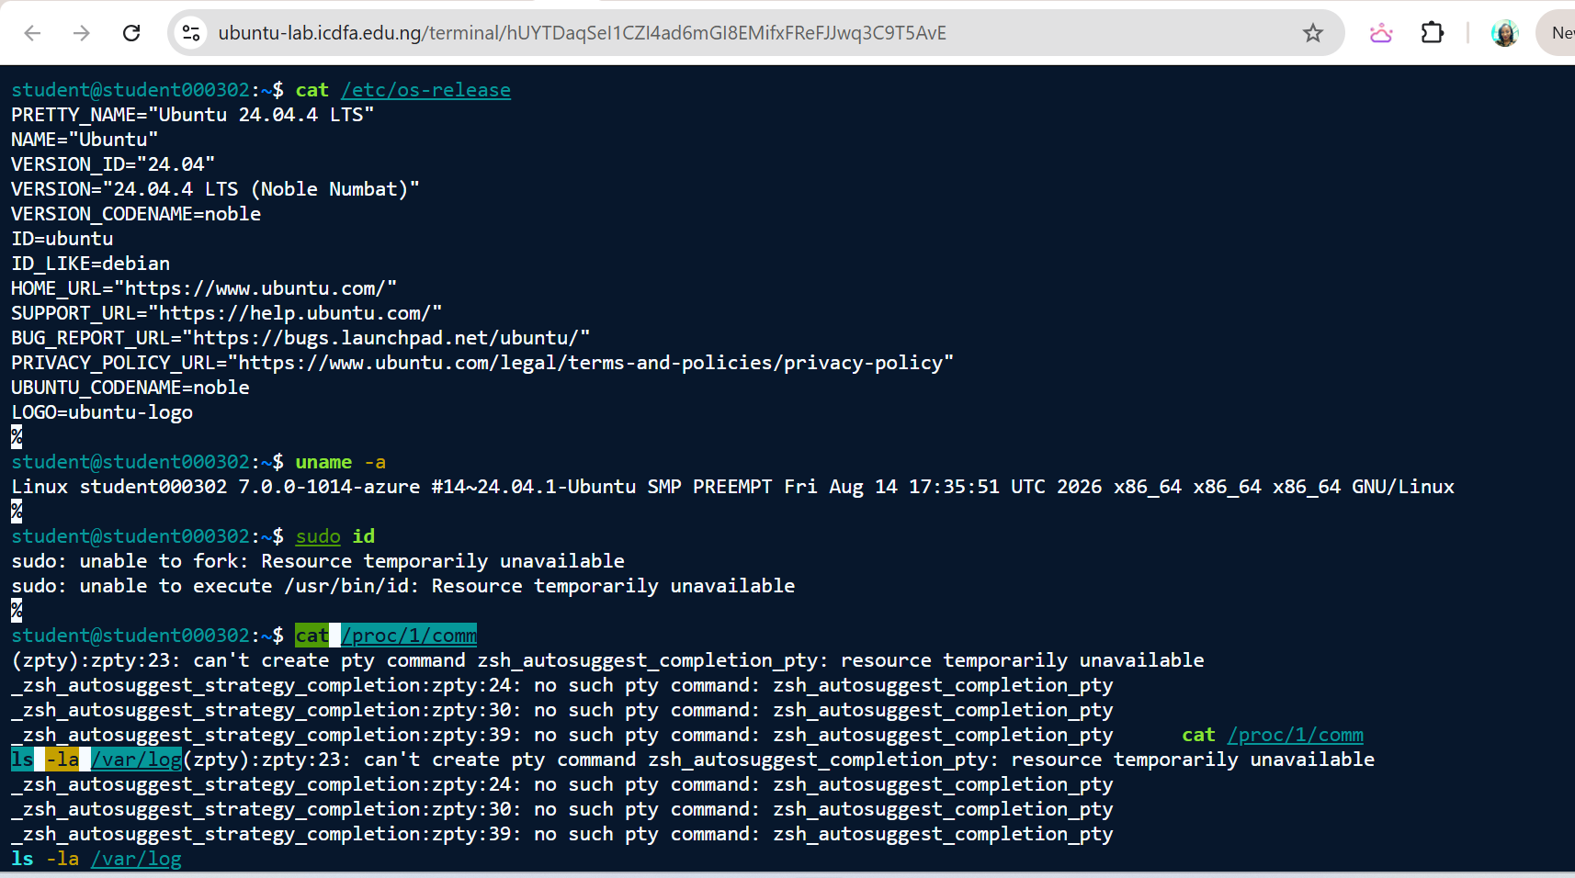
Figure 1. Operating system, kernel and sudo check
Captured 30 Sep 2026, 21:46 WAT. Commands: cat /etc/os-release; uname -a; sudo id. What it shows: Ubuntu 24.04.4 LTS (Noble Numbat); kernel 7.0.0-1014-azure on host student000302. sudo id failed with “sudo: unable to fork: Resource temporarily unavailable”.
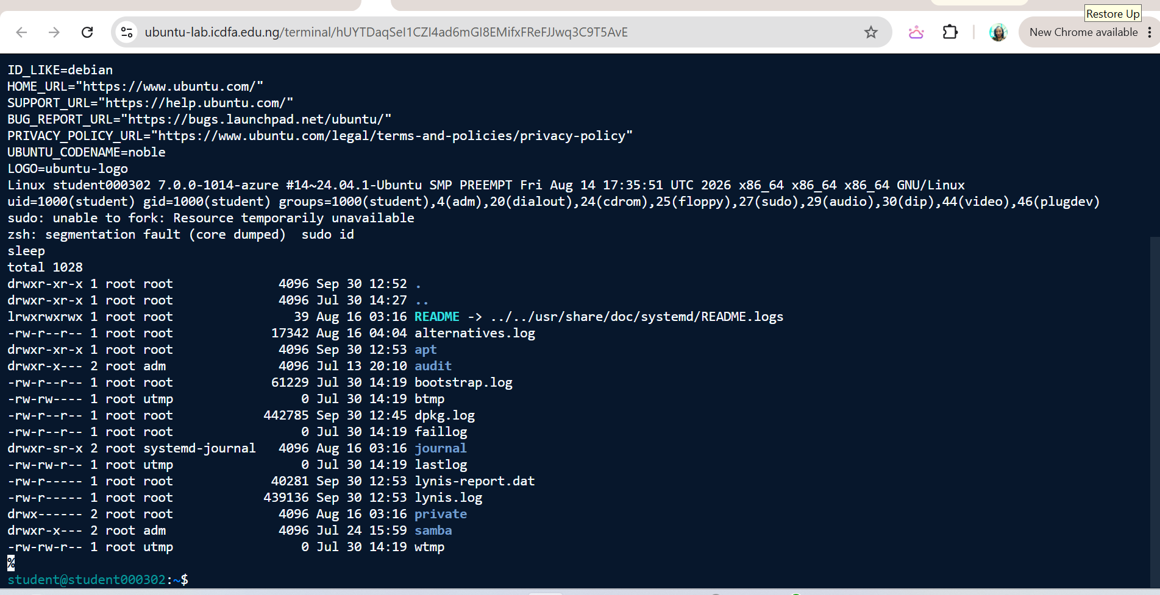
Figure 2. Identity, PID 1 and /var/log inventory
Captured 30 Sep 2026, 21:49 WAT. Commands: id; sudo id; cat /proc/1/comm; ls -la /var/log. What it shows: uid=1000(student) is a member of the sudo and adm groups. PID 1 is sleep (not systemd). /var/log contains no auth.log, syslog or kern.log; wtmp, btmp, lastlog and faillog are 0 bytes; audit/ and journal/ directories exist; dpkg.log was last modified at 12:45 (UTC) and lynis.log / lynis-report.dat at 12:53 (UTC).
Changes I made to the system. In line with the lab rules, I did not disable any logging, delete any evidence or change unrelated configuration. What I did change was limited to this:
- Created /etc/audit/rules.d/custom.rules with five audit rules (Activity 1.2, Figure 8).
- Ran apt update, which refreshes package lists only (I applied no upgrades), and apt install auditd audispd-plugins, which changed nothing because both were already up to date.
- Ran systemctl enable auditd, which synchronised the SysV service script (Figure 5).
- Installed Lynis 3.0.9-1 and its dependency menu 2.1.50 with apt (Figure 16).
- Opened /etc/passwd with sudo nano and closed it without saving, as the brief instructs (Figure 9).
What I did not do: the optional failed local-login attempt (Activity 1.3) and the optional Activity 3.3 hardening retest.

3. Methodology, Equivalent Sources and Limitations
Area | Tools and commands | Approach
Module 1: auditd | systemctl, service, apt, dpkg, ps, auditctl, augenrules, ausearch, aureport | Checked installation and service state, wrote a dedicated rules file, tried to load and list the rules, generated harmless events, then queried by key and ran summary reports.
Module 2: logs | journalctl, less, grep, ls -la /var/log, id | Reviewed the systemd journal and the traditional authentication and syslog files. Where those were missing, I used the equivalent sources I could find (directory inventory, login-accounting files, Lynis logging checks), as the brief allows.
Module 3: Lynis | lynis --version, lynis audit system | Installed Lynis, ran a full system audit, and recorded the hardening index, warnings, suggestions and report locations.
Governance mapping | Control-monitoring table; finding-record template (Appendix A) | Linked each evidence-backed condition to a control objective, owner, status, threshold, risk, remediation and retest.
Module 4: SIEM | Conceptual mapping table | Showed how host evidence could feed enterprise monitoring, and which conditions are alerts and which are governance issues.

3.1 Where my environment differed from the brief: equivalent sources and methods
The brief asks me to document the equivalent log source or method whenever my distribution or environment differs from what it expects (Section 3 rules, Activities 1.2, 2.2 and 2.3, and the lab access notes). The table gathers every case in one place.
Brief expects | What my environment had | Equivalent source or method I used | Figure
systemctl status / start / restart auditd (Activities 1.1, 1.2) | systemd is not the init system (PID 1 is sleep): “System has not been booted with systemd”. | SysV-style sudo service auditd status (“auditd is not running”) and ps aux | grep -i auditd. systemctl enable completed through systemd-sysv-install. | Figures 5, 6, 7
sudo auditctl -l to record the loaded rules (Activity 1.2) | The audit interface refused the query: “Operation not permitted”. | Recorded the rules from the rules file itself (cat /etc/audit/rules.d/custom.rules). A load check with augenrules --check was attempted but blocked by the process limit. I stayed in the assigned environment and recorded what it allowed. | Figures 8, 3
ausearch and aureport records (Activity 1.3) | No /var/log/audit/audit.log exists, and the audit directory is empty. | Documented the exact error output, plus the /var/log/audit and /etc/audit listings, as evidence of the state of the audit subsystem. | Figures 10, 11, 7
journalctl (Activity 2.1) | “No journal files were found” for every variant. | Directory inventory of /var/log and the Lynis logging-daemon checks. | Figures 12, 2, 24
/var/log/auth.log (Activity 2.2) | File does not exist. | Login-accounting files wtmp, btmp, lastlog and faillog (all 0 bytes); id output showing sudo and adm membership; Lynis logging results. | Figures 13, 2, 24
/var/log/syslog (Activity 2.3) | File does not exist. | Lynis warnings and exceptions, and the shell resource errors, as the error and warning evidence. /var/log/apt and dpkg.log exist, but I did not capture their contents. | Figures 14, 21, 4
Auth-log watch “where /var/log/auth.log exists” (Activity 1.2) | auth.log does not exist, yet I added the watch from the brief’s example. | Kept the rule as written. On this kind of host it should point at whichever authentication source is enabled instead (see Section 4.2). | Figures 8, 13
Lynis from an approved method (Activity 3.1) | Lynis was not yet installed. | Installed the Ubuntu noble/universe package (Lynis 3.0.9-1) with apt. Lynis itself flags this release as more than four months old. | Figures 16, 17, 27

How I handled the evidence. Every screenshot sits next to the section that discusses it and carries a caption with its capture time, the commands shown and what it demonstrates. The VM clock runs on UTC, and the VM’s own file timestamps line up with my screenshot times. For example, dpkg.log was last modified at 12:45 UTC, which matches the Lynis installation screenshot taken at 13:45 WAT.
Limitations.
- PID 1 is not systemd, so systemctl and journalctl cannot work, and the audit interface refused rule queries (“Operation not permitted”).
- On the evening of 30 September the session hit a process limit (“unable to fork”). That stopped me re-running the auditd status check and augenrules --check (Figure 3, Figure 4).
- Lynis results describe this lab platform and could differ on a production server. Two Lynis exceptions (PKGS-7410 and KRNL-5788) fit a platform where the kernel is supplied by the host. That is my inference and I have not confirmed it with the platform owner.
- The KPI/KRI thresholds and remediation timelines in this report are my proposals for management approval. They do not come from the lab brief.
The next two screenshots show the VM clock and the resource errors referred to above.
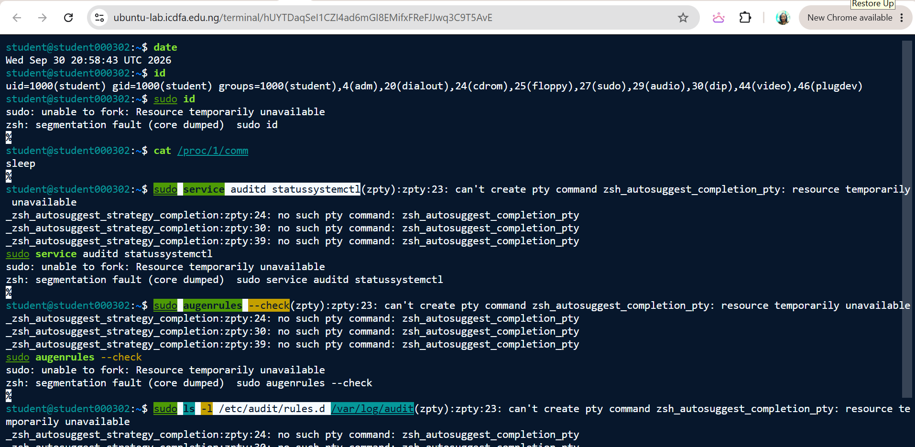
Figure 3. System clock, identity, PID 1 and resource errors
Captured 30 Sep 2026, 22:01 WAT. Commands: date; id; sudo id; cat /proc/1/comm; sudo service auditd status; sudo augenrules --check. What it shows: date reports Wed Sep 30 20:58:43 UTC 2026 (the VM clock is UTC; WAT = UTC+1). sudo commands failed with “unable to fork” and a segmentation fault, so the auditd status re-check and augenrules --check could not execute. Overlapping text is zsh autosuggest output caused by the resource errors.
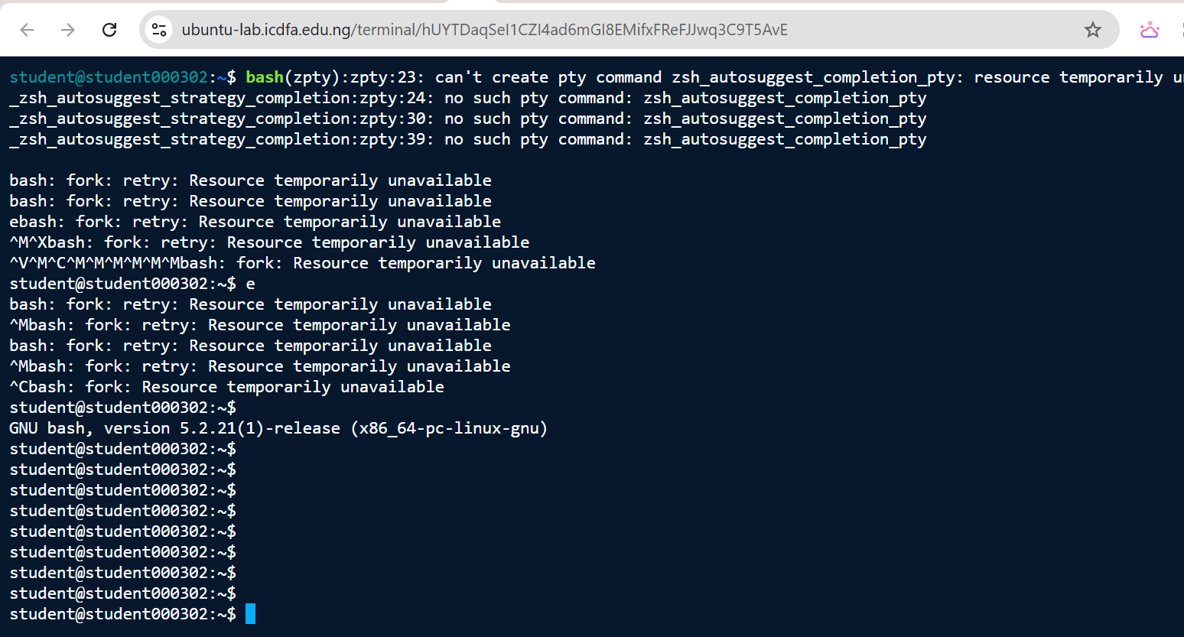
Figure 4. Shell start-up under process-limit errors
Captured 30 Sep 2026, 22:04 WAT. Commands: bash. What it shows: GNU bash 5.2.21 started, but repeated “bash: fork: retry: Resource temporarily unavailable” messages show the session had reached a process/resource limit. Stray characters are keystrokes queued while the shell was blocked.

4. Findings — Evidence Bundle 1: auditd Configuration and Events
auditd is the userspace part of the Linux Auditing System. It records security-relevant events such as file access, system calls and user actions, which makes it a source of evidence for forensics, compliance and continuous monitoring. This section covers Activities 1.1 to 1.3: what I did, and what the evidence shows.

4.1 Verifying auditd (Activity 1.1)
Command | What happened | Figure
sudo systemctl status auditd | System has not been booted with systemd as init system (PID 1). Can’t operate. Failed to connect to bus: Host is down. | Figure 5
sudo apt install auditd audispd-plugins | Both packages are already the newest version (1:3.1.2-2.1ubuntu0.1); nothing newly installed. | Figures 5, 6
sudo systemctl start auditd | Same systemd error, so the service could not be started this way. | Figures 5, 6
sudo systemctl enable auditd | Synchronised auditd.service with the SysV script through systemd-sysv-install, with no error. | Figure 5
sudo auditctl -s | You must be root to run this program, even with sudo. That is a different message from the later auditctl -l error (“Operation not permitted”). In my reading, both mean the audit control interface is not reachable from this session. | Figures 5, 6
sudo dpkg -l auditd | grep auditd | Status ii: auditd 1:3.1.2-2.1ubuntu0.1 amd64 is installed. | Figure 6
cat /proc/1/comm | sleep, so PID 1 is not an init system. | Figures 6, 2
sudo service auditd status | “auditd is not running.” | Figure 6
ps aux | grep -i auditd | Only the grep process itself appears; there is no auditd process. | Figure 7
sudo ls -l /var/log/audit/ | total 0, so the audit log directory is empty. | Figure 7
sudo service auditd status and sudo augenrules --check (re-check, 30 Sep, 22:01) | Neither could run: “sudo: unable to fork: Resource temporarily unavailable”. | Figure 3

What this shows: auditd is installed, but it is not active. The SysV-style check (service auditd status) agrees with the process list.
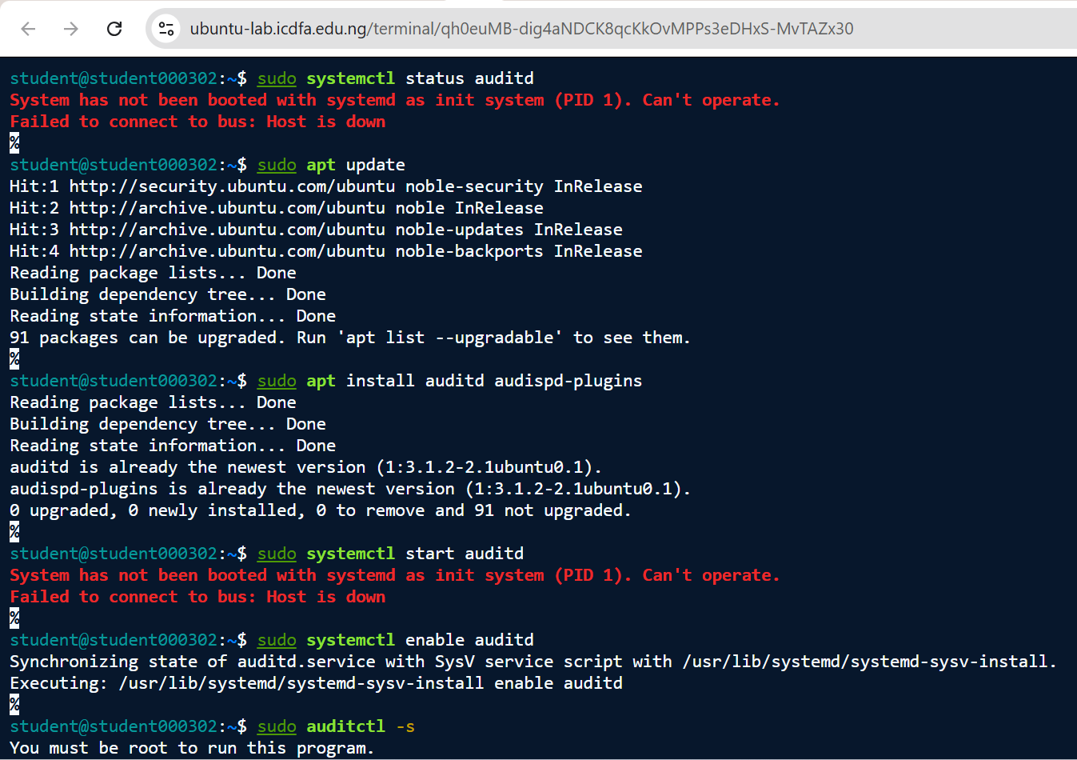
Figure 5. auditd status check, package refresh and install attempt (Activity 1.1)
Captured 29 Sep 2026, 13:17 WAT. Commands: sudo systemctl status auditd; sudo apt update; sudo apt install auditd audispd-plugins; sudo systemctl start auditd; sudo systemctl enable auditd; sudo auditctl -s. What it shows: systemctl cannot operate (“System has not been booted with systemd as init system (PID 1)”). apt update reports 91 packages can be upgraded. auditd and audispd-plugins are already the newest version (1:3.1.2-2.1ubuntu0.1). enable synchronised with the SysV script; auditctl -s returned “You must be root to run this program”.
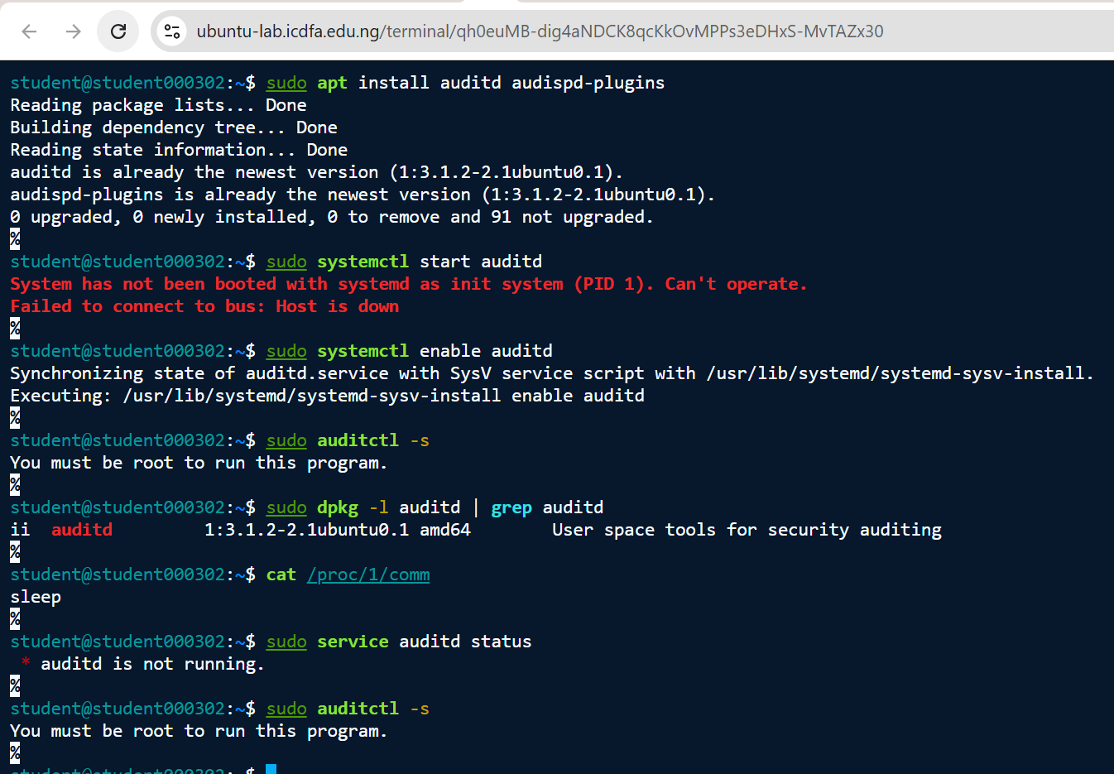
Figure 6. auditd package and service verification
Captured 29 Sep 2026, 13:28 WAT. Commands: sudo apt install auditd audispd-plugins; sudo systemctl start auditd; sudo systemctl enable auditd; sudo auditctl -s; sudo dpkg -l auditd | grep auditd; cat /proc/1/comm; sudo service auditd status. What it shows: dpkg lists auditd 1:3.1.2-2.1ubuntu0.1 as installed (ii). PID 1 command is sleep. The SysV-compatible service auditd status reports “auditd is not running.”
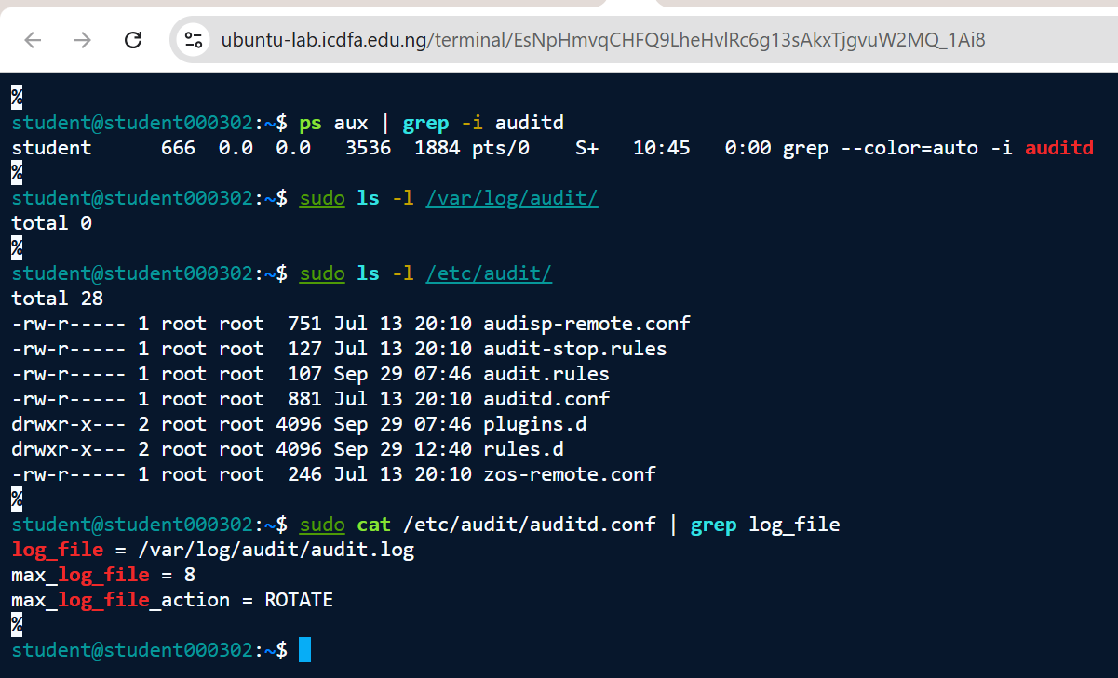
Figure 7. auditd process check and audit directory inspection
Captured 30 Sep 2026, 11:50 WAT. Commands: ps aux | grep -i auditd; sudo ls -l /var/log/audit/; sudo ls -l /etc/audit/; sudo cat /etc/audit/auditd.conf | grep log_file. What it shows: No auditd process is running (only the grep itself). /var/log/audit/ is empty (total 0). /etc/audit/audit.rules is 107 bytes, modified 29 Sep 07:46 (UTC), earlier than rules.d (29 Sep 12:40 UTC). auditd.conf sets log_file=/var/log/audit/audit.log, max_log_file=8 and max_log_file_action=ROTATE. audisp-remote.conf and a plugins.d directory are present.

4.2 Writing the audit rules (Activity 1.2)
I created a separate rules file, /etc/audit/rules.d/custom.rules, instead of editing the main one. Its contents are in Figure 8 below.
Rule | Key | Purpose and control objective
-w /etc/passwd -p rwxa -k passwd_changes | passwd_changes | Record read, write, execute and attribute access to the account database (account integrity).
-w /etc/shadow -p rwxa -k shadow_changes | shadow_changes | Record access to the password-hash store (protecting credentials).
-a always,exit -F arch=b64 -S execve -k program_execution | program_execution | Record 64-bit programme execution (who ran what, and when).
-a always,exit -F arch=b32 -S execve -k program_execution | program_execution | The same for 32-bit programmes, so execution cannot slip past monitoring by architecture.
-w /var/log/auth.log -p wa -k auth_failures | auth_failures | Detect writes to, or attribute changes on, the authentication log (a sign of log tampering).

Loading the rules. I could not get them loaded or listed. sudo systemctl restart auditd failed because there is no systemd, and sudo auditctl -l returned “Error sending rule list data request (Operation not permitted)” followed by “There was an error while processing parameters” (Figure 8). The SysV-style alternatives (service auditd, augenrules --check) could not start auditd or verify the rules either (Figures 6, 3).
A supporting detail. /etc/audit/audit.rules is 107 bytes and was last changed on 29 Sep at 07:46 UTC. That is earlier than the rules.d directory, which changed at 12:40 UTC (13:40 WAT) when I created custom.rules (Figure 7). It fits with the compiled rule set not having been regenerated to include my file, although I could not run augenrules --check to confirm that.
A design point. My auth_failures watch points at /var/log/auth.log, which does not exist on this host (Figures 13, 2). The brief asks for that watch where the file exists. On a host like this one, the watch should point at whichever authentication log source is enabled instead. The settings in auditd.conf (log file /var/log/audit/audit.log, 8 MB cap, rotate when full; Figure 7) should also be checked against the organisation’s retention policy.
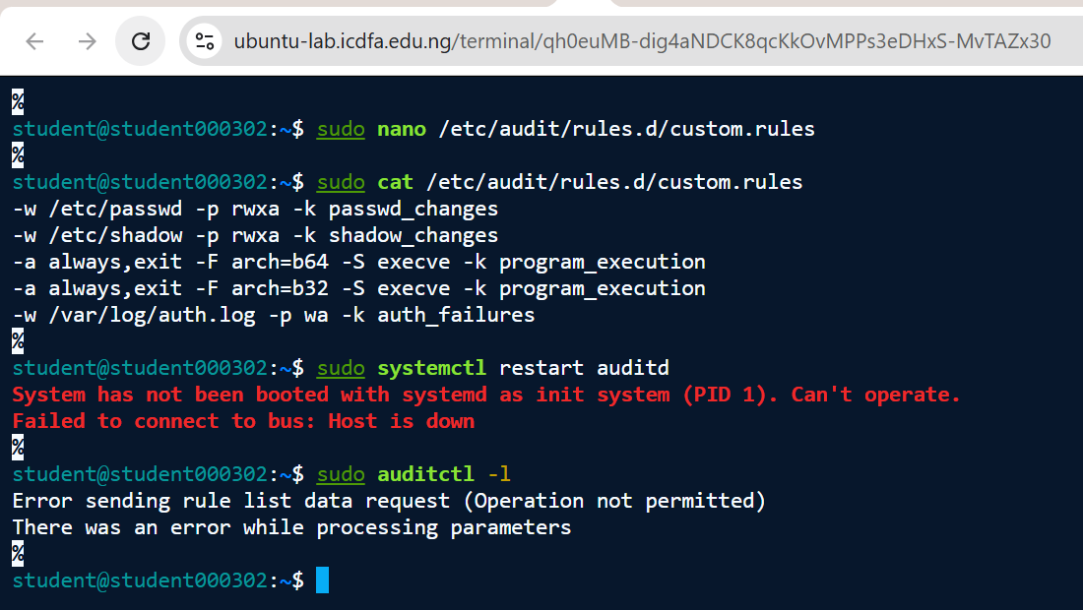
Figure 8. Custom audit rules, restart attempt and loaded-rule query (Activity 1.2)
Captured 29 Sep 2026, 13:41 WAT. Commands: sudo nano /etc/audit/rules.d/custom.rules; sudo cat /etc/audit/rules.d/custom.rules; sudo systemctl restart auditd; sudo auditctl -l. What it shows: custom.rules contains the five required rules (passwd_changes, shadow_changes, two program_execution execve rules, auth_failures). systemctl restart fails (no systemd) and auditctl -l returns “Error sending rule list data request (Operation not permitted)”, so the loaded rule set could not be displayed.

4.3 Generating and querying audit events (Activity 1.3)
Command | What happened | Figure
sudo nano /etc/passwd (closed without saving) | File opened as root and closed unchanged. No output. | Figure 9
ls /tmp | Listed one entry: icdfa-zsh-1000. | Figure 9
sudo ausearch -k passwd_changes | Error opening /var/log/audit/audit.log (No such file or directory). | Figure 11
sudo ausearch -k program_execution | Error opening /var/log/audit/audit.log (No such file or directory). | Figures 10, 11
sudo ausearch -k auth_failures | Error opening /var/log/audit/audit.log (No such file or directory). | Figure 11
sudo aureport | Summary Report heading, then the same error opening audit.log. | Figures 10, 11
sudo aureport --failed | Failed Summary Report heading, then the same error. | Figure 11
sudo aureport --login | Login Report heading (date, time, auid, host, term, exe, success, event), then the same error. | Figures 10, 11

I ran ausearch for all three keys and all three aureport reports (summary, --failed and --login). Every one returned the same error, on 29 September (Figure 11) and again on 30 September (Figure 10), so the audit log was missing on both days and not just once.
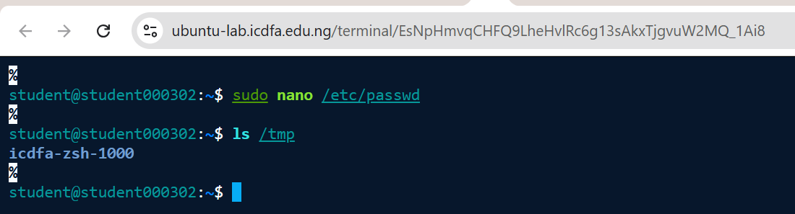
Figure 9. Benign event generation (Activity 1.3)
Captured 30 Sep 2026, 11:24 WAT. Commands: sudo nano /etc/passwd (exited without saving); ls /tmp. What it shows: /etc/passwd was opened as root and closed without saving; ls /tmp listed one entry, icdfa-zsh-1000. These are the activities the passwd_changes and program_execution rules were designed to record.
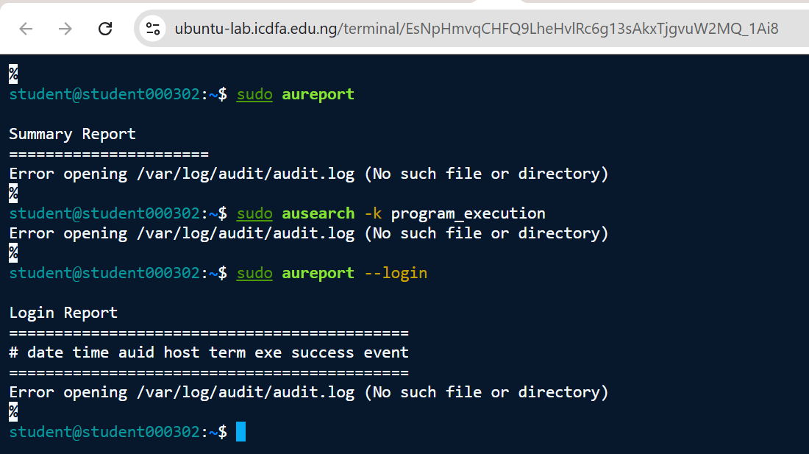
Figure 10. aureport and ausearch attempts (Activity 1.3)
Captured 30 Sep 2026, 11:26 WAT. Commands: sudo aureport; sudo ausearch -k program_execution; sudo aureport --login. What it shows: All three tools fail with “Error opening /var/log/audit/audit.log (No such file or directory)”. No audit records exist to query or summarise.
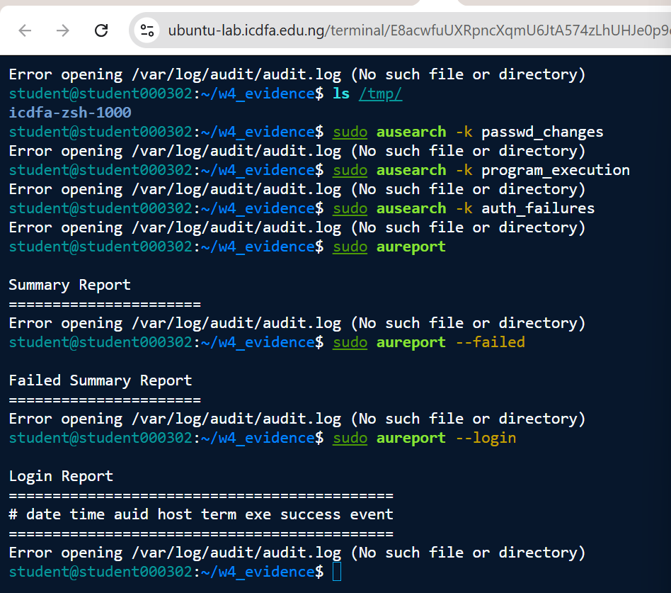
Figure 11. ausearch for all three keys and aureport summaries (Activity 1.3)
Captured 29 Sep 2026, 09:58 WAT. Commands: ls /tmp/; sudo ausearch -k passwd_changes; sudo ausearch -k program_execution; sudo ausearch -k auth_failures; sudo aureport; sudo aureport --failed; sudo aureport --login. What it shows: All three ausearch keys and all three aureport reports (summary, --failed, --login) return “Error opening /var/log/audit/audit.log (No such file or directory)”. The working directory is ~/w4_evidence. The same result appears again on 30 Sep (Figure 10), so the audit log was absent on both days.

4.4 What the evidence says about user, action and time
There is no audit record to read, so I cannot interpret an event directly. The evidence still leads to a clear conclusion. The table compares what an active, correctly loaded rule set would have recorded for my harmless activity in Activity 1.3 with what I could actually see.
Attribute | If auditd were active with the rules loaded | What I could actually see
User | The login UID (auid) and effective UID of the actor. For sudo nano /etc/passwd, this would show user student (uid 1000) acting as root. | Nothing from audit data. Only the shell prompt and id output show the session user is student (Figure 2).
Action | A passwd_changes record for the editor’s access to /etc/passwd, and program_execution records for ls running. | No records. audit.log does not exist, and ausearch and aureport fail (Figures 10, 11).
Time | A kernel-generated timestamp on each record. | Only the screenshot time (30 Sep 2026, about 11:24 WAT) shows when I did it (Figure 9).
Outcome | Success or failure of each operation, plus the executable and key. | Unknown.

Why this matters for governance. The passwd_changes and shadow_changes rules are a detective control over the files that define accounts and credentials. Someone opening /etc/passwd with root rights is exactly the sort of event that has to be attributable, time-stamped and easy to retrieve. With auditd inactive, (1) accountability and non-repudiation for privileged actions cannot be shown, (2) an unauthorised change to account files would go unrecorded, and (3) there is a gap between how the control was designed and whether it operates: the rules exist, but the control is not running. Management cannot rely on it, and an internal assurance review would rate it as not operating.
Bundle 1 in summary: I have evidence of the service state (not running), the rules (file contents; loading blocked), and my query and summary attempts (error output), plus the interpretation above. This is finding W4-F01 (Appendix A).

5. Findings — Evidence Bundle 2: Linux Log Analysis
Linux systems record authentication, service, kernel and application events in systemd journals and in traditional log files. This section covers Activities 2.1 to 2.3, the equivalent sources I used where the standard ones were missing, and a security-event table.

5.1 Reviewing the journal with journalctl (Activity 2.1)
All five commands (sudo journalctl, -u ssh, --since “today”, -p err and -f) returned “No journal files were found.” and “-- No entries --”. I stopped the live view (-f) with Ctrl+C (Figure 12). A /var/log/journal directory does exist (Figure 2), but PID 1 is not systemd, so nothing is running to fill it. No system-log evidence can be retrieved through the journal.
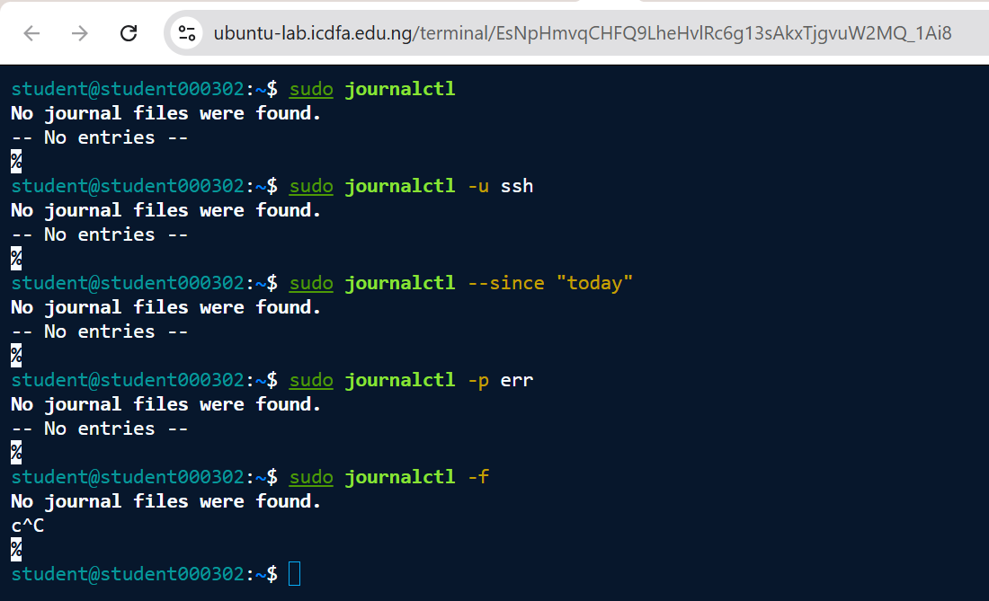
Figure 12. journalctl review (Activity 2.1)
Captured 30 Sep 2026, 12:32 WAT. Commands: sudo journalctl; sudo journalctl -u ssh; sudo journalctl --since “today”; sudo journalctl -p err; sudo journalctl -f (stopped with Ctrl+C). What it shows: Every variant returns “No journal files were found.” / “-- No entries --”; no journal data is available on this host.

5.2 Authentication and privilege use (Activity 2.2)
sudo less /var/log/auth.log, grep -i “failed password” and grep -i “sudo” all returned “No such file or directory” (Figure 13). The brief says to use the equivalent source where a distribution does not use auth.log, so I looked at what else this host offers:
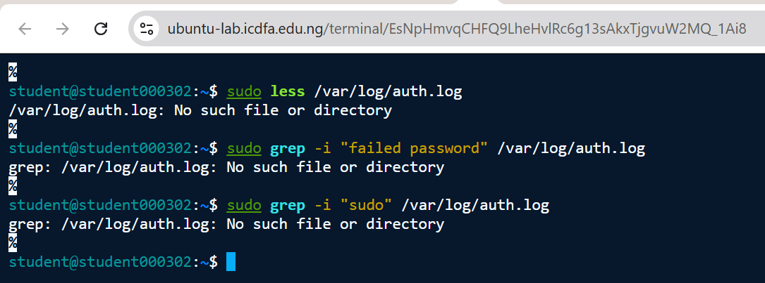
Figure 13. Authentication and privilege-use log review (Activity 2.2)
Captured 30 Sep 2026, 12:39 WAT. Commands: sudo less /var/log/auth.log; sudo grep -i “failed password” /var/log/auth.log; sudo grep -i “sudo” /var/log/auth.log. What it shows: /var/log/auth.log does not exist (“No such file or directory”), so failed-password and sudo events cannot be reviewed from the standard source.
- Directory inventory (Figure 2): /var/log has no auth.log, syslog or kern.log. The login-accounting files wtmp, btmp, lastlog and faillog exist but are all 0 bytes (last modified 30 July), so no successful or failed logins are recorded.
- Account privileges (Figure 2): my user is in the sudo group (root through sudo) and the adm group (read access to log files).
- Lynis logging checks (Figure 24): no log daemon is running, and klogd is not running.
Conclusion. I could not observe any significant authentication event. That does not mean none happened. The sources that would record failed passwords and sudo use are missing or empty, so a privileged-access review cannot be completed on this host at the moment.

5.3 General system log (Activity 2.3)
sudo less /var/log/syslog and the grep -i “error” and grep -i “warning” searches returned “No such file or directory” (Figure 14). For error and warning evidence from an equivalent source, I used these instead: the three Lynis warnings (Figure 21), the Lynis exceptions (Figure 22) and the “unable to fork” and “fork: retry” errors in my shell (Figures 1, 3, 4). Package-management history (/var/log/apt and dpkg.log) does exist (Figure 2), but I did not capture its contents.
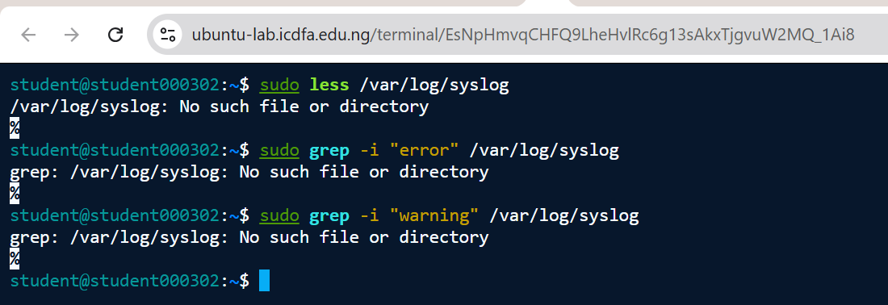
Figure 14. General system log review (Activity 2.3)
Captured 30 Sep 2026, 12:41 WAT. Commands: sudo less /var/log/syslog; sudo grep -i “error” /var/log/syslog; sudo grep -i “warning” /var/log/syslog. What it shows: /var/log/syslog does not exist; no syslog error or warning data can be retrieved from the standard source.

5.4 Security-event table
Event / Condition | Evidence Source | Time | User / Service | Security Significance | Recommended Action
E1. journalctl returns no journal files | journalctl (Figure 12) | 30 Sep, 12:32 WAT | student / systemd-journald (not running) | No journal evidence is kept, so service and authentication events cannot be reconstructed. | Enable persistent journald or rsyslog and forward to the SIEM (F02).
E2. /var/log/auth.log is missing | auth.log; /var/log listing (Figures 13, 2) | 30 Sep, 12:39 and 21:49 WAT | student / sshd, sudo (no log) | Failed logins and privilege use cannot be reviewed. | Log the auth facility, enable sudo logging and review weekly (F02, F05).
E3. /var/log/syslog is missing | syslog (Figure 14) | 30 Sep, 12:41 WAT | student / syslog (not present) | System errors and warnings are unavailable. | Install and enable rsyslog to clear LOGG-2130 (F02).
E4. wtmp, btmp, lastlog and faillog are 0 bytes | ls -la /var/log (Figure 2) | 30 Sep, 21:49 WAT (files dated 30 Jul) | root:utmp / login accounting | No login or failed-login history is recorded. | Check login accounting works and forward it to the SIEM (F02).
E5. Lynis: no running log daemon; klogd not running | Lynis logging checks (Figures 24, 21) | Scan about 13:53 WAT (12:53 UTC) | lynis (root) / logging subsystem | An independent tool confirms there is no logging; kernel messages may be lost. | Install and enable a log daemon and kernel log capture (F02).
E6. 91 packages upgradable; Lynis PKGS-7392 warning | apt update; Lynis (Figures 5, 15, 21) | 29 Sep 13:17; 30 Sep 13:44 WAT | student / apt, dpkg | Pending updates may include security fixes; the count did not change in two days. | Apply updates and enable unattended security upgrades (F03).
E7. Privileged membership (sudo, adm); sudo used during the lab | id output (Figure 2) | 30 Sep, 21:49 WAT | student / sudo | Root and log-read rights exist, but their use cannot be independently reviewed. | Record the authorisation, review access quarterly and enable sudo logging (F05).
E8. “unable to fork”; “fork: retry” | Shell output (Figures 1, 3, 4) | 30 Sep, 21:46–22:04 WAT | student / shell, sudo | Resource exhaustion blocked commands; security tools could fail under the same limit. | Platform owner to review limits and capacity monitoring (F07).
E9. Lynis exceptions PKGS-7410 and KRNL-5788 | Lynis exceptions (Figures 22, 27) | Scan about 13:53 WAT | lynis | Some kernel and package checks cannot be assessed on this platform. | Record as an environment limitation and confirm with the platform owner.

5.5 Routine activity versus real concern
Nothing I collected shows an attack in progress. My own use of sudo to install packages and run Lynis is ordinary lab activity. What does need governance attention is the loss of the evidence sources themselves. With no journal, auth log, syslog or login records, the organisation could not detect or investigate brute-force attempts, unauthorised sudo use or service failures on this host. Lynis reports the same thing independently, so this is a verified control weakness and not a quirk of the commands I used. This is finding W4-F02 (Appendix A).

6. Findings — Evidence Bundle 3: Lynis Security Assessment
Lynis is an open-source auditing tool for Unix-like systems. It runs configuration and security checks and reports warnings, suggestions and a hardening index. It assesses a system; it is not a penetration-testing tool.

6.1 Installation, version and scan (Activities 3.1 and 3.2)
I refreshed the package lists, installed Lynis, checked its version and ran a full system audit. The figures below follow that order and end with the scan summary.
Installation | sudo apt install lynis -y installed Lynis 3.0.9-1 and menu 2.1.50 from archive.ubuntu.com (noble/universe) (Figure 16)
Version | Lynis 3.0.9 (Figure 17)
Execution | sudo lynis audit system (Figure 18); the scan finished at about 12:53 UTC (13:53 WAT), going by the log-file modification time (Figure 2)
System detected | Linux, Ubuntu 24.04, kernel 7.0.0, x86_64, hostname student000302
Hardening index | 62 (Figure 19)
Tests / plugins | 232 tests performed; 1 plugin enabled
Components | Firewall [V]; Malware scanner [X]
Modules | Compliance status [?]; Security audit [V]; Vulnerability scan [V]
Results | 3 warnings and 43 suggestions, with an “Exceptions found” notice (Figures 21, 27, 20)
Report and log files | /var/log/lynis-report.dat and /var/log/lynis.log (Figures 18, 19)
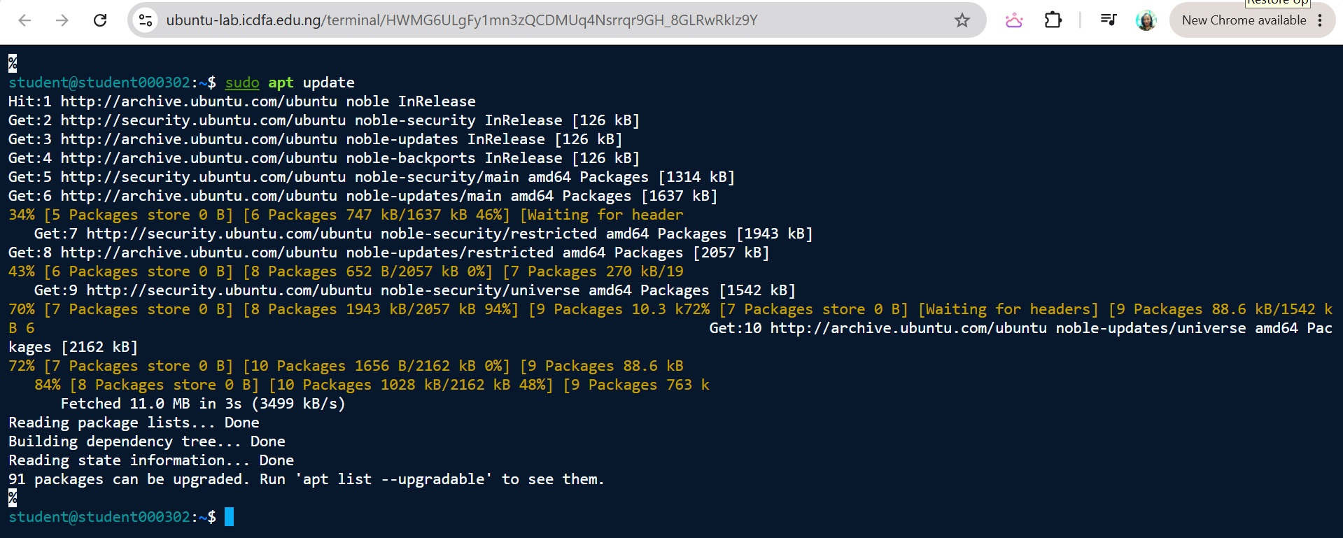
Figure 15. Package list refresh before Lynis installation
Captured 30 Sep 2026, 13:44 WAT. Commands: sudo apt update. What it shows: Ubuntu noble repositories refreshed (11.0 MB fetched). The tool reports “91 packages can be upgraded”, the same count as on 29 Sep (Figure 5).
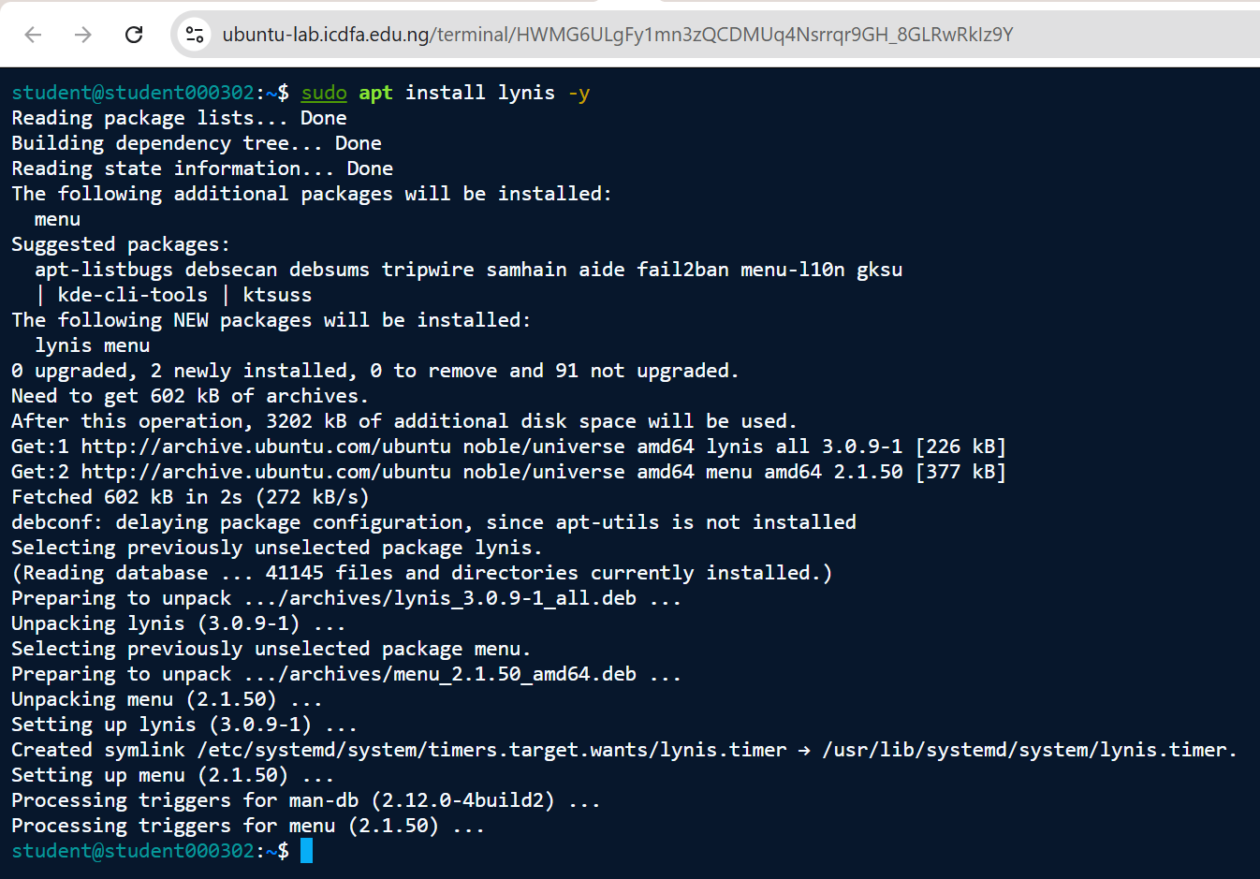
Figure 16. Lynis installation (Activity 3.1)
Captured 30 Sep 2026, 13:45 WAT. Commands: sudo apt install lynis -y. What it shows: Lynis 3.0.9-1 and dependency menu 2.1.50 installed from archive.ubuntu.com (noble/universe). apt lists aide, tripwire, samhain, fail2ban and debsums among suggested packages. A lynis.timer symlink was created under systemd timers.
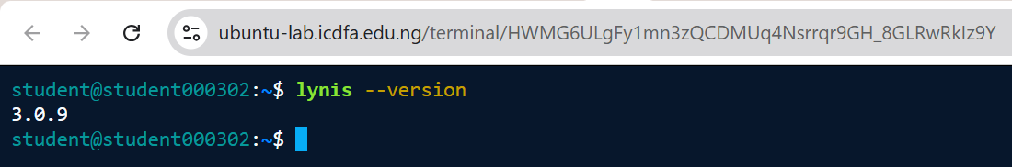
Figure 17. Lynis version
Captured 30 Sep 2026, 13:52 WAT. Commands: lynis --version. What it shows: Lynis version 3.0.9.
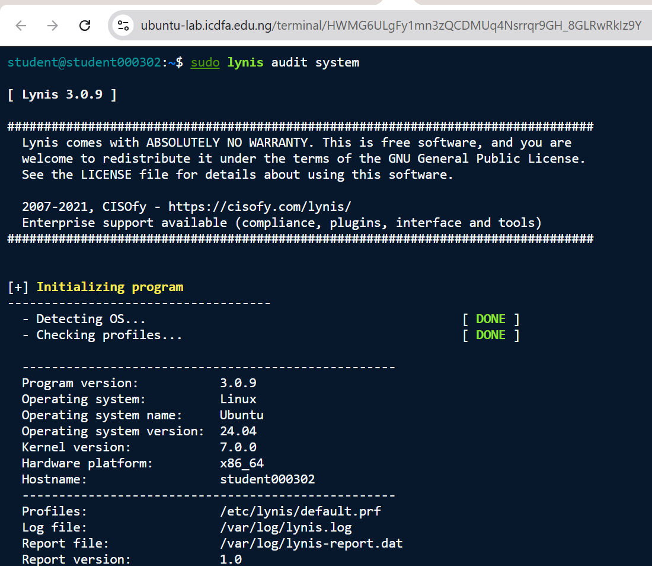
Figure 18. Lynis audit execution and environment detection (Activity 3.2)
Captured 30 Sep 2026, 13:54 WAT. Commands: sudo lynis audit system. What it shows: Lynis 3.0.9 detects Linux / Ubuntu 24.04, kernel 7.0.0, x86_64, hostname student000302. Profile /etc/lynis/default.prf; log /var/log/lynis.log; report /var/log/lynis-report.dat.
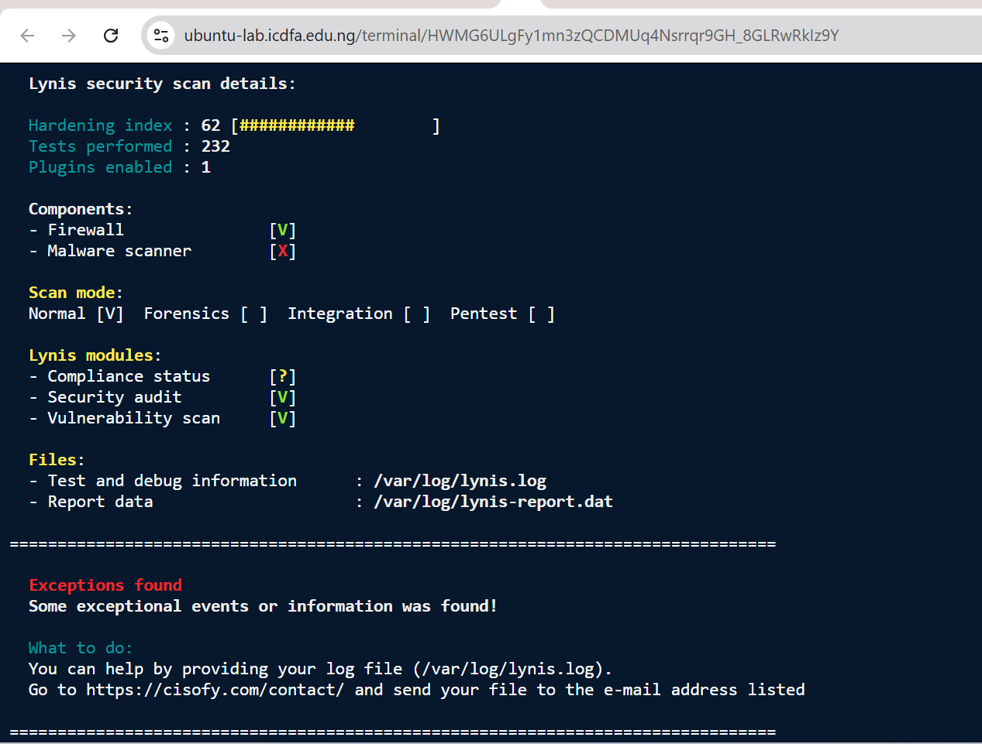
Figure 19. Lynis — scan details and hardening index
Captured 30 Sep 2026, 14:19 WAT. Commands: (Lynis output, “Lynis security scan details”). What it shows: Hardening index 62; tests performed 232; plugins enabled 1. Components: Firewall [V], Malware scanner [X]. Modules: Compliance status [?], Security audit [V], Vulnerability scan [V]. Files: /var/log/lynis.log and /var/log/lynis-report.dat.
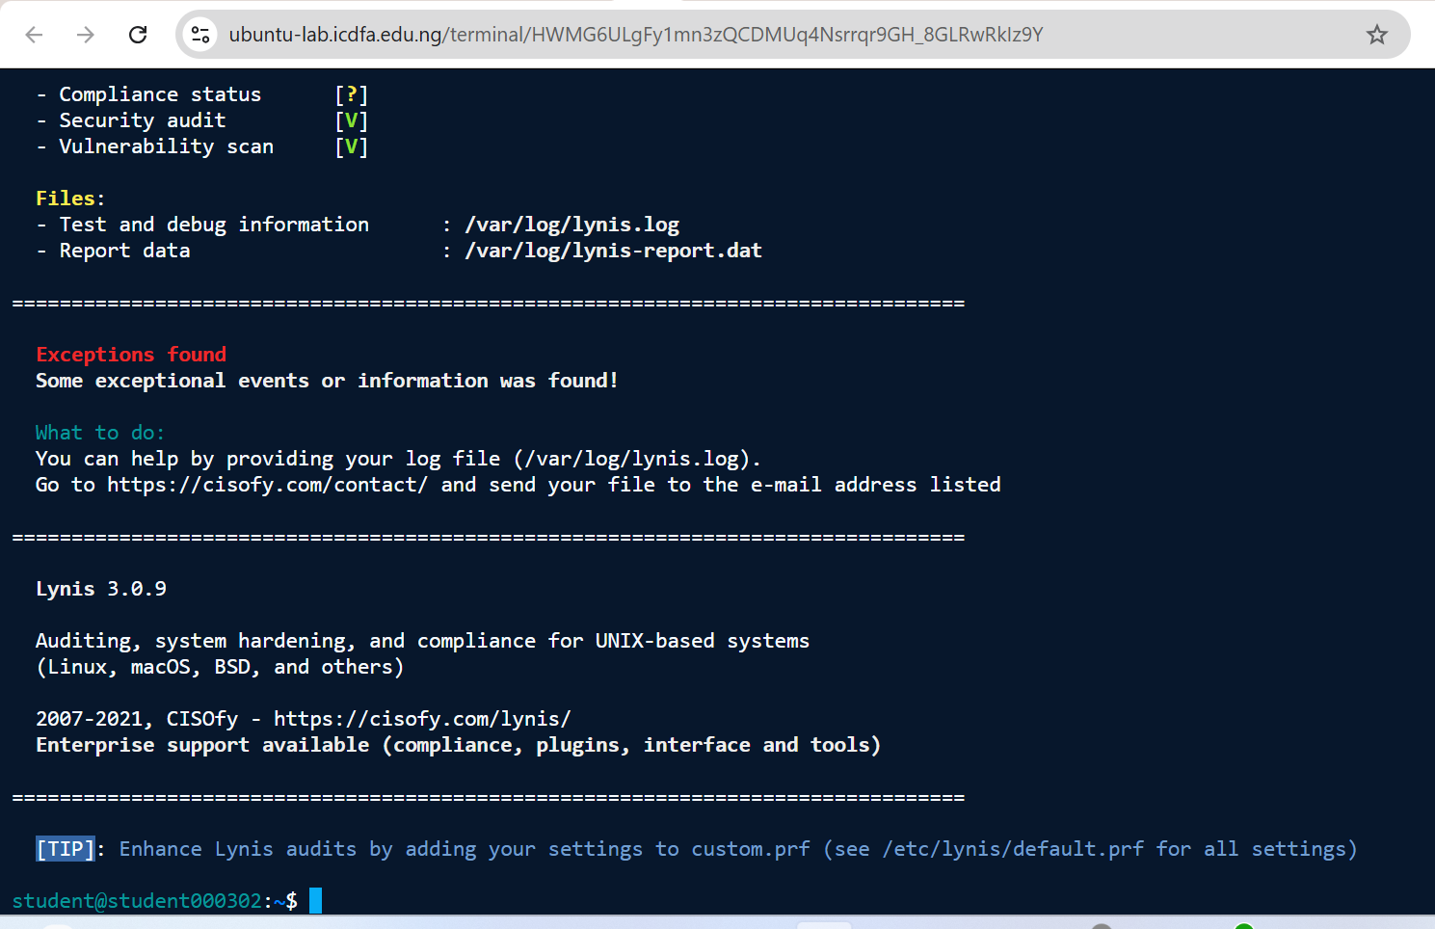
Figure 20. Lynis — end of scan and exceptions notice
Captured 30 Sep 2026, 14:20 WAT. Commands: (Lynis output, end of run). What it shows: Scan completed with the notice “Exceptions found”, report and log file locations, and the closing banner for Lynis 3.0.9.

6.2 Warnings (3)
Lynis ID | Warning | Supporting evidence | Governance significance
PKGS-7392 | Found one or more vulnerable packages. | 91 pending updates (Figures 5, 15); “Checking vulnerable packages” is WARNING (Figure 22) | The patch and vulnerability-management control is not meeting its objective.
NETW-2705 | Couldn’t find 2 responsive nameservers. | Only nameserver 127.0.0.11 is configured (Figure 23) | Single point of failure for name resolution, updates and any log forwarding.
LOGG-2138 | klogd is not running, which could lead to missing kernel messages in log files. | klogd NOT FOUND (Figure 24) | Kernel events may never reach the logs; it reinforces W4-F02.
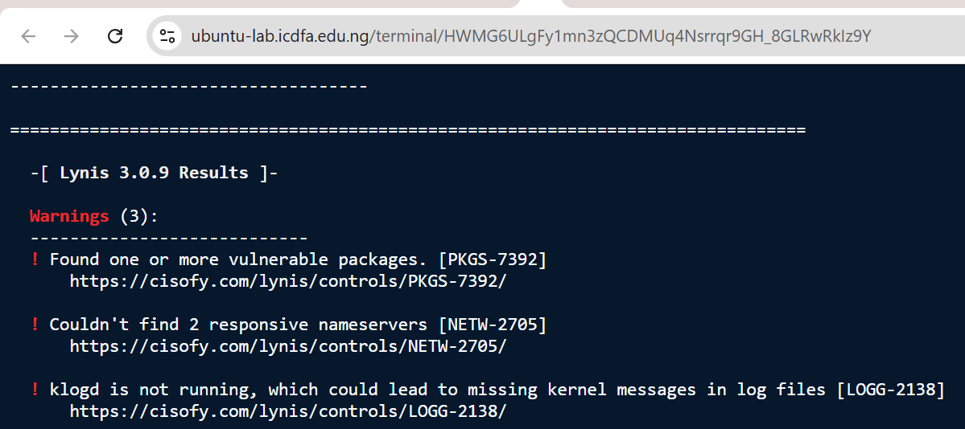
Figure 21. Lynis — Warnings (3)
Captured 30 Sep 2026, 14:16 WAT. Commands: (Lynis output, “Warnings (3)”). What it shows: PKGS-7392 vulnerable packages found; NETW-2705 could not find 2 responsive nameservers; LOGG-2138 klogd is not running (may lead to missing kernel messages in log files).

6.3 Results by scan section
Section | Key results | Figure
Ports and packages | Vulnerable packages: WARNING. Upgradeable-packages check: SKIPPED. Exception PKGS-7410 (no kernel packages found through the package manager). | Figure 22
Networking | IPv6 enabled; nameserver 127.0.0.11 OK; fewer than two responsive nameservers: WARNING; no promiscuous interfaces. | Figure 23
Firewall | iptables support FOUND; host-based firewall ACTIVE. | Figure 23
Logging and files | Running log daemon check: WARNING. Syslog-NG, systemd journal, Metalog, RSyslog, RFC 3195 daemon and minilogd all NOT FOUND; klogd NOT FOUND. logrotate OK. | Figure 24
Insecure services | inetd and telnet server not found; rsh, NIS and TFTP checks OK. | Figure 24
Kernel hardening | 16 sysctl keys reported DIFFERENT from the scan profile (for example fs.protected_fifos, fs.suid_dumpable, kernel.kptr_restrict, kernel.modules_disabled, kernel.sysrq, net.ipv4.conf.all.rp_filter and net.ipv4.conf.all.forwarding). The others were OK. | Figures 25, 26
Hardening checks | Compiler(s) FOUND; malware scanner NOT FOUND. | Figure 26
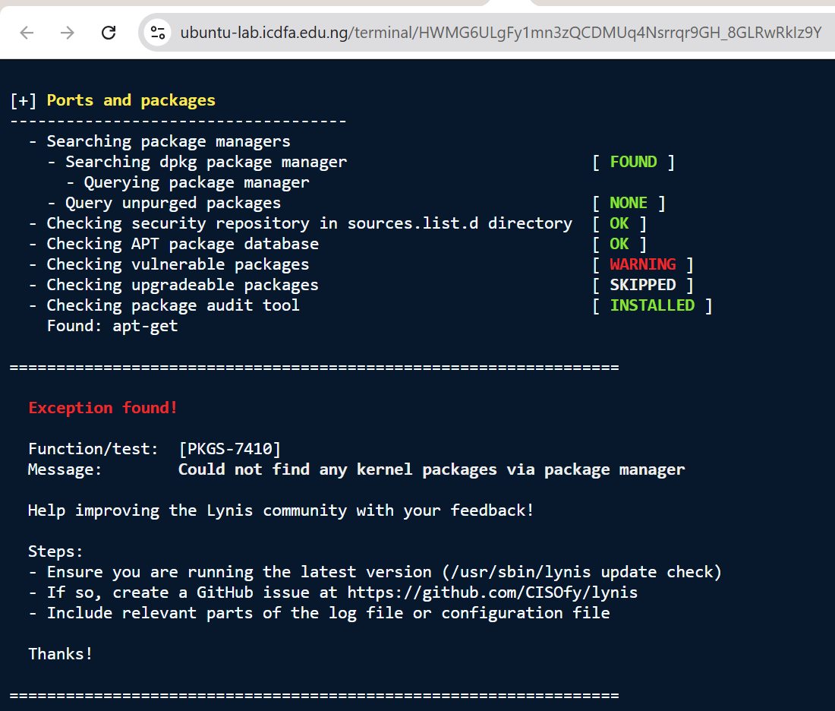
Figure 22. Lynis — ports and packages section
Captured 30 Sep 2026, 14:14 WAT. Commands: (Lynis output, section “Ports and packages”). What it shows: dpkg found; security repository and APT database OK; “Checking vulnerable packages” = WARNING; upgradeable packages check SKIPPED. Exception PKGS-7410: could not find any kernel packages via the package manager.
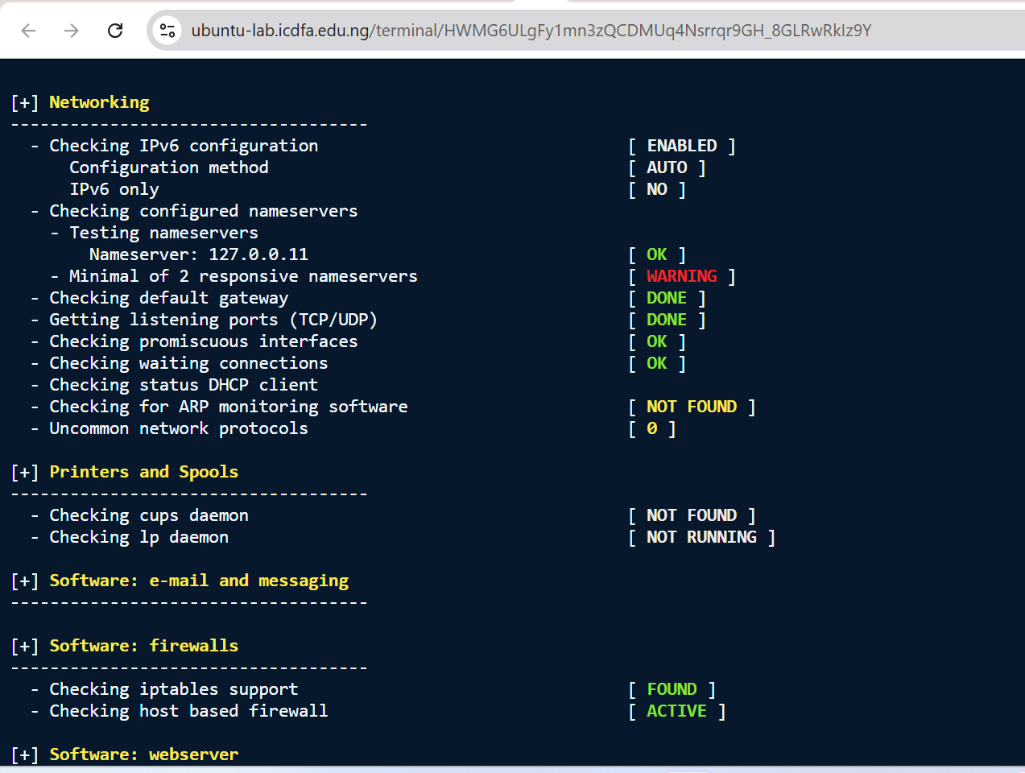
Figure 23. Lynis — networking and firewall sections
Captured 30 Sep 2026, 14:14 WAT. Commands: (Lynis output, sections “Networking” and “Software: firewalls”). What it shows: Nameserver 127.0.0.11 OK, but “Minimal of 2 responsive nameservers” = WARNING. No promiscuous interfaces. iptables support FOUND and host-based firewall ACTIVE.
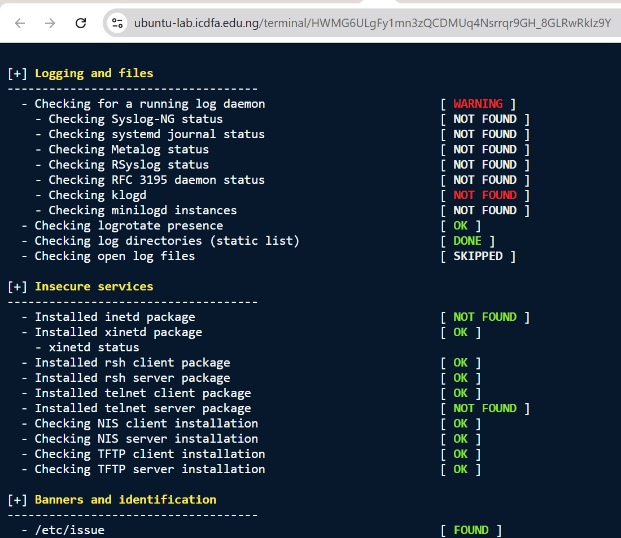
Figure 24. Lynis — logging, insecure services and banners
Captured 30 Sep 2026, 14:14 WAT. Commands: (Lynis output, sections “Logging and files”, “Insecure services”, “Banners and identification”). What it shows: “Checking for a running log daemon” = WARNING; Syslog-NG, systemd journal, Metalog, RSyslog, RFC 3195 daemon and minilogd NOT FOUND; klogd NOT FOUND (flagged red). logrotate OK. No inetd or telnet server found; rsh, NIS and TFTP checks OK. /etc/issue FOUND.
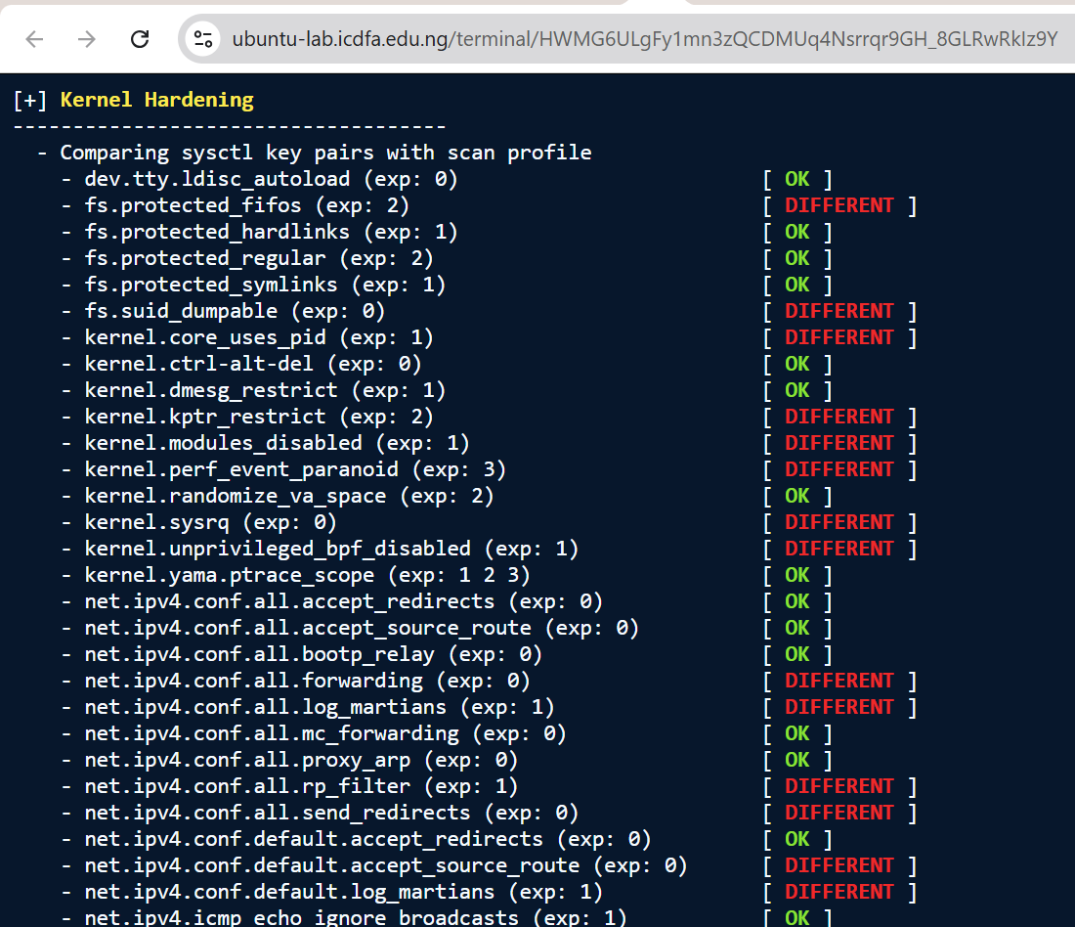
Figure 25. Lynis — kernel hardening (sysctl comparison, part 1)
Captured 30 Sep 2026, 14:15 WAT. Commands: (Lynis output, section “Kernel Hardening”). What it shows: Comparison of sysctl keys with the scan profile. Several keys are OK (e.g. kernel.dmesg_restrict, kernel.randomize_va_space); others are DIFFERENT (e.g. fs.protected_fifos, fs.suid_dumpable, kernel.kptr_restrict, kernel.modules_disabled, kernel.sysrq, net.ipv4.conf.all.rp_filter).
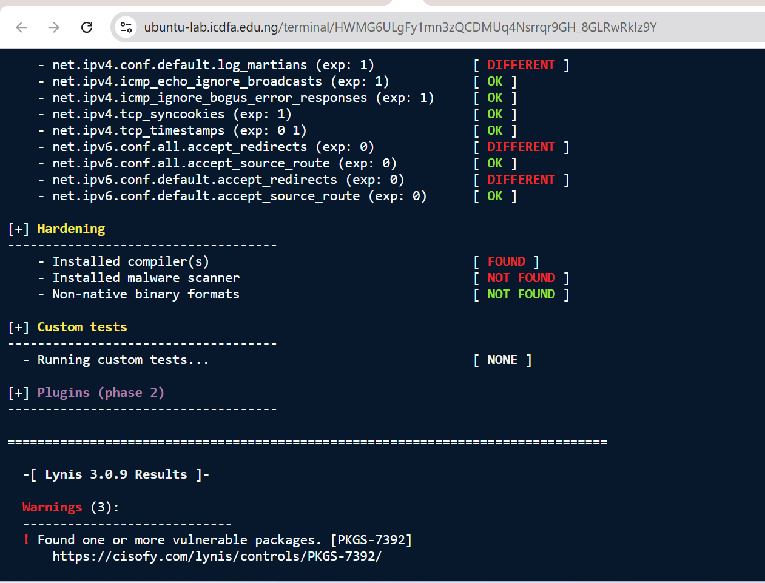
Figure 26. Lynis — kernel hardening (part 2), hardening checks and start of results
Captured 30 Sep 2026, 14:16 WAT. Commands: (Lynis output, sections “Kernel Hardening”, “Hardening”, “Custom tests”, “Lynis 3.0.9 Results”). What it shows: Remaining sysctl results (IPv6 redirect keys DIFFERENT; tcp_syncookies OK). Hardening: compiler(s) FOUND; malware scanner NOT FOUND. Results header and first warning (PKGS-7392).

6.4 The 43 suggestions, grouped by theme
Together, Figures 27, 28, 29, 30, 31 capture all 43 suggestions. The table groups them by theme.
Theme | Lynis IDs | Count | Figure
Logging, accounting, audit and integrity | LOGG-2130, ACCT-9622, ACCT-9626, ACCT-9628, FINT-4350 | 5 | Figure 30
Patch and package management | PKGS-7370, PKGS-7392, PKGS-7394, PKGS-7420, DEB-0810, DEB-0811, DEB-0831 | 7 | Figures 27, 29
Authentication and account policy | AUTH-9230, AUTH-9262, AUTH-9284, AUTH-9286 (x2), AUTH-9328, DEB-0280, DEB-0880 | 8 | Figures 27, 28
Kernel and system hardening | KRNL-5788, KRNL-5820, KRNL-6000, HRDN-7222, HRDN-7230, PROC-3612, BOOT-5180, BOOT-5264 | 8 | Figures 27, 28, 31
Network | NETW-2705, NETW-3200 (dccp, sctp, rds, tipc), NAME-4028 | 6 | Figures 29, 30
File systems and removable media | FILE-6310 (/home, /var), FILE-7524, USB-1000, STRG-1846 | 5 | Figures 28, 29, 31
Legal banners | BANN-7126, BANN-7130 | 2 | Figure 30
Tooling and automation | LYNIS (release older than 4 months), TOOL-5002 | 2 | Figures 27, 30
Total |  | 43
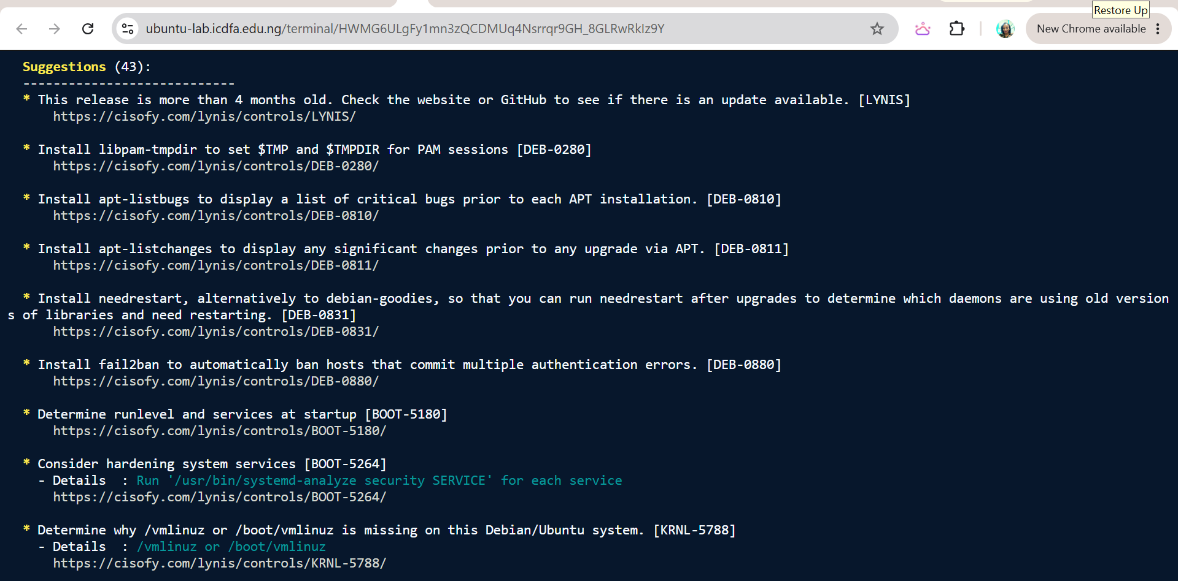
Figure 27. Lynis — Suggestions (43), part 1
Captured 30 Sep 2026, 14:17 WAT. Commands: (Lynis output, “Suggestions (43)”). What it shows: LYNIS (release older than 4 months), DEB-0280, DEB-0810, DEB-0811, DEB-0831, DEB-0880 (fail2ban), BOOT-5180, BOOT-5264, KRNL-5788.
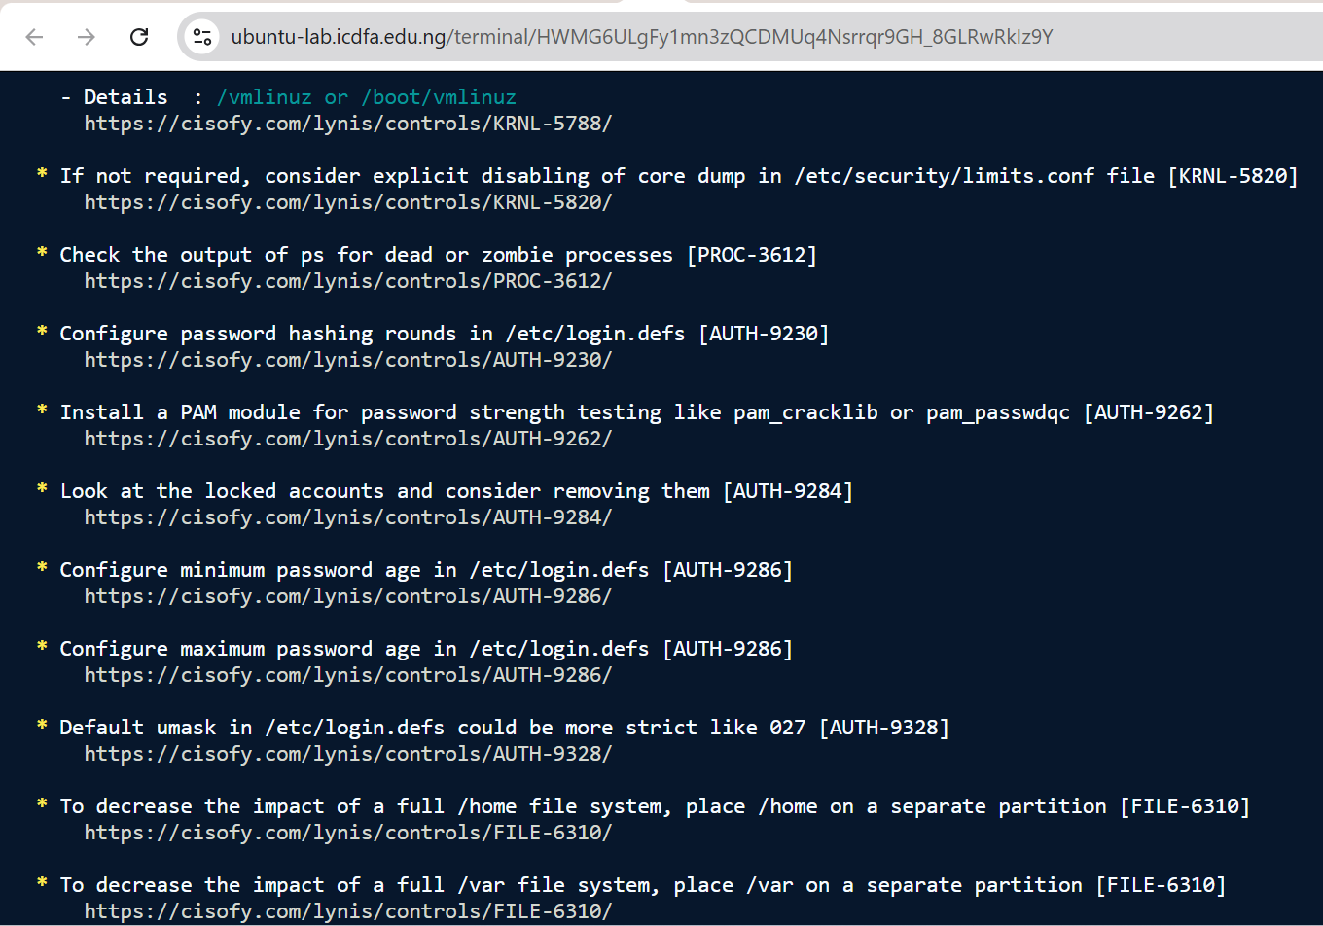
Figure 28. Lynis — Suggestions, part 2
Captured 30 Sep 2026, 14:17 WAT. Commands: (Lynis output, suggestions continued). What it shows: KRNL-5820, PROC-3612, AUTH-9230, AUTH-9262, AUTH-9284, AUTH-9286 (minimum and maximum password age), AUTH-9328 (umask 027), FILE-6310 (/home, /var on separate partitions).
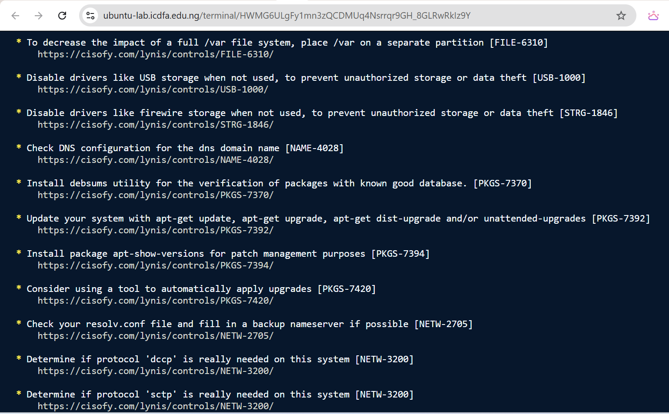
Figure 29. Lynis — Suggestions, part 3
Captured 30 Sep 2026, 14:18 WAT. Commands: (Lynis output, suggestions continued). What it shows: USB-1000, STRG-1846, NAME-4028, PKGS-7370 (debsums), PKGS-7392 (update the system), PKGS-7394, PKGS-7420 (automatic upgrades), NETW-2705, NETW-3200 (dccp, sctp).
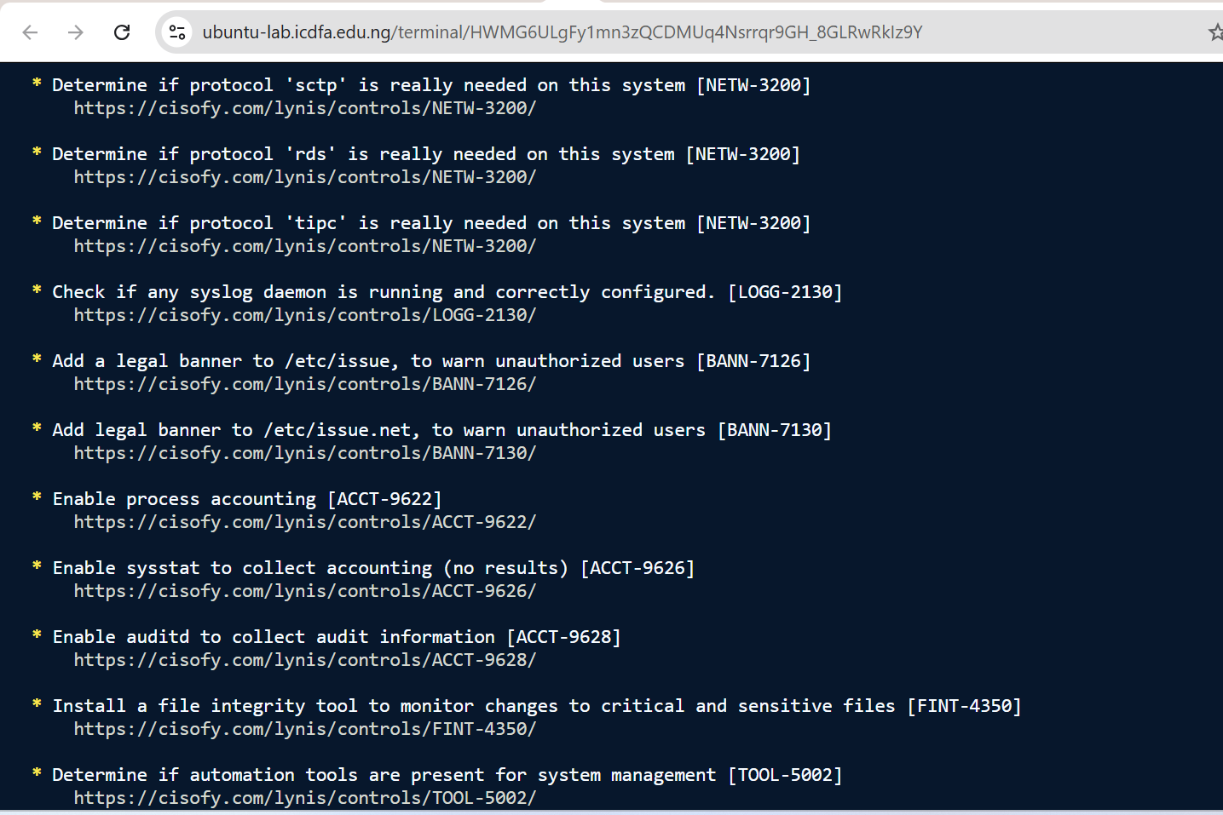
Figure 30. Lynis — Suggestions, part 4
Captured 30 Sep 2026, 14:18 WAT. Commands: (Lynis output, suggestions continued). What it shows: NETW-3200 (rds, tipc), LOGG-2130 (syslog daemon), BANN-7126 and BANN-7130 (legal banners), ACCT-9622 (process accounting), ACCT-9626 (sysstat), ACCT-9628 (enable auditd), FINT-4350 (file integrity tool), TOOL-5002.
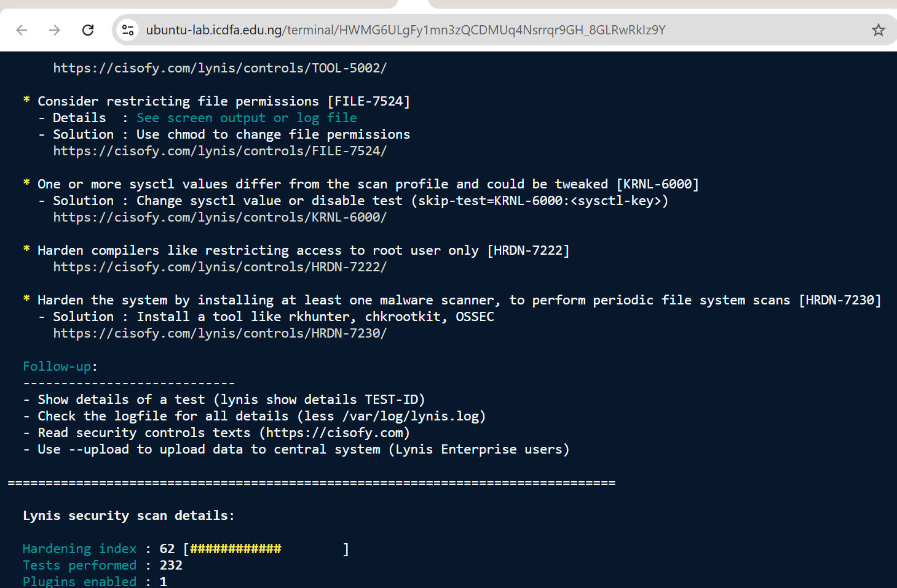
Figure 31. Lynis — Suggestions, part 5 and follow-up
Captured 30 Sep 2026, 14:19 WAT. Commands: (Lynis output, suggestions end; “Lynis security scan details” begins). What it shows: FILE-7524 (file permissions), KRNL-6000 (sysctl values differ from scan profile), HRDN-7222 (restrict compilers), HRDN-7230 (install a malware scanner such as rkhunter, chkrootkit or OSSEC). Follow-up guidance follows.

6.5 Prioritised findings, owners and recommendations
I picked out the most significant Lynis findings. For each, the table gives the risk or control issue, the evidence, the likely owner, what I recommend and the priority.
# | Finding (Lynis ID) | Evidence | Risk / control issue | Likely owner | Recommended remediation | Priority
1 | Vulnerable packages (PKGS-7392) | Figures 21, 15 | Known vulnerabilities may be exploitable; the backlog did not change in two days. | Infrastructure / Patch Management Lead | Review apt list --upgradable, apply security updates in a change window and enable unattended security upgrades (PKGS-7420). | High
2 | No audit or log daemon (ACCT-9628, LOGG-2130, LOGG-2138) | Figures 24, 30, 21 | Detective controls are absent; there is no evidence for incident response. | Security Operations Manager / Platform Engineering | Enable auditd; install rsyslog (or persistent journald) with kernel log capture; forward to the SIEM. | High
3 | No malware scanner or file-integrity tool (HRDN-7230, FINT-4350) | Figures 19, 31, 30 | Malware, or unauthorised change to critical files, could go unnoticed. | Endpoint Security Lead | Install a scanner such as rkhunter, chkrootkit or OSSEC (as Lynis lists) and a file-integrity tool such as AIDE, Tripwire or Samhain (named as suggested packages in Figure 16). | Moderate
4 | Password and account policy; no brute-force throttling (AUTH-9230/9262/9284/9286/9328, DEB-0880) | Figures 27, 28 | Weak password controls and no automatic blocking of repeated failures. | IAM Manager / Platform Engineering | Set hashing rounds, a password-quality PAM module, minimum and maximum age and umask 027 in login.defs; deploy fail2ban or equivalent. | Moderate
5 | Sysctl values differ from the profile (KRNL-6000; 16 keys) | Figures 25, 26 | Kernel and network hardening is weaker than the baseline. | Platform Engineering | Review each key against operational need and apply through /etc/sysctl.d under change control. | Moderate
6 | Single DNS resolver (NETW-2705) | Figure 23 | Availability risk for updates and log forwarding. | Network Operations | Configure a backup nameserver by the approved method. | Low
7 | No legal banner text (BANN-7126, BANN-7130) | Figure 30 | A weaker legal notice to unauthorised users. | Security Policy / Platform Engineering | Add approved banner text to /etc/issue and /etc/issue.net. | Low
8 | Lynis release older than 4 months (LYNIS) | Figure 27 | An outdated assessment tool may miss newer checks. | Security Assurance | Update Lynis through the approved repository and confirm the version. | Low

6.6 Optional hardening and retest (Activity 3.3)
This optional activity was not performed, and no configuration change was made simply to raise the score, which the brief warns against. A sensible low-risk candidate for a future retest is adding approved legal-banner text (BANN-7126 and BANN-7130). The “before” evidence is that Lynis reports the suggestion (Figure 30), and the “after” would be re-running the relevant Lynis check.

6.7 Consolidated findings register (all bundles)
This register brings the findings from Sections 4 to 6 together, with the evidence, the affected control (as numbered in the control-monitoring table in Section 7), the significance, the priority and the recommended action. The full finding records are in Appendix A.
ID | Finding | Evidence | Affected control | Risk / significance | Priority | Recommended action
W4-F01 | Audit system not operating; rules not loaded; no audit log | Figures 6, 8, 10, 11 | C1 Security audit logging | No attributable record of account-file access or programme execution. | High | Enable auditd, load the rules and forward to the SIEM.
W4-F02 | No working log management | Figures 12, 13, 14, 24 | C2 Log management and authentication monitoring | Failed logins, sudo use and errors cannot be reviewed. | High | Enable rsyslog or persistent journald and forward the logs.
W4-F03 | Patch backlog; vulnerable packages | Figures 5, 15, 21 | C3 Patch and vulnerability management | Known vulnerabilities may be exploitable. | High | Apply security updates; enable unattended security upgrades.
W4-F04 | Hardening gaps; no malware scanner or file-integrity tool | Figures 19, 25, 30, 31 | C4 Hardening baseline; C6 Malware and file integrity | Weaker baseline; tampering could go unnoticed. | Moderate | Work through the prioritised Lynis suggestions under change control.
W4-F05 | Privileged access cannot be independently reviewed | Figure 2 | C5 Privileged-access oversight | Cannot verify that sudo use was authorised. | Moderate | Document authorisation, enable sudo logging, recertify quarterly.
W4-F06 | Single DNS resolver | Figure 23 | C7 Network service resilience | Resolver failure would hold up updates and log forwarding. | Low | Add a backup nameserver.
W4-F07 | Platform process limit and restricted environment | Figures 3, 4 | Platform (supports C1 and C2) | Limits stop commands and could stop security tools. | Low | Platform owner to review limits and capacity monitoring.

7. Control-Monitoring Table and Governance Escalation (Evidence Bundle 4)
This table links the technical evidence to control objectives, owners, observed status, proposed thresholds, risk, remediation and retest. Rows C1 to C7 rest directly on evidence from this lab. Row C8 is derived from that evidence, because it depends on C1 and C2. The framework references are indicative mappings to ISO/IEC 27002:2022, and the KPI/KRI thresholds are my proposals for management approval. Figure numbers refer to the screenshots in Sections 2 to 6.
Control / objective | Evidence | Owner | Observed status | KPI/KRI or threshold (proposed) | Risk / significance | Remediation | Retest / follow-up
C1. Security audit logging (evidence-based)  auditd active and rules loaded, so privileged, account-file and execution activity is attributable. ISO 27002 8.15, 8.16. | auditd installed but not running (Figures 6, 7).  custom.rules not loaded; auditctl -l: “Operation not permitted” (Figure 8).  No audit.log; ausearch and aureport error (Figures 10, 11).  Lynis ACCT-9628 (Figure 30). | Security Operations Manager (operation); System Owner (host) | Not operating | KPI: % of in-scope hosts with auditd active and rules loaded; target 100%.  KRI: any host with auditd inactive for more than 24 h goes to the CISO. | No attributable record of account-file access or programme execution; the control cannot be assured. | Enable auditd by the approved platform method; load custom.rules and verify with auditctl -l; forward to the SIEM. | Service active; auditctl -l lists 5 rules; ausearch -k passwd_changes and -k program_execution return records after a harmless test. Within 14 days, then monthly.
C2. Log management and authentication monitoring (evidence-based)  Authentication, privilege and system events are logged, kept and reviewable. ISO 27002 8.15. | No journal files (Figure 12).  auth.log and syslog missing (Figures 13, 14).  wtmp, btmp, lastlog and faillog are 0 bytes (Figure 2).  Lynis: no log daemon; klogd not running (Figures 24, 21). | Security Operations Manager; Platform Engineering | Not operating | KPI: log sources reporting / expected = 100%.  KRI: a log gap over 1 h alerts the SOC; over 24 h goes to the CISO. | Failed logins, sudo use and errors cannot be reviewed; an incident could not be reconstructed. | Install and enable rsyslog or persistent journald with auth and kernel facilities; set up rotation and forwarding. | Generate a harmless sudo event and confirm it in the auth source and the SIEM. Within 14 days, then a monthly log-coverage review.
C3. Patch and vulnerability management (evidence-based)  Security updates are applied within policy. ISO 27002 8.8. | 91 upgradable packages on 29 Sep and 30 Sep (Figures 5, 15).  Lynis PKGS-7392 warning (Figure 21). | Infrastructure / Patch Management Lead | Backlog present | KPI: critical and high patches applied within SLA (proposed 14 / 30 days).  KRI: updates pending beyond SLA go to the Risk function. | Known-vulnerable packages could be exploited; the backlog did not move in two days. | Review pending updates, apply security updates in a change window and enable unattended security upgrades. | apt update shows no pending security updates; PKGS-7392 is gone from a new Lynis run. Within 30 days, then monthly.
C4. System hardening baseline (evidence-based)  Configuration meets the approved baseline. ISO 27002 8.9. | Lynis hardening index 62; 232 tests (Figure 19).  16 sysctl keys DIFFERENT (Figures 25, 26).  43 suggestions (Figure 27 to Figure 31). | Platform Engineering / Security Architecture | Partially effective | KPI: hardening index of 80 or more (proposed target).  KRI: index below 70, or any new warning, goes to the CISO. | A weaker baseline widens the attack surface. | Work through the prioritised suggestions under change control (password policy, sysctl, services, banners). | Re-run Lynis after changes and every quarter; track the index trend and open warnings.
C5. Privileged-access oversight (evidence-based)  Privileged use is authorised and reviewable. ISO 27002 8.2. | My account is in the sudo and adm groups (Figure 2).  sudo was used for installs and the audit, and there is no auth log to review it (Figure 13). | IAM Manager / System Owner | Access exists; review evidence unavailable | KPI: 100% of privileged accounts recertified each quarter.  KRI: privileged use with no log evidence. | It cannot be verified that sudo use was authorised. | Document the authorisation for sudo and adm membership, enable sudo logging (auth log and auditd) and schedule recertification. | Access-review record plus a sample of sudo events in the SIEM. Quarterly.
C6. Malware protection and file integrity (evidence-based)  Malicious or unauthorised file change is detected. ISO 27002 8.7. | Lynis: Malware scanner [X] (Figure 19); “Installed malware scanner NOT FOUND” (Figure 26).  HRDN-7230 and FINT-4350 suggestions (Figures 30, 31). | Endpoint Security Lead | Not implemented | KPI: % of hosts with a scanner and a file-integrity tool.  KRI: a change to a critical file with no approved ticket. | Malware or tampering could go unnoticed. | Deploy an approved scanner and file-integrity tool, and baseline the critical files. | Scan report and integrity baseline produced. Within 60 days.
C7. Network service resilience (DNS) (evidence-based)  Name resolution stays available. ISO 27002 8.20. | Lynis NETW-2705 warning; single nameserver 127.0.0.11 (Figures 23, 21). | Network Operations | Warning | KPI: two or more responsive resolvers per host. | A resolver failure would hold up updates and any log forwarding. | Add a backup nameserver by the approved method. | NETW-2705 no longer reported. Within 30 days.
C8. Centralised monitoring: SIEM forwarding (derived)  Host evidence reaches the SIEM for correlation and alerting. ISO 27002 8.16. | I did not assess this directly. It depends on C1 and C2: at the moment there is no working local log or audit source to forward. | Security Operations Manager | Not evidenced | KPI: % of in-scope hosts forwarding audit and auth logs.  KRI: a host silent for more than 24 h. | Without forwarding, gaps on the host are invisible to the SOC and to management. | Once C1 and C2 are fixed, onboard the host to the SIEM (see Section 8). | Test events visible in the SIEM within 60 days of C1 and C2 closing.

7.1 Governance escalation questions
Question | Answer
Which finding is the highest priority, and why? | W4-F01, the audit system not operating, together with the closely linked W4-F02 (no log management). Every other control is only as assurable as the evidence behind it. With no audit or log records, unauthorised changes to account files, privileged activity and authentication attacks cannot be detected, attributed or investigated, and management cannot be sure that other controls work. W4-F03 (the patch backlog) comes next because it can be exploited directly.
Who should own remediation for each major finding? | F01 and F02: Security Operations Manager (running the control) with Platform Engineering (host configuration).  F03: Infrastructure / Patch Management Lead.  F04 (hardening, malware protection, file integrity): Platform Engineering with the Endpoint Security Lead.  F05: IAM Manager and System Owner. F06: Network Operations. F07: the platform owner.
What should trigger escalation to the CISO, the Risk function or the management committee? (my proposal) | To the CISO: auditd or log collection inactive on an in-scope host for more than 24 h; any unapproved change to /etc/passwd or /etc/shadow; repeated authentication failures across several accounts or against a privileged account; a critical or high patch beyond its SLA; a Lynis hardening index below 70 or a new warning.  To the Risk function: a control failure open for more than 30 days, or one that comes back after a failed retest, recorded in the risk register.  To the management committee: a detective control failing on a business-critical workload for more than 60 days, any request to accept the risk, or repeated failed retests.
What evidence would show the remediation worked? | F01: auditd active; auditctl -l lists the five rules; ausearch and aureport return records with user, action and time after a harmless test.  F02: log files or the journal populated; a harmless sudo or failed-login test visible locally and in the SIEM.  F03: apt update shows no pending security updates, and PKGS-7392 is absent from a new Lynis run.  F04 to F07: the related Lynis items cleared and the hardening index at or above target.
When and how should each control be retested? | By re-running the same commands I used in this lab (status, rule listing, ausearch and aureport, log greps, lynis audit system) and comparing the results with the “before” figures in Sections 4 to 6. My proposed schedule is: F01 and F02 within 14 days of remediation, then monthly; F03 within 30 days, then monthly; F04 to F07 at the next quarterly Lynis assessment. In an enterprise setting, the SIEM checks in Section 8 would run these tests continuously.

8. SIEM / Continuous Monitoring Mapping (Evidence Bundle 5)
One-page view of how the evidence from this lab could feed an enterprise SIEM and continuous monitoring, and which conditions stay technical alerts and which become governance issues. Figure numbers point to my screenshots.
1. Linux host evidence | 2. Collection and transport | 3. SIEM processing | 4. SOC (operational alert) | 5. Governance / control assurance
auditd, journal / syslog, auth logs, wtmp and btmp, Lynis report, package status | Audit dispatcher plugins (audisp-remote present, Figure 7); rsyslog or an agent over TLS; scheduled Lynis run (lynis.timer, Figure 16) | Normalise and parse (auid, uid, exe, key, time); correlate by user, host and time; enrich with asset owner; retain per policy | Rule or analytic alert, SOC notified, ticket opened, triage and contain | Dashboards, automated control tests and reports; breaches escalated to CISO / Risk; remediation tracked to closure

Evidence source and what the lab showed | How it reaches the SIEM | Correlation and analysis | Stays a technical operational alert | Becomes a governance / control-assurance issue
auditd (passwd_changes, shadow_changes, program_execution).  Rules written; service not running; no records (Figures 8, 10, 11). | Forward audit events by dispatcher plugin or agent; parse key=value fields. | Link account-file access and execve by the same auid; flag activity outside change windows. | A write to /etc/shadow, or an unexpected privileged programme running. | auditd inactive or silent for more than 24 h; rules missing against baseline (C1).
Journal / syslog.  No journal, no syslog, no log daemon (Figures 12, 14, 24). | Forward through a syslog daemon or agent over TLS. | Normalise severity; spot service crashes and error spikes. | A service failure or burst of repeated errors on a host. | No log daemon on an in-scope host; coverage below target (C2).
Authentication logs, wtmp, btmp.  auth.log missing; login files 0 bytes (Figures 13, 2). | Collect the auth facility and login-accounting data. | Correlate failed logins by source and account; flag sudo use out of hours. | A brute-force pattern from one source; a success after several failures. | No authentication source; repeated failures across accounts; privileged use that cannot be reviewed (C2, C5).
Lynis report (/var/log/lynis-report.dat).  Index 62; 3 warnings; 43 suggestions (Figures 19, 21). | Ship the report file on a schedule; parse hardening_index and warnings. | Trend the index per host against the baseline. | A new critical warning raises a ticket to the owner. | Index below threshold; warnings open beyond SLA; declining trend (C4).
Package and patch status.  91 pending updates (Figures 5, 15). | Report inventory and update status; integrate a vulnerability scanner. | Map pending updates to known vulnerabilities. | A package with a known, actively exploited vulnerability. | A breach of the patch SLA (C3).
Platform health.  “unable to fork” errors (Figures 1, 4). | Host metrics and agent health. | Correlate resource exhaustion with failing security tools. | Process or memory exhaustion on a host. | Recurring capacity limits that stop security tools running (F07).

8.1 Automation and continuous control monitoring
- Continuous control monitoring and automated control testing: scheduled scripts check that auditd is active, the five rules are loaded, a log daemon is running and the pending-update count is within its threshold, and send the results to the SIEM dashboard.
- Automated alerting and trend analysis: a breached threshold (for example, a host silent for more than 24 h) notifies the SOC automatically, and the Lynis hardening index and warning counts are tracked for each host over time.
- Automated reporting and workflow: recurring control reports go to management, and findings create tickets that are assigned, escalated and tracked to closure through a SOAR or ticketing workflow.
Alert or governance issue? A single event, such as a burst of failed logins or an unexpected write to /etc/shadow, is a technical alert for the SOC to triage. A missing or failing control (no auditd, no log source, a patch backlog beyond SLA, a hardening index below threshold) is a governance and control-assurance issue, because it affects whether the organisation can detect and respond at all. It needs a named owner, a threshold to track against, and escalation to the CISO, the Risk function or the management committee.

9. Remediation and Retest Plan
The owners, priorities and timelines below are my proposals for management approval. Each action lists the evidence that would close it and how it would be retested.
Ref | Remediation action | Owner | Priority | Proposed timeline | Closure evidence | Retest method and timing
F01 | Enable auditd by the approved platform method; load custom.rules; add an equivalent authentication-source watch; forward to the SIEM. | Security Operations Manager; Platform Engineering | High | 14 days | Service active; auditctl -l shows 5 rules; audit.log present. | ausearch -k ... and aureport after a harmless test; monthly control check.
F02 | Install and enable rsyslog or persistent journald with auth and kernel facilities; check login accounting; forward logs. | Security Operations Manager; Platform Engineering | High | 14 days | Auth and syslog sources populated; LOGG-2130 and LOGG-2138 cleared. | A harmless sudo and failed-login test visible locally and in the SIEM; monthly coverage review.
F03 | Review and apply pending updates; enable unattended security upgrades. | Infrastructure / Patch Management Lead | High | 30 days (critical: 14 days) | No pending security updates; PKGS-7392 cleared. | apt update and a new lynis audit system; monthly.
F04 | Work through the prioritised Lynis suggestions under change control: password policy, fail2ban, sysctl values, malware scanner, file-integrity tool, banners. | Platform Engineering; Endpoint Security Lead; IAM Manager | Moderate | 60 days | Related Lynis IDs cleared; hardening index at or above target. | Quarterly lynis audit system; compare the index trend.
F05 | Document authorisation for sudo and adm membership; enable sudo logging; recertify privileged access. | IAM Manager; System Owner | Moderate | 30 days | Approved access record; sudo events visible in logs. | Quarterly access review with a log sample.
F06 | Add a backup DNS resolver. | Network Operations | Low | 30 days | NETW-2705 cleared. | Next Lynis run.
F07 | Review process and resource limits for the lab platform and monitor capacity. | Platform owner | Low | 14 days | No “unable to fork” errors in normal use. | Repeat the lab command set; capacity dashboard.

10. Conclusion
The lab gave me solid evidence that, on the Linux machine I was assigned, the detective controls an organisation would depend on (system auditing and authentication monitoring) are not operating. auditd is installed but inactive, my rules are staged but not loaded, and the journal, auth.log and syslog sources are missing or empty. Lynis confirms the logging gap independently and adds a patch backlog (91 pending updates and warning PKGS-7392), a hardening index of 62 and 43 suggestions for improvement. The main governance point is that these are failures of control operation, not just configuration details. Until audit and log evidence is restored, management cannot be assured about privileged activity, authentication attacks or changes to sensitive files on this host.
I would restore audit and log evidence first (W4-F01 and W4-F02), then clear the patch backlog (W4-F03), then work through the hardening suggestions under change control. Each control should be retested with the same commands I used here and, in an enterprise setting, monitored continuously through a SIEM with clear escalation thresholds. The limits of the lab platform (no systemd, a restricted audit interface and process limits) are set out in Section 3, and they should be confirmed with the platform owner.
What I encountered, and what it taught me. The lab did not go the way the commands in the brief assume. auditd would not start, the audit interface refused my queries, the usual log files were missing, and my session later ran out of processes. Rather than hide any of that, I recorded it exactly as it appeared and explained what each error meant. Whether the platform is deliberately left this way or is simply restricted, the effect is the same: it showed me that a control can be approved, installed and even configured on paper and still produce no evidence. That is the difference between a control existing and a control operating, which is the point of this module. I can explain every command I ran, what each result or error told me, and how I would take the same gaps to an owner, a threshold and a retest.

11. References
- ICDFA. GRC102 Week 4 Practical Laboratory: Linux Security Monitoring and Auditing (laboratory brief, 2026).
- CISOfy. Lynis security auditing tool and control documentation. https://cisofy.com/lynis/ and https://cisofy.com/lynis/controls/ (the control pages cited in the scan output).
- Linux Audit documentation and manual pages: auditd(8), auditctl(8), augenrules(8), ausearch(8), aureport(8).
- ISO/IEC 27002:2022, Information security controls: 8.2 (Privileged access rights), 8.7 (Protection against malware), 8.8 (Management of technical vulnerabilities), 8.9 (Configuration management), 8.15 (Logging), 8.16 (Monitoring activities), 8.20 (Networks security). Used as an indicative mapping.
- NIST SP 800-92, Guide to Computer Security Log Management (2006).

Appendix A — Security Event / Finding Records
Each record follows the template in the lab brief. Times are WAT unless stated. The figures are embedded in Sections 2 to 6 and indexed in Appendix C.

W4-F01 — Audit system not operating
Finding ID | W4-F01
Date / time observed | 29 Sep 2026, 13:17–13:41; 30 Sep 2026, 11:24–11:50 and 22:01
Evidence source | auditd, auditctl, ausearch, aureport, service status, ps, /etc/audit and /var/log/audit listings; Lynis ACCT-9628
Evidence summary | auditd 1:3.1.2-2.1ubuntu0.1 is installed but “not running”; systemctl is unusable (PID 1 is sleep); custom.rules was created but auditctl -l returns “Operation not permitted”; /var/log/audit is empty; ausearch and aureport fail with “Error opening /var/log/audit/audit.log”. (Figures 5, 6, 8, 10, 11, 7, 3)
Security significance | There is no attributable record of access to /etc/passwd or /etc/shadow, or of programme execution. The control exists on paper but is not operating, so it cannot be assured.
Control objective | Affected control: C1 (security audit logging). Security-relevant events on sensitive files and process execution are recorded, attributable to a user and time, retained and available for investigation.
Control owner | Security Operations Manager (operation); System Owner / Platform Engineering (host configuration)
Risk / priority | [object Object]
Recommended action | Enable auditd by the approved platform method; load custom.rules (augenrules --load) and verify with auditctl -l; use an equivalent authentication-source watch where auth.log does not exist; forward events to the SIEM; confirm retention (auditd.conf: 8 MB, ROTATE).
Retest evidence | Status active; auditctl -l lists 5 rules; after sudo nano /etc/passwd (closed without saving) and ls /tmp, ausearch -k passwd_changes and -k program_execution return records with user, time and executable; aureport shows counts.

W4-F02 — No working log management
Finding ID | W4-F02
Date / time observed | 30 Sep 2026, 12:32–12:41; 13:53 (Lynis scan); 21:49
Evidence source | journalctl; grep on auth.log and syslog; /var/log listing; Lynis LOGG-2130 and LOGG-2138
Evidence summary | journalctl: “No journal files were found”; auth.log and syslog do not exist; wtmp, btmp, lastlog and faillog are 0 bytes; Lynis: no running log daemon, klogd not running. (Figures 12, 13, 14, 2, 24, 21)
Security significance | Failed logins, sudo use, service errors and kernel messages cannot be reviewed or forwarded, so investigation and privileged-access review are not possible.
Control objective | Affected control: C2 (log management and authentication monitoring). Authentication, privilege and system events are logged, retained and reviewable, and available to central monitoring.
Control owner | Security Operations Manager; Platform Engineering
Risk / priority | [object Object]
Recommended action | Install and enable rsyslog or persistent journald with auth and kernel facilities; check login accounting; set up rotation and forwarding.
Retest evidence | Auth and syslog sources populated; a harmless sudo event and a failed-login test appear locally and in the SIEM; Lynis LOGG-2130 and LOGG-2138 cleared.

W4-F03 — Patch backlog and vulnerable packages
Finding ID | W4-F03
Date / time observed | 29 Sep 2026, 13:17; 30 Sep 2026, 13:44; Lynis scan about 13:53
Evidence source | apt update output on two days; Lynis PKGS-7392 (warning) and PKGS-7420 (suggestion)
Evidence summary | “91 packages can be upgraded” on both 29 Sep and 30 Sep; Lynis warns that one or more vulnerable packages were found. (Figures 5, 15, 21, 22)
Security significance | Pending updates may include fixes for known vulnerabilities, and the unchanged count suggests nothing was patched in that period.
Control objective | Affected control: C3 (patch and vulnerability management). Security updates are applied within the approved timeframe and verified.
Control owner | Infrastructure / Patch Management Lead
Risk / priority | [object Object]
Recommended action | Review apt list --upgradable; apply security updates in a change window; enable unattended security upgrades.
Retest evidence | apt update shows no pending security updates; PKGS-7392 is absent from a new lynis audit system.

W4-F04 — Hardening gaps, malware protection and file integrity
Finding ID | W4-F04
Date / time observed | 30 Sep 2026, scan about 13:53; reviewed 14:14–14:20
Evidence source | Lynis hardening index, kernel hardening, hardening checks and suggestions
Evidence summary | Hardening index 62; 16 sysctl keys DIFFERENT; malware scanner NOT FOUND; no file-integrity tool (FINT-4350); no fail2ban (DEB-0880); password-policy suggestions (AUTH-9230, 9262, 9286, 9328). (Figures 19, 25, 26, 27, 28, 30, 31)
Security significance | A weaker baseline and no malware or integrity monitoring make it more likely that a compromise or tampering goes unnoticed.
Control objective | Affected controls: C4 (hardening baseline) and C6 (malware protection and file integrity). Systems meet the approved security baseline and unauthorised change is detected.
Control owner | Platform Engineering; Endpoint Security Lead; IAM Manager
Risk / priority | [object Object]
Recommended action | Apply the prioritised suggestions under change control; deploy an approved malware scanner and file-integrity tool; put in place password policy and brute-force throttling.
Retest evidence | Related Lynis IDs cleared; hardening index at or above target in the next quarterly run.

W4-F05 — Privileged access cannot be independently reviewed
Finding ID | W4-F05
Date / time observed | 30 Sep 2026, 21:49
Evidence source | id output; absence of auth.log
Evidence summary | My account (uid 1000) is in the sudo and adm groups and I used sudo throughout the lab; no authentication log exists to verify that use. (Figures 2, 13)
Security significance | Root-level and log-read rights exist without an independent review trail.
Control objective | Affected control: C5 (privileged-access oversight). Privileged access is authorised and recertified, and its use can be reviewed.
Control owner | IAM Manager; System Owner
Risk / priority | [object Object]
Recommended action | Document the authorisation for the membership; enable sudo logging; schedule quarterly recertification.
Retest evidence | Approved access record and a sample of sudo events in logs or the SIEM.

W4-F06 — Single DNS resolver
Finding ID | W4-F06
Date / time observed | 30 Sep 2026, scan about 13:53
Evidence source | Lynis NETW-2705
Evidence summary | Only nameserver 127.0.0.11 is configured; Lynis could not find 2 responsive nameservers. (Figures 23, 21)
Security significance | A resolver failure would hold up updates and any log forwarding.
Control objective | Affected control: C7 (network service resilience). Name resolution remains available to the host.
Control owner | Network Operations
Risk / priority | [object Object]
Recommended action | Add a backup nameserver by the approved method.
Retest evidence | NETW-2705 no longer reported in a new Lynis run.

W4-F07 — Platform process limit and restricted environment
Finding ID | W4-F07
Date / time observed | 30 Sep 2026, 21:46–22:04
Evidence source | Terminal output; cat /proc/1/comm
Evidence summary | “sudo: unable to fork”, segmentation faults and “bash: fork: retry” errors; PID 1 is sleep. (Figures 1, 3, 4)
Security significance | Resource limits interrupted my commands and could just as easily interrupt security tools. The restricted platform also explains why auditd and journald could not run.
Control objective | Affected controls: C1 and C2 (platform dependency). The platform provides enough capacity and services for security controls to operate.
Control owner | Platform owner
Risk / priority | [object Object]
Recommended action | Review process limits and capacity monitoring; confirm which services the platform supports.
Retest evidence | No fork errors in normal use; a capacity dashboard in place.

Appendix B — Evidence Completeness Matrix
This matrix maps each requirement in the lab brief to the evidence I have, including where the environment limited what I could show.
Brief requirement | Status | Where / notes
Document equivalent log sources / methods where my environment differs (Section 3 rules; Activities 1.2, 2.2, 2.3) | Provided | Section 3.1 (one table covering all 8 cases)
Bundle 1: evidence that auditd is running | Provided; shows NOT running | Figures 5, 6, 7; Section 4.1
Bundle 1: loaded custom audit rules | Rules shown; loading blocked | Figure 8; auditctl -l error; Section 4.2
Bundle 1: at least one ausearch result for a configured key | Attempted for all three keys; error output | Figures 10, 11; Section 4.3
Bundle 1: at least one aureport summary | Summary, --failed and --login attempted; error output | Figures 10, 11; Section 4.3
Bundle 1: interpretation of user / action / time | Provided | Section 4.4
Bundle 2: journalctl review | Provided; no journal files | Figure 12; Section 5.1
Bundle 2: authentication / privilege-use evidence | Equivalent sources documented | Figures 13, 2, 24; Section 5.2
Bundle 2: error / warning evidence (syslog or equivalent) | Equivalent sources documented | Figures 14, 21, 4; Section 5.3
Bundle 2: event table | Provided | Section 5.4 (9 rows)
Bundle 3: Lynis version and execution | Provided | Figures 16, 17, 18
Bundle 3: hardening index / summary | Provided (62) | Figure 19
Bundle 3: at least three warnings or suggestions | Provided (3 warnings, 43 suggestions) | Figures 21, 27, 31
Bundle 3: findings with risk, evidence, owner, remediation, priority | Provided | Section 6.5 and Appendix A
Bundle 3: optional retest (before and after) | Not performed (optional) | Section 6.6
Bundle 4: control table (5+ rows; 3+ evidence-based) | Provided (8 rows; 7 evidence-based) | Section 7
Bundle 4: escalation questions | Answered | Section 7.1
Bundle 5: SIEM and automation mapping | Provided | Section 8
Bundle 6: final audit report structure | Provided | This document
Optional: failed local authentication attempt (Activity 1.3) | Not performed (optional) | Optional activity; not carried out

Appendix C — Supporting Screenshot and Command-Output Evidence (Figure Index)
The supporting screenshots and command output (Figures 1–31) are embedded in the section that discusses each one, so the evidence sits beside the analysis. This index lists every figure, with its section and capture time, so that any item can be found quickly.
Figure | Title | Section | Captured (WAT)
1 | Operating system, kernel and sudo check | 2 Scope | 30 Sep 2026, 21:46
2 | Identity, PID 1 and /var/log inventory | 2 Scope | 30 Sep 2026, 21:49
3 | System clock, identity, PID 1 and resource errors | 3 Methodology | 30 Sep 2026, 22:01
4 | Shell start-up under process-limit errors | 3 Methodology | 30 Sep 2026, 22:04
5 | auditd status check, package refresh and install attempt (Activity 1.1) | 4.1 | 29 Sep 2026, 13:17
6 | auditd package and service verification | 4.1 | 29 Sep 2026, 13:28
7 | auditd process check and audit directory inspection | 4.1 | 30 Sep 2026, 11:50
8 | Custom audit rules, restart attempt and loaded-rule query (Activity 1.2) | 4.2 | 29 Sep 2026, 13:41
9 | Benign event generation (Activity 1.3) | 4.3 | 30 Sep 2026, 11:24
10 | aureport and ausearch attempts (Activity 1.3) | 4.3 | 30 Sep 2026, 11:26
11 | ausearch for all three keys and aureport summaries (Activity 1.3) | 4.3 | 29 Sep 2026, 09:58
12 | journalctl review (Activity 2.1) | 5.1 | 30 Sep 2026, 12:32
13 | Authentication and privilege-use log review (Activity 2.2) | 5.2 | 30 Sep 2026, 12:39
14 | General system log review (Activity 2.3) | 5.3 | 30 Sep 2026, 12:41
15 | Package list refresh before Lynis installation | 6.1 | 30 Sep 2026, 13:44
16 | Lynis installation (Activity 3.1) | 6.1 | 30 Sep 2026, 13:45
17 | Lynis version | 6.1 | 30 Sep 2026, 13:52
18 | Lynis audit execution and environment detection (Activity 3.2) | 6.1 | 30 Sep 2026, 13:54
19 | Lynis — scan details and hardening index | 6.1 | 30 Sep 2026, 14:19
20 | Lynis — end of scan and exceptions notice | 6.1 | 30 Sep 2026, 14:20
21 | Lynis — Warnings (3) | 6.2 | 30 Sep 2026, 14:16
22 | Lynis — ports and packages section | 6.3 | 30 Sep 2026, 14:14
23 | Lynis — networking and firewall sections | 6.3 | 30 Sep 2026, 14:14
24 | Lynis — logging, insecure services and banners | 6.3 | 30 Sep 2026, 14:14
25 | Lynis — kernel hardening (sysctl comparison, part 1) | 6.3 | 30 Sep 2026, 14:15
26 | Lynis — kernel hardening (part 2), hardening checks and start of results | 6.3 | 30 Sep 2026, 14:16
27 | Lynis — Suggestions (43), part 1 | 6.4 | 30 Sep 2026, 14:17
28 | Lynis — Suggestions, part 2 | 6.4 | 30 Sep 2026, 14:17
29 | Lynis — Suggestions, part 3 | 6.4 | 30 Sep 2026, 14:18
30 | Lynis — Suggestions, part 4 | 6.4 | 30 Sep 2026, 14:18
31 | Lynis — Suggestions, part 5 and follow-up | 6.4 | 30 Sep 2026, 14:19

