Lab 3B: Advanced Cybersecurity Risk Quantification
End-to-End Quantitative Risk Assessment, Cost-Benefit Analysis and Executive Briefing
SecureBank Financial: Mobile Banking Platform (SecureMobile)
Item | Detail
Prepared by | Chioma Ameh | Registration number C11/26/CGRCE/17567
Course / lab | GRC103 | Lab 3B (Advanced Risk Quantification)
Role | Lead GRC Analyst, reporting to the CISO and CFO
Date | 29 October 2026 (WAT)
Supporting files | Lab3B_Risk_Quantification_Workbook.xlsx (all calculations, live formulas), Lab3B_Executive_Dashboard.pdf, charts folder (10 images), presentation folder (executive briefing slides)
Method | SLE, ARO and ALE as taught in class; control cost-benefit with ROI and payback; heat map and budget optimisation

Executive summary
SecureBank is exposed to about $35,000,000 a year in expected losses from three serious weaknesses that penetration testing found in the SecureMobile app. I looked at three controls: a web application firewall (WAF), stronger multi-factor authentication (MFA) and an API security gateway. Together they cost $700,000 to put in place and $105,000 a year to run. They cut the expected yearly loss by $26,962,500 (77.04%), which leaves $8,037,500. Once the running costs are taken off, the net benefit is $26,857,500 a year.
In the first year the return is 3,249.38% on everything we spend, or 3,751.79% if we count only the up-front cost. The up-front money is earned back in about 9.5 days. The WAF alone accounts for 86.9% of the reduction and has the lowest set-up cost of the three, so it should go first.
My recommendation: deal with all three risks, in this order: WAF, then MFA, then the API gateway. If leadership limits first-year spending to $500,000, buy the WAF and MFA ($350,000). That already removes 97.5% of the reduction we can achieve, and the API gateway can wait until Year 2.
These numbers come from a model. They rest on the figures in the lab sheet and on the assumptions in Section 2, so please read them as estimates, not forecasts.

1. Scenario and methodology
In my role as Lead GRC Analyst, the job here is to turn technical findings into money, so the CISO and CFO can compare the risks and the control costs on the same scale. Executives think in dollars and probabilities, so I used the quantitative approach we learned in class: SLE, ARO and ALE.
Term | Formula | Meaning
Single Loss Expectancy (SLE) | Asset value x Exposure factor, or the direct loss figure | Loss from one incident
Annual Rate of Occurrence (ARO) | Incidents expected per year | How often it is expected
Annualized Loss Expectancy (ALE) | SLE x ARO | Expected loss per year without controls
Residual risk | Inherent ALE x (1 - control effectiveness) | Risk left after the control
Risk reduction (annual benefit) | Inherent ALE - residual ALE | Loss avoided per year
ROI | (Benefit - cost) / cost x 100 | Return per dollar spent
Payback period | Initial investment / annual net cash benefit | Time to recover the investment

2. Assumptions and data sources
The lab sheet gives the numbers but leaves some things open to interpretation. I wrote down each choice I made so it can be checked or changed. All of them are inputs in the workbook.
Ref | Type | Statement
A1 | Given | Exploit probabilities, loss figures, control costs, effectiveness and maintenance come from the Lab 3B sheet.
A2 | Assumed | ARO equals the exploit probability treated as a yearly rate (15% = 0.15 incidents per year). The sheet does not say "per year".
A3 | Assumed | SLE uses the sheet loss figures directly: $5,000,000 (maximum single incident loss); 500,000 records x $250; 5,000 accounts x $1,500. No exposure factor is given, so none is applied.
A4 | Assumed | Each control mitigates the finding it is designed for (API gateway to API bypass, WAF to database injection, MFA to session hijacking) and its effectiveness applies to that finding only.
A5 | Assumed | ROI is shown on initial investment (class formula) and on Year-1 total cost (initial plus first-year maintenance). Payback uses annual risk reduction less annual maintenance.
A6 | Assumed | Priority thresholds: probability High at 30% or more, Medium at 10% or more; impact (SLE) High at $10,000,000 or more, Medium at $1,000,000 or more; heat score (probability x impact, 1 to 3 each) High at 6 or more, Medium at 3 or more.
A7 | Assumed | The sheet sets no budget limit. $500,000 is used as the main constrained case and other budgets are tested.
A8 | Not used | System context (500,000 users, $2,500 average transaction, 50,000 daily transactions, 48-hour detection for the API finding) is context only; the sheet supplies loss figures directly.
A9 | Proposal | The implementation timeline is the analyst's proposal, not given data.

3. Task 1 and Task 2: Inherent risk and prioritisation

Vulnerability 1: API Authentication Bypass
- Exploit probability (ARO): 15% = 0.15
- SLE: $5,000,000 (maximum single incident loss)
- ALE = $5,000,000 x 0.15 = $750,000 per year

Vulnerability 2: Database Injection
- Exploit probability (ARO): 25% = 0.25
- SLE: 500,000 records x $250 = $125,000,000
- ALE = $125,000,000 x 0.25 = $31,250,000 per year

Vulnerability 3: Session Hijacking
- Exploit probability (ARO): 40% = 0.40
- SLE: 5,000 accounts x $1,500 = $7,500,000
- ALE = $7,500,000 x 0.40 = $3,000,000 per year

Table 1. Risk prioritisation matrix (rank by ALE; level from the probability x impact heat score)
Rank | Vulnerability | SLE | ARO | ALE | Heat score | Priority
1 | Database Injection | $125,000,000 | 0.25 | $31,250,000 | Medium x High = 6 | High
2 | Session Hijacking | $7,500,000 | 0.40 | $3,000,000 | High x Medium = 6 | High
3 | API Authentication Bypass | $5,000,000 | 0.15 | $750,000 | Medium x Medium = 4 | Medium
 | Total |  |  | $35,000,000 |  | High

Database injection ranks first. One incident costs $125 million, and we expect one about every four years (ARO 0.25). Session hijacking comes second: it is the most likely event (40%), but each incident costs less. The API bypass has the lowest ALE, but it still needs treatment because a single incident can cost $5 million and it can go undetected for about 48 hours.
I called the database injection risk 'Critical' in an earlier draft. I changed it to High (rank 1) because the lab sheet only uses High, Medium and Low.

4. Task 3: Risk visualisations
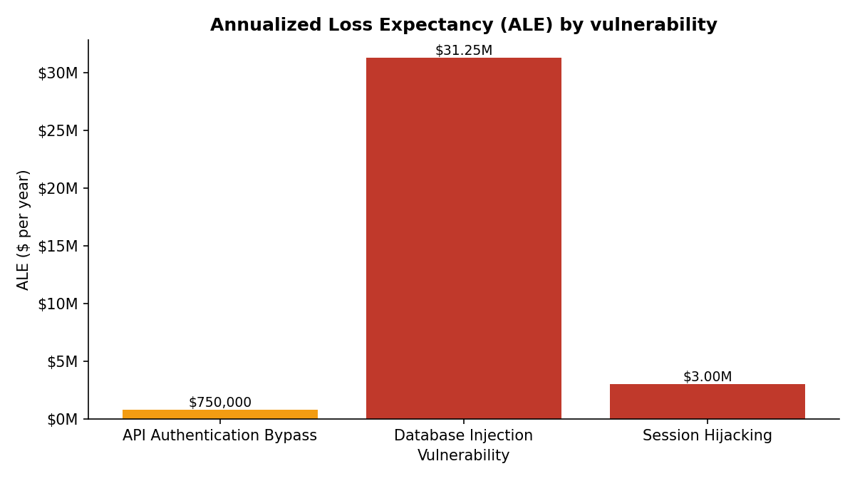
Figure 1. ALE by vulnerability. Red marks High priority and amber marks Medium priority.
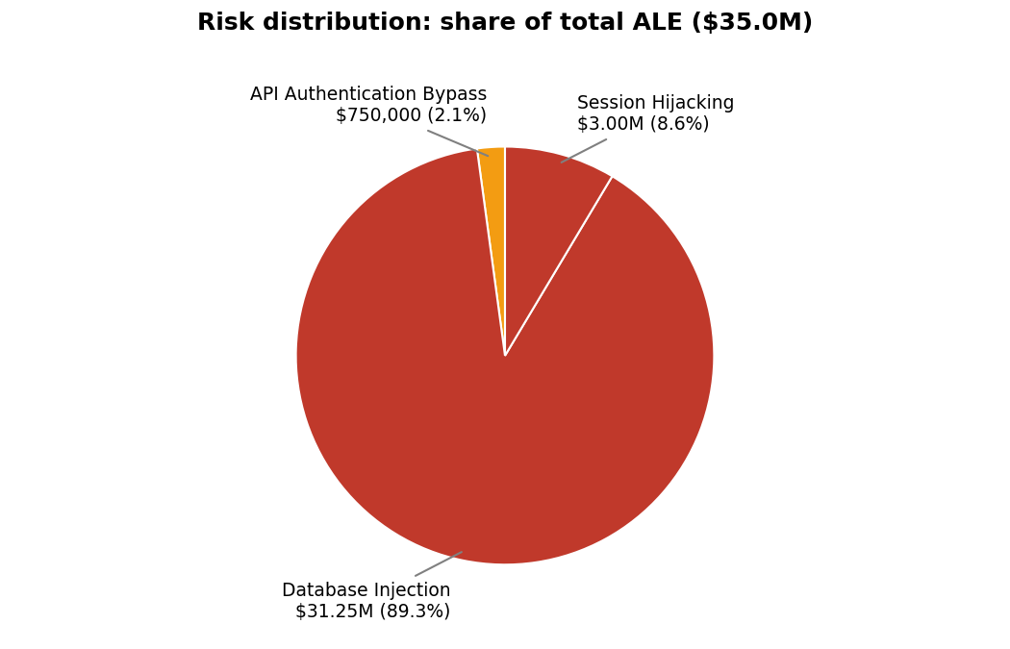
Figure 2. Share of total ALE. Database injection carries 89.3% of the exposure.
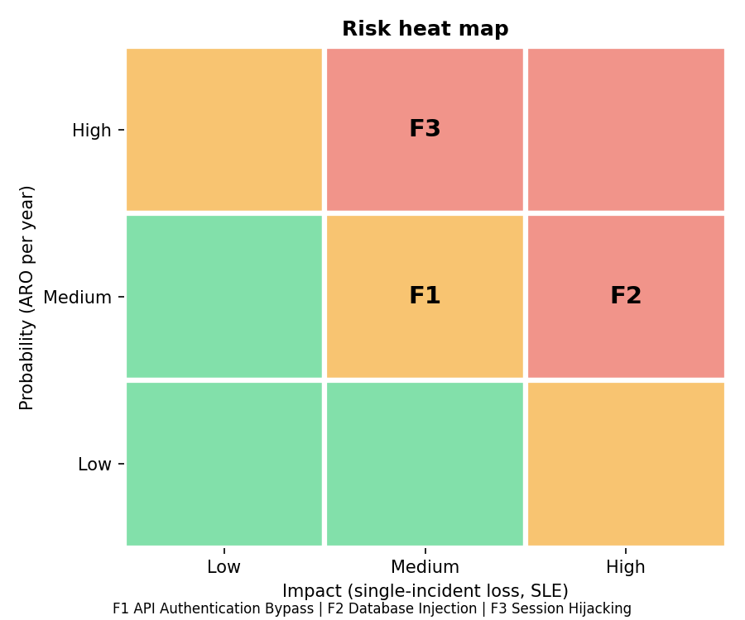
Figure 3. Risk heat map (probability x impact). F1 API bypass, F2 database injection, F3 session hijacking.

5. Task 4: Control cost-benefit analysis
For each control I worked out the up-front cost (CapEx), the yearly running cost (OpEx), how much risk it removes, how much is left, the ROI on both bases, and the payback period. The formulas are the ones in Section 1.

Web Application Firewall (WAF): mitigates Database Injection
- Parameters: initial $150,000 | maintenance $25,000 per year | effectiveness 75%
- Inherent ALE $31,250,000; residual ALE = $31,250,000 x (1 - 0.75) = $7,812,500
- Annual risk reduction = $31,250,000 x 0.75 = $23,437,500
- ROI on initial investment = ($23,437,500 - $150,000) / $150,000 = 15,525.00%
- ROI on Year-1 total cost = ($23,437,500 - $175,000) / $175,000 = 13,292.86%
- Payback = $150,000 / ($23,437,500 - $25,000) = 0.0064 years = 2.3 days

MFA Enhancement: mitigates Session Hijacking
- Parameters: initial $200,000 | maintenance $30,000 per year | effectiveness 95%
- Inherent ALE $3,000,000; residual ALE = $3,000,000 x (1 - 0.95) = $150,000
- Annual risk reduction = $3,000,000 x 0.95 = $2,850,000
- ROI on initial investment = ($2,850,000 - $200,000) / $200,000 = 1,325.00%
- ROI on Year-1 total cost = ($2,850,000 - $230,000) / $230,000 = 1,139.13%
- Payback = $200,000 / ($2,850,000 - $30,000) = 0.0709 years = 25.9 days

Advanced API Security Gateway: mitigates API Authentication Bypass
- Parameters: initial $350,000 | maintenance $50,000 per year | effectiveness 90%
- Inherent ALE $750,000; residual ALE = $750,000 x (1 - 0.90) = $75,000
- Annual risk reduction = $750,000 x 0.90 = $675,000
- ROI on initial investment = ($675,000 - $350,000) / $350,000 = 92.86%
- ROI on Year-1 total cost = ($675,000 - $400,000) / $400,000 = 68.75%
- Payback = $350,000 / ($675,000 - $50,000) = 0.5600 years = 6.7 months

Table 2. Control cost-benefit worksheet
Control | CapEx | OpEx / yr | Eff. | Risk reduction | Residual ALE | ROI (initial) | Payback
Web Application Firewall (WAF) | $150,000 | $25,000 | 75% | $23,437,500 | $7,812,500 | 15,525.0% | 2.3 days
MFA Enhancement | $200,000 | $30,000 | 95% | $2,850,000 | $150,000 | 1,325.0% | 25.9 days
Advanced API Security Gateway | $350,000 | $50,000 | 90% | $675,000 | $75,000 | 92.9% | 6.7 mo
Total portfolio | $700,000 | $105,000 | 77.0% | $26,962,500 | $8,037,500 | 3,751.8% | 9.5 days

Putting it together: the net yearly benefit is $26,962,500 - $105,000 = $26,857,500, so the payback is $700,000 / $26,857,500 = 0.0261 years, about 9.5 days. ROI is 3,751.79% on the up-front cost and 3,249.38% on the full first-year cost. I show both because they answer slightly different questions.

6. Task 5: Control selection analysis
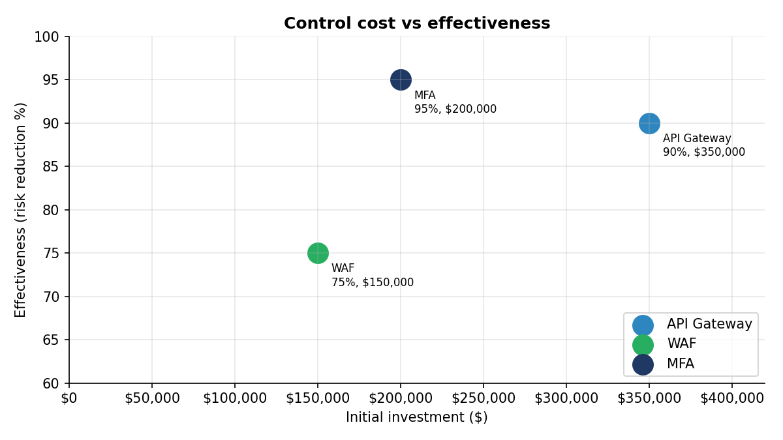
Figure 4. Cost vs effectiveness. MFA is the most effective (95%) at mid cost; the API gateway costs the most for the smallest reduction.
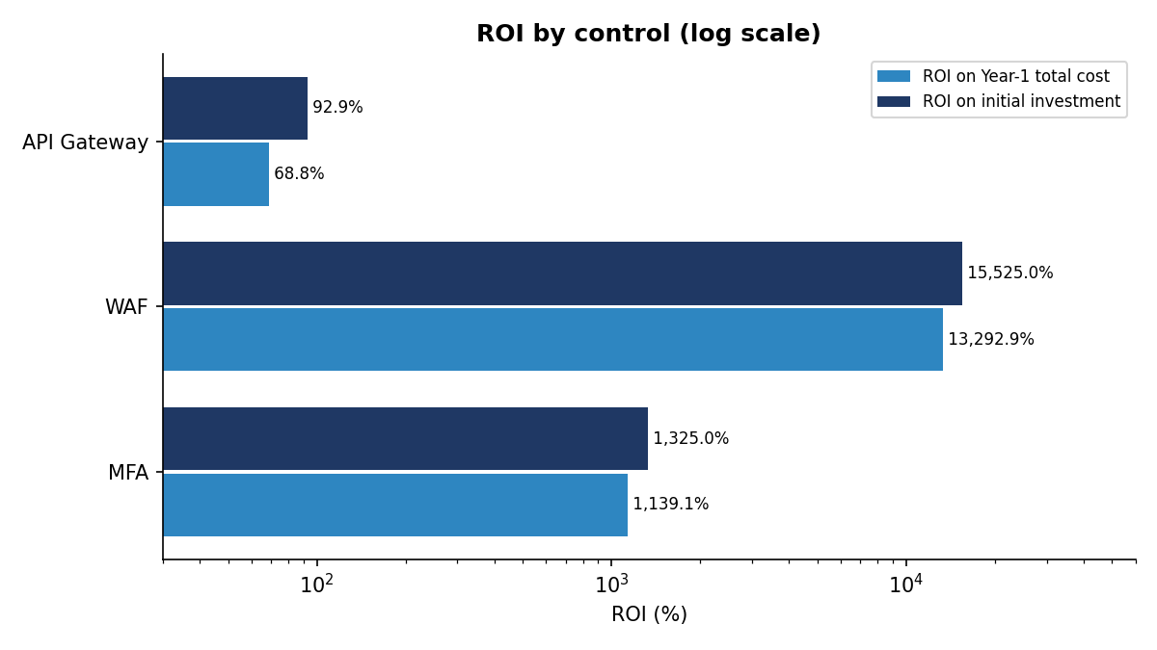
Figure 5. ROI by control on a logarithmic scale. WAF returns the most per dollar; the API gateway still returns a positive 68.75% in Year 1.
What this tells us: how effective a control is and how much it returns are different things. MFA removes the biggest share of its risk (95%), but the WAF returns far more per dollar because the risk it reduces ($31,250,000 a year) is about ten times bigger than the one MFA reduces. Ranked by Year-1 ROI, the order is WAF, then MFA, then the API gateway.
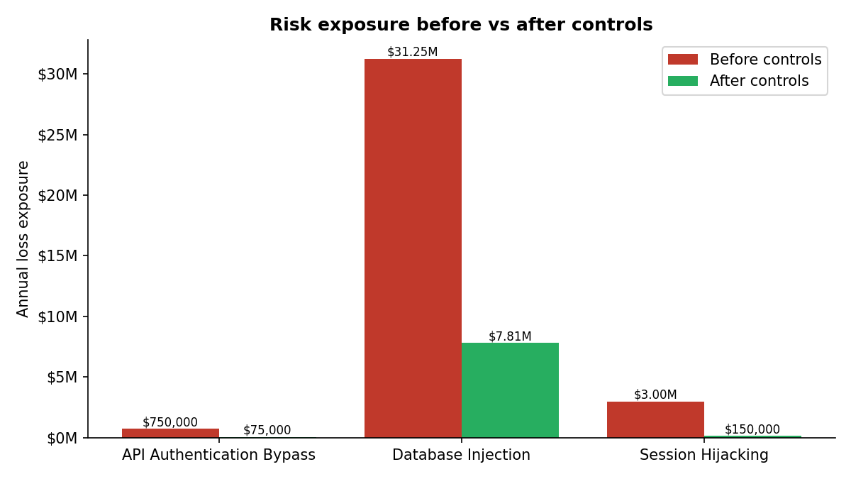
Figure 6. Annual exposure before and after controls.
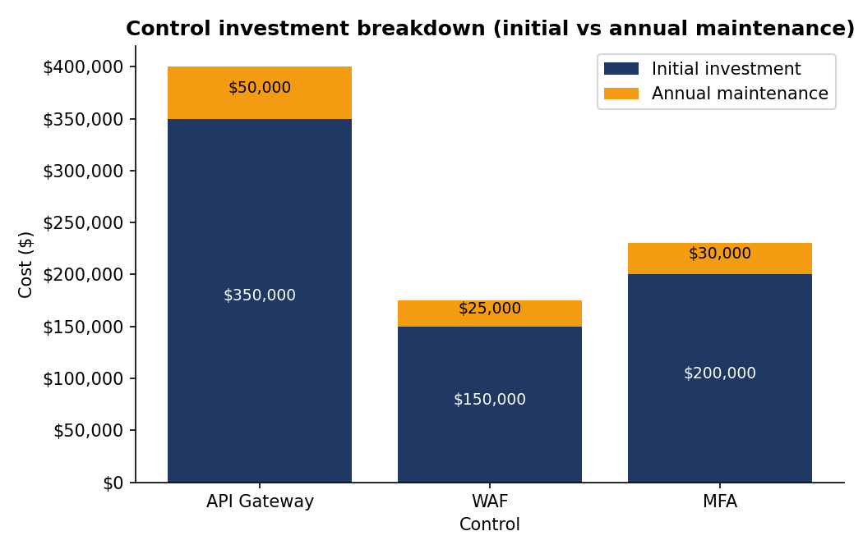
Figure 7. Investment breakdown per control, initial versus annual maintenance.
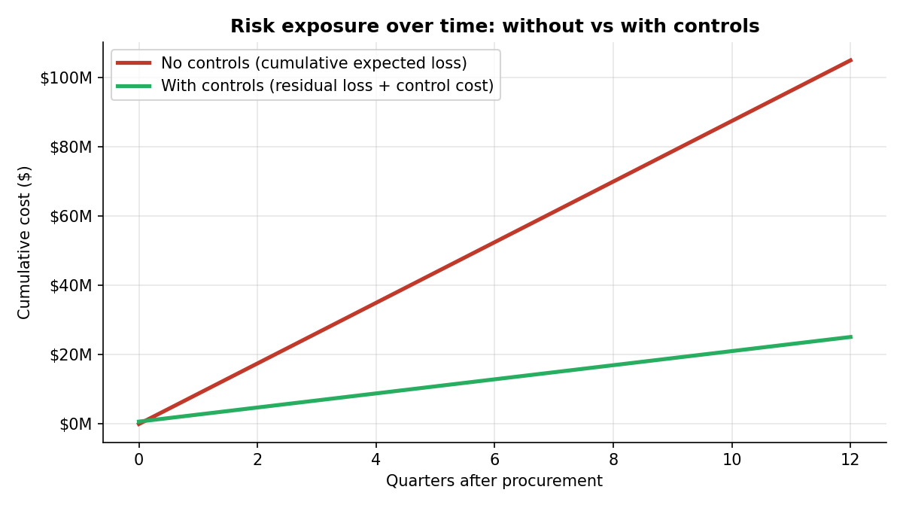
Figure 8. Cumulative cost over three years, without controls and with controls (residual loss plus control cost).
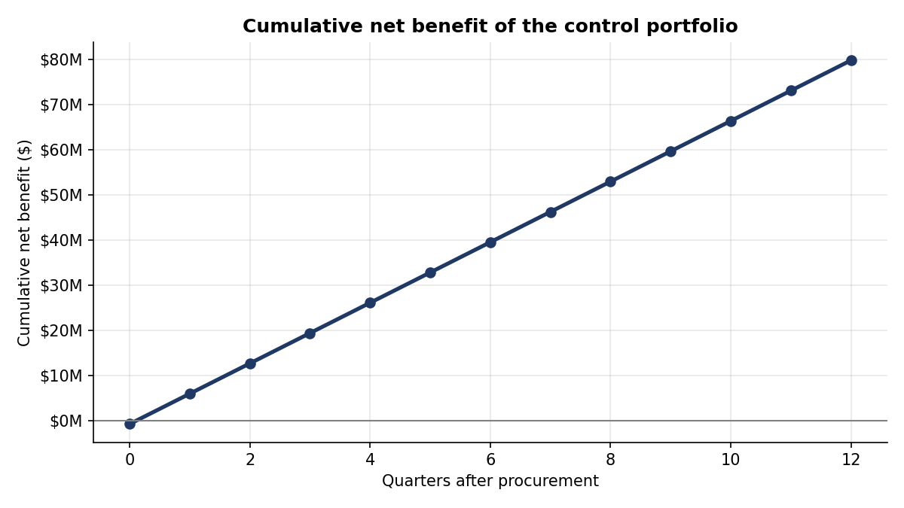
Figure 9. Cumulative net benefit of the control portfolio. It is negative only on day 0 (-$700,000) and reaches $79,872,500 after three years.
Table 3. Multi-year view
Milestone | Inherent ALE | Residual ALE | Cumulative cost | Cumulative saved | Cumulative net
Day 0 (procure) | $35,000,000 | $35,000,000 | $700,000 | $0 | -$700,000
End of Year 1 | $35,000,000 | $8,037,500 | $805,000 | $26,962,500 | $26,157,500
End of Year 2 | $35,000,000 | $8,037,500 | $910,000 | $53,925,000 | $53,015,000
End of Year 3 | $35,000,000 | $8,037,500 | $1,015,000 | $80,887,500 | $79,872,500

7. Task 6: Executive briefing dashboard
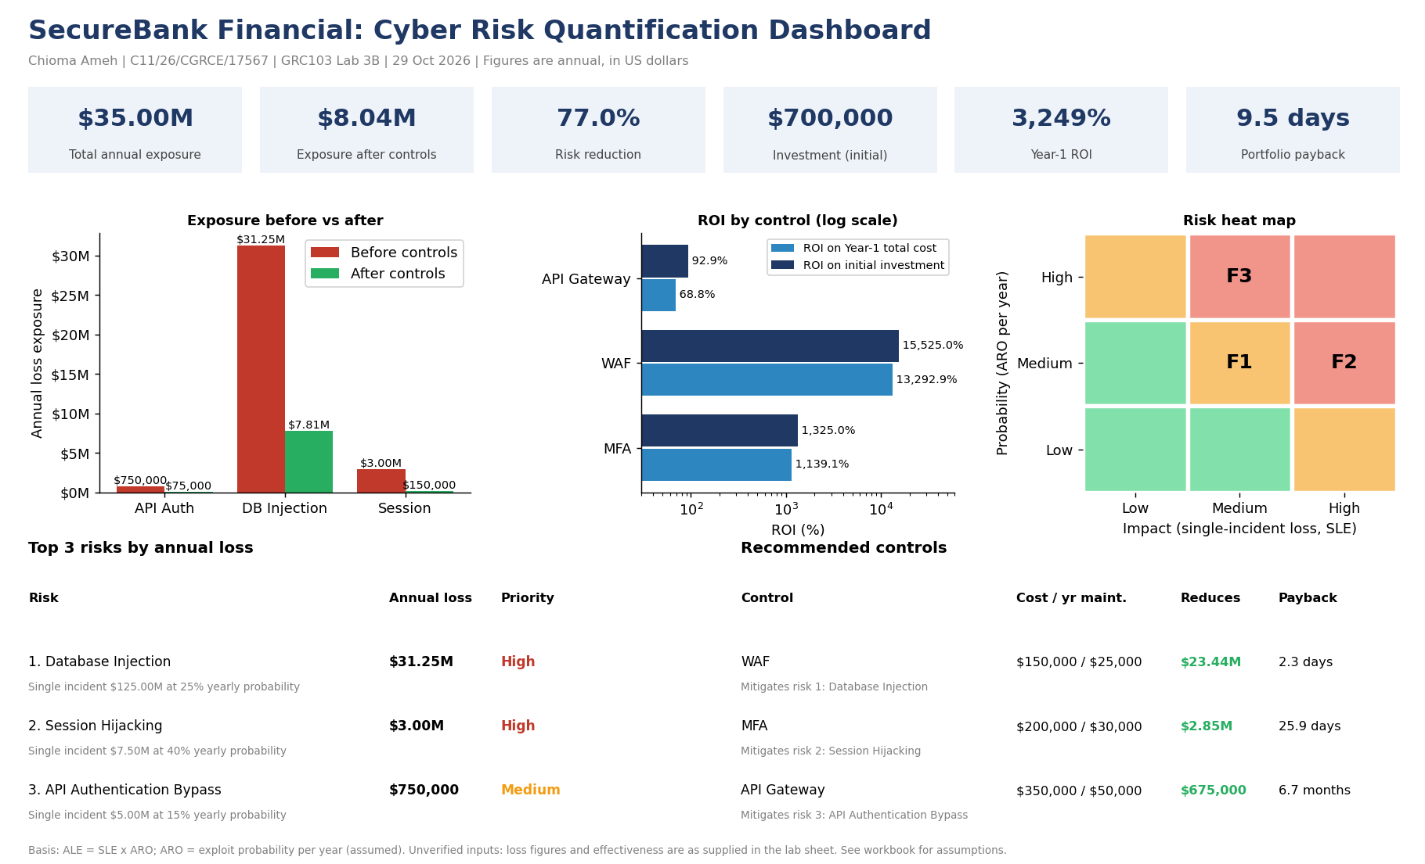
Figure 10. One-page executive dashboard (also supplied as Lab3B_Executive_Dashboard.pdf).

In short: SecureBank is exposed to about $35,000,000 a year on the mobile banking platform. The controls we recommend cost $700,000 up front and $105,000 a year to run, and they cut the yearly exposure by 77.04% ($26,962,500 before running costs, $26,857,500 after). The first-year ROI is 3,249.38%, and the investment pays for itself in about 9.5 days.

8. Task 7: Risk treatment roadmap
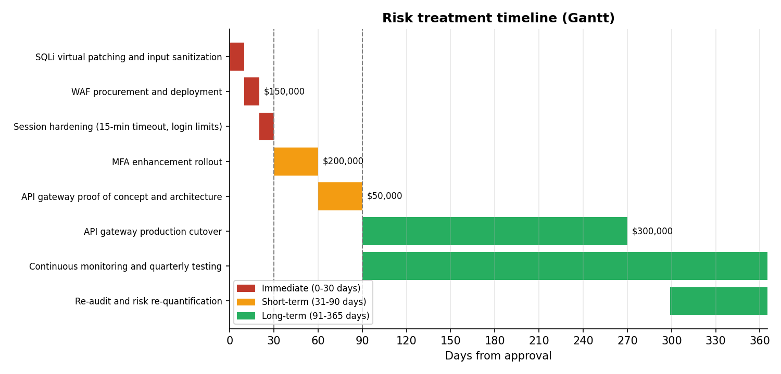
Figure 11. Risk treatment timeline: immediate (0 to 30 days), short-term (31 to 90 days), long-term (to 365 days).
Phase | Days | Action | Budget | Accountable lead
Immediate | 1 to 10 | SQLi virtual patching and input sanitization | Internal operations | SecOps Engineering
Immediate | 11 to 20 | WAF procurement and deployment | $150,000 | Infrastructure / SecOps
Immediate | 21 to 30 | Session hardening (15-min timeout, login limits) | Internal operations | AppSec Team
Short-term | 31 to 60 | MFA enhancement rollout | $200,000 | IAM and Identity Lead
Short-term | 61 to 90 | API gateway proof of concept and architecture | $50,000 | Architecture and GRC
Long-term | 91 to 270 | API gateway production cutover | $300,000 | CISO and Lead GRC Analyst
Long-term | 91 to 365 | Continuous monitoring and quarterly testing | Internal operations | SecOps Engineering
Long-term | 300 to 365 | Re-audit and risk re-quantification | Internal operations | Lead GRC Analyst
Total |  |  | $700,000
The budget column adds up to the initial investment. The timeline is my own proposal (Assumption A9). In the long-term phase I also included continuous monitoring and quarterly testing, which need no capital spend, and a re-audit to refresh this risk quantification.

9. Bonus: Combined risk-control matrix and budget optimisation
Table 4. Combined risk-control matrix (current versus residual risk, cost versus benefit)
Vulnerability | Control | Current ALE | Residual ALE | Initial cost | Year-1 net benefit
Database Injection | Web Application Firewall (WAF) | $31,250,000 | $7,812,500 | $150,000 | $23,262,500
Session Hijacking | MFA Enhancement | $3,000,000 | $150,000 | $200,000 | $2,620,000
API Authentication Bypass | Advanced API Security Gateway | $750,000 | $75,000 | $350,000 | $275,000

Table 5. Best control selection for each budget limit (all eight combinations were evaluated)
Budget limit | Annual risk reduction | Selected controls | Initial cost used | Share of maximum
$150,000 | $23,437,500 | WAF only | $150,000 | 86.9%
$200,000 | $23,437,500 | WAF only | $150,000 | 86.9%
$350,000 | $26,287,500 | WAF + MFA | $350,000 | 97.5%
$500,000 | $26,287,500 | WAF + MFA | $350,000 | 97.5%
$550,000 | $26,287,500 | WAF + MFA | $350,000 | 97.5%
$700,000 | $26,962,500 | All three controls | $700,000 | 100.0%
What stands out: at $350,000 the best choice is already WAF + MFA, and nothing improves on it until the budget reaches $700,000, where the API gateway adds $675,000 a year. With a $500,000 cap, WAF + MFA costs $350,000 and removes $26,287,500 a year (97.5% of the most we can achieve), leaving $150,000 unspent. Its Year-1 ROI is 6,390.74% on total cost (7,410.71% on the up-front cost).
While waiting for the API gateway, engineering could add stopgaps such as stricter token checks and rate limiting. I have not costed them or measured their effect, so I do not count any risk reduction for them.

10. Risk treatment decision
Decision | Why
Treat all three risks | Each control pays back in Year 1, and the total exposure drops from $35.0M to $8.04M.
Fund in this order: WAF, MFA, API gateway | Best return and fastest payback first. The API gateway returns the least and takes longest to pay back (6.7 months).
Do not accept the database injection risk | It makes up 89.3% of the total exposure, so accepting it would be hard to justify.
Re-measure after rollout | Residual risk is modelled, not observed. A retest and a fresh quantification after 12 months will show whether the controls work as assumed.

11. Limitations
- Every loss, probability, cost and effectiveness value comes from the lab sheet. I did not check them independently, and each is a single estimate rather than a range.
- I treated the exploit probability as a yearly rate (Assumption A2). Reading it differently would change every ALE in proportion.
- The results depend heavily on the stated losses. As a test, if the database SLE were only 10% of the stated figure, the WAF would still return about 1,239% in Year 1 and pay for itself in about 24 days.
- I treated the controls as independent, each covering one finding. In practice they overlap (a WAF also blocks some API attacks, for example), so the combined benefit could differ.
- The sheet gives MFA's effectiveness for account takeover, and I applied it to session hijacking. If an attacker steals a session that is already authenticated, MFA may not stop it, so the 95% may be optimistic for this finding.
- The model leaves out discounting, inflation, fines beyond the stated cost per record, and the cost of the stopgap measures in Section 9.

12. Declaration of AI assistance
I used Claude, an AI assistant from Anthropic, throughout this lab. It explained the formulas and the reasoning behind each step, checked my work against the lab sheet, helped build the Excel workbook, charts and dashboard, and helped draft the wording of this report. I reviewed the results and spot-checked the key figures in the workbook myself. Because AI can make mistakes, every number in this report comes from the workbook formulas, which were recalculated and compared with hand calculations.

Appendix A: Spreadsheet implementation (workbook formulas)
The workbook Lab3B_Risk_Quantification_Workbook.xlsx contains the live formulas. Key cells (sheet: cell):
Quantity | Formula | Location
SLE | =IF(Inputs!F5<>"",Inputs!F5,Inputs!D5*Inputs!E5) | Phase1_ALE: C6
ALE | =C6*D6 | Phase1_ALE: E6
Priority level | =IF(J6>=Inputs!$B$19,"High",...) | Phase1_ALE: K6
Annual risk reduction | =F5*E5 | Phase2_Controls: G5
Residual ALE | =F5-G5 | Phase2_Controls: H5
ROI on initial investment | =(G5-C5)/C5 | Phase2_Controls: J5
ROI on Year-1 total cost | =(G5-I5)/I5 | Phase2_Controls: K5
Payback (years / days) | =C5/L5 ; =M5*365 | Phase2_Controls: M5, O5
Best selection for a budget | =_xlfn.MAXIFS(G5:G12,E5:E12,"<="&A17) | Budget: B17

Appendix B: File index
File | Content
README.md | Overview and repository guide
docs/Lab3B_Risk_Quantification_Executive_Report.docx | This report
spreadsheet/Lab3B_Risk_Quantification_Workbook.xlsx | All calculations and native Excel charts
charts/ (10 PNG files) | Every required graph, including the Gantt chart
docs/Lab3B_Executive_Dashboard.pdf (and .png) | One-page executive dashboard
presentation/ | Executive briefing slides

