Using CBPaint

**What is CBPaint?**

CBPaint is a project by ChipFlare Studios as a part of the Crapbox project. This software is designed to work with the Crapbox or any Arduino based device. The end goal of this is to make children interested in Electronics by making is easier to understand. You can use this application to basically draw anything on the OLED display without having to code anything!

**How to make a compatible Arduino based device?**

CBPaint doesn’t need much to run. If you don’t have a Crapbox, just connect an SSD1306 OLED display to any off the shelf Arduino through the i2c interface and you’re good to go! This is how you should connect them:

* *Arduino A5 > OLED SCL*
* *Arduino A4 > OLED SDA*
* *Arduino 5V > OLED VCC*
* *Arduino GND > OLED GND*

**Flashing the Arduino**

Now that you have a Crapbox or a compatible Arduino device, Connect it to your computer via USB. Install Arduino IDE hereif you don’t have it already. Then, Ctrl+click [here](Code/Code.ino) to open the code to your Arduino. Then Press Ctrl+Shift+i and search for and install the following libraries if you don’t have them already.

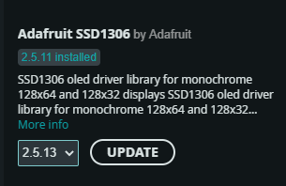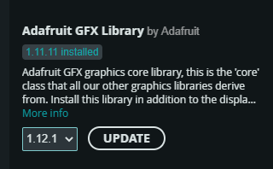

It’s time to flash the Arduino! Click “Select Board” and select your Arduino from the list. If all the listings show up as “unknown”, follow the steps in gray. Or else skip them.

Firstly, Search “Device Manager” in the start menu and press enter. Then, scroll down to “Ports (COM & LPT)” double click on it. A list of devices will show up like the following.

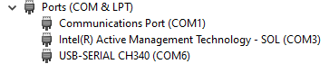

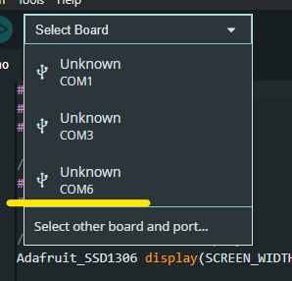

Your Arduino should be something like “Arduino” or “CH340” like above. Remember the port in the brackets for that specific device (COM6 for CH340) and select that COM value in the list from the Arduino IDE.

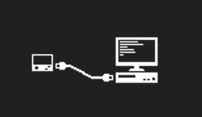It’s time to actually flash the Arduino. Just press Upload (⇨) and wait for the magic to happen. Your Arduino will flash some lights and when done uploading, will show something like this. Congratulations!

**How to use CBPaint?**

Double click on “CBPaint.exe” to run it. The program will try to detect any Arduino that’s connected to your PC, if your Arduino cannot be detected, you’ll be prompted to the message below. Remember that COM port from earlier? Click on that. If you don’t have an Arduino connected, don’t worry because you can still test the program by clicking “Use without device”. If you pick a port from this list, it will be saved for the next time you use the app. You can change the saved port at File > Change Port in the main window.

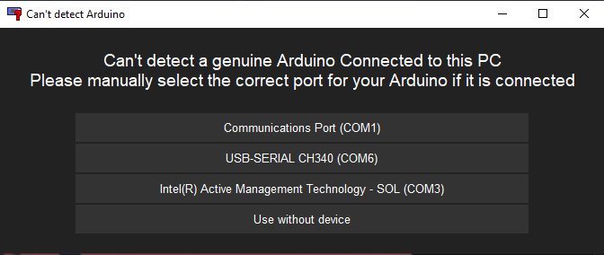

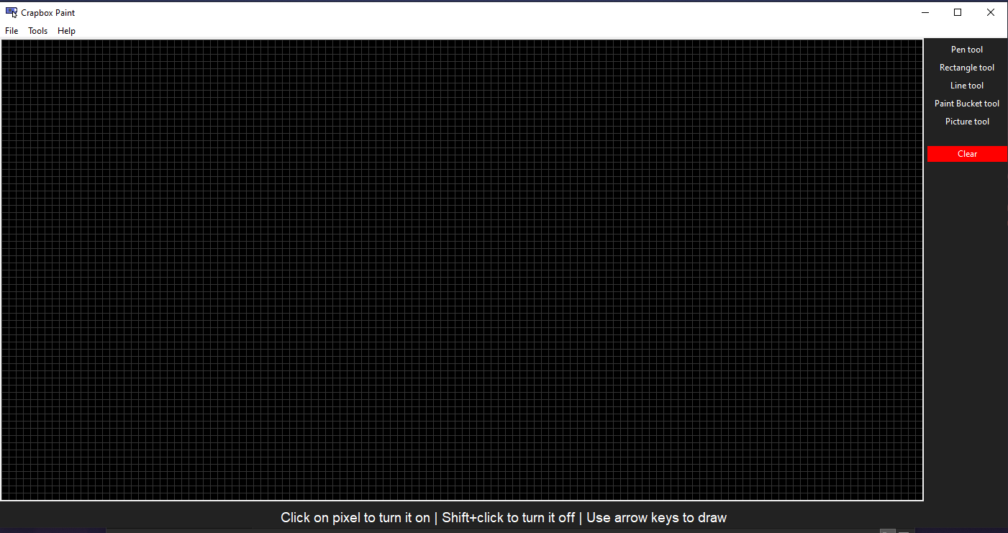after doing that, just wait a few seconds and this window will show up. Well not exactly the same window because I’m constantly working on updates!

All the tools are self-explanatory so I don’t have to write anything about that here. If an Arduino is connected, you’ll see it update in real time to what you’re drawing. You can also change the theme at Help > Theme!

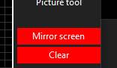**Screen Mirroring**

I included this screen mirroring sketch as a bonus! Just press it and you’ll see your computer screen on the Arduino in real time like magic. It’s not the best viewing experience in the world but cool as heck! You can also launch it directly by double clicking on “Screen_mirror.exe”

Copyright ChipFlare Studios 2025

Leave your questions and suggestions at my [Email](mailto:exploringnewbusiness@gmail.com?subject=CBPaint%20Help)