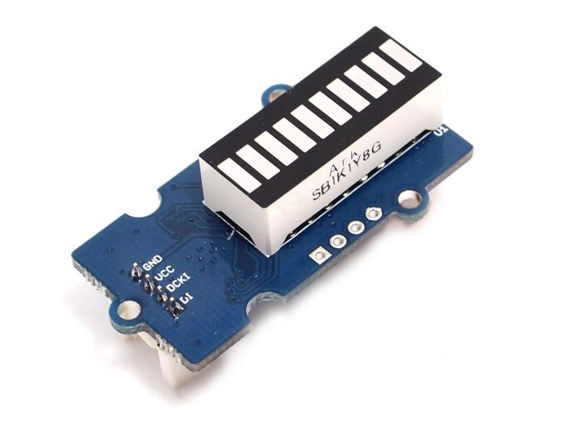
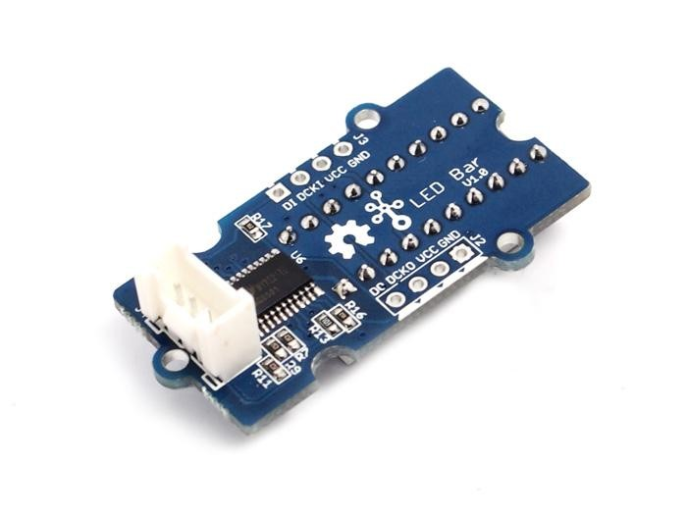
Grove - LED Bar
3.3V 5.0V
Digital

Introduction

Grove – LED Bar is comprised of a 10 segment LED gauge bar and an MY9221 LED controlling chip. It can be used as an indicator for remaining battery life, voltage, water level, music volume or other values that require a gradient display. There are 10 LED bars in the LED bar graph: one red, one yellow, one light green, and seven green bars. Demo code is available to get you up and running quickly. It lights up the LEDs sequentially from red to green, so the entire bar graph is lit up in the end. Want to go further? Go ahead and code your own effect.

Features

- Input Voltage: 3.3V/5V
- Each LED segment can be controlled individually via code
- Intuitive display
- Flexible power option, supports 3-5.5DC
- Available demo code
- Suli-compatible Library

Tip
More details about Grove modules please refer to Grove System

Platforms Supported
Caution

Arduino | Wio | BeagleBone | Raspberry Pi | LinkIt ONE
 |  |  |  | 
The platforms mentioned above as supported is/are an indication of the module's hardware or theoritical compatibility. We only provide software library or code examples for Arduino platform in most cases. It is not possible to provide software library / demo code for all possible MCU platforms. Hence, users have to write their own software library.
Note
More details about Suli-compatible Library, please refer to Suli

Demonstration

With Arduino
This is a simple demo which can you help you to start with Grove - LED Bar quickly. We need a Seeeduino V3.0 and a Grove - Base Shield as well.

Hardware Installation

Plug the Grove - LED Bar onto the digital port 8 on Grove - Base Shield, and then plug the base shield onto Arduino.

Download Code and Upload

You can download the library in github, click here, then extract it to libraries folder of Arduino.

Then open Arduino IDE, File -> examples -> LED_Bar -> Level, you can open the demo code.

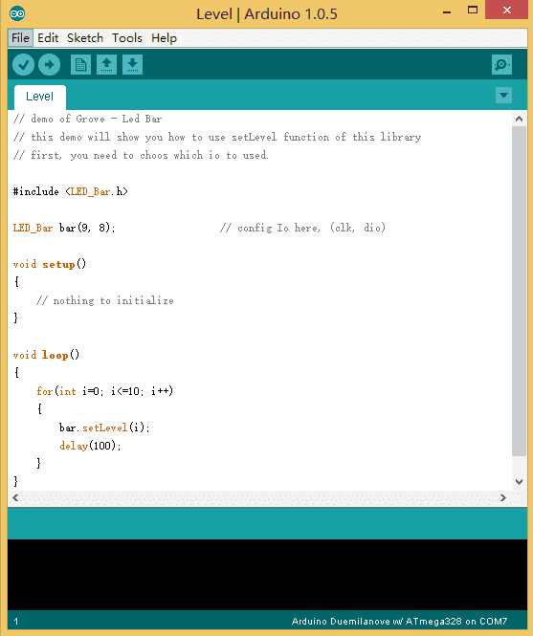

Click Upload to Upload the code, if you have any problem about how to start Arduino, please click here for some help.

Working Now

Your Grove - LED Bar is working now, it’s shine.
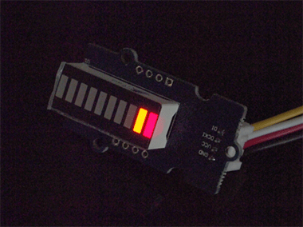

With Raspberry Pi

- You should have got a raspberry pi and a grovepi or grovepi+.

- You should have completed configuring the development enviroment, otherwise follow here.

- Connection

  - Plug the sensor to grovepi socket D3 by using a grove cable.

- Navigate to the demos’ directory:
cd yourpath/GrovePi/Software/Python/

  - To see the code

nano grove_ledbar.py # "Ctrl+x" to exit #
import time
import grovepi
import random

# Connect the Grove LED Bar to digital port D5
# DI,DCKI,VCC,GND
ledbar = 5

grovepi.pinMode(ledbar,"OUTPUT")
time.sleep(1)
i = 0

# LED Bar methods
# grovepi.ledBar_init(pin,orientation)
# grovepi.ledBar_orientation(pin,orientation)
# grovepi.ledBar_setLevel(pin,level)
# grovepi.ledBar_setLed(pin,led,state)
# grovepi.ledBar_toggleLed(pin,led)
# grovepi.ledBar_setBits(pin,state)

# grovepi.ledBar_getBits(pin)
print "Test 1) Initialise - red to green"
# orientation: (0 = red to green, 1 = green to red)
time.sleep(.5)
grovepi.ledBar_init(ledbar, 0)
# ledbar_init(pin,orientation)
try:
while True:
# ledbar_setLevel(pin,level)
for i in range(0,11):

grovepi.ledBar_setLevel(ledbar, i)
time.sleep(.3)
time.sleep(.2)
# level: (0-10)
print "Test 2) Set level"
grovepi.ledBar_setLevel(ledbar, 8)
time.sleep(.5)
grovepi.ledBar_setLevel(ledbar, 2)
time.sleep(.5)
grovepi.ledBar_setLevel(ledbar, 5)
time.sleep(.5)

# ledbar_setLed(pin,led,state) # led: which led (1-10)
# state: off or on (0,1)

grovepi.ledBar_setLed(ledbar, 10, 1)

time.sleep(.5)
print "Test 3) Switch on/off a single LED"

grovepi.ledBar_setLed(ledbar, 9, 1)
time.sleep(.5)
grovepi.ledBar_setLed(ledbar, 8, 1)
time.sleep(.5)
grovepi.ledBar_setLed(ledbar, 1, 0)
time.sleep(.5)
grovepi.ledBar_setLed(ledbar, 2, 0)
time.sleep(.5)
grovepi.ledBar_setLed(ledbar, 3, 0)
time.sleep(.5)
# flip a single led - if it is currently on, it will become off and vice versa
grovepi.ledBar_toggleLed(ledbar, 1)
time.sleep(.5)
# ledbar_toggleLed(ledbar, led)
print "Test 4) Toggle a single LED"
grovepi.ledBar_toggleLed(ledbar, 2)
time.sleep(.5)
grovepi.ledBar_toggleLed(ledbar, 9)
time.sleep(.5)
grovepi.ledBar_toggleLed(ledbar, 10)
time.sleep(.5)
print "Test 5) Set state - control all leds with 10 bits"
for i in range(0,32):
int('1111111111',2))
# state: (0-1023) or (0x00-0x3FF) or (0b0000000000-0b1111111111) or (int('0000000000',2)-
# ledbar_setBits(ledbar, state)

grovepi.ledBar_setBits(ledbar, i)
time.sleep(.3)
time.sleep(.2)
print "Test 6) Get current state"

# state = ledbar_getBits(ledbar)

# state: (0-1023) a bit for each of the 10 LEDs

state = grovepi.ledBar_getBits(ledbar)

print "with first 5 leds lit, the state should be 31 or 0x1F"

print state
# bitwise shift five bits to the left

state = state << 5

# the state should now be 992 or 0x3E0

# when saved the last 5 LEDs will be lit instead of the first 5 LEDs

time.sleep(.5)

# ledbar_setBits(ledbar, state)

# state: (0-1023) a bit for each of the 10 LEDs
grovepi.ledBar_setBits(ledbar, state) time.sleep(.5)
print "Test 7) Set state - save the state we just modified"
print "Test 8) Swap orientation - green to red - current state is preserved"

# ledbar_orientation(pin,orientation)

# orientation: (0 = red to green, 1 = green to red)

# when you reverse the led bar orientation, all methods know how to handle the new LED index # green to red
grovepi.ledBar_orientation(ledbar, 1)

time.sleep(.5)
# red to green

grovepi.ledBar_orientation(ledbar, 0)
time.sleep(.5)

# green to red
grovepi.ledBar_orientation(ledbar, 1)
time.sleep(.5)
# note the red LED is now at index 10 instead of 1
grovepi.ledBar_setLevel(ledbar, i)
time.sleep(.3)
time.sleep(.2)
for i in range(0,11):
# level: (0-10)
# ledbar_setLevel(pin,level)
print "Test 9) Set level, again"

grovepi.ledBar_setLed(ledbar, 1, 0)
time.sleep(.5)
# state: off or on (0,1)
# led: which led (1-10)
# ledbar_setLed(pin,led,state)
print "Test 10) Set a single LED, again"
grovepi.ledBar_setLed(ledbar, 3, 0)
time.sleep(.5)
grovepi.ledBar_setLed(ledbar, 5, 0)
time.sleep(.5)

# ledbar_toggleLed(ledbar, led) grovepi.ledBar_toggleLed(ledbar, 2) time.sleep(.5)
print "Test 11) Toggle a single LED, again"

grovepi.ledBar_toggleLed(ledbar, 4)
time.sleep(.5)

# state = ledbar_getBits(ledbar)

# state: (0-1023) a bit for each of the 10 LEDs
state = grovepi.ledBar_getBits(ledbar)
print "Test 12) Get state"
# the last 5 LEDs are lit, so the state should be 992 or 0x3E0

# bitwise shift five bits to the right
state = state >> 5
# the state should now be 31 or 0x1F

# state: (0-1023) a bit for each of the 10 LEDs
time.sleep(.5)
grovepi.ledBar_setBits(ledbar, state)
# ledbar_setBits(ledbar, state)
print "Test 13) Set state, again"
# step through all 10 LEDs
grovepi.ledBar_setLevel(ledbar, i)
time.sleep(.3)
time.sleep(.2)
for i in range(0,11):
print "Test 14) Step"
print "Test 15) Bounce"
grovepi.ledBar_setLevel(ledbar, 2)
# switch on the first two LEDs

# get the current state (which is 0x3)
state = grovepi.ledBar_getBits(ledbar)

# bit shift left and update
grovepi.ledBar_setBits(ledbar, state)
time.sleep(.2)
state <<= 1;
for i in range(0,9):
# bounce to the right
# bit shift right and update
grovepi.ledBar_setBits(ledbar, state)
time.sleep(.3)
time.sleep(.2)
state >>= 1;
for i in range(0,9):
# bounce to the left

state = random.randint(0,1023) grovepi.ledBar_setBits(ledbar, state)
time.sleep(.3)
time.sleep(.2)
for i in range(0,21):
print "Test 16) Random"
# set every 2nd LED on - 341 or 0x155
for i in range(0,5):

grovepi.ledBar_setBits(ledbar, state)
time.sleep(.2)
state = 341
print "Test 17) Invert"

# bitwise XOR all 10 LEDs on with the current state
state = 0x3FF ^ state
grovepi.ledBar_setBits(ledbar, state)

time.sleep(.2)
time.sleep(.3)

for i in range(0,1024): grovepi.ledBar_setBits(ledbar, i) time.sleep(.1)
time.sleep(.4)
print "Test 18) Walk through all possible combinations"

except KeyboardInterrupt:
grovepi.ledBar_setBits(ledbar, 0)
break
except IOError:
print "Error"
- Run the demo.
sudo python grove_ledbar.py
- This demo may not work if your grovepi dosen’t have the newest firmware, update the firmware.
sudo ./firmware_update.sh
cd yourpath/GrovePi/Firmware

Project


Inspired by OVERWATCH, we have made a very cool Wooden Laser Gun toy for fun these day!

The Wooden Laser Gun and the Gun Target are all based on an Arduino board called Seeeduino Lotus. The laser emitter on the Laser Gun is controlled to fire laser pulse to “activate” the Gun Target. And there are 3 light sensors on the Gun Target to detect the laser pulse. It seems very simple right? If you are interested in our project, please make one for yourself or your child! It’s worth to spend one day DIY it as a Xmas present.

