Group 21

Nicholas Farquhar(Group1) ST10439055
Zain Labuschagne(Group2) ST10442835
Matthew Jackson(Group1) ST10445830
Jaco Smit(Group1) ST10439052
Ethan Chips(Group1) ST10330209
Jarred Blamire(Group1) ST10452547

  - INSY7315

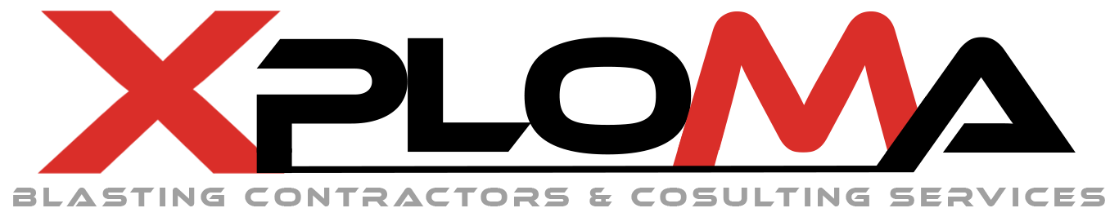
Table of Contents
9.1.4 Introduction 5
9.1.5 Requirements 6
Requirements approach and evidence 6
Research findings: Xploma , project and users 7
Stakeholder needs 8
Functional requirements catalogue 9
Business rules 12
Assumptions, dependencies and constraints 12
Explicit exclusions 13
9.1.6 User Roles 14
Main Company User 14
Blaster 14
Supporting stakeholders (not application roles) 15
Role-permission matrix 15
9.1.7 User Stories 16
Blaster user stories 16
Main Company User stories 18
User Experience Journey Map 19
Screen inventory 19
Blaster screen flow 20
Main Company User screen flow 21
Work Breakdown Structure 22
9.1.8 Non-functional Requirements 25
Open Validation Decisions 27
Chapter 9.1.9: Analysis Artifacts 28
Analysis Artifacts 28
Domain Modelling 28
UML Domain Class Diagram 29
Domain Class Description 30
API Endpoint 30
Sequence Diagrams 31
9.1.10 Implementation 33
UML Sequence Diagrams 33
UML State diagrams 37
Deployment Plan 39
9.1.11 Data Schema 42
Data-storage choice 42
Entity Relationship Diagram 42
ERD explanation 45
Main data rules 45
9.1.12 Architecture Artifacts 46
Architecture pattern 46
Design patterns 46
Azure cloud architecture 46
Azure services, protocols and data flow 48
9.1.13 Security 49
Authentication, authorisation and company isolation 49
Cross-Site Scripting (XSS) prevention 50
Other common vulnerabilities and mitigations 50
Network and infrastructure security 51
9.1.14 DevOps 52
Branching Strategy 52
GitHub Actions Pipeline 54
Automated Testing 55
9.1.15: Running Costs 56
Running cost 56
CI/CD Pipeline alignment 57
Cost saving strategies 57
9.1.16 Change Management 58
Organisational adoption 58
User adoption 58
Handover plan: development to production 59
9.1.17 Appendices 60
Referances: 63
AI Usage Declaration 64

9.1.4 Introduction
Currently Xploma handles blast design work by using a collection of manual drawings and spreadsheets calculations. Once a design has been approved and used on site, these records are difficult to reproduce, review and audit. This introduction is intended for the management of Xploma to summarize why the proposed system is necessary and what it delivers.
This manual process is replaced by a single controller design workspace in the blast design decision support system. A blaster can input data in a single application, assign explosive loading and initiation, run required engineering calculations, resolve warnings and generate a PDF report. This is overseen at the company level by a main company user: managing blaster accounts, maintaining approved reference data (rock types, explosive products, prices and model coefficients) and reviewing designs prior to finalization.
The system is intended to be a decision support system for qualified blasting professionals. It does not initiate blasts, run blasting equipment or substitute professional judgment. The inputs are standardised, calculations and evidence trail behind a proposed design so that the organization can trust, reproduce and audit the work it produces.

The business case or management can be summed up as follows:
The current manual approach causes rework, inconsistent calculations and no reliable record of what was approved and why. Our proposed system tackles this problem head-on, by providing company data isolation, making approved designs unchangeable, capturing the exact version of the model and inputs behind each calculation and generating one reproducible report per design revision.
This reduces the risk of putting an out of date or inaccurate design on site, gives management a complete audit trail of design and review activity and gives blasters a faster and more reliable way to produce and revise their work.
The other sections of this document outline, in turn, the requirements gathered for the system, the analysis and design artifacts created from those requirements, the data schema and architecture selected to support them, the security approach taken to protect the application and its data, the DevOps and running cost planning and the change management approach that will guide adoption of the system by both the organization and its users.

9.1.5 Requirements
This section consolidates the requirement artifacts derived from the supplied product specification. No interview transcripts or Xploma profile were supplied, so the chapter does not claim that interviews, observations or workshops occurred. It converts the available evidence into a baseline that can be validated with the client.

Requirements approach and evidence
Evidence / research source | What it contributed | Use and confidence
Revised Product Feature Specification (04 August 2026) | Product boundary, two roles, access rules, end-to-end design workflow, calculations, review controls, reports, technology direction and exclusions. | Primary project evidence; treated as confirmed unless the document itself marks a decision for review.
W3C Web Content Accessibility Guidelines (WCAG) 2.2 | Testable accessibility principles and Level A/AA success criteria for web content and complete user processes. | External design and test reference; WCAG 2.2 Level AA is proposed for client confirmation.
OWASP Application Security Verification Standard (ASVS) 5.0 | A structured basis for specifying and verifying web-application security controls. | External security reference; exact ASVS level and control set must be selected during architecture and threat modelling.
Microsoft .NET / ASP.NET Core support policy | Use an actively supported .NET and ASP.NET Core release; avoid end-of-life framework versions. | External platform-maintenance reference; exact supported release is selected at implementation start.
Future client validation | Xploma name and policy, named users, representative design sizes, model equations, performance/recovery targets, report branding, database and production environment. | Outstanding elicitation; items remain explicitly marked Proposed or To confirm.

Research findings: Xploma , project and users
Xploma context
- The product is intended for internal use by blasting companies, not for clients or members of the public.
- Each record belongs to one company. Company separation and individual design ownership are central governance requirements.
- A Main Company User provides company-wide oversight, account administration and controlled reference-data management.
- The application is decision support for qualified blasting professionals it does not initiate blasts or replace professional judgement.
Project problem and opportunity
- The current problem is disconnected manual drawing and calculation work that is difficult to reproduce, review and audit.
- The proposed solution is one controlled design workspace linking geometry, holes, explosive loading, initiation, calculations, warnings, revisions and a report.
- The highest-value capability is a scaled irregular rock or bench editor; predetermined shapes are shortcuts rather than constraints.
- Reliability, traceability and model governance are more important for the first release than a large advanced-feature catalogue.
User research insights inferred from the approved workflow
- Blasters need speed and flexibility while retaining visibility of units, assumptions, geometry conflicts, stale results and blast-effect warnings.
- Main Company Users need oversight without breaking ownership boundaries: all company designs are visible, but other companies remain invisible.
- Both roles need a trustworthy history: reviewed revisions, prices, model versions, warnings and reports must not be silently overwritten.
- Critical information cannot depend on colour alone because warnings and review evidence must remain understandable and printable.

Stakeholder needs
ID | Stakeholder | Need | Requirement response | Status
SN-01 | Blaster | Create an accurate irregular rock or bench design from measurements available outside the system. | Geometry editor, scale, top/side views and zones | Confirmed
SN-02 | Blaster | Generate and adjust a hole pattern without placing holes outside permitted geometry. | Pattern generator, exclusions and individual-hole editing | Confirmed
SN-03 | Blaster | Calculate quantities and blast effects from controlled inputs and understand every warning. | Calculation service, model metadata and warning behaviour | Confirmed
SN-04 | Blaster | Save, continue, copy, revise and report on only their own designs. | Design library, ownership checks, revisions and PDF output | Confirmed
SN-05 | Main Company User | Manage blaster access and see all design activity inside the company. | Accounts, dashboard, search, review and audit history | Confirmed
SN-06 | Main Company User | Control rock, explosive, price, range, coefficient, unit and report defaults. | Effective-dated reference data and settings | Confirmed
SN-07 | Qualified blasting specialist | Ensure equations, coefficients, limits and golden cases are valid before production use. | Model governance and engineering verification | Confirmed dependency; person is not an application role
SN-08 | Development / support team | Operate, test, diagnose and safely update the system. | Layered architecture, logs, health checks, migrations, tests and deployment controls | Confirmed direction; targets proposed
SN-09 | Client management | Obtain a reliable, auditable first release without scope expansion into operations or quotations. | Scope controls, prioritisation, UAT and acceptance traceability | Inferred; validate with client

Functional requirements catalogue
Priority uses MoSCoW: Must = first-release acceptance; Should = important when capacity permits; Could = later enhancement. All Must items require client validation before the development baseline is frozen.
ID | Functional requirement | Priority | Acceptance evidence
FR-01 | The system shall authenticate users and establish a company and role context for every session. | Must | Unauthenticated access is rejected; successful login loads the correct role home.
FR-02 | The system shall enforce company isolation on every read, write, calculation, search and report operation. | Must | Cross-company API and UI tests return no data and no indirect identifiers.
FR-03 | The system shall allow a Blaster to discover and operate only on designs they own. | Must | Owner and non-owner tests cover list, direct URL, API, copy, report and download.
FR-04 | The Main Company User shall create, disable, reactivate and manage Blaster accounts in the same company. | Must | Account-state changes take effect and are audited.
FR-05 | The system shall audit login, account, design, calculation, override, review, report and archive events. | Must | Each event records actor, company, time, action and affected record/revision.
FR-06 | The Blaster dashboard shall display only the signed-in Blaster's designs and their state, warnings and stale status. | Must | Seeded multi-user test shows no other owner's design.
FR-07 | The Main Company User dashboard shall summarise all Blasters and designs inside the company. | Must | Counts and lists reconcile with company test data.
FR-08 | Users shall search and filter authorised designs by reference, owner where allowed, rock, explosive, pattern, date and review state. | Must | Each filter returns only authorised matching records and can be cleared.
FR-09 | A Blaster shall create, save, continue and archive a Draft design with optional internal job references. | Must | A draft can be closed and reopened without loss.
FR-10 | A Blaster shall copy an authorised design or create a new revision without changing the source. | Must | Source identifiers, revision and snapshots remain unchanged.
FR-11 | A Blaster shall draw and close a point-by-point irregular boundary on a blank canvas. | Must | Polygon points persist and reopen in the same order and scale state.
FR-12 | The system shall offer editable quick-start shapes that become ordinary editable geometry. | Must | Every generated point and edge can be modified or deleted.

ID | Functional requirement | Priority | Acceptance evidence
FR-13 | The system should support freehand tracing and simplify the trace into editable control points. | Should | Trace output is editable and does not bypass geometry validation.
FR-14 | The geometry editor shall add, insert, move and delete points; zoom, pan and fit; and provide undo/redo and grid snapping controls. | Must | Each tool changes only the intended geometry and supports undo/redo.
FR-15 | The system shall require Metric or Imperial units and scale geometry from at least one known edge before calculations run. | Must | Unscaled designs cannot calculate; a known length establishes a visible scale.
FR-16 | The system shall link the top view with one or more side profiles or height zones. | Must | Changing linked height/profile data makes dependent results stale.
FR-17 | A Blaster shall mark free faces, blast direction, rock/height/water/void zones and internal exclusions. | Must | Each item persists, is labelled and is available as a visual layer.
FR-18 | The server shall detect open/self-crossing boundaries, short invalid edges and other invalid geometry. | Must | Invalid geometry produces a specific corrective message and blocks dependent work.
FR-19 | The system shall generate square, rectangular and staggered patterns from burden, spacing, orientation and free-face offsets. | Must | Reference cases produce expected row orientation, positions and counts.
FR-20 | Automatic pattern generation shall exclude holes outside the boundary and inside exclusions. | Must | Generated patterns contain zero prohibited holes in boundary test cases.
FR-21 | A Blaster shall add, remove, move, exclude, restore and edit an individual hole and its design properties. | Must | Per-hole changes persist and recalculate or mark dependent results stale.
FR-22 | The system shall warn about edge, neighbour and exclusion conflicts after manual hole changes. | Must | Controlled conflict cases identify the affected hole and violated rule.
FR-23 | The Main Company User shall manage effective-dated, versioned company rock definitions and properties. | Must | Historical designs retain the selected rock snapshot.
FR-24 | The Main Company User shall manage explosive products, applicability data, prices, currency, dates and supplier references. | Must | Historical designs retain the product and price snapshot.

ID | Functional requirement | Priority | Acceptance evidence
FR-25 | A Blaster shall assign an explosive product to all holes, a row, a zone or an individual hole. | Must | Bulk assignment and controlled exceptions produce the expected final assignments.
FR-26 | A Blaster shall define charge length/column, mass, stemming, decks and primer position where applicable. | Must | Invalid charge geometry is rejected or clearly warned.
FR-27 | A Blaster shall assign initiation type, starting point and delays by hole, row or group; the system shall calculate maximum charge per delay. | Must | Timing summary and reference cases produce the approved maximum charge per delay.
FR-28 | Every controlled calculation shall store its inputs, outputs, units, formula/model name, version, coefficients, limits and effective date. | Must | A reviewed result can be reproduced from its snapshot.
FR-29 | The system shall calculate area, perimeter, volume, tonnage, rows, hole counts, depths and total drilling metres. | Must | Approved golden cases pass within the agreed numeric tolerance.
FR-30 | The system shall calculate explosive quantity per hole/product/total, powder factor, volume/tonnage per hole and charge per delay. | Must | Approved golden cases pass within the agreed numeric tolerance.
FR-31 | The system shall capture receptors and predict PPV using an approved vibration model and threshold. | Must | Approved model, coefficients, units and golden cases are versioned and pass.
FR-32 | The system shall estimate flyrock distance using an approved model and compare it with receptors/boundaries. | Must | Approved model and golden cases pass; assumptions and limitations display.
FR-33 | The system shall estimate explosive-product cost using the effective quantity and price snapshot only. | Must | Totals reconcile by product; missing/stale prices warn; excluded costs never appear.
FR-34 | The system shall mark dependent results stale after relevant geometry, hole, product, timing, model or reference changes. | Must | Dependency tests show stale state before review/report finalisation.
FR-35 | The system shall classify and display critical errors, blast-effect warnings, design warnings, missing information and information messages. | Must | Messages identify field/value/rule/correction and remain visible at review.
FR-36 | Where permitted, an authorised user shall override a value or warning with the original value, final value, actor, time and reason retained. | Must | Override is visible in later review, history and report.

ID | Functional requirement | Priority | Acceptance evidence
FR-37 | Critical errors shall block review; a successful review shall freeze the exact design, calculation, warning, model and price snapshot. | Must | A reviewed snapshot cannot be edited in place.
FR-38 | The system shall preserve revision creator, reason, geometry, holes, results, warnings, reports and review evidence. | Must | Earlier revisions remain readable after later changes.
FR-39 | Users should compare key dimensions, hole counts, quantities, effects and cost between revisions/alternatives. | Should | Comparison identifies old/new values and revision references.
FR-40 | The system shall generate one stable PDF blast-design and calculation report from a saved revision. | Must | Report contains all specified sections, status and exact source revision.
FR-41 | The Main Company User shall manage approved ranges, units, thresholds, coefficients, review periods and report branding. | Must | Changes are authorised, effective-dated where applicable and audited.
FR-42 | The Main Company User shall view authorised company design activity and revision history. | Must | Audit search returns all and only company events.
FR-43 | The design workspace shall provide switchable layers for geometry, context, holes, loading, initiation and blast effects. | Must | Layer visibility changes presentation without deleting underlying data.
FR-44 | Changing display units shall not change the represented physical design or calculation result. | Must | Round-trip Metric/Imperial tests remain within approved tolerance.

Business rules
ID | Rule
BR-01 | The application has exactly two application roles: Main Company User and Blaster.
BR-02 | Every user and design belongs to one company; no company may access another company's records.
BR-03 | A Blaster may access only designs owned by that Blaster; a Main Company User may access all designs in the same company.
BR-04 | Only the Main Company User may manage Blaster accounts and company-controlled reference/settings data.
BR-05 | Engineering calculations may not run until the geometry is valid, scaled and has the required inputs.
BR-06 | Critical errors block review and final report generation; unresolved warnings remain visible and appear in the report.
BR-07 | A reviewed revision is immutable. Any later change creates a new revision.
BR-08 | Historical designs retain the exact model, coefficient, product and price snapshots used at review.
BR-09 | An override never erases the recommended/calculated value and always requires traceable authority and reason.
BR-10 | Only equations, coefficients, units, applicability limits and golden cases approved by a qualified blasting specialist may be used in production.
BR-11 | Costing includes explosive products only and must not become a client quotation.
BR-12 | The system describes a proposed design only; it does not track actual loading or initiate/control blasting equipment.

Assumptions, dependencies and constraints
Type | Statement | Action / effect
Assumption | Users are trained/qualified for their assigned role and understand that predictions do not guarantee field performance. | Client to confirm role qualification and training policy.
Assumption | The Blaster obtains measurements, receptors and site information outside this application and enters them accurately. | Validate during user walkthrough.
Dependency | A qualified blasting specialist provides approved vibration/flyrock equations, coefficients, units, applicability limits and golden cases. | Blocks production acceptance of FR-31 and FR-32.
Dependency | The client supplies validated rock/explosive catalogues, effective prices, thresholds and report branding. | Required for UAT data and final reports.
Dependency | The project team and client agree representative geometry vertices, zones, profiles and hole counts. | Required to finalise performance targets.
Constraint | Web application built in Visual Studio with supported ASP.NET Core MVC/C#, Entity Framework Core and an agreed relational database. | Technology direction confirmed; exact versions/database to confirm.
Constraint | Current Microsoft Edge and major Chromium-based browsers are supported. | Browser matrix to be approved.
Constraint | No surveying/scanning imports, operational workflow, client portal, permits, quotations, photos/documents or post-blast modules in release one. | Scope change requires formal approval.

Explicit exclusions
- Client accounts, request submission, communication, review and quotation acceptance.
- Mobile surveys, GPS capture, photographs, LiDAR, scans, photogrammetry and point clouds.
- Permit applications/tracking, authority submissions and regulatory workflow.
- Barricades, evacuation, road closures, attendance, briefings, access control and weather checklists.
- Drilling progress, actual loading, blast execution, misfires, incidents and hand-back.
- Client quotations, labour, drilling, equipment, transport, initiation accessories, tax, markup, profit, billing, accounting and CRM.
- General document/photo repository, client reports, operational reports and post-blast reports.

9.1.6 User Roles
The supplied specification defines exactly two application roles. Other stakeholders participate in validation, approval or support but do not receive a third application role in the current scope.

Main Company User
Aspect | Description
Purpose | Provide company-level administration, governance and oversight.
Primary goals | Keep authorised Blasters active; maintain trustworthy reference data; see company design activity; review designs; preserve auditability.
Access | All Blasters, designs, revisions, reports and authorised settings inside the same company only.
Key tasks | Manage accounts; search/open any company design; review warnings and revisions; manage rock/explosive/price/model settings; configure report branding and review periods.
Restrictions | Cannot access another company; cannot silently alter reviewed snapshots; may override only where the selected model and company authority permit.
Success indicators | Accurate company data, timely review, complete audit evidence, no cross-company disclosure and no unapproved model/reference changes.

Blaster
Aspect | Description
Purpose | Create, calculate, review, revise and report on their own proposed blast designs.
Primary goals | Represent irregular rock accurately; produce a valid hole/loading/initiation design; understand warnings; generate a traceable report efficiently.
Access | Only designs owned by the signed-in Blaster and company-controlled reference data in read-only use.
Key tasks | Draw/scale geometry; define profiles/zones/exclusions; generate/edit holes; assign products/delays; calculate quantities/effects/cost; resolve warnings; self-review where policy permits; revise/copy/report.
Restrictions | Cannot discover or access another Blaster's designs; cannot manage accounts or controlled company reference values; cannot modify a reviewed revision in place.
Success indicators | Valid scaled geometry, zero prohibited holes, reproducible calculations, visible warnings/overrides and a complete design report.

Supporting stakeholders (not application roles)
- Qualified blasting specialist: validates the exact engineering models, coefficients, units, limits and golden test cases.
- Client sponsor/management: confirms scope, Xploma al policy, acceptance targets, release priorities and UAT sign-off.
- Development, QA and support team: designs, implements, tests, deploys, monitors and maintains the solution.
- Clients/site personnel: may be represented by optional internal reference information or receptor data but do not log in or participate in workflow.

Role-permission matrix
Capability | Blaster | Main Company User
View dashboard | Own designs | All designs in same company
Create/edit Draft design | Own designs | May open/review; editing policy to confirm
Copy/revise/archive | Own designs | All company designs where authorised
Run calculations and generate report | Own designs | All company designs
Review design | Own designs (self-review) | Any design in same company
Create/disable/reactivate Blaster | No | Yes
Manage rock/explosive/price data | Read/use only | Yes
Manage thresholds/models/ranges/units | Read/use only | Yes, subject to specialist-approved model governance
Manage report branding | No | Yes
View another Blaster's design | No | Yes, same company only
View another company's data | No | No
Alter reviewed revision in place | No | No

9.1.7 User Stories
Each story uses the required standard format. The acceptance summary is deliberately short; detailed acceptance tests should trace back to the functional and non-functional requirement IDs.

Blaster user stories
ID | User story | Priority | Acceptance summary
US-B01 | As a Blaster, I want to sign in securely, so that I can access only my authorised company workspace. | Must | Correct role home; invalid access rejected.
US-B02 | As a Blaster, I want to see only my own designs and their status, so that I can find the work I am permitted to continue. | Must | No other owner's record appears.
US-B03 | As a Blaster, I want to create a design with an internal reference and units, so that I can identify and measure the proposed design correctly. | Must | Draft persists with company/owner/units.
US-B04 | As a Blaster, I want to draw an irregular boundary from a blank canvas, so that I can represent the rock or bench as it exists on site. | Must | Closed polygon saves and reopens.
US-B05 | As a Blaster, I want to start from an editable quick shape, so that I can create simple geometry faster without being restricted by the template. | Must | All generated points/edges remain editable.
US-B06 | As a Blaster, I want to trace a freehand outline, so that I can sketch an irregular boundary quickly and refine its control points. | Should | Simplified trace passes normal geometry validation.
US-B07 | As a Blaster, I want to scale the drawing from a known length, so that all geometry and calculations use real measurements. | Must | Calculation blocked until valid scale exists.
US-B08 | As a Blaster, I want to define top and side representations with height information, so that volume and hole depth reflect the rock profile. | Must | Linked changes mark results stale.
US-B09 | As a Blaster, I want to mark free faces, blast direction, zones and exclusions, so that the pattern reflects design context and prohibited areas. | Must | Items persist and can be shown/hidden.
US-B10 | As a Blaster, I want to generate a square, rectangular or staggered pattern, so that I can establish an initial hole layout efficiently. | Must | Pattern uses burden, spacing, orientation and offsets.
US-B11 | As a Blaster, I want to generate holes only inside permitted geometry, so that prohibited holes are not proposed. | Must | Zero generated holes outside/inside exclusions.
US-B12 | As a Blaster, I want to move, add, remove and edit individual holes, so that I can adapt the generated pattern to actual conditions. | Must | Changes persist and conflicts are identified.

ID | User story | Priority | Acceptance summary
US-B13 | As a Blaster, I want to assign explosive products and charge geometry by design, row, zone or hole, so that loading reflects the proposed design. | Must | Bulk values and exceptions reconcile.
US-B14 | As a Blaster, I want to assign initiation types, starting points and delays, so that the system can summarise timing and maximum charge per delay. | Must | Timing and maximum charge match approved cases.
US-B15 | As a Blaster, I want to calculate geometry, drilling, explosive quantity, tonnage and powder factor, so that I can evaluate the proposed design consistently. | Must | Approved golden cases pass.
US-B16 | As a Blaster, I want to enter sensitive receptors and calculate vibration and flyrock predictions, so that I can identify design-related blast-effect concerns. | Must | Approved models, thresholds, warnings and limitations display.
US-B17 | As a Blaster, I want to receive clear validation messages and visible warnings, so that I know what is wrong, why it matters and how to correct it. | Must | Message identifies value, rule and corrective action.
US-B18 | As a Blaster, I want to see dependent results marked stale after an input change, so that I do not review an outdated calculation. | Must | Stale state blocks review where necessary.
US-B19 | As a Blaster, I want to record an authorised override reason, so that an exceptional design decision remains transparent. | Must | Original/final values, actor, time and reason remain visible.
US-B20 | As a Blaster, I want to see explosive-product cost only, so that I can compare the approximate product requirement without creating a client quotation. | Must | Quantity, price snapshot and product total reconcile.
US-B21 | As a Blaster, I want to review and freeze my design when it has no critical errors, so that I can preserve a trustworthy revision. | Must | Reviewed snapshot is immutable.
US-B22 | As a Blaster, I want to create a new revision or copy a previous design, so that I can explore changes without overwriting history. | Must | Source remains unchanged; lineage is retained.
US-B23 | As a Blaster, I want to compare important values between revisions, so that I can understand the effect of a design change. | Should | Old/new values and revision references display.
US-B24 | As a Blaster, I want to generate a complete PDF design report, so that I can communicate the exact saved revision and its assumptions, warnings and results. | Must | Report traces to one revision and contains all required sections.

Main Company User stories
ID | User story | Priority | Acceptance summary
US-M01 | As a Main Company User, I want to see all Blasters and designs in my company, so that I can oversee company design activity. | Must | Company counts and lists reconcile.
US-M02 | As a Main Company User, I want to search and filter designs by owner and design attributes, so that I can find work requiring review or attention. | Must | Authorised filters return correct results.
US-M03 | As a Main Company User, I want to create, disable and reactivate Blaster accounts, so that only authorised staff can use the system. | Must | Account state is enforced and audited.
US-M04 | As a Main Company User, I want to open and review any company design, so that I can verify its geometry, calculations, warnings and history. | Must | Same-company design opens; other company does not.
US-M05 | As a Main Company User, I want to manage rock definitions and properties, so that Blasters use controlled company reference data. | Must | Effective versions and historical snapshots persist.
US-M06 | As a Main Company User, I want to manage explosive products and prices, so that quantity and cost estimates use current approved data. | Must | Product/price versions are effective-dated and audited.
US-M07 | As a Main Company User, I want to manage approved ranges, thresholds and model coefficients, so that design checks use company-approved controls. | Must | Only specialist-approved models enter production.
US-M08 | As a Main Company User, I want to set units, review periods and report branding, so that company designs and reports are consistent. | Must | Settings apply to new work without rewriting reviewed history.
US-M09 | As a Main Company User, I want to see warnings, overrides and revision activity, so that exceptional decisions remain accountable. | Must | Actor, time, reason and affected revision are visible.
US-M10 | As a Main Company User, I want to generate a report from an authorised saved revision, so that I can verify the exact company design output. | Must | Report uses selected revision snapshot.
US-M11 | As a Main Company User, I want to rely on automatic company and ownership boundary enforcement, so that confidential design data is not exposed to unauthorised users. | Must | Negative authorisation suite passes.

User Experience Journey Map
The journey map treats a screen as a distinct page or major task-focused workspace. Contextual layer switches and property panels remain inside the related design screen rather than becoming separate pages.

Screen inventory
ID | Screen | Role | Purpose | Primary navigation
S-01 | Sign in | Both | Authenticate and establish company/role context | Role home
B-01 | Blaster dashboard / design library | Blaster | Own drafts, reviewed designs, warnings, stale results, search/copy/archive | B-02, B-10, B-11
B-02 | Design details | Blaster | Reference, name, units, rock and saved-draft identity | B-03
B-03 | Geometry and scale workspace | Blaster | Boundary, quick shape/freehand, points, dimensions, scale and top view | B-04
B-04 | Side profile and zones | Blaster | Profiles/heights, free face, direction, rock/water/void zones and exclusions | B-03, B-05
B-05 | Hole-pattern workspace | Blaster | Generate, regenerate and edit holes; show geometry conflicts | B-06
B-06 | Explosive loading | Blaster | Product, charge column, decks, stemming and primers | B-07
B-07 | Initiation and delays | Blaster | Start point, delay assignment, sequence and charge per delay | B-08
B-08 | Calculations and blast-effect checks | Blaster | Quantities, powder factor, receptors, PPV, flyrock and cost | B-09
B-09 | Review and warnings | Blaster / Main | Critical errors, warnings, assumptions, overrides and review decision | Affected design screen or B-10
B-10 | Revision history / comparison | Blaster / Main | View frozen versions, compare, revise or copy | B-01, B-02, S-02
S-02 | Report preview / download | Both | Preview and download PDF for selected revision | Role home or revision history

ID | Screen | Role | Purpose | Primary navigation
M-01 | Company dashboard | Main | Blasters, company designs, drafts, reviews and warnings | M-02 to M-07
M-02 | Blaster accounts | Main | Create, disable, reactivate and view account state | M-01
M-03 | All company designs | Main | Search/filter/open any same-company design | B-09, B-10, S-02
M-04 | Rock and explosive catalogues | Main | Effective-dated rock, products, prices and notes | M-01
M-05 | Models, thresholds and ranges | Main | Approved equations, coefficients, units, limits and review periods | M-01
M-06 | Company and report settings | Main | Branding, contact information, unit and report defaults | M-01
M-07 | Activity and audit history | Main | Account, design, override, review, report and archive events | M-01

Blaster screen flow
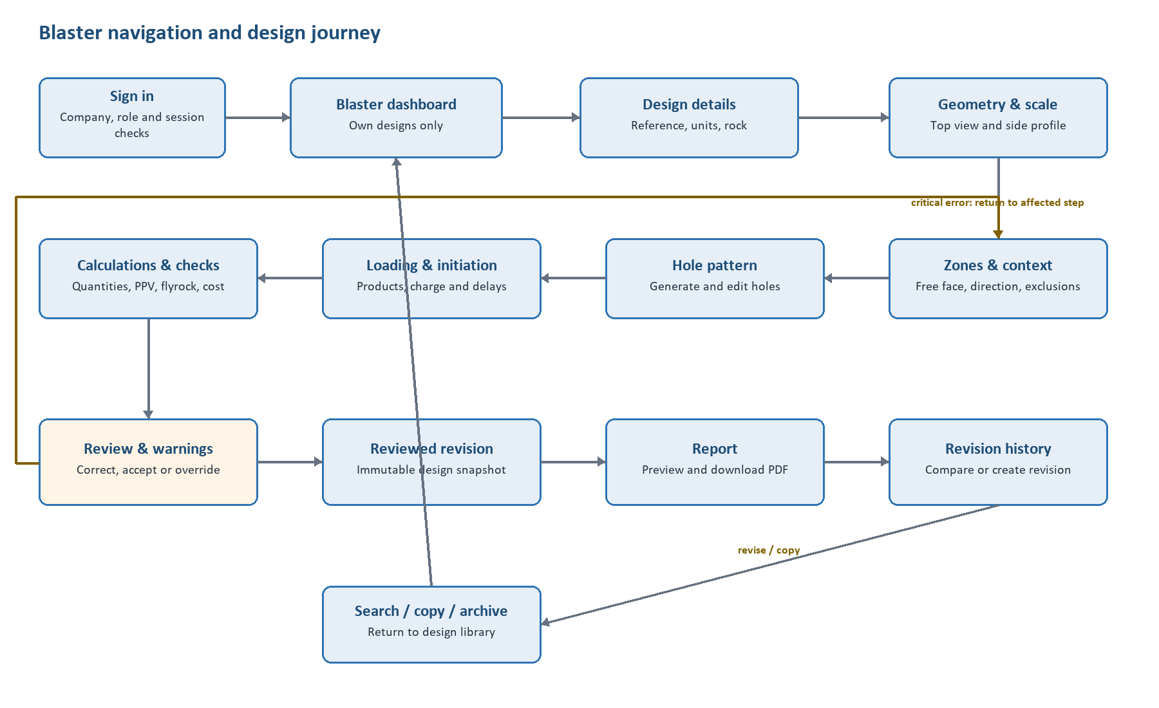
Stage | User action | System response | Decision / next step
Enter | Sign in and select/create authorised work. | Loads only the Blaster's company-owned design library. | Create new, continue, copy, revise or open history.
Model | Enter details; draw/scale boundary; add profile, zones, free face and exclusions. | Validates geometry and keeps top/side data linked. | Correct invalid/unscaled geometry or continue.
Design | Generate/edit holes; assign explosive loading and delays. | Prevents prohibited generated holes and flags conflicts/invalid charge geometry. | Resolve warning or record permitted exception.
Evaluate | Run quantities, blast effects and cost. | Stores model/version/units, identifies stale data and classifies warnings. | Return to affected screen when critical error exists.
Review | Inspect assumptions, warnings, overrides and totals. | Blocks review on critical errors; freezes an eligible revision. | Freeze, revise or return to edit.
Output | Preview/download report; compare/copy/revise later. | Uses exact saved snapshot and preserves lineage. | Return to library or create a new draft revision.

Main Company User screen flow
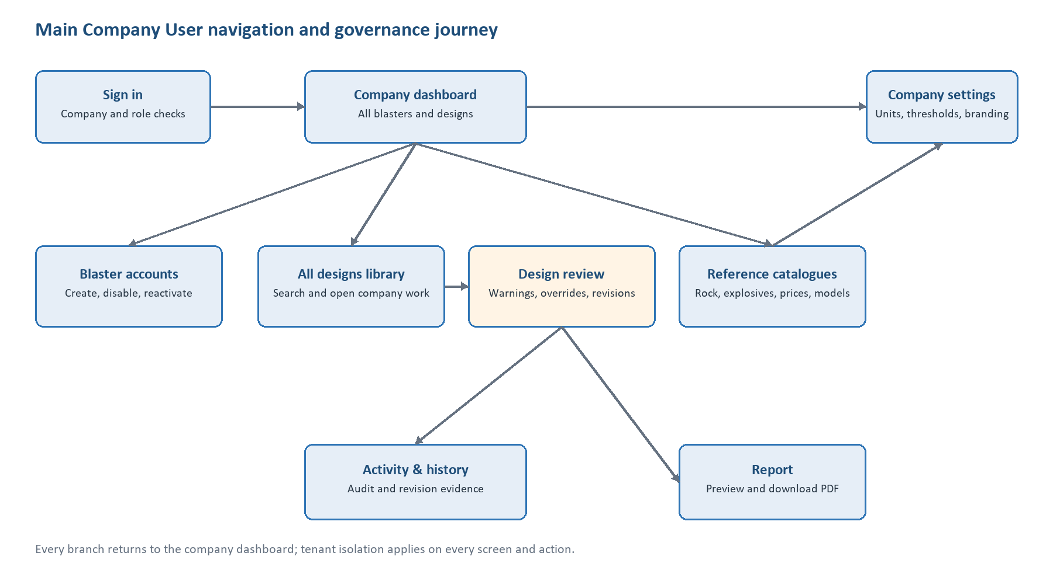
Stage | User action | System response | Decision / next step
Enter | Sign in and open company dashboard. | Shows authorised company summaries only. | Choose accounts, designs, reference data, settings or activity.
Administer | Create/disable/reactivate a Blaster or update authorised settings. | Validates authority, versions controlled data and writes an audit event. | Return to dashboard or continue administration.
Oversee | Search/open a company design and its history. | Shows geometry, results, warnings, overrides and reports for the selected revision. | Review, compare, report or return.
Govern | Maintain catalogues, prices, ranges, thresholds and models. | Preserves effective dates and prevents historical rewrites. | Approve with specialist evidence or keep change out of production.
Audit | Inspect account/design/review/report activity. | Filters same-company events with actor, time and record context. | Investigate or return to dashboard.

Work Breakdown Structure
Durations are estimated working days for a four-person student team and may run in parallel where predecessors permit. Replace the team-role placeholders with actual team-member names before submission. Client SME and blasting specialist entries are review resources, not student-team substitutions.
WBS | Task | Description | Duration | Predecessor(s) | Responsible team member(s) | Resources needed
1.1 | Confirm charter and scope | Agree objective, deliverables, exclusions, decision owners and acceptance process. | 2 d | - | TM1 - BA/PM; all team | Client brief, feature specification, meeting
1.2 | Stakeholder and workflow validation | Walk through current drawing/calculation process with Main User and representative Blasters. | 3 d | 1.1 | TM1 - BA/PM; TM2 - UX | Interview guide, screen-share/site access, notes
1.3 | Requirements baseline | Validate FRs, stories, NFR targets, rules, assumptions, exclusions and traceability. | 4 d | 1.2 | TM1 - BA/PM; TM4 - QA | This chapter, traceability matrix, client review
1.4 | Engineering model confirmation | Obtain approved equations, coefficients, units, limits and golden test cases. | 5 d | 1.1 | TM3 - Backend; Client blasting specialist | Engineering references, golden-case workbook
2.1 | Information architecture | Confirm screen inventory, navigation, states and role-specific flows. | 3 d | 1.3 | TM2 - UX/Frontend | Journey maps, whiteboard/wireframe tool
2.2 | Wireframes and prototype | Design dashboards, geometry workflow, review, administration and report preview. | 5 d | 2.1 | TM2 - UX/Frontend; TM1 | Prototype tool, WCAG checklist, client feedback
2.3 | Usability review | Run task walkthroughs with both roles and revise the prototype. | 3 d | 2.2 | TM2 - UX; TM4 - QA | Prototype, scripts, observation notes
3.1 | Solution and security architecture | Define MVC/services/data boundaries, tenancy, authorisation, audit, reporting and deployment design. | 4 d | 1.3 | TM3 - Backend; TM4 - QA | Architecture diagrams, OWASP ASVS, threat model
3.2 | Development environment and CI | Create repository, branching rules, solution, automated build/test and configuration handling. | 2 d | 3.1 | TM3 - Backend; all team | Visual Studio, Git, CI runner, package feeds
3.3 | Data model and migrations | Implement company, user, design, geometry, holes, catalogues, calculations, revisions and audit entities. | 5 d | 3.1, 3.2 | TM3 - Backend | EF Core, agreed relational DB, ERD
4.1 | Authentication and tenancy | Implement secure login, sessions, role/ownership policies and company isolation. | 5 d | 3.2, 3.3 | TM3 - Backend; TM4 - QA | ASP.NET identity/security services, test data
4.2 | Dashboards and design library | Implement role dashboards, search/filter, create/save/continue/copy/revise/archive. | 5 d | 2.3, 4.1 | TM2 - Frontend; TM3 - Backend | MVC UI, database, design test records

WBS | Task | Description | Duration | Predecessor(s) | Responsible team member(s) | Resources needed
4.3 | Geometry editor foundation | Implement canvas/SVG boundary editing, point tools, undo/redo, zoom/pan/grid and persistence. | 8 d | 2.3, 4.1 | TM2 - Frontend; TM3 - Backend | SVG/canvas library, geometry library, browser dev tools
4.4 | Scale, profile, zones and exclusions | Implement units, known-edge scaling, side profile/heights, free face, direction, zones and exclusions. | 7 d | 4.3 | TM2 - Frontend; TM3 - Backend | Geometry service, validation cases, UX prototype
4.5 | Hole-pattern design | Generate three pattern types, enforce boundaries/exclusions and support individual-hole editing/conflicts. | 7 d | 4.4 | TM2 - Frontend; TM3 - Backend | Pattern algorithms, geometry cases, golden layouts
4.6 | Reference catalogues and admin | Implement rock, explosive, price, ranges, thresholds, model and branding administration. | 5 d | 4.1, 3.3 | TM3 - Backend; TM2 - Frontend | Validated seed data, admin UI, audit service
4.7 | Loading and initiation | Implement product assignment, charge geometry, delays, timing summary and charge per delay. | 6 d | 4.5, 4.6 | TM2 - Frontend; TM3 - Backend | Explosive data, loading/timing golden cases
5.1 | Core calculation service | Implement geometry, volume, tonnage, drilling, quantities and powder-factor calculations. | 8 d | 3.3, 4.4, 4.6 | TM3 - Backend; TM4 - QA | Approved formulas, unit library, golden tests
5.2 | Vibration and flyrock | Integrate approved models, receptors, thresholds, assumptions, limitations and warnings. | 6 d | 1.4, 5.1, 4.7 | TM3 - Backend; Specialist review | Approved models, test cases, visual overlay support
5.3 | Explosive cost estimate | Calculate product quantities, effective price snapshots, stale-price warnings and comparisons. | 3 d | 4.6, 4.7 | TM3 - Backend; TM2 - Frontend | Price seed data, currency rules, test cases
5.4 | Validation and stale-state engine | Implement server/client validation, dependencies, warning levels and corrective messages. | 6 d | 4.4, 4.5, 4.7, 5.1 | TM3 - Backend; TM2 - Frontend; TM4 | Rules catalogue, dependency map, automated tests
5.5 | Review, overrides and revisions | Implement review gate, reasons, immutable snapshots, revision history and comparison. | 7 d | 5.2, 5.3, 5.4 | TM3 - Backend; TM2 - Frontend | Audit service, snapshot design, comparison UI
5.6 | PDF report | Generate complete design/calculation report from an exact saved revision. | 5 d | 5.5 | TM3 - Backend; TM2 - Frontend; TM4 | PDF library, branding, approved report sample
6.1 | Accessibility and browser pass | Verify keyboard focus, contrast, non-colour warnings, responsive layout and browser matrix. | 4 d | 4.2-5.6 | TM2 - Frontend; TM4 - QA | WCAG tools, Edge/Chromium browsers, keyboard

WBS | Task | Description | Duration | Predecessor(s) | Responsible team member(s) | Resources needed
6.2 | Integration and system testing | Run end-to-end, negative, unit conversion, stale-state, revision and report tests. | 7 d | 6.1 | TM4 - QA; all team | Test plan, representative dataset, CI reports
6.3 | Security verification | Test authentication, tenant/owner isolation, input handling, session, audit and dependency risks. | 4 d | 4.1, 6.2 | TM4 - QA; TM3 - Backend | OWASP ASVS checklist, security test tools
6.4 | Performance and recovery tests | Test agreed representative designs, concurrency, backup and restore targets. | 4 d | 6.2 | TM4 - QA; TM3 - Backend | Load scripts, monitoring, backup environment
7.1 | User acceptance testing | Run role-based scenarios and obtain recorded client decisions and defects. | 4 d | 6.3, 6.4 | TM1 - BA/PM; TM4; Client users | UAT plan, staging environment, sign-off log
7.2 | Defect correction and regression | Resolve accepted defects and rerun impacted automated/manual tests. | 5 d | 7.1 | All team; TM4 coordinates | Defect tracker, CI, regression suite
7.3 | Deployment preparation | Finalise migrations, seed data, configuration, monitoring, backup, release and rollback plan. | 3 d | 7.2 | TM3 - Backend; TM4 - QA | Hosting environment, secrets, runbook
7.4 | Pilot deployment | Deploy approved release, run smoke tests and verify monitoring/backup. | 2 d | 7.3 | TM3 - Backend; TM4 - QA | Production/pilot environment, release package
7.5 | Training and handover | Train both roles and hand over user guide, technical notes, test evidence and support process. | 2 d | 7.4 | TM1 - BA/PM; all team | Training environment, manuals, source and runbook

9.1.8 Non-functional Requirements
The supplied specification confirms the quality categories but does not provide all measurable thresholds. The table therefore distinguishes confirmed design constraints from proposed acceptance targets. Proposed values must be approved with the client against representative data before they become contractual acceptance criteria.
ID | Category | Requirement / measure | Verification | Status
NFR-01 | Security | Every request shall revalidate authenticated company, role and ownership authority on the server; hiding UI controls alone is insufficient. | Automated negative authorisation suite for list, direct URL, API, copy, report and download. | Confirmed
NFR-02 | Security | All production traffic shall use HTTPS; passwords shall use the framework's approved adaptive password hashing and secrets shall not be stored in source control. | Configuration review, TLS scan, credential-storage inspection. | Confirmed direction; configuration to confirm
NFR-03 | Security | Session controls shall expire inactive sessions and revoke access promptly after an account is disabled. | Timed session test and disabled-account test. | Target duration to confirm
NFR-04 | Security | Client and server shall validate all geometry, calculation, price, settings, review and report inputs; server validation is authoritative. | Tampered-request and invalid-boundary tests. | Confirmed
NFR-05 | Security | Security design and verification shall use an agreed OWASP ASVS 5.0 control baseline and document exceptions. | Threat model and mapped ASVS verification report. | Proposed; level/control set to confirm
NFR-06 | Privacy | The system shall collect only identity, company, audit and optional internal reference data required by scope, and shall restrict export/download to authorised users. | Data inventory, access review and export tests. | Proposed; jurisdiction/retention to confirm
NFR-07 | Auditability | Audit events shall be append-only to ordinary users and record actor, company, UTC time, action, entity/revision and outcome. | Attempted edit/delete tests and event-field inspection. | Confirmed behaviour; retention to confirm
NFR-08 | Integrity | Reviewed revisions, calculation/model snapshots, price snapshots and generated-report source references shall be immutable. | Database/API mutation tests and revision lineage inspection. | Confirmed
NFR-09 | Calculation accuracy | All formulas and unit conversions shall pass specialist-approved golden cases within a documented numeric tolerance before production use. | Automated golden-case suite signed off by qualified specialist. | Confirmed governance; tolerance to confirm
NFR-10 | Unit consistency | Changing Metric/Imperial display units and converting back shall not materially change the physical design or controlled result. | Round-trip property tests across representative inputs. | Confirmed; numeric tolerance to confirm
NFR-11 | Performance | For an agreed representative design, 95% of ordinary page/navigation/search/save requests should complete within 2 seconds and controlled save actions within 3 seconds, excluding large report generation. | Instrumented staging load test. | Proposed target; workload to confirm
NFR-12 | Performance | Geometry pan, zoom, selection and point/hole movement should remain visibly responsive, targeting at least 30 frames per second on the agreed standard workstation and design size. | Browser performance recording on representative geometry/hole counts. | Proposed; device/load to confirm

ID | Category | Requirement / measure | Verification | Status
NFR-13 | Performance | Core calculation and report generation should complete within client-approved limits and show progress when an operation exceeds 2 seconds. | Timed golden-case and representative-report tests. | Limits to confirm
NFR-14 | Capacity | The application shall meet response targets at the agreed peak concurrent-user count without cross-tenant data leakage or failed saves. | Concurrent load and tenancy-isolation test. | User count to confirm
NFR-15 | Availability | The production service should achieve at least 99.5% monthly availability excluding approved maintenance. | Monitoring report and incident log. | Proposed target
NFR-16 | Recovery | Backups shall cover company, user, geometry, design, reference, audit and report data; restore procedures shall be tested at least quarterly. | Quarterly restore evidence and integrity reconciliation. | Confirmed capability; frequency proposed
NFR-17 | Recovery | A proposed recovery point objective of 24 hours and recovery time objective of 4 hours shall be validated against client risk and hosting capability. | Timed recovery exercise and data-loss measurement. | Proposed; client confirmation required
NFR-18 | Usability | A representative Blaster should complete the first-release happy path without assistance after training, with no unresolved critical error and no loss of entered data. | Observed task-based usability/UAT session. | Proposed acceptance method
NFR-19 | Accessibility | The web application should conform to WCAG 2.2 Level AA for the complete supported workflows, including keyboard operation, visible focus, contrast, labels, errors and status messages. | Automated checks plus manual keyboard/screen-reader review of complete processes. | Proposed standard; supported canvas technique to validate
NFR-20 | Accessibility | Critical errors, warning levels, selection and state shall not be communicated by colour alone. | Visual inspection, high-contrast/grayscale review and accessible-name checks. | Confirmed
NFR-21 | Compatibility | The release shall support client-approved current versions of Microsoft Edge and major Chromium-based browsers on the agreed desktop display sizes. | Published browser matrix and end-to-end regression run. | Confirmed direction; exact matrix to confirm
NFR-22 | Maintainability | The solution shall use separable services for geometry, calculations, security, reporting and data access with dependency injection and automated unit/integration tests. | Architecture review and CI test results. | Confirmed
NFR-23 | Maintainability | The application shall use an actively supported ASP.NET Core/.NET release; framework and third-party dependencies shall be inventoried and reviewed for updates/vulnerabilities. | Support-policy check, dependency inventory and scan. | Confirmed direction
NFR-24 | Testability | Each controlled formula, business rule, authorisation boundary, stale dependency and report section shall trace to one or more automated or manual tests. | Requirements-to-test traceability audit. | Proposed acceptance control

ID | Category | Requirement / measure | Verification | Status
NFR-25 | Observability | The service shall emit structured logs with correlation identifiers, health status and actionable failure details without exposing secrets or unnecessary personal data. | Log review, health-check test and failure injection. | Confirmed direction
NFR-26 | Deployability | Database migrations and environment configuration shall be version-controlled; deployment shall have a tested rollback or forward-fix plan. | Staging deployment/redeployment and rollback rehearsal. | Confirmed direction
NFR-27 | Report quality | The same saved revision and report template version shall produce stable content and preserve the exact source revision, units, models, warnings and overrides. | Repeat-generation content comparison and source-revision check. | Confirmed
NFR-28 | Data lifecycle | Archive/soft deletion shall protect design history from ordinary destructive actions; retention and permanent deletion authority shall follow approved company policy. | Archive/restore tests and policy review. | Confirmed mechanism; policy to confirm

Open Validation Decisions
ID | Decision | Owner | Needed by
VD-01 | Xploma identity, stakeholder names and evidence dates | Client / team | Before report submission
VD-02 | Actual team-member names mapped to TM1-TM4 responsibilities | Student team | Before WBS sign-off
VD-03 | Whether a second person is required to approve a design | Client policy owner | Before review workflow build
VD-04 | Exact vibration and flyrock models, units, coefficients, limits and golden cases | Qualified blasting specialist | Before model implementation/production
VD-05 | Representative vertices, profiles, zones, holes, users and reports for performance tests | Client users + team | Before NFR baseline freeze
VD-06 | Production database, hosting, authentication integration and browser/device matrix | Client IT + architecture | Before deployment design
VD-07 | Report branding, disclaimer, signature/acknowledgement and mandatory fields | Main Company User / client | Before report acceptance
VD-08 | Session duration, uptime, backup/restore, retention, privacy jurisdiction and support targets | Client IT / management | Before operational acceptance

Chapter 9.1.9: Analysis Artifacts
Analysis Artifacts: UML class diagram , UML design class diagram , login flow and business flow and API Endpoint.

Analysis Artifacts
This is the section where I will take the functional requirements namely FR-01 to FR-44 and the user stories US-B01 to US-M11 into a structured domain model and design. The artifacts will make sure we have everything planned out properly before we start coding.

Domain Modelling
This will represent the business concepts without technology, its about the attributes and relationships that keep and enforce the ownership , revision history and the company’s isolation.

UML Domain Class Diagram
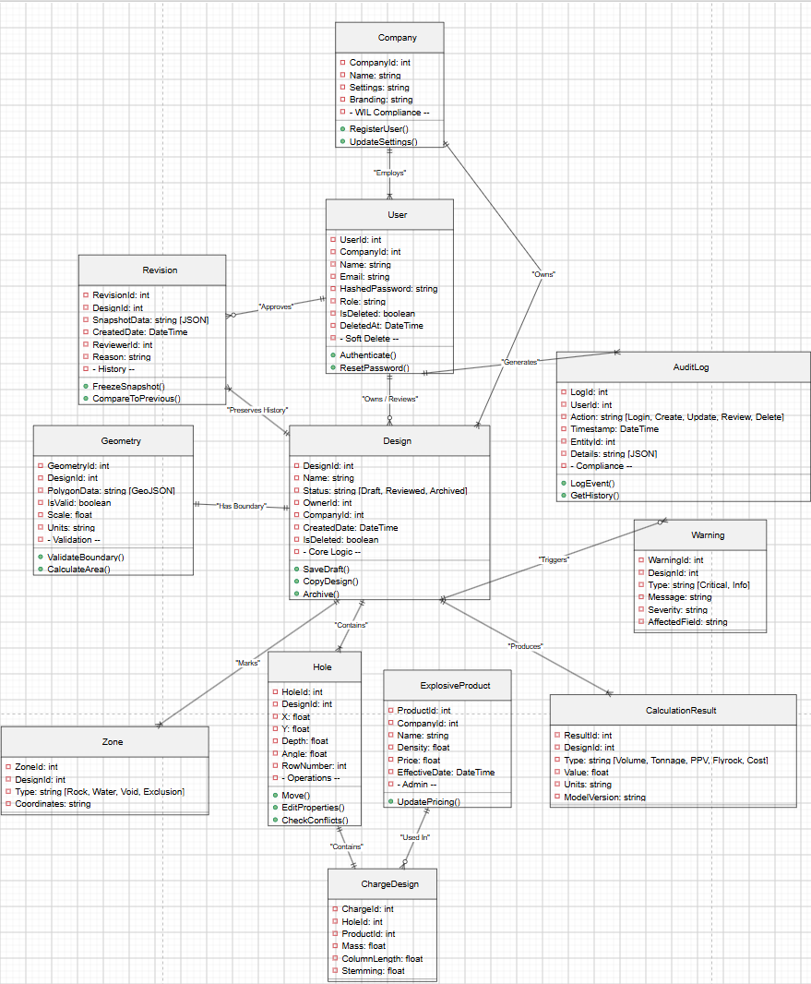

Domain Class Description

Class | Purpose
Company | Makes sure all the users and their designs belong to a single company
User | This is a Blaster or a Company users
Audit Log | This will record every create , update , delete and review made.
Design | This is the blast plan
Revision | This will halt the design while its being reviewed
Geometry | This will cover all the validations before the calculations are done.
Hole | Blast holes created through a patter or manually
Explosive Product | Company chosen explosives and their pricing
Calculation Result | This holds the Volume , Flyrock and the cost models

API Endpoint
Endpoint | Method | Description
api/auth/login | POST | Authenticate the user
api/admin/users | GET | Get all company users
api/designs/geometry | PUT | Update the geometry
api/designs/generate pattern | POST | Generate blast hole patterns
api/designs/review | POST | Freeze while reviewing
api/designs | GET | Get the users designs

Sequence Diagrams
User authentications and login
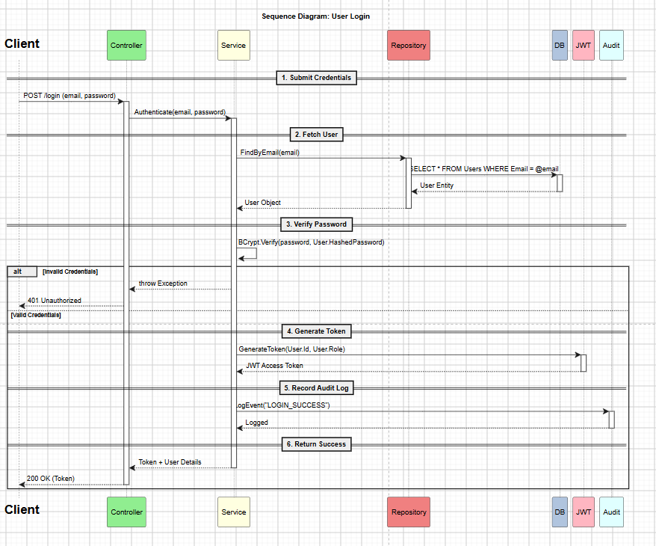

Business Flow
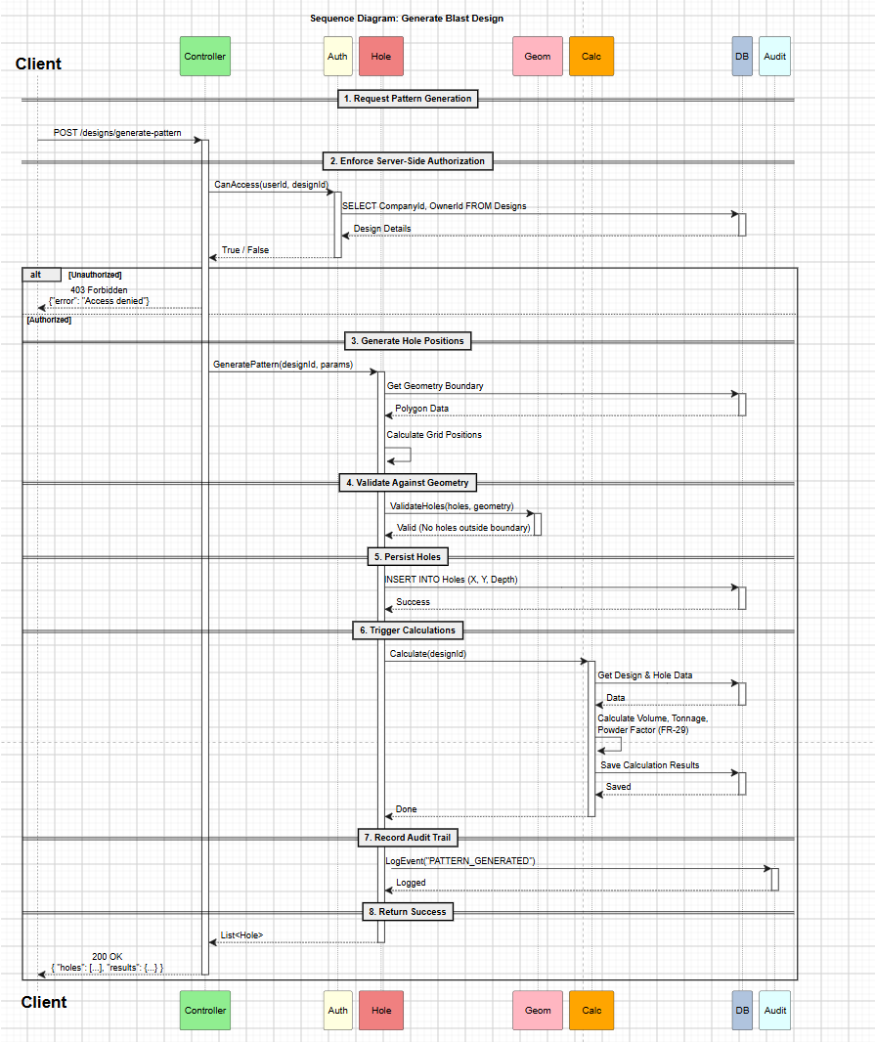

9.1.10 Implementation

UML Sequence Diagrams
Blast Design Creation and geometry editing
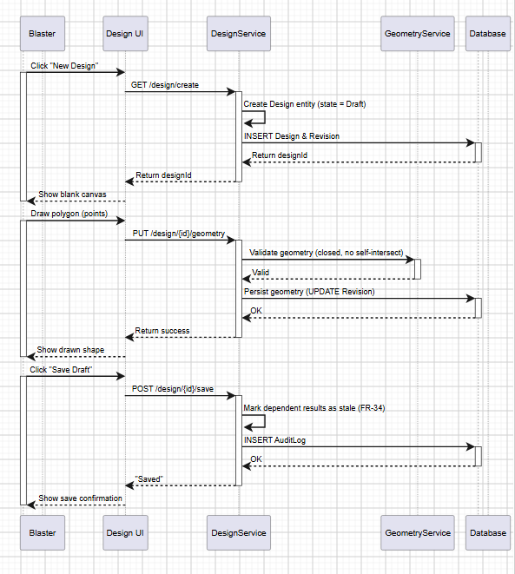

Hole pattern Generation and Editing
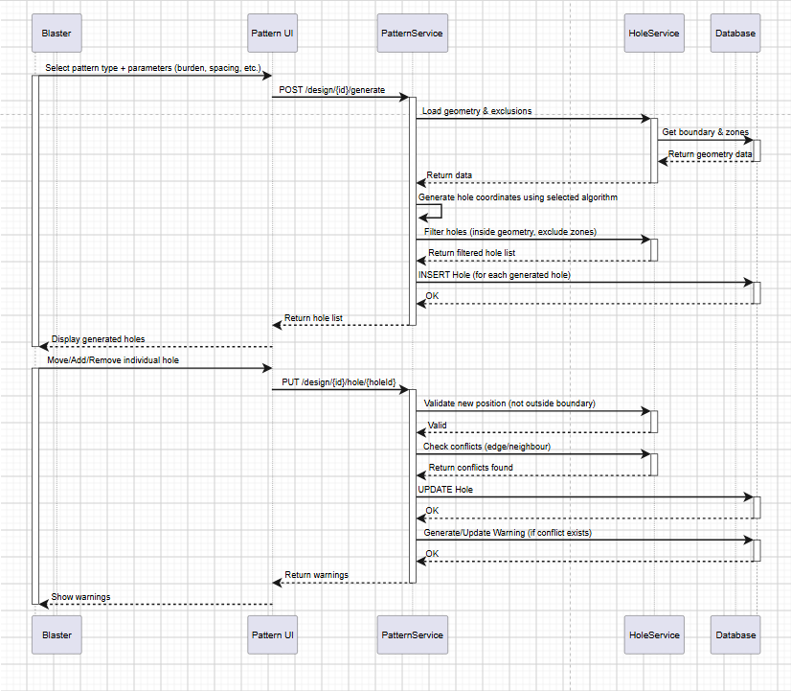
Calculation and Review Flow
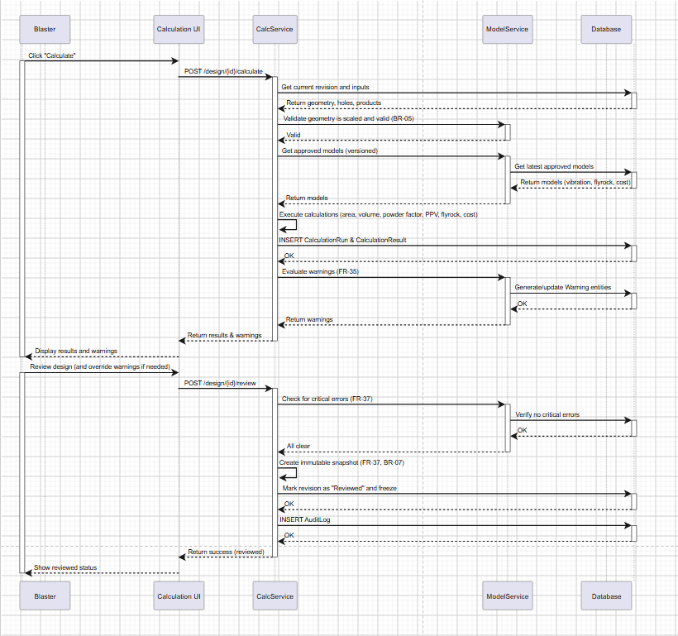
PDF Report Generation
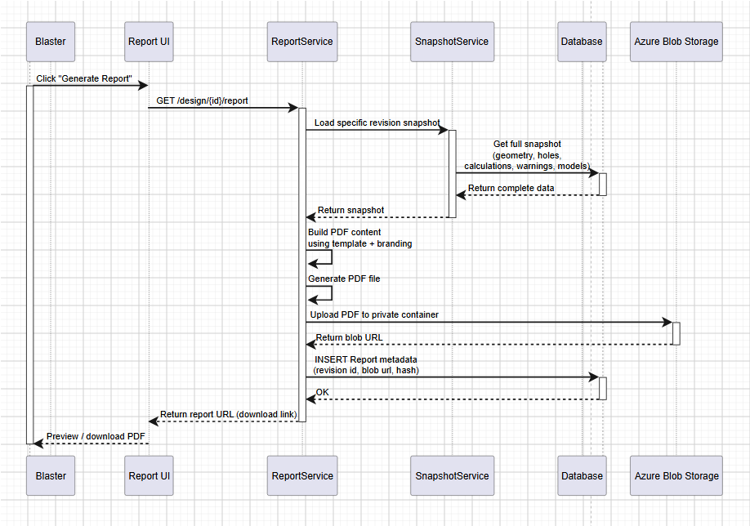

UML State diagrams
Design State
The Design represents a work item that may have revisions. It should reflect the status of the most recent revision
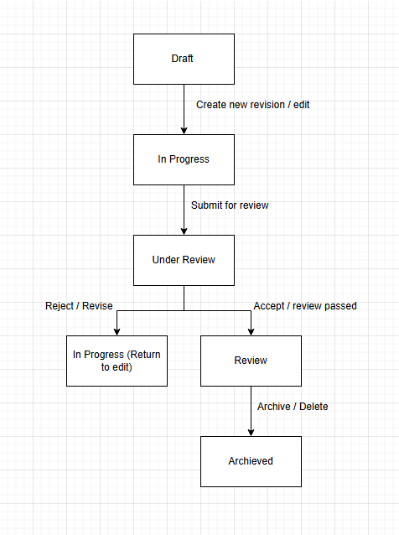
Transitions explained
From | To | Trigger | Conditions
Draft | In progress | Clicked Edit or save geometry | Blaster creates draft
In Progress | Under Review | Request review | No errors and all required inputs present
Under Review | In progress | Review rejected | Reviewer comments on changes that should be made, revision becomes editable
Under Review | Reviewed | Review accepted | Reviewer approves
Reviewed | Archived | Archive design | Executive approves of the design
any | Archived | Delete / archive | Design removed from lists
Revision state
Each revision is a version of a design. A design may have multiple revisions
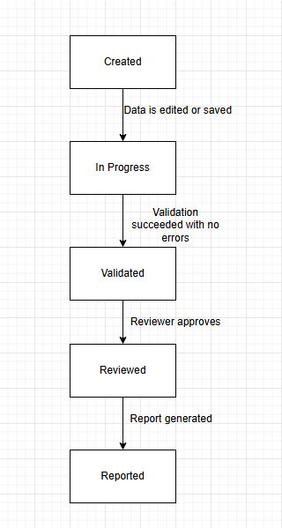
Transition explained
From | To | Trigger | Conditions
Created | In progress | Save of geometry or data | Design ID must exist
In Progress | Validated | User has calculations and resolves errors | No errors, all inputs present and geometry valid
Validated | In Progress | After validation the user edits the design | Stale state flag (according to FR-34)
Validated | Reviewed | User performs review | Review passed (according to FR-37)
Reviewed | Reported | PDF report generated | Report generated successfully and the data was saved
Reviewed | Archived (via design state) | Design archived | Design state is moved to archive, revisions become read-only

Deployment Plan
The deployment plan ensure that the release is easy while also reducing risks. It covers the environment architecture, deployment process, rollback strategies and database migration.
- Environment Architecture
We will use three different environments, they will all have their own Azure App Service slot as well as their own Azure SQL database.
Environments:
Development – local development and unit testing, using developer machines and azure app service.
Staging – integration testing and production validation, using Azure app service staging slot
Production – Live system for end users, using Azure app service production slot

- Deployment Process (CI/CD Pipeline)
The deployment pipeline will be automated via GitHub actions (for further details please see 9.1.14).
- Devloper pushes code to a branch
- Pull request opened for devlop. GitHub Actions runs unit tests, integration tests, and code analysis. When it is successful it will be merged
- Merge to develop triggers deployment. Build and run all tests again. Deploy to staging slot. Run smoke tests on the staging slot, checks login, basic design creation etc. if the smoke test passes the staging slot is swapped to the production slot.
- Release to production. Swap the staging slot into the production slot. Run smoke tests on the production slot. If an error occurs swap back.

- Database Migration Strategy
We use Entity Farmwork Core Migrations to handle schema changes.
All migrations will be code first. Migrations will be applied automatically during the deployment to the target environment using the dotnet ef database update command. We will not rollback schema changes, this means if a migration fails we will use a new migration to fix the error. We can however rollback database changes if a migration fails, we can restore from a backup (according to NFR-17). The steps that will be take pre deployment are; generate a migration script, then back up the target database before applying, finally for production we will run migrations with a maintenance window.

- Zero Downtime Deployment
Azure App Service deployment slots allow swaps with no downtime. Staging slot will be used for final validation. After testing the staging slot will swap with the production slot. The swap happens immediately and does not cause downtime. If a problem occurs we can rollback quickly.
The steps we must take before a swap; Ensure the slot we want to swap in is fully operational. Run automated tests on the staging slot. Finally, we check the database migrations have been applied to the production database, we do this before or during the swap.

- Environment Configuration
We use Azure Key Vault to store secrets, like connection strings, API keys, etc. We will also use Azure App Configuration for environment specific settings. Each environment will have its own App Configuration settings. The application will read the configuration from the environment variables on startup. Secrets will be injected via managed identity (according to NFR-02) and no credentials will be store in the source code.

- Rollback Plan
Rollback plans will be made for the following scenarios
Scenario | Rollback Plan
Code Bug in Application | Immediately swap back the previous production slot. The database schema wont change so the works immediately.
Database migration error | Stop development, restore the database from back ups, then revert to the previous code version. Finally a forward fix migration is created.
Performance issues | Use the swap back approach, then test in staging. We might be required to scale up the App service plan.
Data Corruption | Restore the database from the latest backup, restore with Azure SQL.

- Post Deployment Validation
After each deployment we must make the following checks; Smoke tests, automated tests that check critical user paths like, login design creation, etc. Application insights, we should monitor error rates response times and dependency calls. Finally, we should set up alerts for high error rates or slow response times.

- Release schedule
Development – Continuous integration, every merge to develop uses staging deployment.
Staging – updated daily
Production – releases should be scheduled and hotfixes should be made when needed. Production releases will require a manual approval step.

Summary
The implementation diagrams, sequence and state diagrams, provide a blueprint for coding the flow of the application. The deployment plan ensures that the system can be reliably delivered with minimal downtime. The rollback strategy aligns with the non functional requirements for availability and recovery.

9.1.11 Data Schema

Data-storage choice
Azure SQL Database is selected as the main data store. The system has clear relationships between companies, users, designs, revisions, holes, products, calculations and reviews. A relational database is suitable because it supports foreign keys, transactions and consistent queries. Azure SQL is also a managed service, so the team does not need to maintain its own database server (Microsoft, 2026b).
Entity Framework Core will connect the ASP.NET Core application to Azure SQL. Azure Blob Storage is used only for generated PDF reports; the report name, revision link and content hash remain in SQL. A separate NoSQL database and JSON schema are not required because the main data is relational. Limited JSON columns may still store calculation inputs or model parameters where a fixed set of columns would be impractical (Microsoft, 2025a).

Entity Relationship Diagram
The ERD is divided into two figures so that it remains readable. Figure 1a shows company ownership, design revisions and governed reference data. Figure 1b expands one revision into geometry, holes, charging, initiation, calculations and warnings. Primary keys are marked PK and foreign keys are marked FK.

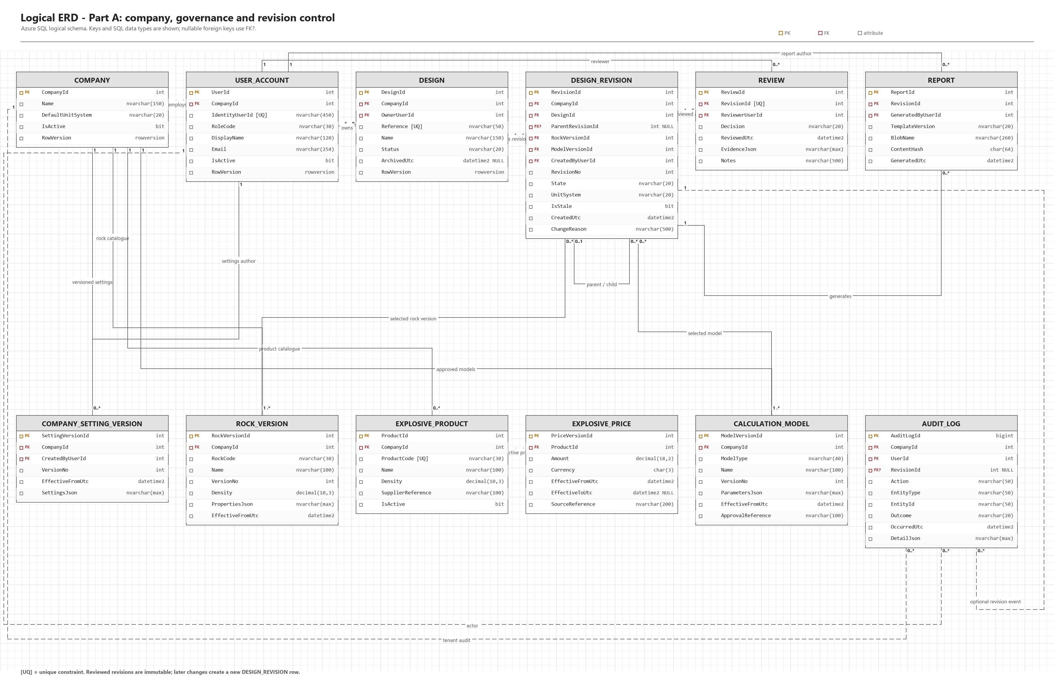

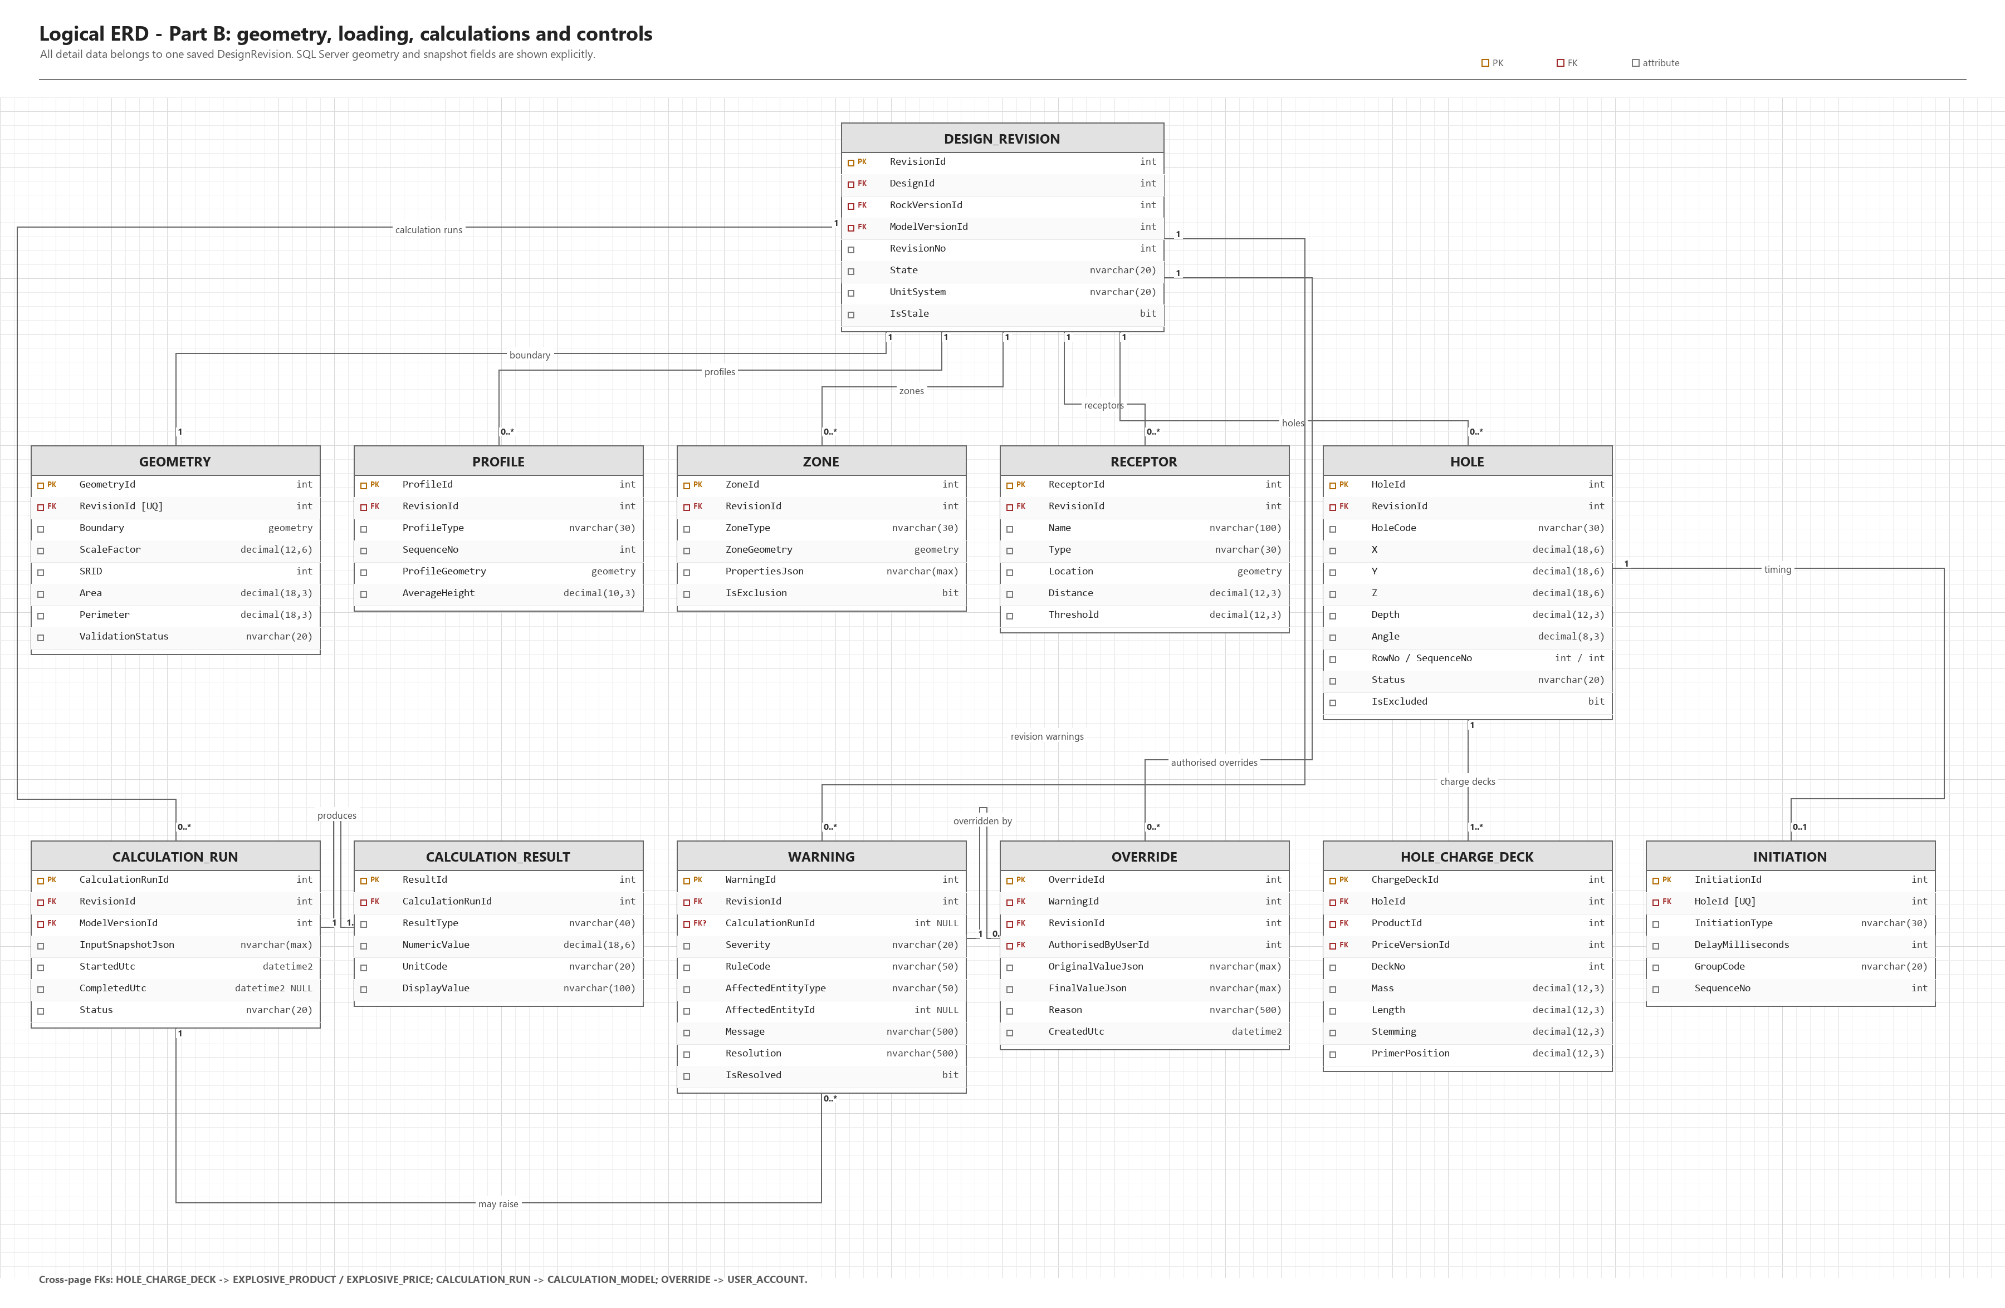

ERD explanation
Company is the main data-isolation record. Every user and design belongs to one company. Design stores the continuing item of work and DesignRevision stores each numbered version. A reviewed revision is not edited; later work creates a new revision. This keeps the original calculations, warnings and report evidence available.
Each revision owns its geometry, zones, receptors and holes. A hole may contain several charge decks and one final initiation record. CalculationRun records the model version and input snapshot, while CalculationResult stores the outputs. Warning and Override keep the original warning and the authorised reason for any accepted exception. This structure follows normalisation principles by separating stable records from repeating or versioned facts (Connolly and Begg, 2015).
Entity group | Purpose and important relationship
Company and User | Separates company data and stores the Main Company User or Blaster role.
Design, Revision and Review | Stores ownership, numbered revisions and the review that makes a revision final.
Geometry, Zone and Receptor | Stores the scaled blast area, special zones and sensitive PPV/flyrock points.
Hole, ChargeDeck and Initiation | Stores the final position, explosive loading and timing for each hole.
Product, Price and Rock | Keeps controlled catalogue values and their effective versions.
Model, Run and Result | Links each calculation to its approved model version, inputs, outputs and units.
Warning and Override | Keeps validation evidence and any authorised exception without deleting the warning.
Report and AuditLog | Links the final PDF to a revision and records important user activity.

Main data rules
- CompanyId is checked on tenant-owned records so that one company cannot access another company's data.
- A Blaster sees only designs they own; a Main Company User may see designs in the same company.
- Reviewed revisions are immutable. A change creates a new DesignRevision linked to the previous revision.
- Calculation runs save the model version and input snapshot so that results can be reproduced.
- Generated PDFs are private Blob objects, while searchable metadata and audit history stay in Azure SQL.

9.1.12 Architecture Artifacts

Architecture pattern
The proposed system is a modular layered monolith using ASP.NET Core MVC. Presentation, application, domain and infrastructure responsibilities are separated in the code, but the prototype is deployed as one Azure App Service application. This is easier for a student team to build and test than microservices, while still allowing modules to be separated later if evidence shows a need.

Design patterns
- MVC separates web pages and controllers from the blast-design rules.
- Repository and Unit of Work keep authorised database operations in one EF Core transaction.
- Strategy and Factory select the approved geometry, vibration, flyrock or cost calculation model without changing the controller (Gamma et al., 1994).
- Immutable Snapshot keeps reviewed inputs, models, prices, warnings and results unchanged.
- Domain Events allow important actions to be written consistently to AuditLog.

Azure cloud architecture
Azure App Service hosts the ASP.NET Core MVC application and Azure SQL stores the relational records. Blob Storage stores generated PDF files, Key Vault keeps secrets or configuration references, and Application Insights collects operational telemetry. A system-assigned managed identity allows the application to access supported Azure services without storing long-lived credentials in source code (Microsoft, 2026a; Microsoft, 2026e).
For the target architecture, App Service uses VNet Integration for outbound traffic. Azure SQL, Blob Storage and Key Vault use private endpoints and private DNS. Private Link gives these services private addresses, while the public application entry remains HTTPS through App Service for the prototype (Microsoft, 2026c; Microsoft, 2026d).

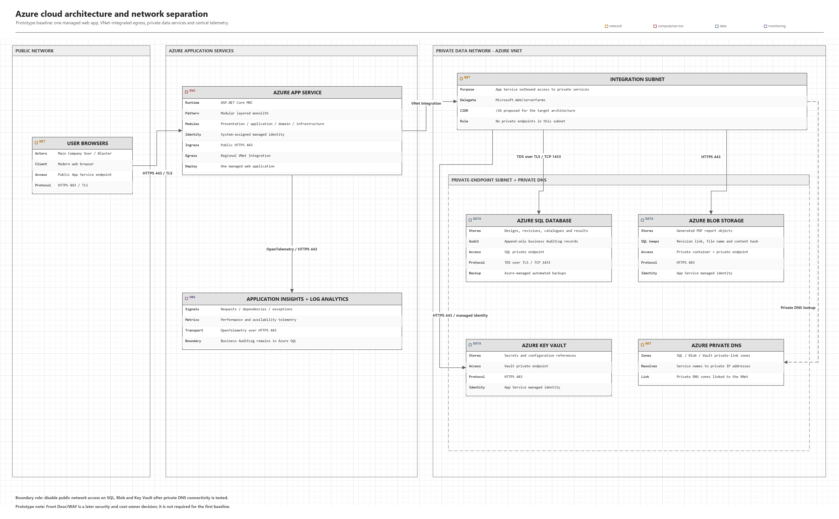

Azure services, protocols and data flow
Connection or service | Purpose | Protocol or control
Browser -> App Service | User access to the MVC web application. | HTTPS 443 using TLS
App Service -> Azure SQL | Reads and writes relational design data. | TDS over TLS, TCP 1433; private endpoint
App Service -> Blob Storage | Writes and retrieves generated PDF reports. | HTTPS 443; private container
App Service -> Key Vault | Reads approved secrets or references. | HTTPS 443; managed identity
Application Insights | Records requests, dependencies, errors and performance. | OpenTelemetry over HTTPS 443

- The user signs in over HTTPS and the application establishes the user's company, identity and role.
- The MVC controller sends the request to an application service, which checks company, ownership and revision state.
- Domain services perform validation or calculations and select the approved calculation strategy where required.
- EF Core reads or writes authorised rows in Azure SQL and records the related AuditLog event.
5. When a report is produced, the PDF is written to private Blob Storage and its metadata is saved in SQL.

9.1.13 Security
Security was considered from the start of the design. OWASP ASVS 5.0 was used as a guide for the security controls, while the OWASP top 10 was used to identify common web application vulnerabilities. The exact ASVS level and full set of controls will be confirmed by the group during the architecture and threat-modelling phase. The discussion below reflects the security decisions already made in the data schema, architecture and development work (Sections 9.1.11, 9.1.12, 9.1.10 and 9.1.14).

Authentication, authorisation and company isolation
Each session must establish who the authenticated users company and role is before returning any application data. The system defines two application roles (Main company user and blaster). Every tenant owned record has a CompanyId, which we validate during each read/write/search/calculation/report operation.
This means requests that are valid against one company cannot ever touch another company’s data. A blaster should be able to find and interact with only the designs they have owned. Main company user can access all of the designs in their company but none outside of theirs.
Authentication will use ASP.NET Core Identity, using hashes/salts for passwords, locking out accounts after too many failed attempts and providing role claims upon login that our application enforces on every controller and API action (Not only just in the user interface).
Actions that could potentially compromise security such as creating/disabling accounts, changing reference data, reviewing work or applying overrides – are restricted to the correct role at the server, so that hiding a button in the UI is never the only control in place.

Cross-Site Scripting (XSS) prevention
Application technology: ASP.NET Core MVC with Razor views: All output is HTML encoded by default. Any user supplied text such as design references, comments, override reason or company names are only displayed via this automatic encoding in Razor views. We don’t use raw HTML rendering.
-Input validation: In addition to client side validation we also validate input on our servers using data annotations and preform model validation before allowing data to reach the database or echoed back to a page.
-A content security policy (CSP) header will be configured to further limit what kind of script, style and frames can be loaded. Limiting the impact of an XSS injection in there is some kind of script injection.
-Cookies for authentication are marked with HttpOnly and secure to prevent an attacker from using their own script to grab our session cookie.
-Any place where design data is later exported or embedded treats all stored text as data, no markup, when it is rendered.

Other common vulnerabilities and mitigations
Risk | Mitigation
SQL Injection | Database access goes through Entity Framework Core with parameterised queries is used against user input.
Session management weakness | Sessions expire after a configurable period of inactivity. Tokens are reissued at login, with role/company context re-validated on each request (not trusted across an entire session).
Cross-Site Request Forgery (CSRF) | ASP.NET Cores built-in anti-forgery tokens are applied to all state-changing forms and validated on the server before an action is executed.
Sensitive data exposure | All traffic is protected using HTTPS/TLS. Azure SQL data is encrypted at rest. Secrets like API keys and connection strings are stored in Azure Key Vault and never committed to source control (or GitHub).
Broken access control | Company/ownership checks are performed at the application/domain layer across all requests and are supported by automated tests.
Insecure credentials | The app service uses a system assigned managed identity to access Key Vault, SQL and Blob storage, removing the need for long lived credentials in configuration or code.
Insufficient logging and monitoring | Login, account, design, calculation, override, review, report and archive events are stored to an AuditLog table, and Azure application insights monitoring errors, performance and unusual activity in production.

Network and infrastructure security
On the infrastructure level (Section 9.1.12 for the complete architecture) Azure App Service is used for the hosting of the application allowing the web application to run within a virtual network where outbound requests get routed via that network. Azure SQL, Blob storage and Key Vault are reached through private endpoints and private DNS rather than public internet addresses. This limits the networks attack surface by having the database, file storage and secrets store not directly reachable from outside the application network.
Deployment makes use of staging slots with automated smoke tests before any release is put into production. Rollback plans exist when dealing with code, migrations and performance issues. This means fixes can be made without downtime.
These combined approaches ensure the client feels comfortable that company data is isolated between tenant, that a reviewed design cannot be changed, assured that standard web attacks like XSS, SQL injection and CSRF get addressed at the framework level and that the infrastructure itself limits what an attacker could reach even if one layer was penetrated.

9.1.14 DevOps

Branching Strategy
Repository Structure
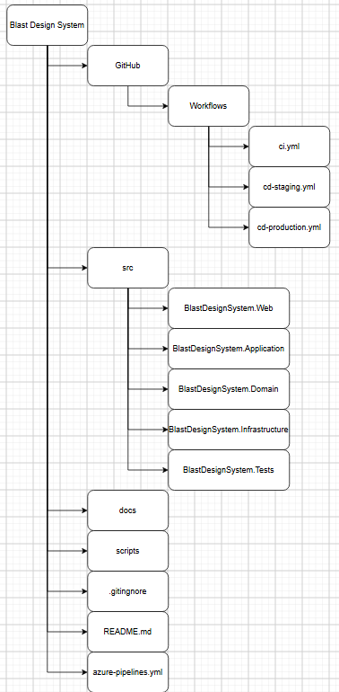
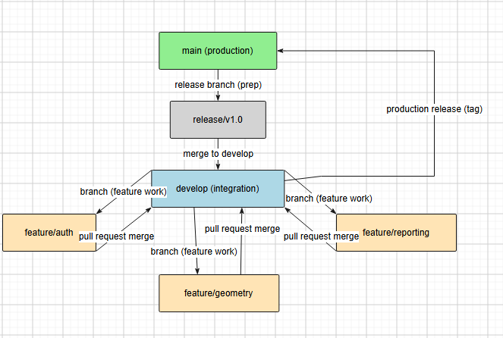
Branching definitions
Main – production code. No direct commits, only merges from develop.
Develop – Integration branch for completed features. Features run here, CI runs on every push.
Feature/ – individual features or bug fixes. It is branched from develop e.g. feature/geometry.
Release/ - preparation for deployment. Branched from develop when ready for release.
Hotfix/ - production fixes. Branched from main. Merged into both main and develop.

Workflow process
The developer creates a feature branch from develop. While working on the feature regular commits are made. When the feature is completed the branch is pushed and a pull request is made to develop. A pull request is accepted when, at least one reviewer approves, all GitHub actions pass checks (tests and builds) and there are no merge conflicts. After approval the pull request is merged into develop. When develop is stable a release branch is created. After the final testing the release branch is merged into main. Finally, after the merge to main the production deployment is triggered.

GitHub Actions Pipeline
The GitHub Actions Pipeline automates CI/CD. The pipeline is defined in the three YAML files.
ci.yml – runs on every push aand pull request
cd-staging.yml - Runs on merge to develop
cd-production.yml – Runs on merge to main. This requires manual approval

Pipeline Architecture
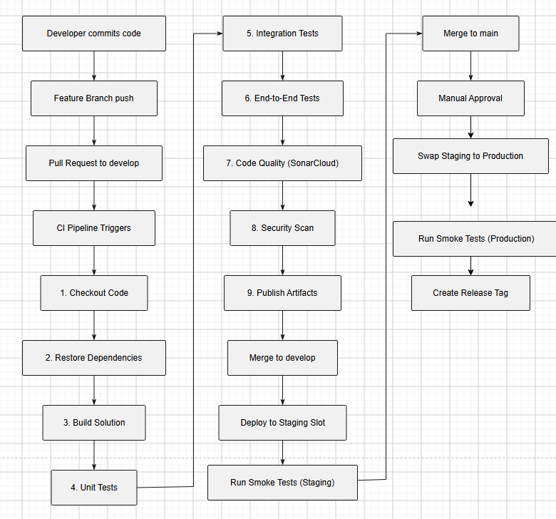

The diagram shows the flow from commit to CI to staging development and finally the production deployment.
The CI pipeline triggers are push, pull request to develop and merge to main. After a CI trigger it goes through 9 stages to make sure that the code is ready to be merged to develop.
When develop is updated the code is deployed on an Azure App service staging slot.
When main is updated and a manual approval is made the production is deployed.
Secrets will be stored in GitHub Secrets and Azure Key Vault.

Automated Testing
CI/CD Pipeline Stages
- Continuous Integration (CI) – ci.yml
This is triggered when a push is made to any branch and when a pull request is made to develop or main. Please refer to pipeline architecture above; on checkout code the repository is cloned, it will fail if the source is not available. Restore uses dotnet restore and it can fail if the NuGet packages are unavailable. Build uses dotnet build –configuration Release and it will fail if there are compilation errors. Unit tests, integration tests and end-to-end tests (E2E) will use dotnet test, they will fail if any tests fail. Code quality will be checked by SonarCloud analysis. Security Scan will use dotnet list package -–vulnerable and it will fail if any vulnerabilities are found. Finaly the publish will be made with dotnet publish and it will fail if the build fails
- Staging Deployment – cd-staging.yml
This is triggered when a merge to develop is made. Refer to pipeline architecture above; On build a solution is built, it will fail if there are compilation errors. All tests are checked again (unit tests, integration tests and E2E tests), it will fail if any test fails. It will then be deployed to an Azure App Service Staging slot, it will fail it deployment fails. Smoke tests will run to check the staging environment and it will fail if an smoke test fails.
- Production Deployment – cd-production.yml
This is triggered when a merge to main is requested. Refer to pipeline architecture above; if the manual approval is denied the test will fail. Deploy to production will swap the staging and production slots, it will fail if the swap fails. Smoke tests are run again and it will fail if any smoke test fails. A health check will be made using the /health endpoint and the test will fail if the endpoint fails. Finally a release tag is made with the version number and it will fail if the tag creation fails.

9.1.15: Running Costs
Running Costs: The monthly cost per user increase , two year growth projections with WIL guidelines and the hosting infrastructure selection of Azure / AWS.

Running cost
Infrastructure selection: We will host on Microsoft Azure as it is still easy to scale, reliable and has security features. We have chosen some of the Azure features.
Component | Azure Service | Justification
Web App | Azure App service | This supports Net Core and has easy automatic scaling
File storage | Azure Blob storage | This will store reports and other different files
Database | Azure Database | A managed relational database with 250 GB storage
Monitoring | Azure Application Insight | This will track errors and performance
Email | Azure Email | Send confirmation emails and password resets
CDN | Azure CDN | Accelerates delivery of static assets

Monthly costs:
Service | Tier | Cost
Azure App | Free service to Premium V2 | $183
Azure Database | Standard Storage | $15
Backup storage | Free | $0
Azure blob storage | Hot tier | $1
Azure CDN | Standard | $1
Application insight | Pay as you use | $0
Azure Email | Pay as you use | $1
This leaves a total monthly cost of around $200
The cost increase as we Scale
Scale | Azure Service | Azure Database | Monthly cost
100 | Premium v2 $183 | S0 $15 | $200
1000 | Premium v2-3 $300 | S1 $30 | $330
10000 | Premium v3-3 $600 | Premium $150 | $750

Growth Projection over two years:
Year | Users | Monthly Cost | Annual Cost
Year 1 | 100 to 300 users | $200 - $250 | $3000
Year 2 | 300 to 1200 | $250 - $350 | $4000
This can be the assumed Cost over a two year growth plan.

CI/CD Pipeline alignment
Pipeline | Azure
Unit Tests | Hosted on GitHub for free
Test deployments | Azure Service staging slots allow for smoke tests before production deployment
Smoke tests | Used against the staging slot
Deployment | Azure Service allows for a quick swap of the final product for deployment

Cost saving strategies
Azure offers a auto scaling configuration allowing for the best price during low usage of the application.
Azure offers a free account period that will allow development and deployment smoothly until the application is used properly.
Insights can be set to a data cap to stop unexpected costs through application feedback and insight.

9.1.16 Change Management
This section describes the approach to managing adoption of the Blast Design Decision Support System by Xploma, its Blasters and the plan for handing the systems over from the development phase into production use.

Organisational adoption
The organisation is expected to adopt the systems because it replaces the manual, error-prone process. With a single controlled workspace that management can audit. The rollout will:
-Start with a pilot: Setup the main company user account, capture company reference data (rock types, explosive products, prices and approved models), and a small group of blasters are onboard before the full rollout.
-Frame the change around the organisation’s goals: This ensures consistent, reproducible and auditable blast designs rather than purely technical upgrades. This will help management see the system as solving a problem.
-Provide management early visibility of the audit log and dashboard so they can see the value of the system as soon as the polit begins. System values like traceability, fewer errors, faster turnarounds.

User adoption
Blasters are expected to adopt the system because it is faster and more reliable than manual calculations. Adoption will be supported rather than assumed.
The strategy is:
-Separately walk each Blaster through the prototype before backend functionality is live. This allows users to give feedback on the workflow while it is still cheap to change.
-Rather than single long training sessions short sessions will be provided. For example, one session on geometry and hole patterns, one on calculations and warnings, one on review and reporting. This will matching the natural stages of a design.
-During the polit identify one or two Blasters that are comfortable with the system early and can support their peers.
-Kee the legacy processes open to prevent a Blaster from being held back by having to learn how to use the new system.

Handover plan: development to production
Phase | Activity | Owner
1.Pilot | Deploy to a staging environment; onboard the Main Company User and a small pilot group of Blasters; capture initial reference data. | Development team, with the client’s main company user
2.Traning | Run role-based training sessions (Blaster workflow; Main Company User administration and review) using the User Guide produced for Task 3. | Development team/project lecturer group, client trainees
3.Parallel run | Pilot users create real designs in the system while the manual process remains available as a fallback; issues are logged and triaged. | Pilot Blasters, with development team support
4.Production cut-over | Full Blaster team onboarded; production swap performed using the deployment slots described in section 9.1.10; manual process retired for new designs. | Development team and main company user
5.Post handover support | A defined support window (e.g. two weeks of priority support) for bug fixes and questions, after which the client's own IT/support contact takes ownership. | Development team, transitioning to client support

The timelines for all phases will then be agreed with the client and included in our final Task 3 report, when we have developed the prototype and completed the implementation (Task 2). At that stage, we’ll be able to prepare actual training materials based on what’s in the system rather than just relying on documents describing how things were designed.
In essence this is a staged approach to change management, enabling an organisation and their people to gain confidence and proficiency through a low risk pilot before full scale replacement of an existing manual process. This minimises the potential for resistance or problems arising at go-live.

9.1.17 Appendices
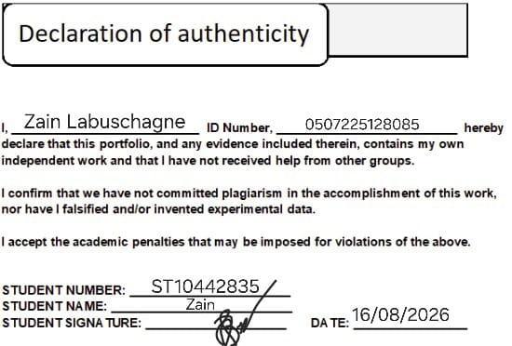
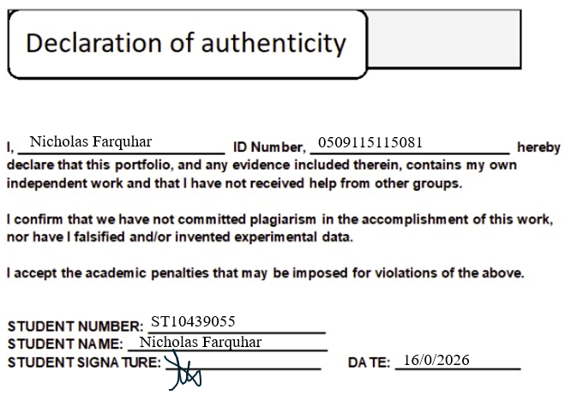
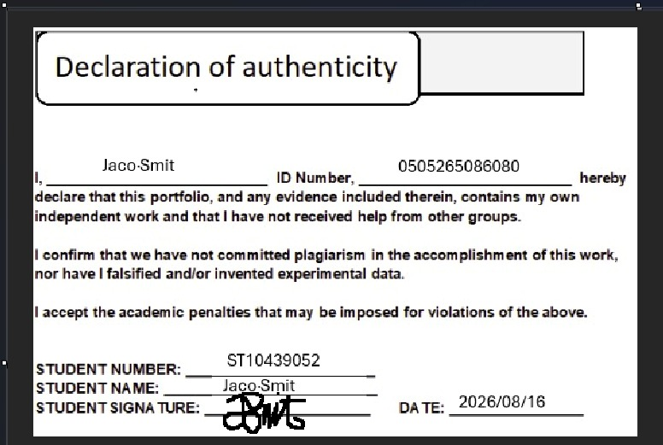
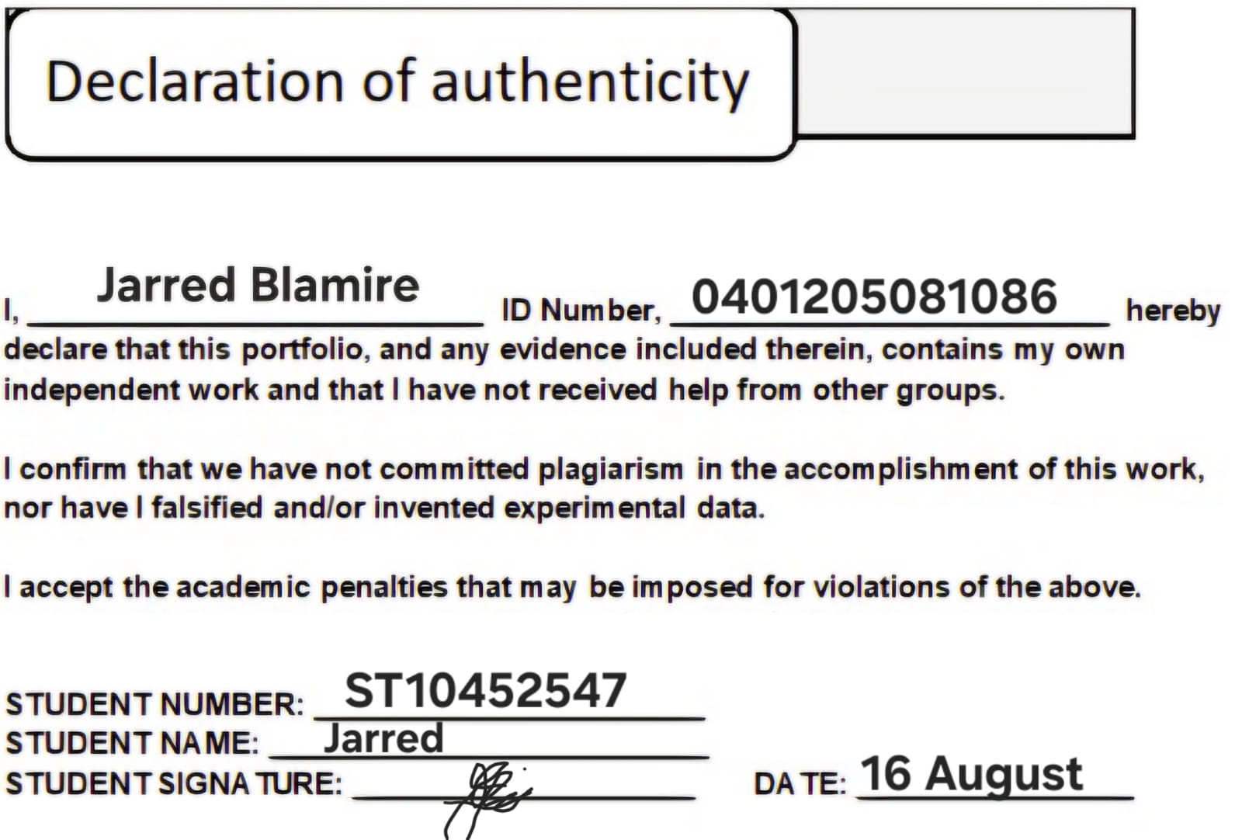

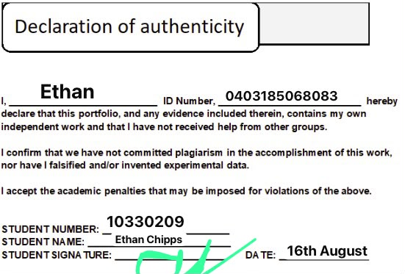
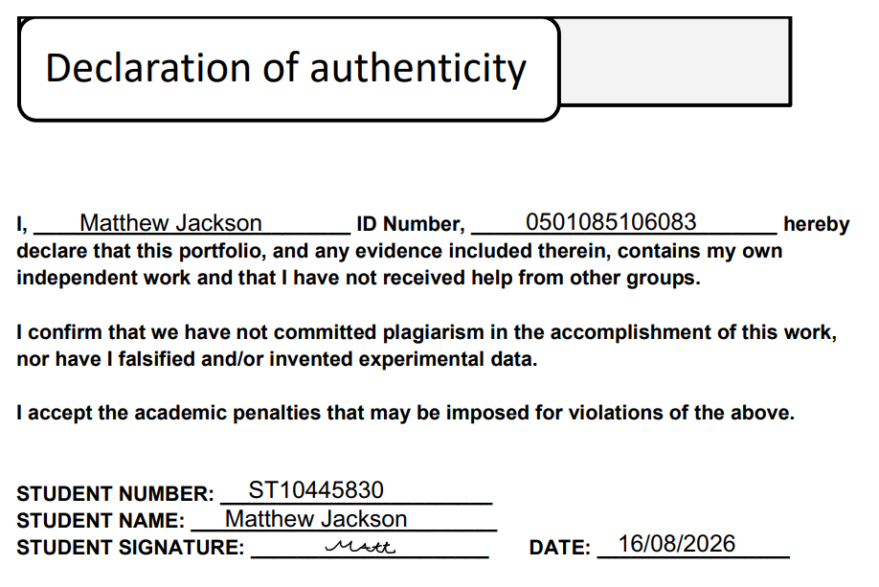

Referances:
- World Wide Web Consortium (W3C), Web Content Accessibility Guidelines (WCAG) 2.2: https://www.w3.org/TR/WCAG22/
- OWASP Foundation, Application Security Verification Standard (ASVS): https://owasp.org/www-project-application-security-verification-standard/
- Microsoft, .NET and ASP.NET Core support policy / lifecycle guidance: https://learn.microsoft.com/en-ie/lifecycle/products/microsoft-net-and-net-core
- Microsoft. (2025). Azure Pricing Calculator. Microsoft Azure [Online] Available at:https://azure.microsoft.com/en-us/pricing/calculator/ [Accessed 12 August 2026].
- draw.io. (2026). diagrams.net - Free Online Diagram Software. draw.io [Online] Available at: https://app.diagrams.net/ [Accessed 12 August 2026].
- Microsoft. (2025). Tutorial - Reduce Azure costs with recommendations - Microsoft Cost Management. Microsoft Learn [Online] Available at: https://learn.microsoft.com/en-us/azure/cost-management-billing/costs/tutorial-acm-opt-recommendations [Accessed 12 August 2026].
- GeeksforGeeks. (2026). Sequence Diagrams - Unified Modeling Language (UML). GeeksforGeeks [Online] Available at: https://www.geeksforgeeks.org/system-design/unified-modeling-language-uml-sequence-diagrams/ [Accessed 12 August 2026]
- Bell, D. (2023) Explore the UML sequence diagram. Available at: https://developer.ibm.com/articles/the-sequence-diagram/ (Accessed: 15 August 2026).
- GeeksforGeeks (2026) State machine diagrams | Unified Modeling Language (UML). Available at: https://www.geeksforgeeks.org/system-design/unified-modeling-language-uml-state-diagrams/ (Accessed: 15 August 2026).
- Octopus Deploy (2026) Software deployment in 2026: 7 strategies & 5 steps with checklist. Available at: https://octopus.com/devops/software-deployments/ (Accessed: 15 August 2026).
- LaunchDarkly (2024) 6 deployment strategies (and how to choose the best for you). Available at: https://launchdarkly.com/blog/deployment-strategies/ (Accessed: 15 August 2026).
- BMC Software (2024) DevOps branching strategies explained. Available at: https://www.bmc.com/blogs/devops-branching-strategies/ (Accessed: 15 August 2026).
- GeeksforGeeks (2026) GitHub Actions CI workflow setup. Available at: https://www.geeksforgeeks.org/devops/how-to-create-a-basic-ci-workflow-using-github-actions/ (Accessed: 15 August 2026).
- Atlassian (2026) How automated testing enables DevOps. Available at: https://www.atlassian.com/devops/devops-tools/test-automation (Accessed: 15 August 2026).
- Chauhan, J. (2024) Bootstrap 5 UI Kit. Available at: https://www.figma.com/community/file/876022745968684318/bootstrap-5-ui-kit (Accessed: 16 August 2026).
- Ahmed, M. (2024) Interactive Input Text Fields using The Keyboard. Available at: https://www.figma.com/community/file/1256283860066065766/interactive-input-text-fields-using-the-keyboard (Accessed: 16 August 2026).
- Seju (2024) DashStack - Free Admin Dashboard UI Kit. Available at: https://www.figma.com/community/file/1324762163080748317/dashstack-free-admin-dashboard-ui-kit-admin-dashboard-ui-kit-admin-dashboard (Accessed: 16 August 2026).

AI Usage Declaration
ChatGPT and Claude was used to help organise the document, improve the academic wording and format the Harvard-style references. The final work was reviewed and adjusted by the student to ensure that it matched the project requirements.

