GROUP 21

Nicholas Farquhar(Group1) ST10439055
Zain Labuschagne(Group2) ST10442835
Matthew Jackson(Group1) ST10445830
Jaco Smit(Group1) ST10439052
Ethan Chips(Group1) ST10330209
Jarred Blamire(Group1) ST10452547

  - INSY7315


Table of Contents
9.2 Prototype 3
Mobile Application Prototype 3
Web application prototype 5
Web Application Prototype Flow 10

9.2 Prototype

Mobile Application Prototype
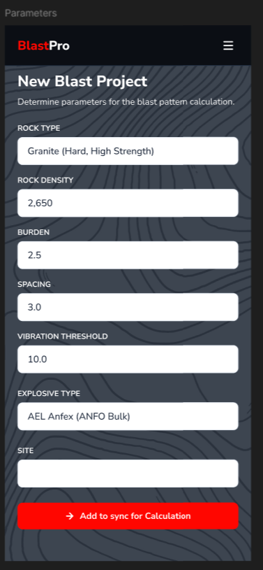
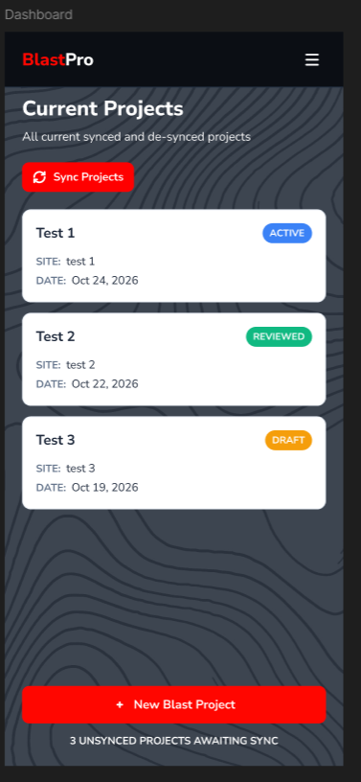
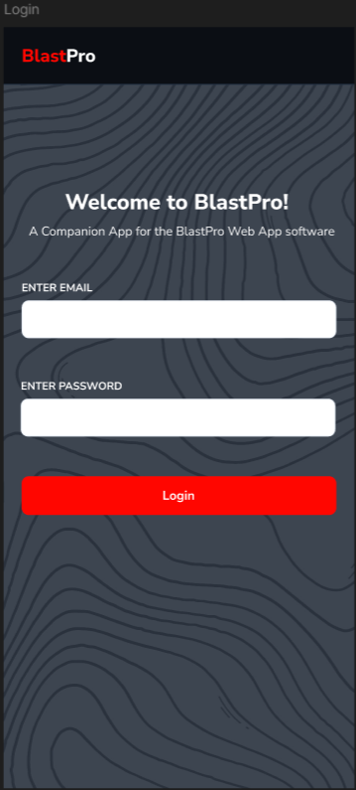
Parameters: Displays all the fields that a blaster can fill in with relation to the project, this includes:
Rock type, Density, Burden, Spacing, vibration threshold, explosive type and site
Contains a add to sync button

Dashboard: indicates all current projects that the user is busy with.
Contains a sync button as well as a new blast project button that will redirect to the parameters page

Login Screen: Displays a welcome message to the user
fields for email and password are present
Contains a Login Button

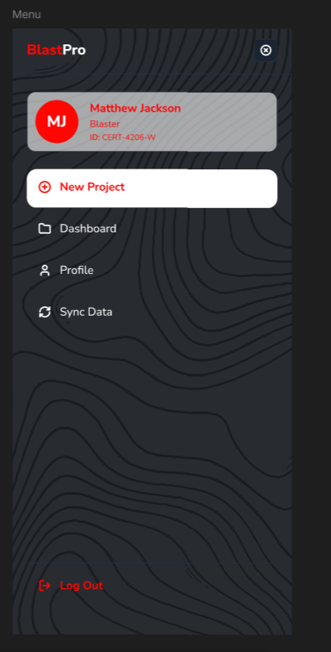
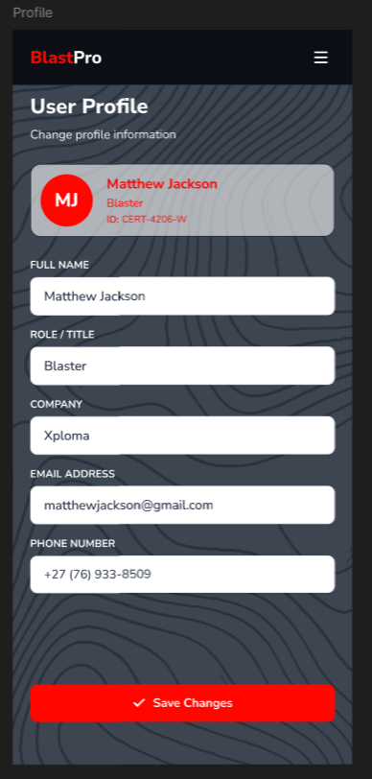

Profile: Shows the Blaster information, user can input, name, role, company, email and phone number.
Contains a save changes button.

Menu: A hamburger style menu that contains navigation for the application, a user can easily swap between these screens via this method.
Contains a log out button.

Web application prototype
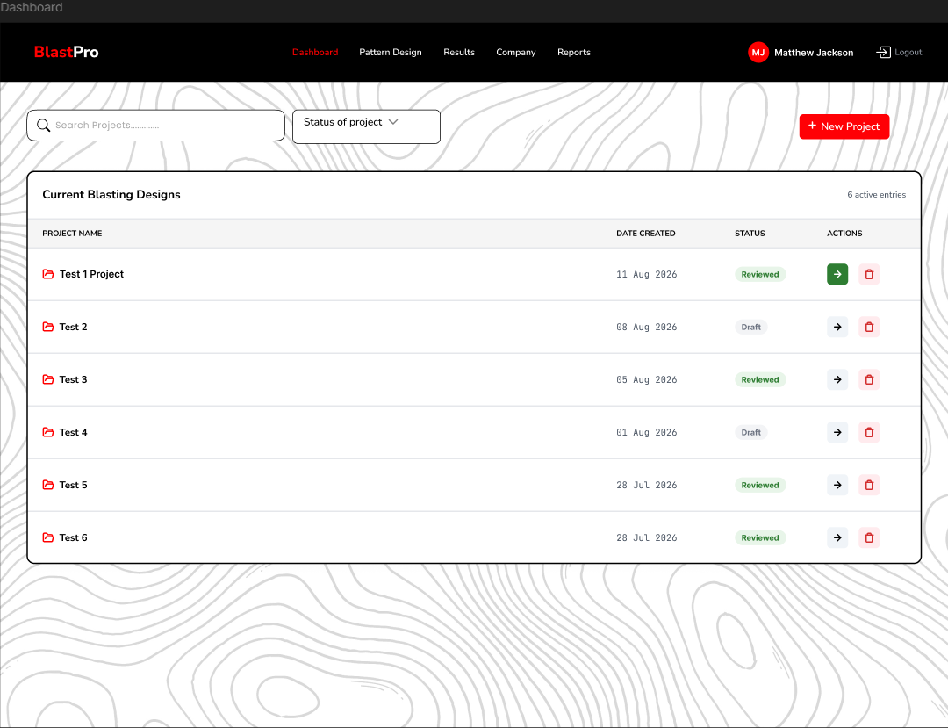
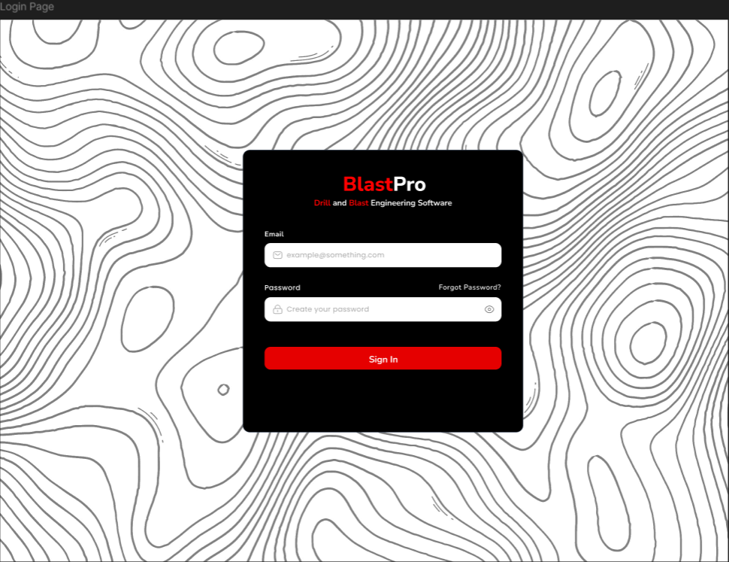
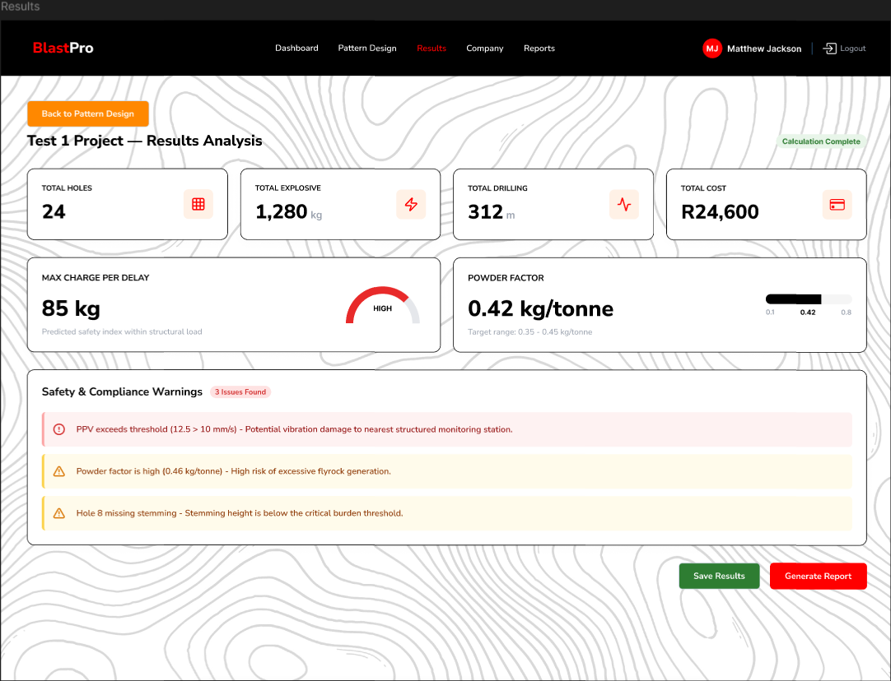
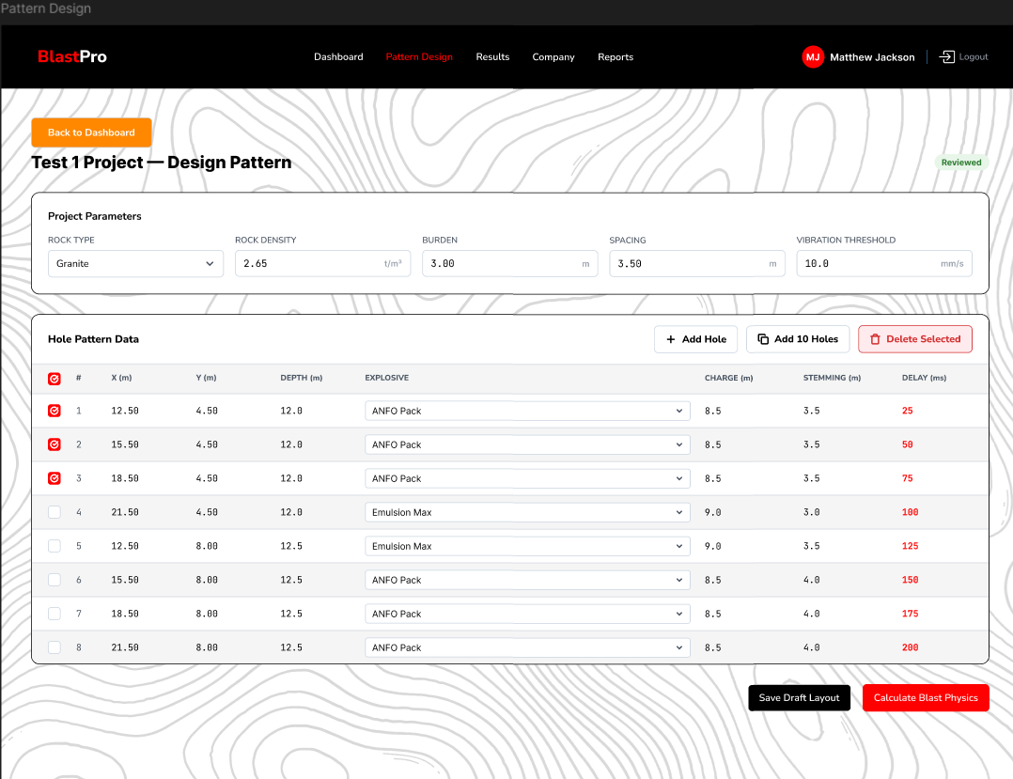
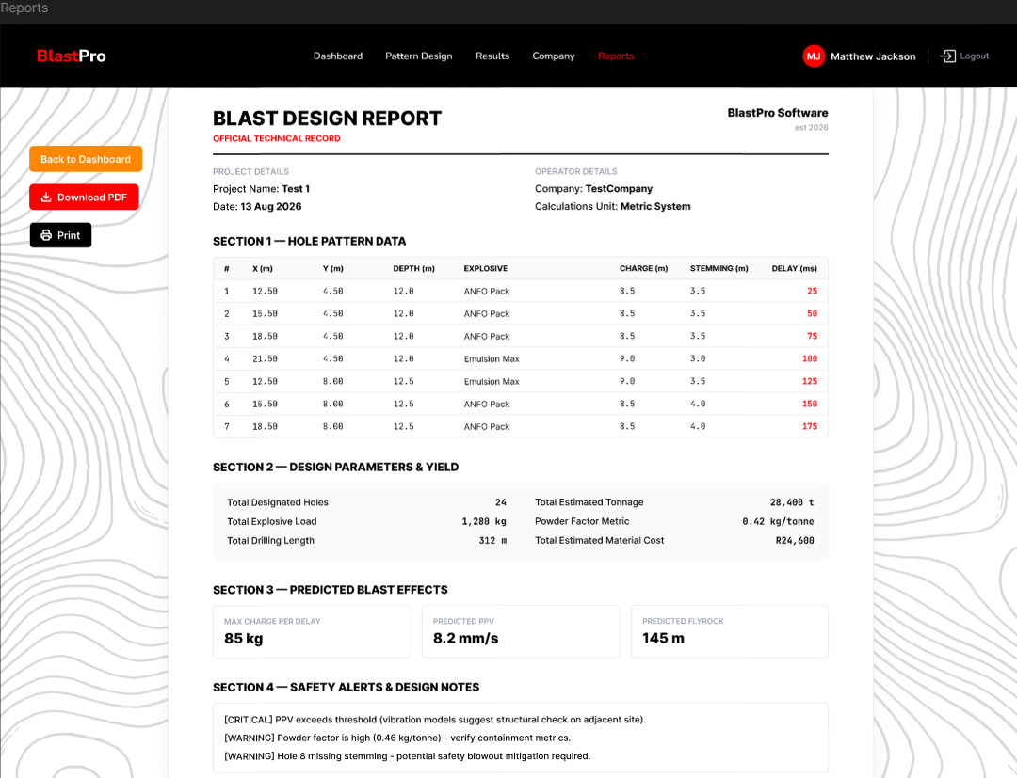
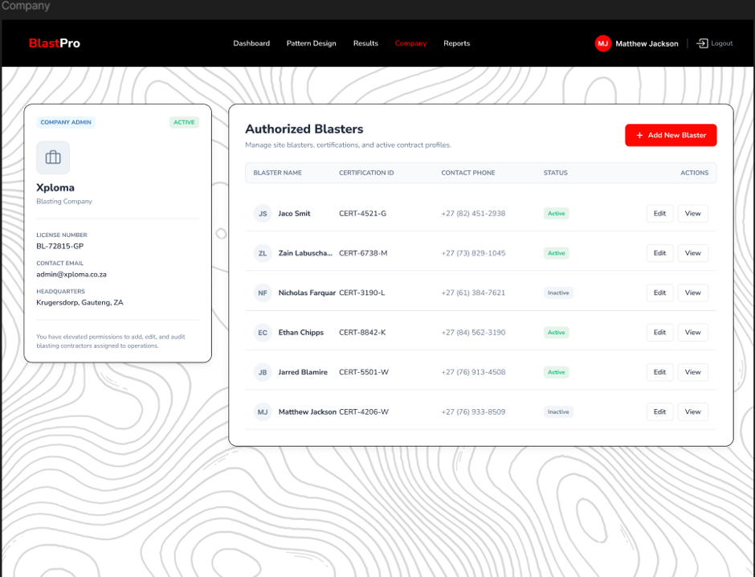
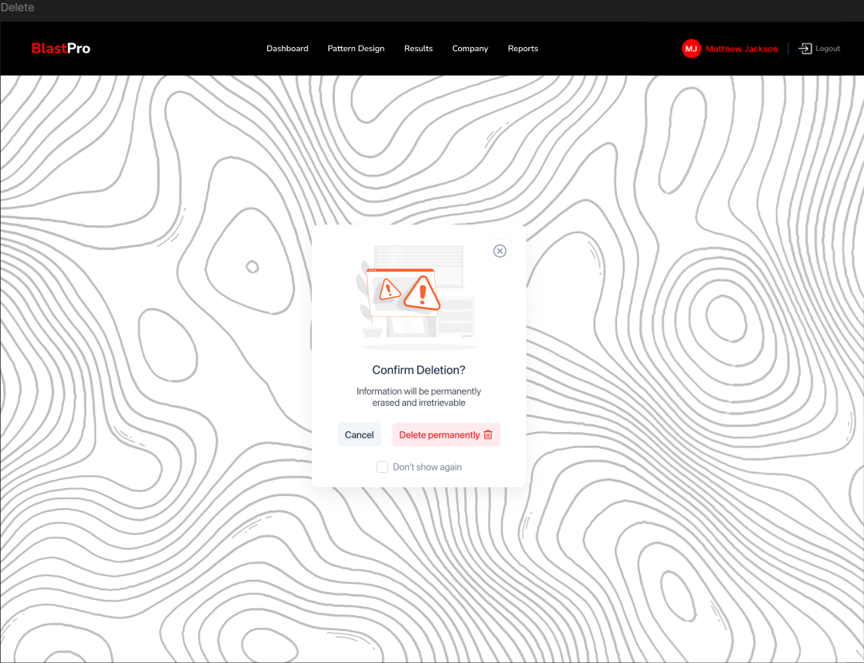
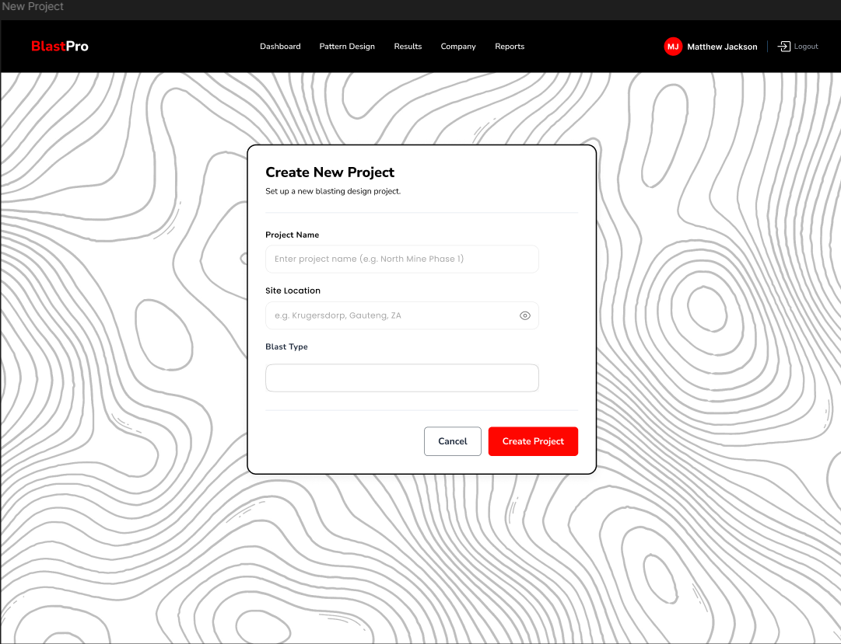
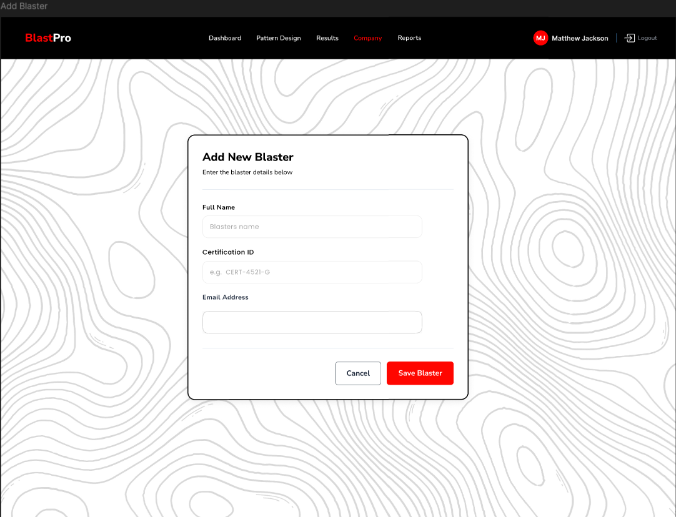
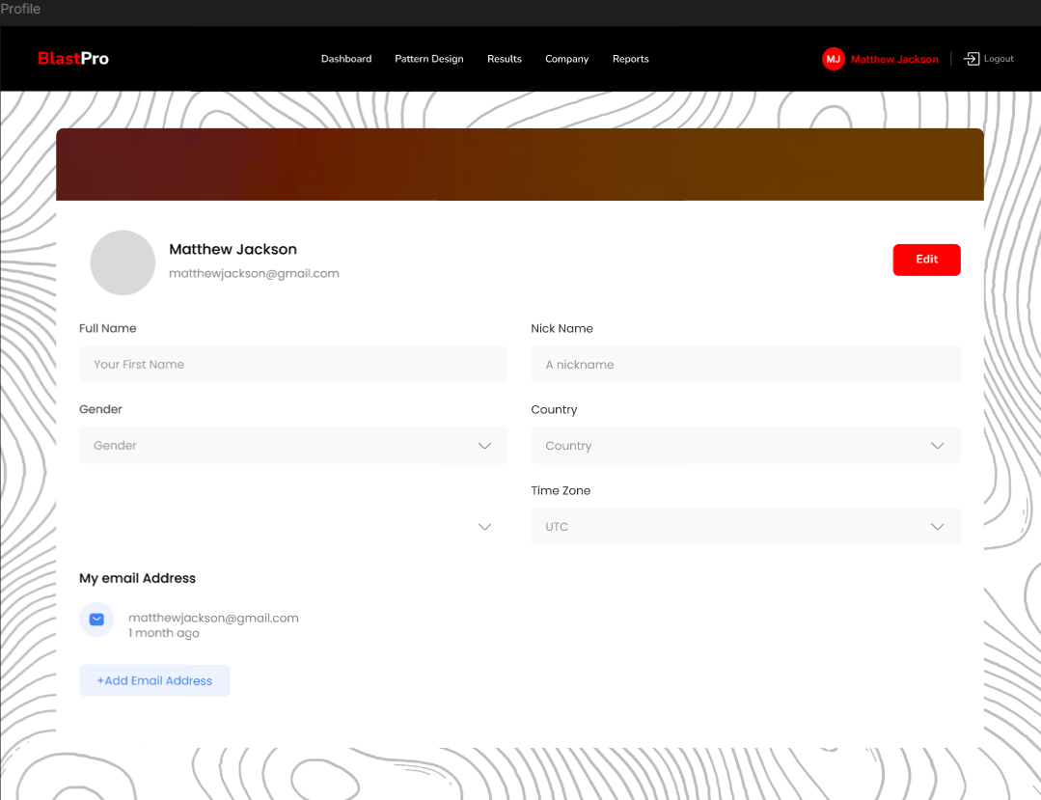

Web Application Prototype Flow
The user journey starts at the Login Page, where email and password are entered to gain access to the central Dashboard. This main dashboard shows a project breakdown, displaying a list of Current Blasting Designs and projects with their status (e.g., "Draft", "Reviewed"), users can interact with the projects and chose to delete them or edit them, or create a new project.
From the Dashboard, users can enter the main pages of the application: Pattern Design. Here, they can view and modify project-specific parameters (like rock type and burden) and input detailed hole pattern data, including coordinates, depth, and explosive type. Users can then use the data that is input to either Save as a draft layout to come back to later, alternatively they can opt to Calculate Blast Physics.
Calculating the blast physics leads to the results page, which summarizes key metrics like total explosive load, cost, and powder factor. It also displays critical safety warnings, such as Peak Particle Velocity (PPV) exceeding thresholds. From here, users have the option to either Save Results and be taken back to the dashboard or have the details generated in a Report.
The Report page displays a technical report containing all project data, parameters, and safety alerts. The Company page provides an administrative interface for managing blasters, while the Profile and Add Blaster screens handle user and personnel details.

Please use the provided links to access the full demo model of each prototype
Web Application: https://www.figma.com/proto/JqFQ3B9VJtPmsiRpbrmhoz/WIL-Project?node-id=163-2925&t=U2POWXesDyQrvrVZ-1
Mobile Application: https://www.figma.com/proto/JqFQ3B9VJtPmsiRpbrmhoz/WIL-Project?node-id=188-235&t=U2POWXesDyQrvrVZ-1

