**TABLE OF CONTENTS**

1. **OBJECTIVE**
2. **INTRODUCTION**
   * **KEY FEATURES**
   * **KEY POINTS**
3. **PROBLEM STATEMENT**
4. **SOFTWARE REQUIREMENT SPECIFICATION(SRS)**
   1. **PURPOSE**
   2. **PROJECT SCOPE**
   3. **PRODUCT FEATURES**
   4. **HARDWARE INTERFACE**
   5. **SOFTWARE INTERFACE**
5. **ENTITY RELATIONSHIP DIAGRAM**
6. **SYSTEM FEATURES**

**6.1 MODULES**

**6.2DATA DICTIONARY**

1. **USER INTERFACE**
   1. **SPLASH SCREEN**
   2. **LOGIN SCREEN**
   3. **MAIN PAGE**
   4. **PATIENT INFORMATION PAGE**
   5. **DOCTOR INFORMATION PAGE**
   6. **REPORTS PAGE**
2. **CONCLUSION**

**8.1 FUTURE ENHANCEMENTS**

**8.2 LIMITATIONS**

1. **BIBLIOGRAPHY**
2. **OBJECTIVE**

The main objective of this project, HOSPITAL MANAGEMENT SYSTEM, is to aid in all the problematic tasks that take place in a hospital. As we know, numerous tasks take place ina hospital, like creating patient records wherein, room allotment, doctor allotment,etc. and creating doctor’s records like what are the contact detail of the doctors, phone numbers, new doctor recruitment takes place ina hospital handling all these tasks physically is very difficult by means of an entry register or any type of entry notebook.In order to remove all these difficulties, this project is created so that the hospital record management becomes relaxed.

1. INTRODUCTION

**HOSPITAL MANAGEMENT SYSTEM:**

Hospital Management System (HMS) is a Java application made using NetBeans as framework and MySQL.

This project, Hospital Management System includes registration of patients by storing their details into the system. This software allows the user to give a unique id for every patient & doctors and store the details of every patient and the doctors automatically. User can find if thedoctor is available and the details of a patient using their patient ID.

The Hospital Management System can be logged in using a Username and Password. It is accessible either by an admin or a receptionist. Only they can add data into the database. The data can be retrieved easily. The interface is very user-friendly. The data is well protected for personal use and makes the data processing very fast.

**KEY FEATURES:**

* Login Page to enter the HMS software
* Dedicated database to show the entered details of Patients & Doctors
* User can easily search and alter the present data in the database
* User can assign unique ID to Patients and Doctors

**KEY POINTS:**

* It is developed completely using JAVA language. MySQL server is used to store the data and perform necessary search operation.
* It is fast, efficient and reliable
* Avoids data redundancy and inconsistency
* User-friendly
* Easy accessibility of data
* Number of personnel required is considerably less
* Provides more security and integrity to data

1. **PROBLEM STATEMENT**

**Lack of emergency retrievals: -**

Sometimes information is a very difficult to retrieve and to find particular information.For example, to findout about any patient’shistory, sometimes the user goes through various registers. This results in inconvenience and wastage of time.

**Lack of immediate storage information: -**

The information generated by various transactions takes efforts and time to be stored at right place.

**Lack of prompt updating: -**

Different changes to an information is difficult to make as paper work is involved.

**Preparation of accurate and prompt reports: -**

This becomes a complex task as information is difficult to collect from various registers.

1. **SOFTWARE REQUIREMENT SPECIFICATION (SRS)**

Software Requirements Specification (SRS), a requirements specification for a software system, is a complete description of the behavior of a system to be developed and may include a set of use cases that describe interactions the users will have with the software. In addition, it also contains non-functional requirements. Non-functional requirements impose constraints on the design or implementation (such as performance engineering requirements, quality standards, or design constraints).

**INTRODUCTION:**

The following subsections of Software Requirement Specifications Document should help in providing the entire overview of the “Hospital Management System” under development. This document targets at defining the overall software requirements for an admin. Requirement have been met by putting the required efforts precisely.

**4.1 PURPOSE:**

The purpose of the project “HOSPITAL MANAGEMENT SYSTEM” is to computerize the Front Office Management of a Hospital to develop software which is user friendly, simple, fast& cost – effective. It deals with the collection of information of patient, details of the diagnosis, etc.

**4.2 PROJECT SCOPE:**

The Hospital Management System will be used in any Hospital, Clinic, Dispensary or Pathology labs in any Hospital, Clinic& Dispensaries to get the information from the patients and then storing that data for future usage. Paper based system is being used in clinics. It is slow and is not able to provide updated lists of patients within a reasonable timeframe. The intention of the system is to reduce over-time pay and increase the number of patients that can be treated accurately. Requirements statements in this document are both functional and non-functional.

**4.3 PRODUCT FEATURES:**

This application has two ends, namely Administrator’s end and User’s end. Admin can manage the entire system. He/she can see all the source code and stored information and hence edit all the code.

**4.4 HARDWARE INTERFACE:**

Hardware Requirements:

|  |  |  |
| --- | --- | --- |
| **Requirement** | **Minimum** | **Best** |
| **Processor** | Intel Pentium 4.2.24 | Any higher processor than Intel Pentium 4.2.24 |
| **Motherboard** | 845GL/GV | 845GL/GV |
| **RAM** | 128 MB | 128 MB – 4GB |
| **HDD** | 20MB | 50 MB+ |
| **Display** | Color Monitor(VGA) | Color AGP(4MB/8MB) |

**4.5 SOFTWARE INTERFACE:**

Software Requirements:

* **Operating System:**Win 8/ Win 10/ Linux
* **Front End:**Java
* **Back End:** MySQL

JAVA

**[](https://en.wikipedia.org/wiki/File:Java_programming_language_logo.svg)**

**Java** is a general-purpose [computer-programming language](https://en.wikipedia.org/wiki/Programming_language) that is [concurrent](https://en.wikipedia.org/wiki/Concurrent_computing), [class-based](https://en.wikipedia.org/wiki/Class-based_programming), [object-oriented](https://en.wikipedia.org/wiki/Object-oriented_programming), and specifically designed to have as few implementation dependencies as possible. It is intended to let application developers "[write once, run anywhere](https://en.wikipedia.org/wiki/Write_once,_run_anywhere)" (WORA), meaning that [compiled](https://en.wikipedia.org/wiki/Compiler) Java code can run on all platforms that support Java without the need for recompilation. Java applications are typically compiled to [bytecode](https://en.wikipedia.org/wiki/Java_bytecode) that can run on any [Java virtual machine](https://en.wikipedia.org/wiki/Java_virtual_machine) (JVM) regardless of [computer architecture](https://en.wikipedia.org/wiki/Computer_architecture). As of 2016, Java is one of the most [popular programming languages in use](https://en.wikipedia.org/wiki/Measuring_programming_language_popularity), particularly for client-server web applications, with a reported 9 million developers. Java was originally developed by [James Gosling](https://en.wikipedia.org/wiki/James_Gosling) at [Sun Microsystems](https://en.wikipedia.org/wiki/Sun_Microsystems)(which has since been [acquired by Oracle Corporation](https://en.wikipedia.org/wiki/Sun_acquisition_by_Oracle)) and released in 1995 as a core component of Sun Microsystems' [Java platform](https://en.wikipedia.org/wiki/Java_(software_platform)). The language derives much of its [syntax](https://en.wikipedia.org/wiki/Syntax_(programming_languages)) from [C](https://en.wikipedia.org/wiki/C_(programming_language)) and [C++](https://en.wikipedia.org/wiki/C%2B%2B), but it has fewer [low-level](https://en.wikipedia.org/wiki/Low-level_programming_language) facilities than either of them.

**MySQL**



**MySQL** is developed, distributed, and supported by Oracle Corporation. MySQL is a database system used on the web it runs on a server. MySQL is ideal for both small and large applications. It is very fast, reliable, and easy to use. It supports standard SQL. MySQL can be compiled on a number of platforms. The data in MySQL is stored in tables. A table is a collection of related data, and it consists of columns and rows. Databases are useful when storing information categorically.

**WHY TO USE MySQL**:

•Leading open source RDBMS

•Ease of use– No frills

•Fast

•Robust

•Security

•Multiple OS support

•Free

•Technical support

•Support large database – up to 50 million rows, file size limit up to 8 Million TB

1. ENTITY RELATIONSHIP DIAGRAM

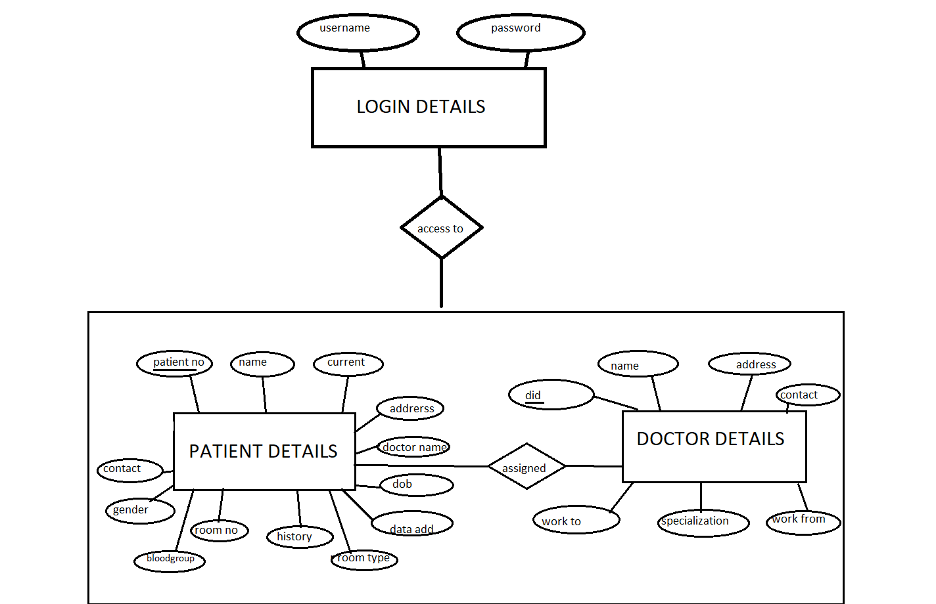

1. **SYSTEM FEATURES**
   1. **Modules:**

* **Login Module**

Description:

In this module, only username and password of the user is recorded.

* **Patient Module**

Description:

It keeps track of all details about patients. Patient ID, Patient name, address, admitted date, room no., etcis entered in a form and stored for future references. Moreover, particular patient details can be viewed in the table using a separate form with an attribute Patient ID.

* **Doctor Module**

Description:

It keeps track of all the details about the Doctors. Doctor ID, Doctor Name, working hours, etc. are entered in a form and stored for future reference.

**6.2Data Dictionary:**

**Login Details:**

|  |  |  |  |
| --- | --- | --- | --- |
| Name: login |  |  |  |
| **NAME** | **TYPE** | **SIZE** | **DESCRIPTION** |
| username | varchar | 20 | Username of the user for login |
| password | varchar | 15 | Password of the user for login |

**Patient Details:**

|  |  |  |  |
| --- | --- | --- | --- |
| Name: pat |  |  |  |
| **NAME** | **TYPE** | **SIZE** | **DESCRIPTION** |
| patientno | int | 6 | Unique Patient ID |
| name | varchar | 55 | Patient Name |
| address | varchar | 100 | Address |
| contact | varchar | 20 | Contact No. |
| bloodgroup | varchar | 50 | Blood Group |
| history | varchar | 100 | Any past history of medication |
| dob | varchar | 20 | Date of birth |
| current | varchar | 50 | Current problem of the patient |
| roomno | varchar | 20 | Hospital Room No. |
| dateadd | varchar | 50 | Date of admission |
| rtype | varchar | 50 | Type of room |
| gender | varchar | 10 | Gender |
| docname | varchar | 50 | Name of the attending doctor |

**Doctor Details:**

|  |  |  |  |
| --- | --- | --- | --- |
| Name: doc |  |  |  |
| **NAME** | **TYPE** | **SIZE** | **DESCRIPTION** |
| did | int | 6 | Unique Doctor ID |
| name | varchar | 50 | Doctor Name |
| address | varchar | 100 | Address |
| contact | varchar | 50 | Contact No. |
| specialization | varchar | 85 | Doctor’s field of specialization |
| workfrom | varchar | 100 | Start of the working hour |
| workto | varchar | 100 | End of the working hour |

1. **Used Case Diagram**

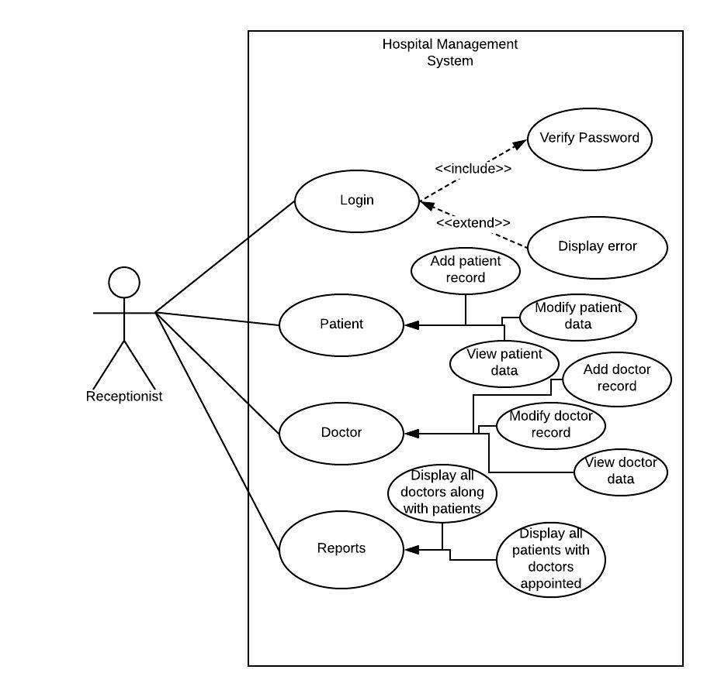

1. **USER INTERFACE**

**8.1 Splash Screen:**



**8.2 Login Page:**

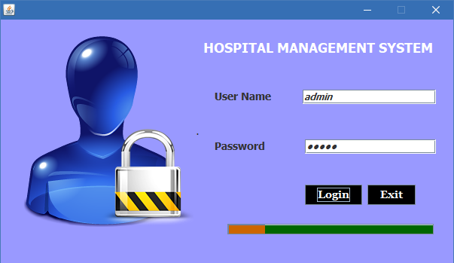

Img 1 – Login Page

**8.3 Main Page:**

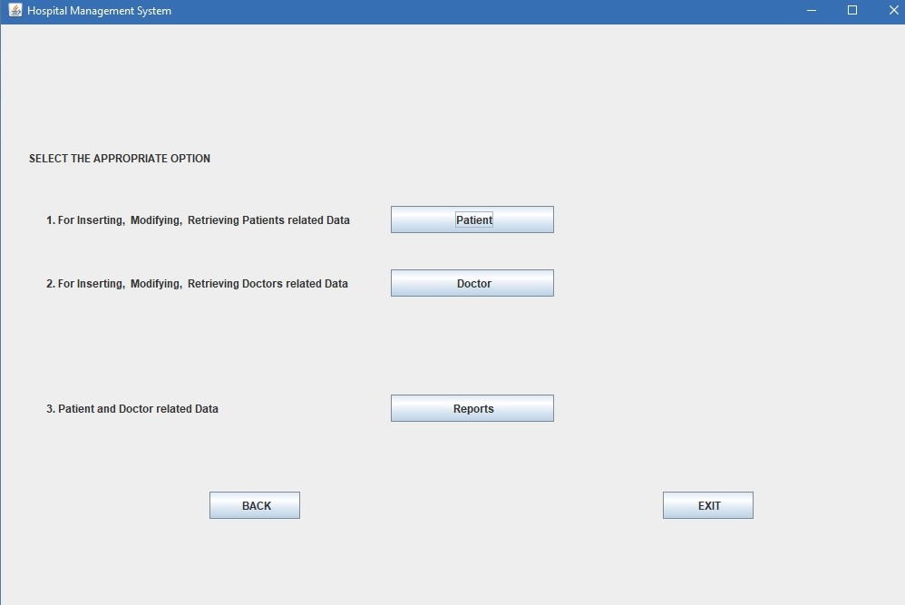

Img 2 – Main page consists of the three modules

**8.4 Patient Information page:**

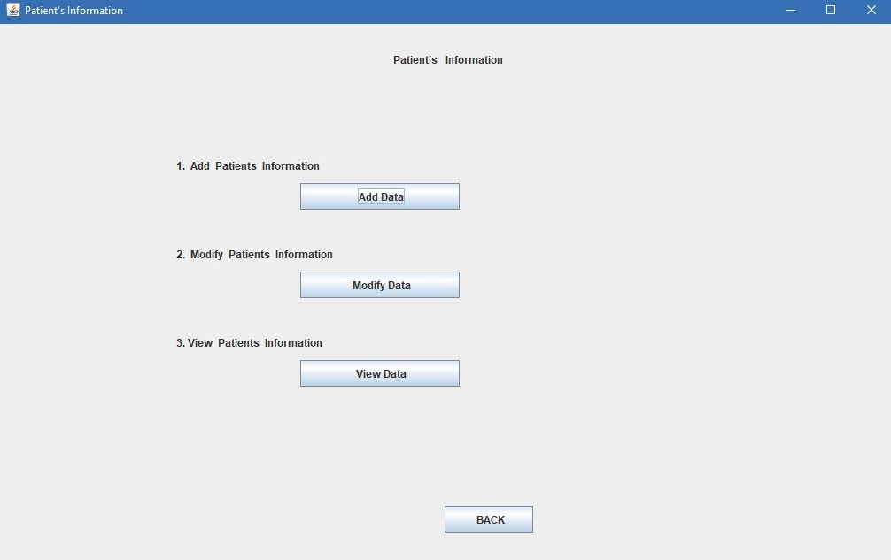

**8.4.1 Add Patient Info page:**

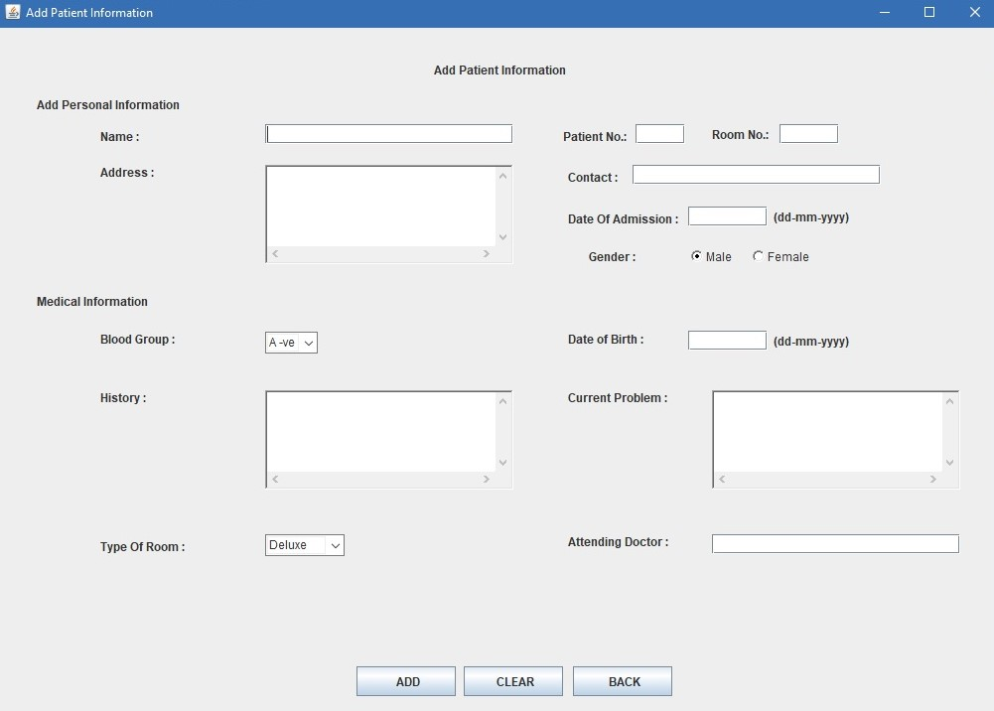

**8.4.2 Modify Patient Info page:**

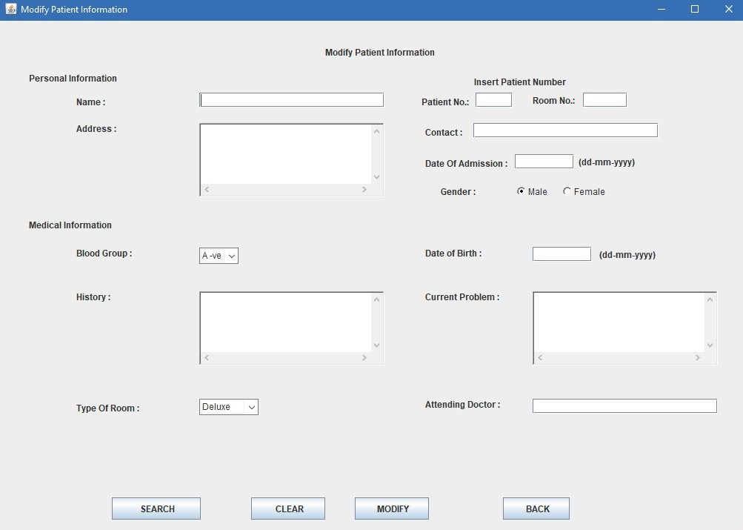

**8.4.3 View Patient Information page:**

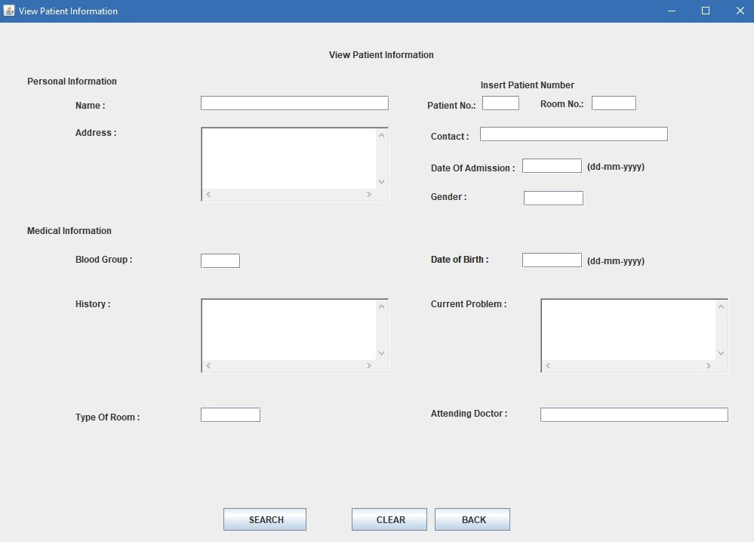

**8.5 Doctor Information page:**

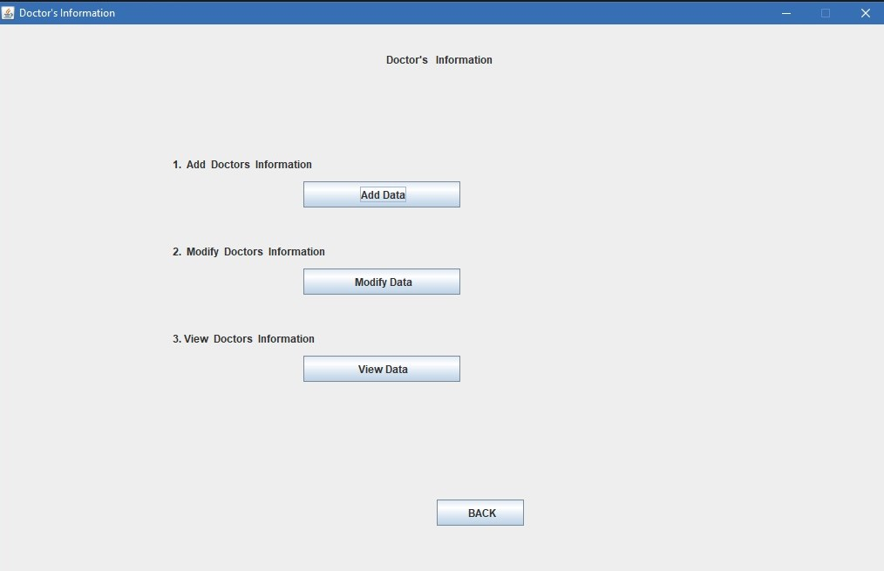

**8.5.1 Add Doctor Info page:**

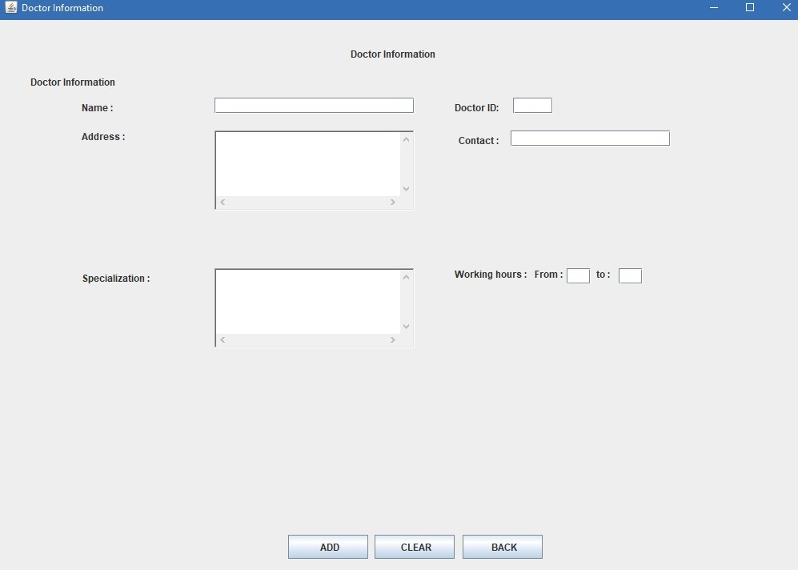

**8.5.2 Modify Doctor Info page:**

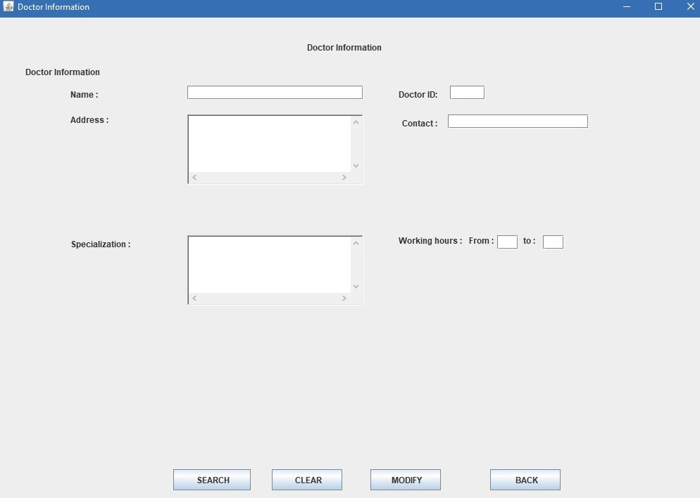

**8.5.3 View Doctor Info page:**

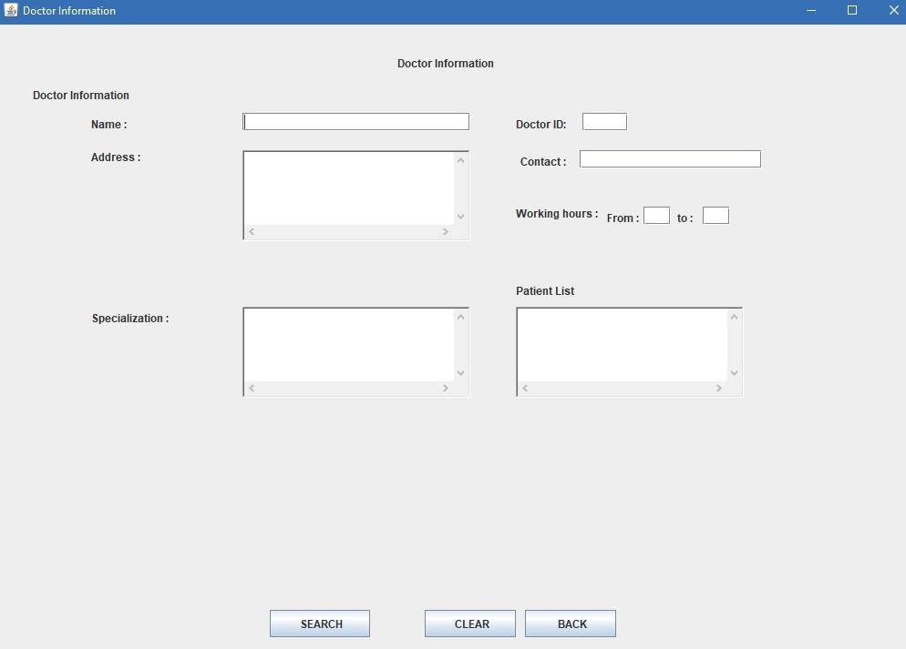

**8.6 Reports page:**

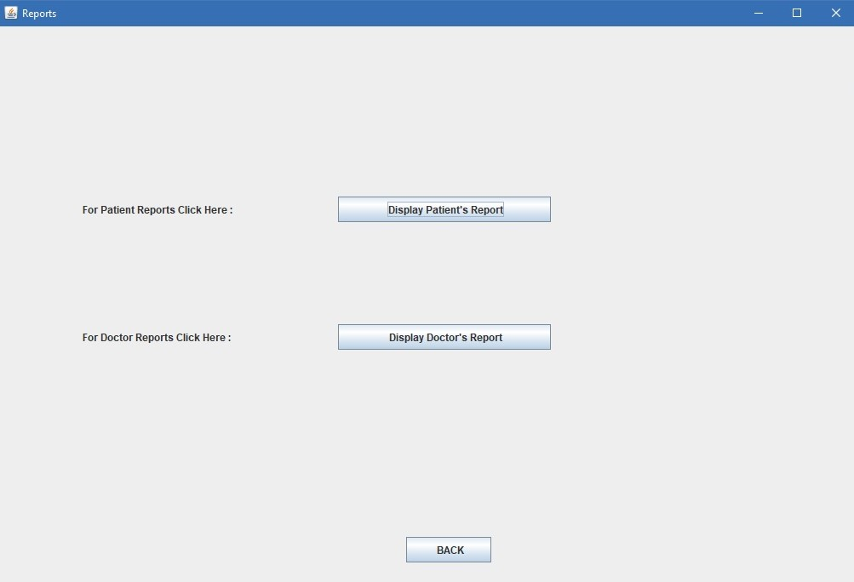

**8.6.1 Patient Reports page:**

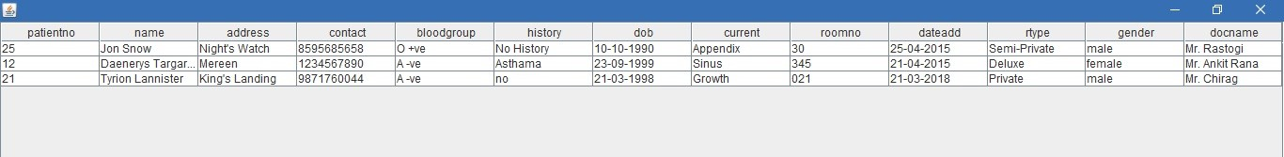

**8.6.2 Doctor Reports page:**

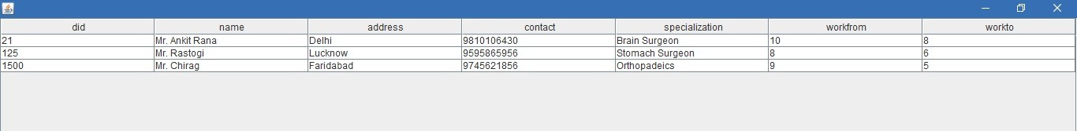

1. **CONCLUSION**

The project Hospital Management System (HMS) is for computerizing and simplifies the working in a hospital. It is a great improvement over the current manual system. The computerization of the system has increased the speed of the process. In the current system of management, the front office managing is very poor. The Hospital Management System was repetitively checked and tested with mock data and thus, is found to be very reliable. The software maintains all the requirements of an average hospital and is capable to provide an easy and effective storage of the information related to patients that come up to the hospital.

* 1. **FUTURE ENHANCEMENTS:**

The proposed system is Hospital Management System. We can enhance this system by including more facilities like pharmacy system for the stock details of medicines in the pharmacy. Providing such features enable the users to include more comments into the system. Also, in this particular project, billing system can be added which can create the amount of the bill depending upon the number of days the patient was admitted and the treatment cost.

* 1. **LIMITATIONS:**

The size of the database increases day-by-day, increasing the load on the database back up and data maintenance activity.

Training for simple computer operations is necessary for the users working on the system.

1. **BIBLIOGRAPHY**

* Herbert Schildt, **Java: A Beginner's Guide**, Seventh Edition
* Seyed M. M. Tahaghoghi, **Learning MySQL**, O’Reilly Publications

**WEB REFERENCES:**

www.google.co.in

www.slideshare.com

www.academia.edu

www.w3schools.com