GAMING DATA ANALYSIS
End-to-End Data Analytics Project Report
Python EDA → PostgreSQL SQL Analysis → Power BI Dashboard
Prepared for project documentation and portfolio use
Contents
1. Project Overview 2
2. Project Objectives 2
3. Tools and Technologies 2
4. Python EDA and Data Preparation 3
4.1 Important Data-Quality Decision 5
5. Multi-Valued Attribute Transformation 5
6. PostgreSQL Database Setup 6
7. SQL Analysis 7
7.1 Main Business Questions Documented in the SQL File 7
7.2 SQL Techniques Used 11
7.3 Examples of Analytical Logic 12
8. Power BI Dashboard 12
8.1 Dashboard Components 13
8.2 Dashboard Analysis 13
9. Key Findings Visible in the Final Dashboard 17
10. Validation, Iteration, and Problems Encountered 17
11. Limitations and Caveats 17
12. Final Project Outcome 18
13. Portfolio / Resume Summary 18

Data Quality Note
This dataset may contain missing ratings, incomplete records, unspecified categories, and multi-valued attributes. Later release years may also have incomplete coverage. Therefore, some metrics and trends may differ from real-world gaming market figures and should be interpreted as dataset-level insights rather than exact market statistics.

1. Project Overview
The Gaming Data Analysis project is an end-to-end analytics workflow built to understand the global gaming market from three perspectives: data quality and structure, business-oriented SQL analysis, and interactive Power BI reporting. The work began with exploratory data analysis and preparation in Python, moved into PostgreSQL for relational analysis and business questions, and finished with a single-page Power BI dashboard designed for quick market-level exploration.
The final dashboard focuses on the overall gaming market and allows users to filter the analysis by date, platform, genre, store, and game mode. The dashboard combines KPI cards, trend analysis, genre and platform distributions, publisher rankings, ESRB ratings, and a table of highly popular games.

2. Project Objectives
- Explore the structure, quality, completeness, and statistical characteristics of the gaming dataset.
- Clean and standardize fields required for reliable analysis.
- Separate multi-valued attributes such as genres, platforms, stores, and tags into analytical
dimension tables.
- Load the prepared data into PostgreSQL and use SQL to answer practical gaming-market questions.
- Build a Power BI dashboard that summarizes market scale, popularity, release trends, publishers, platforms, ratings, and top games.
- Create a portfolio-ready analytical workflow that connects Python, SQL, and Power BI rather than treating each tool as a separate exercise.

3. Tools and Technologies
Tool | Role | Main Work
Jupyter Notebook | Workflow documentation | Documented Python-based preparation and database loading
Python / Pandas | Data preparation & EDA | Loading, profiling, cleaning, type conversion, missing-value handling, feature/table preparation
NumPy | Data processing | Numeric support during analysis
Matplotlib / Seaborn | EDA visualization | Exploratory visualization setup in the notebook
PostgreSQL / pgAdmin | SQL analysis | Relational storage, joins, aggregations, CTEs, percentile logic, CASE expressions, window functions
Power BI | Business dashboard | KPIs, slicers, trend charts, distributions, publisher and game rankings

4. Python EDA and Data Preparation
The notebook documents the following preparation workflow:
- Imported NumPy, Pandas, Matplotlib, and Seaborn.
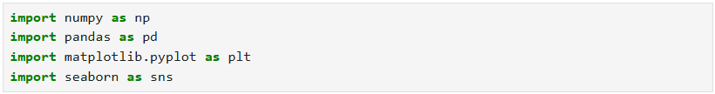

- Loaded the raw gaming dataset into a Pandas Data Frame.

- Inspected the dataset using shape, head, tail, info, descriptive statistics, and column listing.

- Performed basic data exploration on the data (head( ), tail( ), info( )).
- Converted release_date from text to datetime using day-month-year parsing with invalid values coerced to missing.
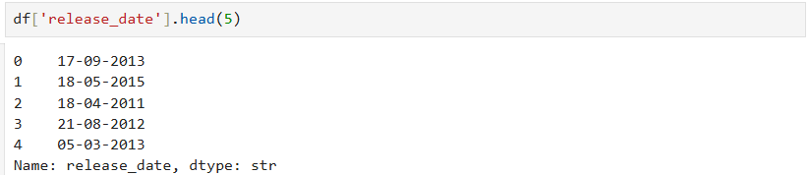
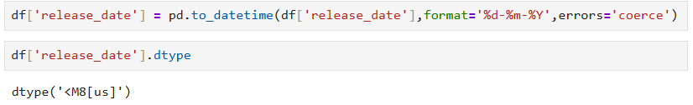
- Converted release_year to numeric and later standardized it to integer.
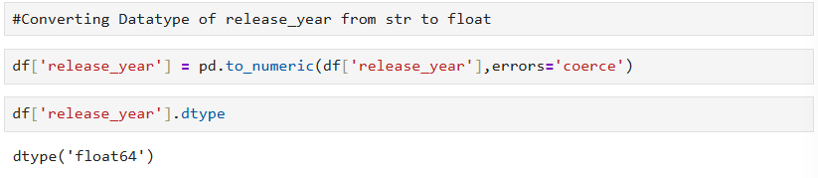
- Checked duplicate records and null values.

- Identified columns with very small numbers of missing values and removed rows containing those small missing-value cases.
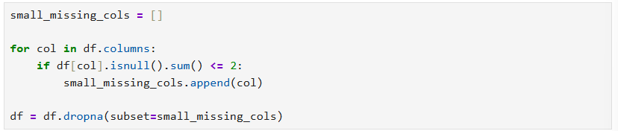

- Calculated the percentage of missing user_rating and metacritic values before imputation.
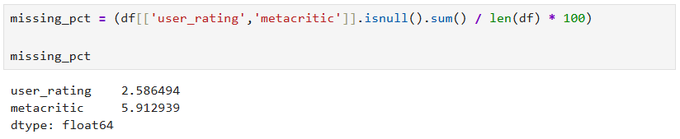

- Imputed missing user_rating and metacritic values using the median for EDA purposes; the notebook explicitly notes the choice was made because of slight skewness.
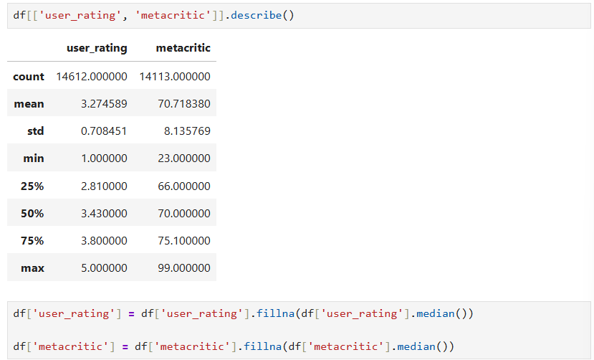

- Removed non-analytical columns including serial_no, cover_image_url, official_website, url_slug, and description_clean.
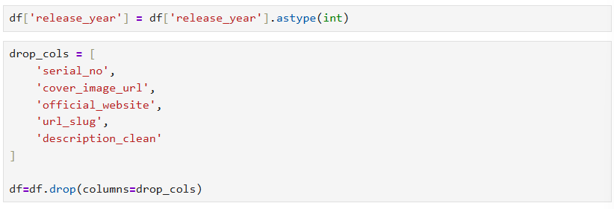

- Saved the prepared dataset as games_eda_ready.csv.

4.1 Important Data-Quality Decision
The missing user_rating and metacritic values were not ignored. Their missingness was measured first, then median imputation was applied for EDA. This is a practical analytical choice, but it also creates an important reporting limitation: imputed values should not be presented as original observations. The project should therefore state that these two fields were imputed for analysis.

5. Multi-Valued Attribute Transformation
Several columns contained multiple values in a single cell separated by '|'. Keeping those values in one field would make relational analysis and filtering less reliable. The notebook therefore created separate tables by splitting, exploding, trimming, and de-duplicating the multi-valued attributes.
- genre_table: game_id + one genre per row.
- platform_table: game_id + one platform per row.
- tag_table: game_id + one tag per row.
- store_table: game_id + one store per row.
The resulting dimension tables were exported to CSV and uploaded into PostgreSQL alongside the main game_data table. This structure supports one-to-many relationships and makes genre, platform, store, and tag analysis possible without forcing multiple values into a single analytical field.
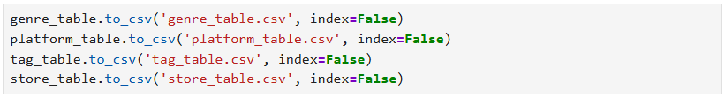

6. PostgreSQL Database Setup
- Created a PostgreSQL database connection using SQLAlchemy.
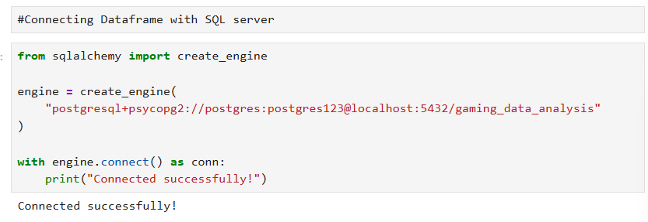

- Uploaded the prepared DataFrame into the game_data table.
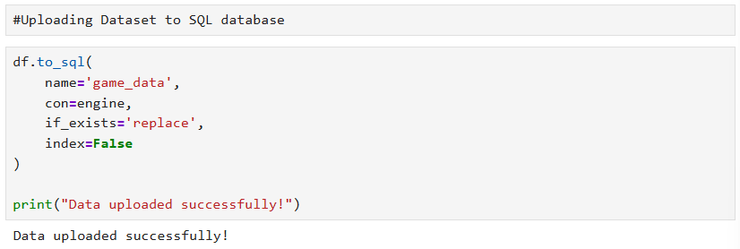

- Verified the database connection by reading records back from PostgreSQL.
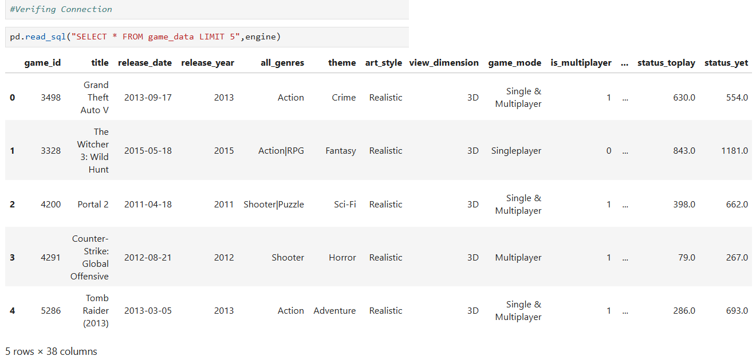

- Uploaded genre_table, platform_table, store_table, and tag_table into PostgreSQL.
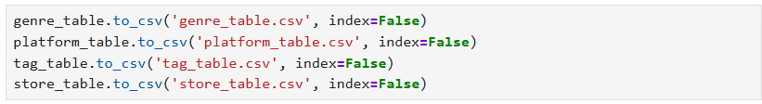

- Standardized game_id to integer in the main and dimension tables where required by the SQL workflow.

7. SQL Analysis
The SQL file contains a broad question bank covering commercial success, genres, player commitment, hidden gems, retention, publisher performance, critic/player disagreement, multiplayer impact, platform strategy, platform quality, genre growth, tags, stores, rating categories, year-over-year genre output, genre rankings, engagement drivers, and publisher consistency.

7.1 Main Business Questions Documented in the SQL File
- What Makes a Game Commercially Successful?
(Compare top-10% popular games vs the rest across multiple KPIs to identify success drivers.)
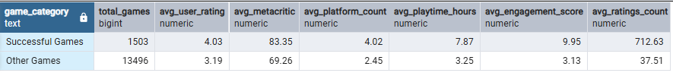

- Which 5 Niche Genres Punch Above Their Weight?
(Find genres with few games but above-average popularity and user rating)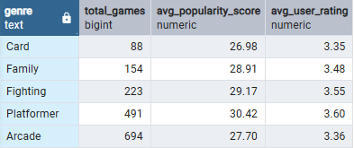

- Which Genres Generate the Highest Player Commitment?
Rank genres by avg playtime and engagement (min 20 games to remove noise) — guides long-term content investment.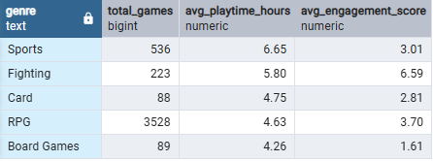

- Which Games Are Hidden Gems?
(High user rating + high playtime but low popularity score, under-marketed games worth promoting.)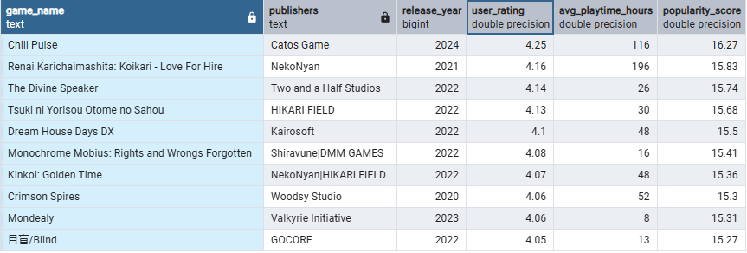

- Which Games Have Retention Problems?
(High popularity (players try it) but low playtime and low engagement ie. games failing to keep players hooked.
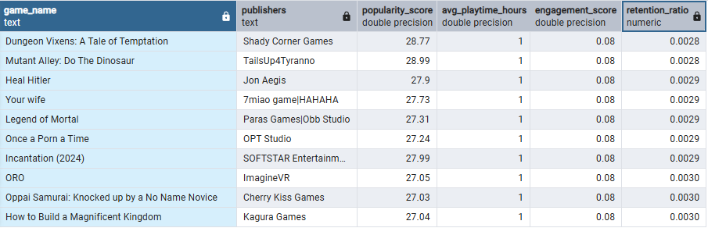

- Which Publishers Consistently Beat Industry Averages?
(Publishers whose catalog avg exceeds overall avg on rating, metacritic, AND popularity.)
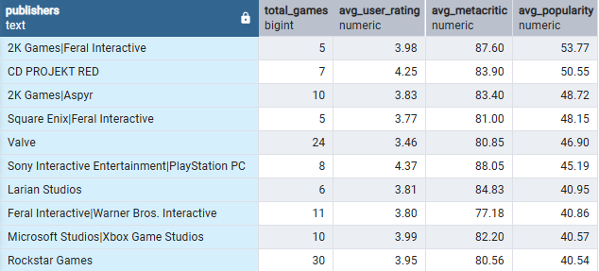

- Which Publishers Overperform Despite Smaller Catalogs?
(Small publishers (< median game count) with above-average popularity — quality-over-quantity studios)
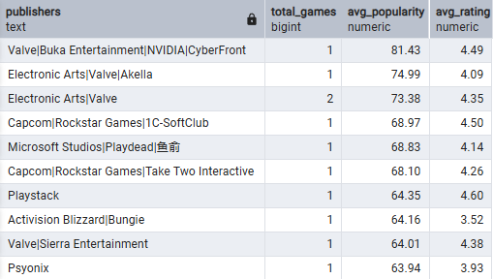

- Do Critics Predict Commercial Success?
(Correlation-proxy: bucket Metacritic scores into bands and compare avg popularity
— does high critic score translate to commercial reach?)
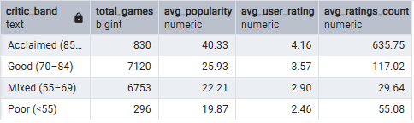

- Which Games Have the Largest Critic–Player Disagreement?
(ABS(Metacritic - user_rating*10) as discord score — surfaces games critics and players see very differently)
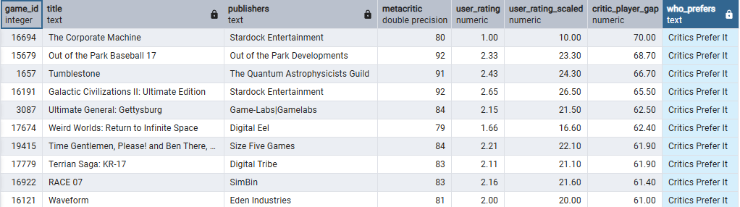

- Which Genres Benefit Most From Multiplayer?
(Compare avg popularity for multiplayer vs single-player within each genre
— informs feature investment. Which Platform Strategy Maximizes Reach?)
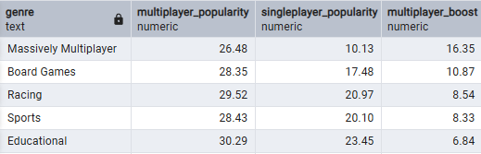
- Which Platform Release Strategy Is Associated With Stronger Game Performance?
(Bucket games by platform count (exclusive, mid, wide) and compare popularity + ratings to find the sweet spot.
Which Genres Have Grown the Most in the Last Decade?)
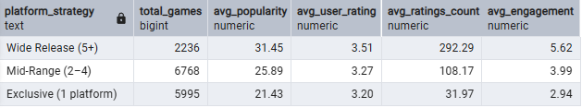

- Which Individual Platforms Host the Best-Rated Games?
(Rank platforms by the average quality of games on them — useful for platform partnership decisions.
Which Stores Carry the Highest-Performing Games?)
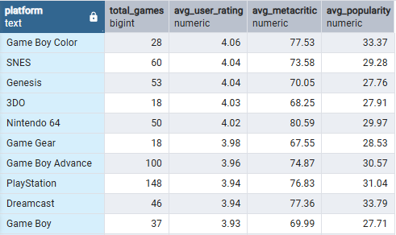

- How Have Genre Release Volumes Changed Over the Last Decade?
(Compare 2016–2020 vs 2021–2025 release counts per genre to identify trending and declining genres)
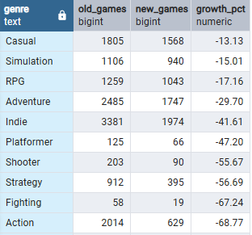

- Which Tags Are Associated with Top-Rated Games?
(Find tags that appear frequently in high-rated games —reveals design elements that resonate with players.
What Is the Year-over-Year Release Trend by Genre?)
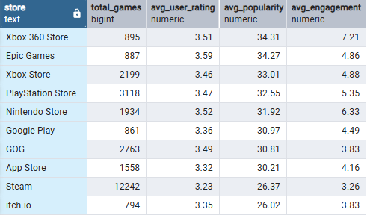

- Which Stores Carry the Highest-Performing Games?
Rank stores by the avg quality of their catalog —-- guides store listing strategy for publishers.
What Predicts Engagement? (Multi-Factor Bucketing)

7.2 SQL Techniques Used
- GROUP BY and aggregate functions such as COUNT, AVG, MIN, MAX, and STDDEV.
- JOIN operations between game_data and the normalized dimension tables.
- HAVING for post-aggregation filtering.
- CASE expressions for business segmentation and bucketing.
- NULLIF to avoid division-by-zero errors.
- PERCENTILE_CONT to create data-driven thresholds instead of relying only on fixed cutoffs.
- CTEs (WITH clauses) to break multi-step analysis into readable stages.
- Conditional aggregation using CASE inside AVG/COUNT.
- Window functions, including RANK() OVER(PARTITION BY ...) for genre-level leaderboards.
- Sorting and LIMIT for ranked outputs.

7.3 Examples of Analytical Logic
Commercial success was defined in the SQL as the top 10% of games by popularity_score using the 90th percentile. Those games were compared with the rest of the market across user rating, Metacritic, platform count, playtime, engagement, and ratings count. This is stronger than simply choosing an arbitrary popularity threshold because the cutoff is derived from the dataset.
For niche genres, the SQL compares genre averages with the overall dataset averages and then orders qualifying genres by game count. The intention is to identify genres that have relatively fewer titles while still achieving above-average popularity and user rating.
For multiplayer impact, the analysis compares average popularity of multiplayer and single-player games within each genre and calculates the difference as multiplayer_boost. This provides a direct comparison rather than simply counting multiplayer titles.
For genre growth, the SQL compares release counts between 2016–2020 and 2021–2025 and calculates percentage growth. The analysis is therefore based on changes in number of releases, not on popularity growth.

8. Power BI Dashboard
The final Power BI page is a single-page gaming analytics dashboard with a dark gaming-themed visual design. The layout is organized into a header, KPI cards, filters, a central time-series section, comparison charts, and a detailed top-games table.
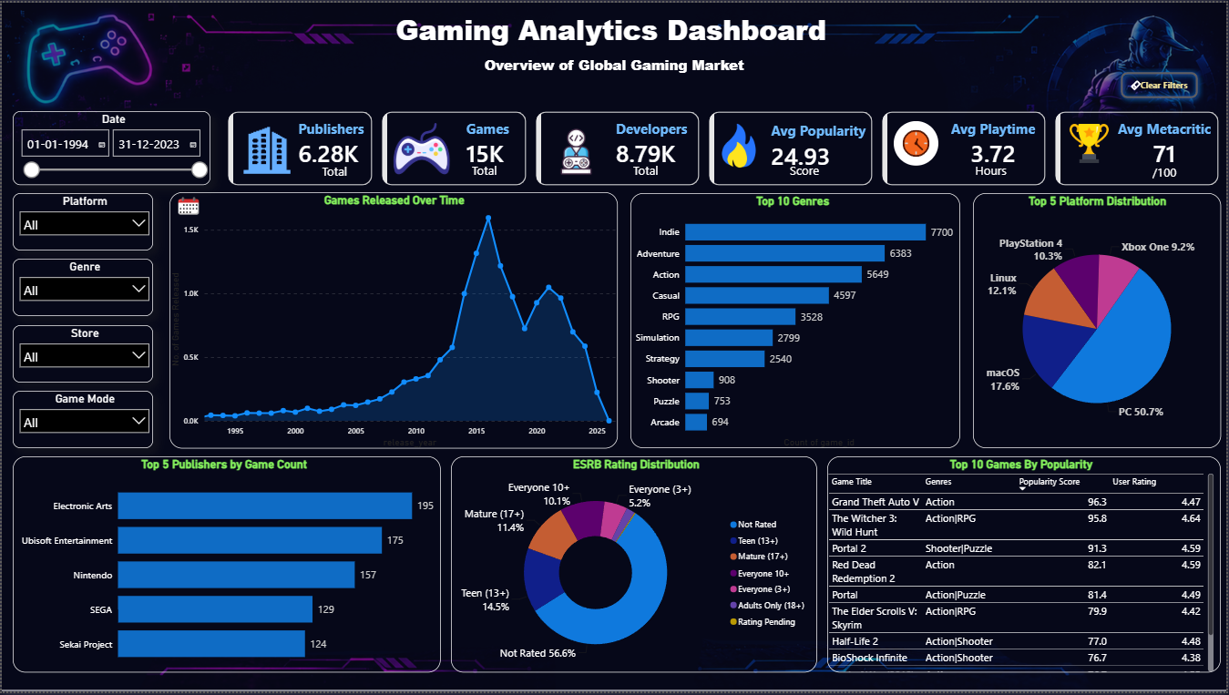
Figure 1. Final single-page Gaming Analytics Dashboard layout.

8.1 Dashboard Components
Element | Purpose / Displayed role
Date slicer | Controls the analysis period; the displayed range is 01-01-1994 to 31-12-2023.
Platform slicer | Filters the dashboard by platform.
Genre slicer | Filters the dashboard by genre.
Store slicer | Filters the dashboard by store.
Game Mode slicer | Filters by game mode.
Publishers KPI | Displays approximately 6.28K in the final screenshot.
Games KPI | Displays approximately 15K.
Developers KPI | Displays approximately 8.79K.
Average Popularity KPI | Displays 24.93.
Average Playtime KPI | Displays 3.72 hours.
Average Metacritic KPI | Displays 71/100.
Games Released Over Time | Line/area trend showing annual release volume.
Top 10 Genres | Horizontal bar chart ranking genres by game count.
Top 5 Platform Distribution | Pie chart showing the leading platforms in the current dashboard view.
Top 5 Publishers by Game Count | Horizontal bar chart ranking publishers by game count.
ESRB Rating Distribution | Donut chart showing the distribution of ESRB categories.
Top 10 Games by Popularity | Table showing game title, genres, popularity score, and user rating.

8.2 Dashboard Analysis
- KPI Cards — "What does the gaming market look like overall?"
Your cards show:
KPI | Value | Story
Publishers | 6.28K | The dataset covers a highly fragmented publishing market
Games | 15K | Large game catalogue
Developers | 8.79K | Large development ecosystem
Avg. Popularity | 24.93 | Average popularity is relatively modest compared with the top games
Avg. Playtime | 3.72 hrs | Typical reported playtime is relatively short
Avg. Metacritic | 71/100 | Overall critical reception is moderately positive

- Date Slicer — "What period are we analyzing?"
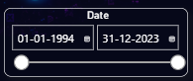
It's an interaction mechanism that allows the user to investigate the other stories across different periods.

- Platform / Genre / Store / Game Mode Filters
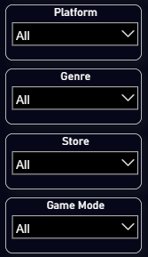
Platform - Controls which gaming platforms you're analyzing.
Genre - Controls the game genre.
Store - Controls the store where the game is available.
Game Mode - Controls whether you're looking at. (Single-player, Multiplayer)

- Games Released Over Time
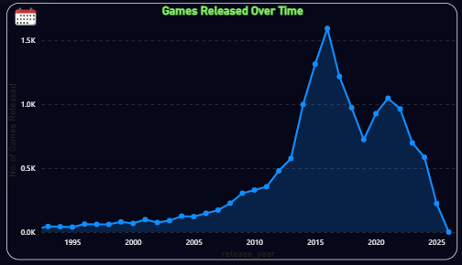
This chart tells the story of how the volume of games in your dataset changed over time.
The number of games rises dramatically into the mid-2010s.
The peak is around 2016, after which the number of recorded releases falls.
That could indicate a genuine change in the market or because the source data appears to have incomplete recent years.

- Top 10 Genres — "Which genres dominate the catalog?
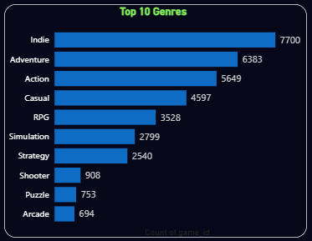
There is a huge concentration toward: Indie + Adventure + Action + Casual.
Action and Adventure clearly have substantial representation.
Shooter, Puzzle, and Arcade are much smaller by comparison.

- Top 5 Platform Distribution — "Where are games represented?
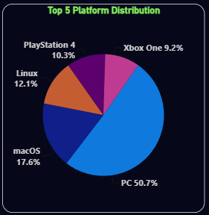
PC dominates the platform distribution. None is remotely close: PC = ~51%
while the other platforms individually are below 20%.

- Top 5 Publishers by Game Count — "Who has the largest catalog?
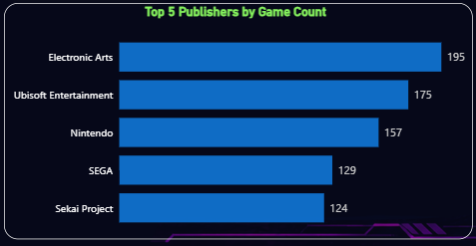
No single publisher dominates the dataset.
Even the #1 publisher has only 195 games, while the dataset has around 15K games overall.
That suggests the market has a long tail of publishers rather than being dominated by a few publishers.

- ESRB Rating Distribution
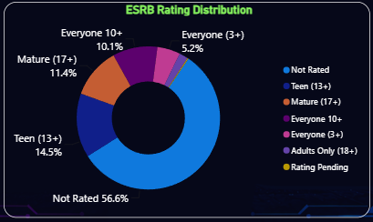
More than half of the games are classified as "Not Rated." That is Because “ESRB” rating information is missing or unavailable for a large portion of the games in this dataset.
- Top 10 Games by Popularity
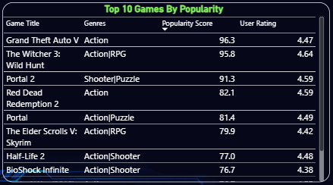

9. Key Findings Visible in the Final Dashboard
- The release trend rises strongly into the mid-2010s, reaches its highest point around 2016, and then declines with a smaller rebound around 2020–2021 before falling again.
- Indie, Adventure, and Action are the three largest genres by game count in the displayed Top 10 Genres chart, with Indie visibly leading.
- PC dominates the displayed Top 5 platform distribution at 50.7%, followed by macOS at 17.6%, Linux at 12.1%, PlayStation 4 at 10.3%, and Xbox One at 9.2%.
- Electronic Arts leads the displayed Top 5 publishers by game count, followed by Ubisoft Entertainment, Nintendo, SEGA, and Sekai Project.
- The ESRB chart shows a large Not Rated segment, displayed at 56.6%, which is important context when interpreting age-rating distributions.
- The top-popularity table includes Grand Theft Auto V, The Witcher 3: Wild Hunt, Portal 2, Red Dead Redemption 2, Portal, The Elder Scrolls V: Skyrim, Half-Life 2, and BioShock Infinite among the displayed high-popularity titles.

Data Quality Note: This dataset contains missing ratings, incomplete records, unspecified categories, and multi-valued attributes. Later release years may also have incomplete coverage. Therefore, some metrics and trends may differ from real-world gaming market figures and should be interpreted as dataset-level insights rather than exact market statistics.

10. Validation, Iteration, and Problems Encountered
- Publisher analysis was checked against the SQL output because the dashboard initially appeared to show unexpectedly low publisher counts. The SQL result confirmed the displayed values when grouped by publisher and excluding the 'Not Specified' category.
- The 'Not Specified' publisher category was removed from the dashboard visual through filtering because it represented missing publisher information rather than a meaningful publisher.
- The multiplayer analysis was simplified from a CTE-based version to conditional aggregation using CASE inside AVG, making the final query shorter and easier to understand.
- Genre-demand questions were iterated because a question such as 'underserved genres' requires an explicit definition of both demand and supply. The final SQL question-bank version uses above-average popularity and user rating with ordering by game count, rather than claiming that a genre is underserved without defining supply.
- The genre-growth query measures growth in release volume, not growth in popularity or revenue. This distinction matters when presenting the result.
- The dashboard was designed as one page, so the project prioritizes high-level market overview rather than attempting to place every SQL analysis into Power BI.

11. Limitations and Caveats
- Missing user_rating and metacritic values were median-imputed for EDA. This can reduce natural variation and may affect averages.
- The dashboard uses a prepared analytical dataset, so the displayed results depend on the cleaning and transformation decisions made in Python.
- Multi-valued dimensions can cause row multiplication when joined directly to game_data. COUNT(DISTINCT game_id) is therefore important in genre/platform/store/tag analysis.
- The release-year trend includes 2026 in the source data, while the dashboard date range shown is limited to 1994–2023. This should be kept consistent if the dashboard is presented as a 1994–2023 analysis.
- Publisher and developer counts depend on how missing or multi-valued text fields are stored in the source dataset.
- Popularity, engagement, playtime, ratings, and Metacritic scores describe the dataset; they do not by themselves prove commercial revenue or profitability.
- The SQL file contains several exploratory questions and question-bank items that were not necessarily visualized in the final Power BI page.

12. Final Project Outcome
The project demonstrates a complete analytics pipeline: raw gaming data was explored and cleaned in Python, transformed into more analysis-friendly structures, loaded into PostgreSQL, analyzed with business-focused SQL, and presented through a polished Power BI dashboard. The strongest part of the workflow is the connection between the three tools: Python handles preparation, SQL handles structured business analysis, and Power BI communicates the results interactively.
The project is suitable as a portfolio case study because it demonstrates practical data-cleaning decisions, relational data modeling, SQL aggregation and analytical logic, and dashboard design rather than only showing isolated charts.

13. Portfolio / Resume Summary
Built an end-to-end Gaming Data Analysis project using Python, PostgreSQL, and Power BI. Cleaned and transformed a multi-valued gaming dataset, created normalized genre/platform/store/tag tables, developed business-focused PostgreSQL queries using CTEs, conditional aggregation, percentiles and window functions, and designed a single-page Power BI dashboard covering gaming-market KPIs, release trends, genres, platforms, publishers, ESRB ratings, and top games.

