AthleteOS - Adaptive Athlete Performance Platform
Project Proposal Document
An Integrated Fitness, Recovery, Nutrition, and Athlete Performance Ecosystem

1. Introduction
AthleteOS is a next-generation athlete performance platform designed to unify workout tracking, nutrition monitoring, recovery estimation, mental readiness, and sports performance analytics into a single adaptive ecosystem. The platform aims to reduce fragmentation caused by multiple disconnected fitness applications and instead provide users with a centralized human-performance operating system.

2. Problem Statement
Most existing fitness applications focus only on isolated components such as workouts, calories, or sleep tracking. Very few systems combine physical training, recovery, nutrition, mood tracking, and sports performance into one seamless and visually engaging platform. Additionally, open-source alternatives with advanced recovery visualization and adaptive recommendations are extremely limited.

3. Objectives
- Create a low-friction workout and recovery tracking system
- Build an athlete-centric dashboard with adaptive insights
- Visualize muscle fatigue and recovery using animated muscle maps
- Provide nutrition and hydration tracking
- Track mental readiness and mood correlations
- Support multiple training modes such as strength training, yoga, sports, and endurance
- Develop a scalable and open-source architecture

4. Core Features

Workout Tracking
- Exercise logging
- Sets, reps, and weight tracking
- Progressive overload monitoring
- Workout templates
- Training split management

Recovery System
- Sleep tracking
- Recovery scores
- Muscle fatigue heatmaps
- Recovery suggestions

Nutrition Tracking
- Meal logging
- Calorie budgeting
- Macro tracking
- Water intake tracking

Mental Readiness
- Mood logging
- Stress tracking
- Energy monitoring
- Journaling support

Sports Performance
- Sprint tracking
- Vertical jump tracking
- Conditioning analysis
- Sport-specific modes

5. Proposed Tech Stack
Component | Technology
Frontend | React / React Native
Animations | Anime.js / Framer Motion
Backend | Node.js + Express.js
Database | PostgreSQL
ORM | Prisma
Authentication | JWT / Clerk
Charts | Recharts / Victory
Deployment | Render / Railway / Vercel

6. System Architecture
The system follows a modular architecture consisting of a frontend interface, backend API layer, recovery and workout logic engine, and PostgreSQL database. Future iterations may integrate AI-based recommendation systems and wearable device APIs.

7. Datasets & APIs
- Free Exercise DB
- WGER API
- USDA FoodData Central
- OpenFoodFacts
- Health Connect
- Apple HealthKit
- Huawei Health Kit

8. UI / UX Philosophy
The design philosophy focuses on smooth motion-driven interfaces, low-friction interactions, clean typography, athlete-focused visualizations, dark themed dashboards, and animated recovery maps. The platform aims to feel immersive, futuristic, and performance-oriented rather than clinical or spreadsheet-like.

9. Future Scope
- AI-assisted adaptive training recommendations
- Wearable device synchronization
- Community challenges
- Predictive recovery estimation
- Advanced analytics dashboard
- Open-source ecosystem expansion

10. Initial Brainstorming & Planning Sketches
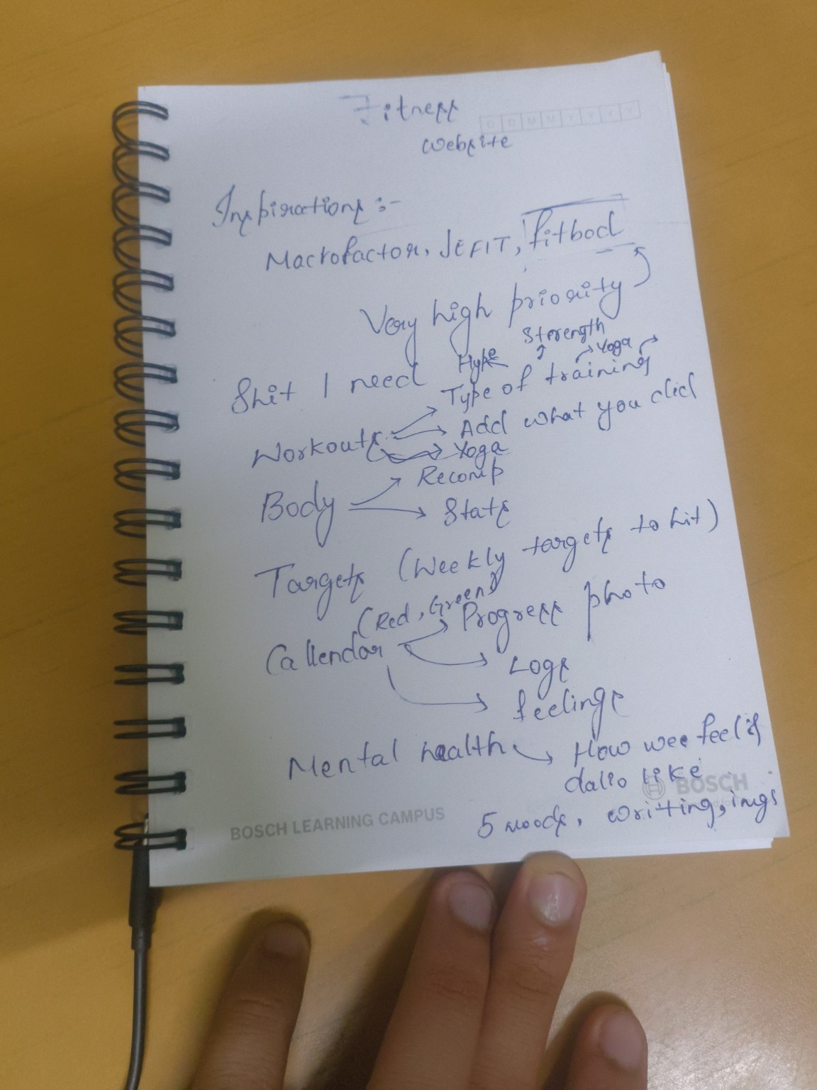
Initial concept notes and feature planning sketches.

Initial concept notes and feature planning sketches.

11. Conclusion
AthleteOS aims to evolve beyond traditional fitness tracking applications and become a comprehensive human performance platform. By integrating workouts, nutrition, recovery, sports analytics, and mental readiness into a unified ecosystem, the project seeks to provide users with actionable insights and a more engaging approach to personal improvement.

