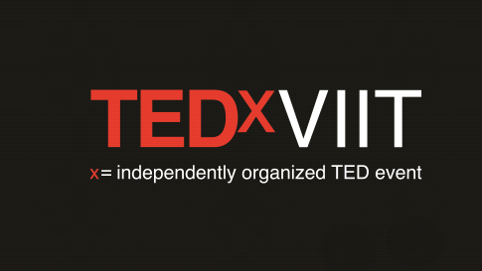

TED, which stands for ‘Technology, Entertainment, Design’ , is a comprehensive disposition of global colloquiums run by the private non-profit Sapling foundation with the motto ‘Ideas worth spreading’. It comprises of talks and videos by profound and well-known moguls of different fields.

TED is a big deal — a gift that is shaped by the world’s most inspired thinkers coming together to spread and seed ideas that matter. And it costs the world nothing to watch.

The difference between TED and TEDx events are that the former takes more of a global approach while the latter typically focuses on a local community that concentrates on local voices. “Officially, the ‘x’ in TEDx stands for independently organized TED event - but TEDx is more of a TED multiplied. It's been the force that has taken TED across the planet and seeded all of these communities

We at TEDxVIIT believe that when we love doing something,anything so much that we put ourselves into it,then our essence gets connected with that accomplishment. We put time, thought, and energy into preparing for these occasions and we leave a piece of ourselves behind. This outlook on life is the very essence of the TEDxVIIT way , and the theme for this years event : ' Meraki '

This is the kind of passion we want to celebrate and try to leave behind a memoir to make each and every beneficiary feel grateful.This Inaugural Edition of this prestigious event is already here and we can't wait for you all to be a part of this journey.The team has worked extremely hard to bring forth this opportunity of enlightenment to you!

We hope to see you all hungry intellectuals there!

|  |  |
| --- | --- |
| Event Organiser :Ketan Shukla, | Event Co-Organzier : Kaustubh Pimparkar. |
| Event Producer: Ali Asgar Fakhruddin. | Event Manager: **Shubham Jha and Suraj Jojan.** |
| Event Budget Head: Gaurav Gandhi and Aarj Jain. | Event Sponsorship Head: **Saurabh Karle.** |
| Event Design Head: Vaibhavi Deo and Siddhi Bhilare. | Curator: **Dhruvatara Bhogishetty.** |
| Website Manager: Sanket Khote. | Photography and videography Head : **Omkar Balwant.** |
| Communication, Editorial and Marketing Head: Saifuddin Raja, Chirag Rathi, V.Anirudh. |  |