Assignment-02
Ques 1:- Write a query that produces all rows from the Customers table for which the salesperson’s number is 1001.
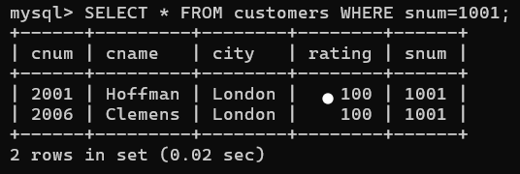
Sol.

Ques 2:- rite a select command that produces the rating followed by the name of each customer in San Jose.
Sol.
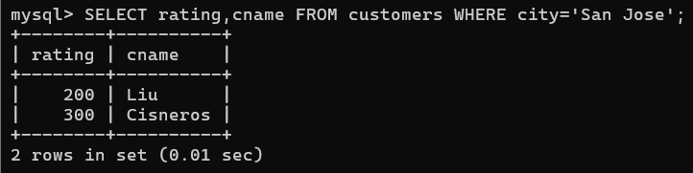
Ques 4. Write a query that will display all the orders for amount more than Rs. 1,000.
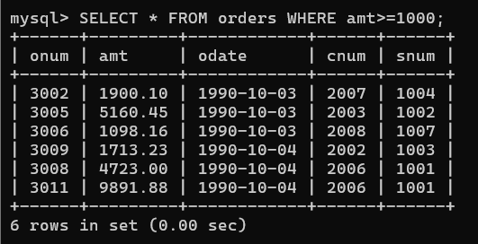
Sol.

Ques 5. Write a query that will give you the names and cities of all salespeople in London with a commission above 0.10.
Sol. 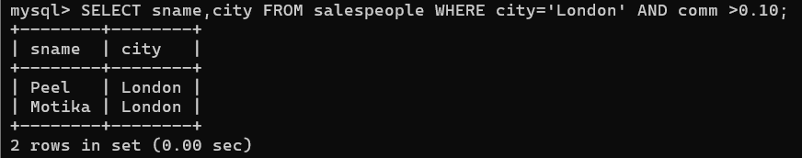
Ques 6. Write an SQL query that returns all customers who have a rating greater than 100, along with the customers located in Rome regardless of their rating.
Sol.
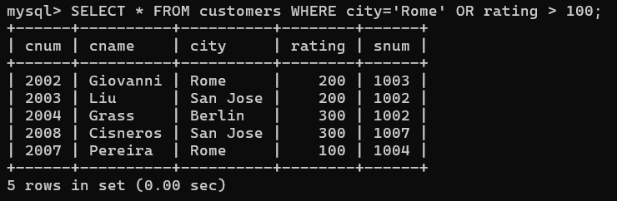
Ques 9. What is a simpler way to write this query? Select snum, sname, city, comm from Salespeople Where (comm >= .12 AND comm <= .14);.
Sol.
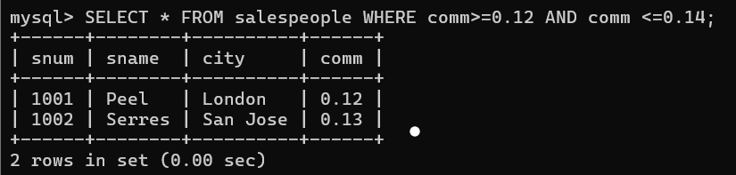

Ques 10. Write a query that selects all orders except those with amount less than 100.
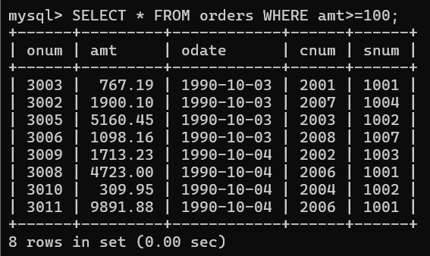
Sol.

