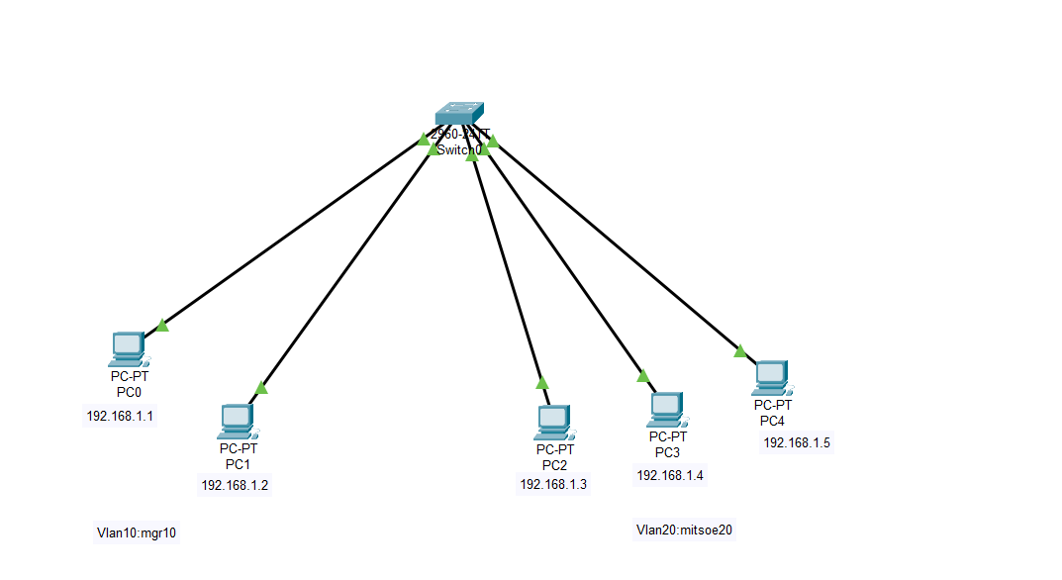

Switch 0:

Switch>en

Switch# conf t

Enter configuration commands, one per line. End with CNTL/Z.

Switch(config)#vlan 10

Switch(config-vlan)#name mgr10

Switch(config-vlan)#exit

Switch(config)#vlan 20

Switch(config-vlan)#name mitsoe20

Switch(config-vlan)#exit

Switch(config)#interface fast

% Incomplete command.

Switch(config)#interface fastEthernet0/1

Switch(config-if)#switchport access vlan10

^

% Invalid input detected at '^' marker.

Switch(config-if)#switchport access vlan 10

Switch(config-if)#exit

Switch(config)#interface Fast 0/2

Switch(config-if)#switchport access vlan 10

Switch(config-if)#exit

Switch(config)#interface Fast 0/2

Switch(config-if)#switchport mode access

Switch(config-if)#exit

Switch(config)#show vlan

^

% Invalid input detected at '^' marker.

Switch(config)#show

Switch#

%SYS-5-CONFIG_I: Configured from console by console

Switch#show vlan brief

Switch#en

Switch#conf t

Enter configuration commands, one per line. End with CNTL/Z.

Switch(config)#interface range fast0/3-5

Switch(config-if-range)#switchport access vlan 20

Switch(config-if-range)#switchport mode access

Switch(config-if-range)#exit

Switch(config)#

Switch#

%SYS-5-CONFIG_I: Configured from console by console

Switch#show vlan

Switch#copy run start

Destination filename [startup-config]?

Building configuration...

[OK]

Switch#