Results of analysis

The analysis conducted on global terrorist incidents yields valuable insights into the dynamics of attacks, the effectiveness of counterterrorism efforts, and the distribution of violence across various dimensions.

1. **Top 10 Countries Able to Tackle Terror Attacks:**
   * **Methodology:** The analysis considered metrics such as the total number of attacks, success rates, and failure rates to evaluate the effectiveness of counterterrorism efforts.
   * **Visualization:** A bar chart was employed to rank and visually represent the top 10 countries successful in countering terrorist attacks.
   * **Insights:** Countries with higher success rates and lower failure rates demonstrated a more robust counterterrorism infrastructure and strategy.

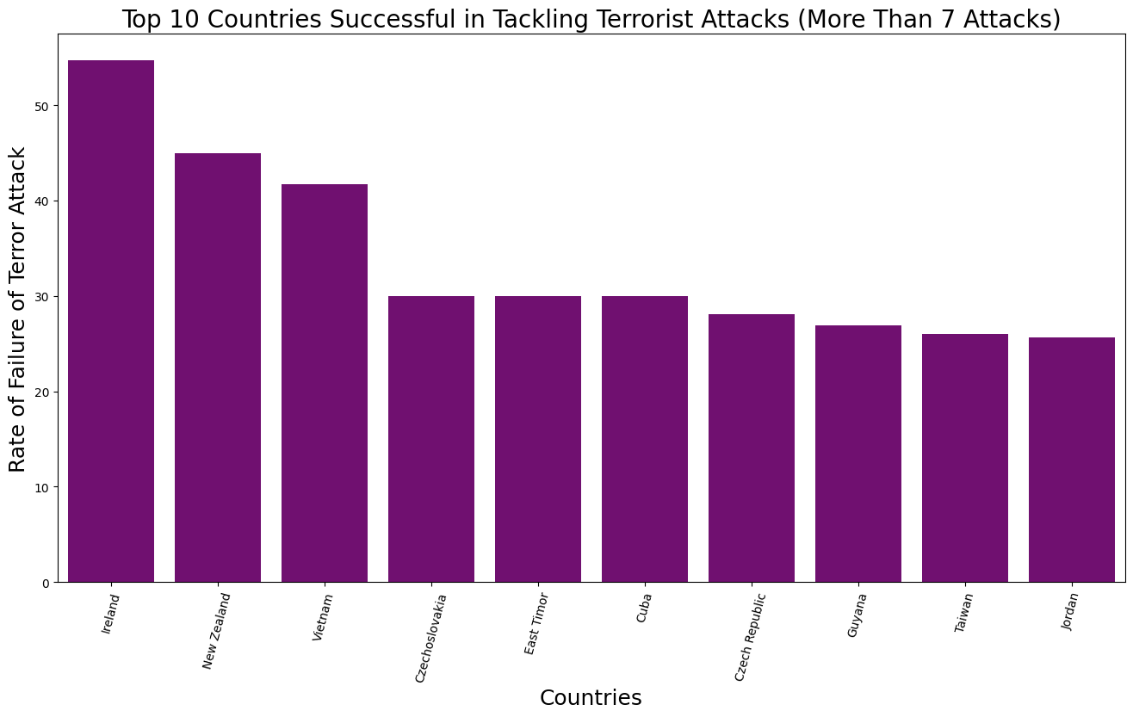

1. **Top 10 Countries Unable to Tackle Terror Attacks:**
   * **Metrics:** The evaluation of countries facing challenges in countering terrorism involved analyzing total attacks, success rates, failure rates, and specificity.
   * **Visualization:** A bar chart highlighted the struggles faced by these countries, emphasizing areas that may require increased support or improved counterterrorism strategies.

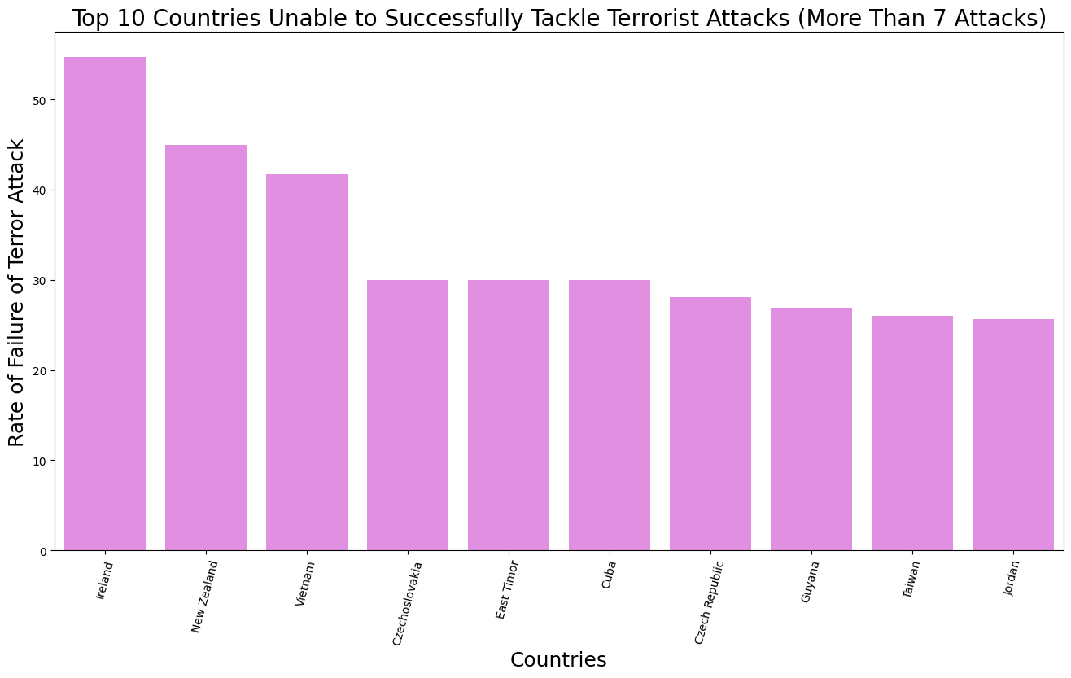

1. **Pie Chart for Successful vs. Failed Attacks:**
   * **Representation:** A pie chart visually conveyed the distribution of successful and failed terrorist attacks, offering a quick overview of the overall efficacy of counterterrorism efforts globally.
   * **Insights:** The proportion of successful and unsuccessful incidents provided insights into the effectiveness of counterterrorism measures.

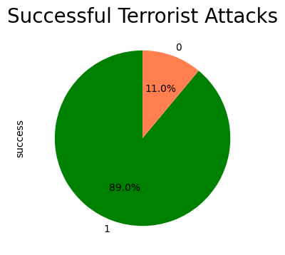

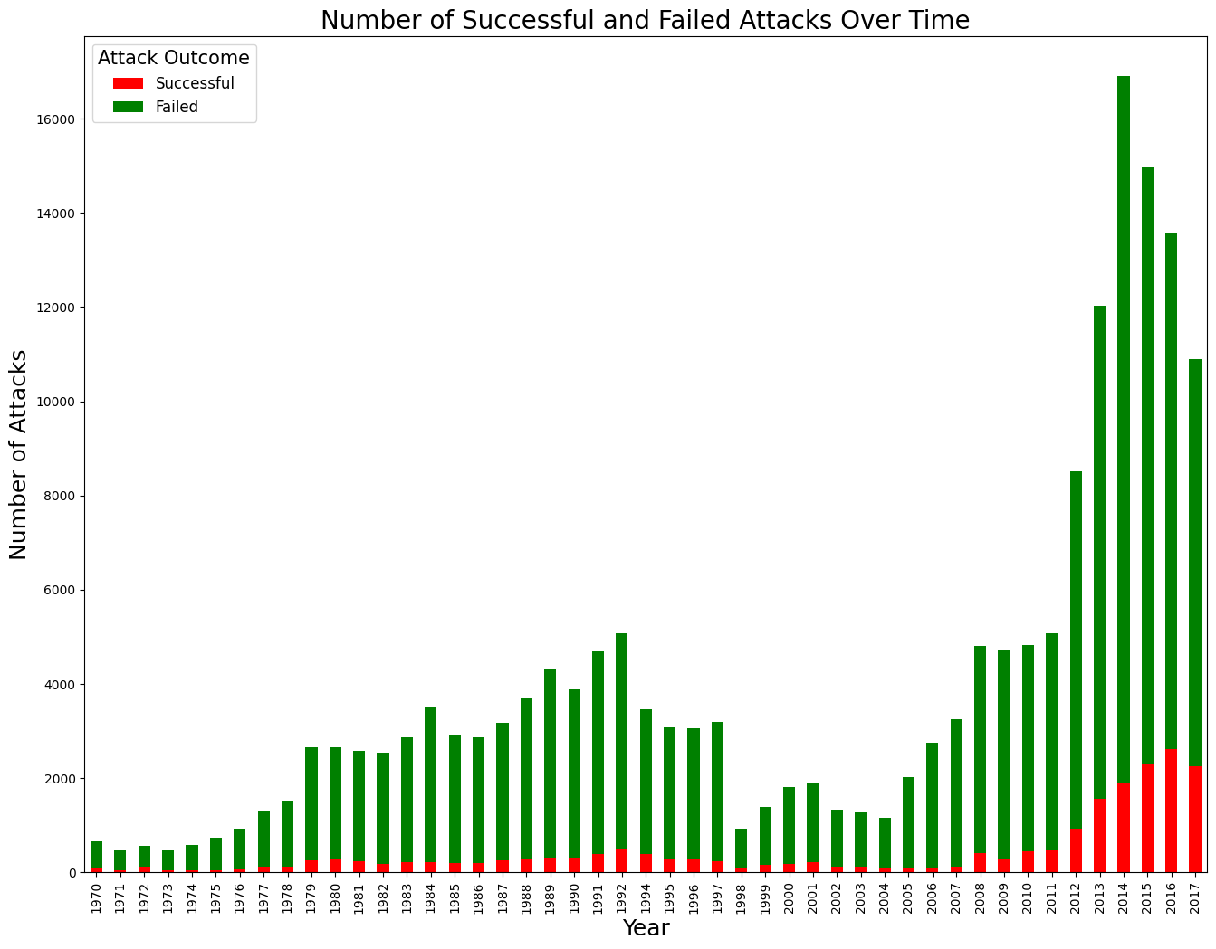

1. **Weapon Usage in Terror Attacks:**
   * **Objective:** The analysis aimed to understand the types of weapons most frequently used in terrorist incidents.
   * **Visualization:** A line graph or bar chart depicted the top 5 most-used weapons over time, illustrating trends in weapon selection and tactics employed by terrorist groups.

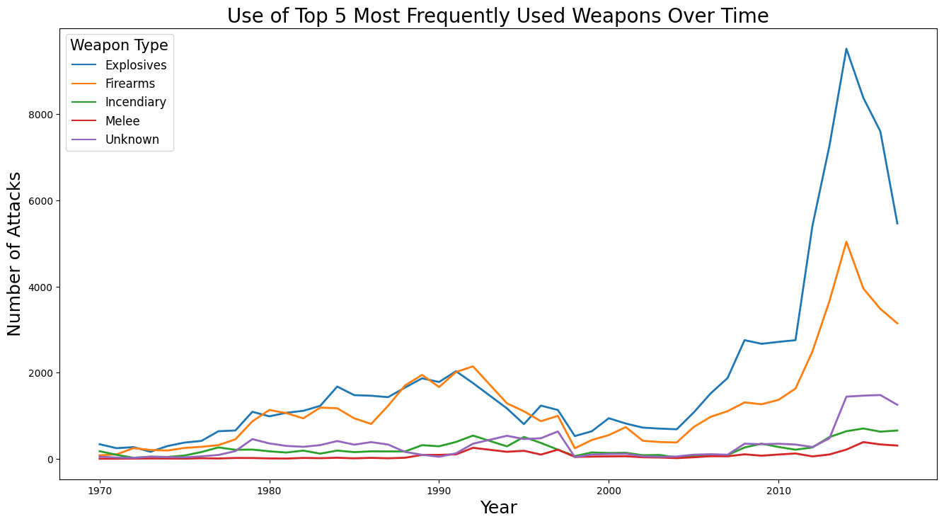

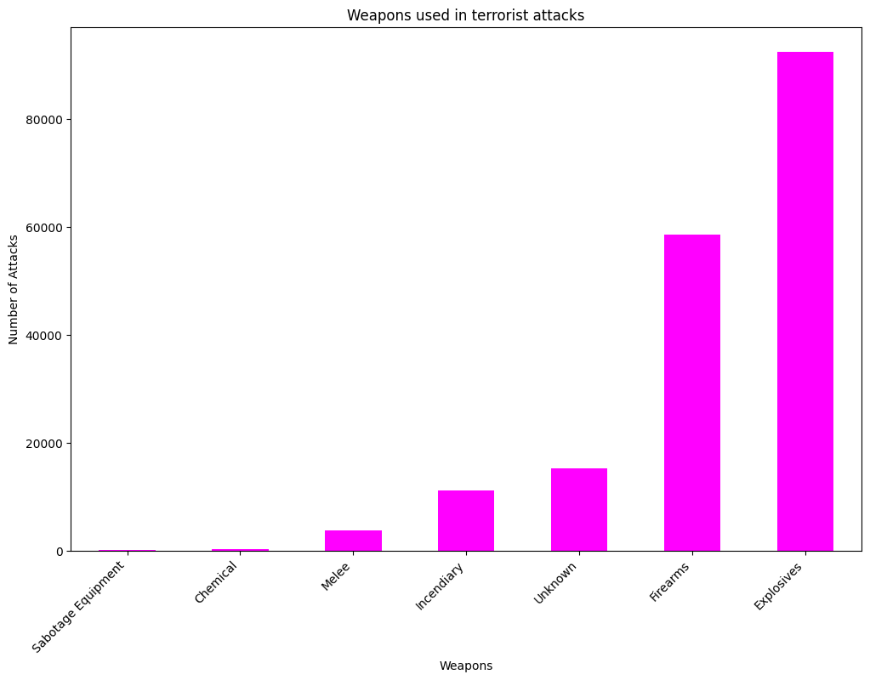

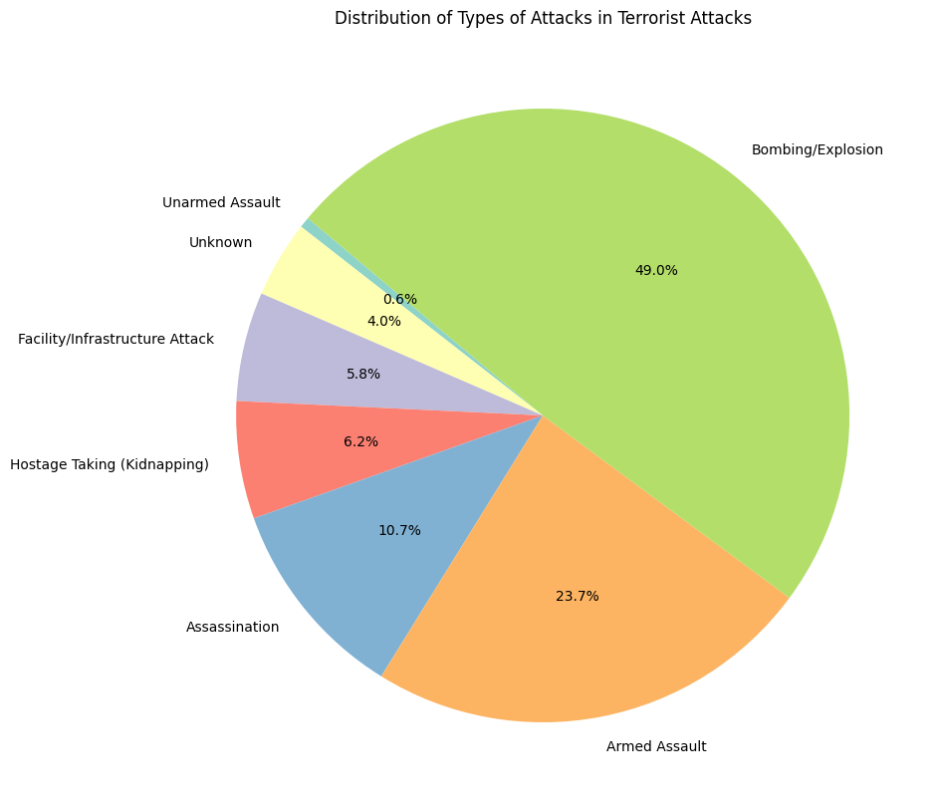

1. **Target Types in Terror Attacks:**
   * **Focus:** The examination focused on identifying the most frequently targeted entities in terrorist attacks.
   * **Visualization:** A line chart showcased the top 7 target types over time, providing insights into the evolving nature of terrorist tactics and preferred targets.

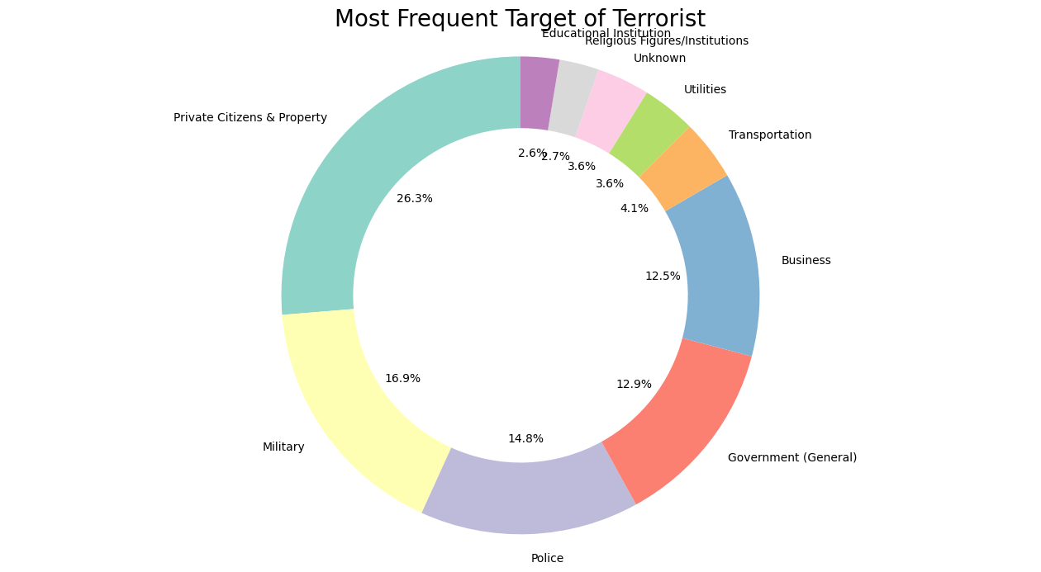

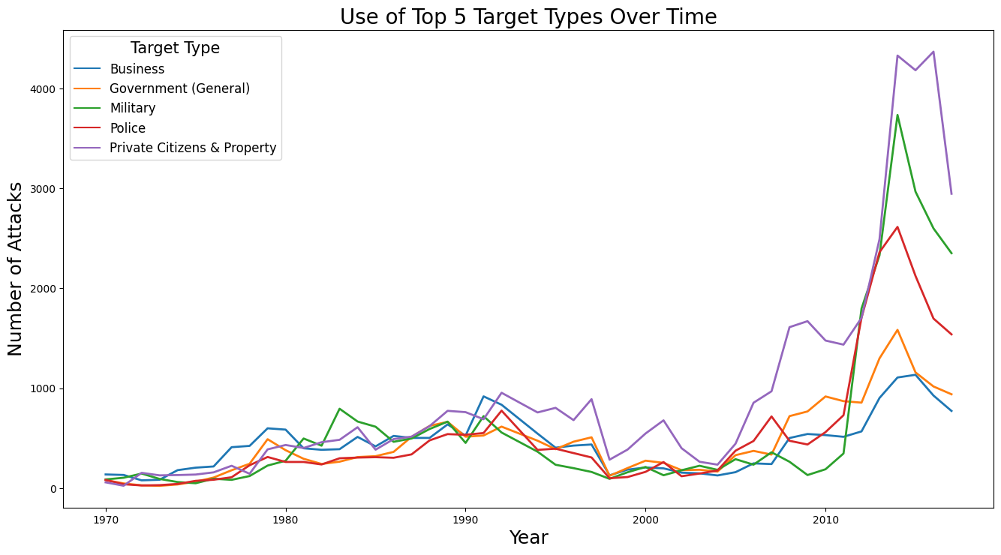

1. **Global Trends and Patterns:**
   * **Temporal Analysis:** A temporal analysis of terrorist incidents revealed trends and patterns over time, aiding in understanding the evolution of terrorism globally.
   * **Geographical Insights:** Examining geographical distributions of attacks highlighted regions prone to higher security risks and geopolitical complexities.

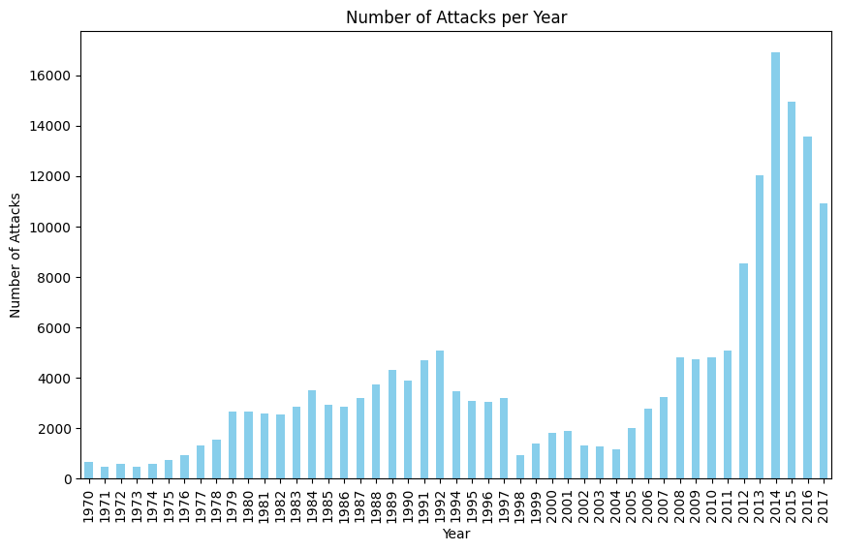

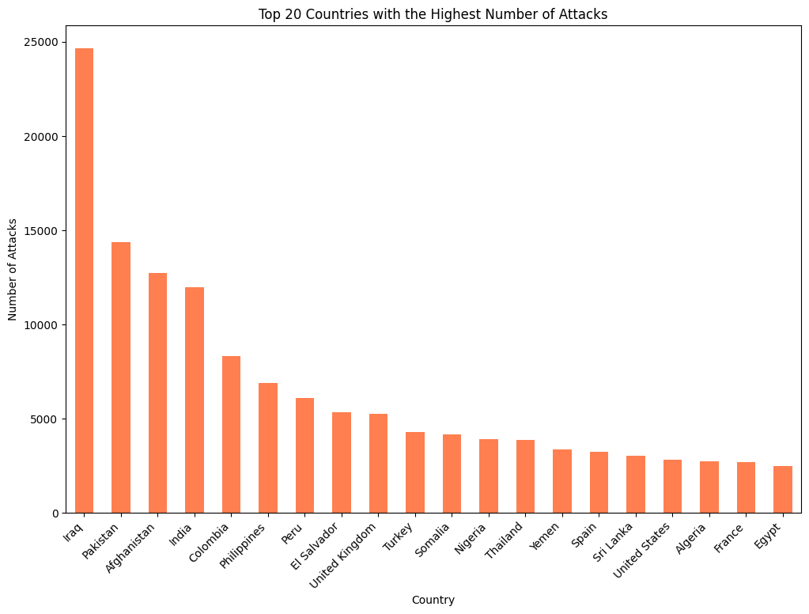

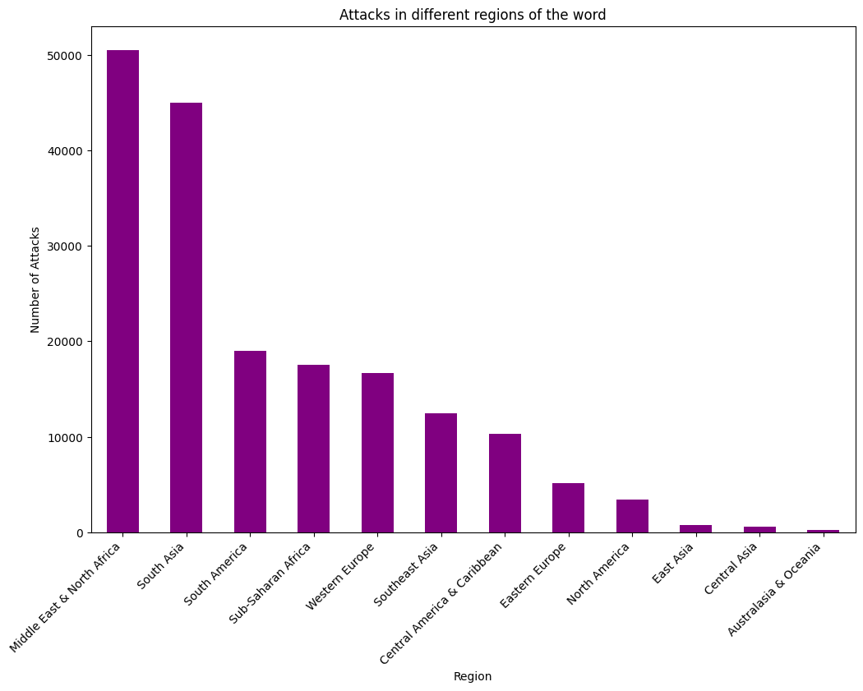

1. **Counterterrorism Strategies:**
   * **Success Factors:** Identifying successful counterterrorism strategies in top-performing countries provided valuable insights for other nations.
   * **Challenges and Solutions:** Countries facing challenges in countering terrorism could benefit from lessons learned and successful strategies implemented elsewhere.
2. **Implications for International Cooperation:**
   * **Collaborative Efforts:** Recognizing successful and struggling nations underscored the importance of international collaboration in the fight against terrorism.
   * **Information Sharing:** Sharing best practices and intelligence becomes crucial for addressing global security challenges posed by terrorist activities.
3. **Policy Recommendations:**
   * **Tailored Approaches:** Insights gained from the analysis could inform the development of tailored counterterrorism policies based on the specific challenges and successes observed in different regions.
   * **Resource Allocation:** Governments and international organizations can allocate resources more effectively by addressing vulnerabilities highlighted in the analysis.
4. **Future Directions:**
   * **Adapting to Emerging Threats:** The analysis sets the stage for anticipating and adapting to emerging threats by understanding the evolving tactics, targets, and weapon choices of terrorist groups.
   * **Research and Development:** The findings provide a foundation for further research and development of strategies and technologies to enhance global security against terrorism.

In conclusion, this detailed analysis goes beyond numerical counts and visualizations, delving into the implications, challenges, and potential solutions associated with global terrorism. It serves as a valuable resource for policymakers, security experts, and researchers working towards a safer and more secure world.