## Project components :

* Encrypted Chat App with Node JS
* Communication through web sockets

This is project includes 2 main projects:

* **AliceChatApp** : Node JS application runs in port 3000
* **BobChatApp** : Node JS application runs in port 4000

## Authentication process:

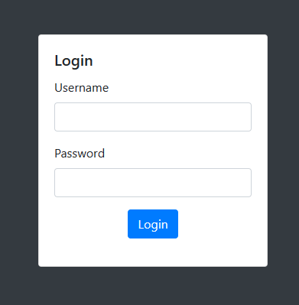

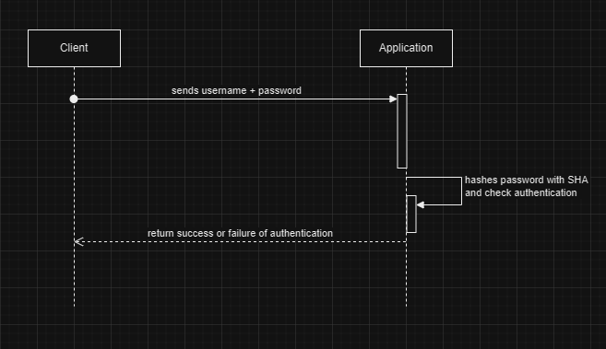

The client inputs his login and password, the program hashes the password with SHA and verifies the credentials (the application stores hashed credentials to avoid stealing data), if it exists, the authentication is successful.

This mechanism guarantees integrity, and never imposes the password as a plain text, it is secure.

* **AliceChatApp : { username : alice, password : test }**
* **BobChatApp : { username : bob, password : test }**

## Messages exchange:

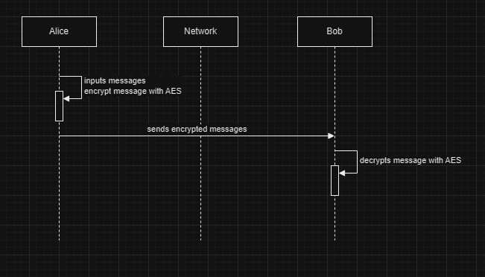

All messages sent and received between the 2 programs are encrypted with AES, with a secret key that each of the program have,

If Alice wants to send a message to Bob, Alice encrypts the message with AES, sends it over the network, Bob receives the cipher and decrypt it.

This guarantees the confidentiality of the exchanged messages.

## Visual cryptography:

The programs can also send images to each other, which is also encrypted, the process goes like this:

If Alice wants to send an image to Bob, Alice will use a local library to split the image into “N” shares and send them to the recipient.

“K” and “N” chosen keys for image splitting.

Bob will receive the list of shares, he will need only to re assemble “K” shares to get the original cipher back into the normal image format.

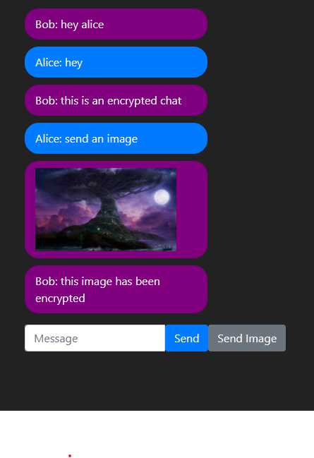

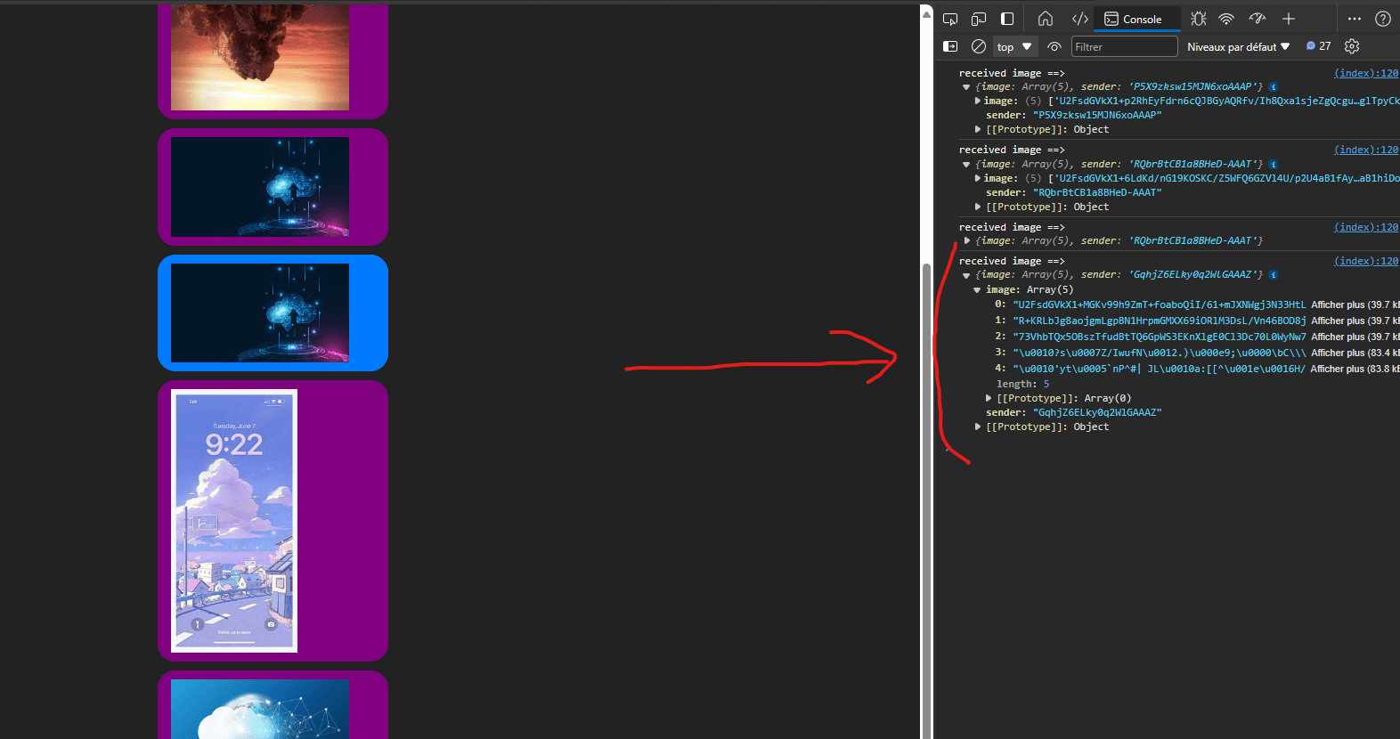

## How to run the programs:

1. Make sure to have NodeJS installed on your computer
2. Copy the 2 folders into different areas
3. In each area, run command line, and run the following commands
   * npm install
   * npm install body-parser cors crypto crypto-js express express-session socket.io sssa sssa-js
   * npm start (*each project will start on a different port*)
4. Authenticate in Alice’s project with alice username, and in Bob’s with bob username, and start using the app