Experiment 1

Numerical Study of Flow Around a NACA 0012 Airfoil

Aim
To examine how changing the angle of attack affects the flow field, wake, pressure distribution, and qualitative lift and drag behaviour around a NACA 0012 airfoil.

Simulation Parameters

Parameter | Value
Streamwise grid points | 120
Cross-stream grid points | 60
Reynolds number | 100
Angles of attack | −5°, 0°, 5°, 10°
Time step | 1.25 × 10³
Iterations | 300

Numerical Method
The incompressible Navier–Stokes equations are solved with a Cartesian immersed-geometry projection approach. The airfoil is represented by a smooth solid mask; velocity penalisation is applied within the body and a pressure-Poisson correction enforces near-zero divergence.

Boundary Conditions
Uniform inflow and far-field conditions are applied at the inlet and outer boundaries. The outlet uses a convective or zero-gradient treatment with a pressure reference. A no-slip condition is imposed on the airfoil through the immersed mask.

Observations
Continuity residuals, wake vorticity, speed distribution, pressure-side and suction-side behaviour, and qualitative lift/drag histories were examined at each incidence angle.

Angle of attack | Drag coefficient (qualitative) | Lift coefficient (qualitative)
−5° | 0.50 | 0.40
0° | 0.45 | 0.00
5° | 0.50 | 0.40
10° | 0.25 | 0.30
20° | 0.25 | -2.8

Conclusion
The continuity residual drops quickly during the early iterations and then levels off, indicating that the solution approaches a steady numerical state. The vorticity plots show a concentrated wake behind the airfoil. The reported force-coefficient values vary with incidence, although the values are qualitative and should be interpreted in the context of the simplified model.

Original Simulation Figures
The following pages contain the plots and simulation outputs from the supplied report.

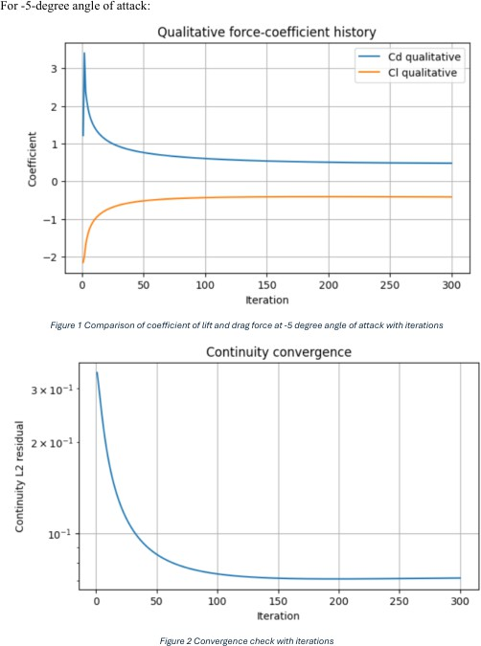

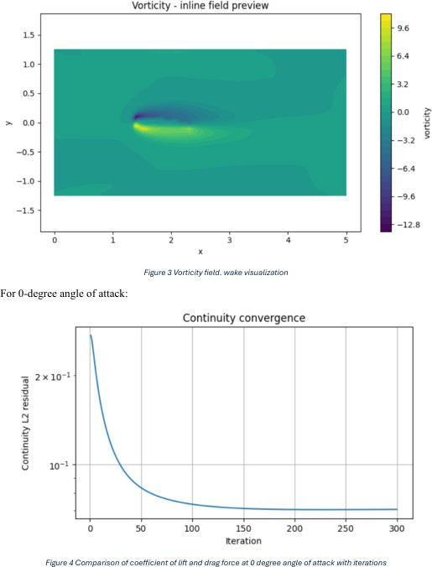

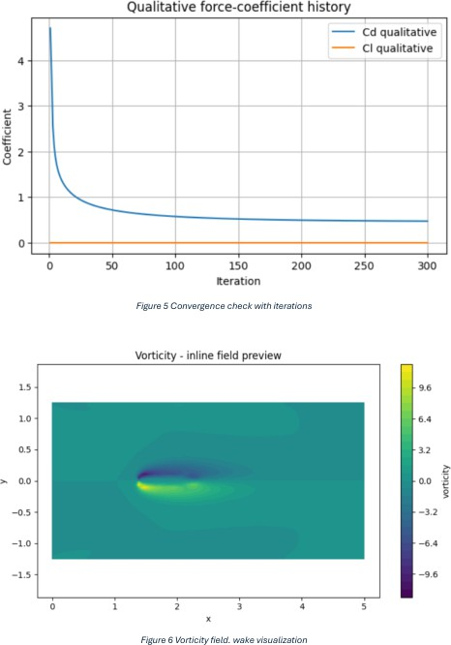

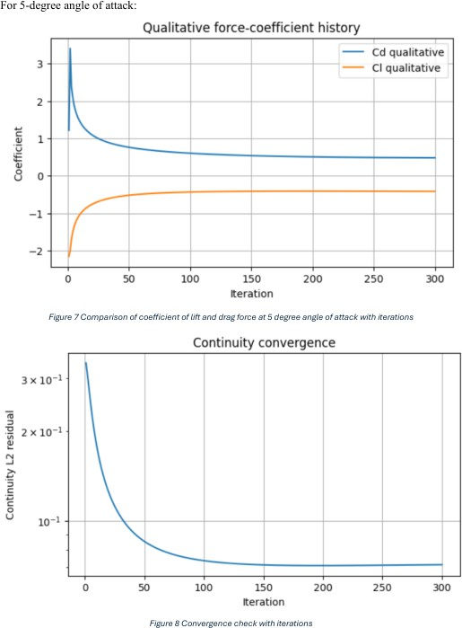

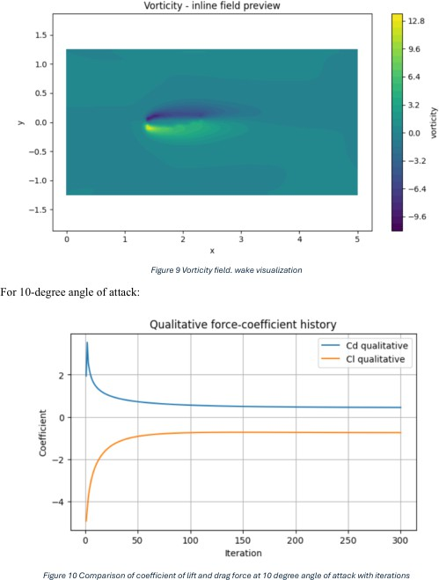

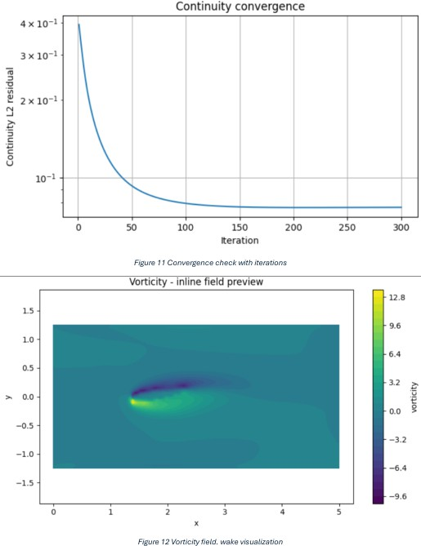

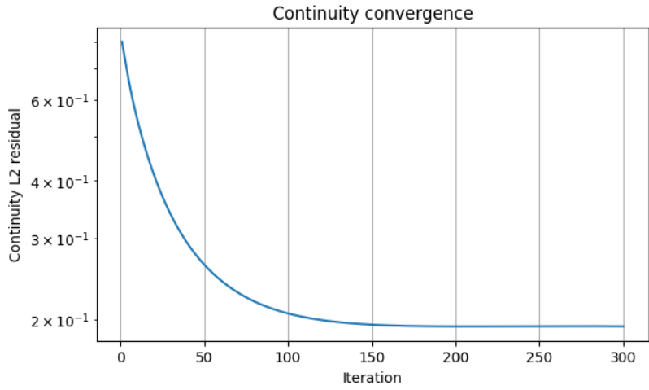
Figure 13 convergence check with iterations

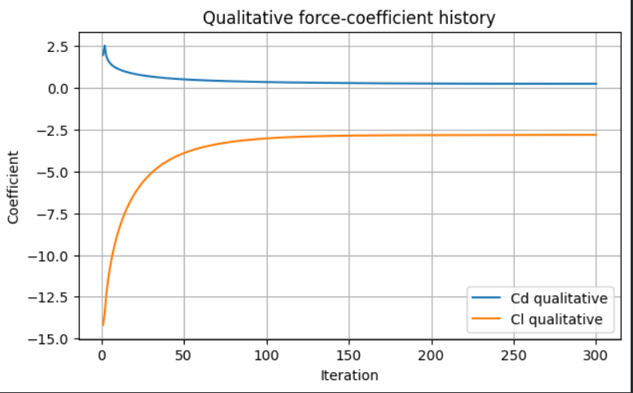
Figure 14 comparison of lift and drag force with attack angle of 20
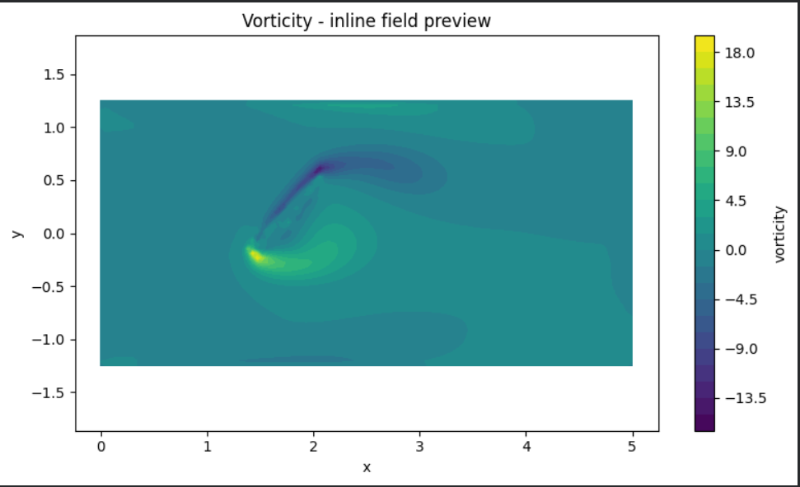

Figure 14 velocity field. wake visualization
Results

Angle of attack | Drag coefficient (qualitative) | Lift coefficient (qualitative)
−5° | 0.50 | 0.40
0° | 0.45 | 0.00
5° | 0.50 | 0.40
10° | 0.25 | 0.30
20° | 0.25 | -2.8

The continuity convergence plots demonstrate a rapid reduction in the L₂ continuity residual during the initial iterations. The residual subsequently approaches a relatively flat region, indicating that the numerical solution is approaching a quasi-steady state. The final continuity residual should be reported separately for each angle based on its corresponding simulation output.

The vorticity contours show the formation of a shear layer and a wake downstream of the airfoil. At an angle of attack of 20°, the flow field exhibits a substantially different pattern from the lower-angle cases. The lift coefficient changes to a negative value of −2.80, while the qualitative drag coefficient is 0.25. These results indicate a marked change in the computed force response at the high angle of attack.

Conclusion
The simulations demonstrate that changing the angle of attack affects the computed flow field, wake structure, continuity residual, and qualitative lift and drag coefficients at Re = 100.

For the cases from −5° to 10°, the reported lift coefficients range from 0.00 to 0.40. At 20°, the lift coefficient becomes strongly negative, reaching −2.80, while the reported drag coefficient is 0.25.

This high-angle result should be interpreted cautiously. The solver uses an immersed-boundary penalty-force approximation, so these coefficients are qualitative indicators rather than validated aerodynamic predictions. The negative lift value at 20° should also be checked against the force calculation and flow-field orientation before drawing a physical conclusion.

