CFD & Heat Transfer Laboratory
Experiment 10
Turbulent Pipe Flow Using Prandtl and van Driest Models

Aim
To study pipe flow using the Prandtl and van Driest models. The effects of grid size, A+ and friction velocity are checked. The Darcy friction factor is also compared with the Blasius value.

Simulation Parameters
Parameter | Value
Pipe radius (R) | 0.025 m
Kinematic viscosity (ν) | 1.5 × 10⁻⁵ m²/s
Density (ρ) | 1.2 kg/m³
Friction velocity (uτ) | 0.18 m/s
von Kármán constant (κ) | 0.41
Damping parameter (A+) | 26
Base grid | 120 radial cells
Roll number | 51
Main grid used for roll number 20 | N = 120 + 20 = 140
Maximum Picard iterations | 1000
Convergence tolerance | 1.0 × 10⁻¹⁰

Numerical Method
The pipe is divided into small radial cells. The velocity is found by solving the radial momentum equation. Effective viscosity includes molecular viscosity and the extra viscosity given by the turbulence model.
Two models are used in this experiment. The Prandtl model uses l = κy. The van Driest model adds a damping function near the pipe wall. The velocity is updated by Picard iterations until the change becomes smaller than the given tolerance.
Bulk velocity is calculated from the velocity distribution over the pipe area. Reynolds number is calculated using pipe diameter and bulk velocity. Darcy friction factor is found using fD = 8(uτ/Ubulk)² and then compared with the Blasius equation.

Boundary Conditions
At the pipe centre, symmetry is used and the velocity gradient is zero. At the wall, the no-slip condition is applied. The distance from the last cell centre to the wall is half a cell.

Student Exercises

1. Grid sensitivity: 60, 120 and 240 radial cells
The grid is changed to 60, 120 and 240 radial cells. The friction velocity and other values are kept the same. Bulk velocity and Darcy friction factor are noted for both models.
Model | Radial cells | Bulk velocity (m/s) | Darcy friction factor
Prandtl | 60 | 1.627859 | 0.097814
Prandtl | 120 | 1.572805 | 0.104782
Prandtl | 240 | 1.566546 | 0.105621
van Driest | 60 | 2.619451 | 0.037776
van Driest | 120 | 2.616125 | 0.037872
van Driest | 240 | 2.615427 | 0.037892

For the van Driest model, the values change only a little when the grid is refined. In the Prandtl model, the change from 60 to 120 cells is larger, while the 120- and 240-cell results are closer. So, both models do not show the same grid sensitivity.
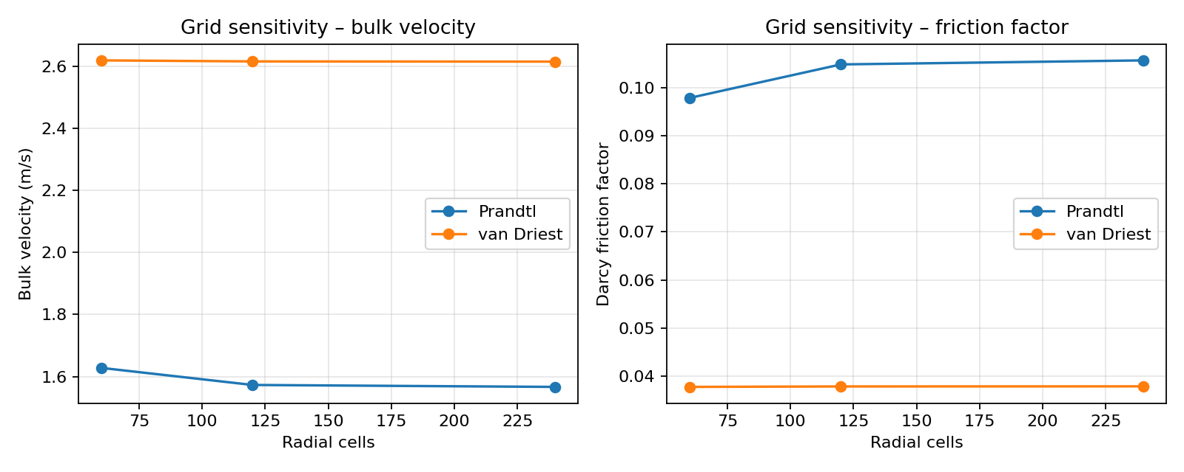
Figure 10.1: Grid sensitivity of bulk velocity and Darcy friction factor.

2. Effect of damping parameter A+
A+ is changed to 20, 26 and 32. The friction velocity is kept at 0.18 m/s. A+ does not affect the Prandtl model, but it is used in the damping function of the van Driest model.
Model | A+ | Bulk velocity (m/s) | Darcy friction factor
Prandtl | 20 | 1.567685 | 0.105467
Prandtl | 26 | 1.567685 | 0.105467
Prandtl | 32 | 1.567685 | 0.105467
van Driest | 20 | 2.424043 | 0.044112
van Driest | 26 | 2.615654 | 0.037886
van Driest | 32 | 2.787609 | 0.033356

The Prandtl results remain the same because A+ is not used in this model. For the van Driest model, increasing A+ reduces the damping near the wall. In these results, bulk velocity increases and Darcy friction factor decreases.
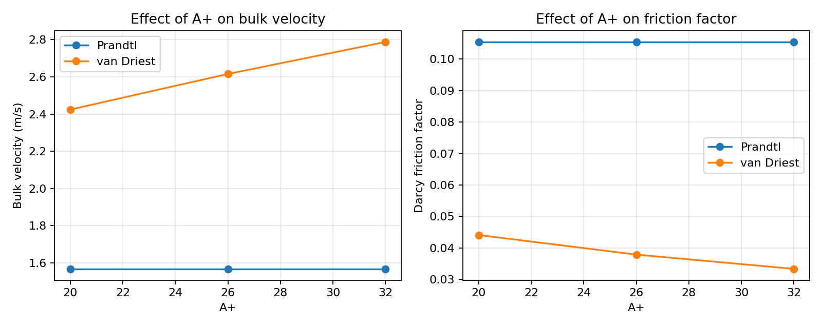
Figure 10.2: Effect of A+ on bulk velocity and Darcy friction factor.

3. Increase friction velocity to 0.25 m/s
The friction velocity is increased from 0.18 to 0.25 m/s. For both models, bulk Reynolds number and Darcy friction factor are calculated. These friction factors are compared with the Blasius values and the percentage difference is found.
Model | Ubulk (m/s) | ReD | Darcy fD | Blasius f | Deviation
Prandtl | 2.376250 | 7920.83 | 0.088549 | 0.033539 | 164.02%
van Driest | 3.871664 | 12905.55 | 0.033356 | 0.029685 | 12.37%

When friction velocity is increased, bulk velocity and Reynolds number also increase in both models. For this case, the van Driest result is closer to the Blasius value than the Prandtl result.
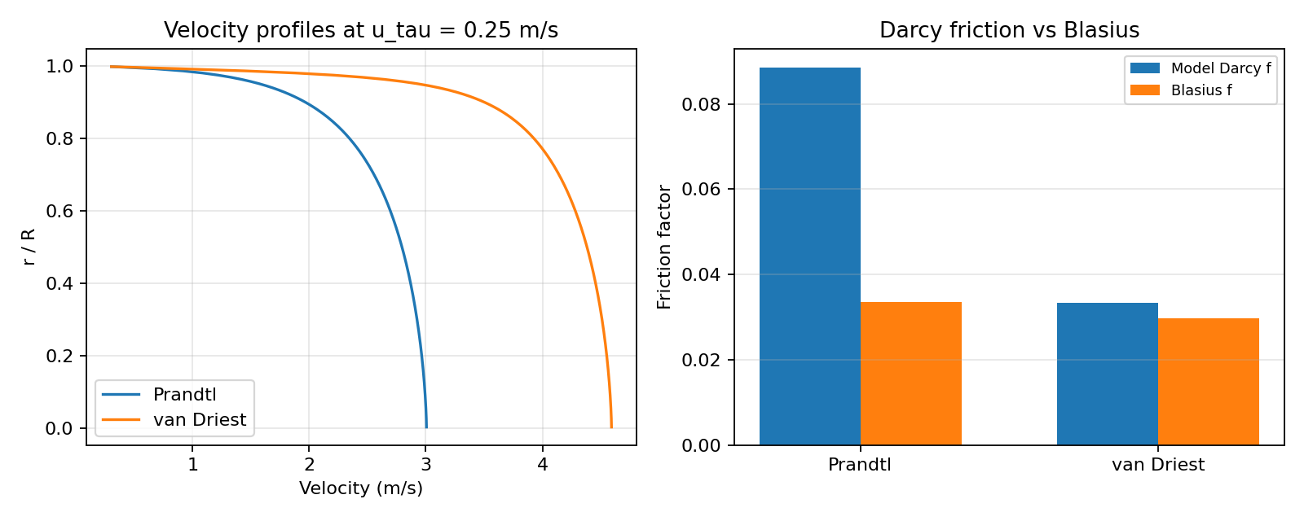
Figure 10.3: Velocity profiles and friction-factor comparison at uτ = 0.25 m/s.

Main Simulation Results – Roll Number 51
For roll number 20, the number of radial cells is taken as 120 + 20 = 140. The friction velocity is 0.18 m/s and A+ is 26.
Model | Ubulk (m/s) | ReD | Darcy fD | Blasius f | Deviation | Iterations | Residual
Prandtl | 1.567685 | 5225.62 | 0.105467 | 0.037214 | 183.41% | 56 | 2.352e-11
van Driest | 2.615654 | 8718.85 | 0.037886 | 0.032743 | 15.71% | 65 | 6.150e-12

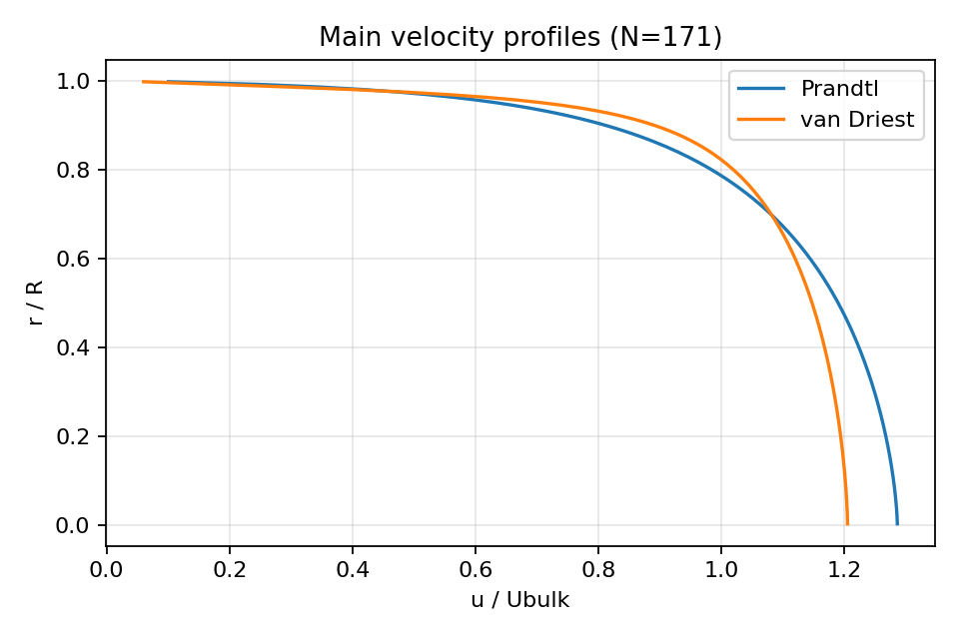
Figure 10.4: Main velocity profiles for the roll-number grid.

Observations
From the grid study, the two models show different changes with grid size. The Prandtl model changes more on the coarser grid, while the van Driest values are close for all three grids. A+ changes the van Driest results but does not change the Prandtl results. Increasing friction velocity increases bulk velocity and Reynolds number.

Conclusion
In this experiment, pipe flow was studied using the Prandtl and van Driest models. Grid size, A+ and friction velocity were changed and their effects were observed. The two models showed different grid behaviour. A+ affected only the van Driest model. At uτ = 0.25 m/s, the van Driest friction factor was closer to the Blasius value.

