EXPERIMENT 11
GENERIC CONVECTION–DIFFUSION TRANSPORT
Chirag Piyeja ( Roll No. 20)

1. Aim
To study temperature transport in three flow cases: forced flow over a flat plate, forced flow through a channel, and a natural-convection surrogate with a prescribed circulating flow. The cases are compared using temperature profiles, outlet or mean temperature, wall heat flux and residual.

2. Governing equation
The code solves a two-dimensional, time-dependent convection–diffusion equation for temperature T(x,y,t):
∂T/∂t + u ∂T/∂x + v ∂T/∂y = α (∂²T/∂x² + ∂²T/∂y²)
Here, u and v are the velocity components in the x and y directions, and α is the diffusivity. In the quick run used for this report, Pe = 100 and α = 1/Pe = 0.01. Convection is calculated using first-order upwind differences and diffusion using central differences. The temperature field is updated explicitly at each time step.

3. Flow cases and boundary conditions

3.1 Forced flat-plate case
The domain is 0 ≤ x ≤ 5 and 0 ≤ y ≤ 1. The flow velocity is prescribed as u = tanh[y/δ(x)] and v = 0, where δ(x) = 0.035 + 0.22√(max(x,dx)/L). The lower wall is heated to T = 1 from x/L ≥ 0.25, while the remaining lower section is kept at T = 0. The inlet and upper boundary are also at T = 0. A zero-gradient condition is used at the outlet.

3.2 Forced pipe/channel case
The domain is 0 ≤ x ≤ 5 and 0 ≤ y ≤ 1. A parabolic velocity profile is used: u = 6η(1−η), where η = y/H, and v = 0. The inlet temperature is T = 0, both channel walls are kept at T = 1, and a zero-gradient condition is applied at the outlet.

3.3 Natural vertical-plate surrogate
The domain is 0 ≤ x ≤ 1 and 0 ≤ y ≤ 1. A circulating velocity field is prescribed using u = −sin(πx/L)cos(πy/H)/H and v = cos(πx/L)sin(πy/H)/L. The initial temperature is T = 1 − x/L. The left boundary is kept at T = 1 and the right boundary at T = 0. The top and bottom use zero-normal-gradient conditions. This is only a prescribed-flow model; it does not solve a fully coupled Boussinesq natural-convection problem.

4. Numerical method and parameter set
The code uses explicit finite-volume-style iterations on a uniform Cartesian grid. At every iteration, it calculates convection with the upwind method and diffusion with central differences. It then updates the interior temperature, limits values to −0.05 to 1.05, applies the boundary conditions again and calculates the RMS change in temperature.
Run mode evidenced by supplied log | quick (8 iterations; workflow check)
Case selection | all three cases
Grid evidenced by quick preset | nx = 25, ny = 21
Peclet number, Pe | 100 (quick preset)
Diffusivity, α = 1/Pe | 0.01
Maximum iterations | 8
Output interval | 8 iterations; logs at iteration 1 and 8
Domain: forced flat plate | 5 × 1
Domain: forced channel | 5 × 1
Domain: natural plate surrogate | 1 × 1
Time-step selection | dt = min[0.35 min(dx/max|u|, dy/max|v|), 0.20 min(dx²,dy²)/α]
Note: the notebook also shows the full lab settings of 121 × 61 grid, Pe = 200 and 3000 iterations. However, the output supplied for this report is from the quick preset: all three cases, 25 × 21 grid, Pe = 100 and 8 iterations. The report uses the settings from the actual output log.

5. Residual definition and convergence history
The residual is calculated as the root-mean-square change in the interior temperature between two consecutive iterations:
Residual = √ mean[(Tⁿ − Tⁿ⁻¹)²] over interior grid points
The following values are taken from the supplied output. The quick run only recorded iterations 1 and 8, so values for the intermediate iterations are not available.
Case | Iteration | Residual | Outlet / mean T | Average wall flux
Forced flat plate | 1 | 4.059061 × 10⁻² | 2.427478 × 10⁻³ | 16.00000
Forced flat plate | 8 | 8.701541 × 10⁻³ | 1.853125 × 10⁻² | 8.391536
Forced pipe/channel | 1 | 6.308611 × 10⁻² | 5.555556 × 10⁻³ | 16.11111
Forced pipe/channel | 8 | 1.395576 × 10⁻² | 4.207700 × 10⁻² | 8.449362
Natural vertical plate surrogate | 1 | 7.249832 × 10⁻³ | 0.500000 | 1.000000
Natural vertical plate surrogate | 8 | 6.989738 × 10⁻³ | 0.500000 | 1.056715
The residual decreases from iteration 1 to iteration 8 for all three cases. The change is small for the natural-plate case and larger for the two forced-flow cases. However, eight iterations are not enough to confirm that the solutions have reached steady state.

6. Quantitative case comparison
The table below shows the final values available from the quick run at iteration 8:
Case | Outlet or mean temperature | Average wall flux | Final residual
Forced flat plate | 0.01853125 | 8.391536 | 8.701541 × 10⁻³
Forced pipe/channel | 0.04207700 | 8.449362 | 1.395576 × 10⁻²
Natural vertical plate surrogate | 0.500000 | 1.056715 | 6.989738 × 10⁻³
The natural-plate case has a mean temperature of 0.5. The forced channel outlet temperature (0.04208) is higher than the forced flat-plate value (0.01853). The average wall flux is about 8.4 for both forced cases and about 1.06 for the natural-plate case. One point to remember is that the temperature values are not calculated in exactly the same way: the forced cases use a velocity-weighted outlet temperature, while the natural case uses the average interior temperature.

7. Extracted temperature profiles
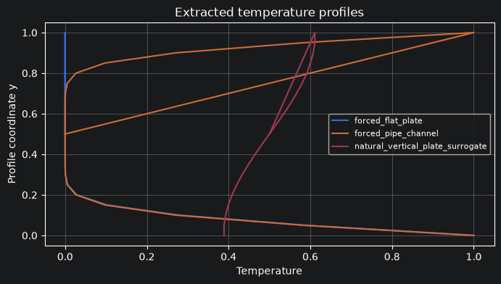
Figure 1. Extracted temperature profiles for the three prescribed-flow cases.
For the flat plate, temperature changes quickly near the heated lower wall and becomes lower farther away from the wall. This shows the thermal boundary layer near the wall. In the channel, both walls are heated and the parabolic velocity affects the temperature profile. The profile is not fully symmetric because the simulation has run for only eight iterations. In the natural-plate case, temperature changes smoothly from the left side to the right side due to the given temperature conditions and circulating flow.

8. Case comparison plot
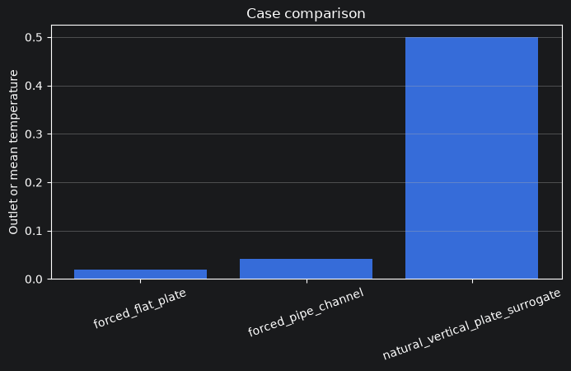
Figure 2. Comparison of outlet or mean temperature at the final recorded iteration.
The natural-plate case has a mean temperature of 0.5. The forced channel outlet temperature is about 0.0421, while the forced flat-plate outlet temperature is about 0.0185.

9. Inline temperature-field visualization
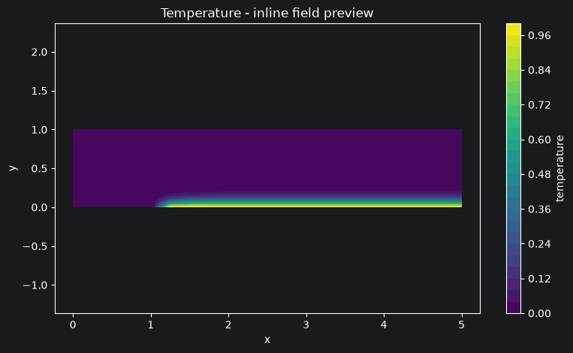
Figure 3. Inline temperature contour for the forced flat-plate case. The x-axis is the streamwise coordinate, the y-axis is the wall-normal coordinate, and the colour bar represents temperature.
The contour shows heating along the lower wall after the unheated starting section. Temperature is highest close to the wall and decreases away from it. The heated layer becomes thicker in the flow direction because of convection and diffusion.

10. Observed numerical behaviour versus physical interpretation

Numerical observations from the supplied results
- At iteration 8, the forced flat-plate outlet temperature is 0.01853125 and its average wall flux is 8.391536.
- At iteration 8, the forced channel outlet temperature is 0.04207700 and its average wall flux is 8.449362.
- At iteration 8, the natural-plate surrogate mean temperature is 0.500000 and its average wall flux is 1.056715.
- The residual decreases between iterations 1 and 8 in all three cases.
- The temperature contour for the flat plate shows a heated near-wall layer that extends downstream.

Physical interpretation
Convection carries temperature in the direction of the flow, while diffusion spreads heat from warmer regions to cooler regions. In the flat-plate case, heating from the lower wall forms a thermal boundary layer that grows downstream. In the channel, both walls are heated and the parabolic flow carries the warmer fluid towards the outlet. In the natural-plate case, the prescribed circulation moves temperature around the domain. However, buoyancy is not calculated from temperature, so this is not a fully coupled natural-convection simulation.

11. Limitations of the teaching model
- The quick run uses a coarse 25 × 21 grid and only eight iterations. These results are preliminary and should not be treated as final converged results.
- The velocity fields are fixed and do not change with temperature.
- The natural-convection case is not a coupled Boussinesq model. The buoyancy and momentum equations are not solved together with the temperature equation.
- The method uses explicit time stepping and first-order upwind convection. This can add numerical diffusion.
- Temperature values are limited to the range −0.05 to 1.05, which can restrict very high or low numerical values.
- The temperature measure is different for the cases: velocity-weighted outlet temperature is used for forced flow, while average interior temperature is used for the natural-plate case.
- Only iterations 1 and 8 are available in the output, so a complete residual graph cannot be made.
- The output does not include a numerical value for boundary-layer thickness. It is discussed only from the profile and contour plots.

12. Conclusion
In this experiment, temperature transport was studied for a flat plate, a channel and a natural-plate flow model. In the eight-iteration run, the channel outlet temperature was higher than the flat-plate outlet temperature. The natural-plate case had a mean temperature of 0.5. The wall flux values were higher for the two forced-flow cases. The flat-plate contour showed a heated layer near the wall that grows downstream. Residuals decreased, but the run was too short to confirm convergence. Therefore, these results show how the code works; the full lab run is needed for final results.

