Experiment 2

Conjugate Heat Transfer in a Double-Pipe Heat Exchanger

Aim
To study thermal interaction between hot and cold laminar streams separated by a conducting wall, including the influence of cold-side Reynolds number and wall-to-fluid heat-transfer ratio.

Simulation Parameters

Parameter | Value
Streamwise grid points | 160
Cold-fluid cross-stream points | 20
Wall cross-stream points | 6
Hot-fluid cross-stream points | 20
Cold-side Reynolds number | 50, 100, 200
Hot-side Reynolds number | 50,100, 200
Solid/fluid heat-transfer ratio | 1 and 100
Time step | 1.25 × 10³
Iterations | 3000

Numerical Method
A steady finite-volume convection–diffusion model is used for the two fluid passages and is coupled to heat conduction in the separating wall. Prescribed parabolic velocity profiles are used to focus the calculation on conjugate thermal transport.

Boundary Conditions
Hot and cold inlet temperatures are prescribed. Zero-gradient conditions are applied at the outlets, the external boundaries are treated as adiabatic, and temperature and heat flux are continuous across each fluid–solid interface.

Observations
Outlet temperatures, heat-transfer rate, effectiveness, temperature residual, relative energy imbalance, and temperature contours were considered for different cold-side Reynolds numbers and conductivity ratios.

Cold-side Re | Solid/fluid ratio | Hot outlet (normalised) | Cold outlet (normalised)
50 | 1 | 0.98 | 0.040
20 | 1 | Re-run required | Re-run required
100 | 1 | 0.97 | 0.023
200 | 1 | 0.98 | 0.020
100 | 100 | 0.96 | 0.040
200 | 100 | 0.965 | 0.030

Conclusion
The temperature contours show heat moving from the hot passage toward the cold passage through the separating wall. Outlet temperatures settle as iterations proceed, while the residual decreases substantially. The results indicate that the flow Reynolds number and the relative thermal conductivity of the wall influence the predicted temperature field and outlet conditions.

Original Simulation Figures
The following pages contain the plots and simulation outputs from the supplied report.

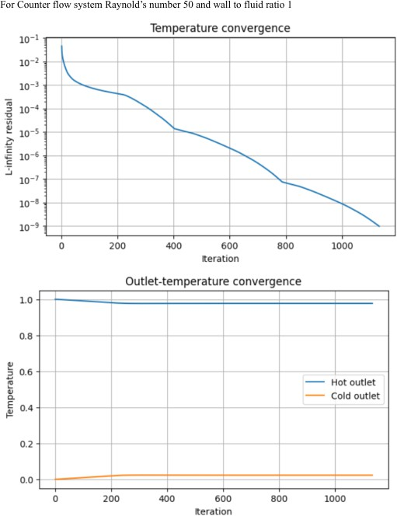

RE = 20 RESULTS
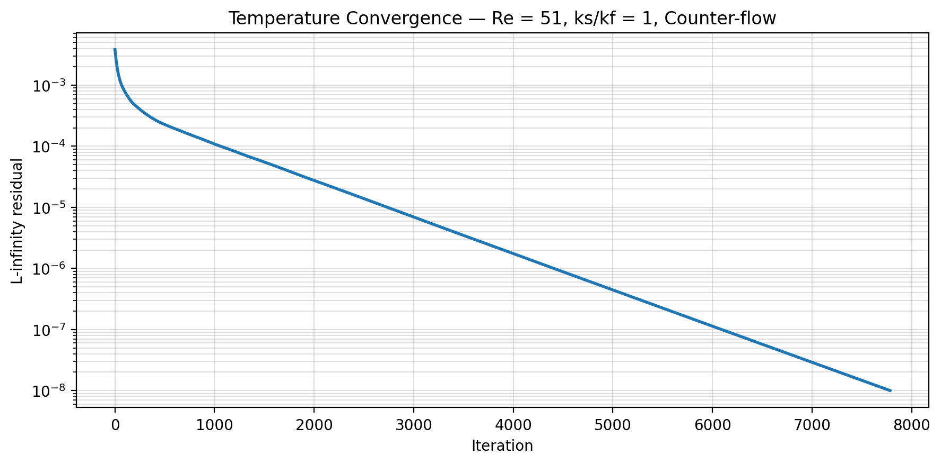
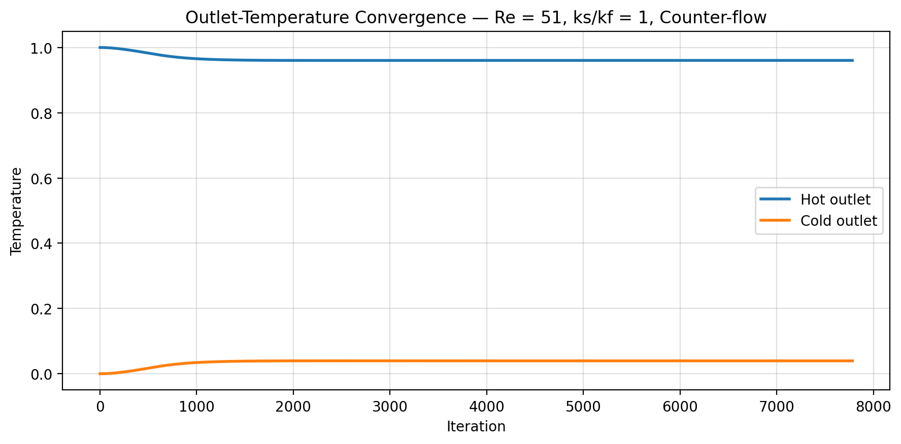

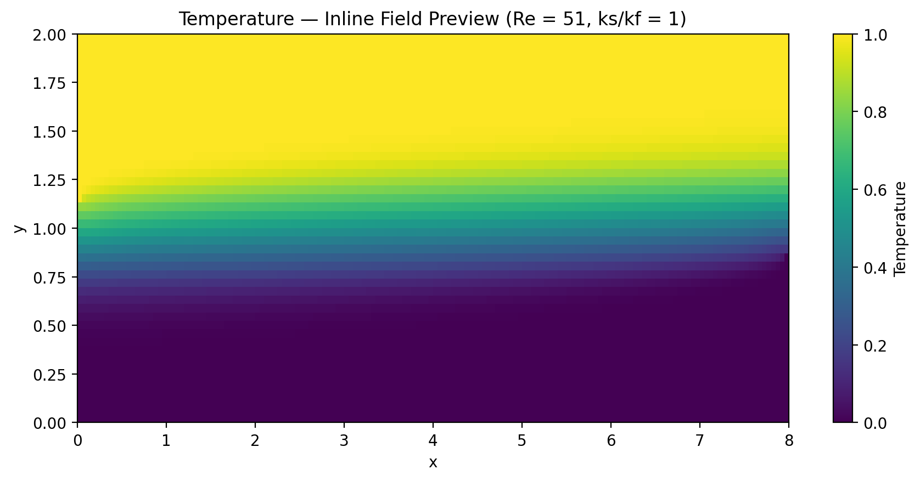

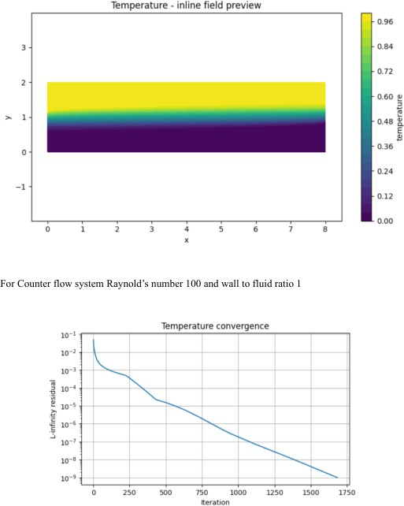

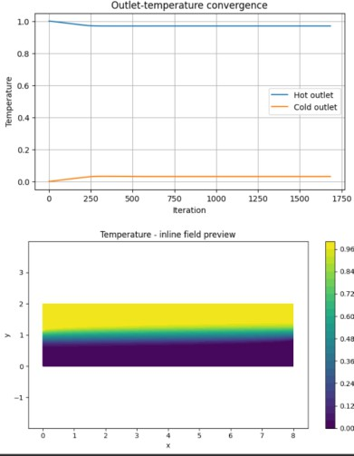

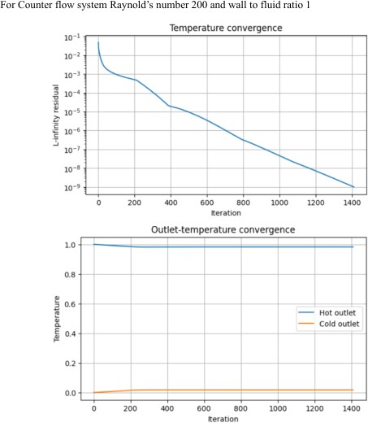

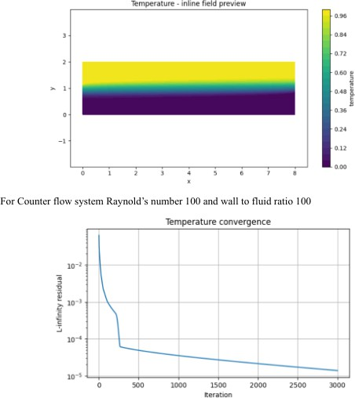

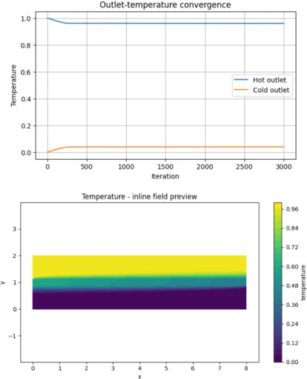

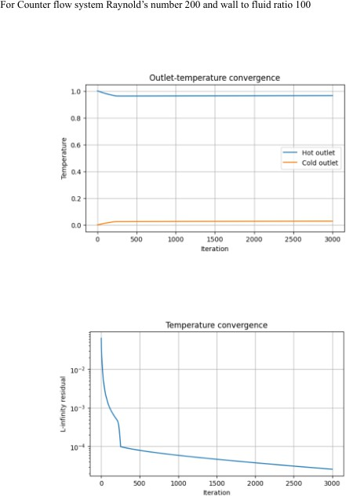

Results and Discussion
A numerical study of conjugate heat transfer in a double-pipe heat exchanger was carried out using the Finite Difference Method (FDM). The simulation was performed under counter-flow conditions with Reynolds numbers of 20 for both the hot and cold streams. The Prandtl number was maintained at 7, and the wall-to-fluid thermal conductivity ratio was set to 1. The inlet temperatures were normalized to 1.0 for the hot fluid and 0.0 for the cold fluid.
The numerical solution converged after 7,783 iterations, reaching a final L-infinity residual of approximately 1.0 × 10⁻⁸. This indicates that the temperature field approached the specified convergence criterion.
The normalized hot-fluid outlet temperature was 0.96054, while the normalized cold-fluid outlet temperature was 0.03946. The decrease in hot-fluid temperature and the increase in cold-fluid temperature indicate heat transfer from the hot stream to the cold stream through the separating solid wall.
The temperature field shows the distribution of temperature across the two fluid channels and the solid wall. The residual convergence graph demonstrates the reduction in numerical error during the iterative solution. The outlet-temperature convergence graph shows the stabilization of the hot and cold outlet temperatures as the solution progresses toward steady state.
These results demonstrate the application of the finite difference approach to modelling conjugate heat transfer in a simplified double-pipe heat exchanger configuration.
Conclusion
The conjugate heat transfer problem for a double-pipe heat exchanger was numerically investigated using the Finite Difference Method under counter-flow conditions. For Reynolds numbers of 20 in both streams and a wall-to-fluid thermal conductivity ratio of 1, the solution converged after 7,783 iterations with a final residual of approximately 1.0 × 10⁻⁸.
The normalized outlet temperatures were 0.96054 for the hot stream and 0.03946 for the cold stream. These results confirm the expected direction of heat transfer from the hot fluid to the cold fluid through the separating wall.
The residual and outlet-temperature convergence plots provide a means of assessing the numerical stability and convergence of the solution. The temperature-field visualization further illustrates the spatial temperature distribution across the fluid and solid regions.
The model uses a planar representation of the double-pipe geometry and a prescribed velocity field. Therefore, the results should be interpreted within these modelling assumptions. Future work could include a more realistic cylindrical geometry, a more detailed velocity solution, and validation against experimental data.

