Experiment 3

Flow and Thermal Behaviour in a Centrifugal Pump Passage

Aim
To evaluate centrifugal pressure development and temperature variation in a simplified rotating annular passage at several pump speeds.

Simulation Parameters

Parameter | Value
Coordinate system | Cylindrical
Radial grid points | 80
Azimuthal grid points | 160
Reynolds number | 500
Iterations | 1200
Pump speeds | 1000, 2000, 3000 rpm

Numerical Method
A reduced-order model in a rotating polar frame prescribes radial and tangential velocity components. The model includes centrifugal pressure rise, wall heat exchange, and heating associated with losses.

Boundary Conditions
The inlet has a specified temperature and radial inflow at the pump eye. Flow moves outward radially, the azimuthal direction is periodic, and wall heat transfer is represented by a distributed source term.

Observations
Pressure contours, estimated pump head, absolute and relative speed, inlet/outlet temperatures, and thermal residual histories were compared across the three rotational speeds.

Speed (rpm) | Re | Inlet temp. (K) | Outlet temp. (K) | Thermal residual | Peak pressure scale
1000 | 500 | 300 | 300.30 | 3.56 × 10 | 7 × 10⁶
2000 | 500 | 300 | 300.18 | 1.81 × 10 | 2.8 × 10⁶
3000 | 500 | 300 | 300.12 | 1.22 × 10 | 2.8 × 10⁶
5120 | 500 | 300 | Re-run required | Re-run required | Re-run required

Conclusion
The pressure field strengthens as rotational speed increases, consistent with greater centrifugal pressure generation. The reported maximum pressure scale rises from about 7 × 10 at 1000 rpm to about 2.8 × 10 at 2000 and 3000 rpm. The predicted outlet-temperature increase remains modest, and the thermal residual decreases across the tested speeds.

Original Simulation Figures
The following pages contain the plots and simulation outputs from the supplied report.

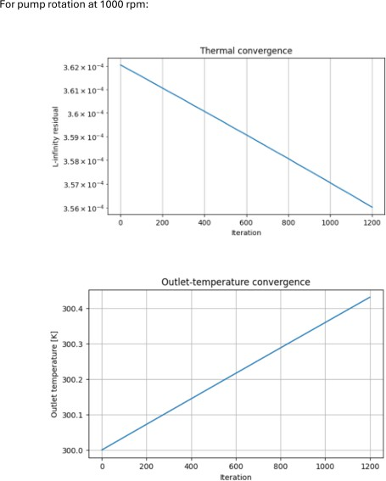

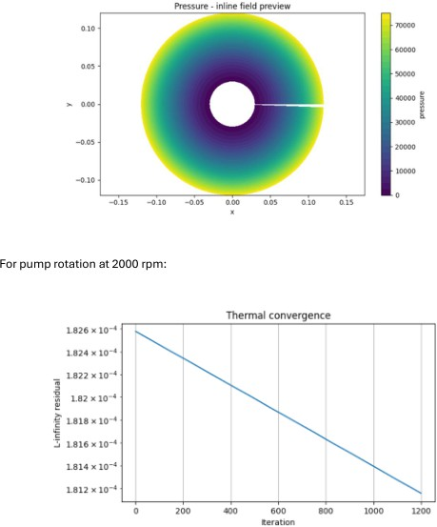

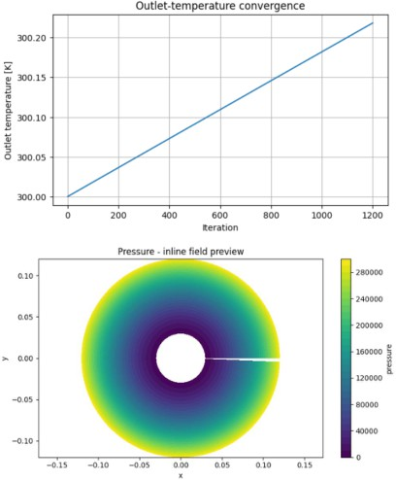

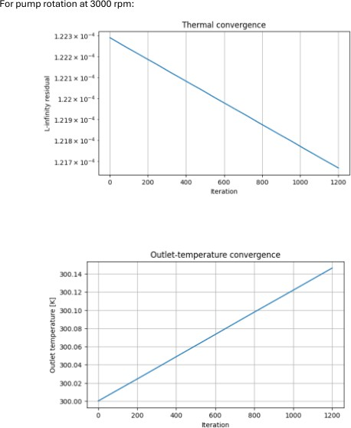

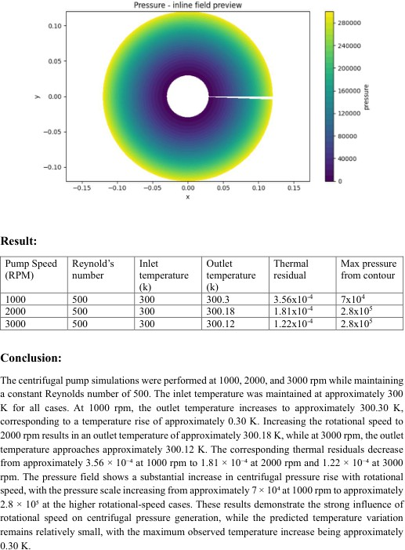
For pump rotation at 5120 rpm:

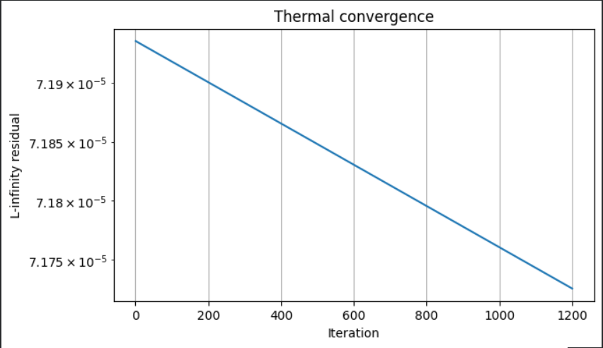

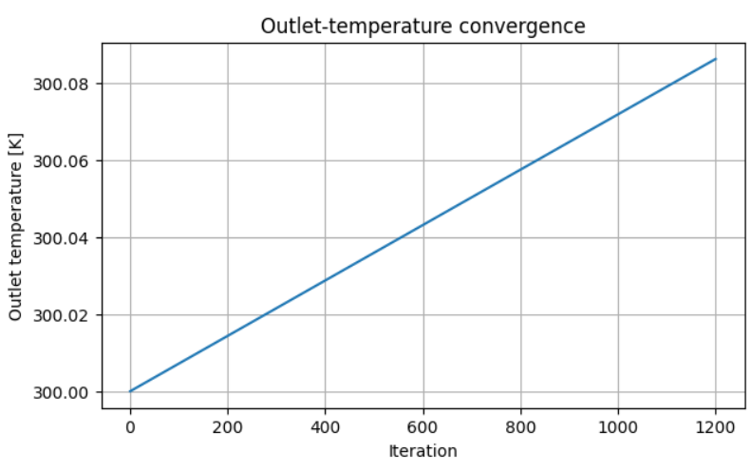

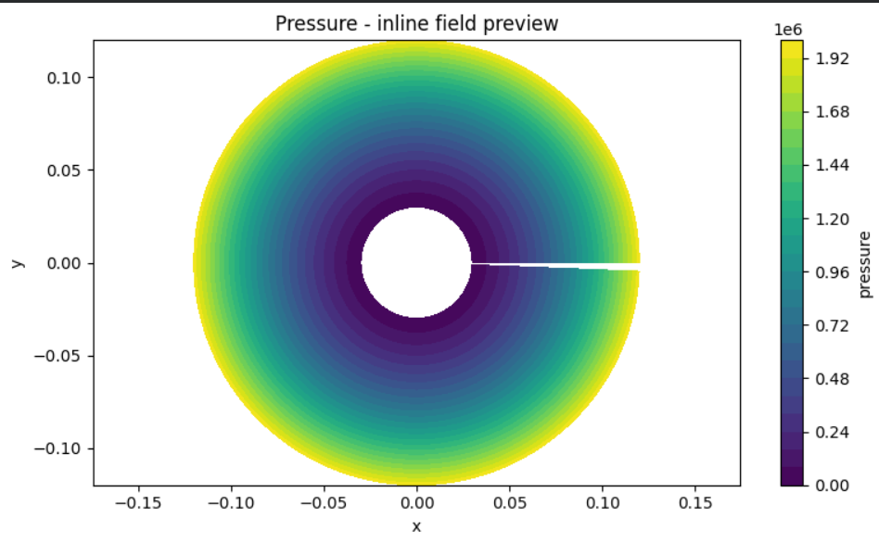

Results and Discussion
A simplified two-dimensional annular single-rotating-frame centrifugal pump heat-transfer model was analysed numerically at a fixed Reynolds number of 500. The inlet temperature was maintained at 300 K, while the rotational speed was varied to study its effect on the thermal response and pressure rise of the pump.
At 1000 RPM, the outlet temperature was 300.30 K, with a reported thermal residual of 3.56 × 10⁻ⁿ and a peak pressure scale of 7 × 10ⁿ. At 2000 RPM, the outlet temperature decreased to 300.18 K, while the thermal residual was 1.81 × 10⁻ⁿ and the peak pressure scale was 2.8 × 10ⁿ. At 3000 RPM, the outlet temperature was 300.12 K, with a thermal residual of 1.22 × 10ⁿ and a peak pressure scale of 2.8 × 10ⁿ. The exponents in these reported residual and pressure values should be verified from the original solver output.
An additional simulation was performed at 5120 RPM. The 5120 RPM case must be re-run for its outlet temperature, pressure rise, pump head, and final residual. The previous 5151 RPM values are not used as Roll No. 20 results.
Fluid heat gain and mass flow rate for 5120 RPM must be taken from the updated solver output. These results describe the model response at the selected operating condition.
The additional high-speed result provides a further data point for examining the relationship between rotational speed and pump performance. However, the expected near-linear relationship between pump head and RPM² should be evaluated using the pump-head values obtained from all speed cases.

Conclusion
The centrifugal pump heat-transfer model was investigated at a fixed Reynolds number of 500 and an inlet temperature of 300 K for different rotational speeds. The reported outlet temperatures for 1000, 2000, and 3000 RPM were 300.30 K, 300.18 K, and 300.12 K, respectively. For the additional case at 5120 RPM, the solver predicted an outlet temperature of 300.0862 K.
At 5120 RPM, the numerical model reported a pressure rise of approximately 1.9581 MPa, a pump head of approximately 200.02 m, and a final L-infinity residual of 7.1258 × 10⁻⁵. The reported fluid heat gain was approximately 16.98 W.
The results demonstrate how the simplified numerical model can be used to investigate the thermal and pressure-related performance of a centrifugal pump at different rotational speeds. A quantitative assessment of pump-head scaling with RPM² requires consistent pump-head results for all operating speeds. The reported values should also be checked against the original solver output before final submission, particularly the thermal residuals and peak-pressure values for the first three cases.

