Experiment 4

Numerical Investigation of Kármán Vortex Shedding

Aim
To capture alternating vortex formation downstream of a circular cylinder and estimate the corresponding Strouhal number from the unsteady force response.

Simulation Parameters

Parameter | Value
Coordinate system | Cylindrical
Radial grid points | 80
Azimuthal grid points | 160
Reynolds number | 520
Iterations | 1200
Lattice model | D2Q9 BGK Lattice Boltzmann

Numerical Method
The D2Q9 BGK lattice Boltzmann method is used with bounce-back treatment at the cylinder. Drag and lift are evaluated using momentum exchange, and the vortex-shedding frequency is estimated from the force history.

Boundary Conditions
A low-Mach inlet velocity and open outlet are used. The upper and lower boundaries use wall treatment, while no-slip at the cylinder is enforced with bounce-back.

Observations
Lift and drag histories, average drag, lift amplitude, estimated Strouhal number, density deviation, vorticity contours, and downstream wake periodicity were reviewed.

Quantity | Approximate result
Maximum lift coefficient | +0.21
Minimum lift coefficient | −0.15
Lift peak-to-peak range | 0.36
Initial maximum drag coefficient | 20
Developed mean drag coefficient | 1.5–1.6
Vortex-shedding period | 7–8 (dimensionless time)
Estimated Strouhal number | 0.13–0.14
Vorticity range | −9 to +7.5

Conclusion
The lift signal develops alternating positive and negative peaks, consistent with vortices being shed from opposite sides of the cylinder. After a strong initial transient, the drag coefficient settles near 1.5–1.6. The vorticity field displays alternating structures downstream, forming a Kármán vortex street. The Strouhal estimate is approximate because the oscillations are still developing near the end of the simulated interval.

Original Simulation Figures
The following pages contain the plots and simulation outputs from the supplied report.

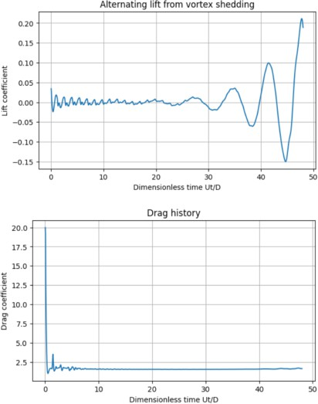

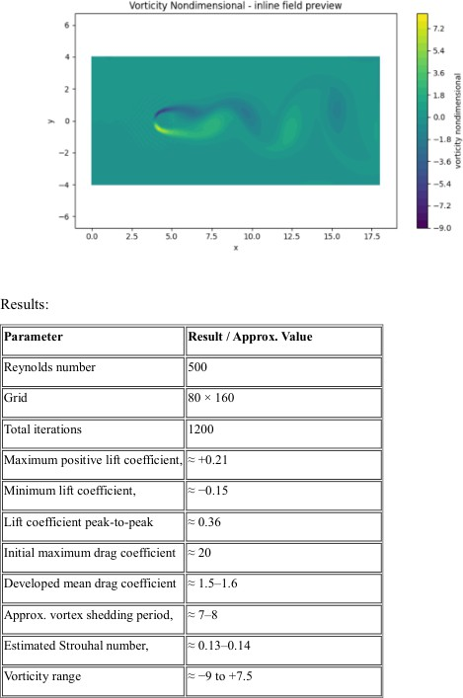

For RE = 520
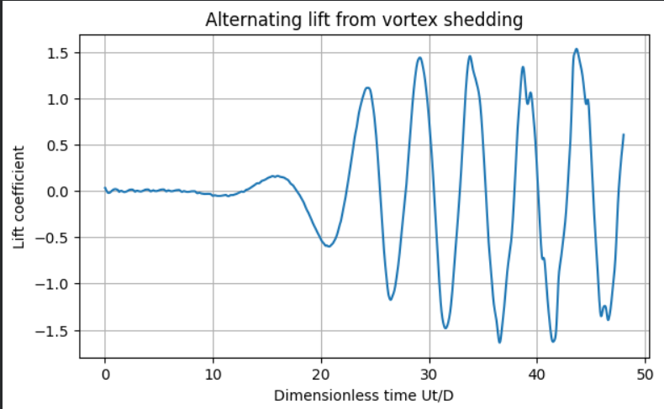

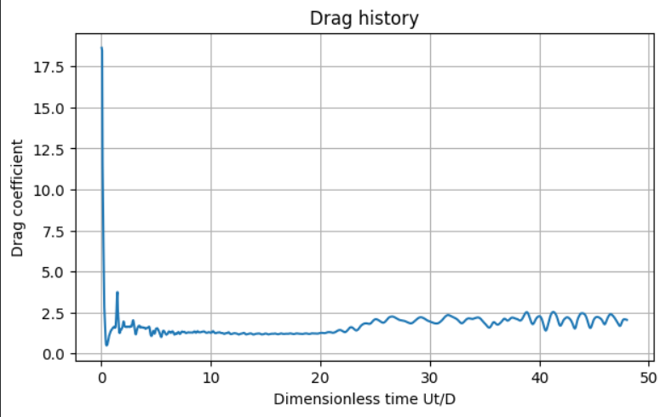

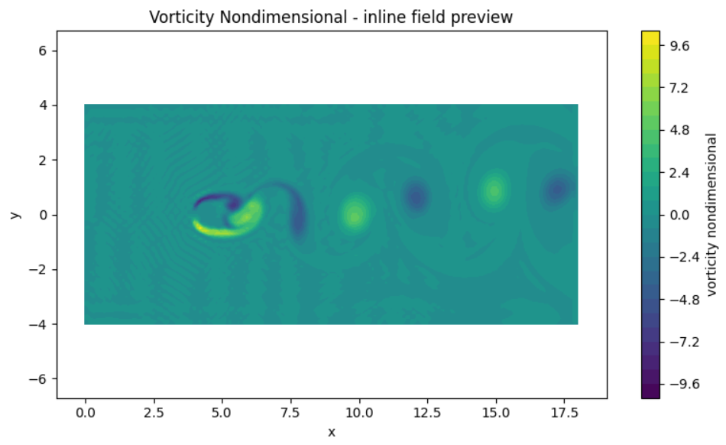

Parameter | Result / Approx. Value
Reynolds number | 520
Grid | 80 × 160
Total iterations | 1200
Maximum positive lift coefficient | ≈ +1.5
Minimum lift coefficient | ≈ −1.6
Lift coefficient peak-to-peak | ≈ 3.1
Initial maximum drag coefficient | ≈ 19
Developed mean drag coefficient | ≈ 1.5–2.5
Approx. vortex shedding period | ≈ 5–7
Estimated Strouhal number | ≈ 0.14–0.20
Vorticity range | ≈ −10 to +10

Results and Discussion
The numerical simulation of vortex shedding behind a circular cylinder was performed at a Reynolds number of 520 using a computational grid of 80 × 160 and 1200 iterations. The lift coefficient history shows alternating positive and negative fluctuations, indicating the formation of an unsteady wake behind the cylinder.
From the plotted lift history, the maximum positive lift coefficient is approximately +1.5, while the minimum value is approximately −1.6. The peak-to-peak lift coefficient is therefore approximately 3.1. The drag coefficient initially reaches a high value of approximately 19 during the transient stage and subsequently fluctuates around an estimated range of 1.5–2.5.
The vorticity contour illustrates alternating regions of positive and negative vorticity downstream of the cylinder, which are characteristic of vortex shedding. The observed fluctuations in lift and drag indicate the unsteady aerodynamic forces associated with the wake.
The vortex shedding period and Strouhal number should be determined from successive peaks in the lift coefficient history. The values estimated visually from the available graphs are preliminary and require confirmation using the numerical output.
Conclusion
The flow around a circular cylinder at a Reynolds number of 520 was investigated numerically. The lift coefficient history showed alternating oscillations, while the drag coefficient exhibited a large initial transient followed by smaller fluctuations. The vorticity field displayed alternating positive and negative structures in the downstream wake, indicating vortex shedding.
The approximate maximum and minimum lift coefficients were +1.5 and −1.6, respectively, giving a peak-to-peak range of approximately 3.1. The drag coefficient fluctuated around an estimated range of 1.5–2.5 after the initial transient.
The results demonstrate the unsteady nature of the flow and the associated variation in aerodynamic forces. However, the shedding period and Strouhal number require quantitative analysis of the lift history, and the approximate graph-based values should be verified against the solver output before final submission.

