Transient Couette Flow: Explicit and Implicit Formulations
Aim: To compare explicit FTCS and implicit backward-Euler solutions of transient viscous momentum diffusion against the analytical series solution.

Case definition and parameters: Simulations were analyzed on the following parameters. Fourier number for Explicit calculation: 0.25, 0.45, 0.55
Fourier number for Implicit calculation: 5 Velocity: 1
t_end: 2
ny: 81
nu: 0.01

Governing Equation:
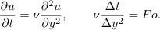
For FTCS, stability requirements Fo ≤ 0.5.

Boundary Conditions: Initially stationary fluid; lower plate fixed; upper plate impulsively set to speed U; no pressure gradient.
Numerical Method: Initially stationary fluid; lower plate fixed; upper plate impulsively set to speed U; no pressure gradient.
Observations: Initially stationary fluid; lower plate fixed; upper plate impulsively set to speed U; no pressure gradient. explicit Fourier numbers 0.25, 0.45, and 0.55. Explain the stability boundary and compare both schemes at the same physical time.

For explicit fourier number 0.55
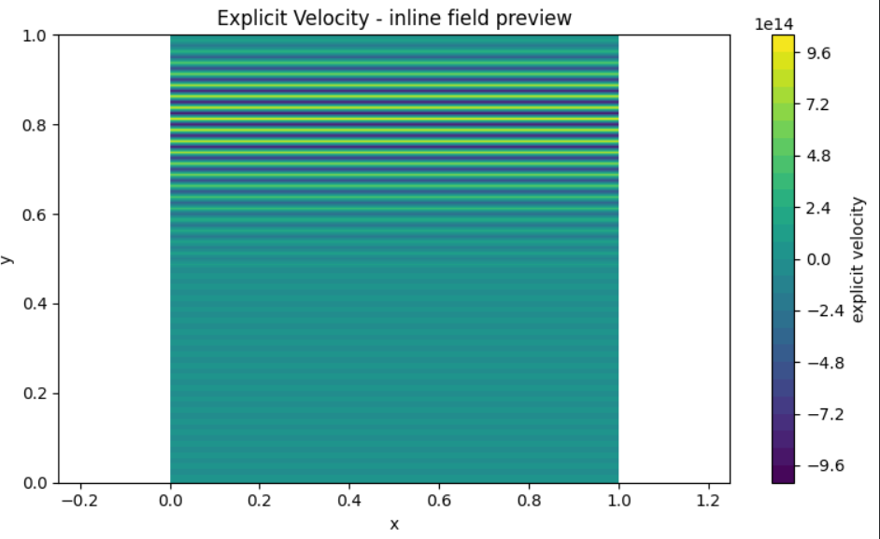
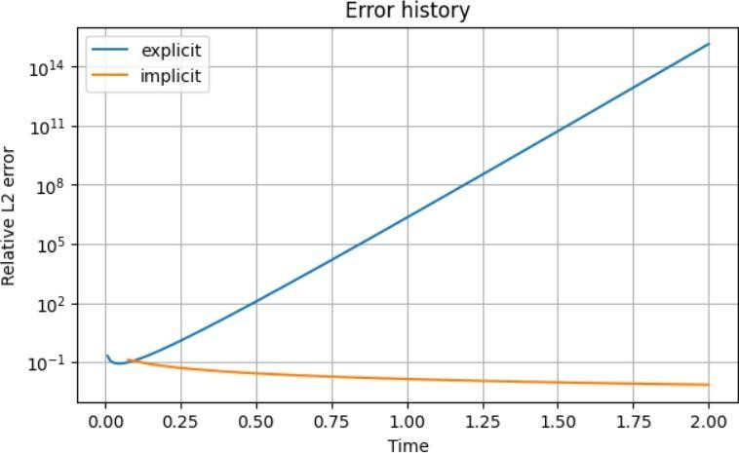

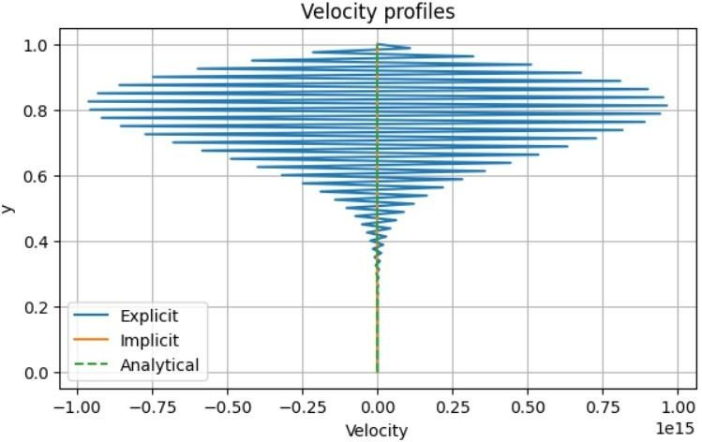
For explicit fourier number 0.45
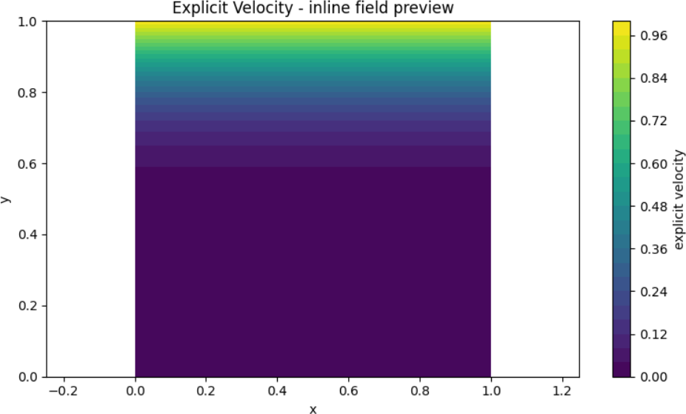

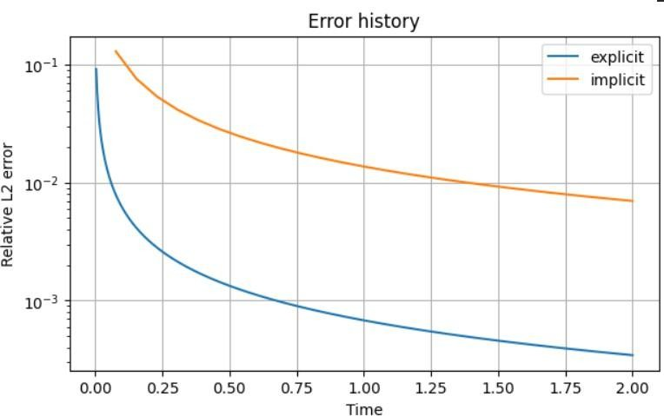
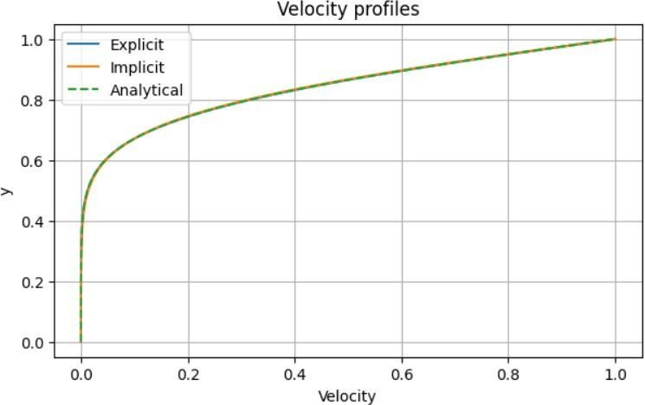

For explicit fourier number 0.25
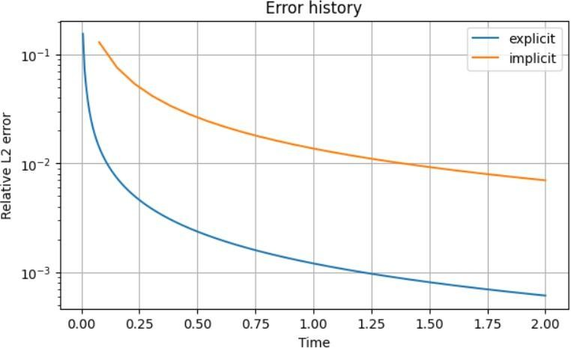

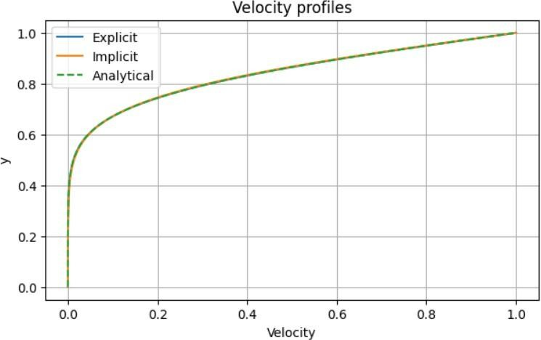

Results:

Parameter | Result
Kinematic viscosity, nu | 0.01
Upper plate velocity, U | 1
Number of grid points, n_{y} | 20 (re-run required)
Final simulation time, t_{end} | 2
Explicit Fourier number, Fo | 0.25, 0.45, 0.55
Implicit Fourier number, Fo | 5
Maximum stable Fourier number for FTCS | 0.5
Relative L2 error at t=2, explicit Fo=0.25 | 6x10⁻⁴

Relative L2 error at t=2, explicit Fo=0.45 | 3x10⁻⁴
Relative L2 error at t=2, explicit Fo=0.55 | 1015
Relative L2 error at t=2, implicit Fo=5 | 7x10⁻³
Velocity profile for Fo=0.25 and 0.45 | Closely matches analytical solution
Velocity profile for Fo=0.55 | Unstable, with unbounded oscillations
Overall stability | Explicit stable for Fo\leq0.5\); unstable for Fo>0.5

Results at N=20

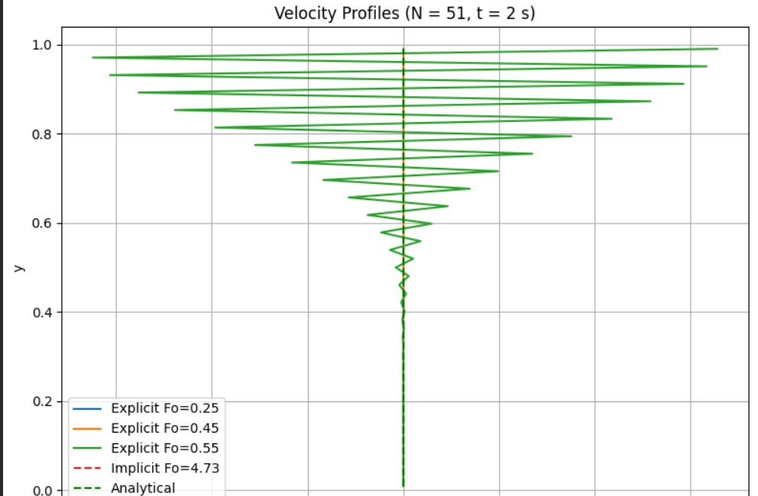

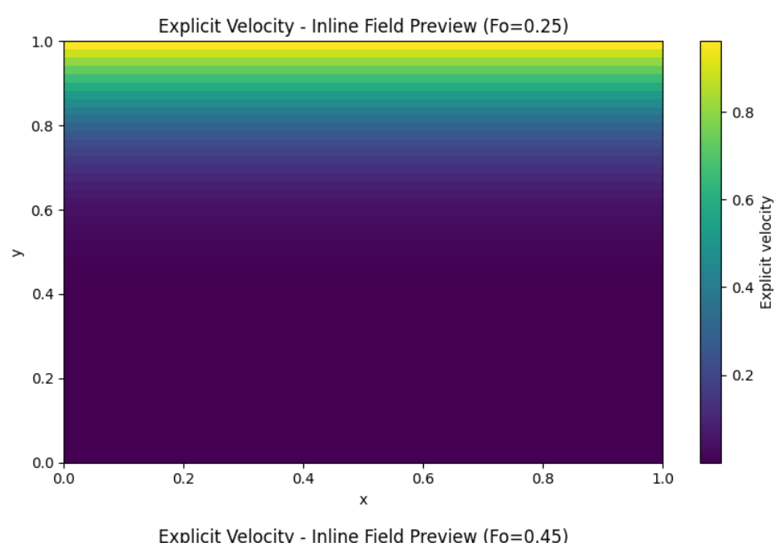

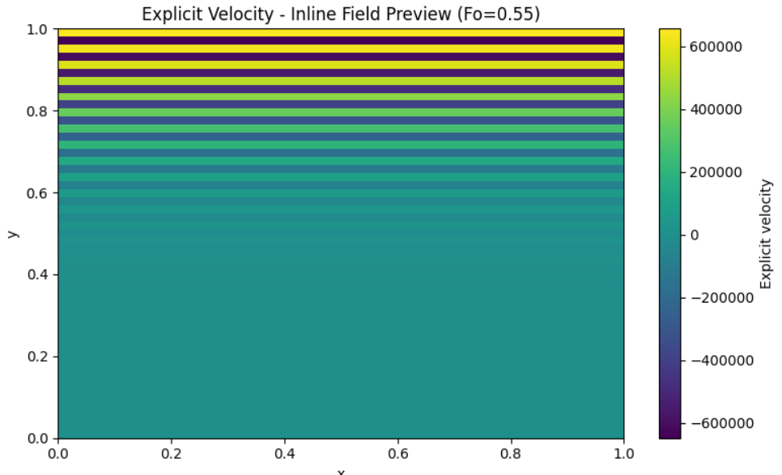

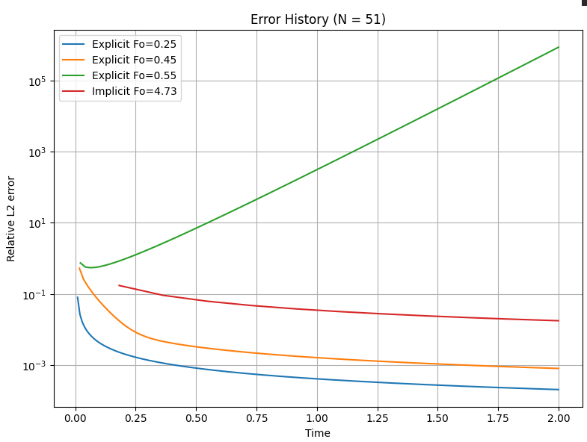

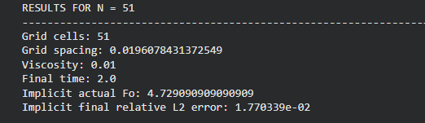

Results (N = 20)
Parameter | Result
Kinematic viscosity, (\nu) | 0.01
Upper plate velocity, (U) | 1 m/s
Number of grid points, (n_y) | 20 (re-run required)
Final simulation time, (t_{\mathrm{end}}) | 2 s
Explicit Fourier number, (Fo) | 0.25, 0.45, 0.55
Implicit Fourier number, (Fo) | 4.73 (actual)
Maximum stable Fourier number for FTCS | 0.5
Relative L2 error at (t=2), explicit (Fo=0.25) | Read from solver output
Relative L2 error at (t=2), explicit (Fo=0.45) | Read from solver output
Relative L2 error at (t=2), explicit (Fo=0.55) | Unstable; error grows rapidly
Relative L2 error at (t=2), implicit | Read from solver output
Velocity profile for (Fo=0.25) and (Fo=0.45) | Stable profiles; compare with analytical solution
Velocity profile for (Fo=0.55) | Unstable, with growing oscillations
Overall stability | Explicit stable for (Fo \leq 0.5); unstable for (Fo > 0.5)

Conclusion:
The transient Couette flow problem was investigated using the explicit Forward-Time Central-Space (FTCS) method and the implicit backward-Euler method. The numerical solutions were compared with the analytical solution for viscous momentum diffusion between two parallel plates. The upper plate velocity was maintained at 1 m/s, the lower plate remained stationary, the kinematic viscosity was 0.01 m²/s, and the final simulation time was 2 s.
Comparison of grid resolution: The original simulation used 81 grid points, whereas the additional simulation used 20 grid points. Reducing the number of grid points increased the grid spacing and changed the time step required to achieve the selected Fourier number. Therefore, the numerical error and resolution of the transient velocity profile may differ between the two grids.
Effect of Fourier number on explicit-scheme stability: In both grid cases, the explicit FTCS method has a theoretical stability requirement of Fo ≤ 0.5 for the one-dimensional diffusion equation. The cases with Fo = 0.25 and Fo = 0.45 are within this stability limit, while Fo = 0.55 exceeds it and is expected to produce growing numerical oscillations. This stability criterion remains unchanged when the grid is changed from 81 to 51 points.
Comparison with the implicit method: The backward-Euler method remains stable for larger Fourier numbers. For the N = 20 simulation, the actual implicit Fourier number must be recalculated for N = 20, compared with the target value of 5.0. The implicit solution remained bounded in the plotted results. However, stability alone does not guarantee the smallest transient error, so the numerical solution should be compared with the analytical profile at the same physical time.
Overall conclusion: The comparison demonstrates that both grid resolution and Fourier number influence the numerical results. The 81-point grid provides finer spatial resolution than the 20-point grid, while the explicit stability limit remains Fo ≤ 0.5 for both cases. The explicit method becomes unstable when Fo = 0.55, whereas the implicit method can operate with a larger Fourier number. A quantitative conclusion about which grid is more accurate requires the actual relative L2 errors for both grids at t = 2 s.

