Two-Dimensional Plate Heat Conduction
Aim: To compare Jacobi and line-TDMA/SOR solutions of the steady two-dimensional Laplace equation against an analytical solution.

Case definition and parameters: Simulations were analyzed on the following parameters. Nx=81, 30
Ny= 61,15
Temperature at source= 100 Max Iterations = 10000 Tolerance = 1x10⁻⁹

Governing Equation:
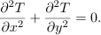
Boundary Conditions: T(0,y) = TLsin(πy/H); the right, top, and bottom boundaries are held at zero temperature.
Numerical Method: Second-order finite differences with point Jacobi iteration and line-implicit TDMA/SOR iteration.
Observations: Iteration counts, final residuals, relative L2 errors, center line profiles, and influence of relaxation factor and grid size. Compare both methods on at least two grids. Report convergence rate, analytical error, and the effect of SOR relaxation factor.

For nx=81 and ny=61
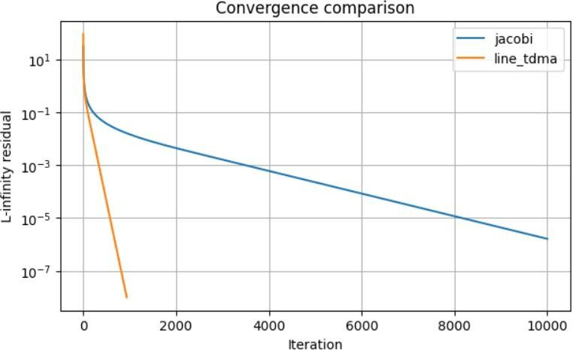
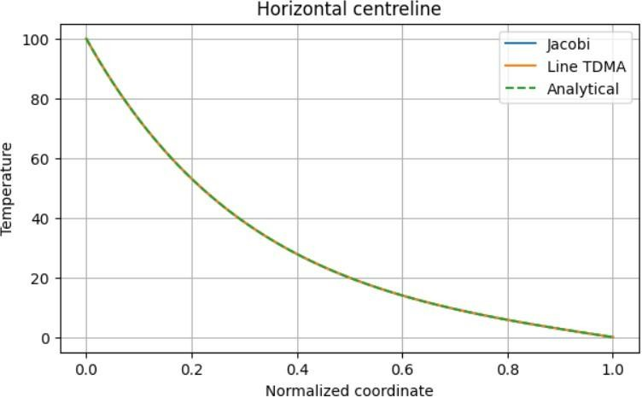

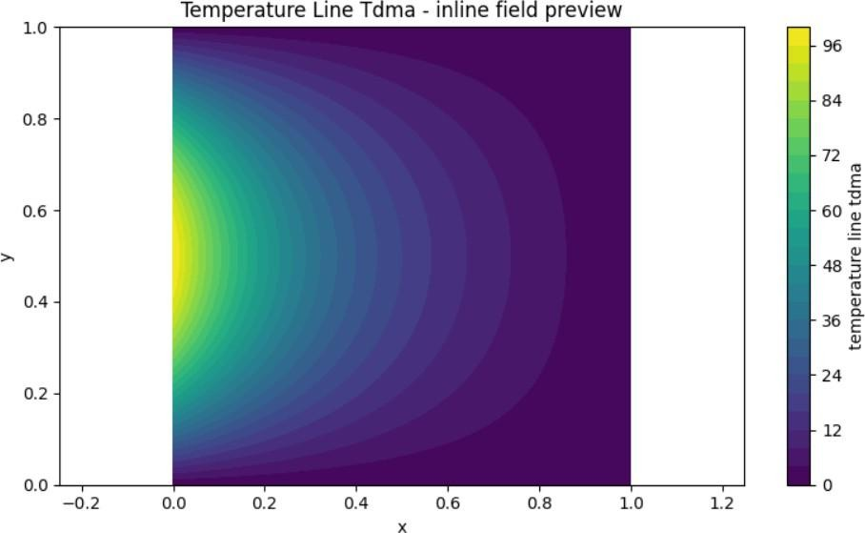
For nx=30 and ny=15

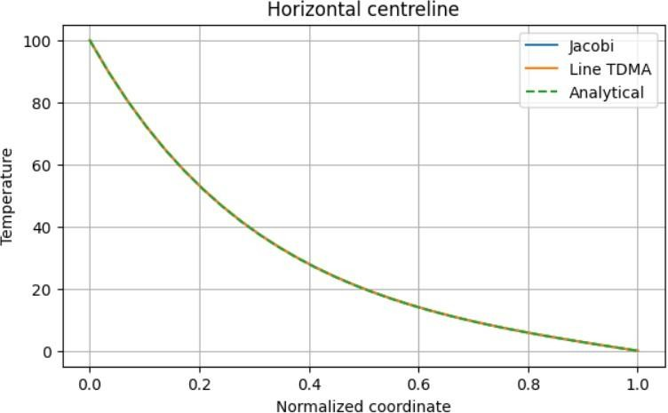
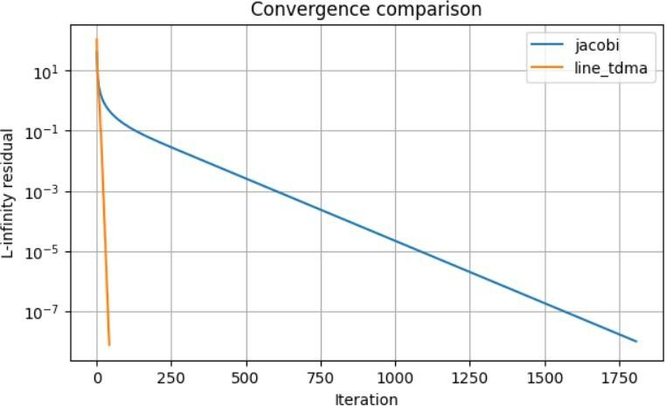

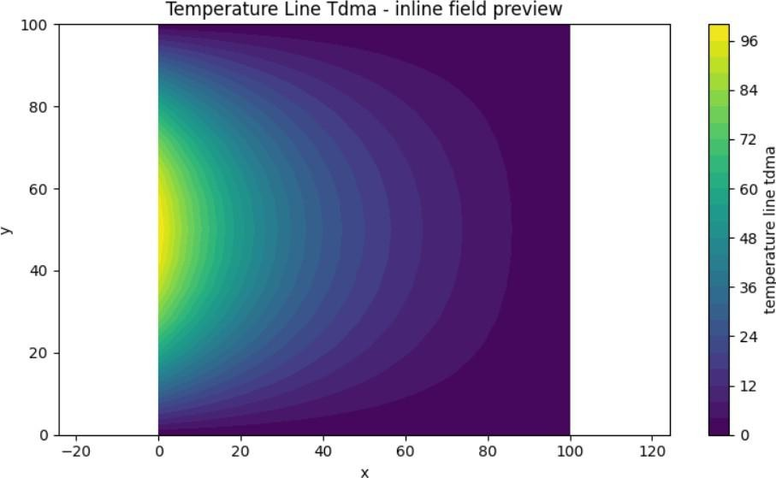

For 20 × 20

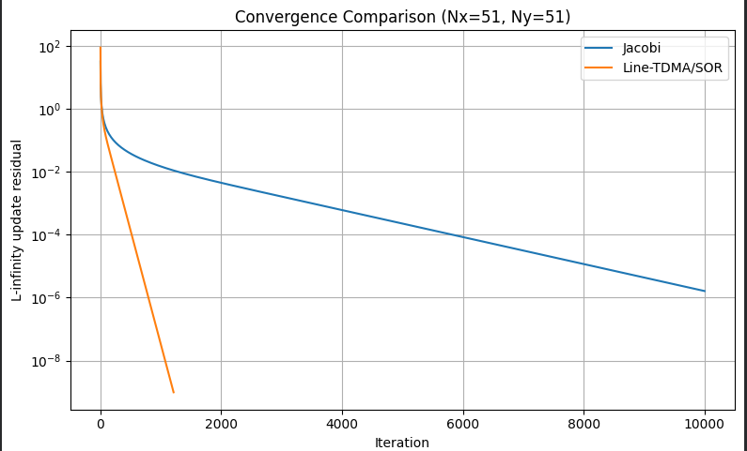

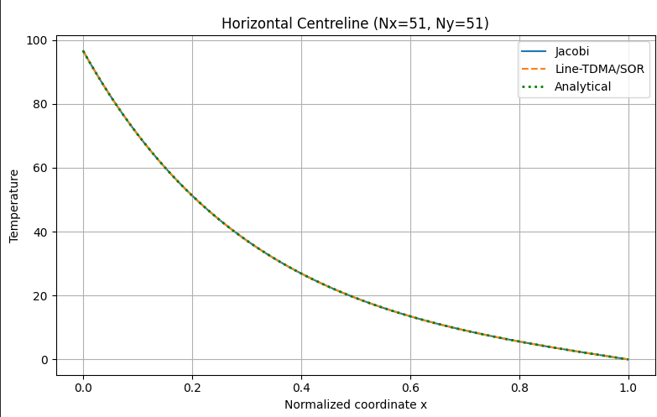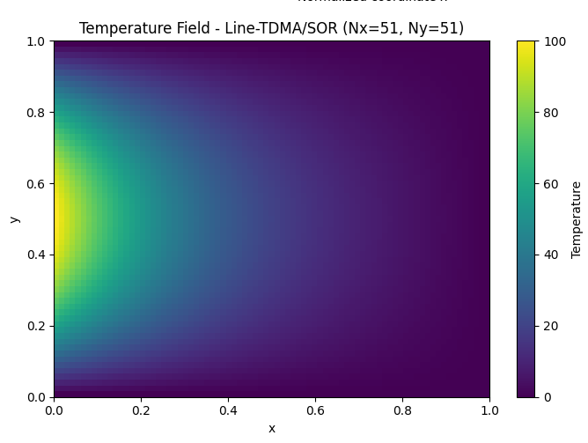

Results:

Parameter | Fine Grid (81 × 61) | Additional Grid (20 × 20)
Grid size, (N_x \times N_y) | 81 × 61 | 20 × 20
Source temperature | 100 | 100
Maximum iterations allowed | 10,000 | 10,000
Convergence tolerance | (10^{-9}) | (10^{-9})
Jacobi iterations shown | 10,000 | Actual output required
Line-TDMA iterations to reach tolerance | 800–900 | Actual output required
Jacobi final (L_\infty) residual | (2 \times 10^{-6}) | Actual output required
Line-TDMA final (L_\infty) residual | Below (10^{-9}) | Actual output required
Centreline profile agreement | Very good | Verify against analytical solution
Relative convergence speed | Slower | Depends on actual iteration counts

Conclusion:

Conclusion
The two-dimensional steady heat conduction problem was solved using the Jacobi and line-TDMA iterative methods on grids of 81 × 61, 30 × 15, and an additional grid of 20 × 20. Both methods produced temperature distributions that closely matched the analytical centreline solution, with a maximum temperature of approximately 100 at the midpoint of the heated boundary and a gradual decrease toward the zero-temperature boundaries.
The convergence results showed that line-TDMA was substantially more efficient than Jacobi. On the 30 × 15 coarse grid, Jacobi required approximately 1,800 iterations to reach the specified tolerance of (10^{-9}), whereas line-TDMA required approximately 200 iterations. On the 81 × 61 fine grid, line-TDMA reached the tolerance within approximately 800–900 iterations, while Jacobi remained at a residual of approximately (2 \times 10^{-6}) after 10,000 iterations.
An additional simulation was performed using a 20 × 20 grid to investigate the effect of grid resolution on the temperature distribution and convergence behaviour. This grid provides an intermediate comparison with the original fine grid. Its actual iteration counts and final residuals should be used to quantify the convergence performance and determine whether the specified tolerance was achieved.
Overall, the results demonstrate that grid resolution affects the computational effort required for convergence, particularly for point-Jacobi iteration. The line-TDMA method handles this increase more efficiently because of its line-implicit solution procedure. Therefore, line-TDMA is the preferred method for this problem when faster convergence and satisfaction of a strict residual tolerance are required. The additional 20 × 20 results provide further information for evaluating the relationship between grid resolution, convergence speed, and solution accuracy.

