Experiment 8
Rayleigh–Taylor Instability Using the Volume-of-Fluid Method

Aim
To study the Rayleigh–Taylor instability between two fluids of different densities using a two-dimensional VOF method. The effect of interface perturbation, grid size and density contrast is investigated. The conservation of the heavy-fluid phase is also monitored.

Simulation Parameters
Parameter | Value
Domain length (Lx) | 1.0 m
Domain height (Ly) | 2.0 m
Base grid | 48 × 96
Light-fluid density | 1.0
Heavy-fluid density | 1.2
Gravitational acceleration | 9.81 m/s²
Kinematic viscosity | 0.005
Initial perturbation amplitude | 0.04 m
Final simulation time | 2.1 s
Maximum time step | 0.003 s
Roll number | 20
Grid used for main run | 68 × 136

Numerical Method
The volume fraction α is used to identify the heavy fluid. A value of α = 1 represents the heavy fluid, α = 0 represents the light fluid and intermediate values represent cells containing the interface. The VOF equation is solved using donor-cell upwind fluxes.
The momentum equations include convection, viscous diffusion and buoyancy terms. A pressure-correction step is used to reduce the velocity divergence. The time step is selected using advective and viscous restrictions.

Initial and Boundary Conditions
The initial interface is defined by y = 1 + 0.04 cos(2πx/Lx). Both velocity components are initially zero. The horizontal direction is treated periodically. The vertical velocity is stored at the cell faces, with the boundary treatment specified in the numerical code.

STUDENT EXERCISES

Exercise 1 – Zero perturbation amplitude
With zero perturbation, the interface remains horizontal in this calculation. The maximum speed is approximately 9.50 × 10⁻¹⁵ m/s, which is effectively zero. The initial and final heavy-fluid areas are equal.
Output | Computed value
Time steps | 167
Maximum speed (m/s) | 9.496e-15
Initial heavy-fluid area | 1.000000000000
Final heavy-fluid area | 1.000000000000
Relative mass error | 0.000e+00

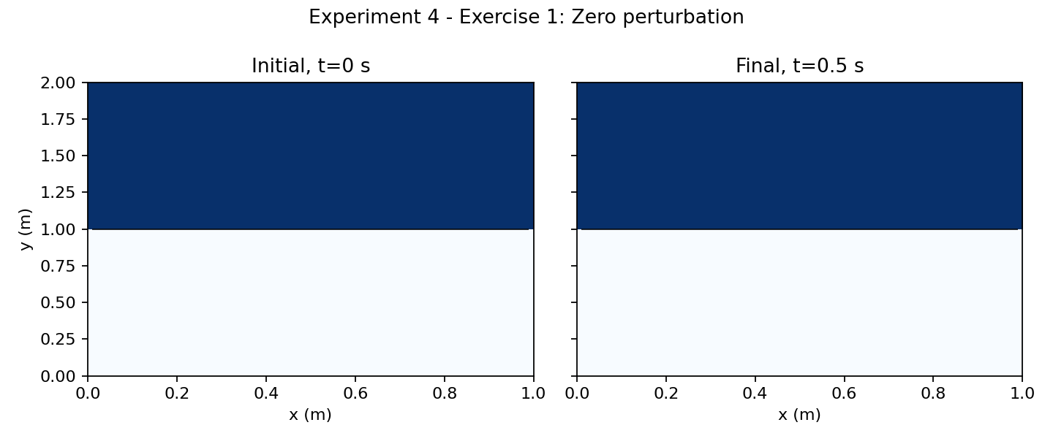
Figure 4.6: Initial and final interface for zero perturbation.

Exercise 2 – Grid refinement
The measured mixed-cell interface thickness decreases as the grid is refined. The heavy-fluid area is conserved to numerical precision in all three runs. The thickness is a grid-dependent measure and is reported in physical units.
Grid | Steps | Mean interface thickness (m) | Relative mass error
24 × 48 | 700 | 0.750000 | 3.331e-16
48 × 96 | 700 | 0.588542 | 3.331e-16
96 × 192 | 861 | 0.438368 | 1.665e-15

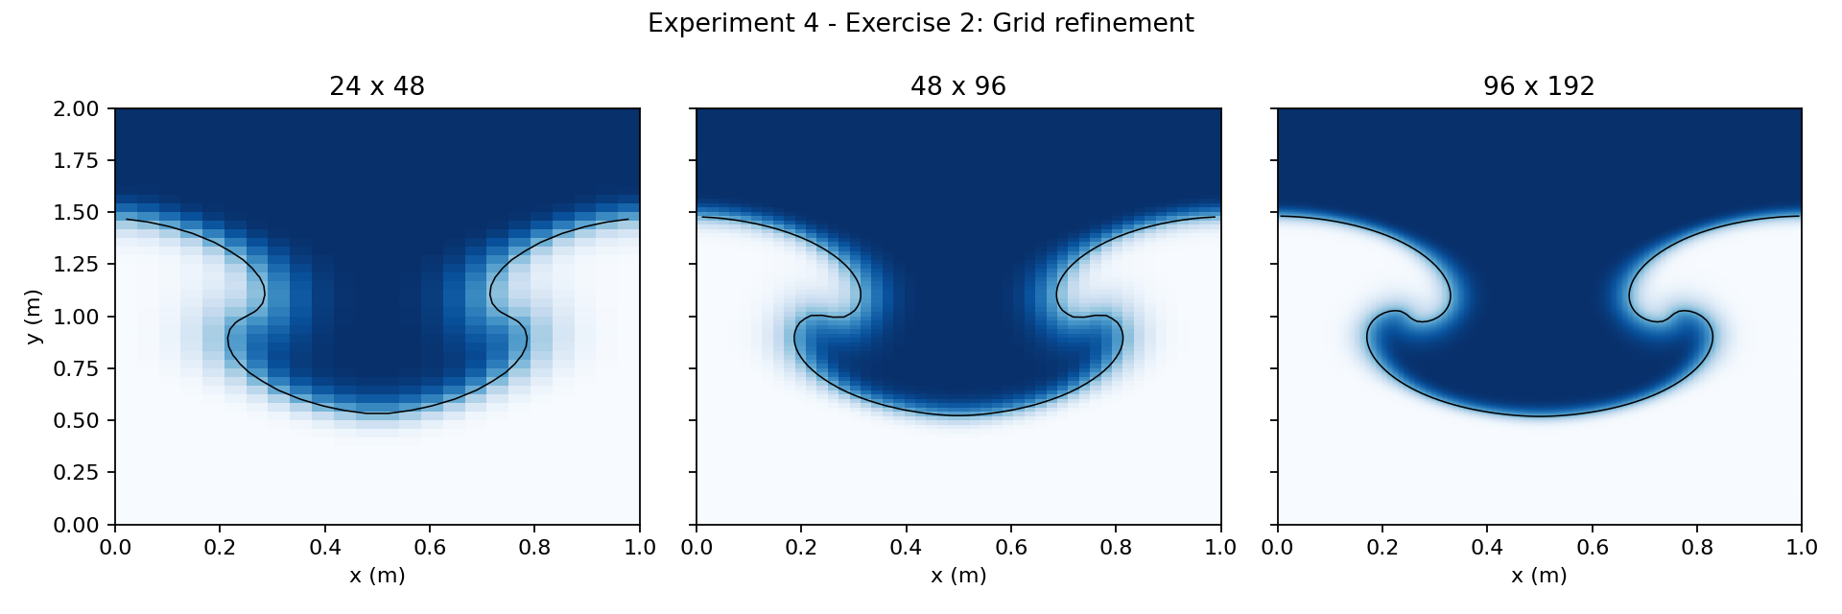
Figure 4.7: Final interface on three grid resolutions.

Exercise 3 – Density contrast
The Atwood number and maximum speed increase as the heavy-fluid density is increased. This is the response produced by the supplied Boussinesq-style model for the selected density values. The larger-contrast cases should be interpreted with care because the Boussinesq approximation is less suitable at larger density differences.
Heavy density | Atwood number | Maximum speed (m/s) | Relative mass error
1.05 | 0.024390 | 0.047789 | 0.000e+00
1.20 | 0.090909 | 0.245761 | 3.331e-16
1.50 | 0.200000 | 0.678173 | 4.441e-16
2.00 | 0.333333 | 1.448448 | 6.661e-16

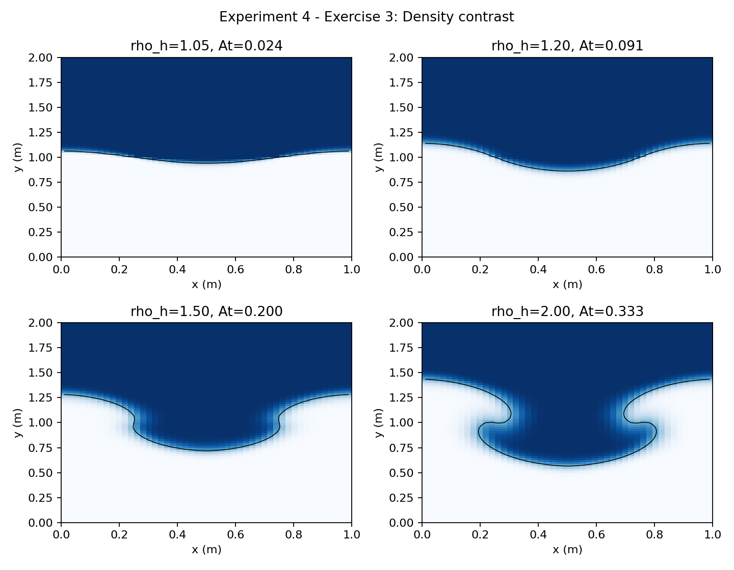
Figure 4.8: Interface fields for different density contrasts.

Exercise 4 – Phase conservation
The heavy-fluid area remains effectively constant during the simulation. The relative mass error is approximately 3.33 × 10⁻¹⁶, showing conservation to floating-point precision for this run.
Output | Computed value
Initial heavy-fluid area | 1.000000000000
Final heavy-fluid area | 1.000000000000
Relative mass error | 3.331e-16
Maximum projected divergence | 2.244e-12
Time steps | 700

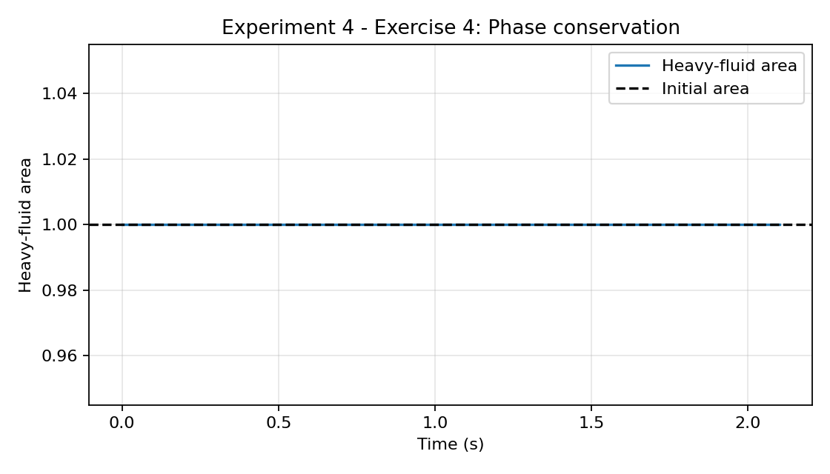
Figure 4.9: Heavy-fluid area versus time.

Exercise 5 – Donor-cell VOF and geometrical reconstruction
The supplied program implements donor-cell VOF only. Donor-cell transport uses the upwind cell fraction and is simple to implement, but it can diffuse the interface. PLIC reconstructs the interface geometry in mixed cells and can give a sharper interface, with greater implementation complexity. The figure is a conceptual schematic, not a numerical comparison from two solvers.
Method | Result
Donor-cell VOF | Implemented in the supplied code; upwind cell fraction is used.
Geometrical reconstruction (PLIC) | Discussed for comparison; not implemented in the supplied code.

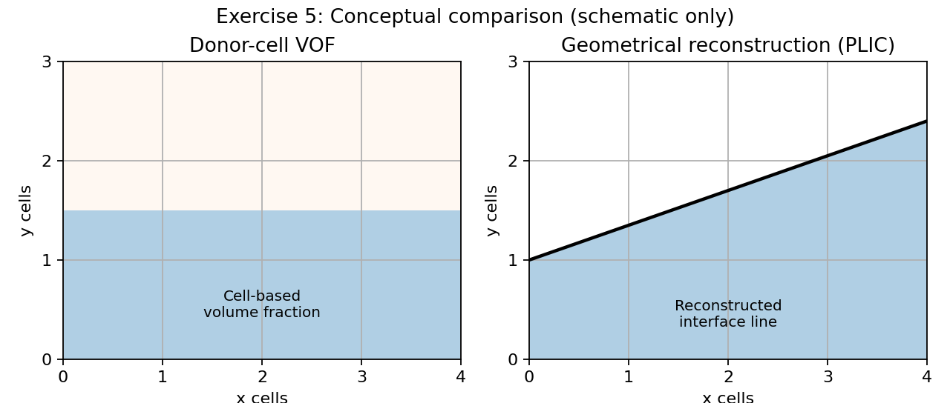
Figure 4.10: Conceptual schematic of the two interface treatments.

Main roll-number simulation – 68 × 136
For roll number 20, the main grid is 68 × 136. The calculation completed 915 time steps. The initial and final heavy-fluid areas agree to numerical precision. The maximum projected divergence and maximum speed are reported below.
Output | Computed value
Grid | 68 × 136
Time steps | 915
Δx (m) | 0.01010101
Δy (m) | 0.01010101
Initial heavy-fluid area | 1.000000000000
Final heavy-fluid area | 1.000000000000
Relative mass error | 8.882e-16
Minimum α | 0.000000
Maximum α | 1.000000
Maximum projected divergence | 1.709e-11
Maximum speed (m/s) | 0.876987
Mean interface thickness (m) | 0.433425

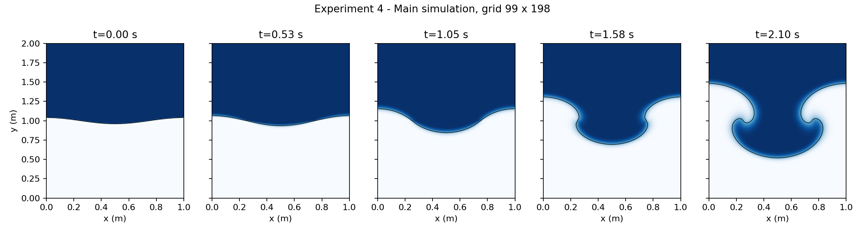
Figure 4.11: Rayleigh–Taylor instability snapshots for the roll-number grid.

