Experiment 2

Aim: Create a Blockchain using Python

Theory:
Blockchain is a distributed and immutable ledger that records data in a sequence of linked blocks. Each block contains a timestamp, proof (from Proof-of-Work), and the hash of the previous block, ensuring integrity and security.
In this program:
- Block Creation – A block is generated using create_block() with a proof and previous hash.
- Proof-of-Work (PoW) – Implemented to mine a block by solving a cryptographic puzzle (finding a hash with leading zeros).
- Hashing – SHA-256 algorithm ensures data immutability.
- Validation – is_chain_valid() checks that every block correctly references the previous hash and satisfies PoW conditions.
- Flask Web API – Routes /mine_block, /get_chain, and /is_valid allow mining, fetching the chain, and verifying blockchain integrity through a browser or API client.
This program runs on a local server and simulates mining a blockchain without a network of nodes, making it an ideal introductory model to understand blockchain basics.
Code:

1. Importing Required Libraries
- datetime → to timestamp each block
- hashlib → to generate SHA-256 hashes
- json → to encode blocks as JSON for hashing
- Flask → to run the blockchain API server

2. Blockchain Class – Core Logic
This contains everything needed to:
- create blocks
- store the chain
- implement Proof of Work
- validate chain integrity

3. Flask Web API
Provides endpoints:
- /mine_block → mine a new block
- /get_chain → fetch full blockchain
- /is_valid → verify blockchain
# ------------------------------------------------------------
# Module 1 - Create a Simple Blockchain (Fully Commented)
# ------------------------------------------------------------

# Required installation:(run cmd as administrator)
# pip install flask==2.2.5

# Importing libraries
import datetime # To generate timestamps for blocks
import hashlib # To generate SHA256 hashes
import json # To convert block data into JSON
from flask import Flask, jsonify # To create API endpoints

# ------------------------------------------------------------
# Part 1 - Building the Blockchain
# ------------------------------------------------------------

class Blockchain:

def __init__(self):
# This list will store the entire chain of blocks
self.chain = []

# Create the genesis block (first block)
# proof = 1 → arbitrary
# previous_hash = '0' → since no previous block exists
self.create_block(proof=1, previous_hash='0')

def create_block(self, proof, previous_hash):
"""
Creates a new block and adds it to the chain.
Each block contains:
- index
- timestamp
- proof (PoW output)
- previous block hash
"""
block = {
'index': len(self.chain) + 1, # Position of block in chain
'timestamp': str(datetime.datetime.now()), # Current timestamp
'proof': proof, # PoW result
'previous_hash': previous_hash # Hash of the previous block
}

# Add block to the chain
self.chain.append(block)
return block

def get_previous_block(self):
"""
Returns the last block in the chain.
"""
return self.chain[-1]

def proof_of_work(self, previous_proof):
"""
Simple Proof of Work (PoW) algorithm:
- Find a number (new_proof)
- Such that the SHA256 hash of (new_proof^2 - previous_proof^2)
starts with '0000'

This is a computational puzzle to secure the network.
"""
new_proof = 1
check_proof = False

while check_proof is False:
# Cryptographic puzzle: hash difference of squares
hash_operation = hashlib.sha256(
str(new_proof**2 - previous_proof**2).encode()
).hexdigest()

# Check if hash begins with 4 leading zeros
if hash_operation[:4] == '0000':
check_proof = True
else:
new_proof += 1

return new_proof

def hash(self, block):
"""
Creates a SHA256 hash of a block.
- Sort keys to ensure consistent hashing
"""
encoded_block = json.dumps(block, sort_keys=True).encode()
return hashlib.sha256(encoded_block).hexdigest()

def is_chain_valid(self, chain):
"""
Validates the blockchain by checking:
1. The previous_hash field matches the actual hash of the previous block.
2. The PoW condition (hash starting with '0000') is satisfied for each block.
"""
previous_block = chain[0] # Genesis block
block_index = 1 # Start checking from block 2

while block_index < len(chain):
block = chain[block_index]

# Check previous hash correctness
if block['previous_hash'] != self.hash(previous_block):
return False

# Validate Proof of Work
previous_proof = previous_block['proof']
proof = block['proof']
hash_operation = hashlib.sha256(
str(proof**2 - previous_proof**2).encode()
).hexdigest()

if hash_operation[:4] != '0000':
return False

# Move to next block
previous_block = block
block_index += 1

return True

# ------------------------------------------------------------
# Part 2 - Mining our Blockchain (Flask API)
# ------------------------------------------------------------

# Initialize Flask web application
app = Flask(__name__)

# Create an instance of the Blockchain
blockchain = Blockchain()

# ------------------------------------------------------------
# API Endpoint: Mine a new block
# ------------------------------------------------------------
@app.route('/mine_block', methods=['GET'])
def mine_block():
# Get the previous block
previous_block = blockchain.get_previous_block()

# Extract previous proof
previous_proof = previous_block['proof']

# Run Proof of Work algorithm
proof = blockchain.proof_of_work(previous_proof)

# Get hash of previous block
previous_hash = blockchain.hash(previous_block)

# Create the new block
block = blockchain.create_block(proof, previous_hash)

# Prepare response
response = {
'message': 'Congratulations, you just mined a block!',
'index': block['index'],
'timestamp': block['timestamp'],
'proof': block['proof'],
'previous_hash': block['previous_hash']
}
return jsonify(response), 200

# ------------------------------------------------------------
# API Endpoint: Get the full blockchain
# ------------------------------------------------------------
@app.route('/get_chain', methods=['GET'])
def get_chain():
response = {
'chain': blockchain.chain,
'length': len(blockchain.chain)
}
return jsonify(response), 200

# ------------------------------------------------------------
# API Endpoint: Check if blockchain is valid
# ------------------------------------------------------------
@app.route('/is_valid', methods=['GET'])
def is_valid():
is_valid = blockchain.is_chain_valid(blockchain.chain)

if is_valid:
response = {'message': 'All good. The Blockchain is valid.'}
else:
response = {'message': 'Houston, we have a problem. The Blockchain is not valid.'}

return jsonify(response), 200

# ------------------------------------------------------------
# Run the Flask app
# ------------------------------------------------------------
app.run(host='0.0.0.0', port=5000)

Output:
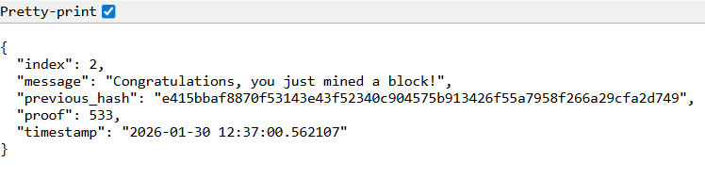
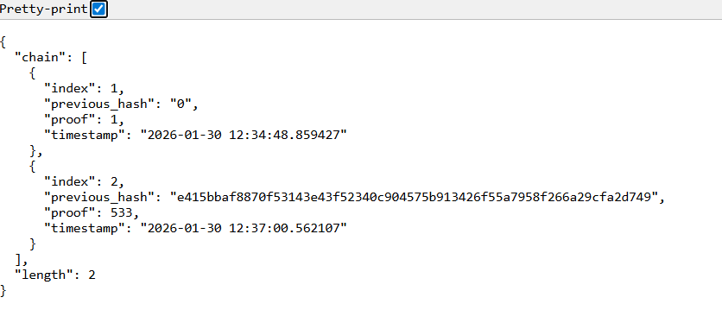
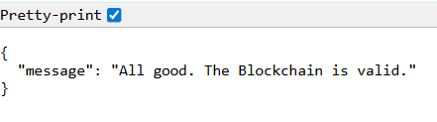

Conclusion:
We successfully created a basic blockchain using Python and Flask that supports block mining, chain retrieval, and validity checks. Proof-of-Work ensures security by making block creation computationally intensive, while cryptographic hashing guarantees immutability. The implementation demonstrates core blockchain principles—decentralization, immutability, and consensus—in a simplified environment, providing a strong foundation for building more advanced blockchain systems.
