Groundwater Resources of Lesser Himalayan Watersheds in Himachal Pradesh, India: A Comparative Review of Occurrence, Hydrochemistry and Recharge Planning
First Author^{1*} and Second Author²
Abstract
Mountain aquifers of the Indian Himalaya sustain drinking water, minor irrigation and spring flow for a large and growing population, yet they remain far less understood than the aquifers of the plains. This review compares three studies from two Lesser Himalayan catchments of Himachal Pradesh: a hydrogeological appraisal of groundwater development in the Suketi river basin (Mandi district), a two-season hydrochemical survey of the same basin, and a geospatial multi-criteria analysis of groundwater potential and recharge siting in the Gaj watershed (Kangra district). The studies are read through a common framework covering physical setting, data and methods, groundwater occurrence, water quality, temporal behaviour and management proposals. In the Suketi basin, usable groundwater is concentrated in the valley-fill of the Balh valley, where only about 22% of the assessed dynamic resource is drawn, while the surrounding hills rely on low-yield fracture and depression springs that mostly fall in Meinzer magnitudes VI to VIII. The groundwater there is a slightly alkaline Ca–HCO₃ water that is generally fit for drinking and irrigation, apart from one granite-hosted bore well with 4.2 mg/L fluoride and raised nitrate near the towns of Mandi and Rewalsar. In the Gaj watershed, the share of very high groundwater potential fell between 2010 and 2022 together with weaker monsoon rainfall, and the most promising recharge sites lie on gentle to moderate slopes in the populated foothills. Taken together, the studies move from quantity to quality to spatial planning, but none of them joins all three. The main gaps are single-year chemical data, a lack of isotopic and observation-well records, partial circularity in map validation and little socio-economic appraisal. An integrated quantity–quality–space framework is proposed to guide springshed-based recharge planning in the region.
¹Department of Geology, Name of University, City – PIN, India
²Department / Institute, Name of University, City – PIN, India
*E-mail: corresponding.author@example.com
Keywords:Mountain aquifers, Springs, Hydrochemistry, Groundwater potential zones, Analytic hierarchy process, Artificial recharge, Himachal Himalaya.

Introduction
India draws more groundwater than any other country, and a large part of its drinking water and irrigation supply now depends on wells rather than on surface storage. Satellite gravity records have shown sustained loss of groundwater storage across northern India (Rodell et al., 2009), and global budgeting suggests that the abstraction from several major aquifers already exceeds what natural recharge can replace (Gleeson et al., 2012). The National Water Policy therefore asks that groundwater be planned at the scale of the hydrological unit, with quantity, quality and environmental needs considered together (MoWR, 2002).
The Himalaya is often called the water tower of Asia, because its snow, ice and monsoon rain feed the great river systems downstream (Immerzeel et al., 2010). Within the mountains, however, settlements in the middle hills seldom use those large rivers directly. They rely on springs, shallow dug wells, hand-pump bore wells and a range of traditional structures that tap small, fractured and strongly compartmentalised aquifers. Reports of falling spring discharge go back more than three decades in the Kumaun Himalaya (Valdiya and Bartarya, 1989), and a national working group estimated that a large share of Himalayan springs are drying or becoming seasonal (NITI Aayog, 2018). Field experiments in Sikkim have shown that targeted recharge in the spring catchment can restore flow (Tambe et al., 2012), but such work needs basic knowledge of where water enters the ground, how it moves along structures, and how good it is once it emerges.
Hard-rock hill tracts are also difficult to assess with the standard methods used on the plains. Steep slopes push most rainfall into fast runoff, thrusts and fractures make aquifers patchy, and the observation network is thin. In Himachal Pradesh, official groundwater resources are computed only for the valley areas; the hills, which make up most of the land, are not quantified (CGWB, 2006; Pophare and Balpande, 2015). Meanwhile, population, tourism and irrigated farming are expanding in the foothill districts of Mandi and Kangra.
Against this background, three studies from the Beas catchment offer an instructive contrast. Pophare and Balpande (2015) described the groundwater regime of the Suketi river basin and proposed separate development plans for its central valley and surrounding hills. Pophare et al. (2018) examined the chemistry of groundwater and river water in the same basin across the pre- and post-monsoon seasons of 2009. Sharma et al. (2025) used remote sensing, GIS and the analytic hierarchy process (AHP) to map groundwater potential in the Gaj watershed for 2010 and 2022 and to select sites for artificial recharge. The three works therefore apply field hydrogeology, hydrochemistry and geospatial decision analysis to neighbouring Lesser and Outer Himalayan catchments, and together they span data collected between 2009 and 2022.
No synthesis of these studies is available. The present review aims to: (i) compare their settings, data and methods; (ii) bring together their findings on groundwater occurrence, quality, temporal change and recharge; (iii) evaluate the strengths and weaknesses of each approach; and (iv) identify research gaps and outline an integrated framework for groundwater management in similar Himalayan watersheds.

Approach of the Review
The review follows a structured comparative design (Fig. 1). The three studies were chosen because they share a regional setting (tributary catchments of the Beas river in Himachal Pradesh), address complementary parts of the groundwater problem, and report their data in enough detail to allow quantitative comparison. Each paper was read in full, and information was extracted under six themes: physical setting; data sources and sampling design; analytical methods; groundwater occurrence and potential; water quality; and management or recharge proposals. Numerical results were taken from the text and tables of the source papers. Where the present review derives additional indicators, such as percentage changes between years or shares of wells in a depth class, these are stated as derived values. The extracted material was then examined for agreement, contrast and missing elements, which form the basis of the discussion and of the framework proposed at the end.
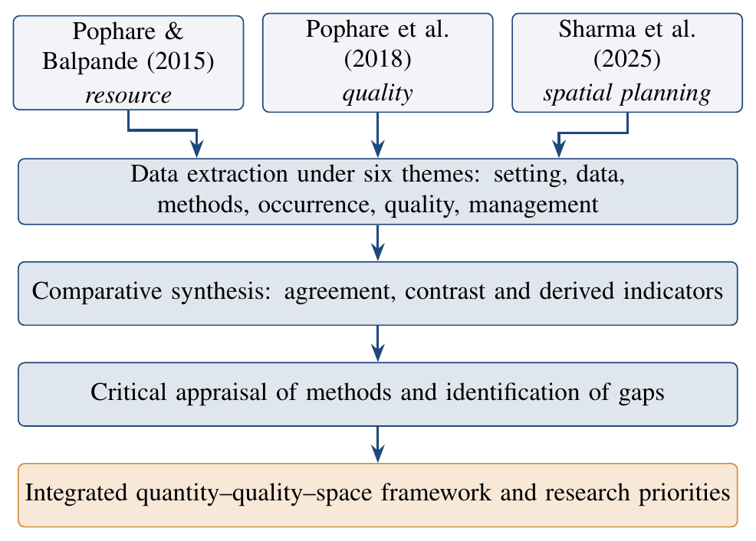
Fig. 1. Workflow adopted for the comparative review.

Profile of the Reviewed Studies
Table 1 sets out the main features of the three studies. They differ in publication type, in the period they represent and, most of all, in the question each one asks. The first is a broad hydrogeological account built on field inventory; the second is a focused chemical survey; the third is a model-based spatial analysis that relies mostly on satellite and secondary data.
Table 1. Profile of the three studies reviewed.
Attribute | Pophare and Balpande (2015) | Pophare et al. (2018) | Sharma et al. (2025)
Type of publication | Book chapter (Frontiers of Earth Science) | Journal article (Journal of Geosciences Research) | Journal article (Discover Sustainability)
Study area | Suketi river basin, Mandi district | Suketi river basin, Mandi district | Gaj watershed, Kangra district
Period of data | Field seasons of 2009; resource figures for March 2004 | May and November 2009 | 2010 and 2022 (pre- and post-monsoon); climate series 2010–2023
Central question | How much groundwater is there, where, and how should it be developed? | Is the water fit for drinking and irrigation, and what controls its chemistry? | Where is groundwater potential highest, how has it changed, and where should recharge structures go?
Core data | 28 dug wells, 64 tube wells, 93 springs, bore wells; thematic and morphometric maps | 31 groundwater and 5 river samples; 14 parameters | 12.5 m DEM, LISS-IV imagery, FAO soils, IMD/CGWB rainfall, temperature, geology
Main tools | Well and spring inventory, water-level contouring, morphometry, runoff formulae, watershed delineation | Ionic ratios, correlation, Schoeller, Piper and Gibbs plots, drinking and irrigation indices | VIF screening, AHP weighting, weighted overlay, ROC–AUC, infiltration index, site overlay
Principal output | Separate development plans for valley and hills | Water-quality status and contamination hot spots | Groundwater potential maps and recharge site map

Physical Setting of the Study Areas

Suketi River Basin
The Suketi river joins the Beas near Mandi and drains an elongated basin of about 422 km² between Mandi in the north and Sundernagar in the south (31°27′–31°45′N; 76°48′–77°03′E). Its most distinctive feature is the Balh valley, an intermontane basin of about 79 km² (roughly 19% of the catchment) lying at about 790 m elevation. The valley is filled with up to about 370 m of Quaternary boulders, gravel, sand, silt and clay, and it is bounded by two major faults, the Main Central Thrust and the Mandi thrust (Srikantia and Bhargava, 1998; Pophare et al., 2018). The surrounding hills cover about 343 km² and rise from 800 m to nearly 2,900 m. They expose the Dhauladhar granite, Proterozoic meta-sediments of the Shali, Sundernagar and Salkhala groups, and Cenozoic rocks of the Subathu and Siwalik groups.
Mandi district receives about 1,136 mm of rain in an average year, mostly between July and September, and the higher peaks receive winter snow (CGWB, 2006). Morphometric analysis classed the basin as seventh order, with 1,671 stream segments, a drainage density of 2.69 km/km², a basin relief of 2,130 m and a ruggedness number of 5.73 (Pophare and Balpande, 2014; Pophare and Balpande, 2015). Its elongation ratio (0.80) and form factor (0.50) point to an elongated shape that delays peak runoff, which the authors regarded as a modest advantage for recharge.

Gaj Watershed
The Gaj watershed lies in the Kangra valley, roughly between 32°00′–32°25′N and 76°00′–76°25′E, and drains about 900 km² towards the Beas (Sharma et al., 2025). Its upper reaches climb to about 4,500 m along the Dhauladhar range, and it receives far more precipitation than the Suketi basin, around 2,600 mm a year, with heavy monsoon rain on the southern slopes and snow at higher levels. Porous formations (recent alluvium in the south, and the Pinjore and Dhok Pathan units of the Siwalik group in the west) contrast with fissured hard rocks: the eastern Chail formation and, towards the north, the Dhauladhar granite. The area is crossed by the Main Boundary Thrust and by the Jawalamukhi, Drini, Panjal and Chail thrusts, and most springs follow these structures (Kumar and Mahajan, 2001; Sharma et al., 2025).

Comparison of Settings
Table 2 summarises the two settings. The Gaj watershed is about twice as large, reaches a much higher elevation and receives more than twice the rainfall of the Suketi basin. Both, however, combine a productive unconsolidated aquifer (the Balh valley fill and the southern Kangra alluvium) with large tracts of fractured hard rock where groundwater is stored in weathered zones, joints and faults. This shared two-part structure is the key to comparing the studies.
Table 2. Physical setting of the two catchments (compiled from Pophare and Balpande, 2015; Pophare et al., 2018; Sharma et al., 2025).
Feature | Suketi basin | Gaj watershed
District | Mandi | Kangra
Area | ∼422 km² | ∼900 km²
Elevation | 760–2,890 m | foothills to ∼4,500 m
Rainfall | ∼1,136 mm/yr | ∼2,600 mm/yr
Tectonic frame | Between Mandi thrust and MCT | MBT and several thrusts
Porous aquifer | Balh valley fill (79 km²) | Southern alluvium, Siwalik units
Hard-rock aquifer | Meta-sediments, granite, limestone | Chail formation, Dhauladhar granite
Main abstraction | Dug and tube wells (valley); springs and bore wells (hills) | Springs, hand pumps, bowris

Comparison of Methods

Field Hydrogeological Appraisal
Pophare and Balpande (2015) built their account on a 1:50,000 base map prepared from Survey of India toposheets. Within the Balh valley they used 28 dug wells as key observation points, measured them in May and November 2009 and contoured the depth to water; records of 64 tube wells came from the state I&PH department. In the hills, 93 springs were visited and described by type, host rock and discharge, and their size was rated on the classification of Meinzer (1923). Thematic maps of geology, drainage, soils, land use, lineaments and slope were prepared, and stream ordering followed Strahler (1957). The basin was then divided into 53 micro-watersheds within five sub-basins to serve as planning units. Harvestable runoff was estimated using three empirical approaches (Strange’s coefficients, Binnie’s percentages and the Inglis formula), and the lowest result was retained for recharge planning. Resource figures for the valley were taken from official estimates (CGWB, 2006).

Hydrochemical Survey
Pophare et al. (2018) collected 31 groundwater samples in each of the two seasons of 2009: five from dug wells and six from tube wells in the valley, and thirteen from springs and seven from bore wells in the hills. Five river samples were added for comparison. pH, electrical conductivity (EC) and total dissolved solids (TDS) were recorded on site, and the major ions, hardness, nitrate and fluoride were determined following standard methods (APHA, 1998). The results were interpreted with a correlation matrix, the classification of Schoeller (1967), the trilinear diagram of Piper (1944), chloro-alkaline indices and the diagram of Gibbs (1970). Suitability for drinking was judged against national and international limits; suitability for irrigation was judged with a set of indices (Eqs. 1–5, all concentrations in meq/L) and the salinity diagram of Richards (1954):
$$\begin{matrix}SAR & =\frac{Na}{\sqrt{\left(Ca+Mg\right)/2}} \text{(1)} \\ \%Na & =\frac{Na+K}{Ca+Mg+Na+K}×100 \text{(2)} \\ RSC & =\left(HCO_{3}+CO_{3}\right)−\left(Ca+Mg\right) \text{(3)} \\ KR & =\frac{Na}{Ca+Mg} \text{(4)} \\ PI & =\frac{Na+\sqrt{HCO_{3}}}{Ca+Mg+Na}×100 \text{(5)}\end{matrix}$$
Soluble sodium percentage, magnesium ratio and corrosivity ratio were also computed, together with the Collins ratio as a drinking-water indicator.

Geospatial Multi-criteria Analysis
Sharma et al. (2025) prepared eleven factor maps (aspect, curvature, drainage density, geology, lineament density, land use/land cover, rainfall, soil, slope, stream order and temperature) from a 12.5 m ALOS PALSAR elevation model, LISS-IV imagery, FAO soil data and Indian Meteorological Department records. The land-use map reached an overall accuracy of 86.3% and a kappa coefficient of 0.84. Collinearity among predictors was checked with the variance inflation factor (VIF),
$${VIF}_{i}=\frac{1}{1−R_{i}^{2}}, \text{(6)}$$
where $R_{i}^{2}$ is obtained by regressing factor i on the others. All retained layers had VIF values between 1.88 and 3.65, below the commonly used limit of 5, although such cut-offs should be applied with care (O’Brien, 2007). Layer and class weights were then derived by pairwise comparison (Saaty, 1980), with the consistency of each matrix checked through
$$CR=\frac{CI}{RI}, CI=\frac{λ_{max}−n}{n−1}, \text{(7)}$$
where λmax is the principal eigenvalue, n the number of criteria and RI the random index; matrices were accepted when CR was below 0.1. The groundwater potential index of each cell was obtained by weighted overlay,
$${GWPI}_{i}=\sum_{j=1}^{n}{w_{j}} r_{ij}, \text{(8)}$$
where wj is the weight of factor j and rij the rating of its class at cell i (Malczewski, 2006). Four maps were produced (pre- and post-monsoon for 2010 and 2022) by changing only the rainfall layer, and each was split into five classes using natural breaks. Accuracy was tested with the area under the receiver operating characteristic curve (Fawcett, 2006). A separate infiltration-capacity index was built from soil, slope, temperature, land use and curvature (CR = 0.072) and cross-tabulated with the potential maps. Candidate recharge points were placed at intersections of lineaments with the drainage network and filtered by slope, land use and groundwater potential.

Methodological Contrasts
The three approaches sit at different points on a scale from direct observation to inference. The Suketi studies are grounded in measurements at wells and springs but extend those measurements across the basin only qualitatively. The Gaj study covers every cell of the watershed in a consistent way but depends on expert weights and on proxies for the subsurface. Field inventories capture what is actually happening at a source; index models capture where conditions favour storage and recharge. Neither is sufficient alone, and the two are best seen as partners: point data can calibrate and test the maps, and the maps can guide where new points should be measured.

Synthesis of Findings

Groundwater Occurrence and Resource Potential

Valley aquifers
In the Balh valley, dug wells no deeper than about 15 m tap a phreatic aquifer, while tube wells, mostly 50–125 m deep (recorded range about 27–135 m), draw from layered sand, gravel and boulder horizons separated from the shallow zone by clay (Pophare and Balpande, 2015). Some tube wells flow freely at the surface, showing confined conditions. Reported yields of tube wells range from about 5.5 to 84 L/s, with most between 9 and 45 L/s. In 2009 the water table stood within 12 m of the surface before the monsoon and within 10 m after it, and 27 of the 28 observation wells (96%) changed by less than 2 m between seasons (Table 3). By derived count, about 54% of wells in May and 61% in November had water levels shallower than 4 m, and 21–36% were shallower than 2 m, which indicates a tendency to waterlogging in parts of the valley.
Official figures for March 2004 put the yearly net groundwater availability of the valley at 3.48 Mm³, while only 0.78 Mm³ was being drawn, giving a stage of development of about 22% (CGWB, 2006; Pophare and Balpande, 2015). A stage this low means that the valley aquifer is under-used rather than stressed, and it could support further, carefully planned abstraction.
Table 3. Distribution of the 28 observation dug wells of the Balh valley by depth to water level in 2009 (from Pophare and Balpande, 2015).
Depth class (m bgl) | May 2009 | Nov. 2009
0–2 | 6 (21%) | 10 (36%)
2–4 | 9 (32%) | 7 (25%)
4–8 | 9 (32%) | 7 (25%)
>8 | 4 (15%) | 4 (14%)
Seasonal change <2 m | 27 wells (96%)

Hill aquifers and springs
The hills of the Suketi basin present a very different picture. Groundwater is held in thin weathered mantles and in fractures, and it reaches people through springs and through bore wells of about 50–70 m depth fitted with hand pumps (Pophare and Balpande, 2015). Most of the 93 springs inventoried are fracture or depression springs in sandstone, phyllite or boulder beds. In May 2009 many of them were dry or produced less than 0.01 L/s, and in November most yielded only about 0.1–0.4 L/s; on Meinzer’s scale the majority fall in magnitudes VI to VIII. A handful of springs linked to limestone solution features or major structures, such as those near Nalni, Nagchalla and Mandi, flow at more than 10 L/s. The authors also noted that many fracture springs revive only briefly after the monsoon, which points to small storage and fast drainage.
Morphometry supports this reading. The very fine drainage texture (14.88) and high infiltration number (10.66) indicate a landscape that sheds water quickly (Pophare and Balpande, 2014). Slope zoning separates three belts: hills steeper than 10° that act mainly as runoff zones, a piedmont belt of 5–10° that serves as the main recharge zone, and the valley floor below 5° where groundwater discharges (Pophare and Balpande, 2015).

Groundwater potential in the Gaj watershed
In the Gaj watershed, moderate to very high potential is concentrated along the major thrusts and lineaments and over the southern alluvium, while steep northern slopes score low (Sharma et al., 2025). Table 4 and Fig. 2 give the class areas. The very high class shrank from 4.20% to 2.63% of the area in the pre-monsoon maps and from 4.46% to 3.20% in the post-monsoon maps between 2010 and 2022, a relative decline of about 37% and 28%, respectively (derived). The high class changed much less. In the post-monsoon maps, the low and very low classes together fell from 33.8% to 26.5%, while the moderate class expanded, so the distribution became more concentrated in the middle classes. The authors reported AUC values of 0.82 and 0.81, and found more than 90% agreement between the high classes of the potential and infiltration maps.
Table 4. Share of the Gaj watershed (%) in each groundwater potential class (from Sharma et al., 2025); Δ is the change from 2010 to 2022 in percentage points (derived).
 | Pre-monsoon |  |  | Post-monsoon
Class | 2010 | 2022 | Δ | 2010 | 2022 | Δ
Very high | 4.20 | 2.63 | −1.57 | 4.46 | 3.20 | −1.26
High | 37.90 | 37.08 | −0.82 | 33.77 | 37.76 | +3.99
Moderate | 24.16 | 27.15 | +2.99 | 27.98 | 32.49 | +4.51
Low | 31.84 | 31.87 | +0.03 | 30.67 | 25.65 | −5.02
Very low | 1.90 | 1.27 | −0.63 | 3.13 | 0.89 | −2.24
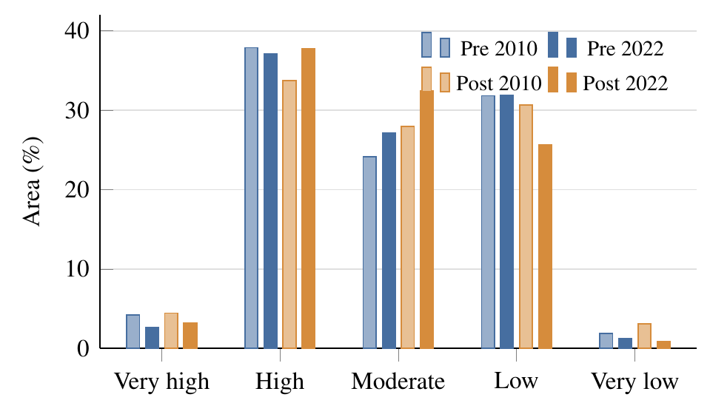
Fig. 2. Groundwater potential class areas in the Gaj watershed, plotted from the values reported by Sharma et al. (2025).

Common controls
Although the methods differ, both catchments point to the same controls. Structures (thrusts, faults and lineaments) concentrate both springs and high potential; slope decides whether rain runs off or infiltrates; and unconsolidated valley fill or alluvium forms the only aquifer with appreciable storage. The Suketi work reaches these conclusions from field observation, while the Gaj work expresses them as factor weights. The agreement between two independent lines of evidence gives confidence that these controls are general for the Lesser and Outer Himalaya of the region.

Groundwater Quality
Water quality was examined only in the Suketi basin (Pophare et al., 2018). The key outcomes are summarised in Table 5.

Mineralisation and facies
All waters are slightly alkaline, with mean pH between about 7.3 and 7.9, and their mineral content is low. Mean EC follows the order dug wells > bore wells > tube wells > river water > springs in both seasons, and every source is more dilute after the monsoon (Fig. 3). Bicarbonate is the dominant anion and calcium the dominant cation, followed by magnesium and sodium; total hardness stays below 300 mg/L and is mainly of the carbonate (temporary) kind. On the Piper diagram most samples plot as Ca–HCO$​_{3}$ water, in which alkaline earths exceed alkalis and weak acids exceed strong acids. Strong correlations of calcium and magnesium with bicarbonate point to carbonate and silicate weathering as a shared source (Hem, 1985).
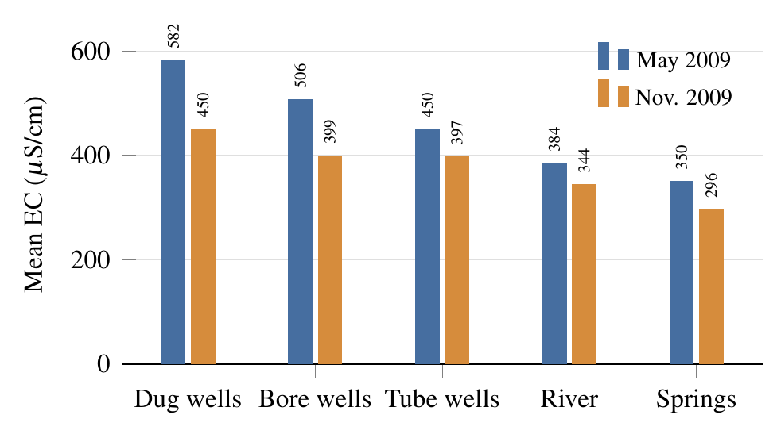
Fig. 3. Mean electrical conductivity by water source in the Suketi basin, plotted from the values reported by Pophare et al. (2018).

Controlling processes
On the Gibbs diagram most samples fall in the field of precipitation dominance and only a few show the influence of rock weathering. Combined with the low TDS, this suggests that recharge water moves quickly through the steep terrain and has little time to react with the rocks (Pophare et al., 2018). The chloro-alkaline indices were positive in about 68% of samples before the monsoon but in only 45% after it, implying that fresh recharge temporarily shifts the balance of ion exchange. A further useful result is that spring water and river water have nearly identical ionic make-up, supporting the view that shallow hill aquifers sustain the base flow of the Suketi and its tributaries.

Contamination signals
Two local problems stand out. A bore well at Pabu, on granite, contained 4.2 mg/L fluoride in May and 2.2 mg/L in November, well above the 1.5 mg/L limit (BIS, 2012; WHO, 2017); the authors attribute this to release from fluoride-bearing minerals during long contact with the host rock. Second, nitrate reached 36–37 mg/L in a spring at Mandi and 28–32 mg/L in a bore well at Rewalsar, far above the values found at most other sites. These levels are below the 45 mg/L limit, but their location in crowded towns and their correlation with sulphate and potassium point to sewage and farm inputs. Such early signals deserve regular monitoring because nitrate tends to rise as settlements grow.

Suitability for irrigation
All irrigation indices fall in safe ranges (Table 5). SAR is below 10 in every sample, and most samples plot in the C2–S1 class (medium salinity, low sodium hazard) of the salinity diagram (Richards, 1954). Residual sodium carbonate is below 1.25 meq/L, Kelley’s ratio is below 1, and the permeability index averages 58–67%, which falls within the suitable classes of Doneen (1964). The magnesium ratio exceeded 50 in nine samples before the monsoon but in only one afterwards. The main practical concern is the corrosivity ratio, which was above 1 in six samples in each season and could shorten the life of metal pipes in water supply schemes.
Table 5. Water-quality indicators for groundwater of the Suketi basin, 2009 (results from Pophare et al., 2018).
Indicator | Criterion | Outcome
pH | 6.5–8.5 | Mean 7.3–7.9; slightly alkaline
Facies | Piper | Mainly Ca–HCO$​_{3}$
Fluoride | ≤1.5 mg/L | One bore well 4.2/2.2 mg/L
Nitrate | ≤45 mg/L | All within limit; 28–37 mg/L at Mandi and Rewalsar
Collins ratio | ≤1 good | <1 in all samples
SAR | <10 excellent | All samples
%Na | ≤60 | Excellent in 84–90%
RSC | <1.25 meq/L | All samples safe
Kelley’s ratio | <1 | All samples
Mg ratio | <50 | 9 samples (May), 1 (Nov.) exceed
PI | Class I–II | Mean 58–67%
Corrosivity | <1 | 6 samples exceed per season

Relevance to the Gaj watershed
No chemical data are reported for the Gaj watershed. Yet the two areas share the same kinds of rock, including the Dhauladhar granite, and the same pressures from growing towns. The Suketi results therefore suggest that fluoride should be checked in granite-hosted wells and springs of the Gaj, and that nitrate should be watched in the foothill settlements that Sharma et al. (2025) identified as priorities for recharge. This matters because a recharge structure built where runoff collects from roads, drains or farm land can carry pollutants into the very aquifer it is meant to protect.

Temporal Behaviour and Climate Signal
The Suketi studies capture a single year and show only seasonal behaviour: modest water-level rise in the valley and strong post-monsoon dilution of the water. The Gaj study adds a decadal view. Monsoon rainfall in the watershed was markedly lower in several years after 2010, and the potential maps for 2022 show a smaller very high class (Sharma et al., 2025). Official records cited in that study report water-table rises of up to 2.94 m and falls of up to 7.16 m in the area, a decadal water-level variation of about 6 m in Kangra, and 235 of 4,535 hand pumps in need of repair or abandonment, partly because of low water levels. Maximum temperature increased and minimum temperature decreased between 2010 and 2023, which may lengthen dry spells and raise evaporative demand. At the same time, the population of Kangra district grew from about 1.51 million in 2011 to about 1.69 million in 2023, an increase of nearly 12% (derived).
One caution applies. Because rainfall was the only layer that changed between the 2010 and 2022 maps, the shift in potential classes reflects changed recharge conditions rather than a measured change in stored groundwater. The trend agrees with the official water-level records, which is encouraging, but it should not be read as a direct measurement of depletion.

Management and Recharge Proposals
Table 6 compares the management proposals. Both studies favour small, low-cost structures placed on low-order streams and gentle slopes, but they reach their recommendations in different ways.
Pophare and Balpande (2015) argued that the valley and the hills need separate plans. For the valley, the low stage of development and shallow water levels mean that domestic and irrigation demand can be met from adequately sized dug wells; managed recharge is recommended where post-monsoon levels are deeper than about 3 m, and old village ponds could be desilted and deepened to store more water. For the hills, the authors recommend about three check dams or gabion structures (each roughly 15 m wide and 1.5 m high) for every spring, or around 282 structures for the 94 springs counted in their plan, along with rooftop rainwater harvesting, farm ponds and small underground tanks. They also match structures to stream order: the smallest channels (orders one and two) suit gully plugs and gabions, channels of order two to three suit nala bunds and percolation tanks, and larger channels (orders four to seven) suit check dams or subsurface dykes (CGWB, 2007). Harvestable runoff of the basin was estimated at 262–375 Mm³ a year, which is about 75 times the assessed groundwater availability of the valley (derived), so water for recharge is not the limiting factor; the limiting factors are storage and suitable sites. Finally, they stress the revival of traditional systems such as baudis (stone-lined spring pits), nauns (covered spring tanks), chhrudus (piped spring outlets) and kuhls (gravity irrigation channels), many of which are falling into disuse (Sharma and Kanwar, 2009).
Sharma et al. (2025) used a spatial filter instead of a rule of thumb. Candidate points at lineament–drainage intersections were kept only on low to moderate slopes and on suitable land uses, and were then ranked by the needs of populated foothill areas. The suggested structures include check dams, gabions, contour trenches, pony-pit wells, roof-water storage tanks and water-spreading weirs. Steep sites were rejected both because water runs off too quickly and because heavy structures might destabilise slopes, a practical point for a seismically active belt.
Neither study estimates how much recharge the proposed structures would add, what they would cost, or who would own and maintain them. Experience with managed recharge shows that these questions largely decide whether a scheme succeeds (Bouwer, 2002).
Table 6. Comparison of management and recharge proposals.
Aspect | Suketi basin (Pophare and Balpande, 2015) | Gaj watershed (Sharma et al., 2025)
Planning unit | 53 micro-watersheds in five sub-basins; valley and hills planned separately | Whole watershed; cells ranked by potential and infiltration
Siting logic | Stream order, slope belt and spring location; micro-level surveys advised | Lineament–drainage intersections filtered by slope, land use and potential
Recommended structures | Gully plugs, gabions, nala bunds, percolation tanks, check dams, subsurface dykes, rooftop harvesting, farm ponds, underground tanks | Check dams, gabions, contour trenches, pony-pit wells, roof-water storage tanks, water-spreading weirs
Scale of intervention | About 282 check dams/gabions for spring revival | Strategic points mapped; number and size not fixed
Traditional systems | Revival of baudi, naun, chhrudu and kuhl | Mentions bowris as natural sources
Priority areas | Spring catchments in hills; valley zones with deeper post-monsoon levels | Densely populated foothills with lower potential
Not addressed | Recharge volumes, cost, water quality of recharge source | Field feasibility, cost–benefit, land ownership, water quality

Discussion

How the Studies Complement Each Other
Read in order of publication, the three studies show a clear shift in method over a decade: from field-based descriptive hydrogeology, through process-oriented hydrochemistry, to data-driven spatial decision support. Each answers a question the others leave open. The resource study shows where water is stored and how it is used, but it cannot say whether the water is safe or how conditions vary across unsampled hills. The chemical study shows that the water is generally safe and that hill aquifers feed the rivers, but it says little about volume. The geospatial study covers the whole watershed and tracks change through time, but it has no direct measure of water levels or quality. A combined reading is therefore more useful for planning than any single paper.

Strengths and Limitations
Table 7 summarises the main strengths and weaknesses. Several points need emphasis.
Temporal coverage. Both Suketi data sets come from a single hydrological year (2009). Seasonal contrasts are captured, but year-to-year variability and long-term trends are not, and the data are now more than fifteen years old. The resource figures refer to 2004.
Observation data. In the Gaj study, the absence of observation-well records is acknowledged by the authors themselves. Without measured water levels or spring discharge, the potential maps remain hypotheses about where groundwater should be, rather than evidence of where it is.
Subjectivity and validation. AHP weights rest on expert judgement, and no sensitivity analysis was reported to show how the maps would change under different weights. The description of which layers entered the final overlay is also not fully consistent between sections of the paper. More importantly, the infiltration map used to cross-check the potential maps was built from five layers (soil, slope, temperature, land use and curvature) that also enter the potential model. A high level of agreement between the two maps is therefore partly expected and is not fully independent validation. Testing against measured spring discharge, well yields or water-level change would be much stronger (Machiwal et al., 2011; Fawcett, 2006).
Analytical scope. The chemical survey covers the major ions, nitrate and fluoride, but not trace metals, microbial quality or stable isotopes. Bacterial contamination of springs is a common health problem in hill towns, and isotopes of oxygen and hydrogen could identify the altitude and location of spring recharge areas, which is exactly the information needed to place recharge structures (NITI Aayog, 2018). The drinking-water limits used in 2018 were also earlier editions of the current standards (BIS, 2012).
Resource accounting. In the Suketi study, the hills were not quantified, and the recommended number of structures follows a uniform rule of three per spring rather than a water balance for each spring catchment. The runoff estimate itself varies by about 40% between methods, and the rainfall used for it (1,350 mm) differs from the district average cited elsewhere (1,136 mm).
Social dimension. Both studies recognise the importance of local communities, but neither assesses land ownership, willingness to maintain structures, or costs and benefits. The Suketi study does, however, offer a rare record of traditional water systems, which could anchor community-based management (Sharma and Kanwar, 2009).
Table 7. Strengths, limitations and principal gaps of the reviewed studies.
 | Pophare and Balpande (2015) | Pophare et al. (2018) | Sharma et al. (2025)
Main strengths | Extensive field inventory of wells and springs; clear valley–hill contrast; watershed-level planning units; record of traditional systems | Two-season sampling of all source types; wide set of drinking and irrigation indices; spring–river link identified | Consistent basin-wide coverage; collinearity screening; decadal comparison; explicit siting of recharge points
Main limitations | One year of data; hills not quantified; structure count based on a uniform rule; runoff estimates differ widely | One year of data; no trace metals, microbes or isotopes; few samples per source class; older standards | No observation wells; subjective weights without sensitivity test; partly circular validation; only rainfall varied in time
Key gap | Water balance and recharge volumes for spring catchments | Long-term quality monitoring and source tracing | Field validation, water quality and socio-economic feasibility

Transferability Between the Two Catchments
Because the two catchments share a similar structure, the methods could usefully be exchanged. The Suketi inventory of 93 springs and 28 observation wells is the kind of data set that the Gaj model lacks for validation; a similar inventory in the Gaj would greatly strengthen its conclusions. In the other direction, the AHP workflow could map potential across the Suketi hills, where official estimates are not made, and could help choose which of the 53 micro-watersheds should receive recharge structures first. The Suketi chemistry, in turn, offers a baseline against which future surveys in either catchment can be compared.

Towards an Integrated Framework
Drawing these threads together, Fig. 4 proposes a framework that links the three strands of evidence. Field inventory, hydrochemistry with isotopes, and remote sensing with climate data form the evidence base. These feed three parallel analyses: resource estimation and morphometry; quality indices and facies; and multi-criteria mapping of potential and infiltration. The outputs are then combined into a quality-screened recharge suitability map, delineated at the scale of individual springsheds, and ranked by demand and vulnerability. Implementation should involve local institutions and traditional systems, and a monitoring network of wells and springs should feed results back into the model so that weights and site choices can be revised over time. Such an approach is consistent with the basin-scale planning required by national policy (MoWR, 2002) and with the springshed approach recommended for the Himalaya (NITI Aayog, 2018; Tambe et al., 2012).
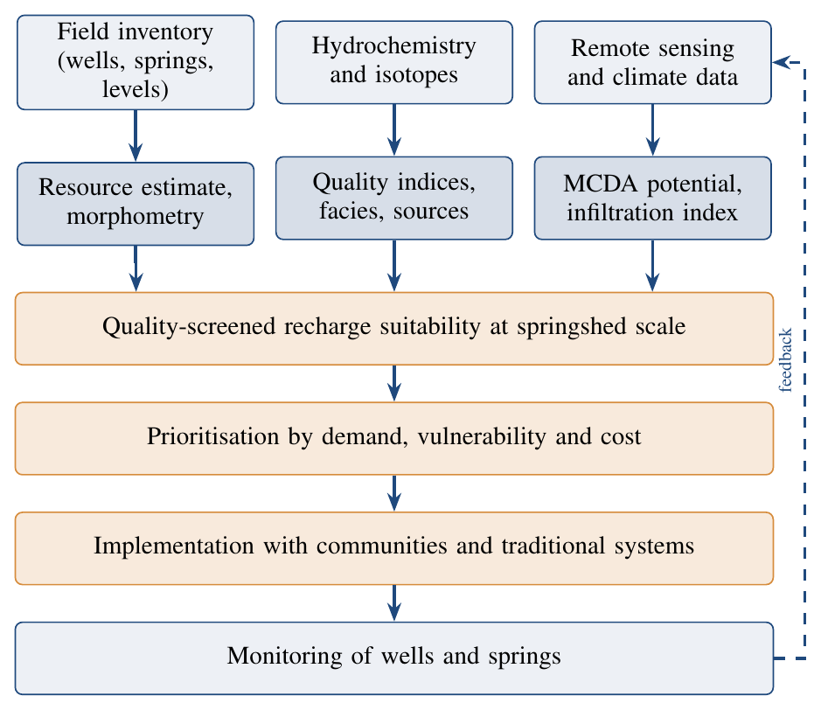
Fig. 4. Proposed quantity–quality–space framework for groundwater management in Lesser Himalayan watersheds.

Conclusions
This review compared three studies of groundwater in two Lesser Himalayan catchments of Himachal Pradesh. Taken together, they show that groundwater in these mountains has two contrasting parts. Valley-fill aquifers such as the Balh valley hold usable, under-developed reserves with shallow water levels, while hill tracts depend on small, fracture-controlled springs whose flow is low and strongly seasonal. The groundwater of the Suketi basin is of good chemical quality and suitable for drinking and irrigation, but local fluoride in granite and rising nitrate in towns show that quality cannot be taken for granted. In the Gaj watershed, geospatial analysis shows a decline in the most favourable recharge zones between 2010 and 2022, together with weaker monsoons, warmer maximum temperatures and a growing population.
The three studies complement one another: the first addresses quantity, the second quality and the third spatial planning. Their main shortcomings are short records, limited field validation of maps, missing isotopic and microbial data, and little assessment of recharge volumes, costs or community roles. Future work should join these strands within a single framework that screens recharge sites for water quality, works at the scale of spring catchments, and is tested against a sustained monitoring network. Such an approach would give planners in the Himalayan foothills a stronger basis for protecting both the quantity and the quality of groundwater for the long term.

Research Gaps and Future Directions
The comparison points to the following priorities for future work in the Suketi, Gaj and similar Himalayan catchments.
- Long-term monitoring. Establish a network of observation wells and gauged springs, measured at least seasonally, to provide time series of levels, discharge and chemistry and to update the 2004 and 2009 baselines.
- Springshed delineation. Combine geological mapping with stable isotopes and tracer tests to identify the recharge area of important springs before structures are built.
- Wider quality coverage. Add trace elements, microbial indicators and emerging contaminants, and extend sampling to the Gaj watershed, with attention to fluoride in granite terrain and nitrate in growing towns.
- Robust mapping. Test the sensitivity of AHP weights, compare AHP with statistical or machine-learning methods, and validate maps with independent field data rather than with layers derived from the same inputs (Machiwal et al., 2011).
- Recharge accounting. Estimate the volume each proposed structure can add, using water-balance or simple numerical models, and then monitor actual performance after construction.
- Climate scenarios. Link groundwater potential to projected changes in rainfall, snow and temperature so that structures are designed for future rather than past conditions (Immerzeel et al., 2010).
- Social and economic feasibility. Assess land tenure, community willingness, maintenance arrangements and costs and benefits, and consider how traditional systems can be restored alongside new structures.

Acknowledgements
The authors thank the researchers whose published work forms the basis of this review. [Add institutional or funding acknowledgements here.]

Declarations
Conflict of interest: The authors declare that they have no competing interests.
Data availability: All data discussed are drawn from the published sources cited; derived values can be reproduced from those sources.

References
APHA (1998). Standard Methods for the Examination of Water and Wastewater, 20th edn. American Public Health Association, Washington, D.C.
BIS (2012). Indian Standard Drinking Water – Specification (Second Revision), IS 10500:2012. Bureau of Indian Standards, New Delhi.
Bouwer, H. (2002). Artificial recharge of groundwater: hydrogeology and engineering. Hydrogeology Journal, v. 10(1), pp. 121–142.
CGWB (2006). Ground Water Information Booklet, Mandi District, Himachal Pradesh. Central Ground Water Board, North Western Himalayan Region, Dharamshala.
CGWB (2007). Manual on Artificial Recharge of Ground Water. Central Ground Water Board, Ministry of Water Resources, Government of India, New Delhi.
Doneen, L.D. (1964). Notes on Water Quality in Agriculture. Water Science and Engineering Paper 4001, Department of Water Science and Engineering, University of California, Davis.
Fawcett, T. (2006). An introduction to ROC analysis. Pattern Recognition Letters, v. 27(8), pp. 861–874.
Gibbs, R.J. (1970). Mechanisms controlling world water chemistry. Science, v. 170(3962), pp. 1088–1090.
Gleeson, T., Wada, Y., Bierkens, M.F.P. and van Beek, L.P.H. (2012). Water balance of global aquifers revealed by groundwater footprint. Nature, v. 488(7410), pp. 197–200.
Hem, J.D. (1985). Study and Interpretation of the Chemical Characteristics of Natural Water, 3rd edn. U.S. Geological Survey Water-Supply Paper 2254, Washington, D.C.
Immerzeel, W.W., van Beek, L.P.H. and Bierkens, M.F.P. (2010). Climate change will affect the Asian water towers. Science, v. 328(5984), pp. 1382–1385.
Kumar, S. and Mahajan, A.K. (2001). Seismotectonics of the Kangra region, northwest Himalaya. Tectonophysics, v. 331(4), pp. 359–371.
Machiwal, D., Jha, M.K. and Mal, B.C. (2011). Assessment of groundwater potential in a semi-arid region of India using remote sensing, GIS and MCDM techniques. Water Resources Management, v. 25(5), pp. 1359–1386.
Malczewski, J. (2006). GIS-based multicriteria decision analysis: a survey of the literature. International Journal of Geographical Information Science, v. 20(7), pp. 703–726.
Meinzer, O.E. (1923). Outline of Ground-water Hydrology, with Definitions. U.S. Geological Survey Water-Supply Paper 494, Washington, D.C.
MoWR (2002). National Water Policy. Ministry of Water Resources, Government of India, New Delhi.
NITI Aayog (2018). Inventory and Revival of Springs in the Himalayas for Water Security. Report of Working Group I, Government of India, New Delhi.
O’Brien, R.M. (2007). A caution regarding rules of thumb for variance inflation factors. Quality & Quantity, v. 41(5), pp. 673–690.
Piper, A.M. (1944). A graphic procedure in the geochemical interpretation of water-analyses. Transactions, American Geophysical Union, v. 25(6), pp. 914–928.
Pophare, A.M. and Balpande, U.S. (2014). Morphometric analysis of Suketi river basin, Himachal Himalaya, India. Journal of Earth System Science, v. 123(7), pp. 1501–1515.
Pophare, A.M. and Balpande, U.S. (2015). Groundwater resource development and management in Suketi river basin, Himachal Himalaya, India. In: Shrivastava, K.L. and Srivastava, P.K. (Eds.), Frontiers of Earth Science. Scientific Publishers (India), pp. 499–526.
Pophare, A.M., Balpande, U.S. and Nawale, V.P. (2018). Hydrochemistry of groundwater in Suketi river basin, Himachal Himalaya, India. Journal of Geosciences Research, v. 3(1), pp. 67–83.
Richards, L.A. (Ed.) (1954). Diagnosis and Improvement of Saline and Alkali Soils. Agriculture Handbook No. 60, United States Department of Agriculture, Washington, D.C.
Rodell, M., Velicogna, I. and Famiglietti, J.S. (2009). Satellite-based estimates of groundwater depletion in India. Nature, v. 460(7258), pp. 999–1002.
Saaty, T.L. (1980). The Analytic Hierarchy Process. McGraw-Hill, New York.
Schoeller, H. (1967). Qualitative evaluation of groundwater resources. In: Methods and Techniques of Groundwater Investigation and Development. Water Resources Series No. 33, UNESCO, Paris, pp. 44–52.
Sharma, N. and Kanwar, P. (2009). Indigenous water conservation systems – a rich tradition of rural Himachal Pradesh. Indian Journal of Traditional Knowledge, v. 8(4), pp. 510–513.
Sharma, S., Tamrakar, Y., Deep, A. and Mahajan, A.K. (2025). Multi-criteria assessment and decision-making approach for planning of groundwater recharge structures in a highland watershed. Discover Sustainability, v. 6, Article 1163. https://doi.org/10.1007/s43621-025-02054-3
Srikantia, S.V. and Bhargava, O.N. (1998). Geology of Himachal Pradesh. Geological Society of India, Bangalore, 406p.
Strahler, A.N. (1957). Quantitative analysis of watershed geomorphology. Transactions, American Geophysical Union, v. 38(6), pp. 913–920.
Tambe, S., Kharel, G., Arrawatia, M.L., Kulkarni, H., Mahamuni, K. and Ganeriwala, A.K. (2012). Reviving dying springs: climate change adaptation experiments from the Sikkim Himalaya. Mountain Research and Development, v. 32(1), pp. 62–72.
Valdiya, K.S. and Bartarya, S.K. (1989). Diminishing discharges of mountain springs in a part of Kumaun Himalaya. Current Science, v. 58(8), pp. 417–426.
WHO (2017). Guidelines for Drinking-water Quality: Fourth Edition Incorporating the First Addendum. World Health Organization, Geneva.

