Enterprise AI Data Assistant
Technical Documentation
README · Architecture · API Reference
Capstone Project — Contoso Trading Services (sample data)
React → PHP REST → FastAPI → MySQL + Chroma

Contents
1. Overview
2. Architecture
3. Setup and Run
4. Using the App
5. API Reference
6. Database
7. Security
8. Tests
9. Status

1. Overview
Ask a business question about Contoso Trading Services in plain English and get back the SQL that answers it, the actual results, and a plain-English explanation of what the query did — plus a separate chat mode that answers questions from uploaded policy documents (returns, warranty, sales terms).

1.1 Tech Stack
Layer | Technology
Frontend | React 19 + Vite
REST layer | PHP 8.2, built-in dev server
AI service | FastAPI + LangChain (Python 3.11)
LLM | Groq, openai/gpt-oss-20b
Embeddings | HuggingFace sentence-transformers/all-MiniLM-L6-v2 (local, free)
Vector store | ChromaDB, persisted to disk
Database | MySQL 8

1.2 Repository Structure

enterprise-ai-data-assistant/
├── README.md
├── .env <- real secrets, gitignored
├── .env.example <- placeholders, committed
├── db/ schema, seed data, read-only user, *.sql scripts
├── docs/
│ ├── architecture.md request-by-request walkthrough + diagrams
│ ├── api.md endpoint reference
│ ├── schema_context.md database schema fed to the LLM
│ └── samples/ policy documents used by Chat Docs (RAG)
├── ai-service/ FastAPI + LangChain (Python)
│ ├── main.py FastAPI app + routes (/health, /ask, /ask-docs)
│ ├── llm_provider.py only file that imports the Groq SDK
│ ├── nl2sql.py Module 2 - English -> SQL
│ ├── db.py Module 3 - SQL guard + execution (capstone_ro)
│ ├── explain.py Module 4 - structured SQL explanation
│ ├── ingest_docs.py builds the document vector store
│ ├── rag.py Module 5 - document Q&A
│ ├── requirements.txt
│ └── tests/
├── backend-php/ index.php (router), config.php, cors.php, fastapi_client.php
└── frontend/ React + Vite (Ask Data / Chat Docs)

2. Architecture
PHP does no NL→SQL, no SQL execution, and holds no MySQL connection of its own — it is a thin proxy. FastAPI’s db.py is the only thing that ever talks to MySQL, and it always connects as the read-only capstone_ro user.

2.1 System Diagram
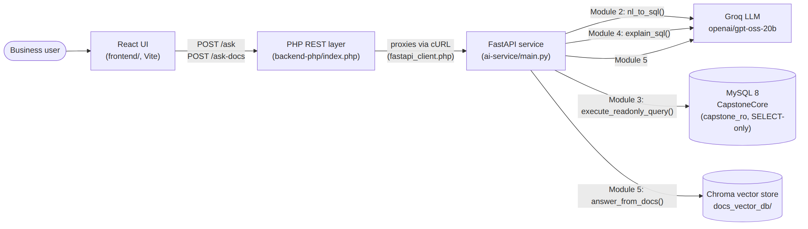
Figure 1. Component-level architecture — React, PHP REST, FastAPI, MySQL, and the Chroma vector store.

2.2 Layer Responsibilities
- React (frontend/) never calls FastAPI directly, and never talks to MySQL. It only knows the PHP layer’s base URL (frontend\.env.local → VITE_API_BASE_URL).
- PHP (backend-php/index.php) is a pure proxy. It has no MySQL connection, no LLM calls, and no SQL logic of its own — cors.php handles CORS/preflight, config.php loads settings from the repo-root .env, and fastapi_client.php forwards the request to FastAPI over cURL and returns its response body and status code unchanged.
- FastAPI (ai-service/main.py) does all the real work, split into independent modules it wires together per route.
- MySQL is only ever reached from db.py, only as the read-only capstone_ro user. Chroma (the vector store) is only ever reached from rag.py.

2.3 Module Boundaries
Each Python module in ai-service/ does exactly one job and is safe to run and test standalone (python nl2sql.py, python db.py, python explain.py, python rag.py each have a __main__ smoke test):
- nl2sql.py only generates and lightly sanity-checks SQL text. It never executes anything.
- db.py is the only module that ever opens a MySQL connection, and the only real security boundary — it re-validates SQL independently of whatever produced it.
- explain.py only explains SQL text that has already run — it receives the guarded, row-capped SQL from db.py’s result, not the raw LLM output, so the explanation always describes what actually executed.
- rag.py only reasons over document text. It never touches MySQL and is not a security boundary.
- llm_provider.py is the only file in the whole project that imports the Groq SDK — every other module calls call_llm(), so swapping LLM providers later touches one file.
This means a bug or outage in one module degrades gracefully rather than taking down the others — e.g. /ask still returns real query results even if explain_sql() is failing, and /ask-docs failing has no effect on /ask.

3. Setup and Run
All commands are PowerShell, run from the repo root unless noted.

3.1 Prerequisites
- Windows with PowerShell
- Node.js 20+ and npm
- Python 3.11
- PHP 8.2
- MySQL 8.x, running locally with database CapstoneCore already created (see Section 6, Database)
- A Groq API key (console.groq.com)

3.2 Clone and Configure Secrets

git clone git@github.com:ChiragAnblicks/enterprise-ai-data-assistant.git
cd enterprise-ai-data-assistant
Copy-Item .env.example .env

Open .env and fill in GROQ_API_KEY and DB_RO_PASSWORD (see Section 3.6, Environment Variables).

3.3 AI Service (FastAPI)

cd ai-service
python -m venv .venv
.venv\Scripts\Activate.ps1
pip install -r requirements.txt
python ingest_docs.py
uvicorn main:app --reload --port 8000

ingest_docs.py only needs to be run once (or again whenever a file in docs\samples\ changes) — it builds the vector store Chat Docs reads from. Leave uvicorn running in this window.
Verify: open http://127.0.0.1:8000/docs in a browser — you should see the FastAPI interactive docs (Swagger UI) listing /health, /ask, and /ask-docs.

3.4 PHP REST Layer
In a new PowerShell window:

cd backend-php
php -S localhost:8080 index.php

Verify:

Invoke-RestMethod http://localhost:8080/health

should return fastapi_reachable: True. If it returns False, the FastAPI service from Section 3.3 isn’t running or isn’t reachable at the FASTAPI_BASE_URL in .env.

3.5 Frontend (React)
In a new PowerShell window:

cd frontend
npm install
npm run dev

Open the printed URL (normally http://localhost:5173/). Make sure frontend\.env.local contains:

VITE_API_BASE_URL=http://localhost:8080

3.6 Environment Variables
Repo-root .env (copied from .env.example, gitignored):
Variable | Used by | Meaning
GROQ_API_KEY | ai-service | Your Groq API key. Required.
GROQ_MODEL | ai-service | LLM model id, openai/gpt-oss-20b.
DB_HOST | ai-service | MySQL host, default localhost.
DB_PORT | ai-service | MySQL port, default 3306.
DB_NAME | ai-service | Database name, CapstoneCore.
DB_RO_USER | ai-service | Read-only MySQL user, capstone_ro.
DB_RO_PASSWORD | ai-service | Password for capstone_ro. Required.
FASTAPI_BASE_URL | backend-php | Where PHP forwards requests, default http://127.0.0.1:8000.
PHP_CORS_ALLOWED_ORIGIN | backend-php | Origin allowed to call the PHP API, default http://localhost:5173.

frontend\.env.local (gitignored; frontend\.env.local.example holds the placeholder and is committed):
Variable | Meaning
VITE_API_BASE_URL | Base URL of the PHP REST layer, e.g. http://localhost:8080.

4. Using the App
The React UI has two modes:

4.1 Ask Data
Type a business question (e.g. “What were total sales by region last year?”). Returns the generated SQL, the result rows, and a structured explanation (summary, tables used, filters, grouping, sorting, row limit, caveats).

4.2 Chat Docs
Ask about return policy, warranty terms, or sales policy. Answers are grounded only in the files in docs\samples\ (ReturnPolicy.txt, SalesPolicy.pdf, WarrantyTerms.docx) and say so when the answer isn’t in those documents.

5. API Reference
Two equivalent bases, same three routes:
- PHP REST layer (what the React app calls): http://localhost:8080
- FastAPI service directly (for testing/debugging): http://127.0.0.1:8000 — also has interactive Swagger docs at http://127.0.0.1:8000/docs
The PHP layer (backend-php/index.php) is a pure proxy: it forwards the method, path, and JSON body to FastAPI via fastapi_client.php and returns FastAPI’s response body and status code unchanged. There is no authentication on either layer — this is a local development project, not a deployed service. All responses are application/json.

5.1 GET /health
Liveness check for the PHP layer, plus a check that it can reach FastAPI.
Response 200 (FastAPI reachable) or 502 (it isn’t):

{
"php": "ok",
"fastapi_reachable": true,
"fastapi_base_url": "http://127.0.0.1:8000",
"fastapi_response": { "status": "ok" }
}

5.2 POST /ask
English question → generated SQL → executed against MySQL (read-only, row-capped) → structured plain-English explanation of the SQL that ran.
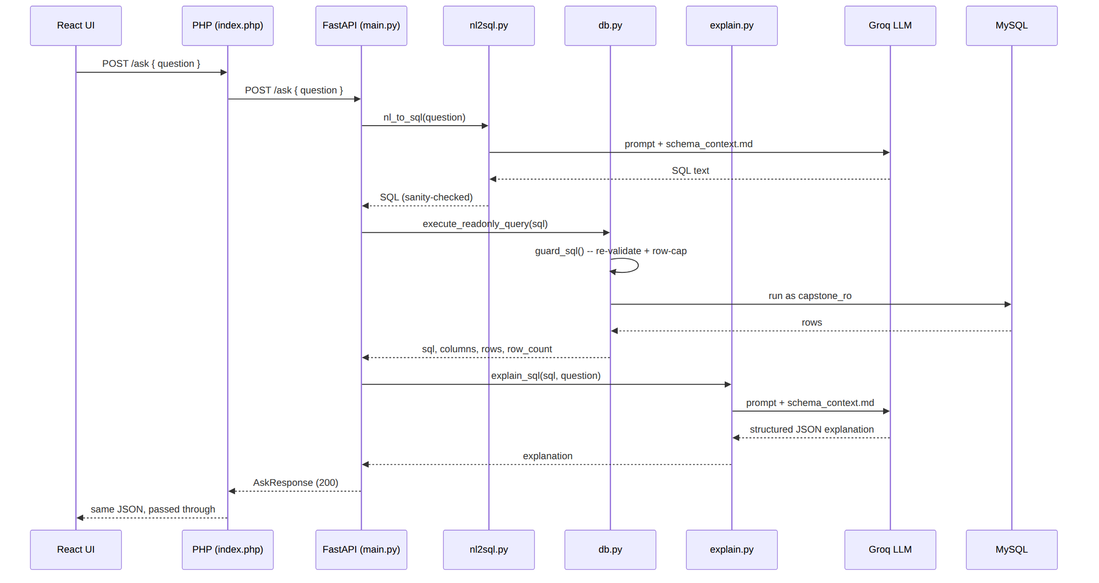
Figure 2. Request flow for POST /ask.

Request

{ "question": "What were total sales by region last year?" }

Response 200

{
"question": "What were total sales by region last year?",
"sql": "SELECT r.region_name, ROUND(SUM(...
"columns": ["region_name", "revenue"],
"rows": [
{ "region_name": "West", "revenue": 152340.50 },
{ "region_name": "East", "revenue": 98120.00 }
],
"row_count": 2,
"explanation": {
"summary": "Total revenue per region over the last 12 months.",
"tables_used": ["orders", "customers", "regions", "order_items"],
"filters": ["Excludes cancelled orders", "Last 12 months only"],
"grouping": ["Grouped by region name"],
"sorting": "Sorted by revenue, highest first",
"row_limit": 200,
"caveats": ["Freight not included in revenue"]
},
"explanation_error": null
}

rows is an array of objects keyed by column name (not an array of arrays) — index into each row with the names in columns. explanation is best-effort: if the LLM’s explanation step fails, explanation is null and explanation_error holds the reason, while sql/columns/rows are still returned normally.

Error Responses
Status | Meaning | Example detail
400 | Empty question | "question must not be empty."
422 | Model refused, or its SQL failed the guard | "Generated SQL failed the safety guard: ..."
502 | Database error, or PHP couldn’t reach FastAPI | "Database error: ..."

5.3 POST /ask-docs
Answers a question using only the policy documents in docs/samples/ (ReturnPolicy.txt, SalesPolicy.pdf, WarrantyTerms.docx), retrieved from the Chroma vector store built by ai-service/ingest_docs.py.
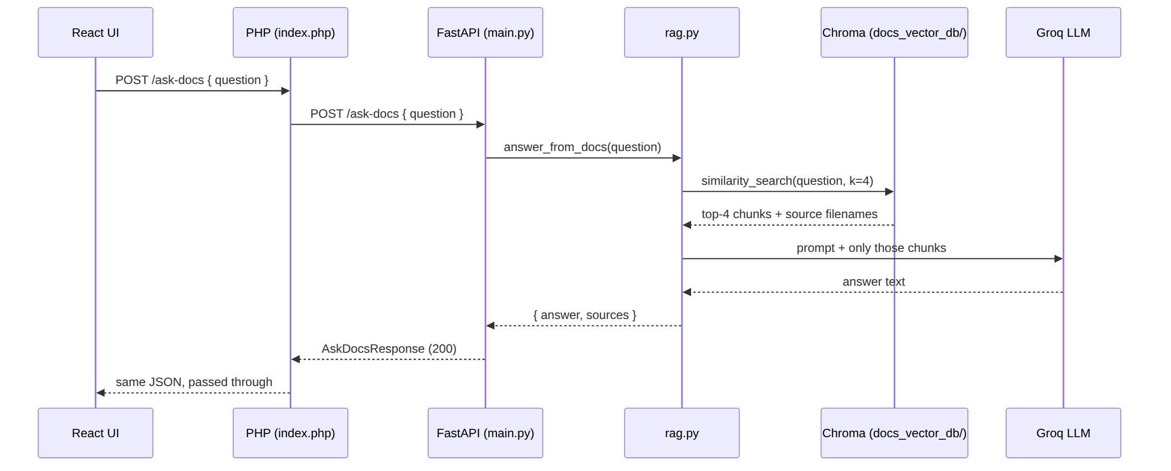
Figure 3. Request flow for POST /ask-docs.

Request

{ "question": "How many days do I have to return a product?" }

Response 200

{
"question": "How many days do I have to return a product?",
"answer": "Per the Returns and Refunds Policy, you have 30 days
from the delivery date to return a product for a
full refund.",
"sources": ["ReturnPolicy.txt"]
}

If the question isn’t covered by any ingested document, answer is literally "I couldn’t find that in the policy documents provided." and sources is [] — this is a normal 200 response, not an error. Each call is independent — there is no server-side conversation history; the React UI keeps the message thread client-side only.

Error Responses
Status | Meaning | Example detail
400 | Empty question | "question must not be empty."
503 | Vector store not built yet, or RAG pipeline errored | "Document Q&A unavailable: ..." (run ingest_docs.py)

5.4 Unmatched Routes
Any method/path the PHP router doesn’t recognize returns 404:

{ "detail": "No route for GET /nope" }

6. Database
Scripts in db\, run in order against a local MySQL 8 server:

Get-Content db\00_CommandsToCreateNewDatabase.sql | mysql -u root -p
Get-Content db\01_schema.sql | mysql -u root -p CapstoneCore
Get-Content db\02_seed_data.sql | mysql -u root -p CapstoneCore
Get-Content db\03_readonly_user.sql | mysql -u root -p

This creates CapstoneCore (11 tables: regions, categories, suppliers, shippers, employees, customers, products, orders, order_items, payments, product_returns), loads sample data for the fictional company Contoso Trading Services, and creates the read-only capstone_ro user used by ai-service/db.py. 04_generate_schema_context.sql regenerates docs/schema_context.md if the schema ever changes — that file is what grounds the LLM’s SQL generation and explanations, so re-run it after any schema edit.

6.1 Key Business Rules
- Line revenue = oi.quantity × oi.unit_price × (1 − oi.discount_pct / 100).
- orders.freight is a header-level delivery charge — not included in line revenue unless explicitly asked about.
- Cancelled orders are excluded from every revenue figure.
- Net revenue = revenue − refunds (product_returns.refund_amount).
- payments.amount is cash received and may be partial; it is not revenue.
- Warranty length comes from categories.warranty_months, not from products.
Full column-level schema and MySQL dialect rules used to ground the LLM: docs/schema_context.md.

7. Security
- Read-only DB access — ai-service connects to MySQL only as capstone_ro, a user with SELECT-only privileges, enforced at the MySQL grant level, not just in application code.
- Independent SQL guard — every generated statement is re-validated in db.py regardless of what nl2sql.py already checked: must parse as exactly one statement, must start with SELECT/WITH, must not contain any write/DDL/session keyword, and gets a row cap (LIMIT 200 by default) rewritten or appended before it runs.
- No secrets in source — .env lives at the repo root and is gitignored; .env.example and frontend\.env.local.example hold placeholders only.
- No absolute paths in code — all paths are resolved relative to the repo root at runtime, so the project runs after a plain git clone on any machine.

8. Tests

cd ai-service
.venv\Scripts\Activate.ps1
pytest

Covers nl2sql.py, explain.py, and llm_provider.py (ai-service\tests\).

9. Status
Database, both backend services, and the React UI (Ask Data / Chat Docs) are working end-to-end. Remaining: demo video.

