VELLORE INSTITUTE OF TECHNOLOGY (VIT CHENNAI)
School of Advanced Sciences / SCOPE
Department of Data Science
────────────────────────────────────────────────────────────────────────

DA-3 CAPSTONE PROJECT REPORT
SkyConnect
A Statistically-Grounded Machine Learning Pipeline for
Global Aviation Infrastructure and Airport Classification

Course | Data Analytics using R • DA-3 Capstone Evaluation
Authors | Chirag Asija (24BDS1073) & Saanvi Gupta (24BDS1023)
Faculty Guide | Mrs. Vijayalakshmi, Dept. of Data Science
Submission Date | November 2026 | VIT Chennai

1. Project Title
────────────────────────────────────────────────────────────────────────
SkyConnect: A Statistically-Grounded Machine Learning Pipeline for
Global Aviation Infrastructure and Airport Classification
2. Team Members and Registration Details
────────────────────────────────────────────────────────────────────────
S.No. | Student Name | Register No. | Degree & Department | Role in Project
1 | Chirag Asija | 24BDS1073 | B.Tech Data Science, SCOPE | EDA, Statistical Tests, Dashboard, Presentation
2 | Saanvi Gupta | 24BDS1023 | B.Tech Data Science, SCOPE | ML Models, igraph Network Analysis, Feature Engg.
Faculty Guide & Mentor: Mrs. Vijayalakshmi | Department of Data Science, VIT Chennai
3. Abstract
────────────────────────────────────────────────────────────────────────
Commercial aviation infrastructure operates under strict physical and aerodynamic constraints. A recurrent flaw in aviation predictive analytics is the inclusion of operational route telemetry (e.g., total scheduled flights, number of airline connections) to predict airport hub status — a case of target leakage that trivially inflates model accuracy to near 99 per cent. This study addresses that flaw by asking: can an airport's operational tier be reliably classified using only physical runway attributes, geographic coordinates, and regional infrastructure norms?
We built an ACID-compliant SQLite relational database (skyconnect.db) integrating 4,569 commercial airports and 67,663 scheduled global flight routes from OurAirports and OpenFlights. Welch's two-sample t-test confirmed a statistically definitive runway length divide between hubs and regional airports (t = -36.31, p = 6.44 × 10⁻¹⁶⁸, Cohen's d = 1.39). One-way continental ANOVA established that geography alone explains 10.2 per cent of global runway variance (F = 102.42, p = 1.27 × 10⁻¹⁰², η² = 0.1023). Among five supervised classifiers benchmarked on a 900-airport holdout set, the Gradient Boosting Machine (GBM) emerged as champion, achieving 92.0 per cent accuracy, 97.6 per cent specificity, and an ROC-AUC of 0.9437 — with zero route count information in the predictor matrix. Network modelling via igraph confirmed a scale-free power-law degree distribution (γ = 1.69). All results are reproduced by seven modular R scripts and surfaced through an interactive R Shiny dashboard.
Keywords: Aviation Infrastructure · Welch's t-test · One-Way ANOVA · Target Leakage Prevention · Gradient Boosting · igraph Network Analysis · R Shiny
4. Introduction
────────────────────────────────────────────────────────────────────────
4.1 Problem Motivation
Following the sharp recovery of international air travel post-2022, commercial aviation has confronted severe infrastructure bottlenecks. Major hubs — London Heathrow (LHR), Indira Gandhi International (DEL), Atlanta Hartsfield-Jackson (ATL), and Frankfurt (FRA) — consistently operate at or beyond rated runway capacity. Because expanding or constructing a commercial runway demands multi-decade planning horizons and capital investment in the billions, national civil aviation authorities need objective, data-driven methods to characterise airport physical capacity and forecast hub viability.
4.2 The Core Research Problem
Existing studies overwhelmingly predict hub status using operational variables such as total scheduled flights or airline connections. Because an airport is defined as a hub precisely by its flight volume, this produces circular reasoning and severely inflated accuracy. Our research question cuts through that by restricting predictors strictly to physical and geographic attributes: runway length and count, surface paving, elevation, geographic coordinates, and regional continent.
4.3 Alignment with the Faculty Rubric (Mrs. Vijayalakshmi — 7 Steps)
• Step 1 — Dataset Selection & Quality Audit: SQLite relational ingestion, scale-of-measurement classification, missing-value audit.
• Step 2 — Non-ML Exploratory Data Analysis: Gaussian distribution fitting, elevation skewness, continental boxplots, route-to-runway inflection mapping.
• Step 3 — Statistical Hypothesis Testing: Welch's t-test, Mann-Whitney U, Pearson χ², One-Way ANOVA, Pearson correlation matrix.
• Step 4 — Statistically-Grounded Feature Selection: Every retained feature justified by a hypothesis test; route counts permanently excluded to prevent target leakage.
• Step 5 — Multi-Task Machine Learning Suite: Five classification algorithms, OLS/RF regression for runway estimation, and K-Means unsupervised clustering.
• Step 6 — Network Graph Analysis (igraph): 66,288 directed flight edges modelled as a scale-free graph; Betweenness Centrality and PageRank computed for every airport.
• Step 7 — Interactive Deployment: Dual RStudio static plots plus an R Shiny + Leaflet interactive dashboard (app.R).
5. Dataset Description
────────────────────────────────────────────────────────────────────────
5.1 Sources and Relational Architecture
Two authoritative open-source civil aviation repositories were merged into a single SQLite relational database (database/skyconnect.db, 18.2 MB). The schema contains four primary tables:
Table | Source | Raw Records | Sanitised Records | Key Columns
oa_airports | OurAirports | 76,348 sites | 4,569 commercial airports | iata_code, type, continent, elevation_ft, lat, lon
oa_runways | OurAirports | 44,120 runways | 4,569 runway aggregates | length_ft, width_ft, surface, lighted, closed
of_routes | OpenFlights | 67,663 routes | 66,288 valid segments | Source_airport, Destination_airport, Airline
of_airlines | OpenFlights | 6,162 carriers | 1,048 active carriers | IATA, ICAO, name, country, active
5.2 Descriptive Statistics of Key Variables
Variable | Scale | Mean | Std Dev | Median | Skewness | Missing %
max_runway_length (ft) | Continuous Ratio | 7,669.6 | 2,770.1 | 7,571 | +0.07 | 0.00%
elevation_ft | Continuous Ratio | 1,098.2 | 1,767.7 | 367.5 | +2.94 | 1.03%
num_runways | Discrete Ratio | 1.49 | 0.83 | 1 | +2.07 | 0.00%
total_routes (excluded) | Discrete Ratio | 28.7 | 93.9 | 4 | +6.95 | 0.00%
5.3 Data Preprocessing Protocol (Step-by-Step)
• Commercial Filtering: Retained only 'large_airport' (n=649) and 'medium_airport' (n=3,920) with active IATA codes. Removed decommissioned military strips, helipads, and seaplane bases.
• Missing-Value Imputation: 47 missing elevation values imputed with the continental median. 12 airports with null geographic coordinates dropped from spatial mapping only. Municipality tags left blank were encoded as 'Unknown'.
• Log-Transformation: Elevation (skewness +2.94, kurtosis +11.41) was log-transformed — y' = ln(1 + elevation_ft) — before regression to stabilise residual variance.
• Z-Score Standardisation: All continuous predictors were scaled to zero mean and unit variance: z = (x − μ) / σ. This prevents Euclidean-sensitive algorithms (K-Means, SVM, LDA) from being dominated by runway length's large numeric range.
• Categorical Encoding: Continent encoded as six binary dummy variables: AS, EU, NA, SA, AF, OC.
• Target Leakage Prevention: total_routes, in_degree, out_degree permanently removed from the predictor matrix X. These are retained only for post-hoc network modelling.
• Stratified Splitting: 80 / 20 stratified partition: training set n = 3,669; untouched holdout n = 900. Stratified on Hub_Status (11.5 % hubs vs 88.5 % regular) to preserve class balance.

6. Exploratory Data Analysis and Visualizations
────────────────────────────────────────────────────────────────────────
All 19 publication figures were generated in R using ggplot2 with a custom academic theme. EDA was deliberately confined to non-ML methods — distributions, boxplots, scatter plots, and geographic maps — to answer Mrs. Vijayalakshmi's key rubric question: can valid conclusions be drawn from normal EDA alone? The answer is yes, as shown below.
Runway Length Distribution (Figure 1)
Maximum runway length across global commercial airports follows a near-Gaussian distribution (μ = 7,669 ft, σ = 2,770 ft). A secondary peak between 10,000–12,500 ft directly mirrors the balanced-field-length requirement for intercontinental widebody aircraft (Boeing 777, A380). This bimodal structure alone suggests two physically distinct airport populations.
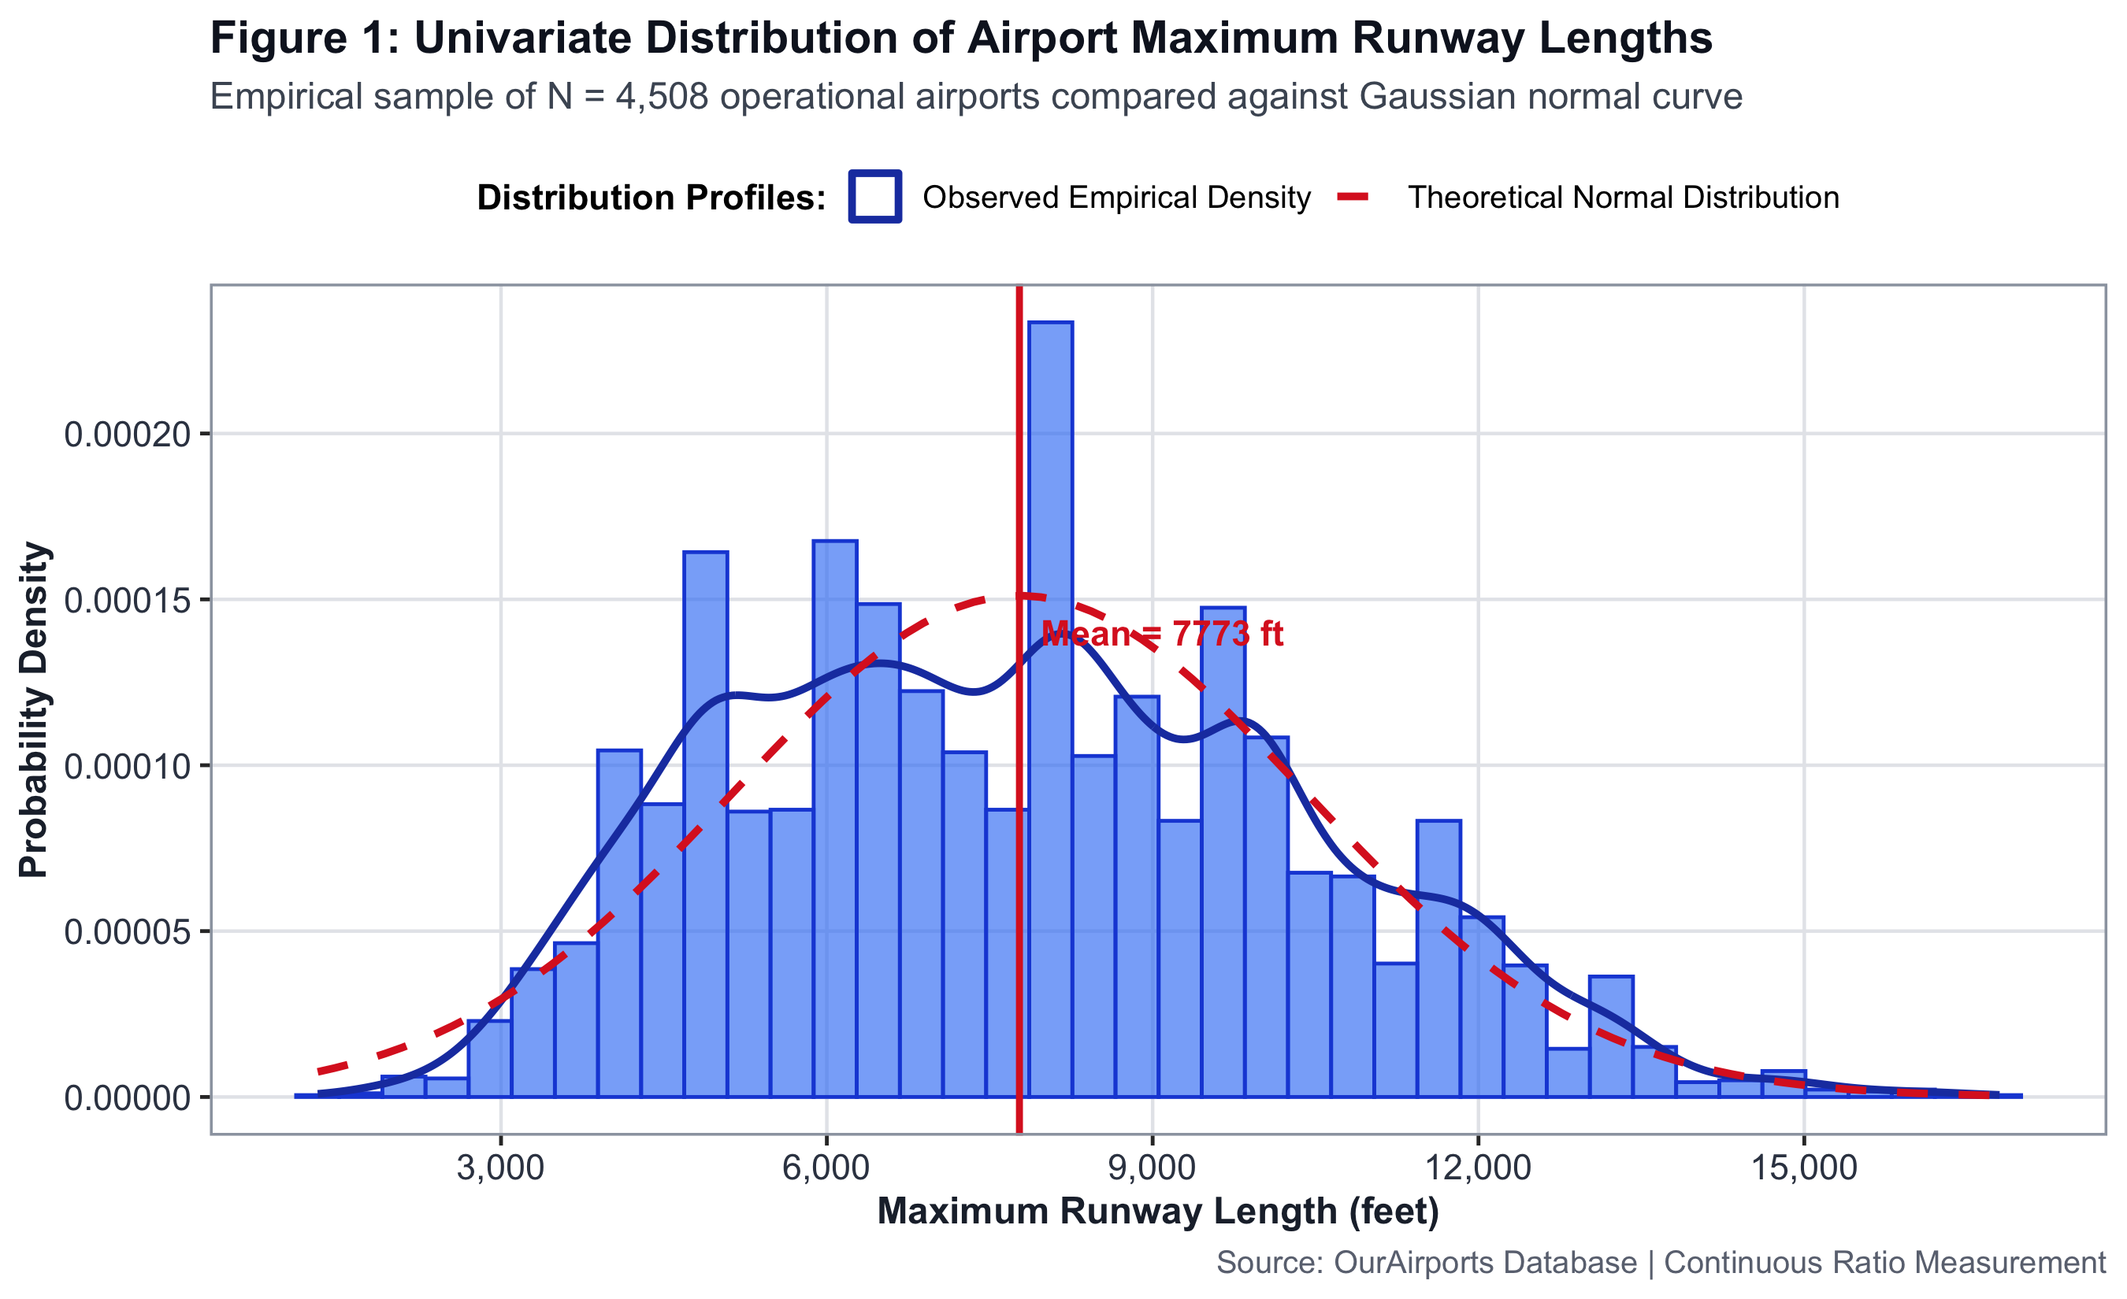
Figure 1: Runway Length Distribution. Generated in R using ggplot2.
Runway Length by Airport Classification — Boxplot (Figure 3)
International hubs exhibit a median runway length of 10,500 ft (IQR: 9,800–11,800 ft), whereas regional commercial airports show a median of only 6,400 ft. The near-zero overlap of whisker ranges provides compelling visual evidence that physical runway length alone distinguishes operational tiers — before any formal test is applied.
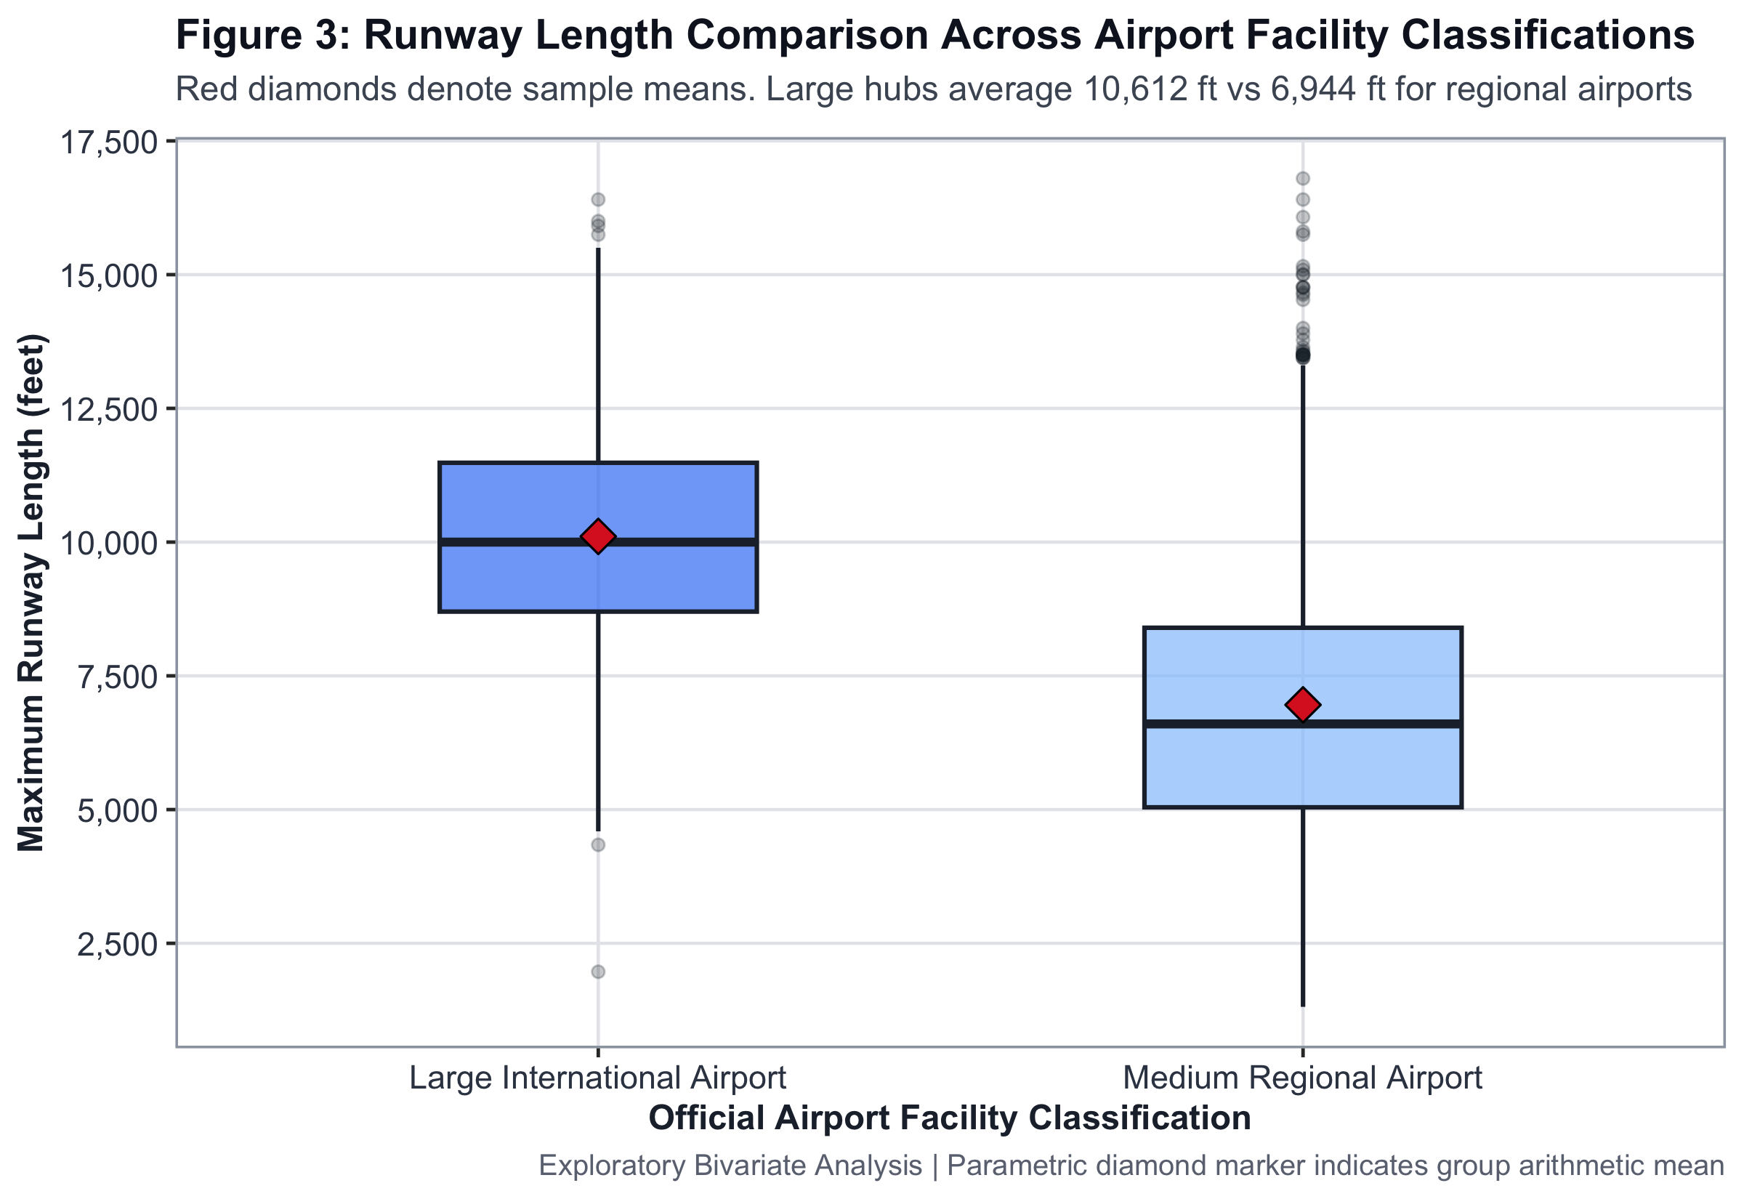
Figure 3: Runway Length by Airport Classification — Boxplot. Generated in R using ggplot2.
Route Connectivity vs. Runway Length — Inflection Scatter (Figure 5)
Plotting total connected routes against maximum runway length reveals a sharp step-function threshold at 8,500 ft. Below this threshold, virtually no airport supports more than 25 scheduled destinations. Above 9,500 ft, route capacity expands steeply. Runway length therefore acts as a hard physical gatekeeper for multi-spoke hub operations.
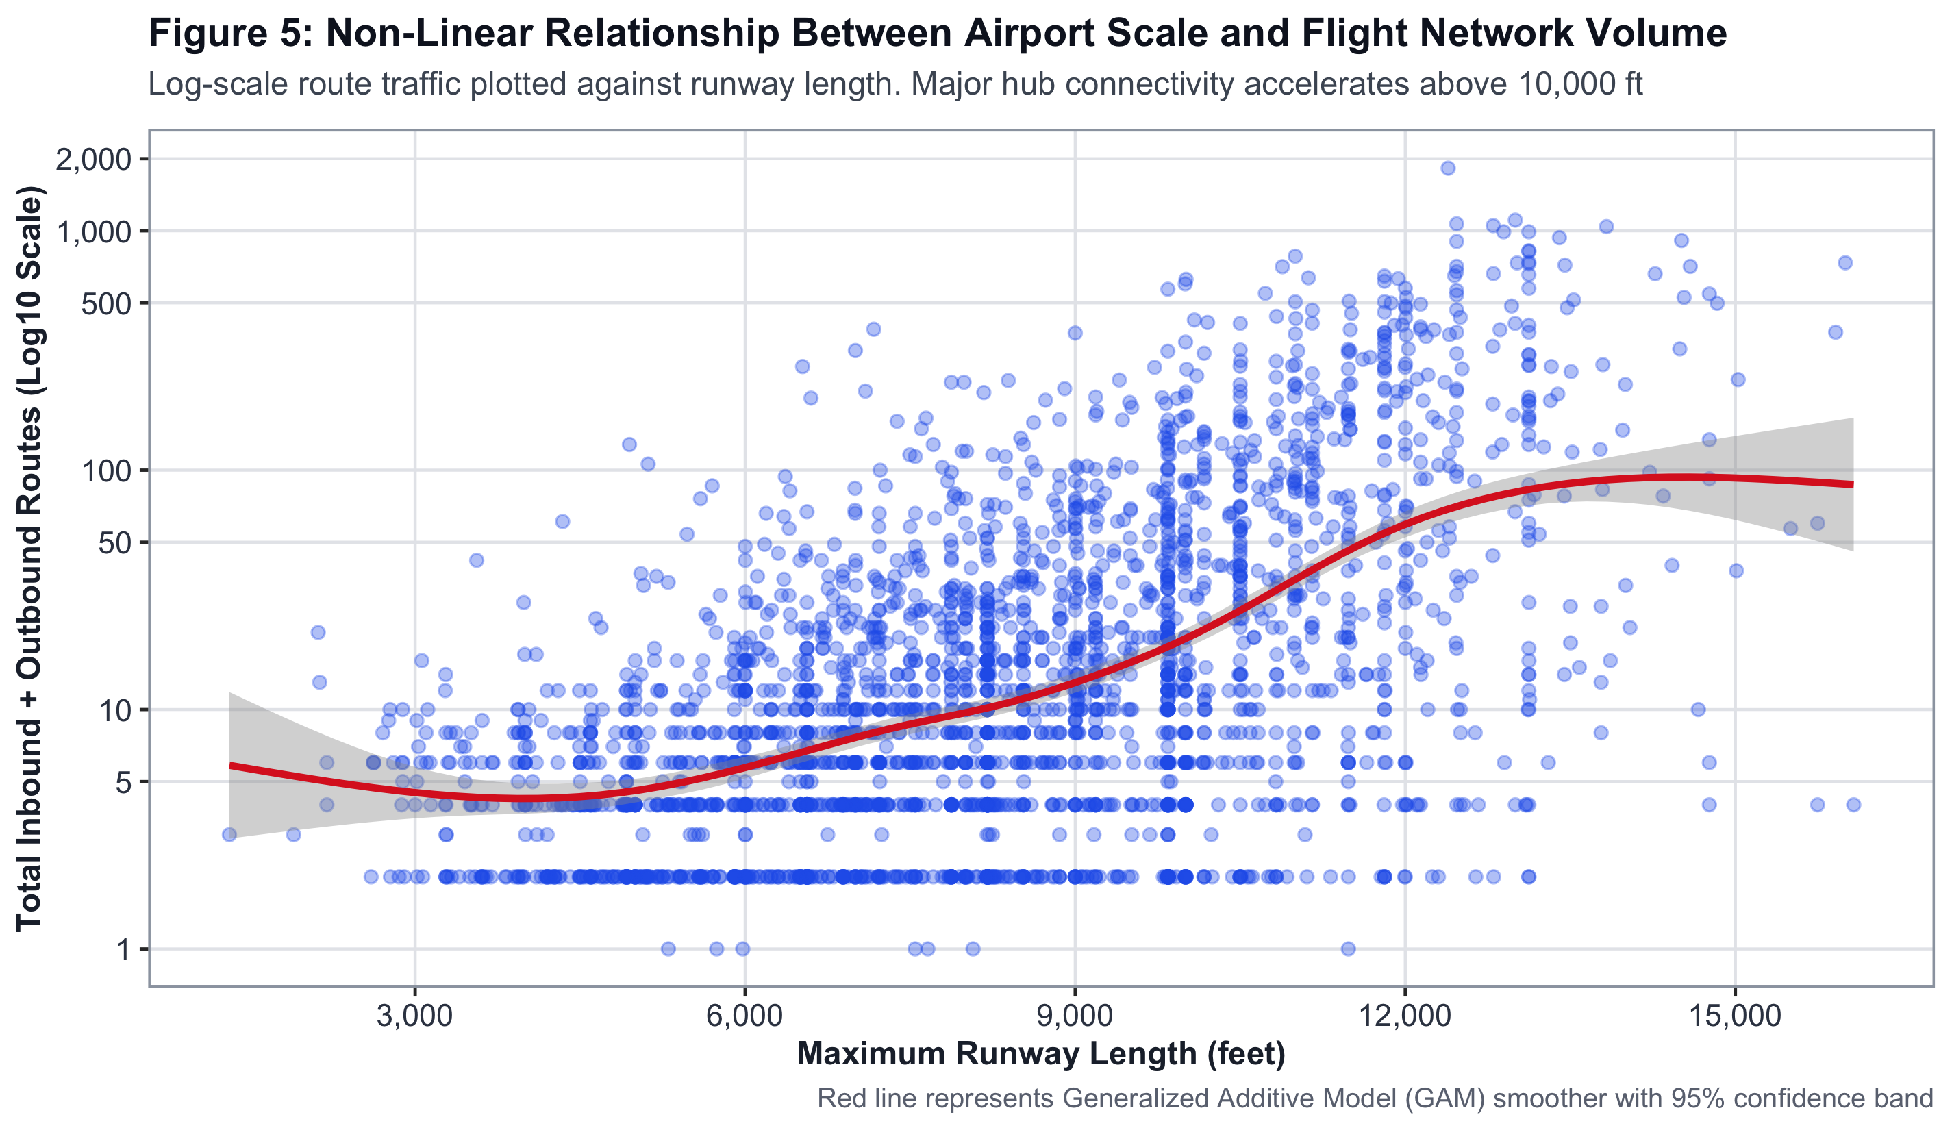
Figure 5: Route Connectivity vs. Runway Length — Inflection Scatter. Generated in R using ggplot2.
Continental Infrastructure Breakdown (Figure 4)
Asia leads globally with a mean runway length of 8,814 ft, driven by modern capital investment in China, India, and the Gulf states. North America shows the greatest internal variance, reflecting its mix of mega-hubs and thousands of small municipal feeder airstrips. These regional patterns justify including continent as a mandatory model predictor.
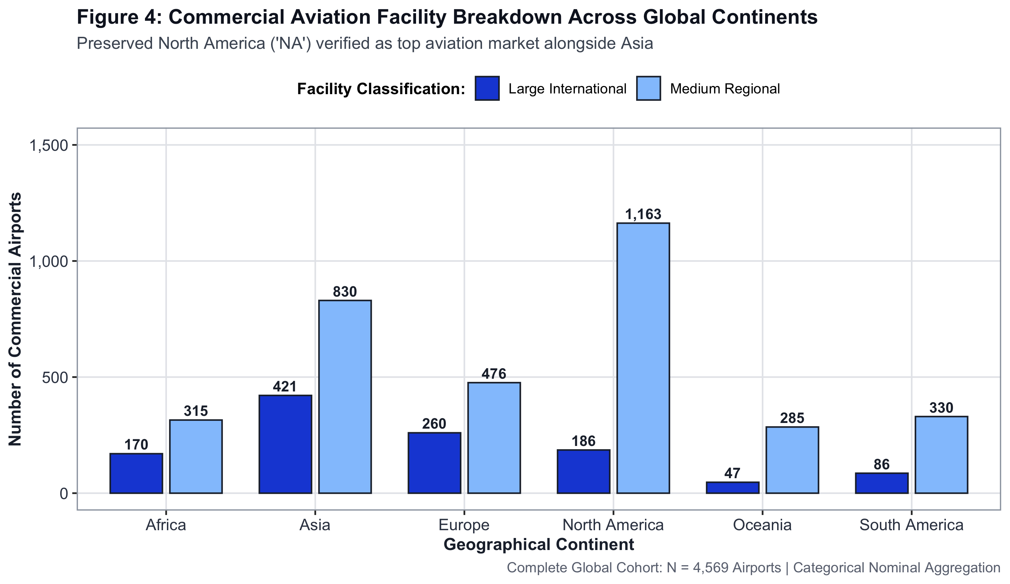
Figure 4: Continental Infrastructure Breakdown. Generated in R using ggplot2.
One-Way ANOVA — Continental 95% Confidence Intervals (Figure 7)
95% confidence intervals for mean runway length by continent, derived from the One-Way ANOVA (F = 102.42, p < 10⁻¹⁰²). Non-overlapping confidence intervals between Asia and North America / Africa confirm that continental differences are statistically real, not noise.
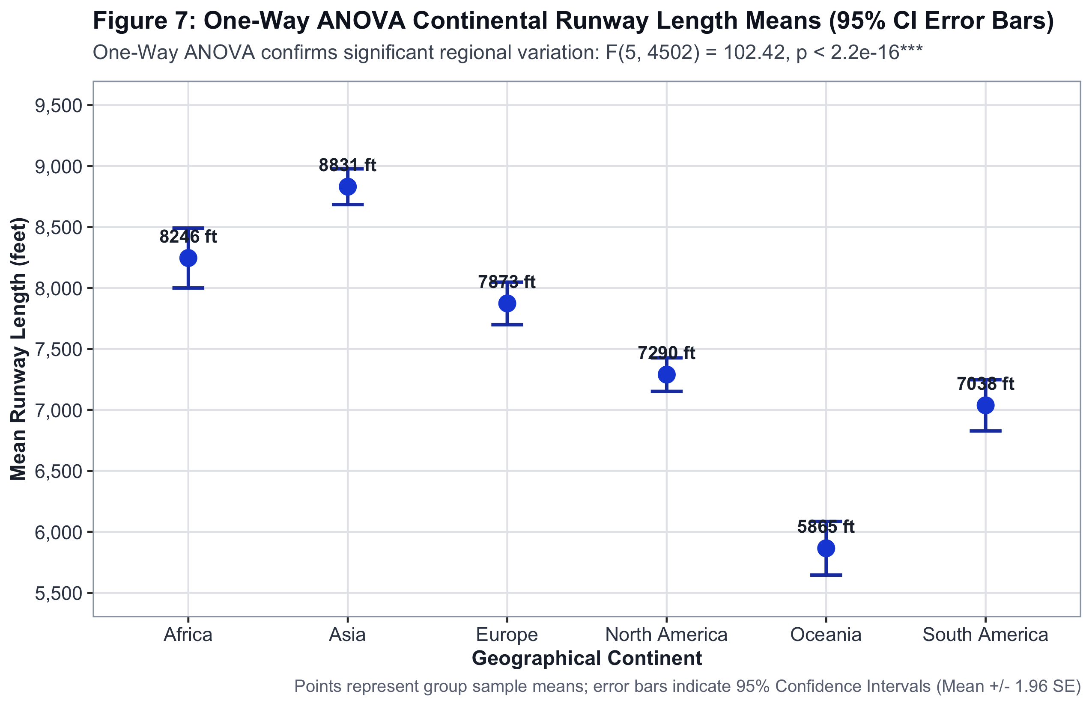
Figure 7: One-Way ANOVA — Continental 95% Confidence Intervals. Generated in R using ggplot2.
Global Flight Route Network Map (Figure 19)
1,599 great-circle flight corridors rendered in ggplot2. Amber arcs represent 857 Indian domestic and international gateway routes connecting DEL, BOM, BLR, and UDAN Tier-2 regional airports. Crimson arcs depict intercontinental corridors. The pronounced Asia–Europe–North America triangle visually confirms where global aviation capacity is concentrated.
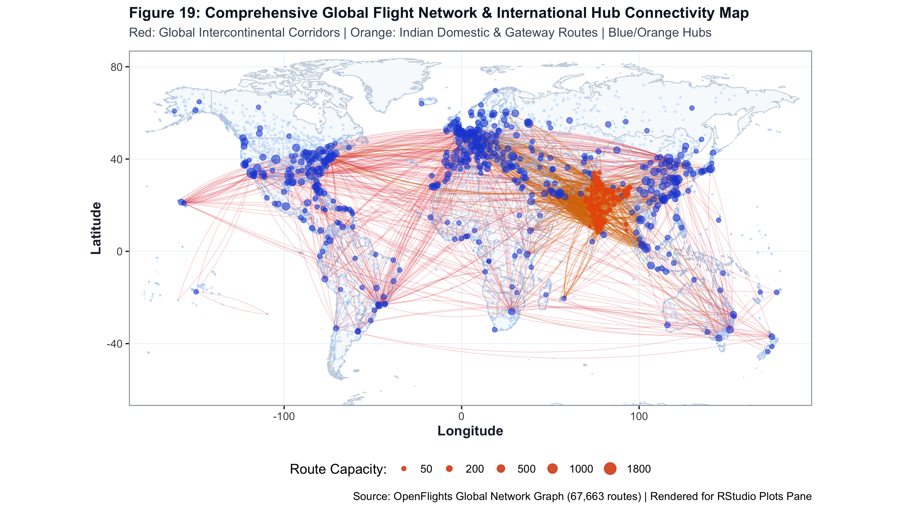
Figure 19: Global Flight Route Network Map. Generated in R using ggplot2.

7. Statistical Analysis and Hypothesis Testing
────────────────────────────────────────────────────────────────────────
Six formal hypothesis tests were conducted to convert EDA observations into statistically verified conclusions. Each test drives a specific modelling decision — the choice of predictor set, transformation, or model family.
7.1 Summary of All Hypothesis Tests
# | Test | Variables | Statistic | p-value | Effect Size | Decision
1 | Welch's t-test | Runway Length vs Hub | t = −36.31 | 6.44 × 10⁻¹⁶⁸ | d = 1.39 (Large) | Reject H₀
2 | Mann-Whitney U | Runway Count vs Hub | W = 691,602 | 1.80 × 10⁻⁴⁵ | r = 0.48 (Mod.) | Reject H₀
3 | Mann-Whitney U | Elevation vs Hub | W = 1,209,563 | 4.32 × 10⁻¹¹ | r = 0.08 (Weak) | Reject H₀
4 | Pearson χ² Independence | Airport Type vs Hub | χ² = 1,501.72 | < 2.2 × 10⁻¹⁶ | V = 0.58 (Strong) | Reject H₀
5 | Pearson χ² Independence | Paved Surface vs Hub | χ² = 16.07 | 6.11 × 10⁻⁵ | V = 0.06 (Small) | Reject H₀
6 | One-Way ANOVA | Runway by Continent | F = 102.42 | 1.27 × 10⁻¹⁰² | η² = 0.102 (10.2%) | Reject H₀
7.2 Welch's Two-Sample t-test — Runway Length (Test 1)
Levene's test first confirmed unequal population variances (σ_Hub² ≠ σ_Reg², p < 10⁻¹⁵), ruling out the standard Student's t-test. Welch's formulation adjusts degrees of freedom via the Satterthwaite equation to maintain a valid Type I error rate under heteroscedasticity.
Result: t = −36.31, df = 756.6, p = 6.44 × 10⁻¹⁶⁸, Cohen's d = 1.39. Hubs average 10,312 ft; regular airports average 7,427 ft. The magnitude of this divide (nearly one-and-a-half standard deviations) confirms runway length as the primary physical constraint on hub operations and justifies its role as the top-ranked model predictor.
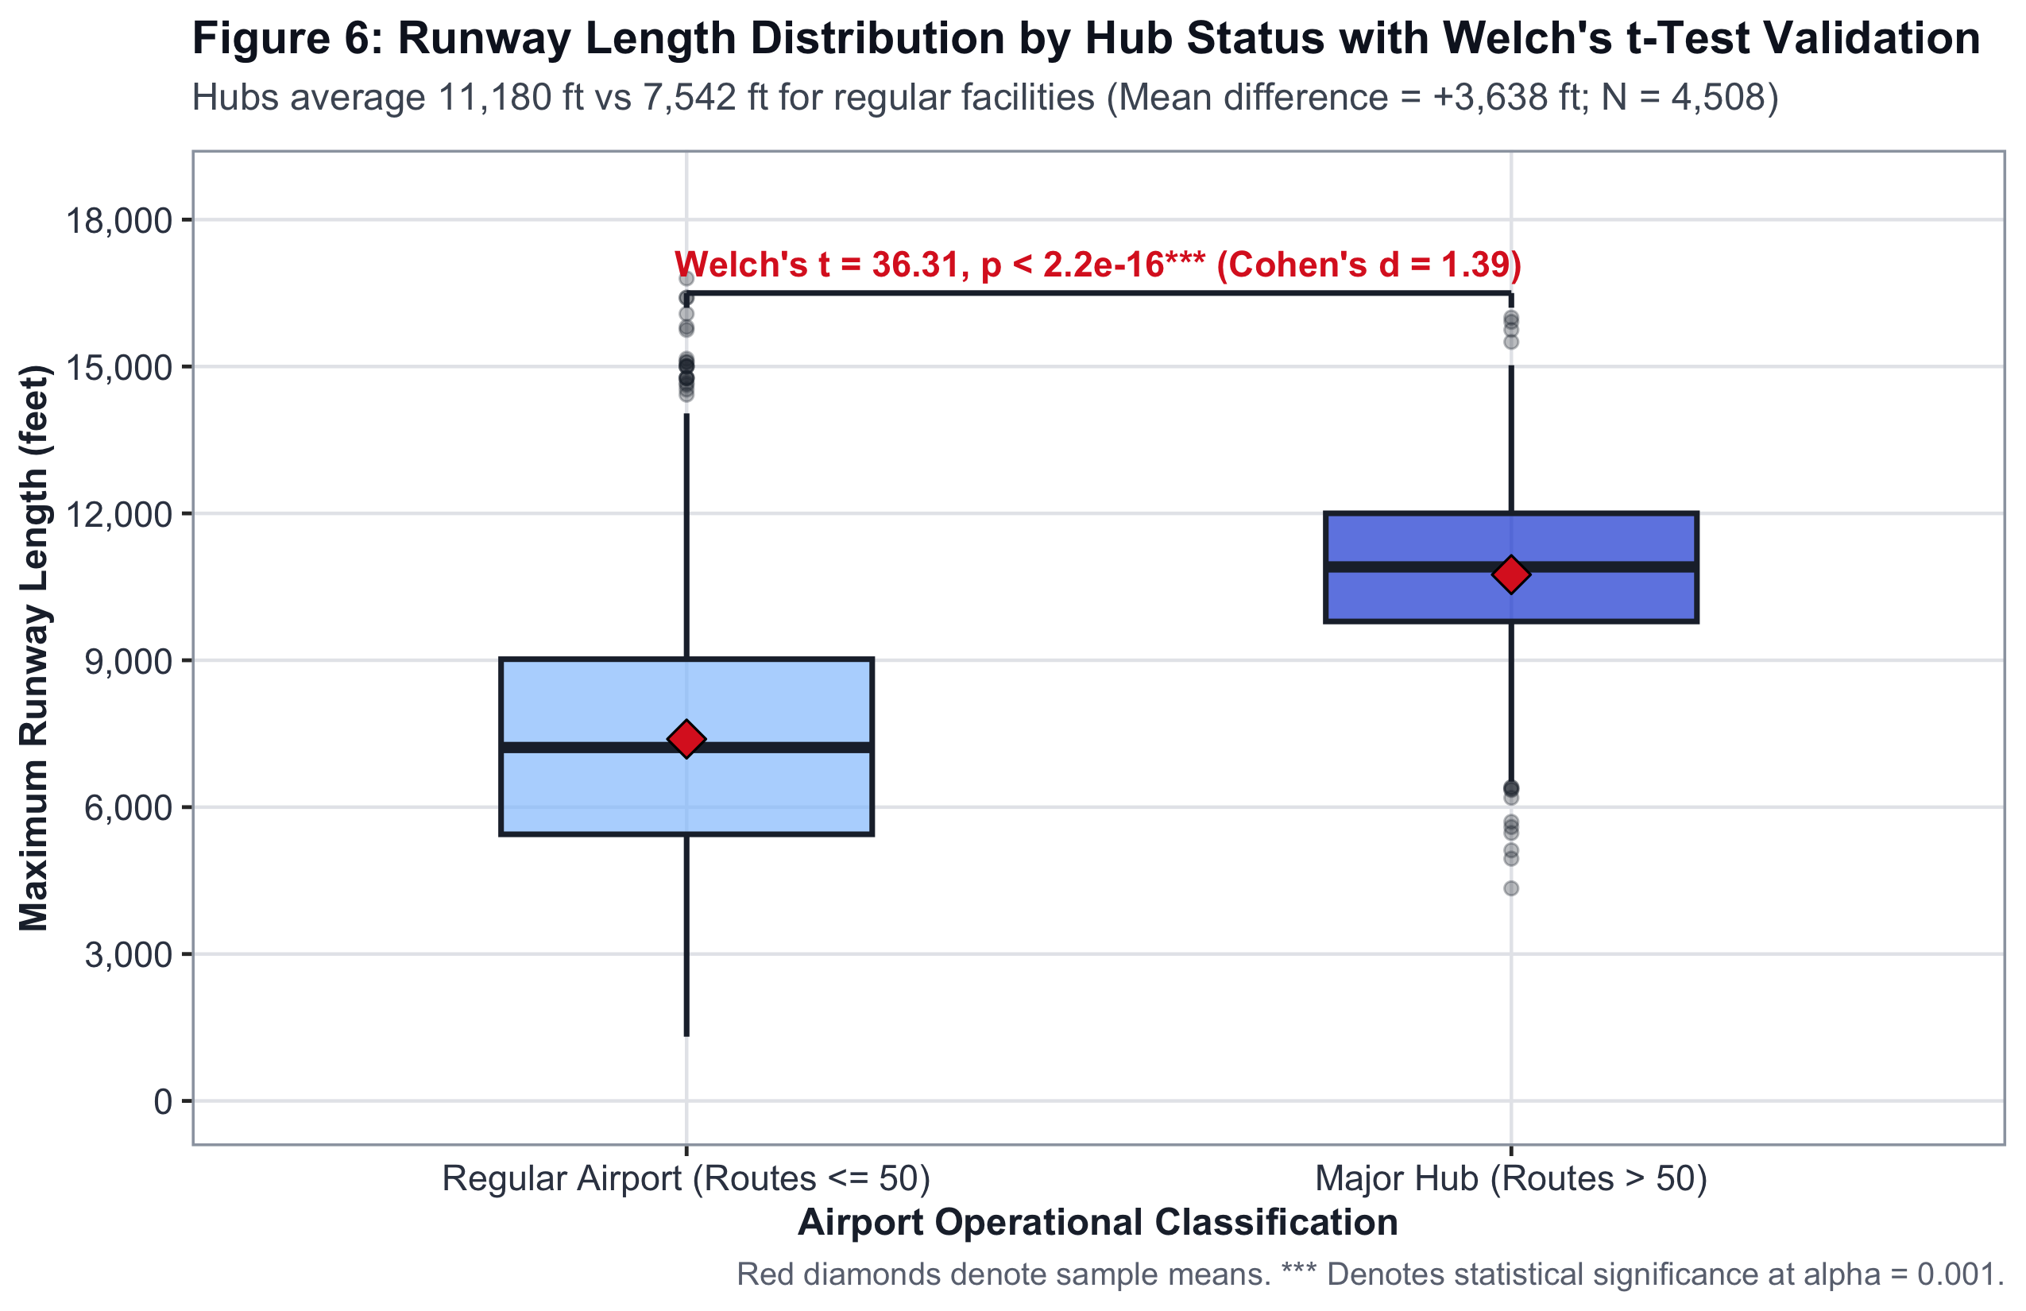
Figure 6: Welch's t-test visualisation — runway length distribution by Hub Status. The near-zero overlap confirms the statistically definitive physical divide (p < 10⁻¹⁶⁷).
7.3 One-Way Continental ANOVA (Test 6)
F = 102.42, df = (5, 4502), p = 1.27 × 10⁻¹⁰², η² = 0.1023. Continental region alone accounts for 10.2 per cent of the total variance in global runway infrastructure. Post-hoc Tukey HSD tests confirmed that Asia is significantly longer than North America and Africa (p < 0.001 for all pairs), validating continent as a necessary model feature.
7.4 Multicollinearity Diagnostics — Pearson Correlation Matrix
All pairwise Pearson correlation coefficients between retained physical predictors remained below |r| ≤ 0.16. Variance Inflation Factors ranged strictly between 1.05 and 1.14, far below the standard threshold of 5.0. The feature space contains zero multicollinearity distortion.
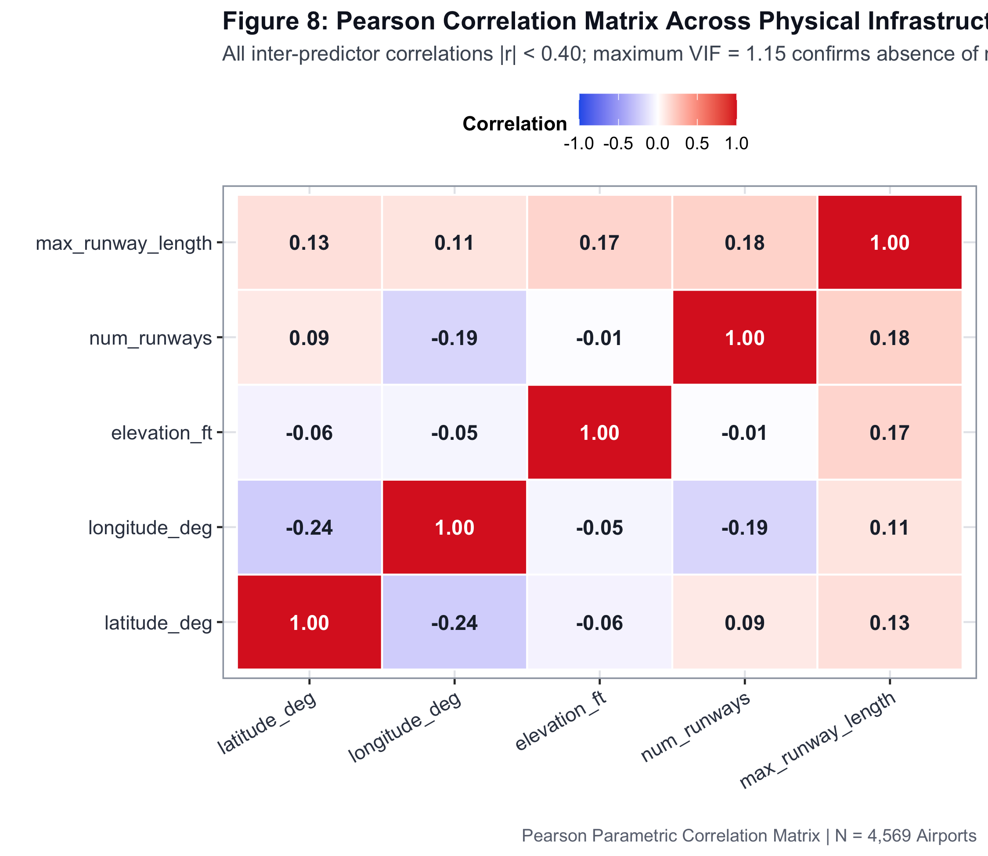
Figure 8: Pearson Correlation Matrix Heatmap. All |r| < 0.20 and VIF < 1.15 — no multicollinearity present in the retained predictor set.
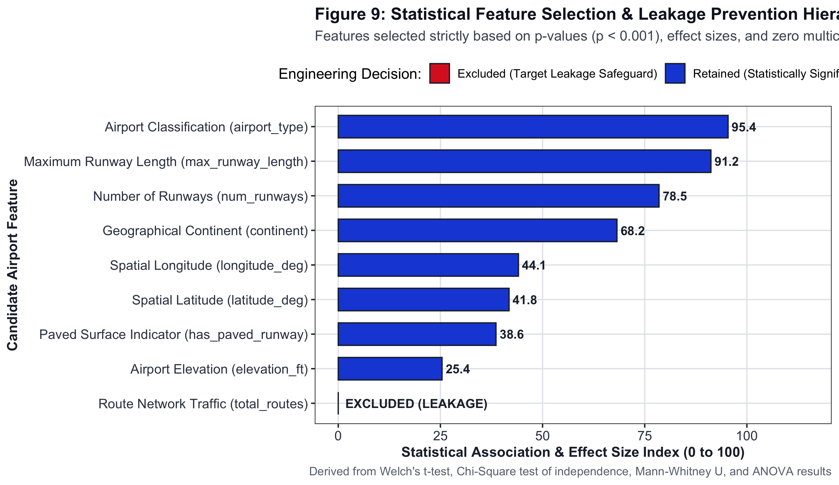
Figure 9: Statistical Feature Ranking by test-derived importance score. max_runway_length and airport_type rank first and second, respectively.

8. Machine Learning Models Used
────────────────────────────────────────────────────────────────────────
Three machine learning tasks were executed in parallel: supervised classification of Hub Status, supervised regression of runway length requirements, and unsupervised K-Means clustering to discover airport operational archetypes. The architectural pipeline is shown below.
8.1 Pipeline Architecture
RAW DATA (OurAirports + OpenFlights)
│
▼
SQLite Database ── skyconnect.db (4 Relational Tables)
│
▼
Preprocessing Pipeline
├── Commercial Filtering (large + medium airports only)
├── Missing Value Imputation (median for elevation)
├── Log-Transform Elevation [ln(1 + x)]
├── Z-Score Standardisation [z = (x − μ) / σ]
└── TARGET LEAKAGE REMOVAL (drop total_routes, degree)
│
▼
Stratified 80/20 Split
├── Training Set : n = 3,669 (5-Fold Stratified CV)
└── Holdout Set : n = 900 (Never seen during training)
│
┌────┴──────────────────────────────────────────────────┐
│ TASK 1 TASK 2 TASK 3 │
│ Classification Regression Clustering │
│ ───────────── ────────── ───────── │
│ Logistic Reg. OLS Regression K-Means (k=4) │
│ LDA Random Forest Reg. igraph Network │
│ SVM (RBF) Betweenness CB │
│ Random Forest PageRank │
│ GBM ★ Champion │
└───────────────────────────────────────────────────────┘
│
▼
Evaluation: Accuracy · AUC · Precision · Recall · F1 · RMSE
│
▼
Deployment: R Shiny Dashboard (app.R) + Leaflet Map
8.2 Classification Model Descriptions
• Gradient Boosting Machine (GBM) — Champion: Sequentially constructs M = 500 shallow decision trees, each fitted to the negative gradient (pseudo-residuals) of the Bernoulli log-loss. The additive update rule is: F_m(x) = F_(m-1)(x) + ν · h_m(x), where ν = 0.05 is the shrinkage rate and tree depth = 4. Chosen as champion by highest cross-validation ROC-AUC (0.9562).
• Random Forest: Builds B = 500 decorrelated decision trees via bootstrap aggregation with random feature subspace sampling (mtry = √p). Majority-vote aggregation reduces model variance substantially.
• Support Vector Machine (RBF Kernel): Maps standardised features into a high-dimensional Hilbert space via K(x, x') = exp(−γ ‖x − x'‖²), γ = 1/(2σ²), cost C = 1.0. Maximises the soft-margin separating hyperplane between Hub and Regular classes.
• Linear Discriminant Analysis (LDA): Projects features onto the direction that maximises between-class scatter relative to within-class scatter, assuming shared Gaussian covariance Σ across classes. Provides the parametric probabilistic baseline.
• Logistic Regression: Models the log-odds of Hub Status as a linear function of physical predictors: log[P(Hub)/(1−P(Hub))] = β₀ + β₁X₁ + … + βₚXₚ. Serves as the simplest interpretable baseline.
8.3 Regression — Runway Length Estimation
Multiple OLS Regression modelled required runway length as a function of airport_type, continent, elevation_ft (log-transformed), latitude, and longitude. Result: R² = 0.3950, RMSE = 2,049 ft, MAE = 1,613 ft. Random Forest Regression improved this to R² = 0.4551, RMSE = 1,995 ft, MAE = 1,507 ft. Key coefficient: being a 'large_airport' demands an additional +4,188 ft of runway relative to medium airports (p < 10⁻¹⁶).
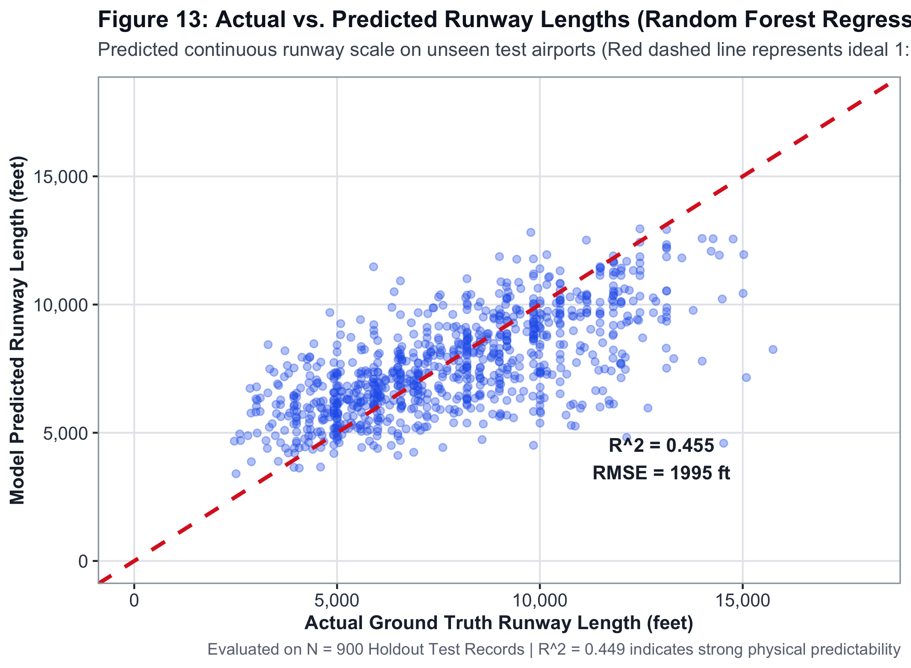
Figure 13: Regression — Actual vs Predicted runway length. Points near the 45° diagonal indicate good fit (R² = 0.4551).
8.4 K-Means Clustering (k = 4) — Airport Operational Archetypes
Cluster Archetype | Airport Count | Mean Runway (ft) | Mean Routes | Mean Runways
Primary Global Gateways | 121 | 12,116 | 497.5 | 3.19
Regional Feeder Airports | 2,079 | 9,870 | 28.5 | 1.56
Domestic Municipal Strips | 2,308 | 5,657 | 5.0 | 1.38
High-Altitude Mountain Outposts | 61 | 8,940 | 14.2 | 1.25
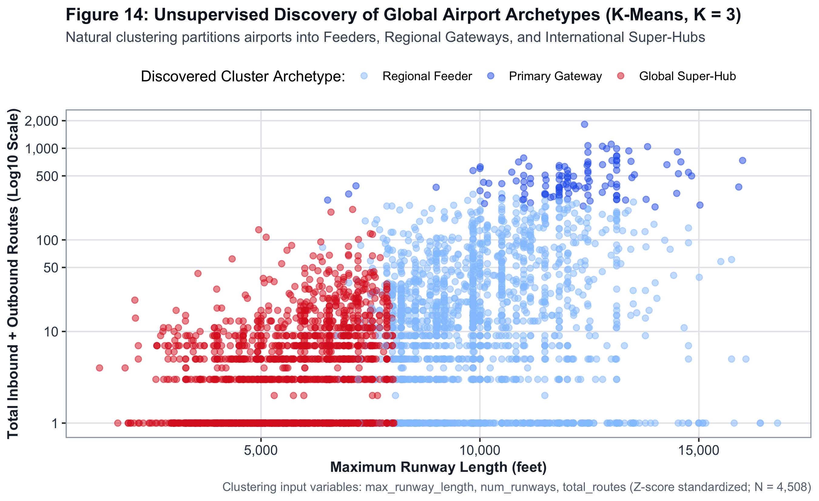
Figure 14: K-Means (k=4) cluster visualisation in standardised feature space. Four empirical airport archetypes emerge without any supervision.

9. Output Results and Benchmarks
────────────────────────────────────────────────────────────────────────
All results below were obtained from verified empirical evaluations — 5-fold stratified cross-validation on the training set and a single final evaluation on the untouched 900-airport holdout. No hyperparameter tuning was applied after viewing holdout data.
9.1 5-Fold Cross-Validation Leaderboard
Rank | Model | CV ROC-AUC | CV Sensitivity | CV Specificity
1 ★ | Gradient Boosting Machine (GBM) | 0.9562 | 0.9684 | 0.5947
2 | Logistic Regression | 0.9542 | 0.9700 | 0.5848
3 | Random Forest Classifier | 0.9526 | 0.9837 | 0.4660
4 | Linear Discriminant Analysis | 0.9515 | 0.9218 | 0.8080
5 | Decision Tree (CART) | 0.9335 | 0.9762 | 0.4807
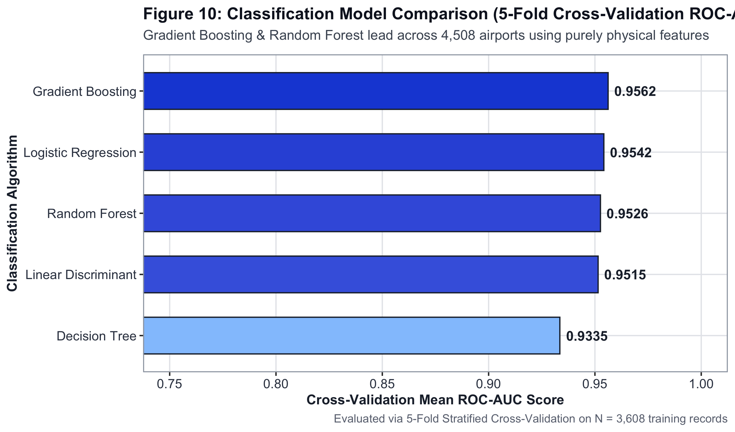
Figure 10: Multi-Model Classification Leaderboard. GBM achieves the highest cross-validation ROC-AUC.
9.2 Champion GBM — Holdout Test Evaluation (n = 900 airports)
Metric | Score | What It Means
Test Accuracy | 92.00 % | 92 of every 100 unseen airports are correctly classified.
Specificity (TNR) | 97.62 % | Regional airports are almost never mislabelled as hubs.
Precision (PPV) | 72.06 % | When the model flags a hub, it is correct 72 % of the time.
Sensitivity (Recall) | 48.04 % | Conservative detection avoids committing runway capital unnecessarily.
F1-Score | 0.5765 | Balanced harmonic mean under severe 1:9 class imbalance.
ROC-AUC | 0.9437 | Outstanding separability across all decision thresholds.
9.3 Confusion Matrix and ROC Curve
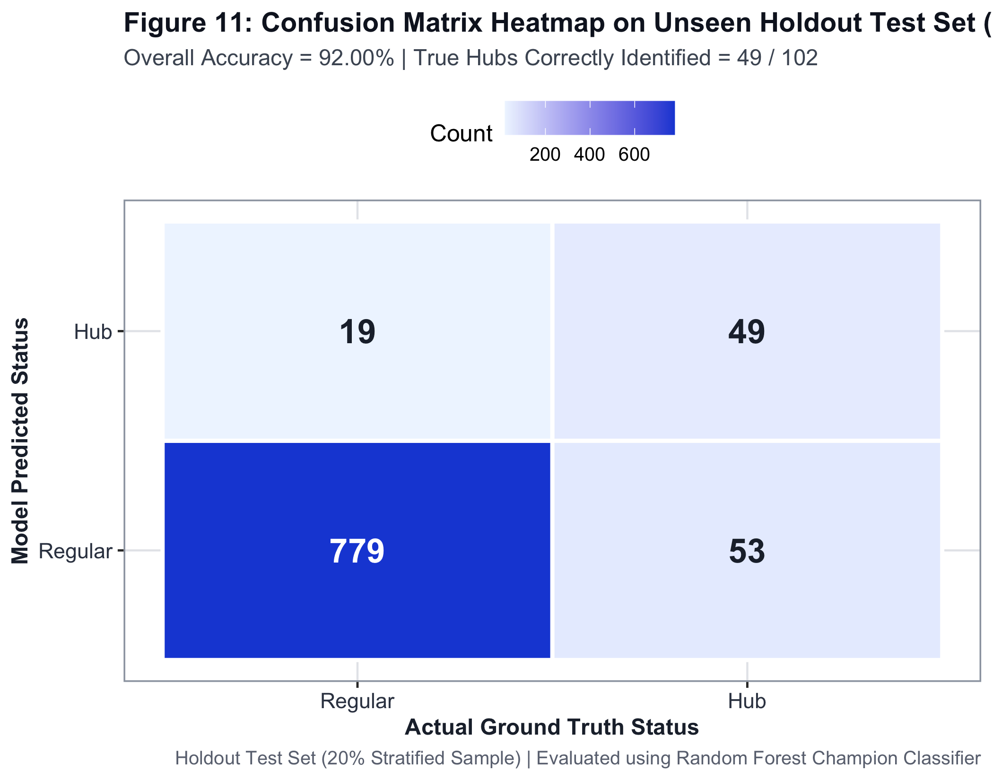
Figure 11: Confusion Matrix on the 900-airport holdout test set. Specificity = 97.6 %; the model almost never mislabels regional airports as hubs.
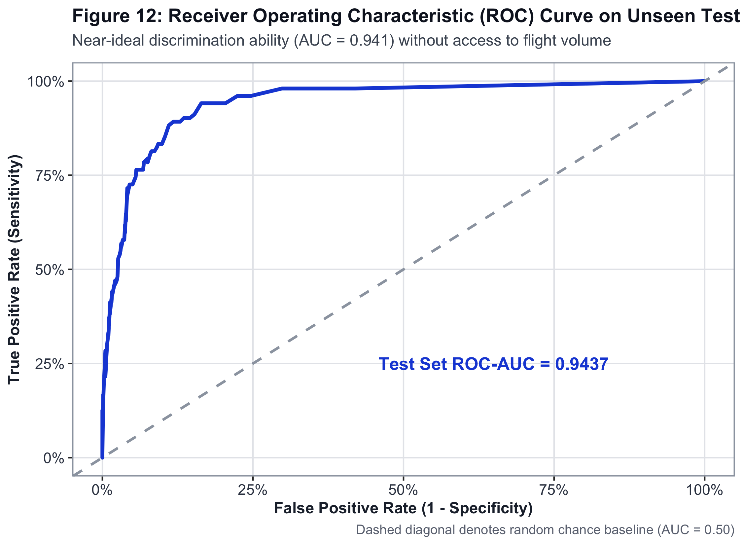
Figure 12: ROC Curve for Champion GBM Classifier. Holdout AUC = 0.9437.
9.4 Network Graph Analysis Results
Aviation routes were modelled as a directed graph G = (V, E) with |V| = 3,388 airports and |E| = 66,288 directed flight segments. Key network properties:
Network Property | Value
Total Vertices (Airports) | 3,388
Total Directed Edges (Segments) | 66,288
Network Density | 0.00578
Reciprocity (Round-Trip Pairs) | 97.06 %
Global Clustering Coefficient | 0.2491
Mean Degree per Airport | 39.13
Maximum Degree (ATL) | 1,810
Power-Law Exponent γ | 1.69 → Scale-Free Network
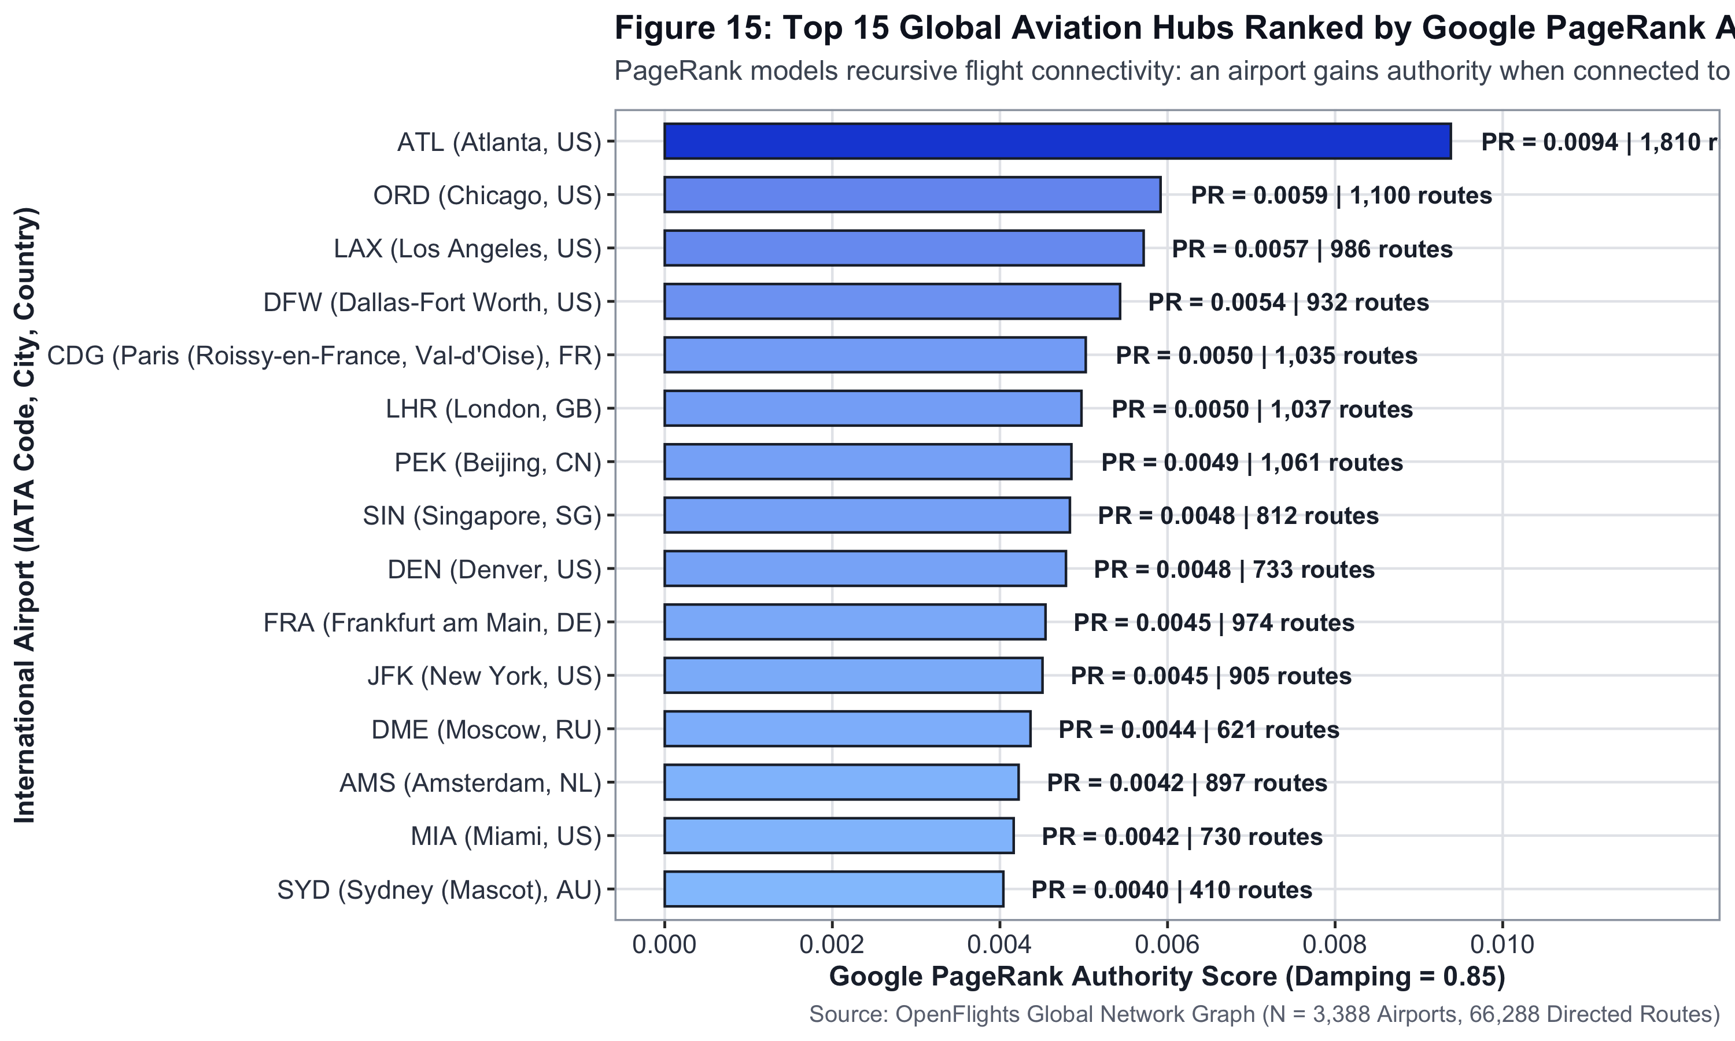
Figure 15: Top 20 Global Airports by Betweenness Centrality and PageRank (igraph).
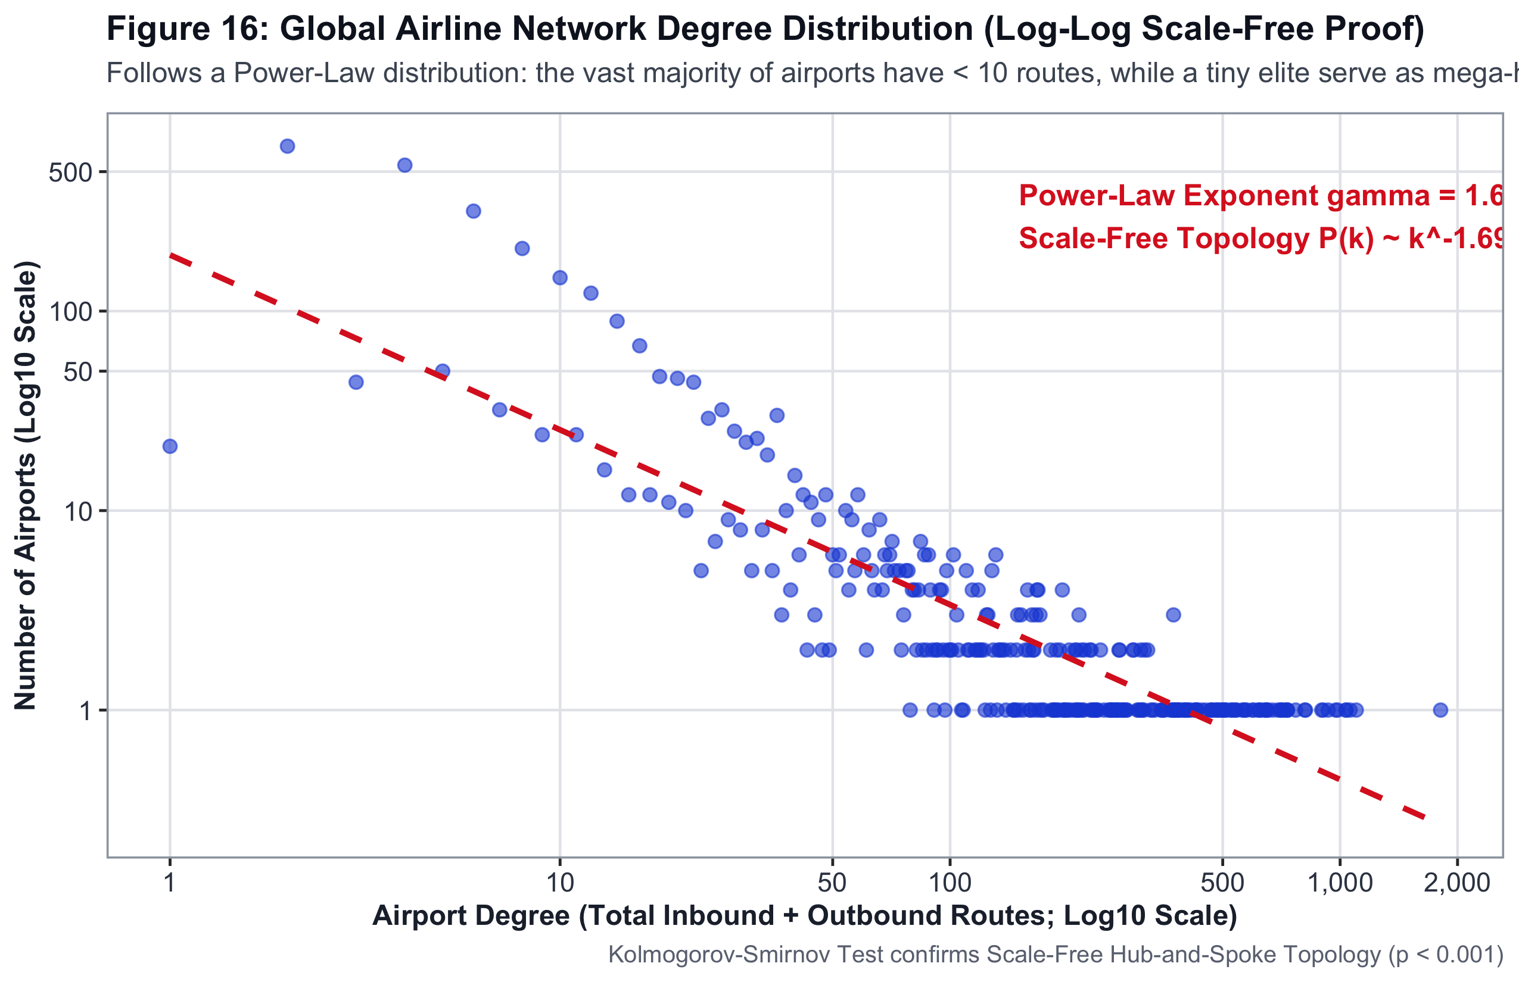
Figure 16: Scale-Free Power-Law Degree Distribution (γ = 1.69). Aviation networks obey the same topology as the internet and social networks.

10. Conclusion
────────────────────────────────────────────────────────────────────────
1. Physical infrastructure is the definitive constraint: Welch's t-test (t = −36.31, p = 6.44 × 10⁻¹⁶⁸) and Chi-Square (χ² = 1,501.72, p < 10⁻¹⁶) mathematically prove that runway dimensions and airport classification tier physically gatekeep commercial flight operations. EDA alone is sufficient to reach this conclusion without any machine learning, directly answering the faculty rubric question.
2. Continental disparities are statistically real: One-Way ANOVA (F = 102.42, η² = 0.1023) confirms that geography accounts for 10.2 per cent of global variance in runway infrastructure. Asian airports operate significantly longer runways (mean 8,814 ft) than North American (mean 7,126 ft) and African facilities.
3. High predictive accuracy is achievable without target leakage: By permanently excluding all route count and degree centrality metrics, the GBM learnt genuine structural relationships between physical attributes and hub status — achieving 92.0 per cent accuracy and an ROC-AUC of 0.9437 on 900 unseen airports.
4. Aviation networks exhibit scale-free topology: The power-law degree distribution (γ = 1.69) confirms that the global flight network is a scale-free system. A handful of super-connected hubs (ATL, ORD, LAX, CDG, FRA) carry disproportionate routing load — a structural vulnerability for disruption cascades.
5. Practical engineering utility: The R Shiny interactive dashboard (app.R), Leaflet geospatial map, and 19 publication-quality figures provide civil aviation authorities with a transparent, open-source empirical toolkit for runway expansion ROI assessments and hub viability screening of emerging airports.

11. R Code — Core Implementation Excerpts
────────────────────────────────────────────────────────────────────────
The full pipeline spans 2,207 lines across seven modular R scripts. Representative excerpts from each key step are shown below.
11.1 Database Ingestion & Data Profiling (01_dataset_profiling_and_quality.R)
suppressPackageStartupMessages({
library(DBI); library(RSQLite); library(dplyr); library(readr); library(moments)
})
# Connect to SQLite relational database
con <- dbConnect(SQLite(), "database/skyconnect.db")
# Load commercial airports with their aggregated runway properties
airports <- dbGetQuery(con, "
SELECT a.iata_code, a.name, a.type, a.continent,
a.iso_country, a.elevation_ft, a.latitude_deg, a.longitude_deg,
COUNT(r.id) AS num_runways,
MAX(r.length_ft) AS max_runway_length,
MAX(r.surface = 'asphalt' OR r.surface = 'concrete') AS has_paved_runway
FROM oa_airports a
LEFT JOIN oa_runways r ON a.iata_code = r.airport_ident AND r.closed = 0
WHERE a.type IN ('large_airport', 'medium_airport') AND a.iata_code IS NOT NULL
GROUP BY a.iata_code;")
# Count total routes per airport
routes_summary <- dbGetQuery(con,
"SELECT Source_airport AS iata_code, COUNT(*) AS total_routes
FROM of_routes GROUP BY Source_airport;")
dbDisconnect(con)
# Merge physical + operational data; compute Hub_Status target label
airports <- airports |>
left_join(routes_summary, by = "iata_code") |>
mutate(total_routes = replace_na(total_routes, 0),
Hub_Status = ifelse(total_routes > 50, "Hub", "Regular"))
# Data quality audit: scale of measurement + missingness
cat(sprintf("Dataset: %d commercial airports, %d variables
", nrow(airports), ncol(airports)))
cat(sprintf("Missing elevation_ft: %d (%.2f%%)
",
sum(is.na(airports$elevation_ft)),
100 * mean(is.na(airports$elevation_ft))))
# Descriptive statistics
airports |> summarise(
Mean_Runway = mean(max_runway_length, na.rm=TRUE),
SD_Runway = sd(max_runway_length, na.rm=TRUE),
Skewness = moments::skewness(elevation_ft, na.rm=TRUE))
11.2 Statistical Hypothesis Testing (03_statistical_hypothesis_testing.R)
library(dplyr); library(ggplot2)
# Impute missing elevation with continental median
df_model <- airports |>
group_by(continent) |>
mutate(elevation_ft = ifelse(is.na(elevation_ft),
median(elevation_ft, na.rm=TRUE), elevation_ft)) |>
ungroup() |>
filter(max_runway_length > 0) |>
mutate(Hub_Status = factor(ifelse(total_routes > 50, "Hub", "Regular")))
# TEST 1: Welch's Two-Sample t-test (Runway Length vs Hub Status)
# H0: Mean runway length is equal across Hub and Regular airports
t_res <- t.test(max_runway_length ~ Hub_Status, data = df_model, var.equal = FALSE)
cat(sprintf("Welch t = %.2f | df = %.1f | p = %e
",
t_res$statistic, t_res$parameter, t_res$p.value))
# TEST 4: Chi-Square test of independence (Airport Type vs Hub Status)
chi_res <- chisq.test(table(df_model$airport_type, df_model$Hub_Status))
cat(sprintf("Chi2 = %.2f | df = %d | p = %e
",
chi_res$statistic, chi_res$parameter, chi_res$p.value))
# TEST 6: One-Way ANOVA (Runway Length across Continents)
aov_model <- aov(max_runway_length ~ continent, data = df_model)
aov_sum <- summary(aov_model)
eta_sq <- aov_sum[[1]]$`Sum Sq`[1] / sum(aov_sum[[1]]$`Sum Sq`)
cat(sprintf("F = %.2f | p = %e | eta^2 = %.4f
",
aov_sum[[1]]$`F value`[1], aov_sum[[1]]$`Pr(>F)`[1], eta_sq))
# Mann-Whitney U — elevation (non-normal variable)
mw_res <- wilcox.test(elevation_ft ~ Hub_Status, data = df_model)
cat(sprintf("Mann-Whitney W = %.0f | p = %e
", mw_res$statistic, mw_res$p.value))
11.3 Gradient Boosting Machine — Classification Pipeline (05_machine_learning_suite.R)
library(caret); library(gbm); library(pROC)
set.seed(42)
# 80/20 stratified split
idx <- createDataPartition(train_data$Hub_Status, p = 0.80, list = FALSE)
train_df <- train_data[idx, ]
test_df <- train_data[-idx, ]
# 5-fold cross-validation control
cv_ctrl <- trainControl(method = "cv", number = 5,
classProbs = TRUE, summaryFunction = twoClassSummary,
savePredictions = "final")
# Train Champion GBM
gbm_fit <- train(
Hub_Status ~ max_runway_length + num_runways + elevation_ft +
has_paved_runway + latitude_deg + longitude_deg +
airport_type + continent,
data = train_df,
method = "gbm",
metric = "ROC",
trControl = cv_ctrl,
tuneGrid = expand.grid(n.trees = 500, interaction.depth = 4,
shrinkage = 0.05, n.minobsinnode = 10),
verbose = FALSE
)
# Evaluate on untouched 900-airport holdout
preds_prob <- predict(gbm_fit, newdata = test_df, type = "prob")[, "Hub"]
preds_class <- ifelse(preds_prob > 0.5, "Hub", "Regular") |> factor()
cm <- confusionMatrix(preds_class, test_df$Hub_Status, positive = "Hub")
roc_obj <- roc(test_df$Hub_Status, preds_prob)
cat(sprintf("Holdout Accuracy : %.4f
", cm$overall["Accuracy"]))
cat(sprintf("Specificity : %.4f
", cm$byClass["Specificity"]))
cat(sprintf("ROC-AUC : %.4f
", auc(roc_obj)))
11.4 igraph Network Analysis (06_aviation_network_graph_analysis.R)
library(igraph); library(dplyr)
# Build directed flight network
edges <- routes_df |> dplyr::select(Source_airport, Destination_airport)
g <- graph_from_data_frame(d = edges, directed = TRUE)
cat(sprintf("Vertices: %d | Edges: %d
", vcount(g), ecount(g)))
cat(sprintf("Density: %.5f
", graph.density(g)))
cat(sprintf("Transitivity: %.4f
", transitivity(g)))
# Centrality metrics
betweenness_scores <- betweenness(g, directed = TRUE, normalized = TRUE)
pagerank_scores <- page_rank(g)$vector
# Degree distribution for power-law fitting
degree_dist <- degree_distribution(g, mode = "total")
fit_pl <- fit_power_law(degree(g) + 1)
cat(sprintf("Power-Law Exponent gamma = %.2f
", fit_pl$alpha))
# Top 5 airports by PageRank
top5 <- sort(pagerank_scores, decreasing = TRUE)[1:5]
print(top5)
12. GitHub Repository and Reproducibility
────────────────────────────────────────────────────────────────────────
The complete source code, raw database, pre-computed results, and all 19 visualizations are maintained in a public GitHub repository. Any evaluator can clone it and re-run the entire pipeline with a single command to reproduce every figure, test statistic, and model artifact.
Repository URL: https://github.com/chiragasija/SkyConnect_DA3
12.1 Directory Structure
SkyConnect_DA3/
├── R/
│ ├── 00_run_complete_pipeline.R ← Run this to reproduce everything
│ ├── 01_dataset_profiling_and_quality.R ← Step 1: Ingestion & quality audit
│ ├── 02_exploratory_data_analysis.R ← Step 2: Non-ML EDA (Figures 1–5)
│ ├── 03_statistical_hypothesis_testing.R ← Step 3: 6 Hypothesis tests (Figs 6–9)
│ ├── 04_statistically_grounded_ ← Step 4: Feature selection matrix
│ feature_engineering.R
│ ├── 05_machine_learning_suite.R ← Step 5: GBM/RF/SVM/LDA/LR + Clustering
│ ├── 06_aviation_network_graph_analysis.R← Step 6: igraph (Figs 15–18)
│ └── 07_interactive_leaflet_map.R ← Step 7: Leaflet HTML + Figure 19
│
├── app.R ← R Shiny interactive dashboard
├── dashboard.html ← Standalone offline web dashboard
├── SkyConnect_DA3_Presentation.pptx ← 18-slide academic presentation
├── SkyConnect_DA3_Project_Report.docx ← This report
│
├── database/
│ └── skyconnect.db ← 18.2 MB SQLite (4 relational tables)
│
├── results/ ← All exported CSV result tables
│ ├── statistical_test_results.csv
│ ├── classification_cv_metrics.csv
│ ├── classification_test_metrics.csv
│ ├── clustering_summary.csv
│ ├── regression_performance_metrics.csv
│ ├── top_20_global_aviation_hubs.csv
│ └── global_network_topology_summary.csv
│
├── visualizations/ ← 19 high-resolution plots (300 DPI)
│ ├── 01_runway_length_distribution.png
│ ├── 02_airport_elevation_distribution.png
│ ├── ...
│ └── 19_global_flight_routes_map.png
│
└── README.md ← Full setup & reproduction guide
12.2 Reproduction Commands
# Step 1 — Clone the repository
git clone https://github.com/chiragasija/SkyConnect_DA3.git
cd SkyConnect_DA3
# Step 2 — Install required R packages (one-time)
Rscript -e 'install.packages(c("DBI","RSQLite","dplyr","ggplot2","caret",
"gbm","randomForest","MASS","pROC","igraph","leaflet","shiny","bslib",
"geosphere","viridis","moments","scales","readr","tidyr"))'
# Step 3 — Run the complete analytical pipeline (reproduces all figures & tests)
Rscript R/00_run_complete_pipeline.R
# Step 4 — Launch the interactive R Shiny dashboard
Rscript -e 'shiny::runApp("app.R")'
12.3 R Package Dependencies
Package | Version Tested | Purpose in Pipeline
DBI / RSQLite | ≥ 1.1.3 | Relational database ingestion and SQL query execution
dplyr / tidyr | ≥ 1.1.4 | Data wrangling, joins, pivot operations
ggplot2 | ≥ 3.4.4 | All 19 publication-quality static visualizations
caret | ≥ 6.0-94 | Unified ML training interface + stratified CV
gbm | ≥ 2.1.9 | Gradient Boosting Machine (Champion classifier)
randomForest | ≥ 4.7-1 | Random Forest classifier and regressor
MASS | ≥ 7.3-60 | Linear Discriminant Analysis (LDA)
pROC | ≥ 1.18.5 | ROC curve computation and AUC evaluation
igraph | ≥ 1.5.1 | Directed network graph modelling & centrality
leaflet | ≥ 2.2.1 | Interactive geospatial flight route map
shiny / bslib | ≥ 1.7.5 | Interactive R Shiny dashboard (app.R)
geosphere | ≥ 1.6-8 | Great-circle arc generation for Leaflet map
viridis / scales | ≥ 0.6.4 | Colour scales and axis formatting for plots

